Research on Governmental Policies’ Effects on

China’s Real Estate Market

(Focusing on Zhejiang Province)

By

Zhenyu Chen

An honors thesis submitted in partial fulfillment

of the requirements for the degree of

Bachelor of Science

Business Honors Program

NYU Shanghai

May 2018

Professor Marti G. Subrahmanyam Professor Joseph Foudy
Professor Yiqing Lu

Faculty Advisers Thesis Adviser
ABSTRACT
Discussions about China’s real estate market are long lasting as the potential bubbles in this market may negatively impact on China’s economy and further threaten global markets. To stabilize China’s economy, governmental policies and regulations on the real estate market have been implemented, though their actual effects are often doubted by scholars and the public. This paper researches on governmental policies’ actual outcomes with the data support from Zhejiang, China using difference in difference model. It is found that country level policies are more effective than local level policies in China’s real estate market, and that supply side policies should be implemented if the government is seeking for a better controlment. Chinese government’s income structure will be further discussed.
- INTRODUCTION
The real estate market in China is growing rapidly and it is tightly connected to China’s economy because it not only contributes to a large portion of China’s GDP, but also promotes relative industries such as manufacture and transportation industries, so any market disorder in this market might heavily threaten China’s economy. To stabilize China’s economy and to further enhance social security, Chinese government has implemented governmental policies at different levels to better control this market. However, as the residential property prices continue to increase to a level that is beyond average people’s affordability, these policies’ actual outcomes are questioned by the Chinese people. This paper evaluates governmental real estate policies’ outcomes from an academic perspective. Statistical approaches including difference in difference and simple regressions are used for analyzing the market supply side dataset from the Bureaus of Statistics in Zhejiang Province. Some of the results will be useful in government decision making processes.
As China’s real estate market is a widely discussed one, many researchers have made valuable contributions. Most of the research in this field focus on the purchase limitation policies (Xiangou Zhengce), which have been implemented by major Chinese cities at the times when real estate markets are considered overheated. Once purchase limitation policies are implemented, down payments usually increase and non-locals often face stricter regulations. Researchers are relatively optimistic toward purchase limitation policies. Huifeng Pan and Xitong Liu (2017) suggest that, the purchase limitation policies have positive effects in the mid-and-long run. Also, the policies will restrain both supply and demand. Xing Fang (2018) finds that the purchase limitation policies are especially effective on restraining speculative demand and the increasing demand in mid-small cities. Fang also argues implementing purchase limitation policies is not a permanent solution to cool down the market.
Many scholars research on the affordable housing policies (jingji shiyong fang, lianzu fang, anju fang, etc.) Affordable housing policies are commonly used in China and many Asian countries like Singapore, aiming to satisfy people’s basic living demands at low cost with the accommodations provided by the government. Researchers are more skeptical about these policies. Yonghua Zou (2013) criticizes China’s inter-governmental structures set barriers to local governments’ fiscal capacities and motivations to meet the targets. However, he still holds an optimistic view on the prospective innovative governmental strategies. Kioe Sheng Yap (2015) also points out that low income housing programs’ effectiveness heavily depends on local governments’ financial and technical capacities. Some researchers also try to find other potential solutions, like introducing property tax policies to the market. Jingwei Zhang (2017) believes collecting property taxes will only be effective in the short term. However, since the policies have not been officially implemented to China’s real estate yet, there is no sufficient data to evaluate this hypothesis.
In general, the research on China’s real estate market and the market policies mainly discuss specific types of policies and their corresponding outcomes. They successfully explore the market in depth and provide valuable knowledge. At the same time, I also notice that even within a specific policy category, each similar policy’s effectiveness should be different. Due to China’s governmental structures, the same policy will be designed and announced at different levels, following the top to bottom structure. For example, in February, 2013, the State Council published “Five Restrictions” (Guo Wutiao), which ask all provinces to establish a complete real estate market monitory system. Few months later, each province published their provincial level restriction rules, which follow State Council’s Five Restrictions, but conclude more details to better fit the province’s specific situations. Will a country level policy’s effectiveness different from a provincial or city level policy’s effectiveness in China’s real estate market? Little research can be found about this topic, but the knowledge behind this question will be useful for the government to find appropriate governance approaches. Therefore, this will be valuable to further investigate into.
- THE INCREASING DEMAND
Before analyzing governmental policies, I would like to emphasize some facts about China’s real estate market, which are often ignored by people and will be useful in understanding this market. One key fact is that a huge rigid demand exists in the market. Though in many government documents, the “speculating adventurers” are the blame for lifting residential property prices, it can be found that the demand for housing without speculating considerations is also increasing in China. Many factors contribute to the increasing rigid demand.
Urbanization. China is experiencing an unprecedented progress of urbanization since last century. From 1990 to 2016, the urbanization rate, defined by urban population divided by total population, is growing stably at 3.0% per year, which is higher than the 2.1% East Asia and Pacific average (Appendix Figure 1). Given China’s huge population, a 3.0% yearly growth indicates an estimation of 42 million people will shift to urban areas every year. These new citizens create rigid demand for accommodations in big cities. The other research finished by She et al (2015) confirms the positive correlation between housing prices and urbanization rates.
Tradition. Traditionally, driven by the insufficient health care system and social security system, Chinese people tend to pursue “low risk” investments like depositing in commercial banks and purchasing precious metals like gold. Investing in real estates is another “low risk” investment options. This kind of investment is classified as “rigid demand” in this paper because it is not speculating driven. People only seek to maintain their assets’ values in extreme circumstances like inflations and family accidents though these investments, thus these investments are ideally closer to “risk-free” deposits. This phenomenon also exists in gross saving rates: the gross savings in China, in % of GDP, is almost three times higher than that of in US and is much higher than the East Asia and Pacific region average (Appendix Figure 2).
Living Quality Improvement. The per capita disposable income in China grew at an average of 11.1% per year from 2001 to 2016 (Appendix Figure 3). Though the absolute statistics are still far behind mature markets like the US’s, there are signs showing the size of middle class in China is growing. The increase in disposable income and absolute income encourage the growing middle class to pursue for better quality lives. Purchasing larger housings located at good places improves life quality by providing personal enjoyment and next generation’s education opportunities. We can infer that this kind of improvement is also encouraged by the government. The terms “industry upgrading” (chanye shengji) and “supply side reform” (gongjice gaige), which encourage corporations to produce higher-end products, frequently appear on government documents and announcements since 2016. As a result, newly developed high-end properties are encouraged.
Information Transparency. Without a sufficient housing listing system like the US’s Multiple Listing Service, Chinese people relatively have less knowledge about the accurate supply and demand information. In October 2017, two central government committees jointly released a document pressuring property developers to control housing prices by spreading misguiding supply and demand information. This document shows the government’s attention towards the existing information transparency problem.
- MAIN MARKET CONTROLLING APPROACHES
Responding to the demand discussed in the previous section, President Xi Jinping's report at 19th CPC National Congress concludes the Party and the government’s focus on China’s real estate market as the following:
“We must not forget that housing is for living in, not for speculation. With this in mind, we will move faster to put in place a housing system that ensures supply through multiple sources, provides housing support through multiple channels, and encourages both housing purchase and renting. This will make us better placed to meet the housing needs of all of our people.”
Commonly used approaches to achieve these goals include purchase restriction, price restriction, increase cheap land supply and increase affordable housing supply. All these approaches’ implementations require a powerful and centralized government, which has a strong control over the nation’s resources. For instance, a typical price restriction policy asks real estate developers to sell properties at a certain low-price range. Without a tight control over real estate corporations, these price restriction policies are not likely to be implemented since corporations naturally pursue profits and therefore will not strictly follow the policies. Increase cheap land supply is possible in China because all the lands in China are owned by the country, thus the lands can be sold at desirable low prices.
If running successfully, the purchase restriction policies should decrease demand, especially the demand from speculating investors, and the policies that aim to increase land and affordable housing supply should increase the overall cheap housing supply. In general, these policies will theoretically help resolve the current problems.
- CASE STUDY: ZHEJIANG PROVINCE
  - Data Description
Main Dataset. The dataset used in this project was requested from the Bureau of Statistics in Zhejiang Province. Named “Real Estate Investment Status in Zhejiang Province”, the dataset concludes 118 separate monthly reports on real estate investment and development status in Zhejiang Province through a ten-year period. Some important entries in this dataset include planned total investment, completed total investment, construction area, rented area and sold area. Sub-entries that classified the investments or areas by housing usages, including residence, offices, commercial buildings and others are available, thus further analysis on housing usages are possible.
Policy List. A list of real estate policies was crawled from newspaper headlines. Chinese government has a tight control over mass medias for propaganda purposes, so if there is any policy that the government thinks important, then this policy must had appeared on mass medias. The media source was Qianjiang Evening News (Qianjiang Wanbao). 400 real estate related news from July 2009 to November 2017 were collected by Python program. 44 government policies are sorted from the 400 related news.
“Important Policy List”. Each of the 44 policies are evaluated by their announcing periods, outcome expectations and appearance frequency. After the evaluation, 6 “important policies” are sorted out (Figure 1).
Figure 1: Important Policy List
Year-Month | Level | Policy | Expectations
2011-08 | Country | Policy tighten | Mitigate
2013-03 | Country | Five restrictions | Mitigate
2013-11 | Provincial/City | Raise down payments to 70% | Mitigate
2014-07 | Provincial/City | Loosen purchasing limits | Stimulate
2015-03 | Country | Decrease interest rates, lower down payments to 40% | Stimulate
2016-09 | Provincial/City | Purchase restriction, 50% down payment, “hukou” restriction | Mitigate

  - Intro-Province/City Similarities
Evidences have shown there exists a strong correlation among major cities’ housing prices.
Figure 2: Residence Prices in Beijing and Zhejiang, with Policy News
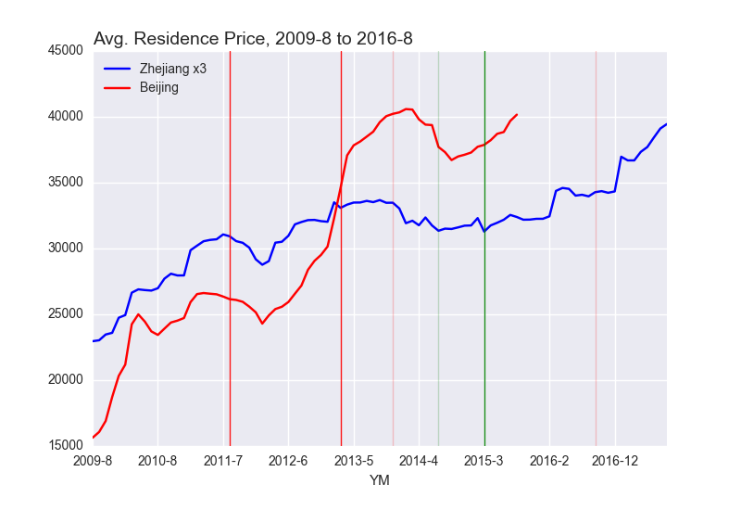
Vertical Lines:
 | Country Level Mitigation |  | Country Level Stimulation
 | Province or Below Level Mitigation |  | Province or Below Level Stimulation
Figure 2 shows the average prices for residence housings in Beijing and Zhejiang from August 2009 to August 2015. Note that for clarity, the data for Zhejiang is multiplied by 3 in the graph, thus the absolute values are not meaningful in this graph. The strong correlation of 0.837 shows the price movements’ similarity between Beijing and Zhejiang. This phenomenon appears among other major cities and provinces (Wei et al, 2015). Researching on Zhejiang Province is also meaningful for solving problems in other provinces and cities in China.

  - Findings
Frequent Governmental Attempts to Control. In the policy list, 44 real estate policies were implemented over a 100-month period. Policies aim to mitigate and stimulate the market can be announced within a few months depending on the market performance. This shows the flexibility within this market, or inconsistency, if judged from an opposite perspective.
Strong Control from Central Government. Difference in difference analysis can be conducted using the market performances in Beijing and Zhejiang shown in figure 2. Residential property prices in both Beijing and Zhejiang are affected by national policies. However, prices in Beijing will not be affected by Zhejiang policies. Figure 2 shows the prices in Beijing and Zhejiang moved together after Zhejiang policies were implemented, which shows the price trend in Zhejiang would behave like what we have now even if no Zhejiang provincial policies were announced. This shows provincial policies are not so effective as expected. In this specific case, Zhejiang and Beijing did not announce policies at the same time. Otherwise, the difference in difference analysis’ results will be affected.
At the same time, residential property prices and other variables behave better after national policies were announced. Variable behaviors are evaluated in two approaches. The first approach is also based on the difference in difference model. If the price in Zhejiang behaviors differently from Beijing, then it is likely caused by provincial policies. The second approach is more intuitive. If a jump in price appears suddenly after a policy is implemented, then this jump is likely caused by that policy.
Little Effects on Demand. Evidences show all policies have little effects on demand (rented area, housings sold variables).
Figure 3: Percent Increase on Rented Area and Sold Area
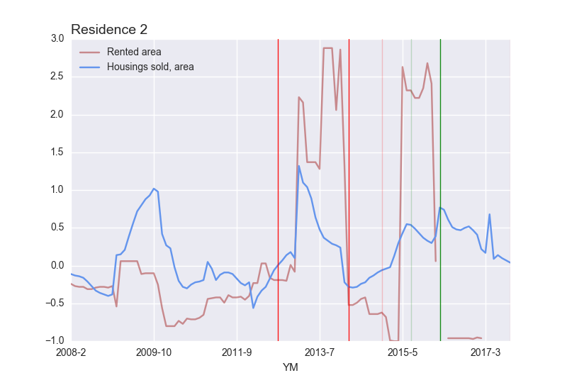
Vertical Lines:
 | Country Level Mitigation |  | Country Level Stimulation
 | Province or Below Level Mitigation |  | Province or Below Level Stimulation
As it can be shown in the figure, the rented area and housings sold area variables are very volatile, and they do not move in the ways we would expect: the statistics may increase after mitigation polices were announced and decrease after stimulation policies were implemented. Therefore, the governmental policies seem not affect housing demand. The simple regression result also proves this. In the regression, the dependent variable is rented residence area while the significant independent variables are kept (See Appendix Figure 4 for details):
Rented residence area (square meters) = 27971.93
+ 0.089 Investments on villas and luxury housings constructions (10k RMB)
- 0.015 Investments on other housings constructions (10k RMB)
- 0.027 Newly started villas and luxury housings constructions (square meters)
- 0.059 Completed villas and luxury housings constructions (square meters)
+ 0.128 Completed villas and luxury housings constructions (10k RMB)
+ 0.034 Residence sold, larger than 140 square meters (square meters)
- 0.027 Residence sold, larger than 140 square meters (10k RMB)
The high adjusted R^2 of 58.4% shows the regression fits the data points well, and the F-statistics of 32.9% shows the variables’ significance. The result shows that rented residence area is tightly related to luxury housings and housings larger than 140 square meters. To some extent, housings larger than 140 square meters can also be described as “luxury” in China, as the household income is still relatively low in China. Based on the regression result, if the government hopes to increase residential property supply, it should focus more on regulating luxury properties. Other regressions’ results suggest the average housing prices variable is also affected by luxury housings.
Not Clear Effects on Supply. Governmental policies’ effects on supply remain unclear. The average land cost increases continuously, though the government promised to lower the land cost.
Figure 4: Average Land Cost, 2008 – 2017
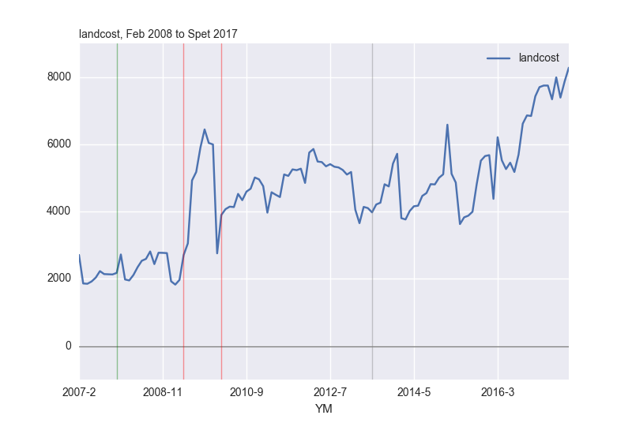
Vertical Lines:
 | Country Level Mitigation |  | Country Level Stimulation
 | Province or Below Level Mitigation |  | Province or Below Level Stimulation
Meanwhile, whether the government successfully meets the goal of providing enough reasonably priced properties to the ones in need remains unknown, as the government does not share relative information to the public. Some local governments did share some statistics at certain years, but these statistics are incomplete and are possibly inaccurate for further analysis. The dataset from the Bureau of Statistics in Zhejiang records only 8 months’ affordable housing supply data at 2009. Within these 8 months, the supply of affordable housings did increase. However, the related entries were removed after 2009.
In fact, in many cities, the statistics are meaningless even if they are available. In some cities, the local governments ask property developers to sell the properties they built at low prices, by asking all developers to get the government’s approval before selling their newly built properties. The property developers’ proposals of selling residential properties at high prices will be rejected, which means the government is setting price ceilings for property developers. Obviously, this threatens property developers’ profit. As a result, property developers sometimes accept only full payments, and sell parking spaces at extremely high prices. This is unaffordable for the relative low-class people, who would like to buy their first housings. Therefore, though some evidences indicate cheaper residential property supply is available, the actual benefit may not be perceived by the ones in need.
Strong Control over SOEs. Evidences show the Chinese government has a tight control over state owned enterprises. This is mainly shown from their investments before and immediately after important policies are announced.
Figure 5: Percent Increase on Real Estate Investments, by Investors
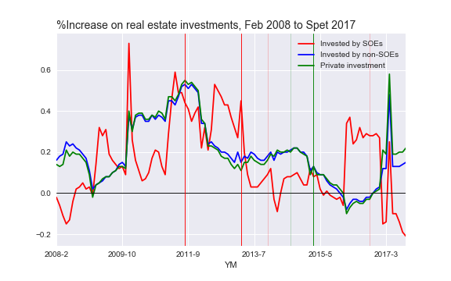
Vertical Lines:
 | Country Level Mitigation |  | Country Level Stimulation
 | Province or Below Level Mitigation |  | Province or Below Level Stimulation
SOEs and non-SOEs respond to policies differently. When mitigative policies were implemented, sharp decreases on SOE’s percent investment increase are observed almost immediately, while non-SOEs did not behave in the same way. Both SOEs and non-SOEs moved in the same way when simulative policies were implemented. Though SOEs only shared about 10% of the total investment over the years, the huge absolute amount was enough to have significant influence the overall real estate market (See Appendix Figure 5 and Appendix Figure 6 for details). The possible conclusion: SOEs are more “cooperative” to government mitigative policies than non-SOEs.
- FURTHER DISCUSSIONS
In section 4 we discussed about real estate policies’ effects and the relevant findings. In general, national policies usually have better effects than provincial policies, governmental policies have little effects on the demand while the effects are unclear on the supply, and state-owned enterprises are more cooperative to governmental policies. At the same time, we see the local government failed to supply lands at low prices. This discovery helps uncover more fundamental problems in China’s political and economy structures.
Recall Yonghua Zou (2013) and Kioe Sheng Yap (2015)’s research result that the implementation of policies depends on local government’s financial and technical capacities and motivations. In their special case of affordable housing, they find that local governments in China lack motivations because of the country’s political structure. Based on their result, I would like to examine local Chinese governments’ capacities and motivations on implementing real estate policies.
Capacities. The Chinese government has a relatively strong financial and technical capacities to implement real estate policies. As already discussed in the previous sections, the Chinese government has strong controls over all kinds of resources: state-owned enterprises, interest rates, land ownerships, etc. This means the government has a sufficient number of weapons to derive desirable outcomes. Therefore, the government’s financial and technical capacities is not an issue. The only concern is about the officials’ experience and intellectual capacities. Since 2014, when the Chinese Communist Party started a new round of anti-corruption campaign, many incapable officials were also ousted from power with corrupted officials. This action further enhanced the central government’s control over local governments. There is no evidence showing all corrupted officials and all incapable officials are expelled, but relatively the officials’ capacities are becoming less of a problem.
Motivations. The government’s income is heavily depending on land sales.
Figure 5 Local Governments’ Land Reliance
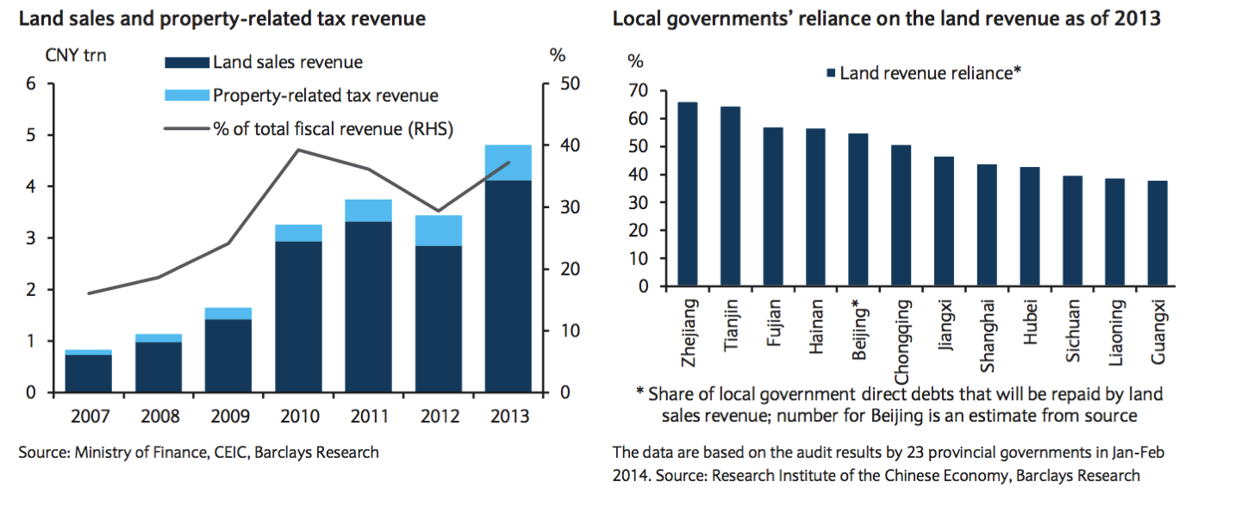
According to the research from Barclays, land revenue contributes nearly 65% of the government income in Zhejiang Province. In other provinces, it is common for land revenue to contribute more than 40% of local government’s income. This explains why the land cost continues to increase: the local government is depending too much on land revenue to lower the land prices. This puts local governments in a dilemma. On the one hand, local governments need to implement real estate policies and control all the statistics at satisfying levels; on the other hand, it is impossible or too painful to control some of the statistics like land revenue. With these considerations, regardless of the policies’ actual outcomes, the local governments’ governance efficiencies are affected. In general, local governments’ policy implementation motivations are weakened by their financial structures.
- CONCLUSIONS
Based on the previous discussions, we can draw several conclusions, which might also help the government make decisions.
Current policies mainly aim to reduce people’s demand on housings, but as the process of urbanization continues, the demand for more housings will continue exist, therefore simply enforce people to give up purchasing is not sustainable. Therefore, reasonable focus should be put on the supply side: more affordable housings, cheaper rental housings, cheaper land supply, etc. Many new attempts are recently announced: providing 40-year property right housings, allowing a property’s owners and renters to have the same right (e.g. children can attend regional schools even if they live in rented housings), etc.
Given central government has stronger control over the market, important policies should be announced at country level. The governmental should make full use of state-owned enterprises, as they are usually more cooperative to governmental policies. Also, the government should pay more attentions on luxury properties, as they potentially affect property prices and rental prices.
A fundamental contradiction lies between the government’s governance target and the government’s income structure. The local governments are relying too much on land revenues to efficiently design and implement real estate policies. This is dangerous as land revenue is not a sustainable source of income. It may take long time to change the income structures, but if the local governments were successfully managed to change, the result of which would benefit their control over this specific market and other governance fields.

Appendix 1: Figures
Appendix Figure 1
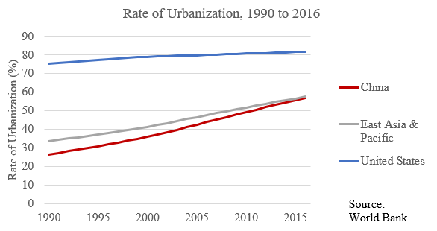
Appendix Figure 2
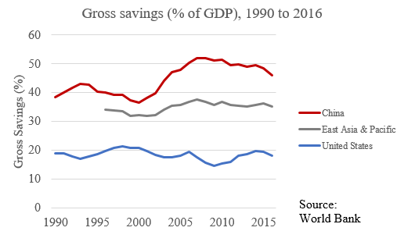
Appendix Figure 3
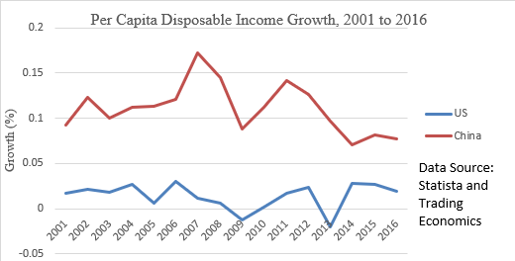
Appendix Figure 4: Regression Result
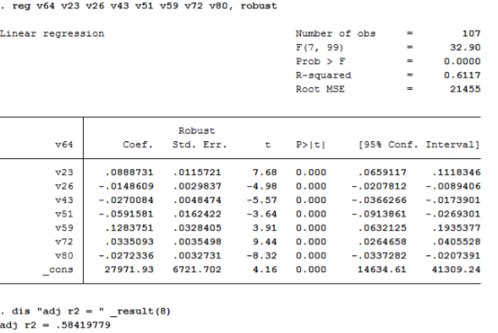
Appendix Figure 5
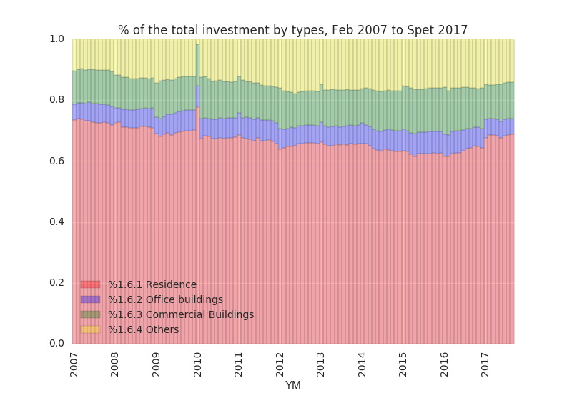
Appendix Figure 6
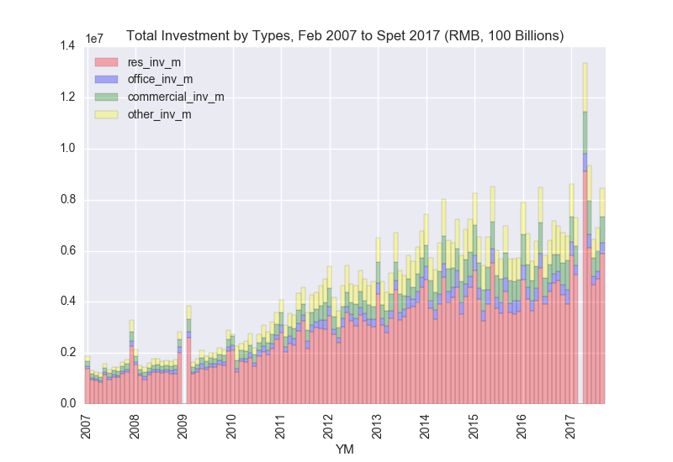
The investments in China’s real estate market are mainly for residence constructions. The total amount is growing.

Appendix 2: Important Policies’ Evaluation
Having 44 policy-related news is a good result but consider all the 44 policies appeared in a 100-month period, on average, there will be a new policy every two month. This high frequency makes it hard to differentiate the policies’ individual effects in the following steps: 1) The frequency of policy news appeared each month was generated (Column Total); 2) The government’s attitudes toward the real estate market behind these policies were analyzed (hope to stimulate or mitigate the market? In most of the situations, the government’s opinions can be easily read from the text. Column Stimulate to Neural); 3) The government’s overall attitude towards the market is evaluated by the number of simulative policies (Column Stimulate) subtracted by the number of mitigative policies (Column Mitigate). The more positive the results (Column Attitude) are, the harder the government tried to simulate the real estate market. A separate “Rental” column was marked as “1” if the policies are related to encourage rental and purchasing affordable housings. Take both the numbers of policies published in each month (observed a fact that similar news may appeared on the headlines repeatly if the policies are “important”) and the overall governmental attitude towards the market (if the government really tried hard to stimulate or mitigate the real estate market) into consideration, the months marked in colors are months considered “significant” in this research. The significant months are significant because either important country or province level policies were released.
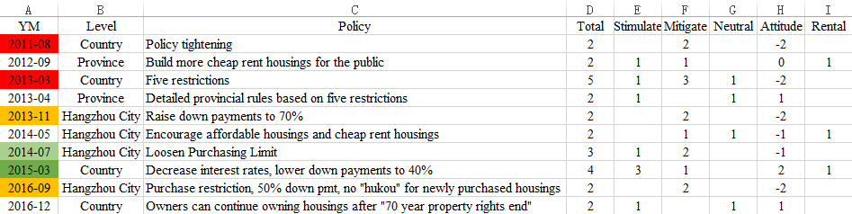

References
Fang Tianxia. Housing Prices in Beijing. www.fang.com.
Fang, Xing. Is House Purchase Limit Effective to Control Housing Price in China? An Empirical Study Based on 70 Large and Medium Cities. Financial Science. 2018(01):41-53. 方兴.中国房地产 限购政策能够有效抑制房价上涨吗——基于70个大中城市的实证研究[J].财经科 学,2018(01):41-53.
Kioe Sheng Yap. The enabling strategy and its discontent: Low-income housing policies and practices in Asia. Habitat International 54 (2016) 166–172. 2015.
Ministry of Housing and Urban-Rural Development of the People’s Republic of China http://www.mohurd.gov.cn/zxydt/201710/t20171025_233705.html
Pan, Huifeng and Liu, Xitong. Control Effect of House Purchase Quota Policy on Housing Price, Suppy and Demand -- Evidence from Beijing. China Academic Journal Electronic Public House. 2017(08):48-51. 潘慧峰,刘曦彤.限购政策对房地产价格及供求的调控效果研究——以北 京市为例[J].价格理论与实践,2017(08):48-51.
Qianjiang Evening News. http://qjwb.zjol.com.cn/html/2018-05/10/node_77.htm.
Shi, Wei, Chen Jie and Wang, Hongwei. Affordable housing policy in China: New developments and new Challenges. Habitat International 54 (2016) 224 – 233. 2015.
Trading Economics. China Disposable Income per Capita.
https://tradingeconomics.com/china/disposable-personal-income
World Bank. Gross Savings. https://data.worldbank.org/indicator/NY.GNS.ICTR.ZS
World Bank. Urban Population. https://data.worldbank.org/indicator/SP.URB.TOTL.IN.ZS
Xi, Jinping. President Xi Jinping's report at 19th CPC National Congress. China Daily. November 4, 2017. http://www.chinadaily.com.cn/china/19thcpcnationalcongress/2017- 11/04/content_34115212.htm
Zhang, Jingwei. Study on the effect of implementing property tax on the price of residential real estate in China. 2017. 张敬伟.开征房产税对我国住宅商品房价格的影响研究[D].湘潭大 学,2017.
Zou, Youghua. Contradictions in China’s affordable housing policy: Goals vs. structure. Habitat International 41 (2014) 8-16. 2013.

Special thanks to my thesis advisor Professor Joseph Foudy at New York University Stern School of Business for providing me with a profusion of helpful comments, suggestions, insights and inspirations. I would not be able to finish this paper without Professor Foudy’s valuable guidance. I thank Professor Marti G. Subrahmanyam at New York University Stern School of Business, Professor Yiqing Lu and Xinyi Yang at New York University Shanghai for organizing NYU Shanghai Business Honors Program, which provides me this academic research opportunity. I would also like to show my gratitude to the Bureau of Statistics in Zhejiang Province for the dataset.
Based on the comparison between Chinese people’s average income and average housing prices.
“Non-locals” are defined by their “hukou”, a system of household registration in China. Specific regulations may include: one family can only purchase one housing, the purchaser must pay taxes to that city for a certain amount of time, etc. Ideally, a lower demand driven by the purchase limitation policies will bring down housing prices.
Fang Xing. Is House Purchase Limit Effective to Control Housing Price in China? An Empirical Study Based on 70 Large and Medium Cities. Financial Science. 2018(01):41-53. 方兴.中国房地产限购政策能够有效抑制房价上涨吗——基于70个大中城市的实证研究[J].财经科学,2018(01):41-53.
Pan Huifeng and Liu Xitong. Control Effect of House Purchase Quota Policy on Housing Price, Suppy and Demand -- Evidence from Beijing. China Academic Journal Electronic Public House. 2017(08):48-51. 潘慧峰,刘曦彤.限购政策对房地产价格及供求的调控效果研究——以北京市为例[J].价格理论与实践,2017(08):48-51.
Youghua Zou. Contradictions in China’s affordable housing policy: Goals vs. structure. Habitat International 41 (2014) 8-16. 2013.
Kioe Sheng Yap. The enabling strategy and its discontent: Low-income housing policies and practices in Asia. Habitat International 54 (2016) 166–172. 2015.
Jingwei Zhang. Study on the effect of implementing property tax on the price of residential real estate in China. 2017. 张敬伟.开征房产税对我国住宅商品房价格的影响研究[D].湘潭大学,2017.
Data source: World Bank. https://data.worldbank.org/indicator/SP.URB.TOTL.IN.ZS
Wei Shi, Jie Chen and Hongwei Wang. Affordable housing policy in China: New developments and new Challenges. Habitat International 54 (2016) 224 – 233. 2015.
Data source: World Bank. https://data.worldbank.org/indicator/NY.GNS.ICTR.ZS
Data source: Trading Economics. https://tradingeconomics.com/china/disposable-personal-income
Full document: http://www.mohurd.gov.cn/zxydt/201710/t20171025_233705.html
Full text of President Xi Jinping's report at 19th CPC National Congress. China Daily. November 4, 2017. http://www.chinadaily.com.cn/china/19thcpcnationalcongress/2017-11/04/content_34115212.htm
Among all the local bureaus I had requested, only the Bureau of Statistics in Zhejiang Province agreed to provide a dataset for academic purposes.
Qianjiang Evening News (Qianjiang Wanbao) is one of the best-selling provincial newspapers that report all varieties of news including both country, provincial and city level news, so it will provide the most complete policy list. Besides, it offers free online versions, which make Python based data crawling possible. Sample page: http://qjwb.zjol.com.cn/html/2018-05/10/node_77.htm.
The 400 news were carefully sorted by hand to best reduce classification errors.
See Appendix 2 for specific evaluation approaches.
Data Source: Fang Tianxia: www.fang.com. The data for Zhejiang is derived from the main dataset using the formula housing price = total value of housings sold / total area of housings sold.
Wei Shi, Jie Chen and Hongwei Wang. Affordable housing policy in China: New developments and new Challenges. Habitat International 54 (2016) 224 – 233. 2015.
Note that aside from the original data’s sample validity, threats to the regression’s internal validity include functional form misspecification (log and power relationship should also be considered) and simultaneous causality (residence sold, for example, might be related to dependent variable).
The land cost statistics are derived from the main dataset using the average land cost = total value of lands sold / total area of lands sold.
In China, real estate developers also serve the functions of real estate agents. They built properties and sell these properties themselves.
The prices for parking spaces are usually not tightly regulated by the local governments. In some cases, the prices are above 600 thousand RMB (around 100 thousand USD). The requirement of accepting only full payment is not legal, but usually local governments will not strict regulate this, since this benefits both property developers and local governments (less risk of having bad debts for state owned commercial banks).
Derived from the main dataset.
Youghua Zou. Contradictions in China’s affordable housing policy: Goals vs. structure. Habitat International 41 (2014) 8-16. 2013. Kioe Sheng Yap. The enabling strategy and its discontent: Low-income housing policies and practices in Asia. Habitat International 54 (2016) 166–172. 2015.
Ministry of Finance, CEIC, Barclays Research. Acknowledge Prof. Foudy for providing this chart.
This is originally difficult under China’s “hukou” system.

