IPO Underpricing in China and
Contributing Factors
from the Market with Distinct Characteristics

by

Dian (Colleen) Jin

An honors thesis draft submitted in partial fulfillment

of the requirements for the degree of

Bachelor of Science

Business Honors Program

NYU Shanghai

Nov 2018

Professor Marti G. Subrahmanyam Professor Robert Whitelaw
Professor Yiqing Lu

Faculty Advisers Thesis Adviser

Abstract
The underpricing in initial public offerings (IPO) refers to the phenomenon where new shares are given a relatively lower price when they are initially issued and proceed to trade at a higher pricing when they are listed in the stock market. When this phenomenon prevails, the general investors believe that successful subscription of new shares will almost definitely lead to an excessive level of returns. Since Reilly and Hatfield (1969), and Stoll and Curly (1970) found that IPO shares tend to be priced too low, more studies have been conducted on this very phenomenon regarded as a popular topic in financial research.
I believe that in China, regulatory issues regarding the IPO market, whether they are explicit as stated in official documents or implicit as generally conformed to by IPO participants including the issuers, underwriters and investors but never officially or publicly confirmed, are the dominating factors influencing the level of IPO underpricing. This paper investigated the initial public offering underpricing in China’s A-share market between 2005 and 2017, with a look into the development of the regulatory policy governing the domestic capital market and a record of how the constantly adjusting policies have been influencing the IPO underpricing in China. This article includes the difference in ratio of P/E between IPO shares and the market, to measure the changes in IPO regulations as well as to analyze how they affect the level of underpricing. Some indication from data: in the early stage of the IPO regulation reform, the difference in ratio of P/E had significant influence over IPO underpricing; as the difference in ratio increases, the IPO underpricing level decreases; in the later stage of the IPO regulation reform, the same influence weakens, indicating that the marketization of IPO regulations, which give more power to the market force and all participants relative to authoritative agency, is gradually becoming effective. The paper proceeds to divide the data into sections according to the different IPO policy phases they belong to and systematically compare the level of IPO underpricing in China’s main board, small and medium board (SME) and the growth enterprise board (GEM). It finds that the level of IPO underpricing is smaller in the growth enterprise board than those of the main board and SME. The latest IPO underpricing in the data set for GEM is as low as 17.20%, coming closer to the level in more developed markets. This paper hopes to give some thoughts on accelerating the construction of a multi-layered, more mature capital market in China by pondering over the reform of IPO share issuance.

Table of Contents
Abstract 2
Index 4
Section 1 – Introduction 6
  - Context 6
  - Significance 7
  - Research Idea, Framework and Methods 9
  - Creative Thinking 11
Section 2 - Literature Review 12
2.1 Overseas Literature Review 12
Section 3 - Regulatory Development of IPOs in China 14
3.1 Changes in Monitoring Regulations 14
3.2 Changes in Pricing Regulations 17
Section 4 - Theoretical Analysis and Research Design 17
4.1 Analysis of IPO Regulation Reform and 18
Changes in Level of IPO Underpricing
4.2 Hypotheses 20
Section 5 - Experiment Design and Model 22
5.1 Sample Choosing and Data Source 22
5.2 Variable Design 22
5.3 Model Construction 24
Section 6 - Experiment Results and Discussion 25
6.1 Data Descriptive Statistics 25
6.2 Multivariate Regression Analysis 27
6.2.1 Changes in IPO Underpricing under 27
Difference New Share Regulations
6.2.2 Comparison of IPO Underpricing in 30
the Main Board, SME and GEM
Section 7 - Conclusion, Restriction and Implications 33
7.1 Research Conclusions 33
7.2 Restriction and Subsequent Suggestions 36
Section 8 – References 37

Section 1 - Introduction
  - Context
The studies related to IPO originated in the late 1960s. After a decade of development till the 1980s, financial economists started to approach the problems in IPOs via systematic, theoretical and empirical research. So far, the research works around initial public offering have been focusing on the main three “mysteries”, namely the low pricing in IPO, the long-run weak performance after issuance and clustered subscription. It was as early as the end of 1960s when Reilly and Hatfield (1969) and Stoll and Curly (1970) uncovered the short-term underpricing in the IPO market.
In order to promote economic reform, China launched the Shanghai Stock Exchange (SSE) in 1990 and the Shenzhen Stock Exchange (SZSE) in 1991. In the early stage of the stock market, it was China’s governing authorities that played a leading role. China Securities Regulatory Commission (CSRC) was making the decision of which companies get to go public and how much they should price the new shares. The government’s control over the capital market largely twisted the natural market mechanism, and it was one the main reasons behind the exceptionally high level of IPO underpricing at that time. Originally, the CSRC used a fixed P/E ratio to help determine the issuance price for IPOs, which totally ignored the differences across industries, let alone the specific companies themselves. In July 1999, the CSRC introduced the cumulative auction method to price IPO shares. This particular method involves the underwriters providing a reasonable price rage based on previous experiences so that investors are easier to find because they are sure to price within this range. Apparently, there are multiple subjective terms in this method which led to vague authoritative instruction in practice. Theoretically speaking, the IPO shares priced using this method have a better representation of the market demand and the valuation of the issuer company. However, while the accumulative auction method may work in the developed markets, it proved to be practically useless in China’s context. The investors, especially retail investors who dominate the investor population in China, find it difficult to correctly estimate the issuing company’s inherent value. This fact led to the particularly high P/E ratios for some overly popular new shares in 2000. In July 2001, the CSRC introduced the cumulative inquiry method to set a cap for P/E ratios, aiming to curb the fanatic new share pricings. Unfortunately, this method did not consider differentiating among industries, causing an imbalance between supply and demand of new share in the market. In January 2005, an accumulative inquiry method based on institutional investors are applied to pricing new shares. This method allows the underwriters to solicit tender offer from a selective group of institutional investors and to have the final negotiated price to use in detail issuance.
Regarding the IPO underpricing phenomenon, overseas scholarly works tend to focus on related theories in informational economics, while domestic researchers are prone to perform adaptive tests for western theories that originate from markets of vastly different form from that of China, or to focus on issuance pricing. Merely using some static methods in analysis or applying western theories to explain the Chinese market may be able to explain and conclude some market behaviors in the short term. It does not suffice to explain the high level of underpricing in China’s A-share IPOs or their strong post performance in the long term. Without considering the changes in regulatory policies that constitute the “characteristics” that feature China’s capital markets, almost none of the known theories are able to fit entirely into the China context.
  - Significance
It has been over 20 years since the dawn of China’s securities market. To make it more mature and sophisticated, the regulatory policies have been changed constantly to adjust to new market conditions. The degree to which the policies are changing violently and frequently is rare in the history of securities around the world. Since the securities market was established, high level of underpricing and strong post performance in the long term were persisting in China’s A-share IPOs, highlighting its difference with the western market where IPO companies tend to present weaker post performance in the long term and underpricing is lower and more stable. It does not work as expected to use western scholars’’ theories based on other markets and information economics to hypothesize about the IPO underpricing in China’s A-shares. Much attention and study must be given to the characteristics specific to China’s market so that the phenomenon can be explained properly. I considered the reasons behind the phenomenon and think that the governing and regulatory body has a large impact over the market, especially in earlier stages when regulatory polices completely dominate IPO underpricing. Although as the policies gradually evolve towards a system majorly dominated by the market, they still cannot take care of every aspect of the securities market in China. In several following attempts, there were failed gestures that were ignorant to the situation in China. But it is safe to say that every reform was a major turning point in history and the IPO as well as the IPO underpricing level was very different between each major change.
So to place the IPO underpricing phenomenon in China in the context of policy change to perform a thorough description and analysis of its dynamic evolution process and to understand how these changes are impacting IPO underpricing, would greatly help the regulatory policy reform later in its attempt to make the market mechanism play a stronger role in determining new share prices, to raise market transparency, to allow IPO prices to better reflect market supply and demand, to better protect investor and help them correctly predict the value of the issuers. It may also provide some shallow insights into studying IPO underpricing with Chinese characteristics.
  - Research Idea, Framework and Methods
As China’s securities market enters a new phase of development, it is very meaningful to study the evolution of new share issuance policies. Since the SSE and SZSE were established, IPO underpricing, namely the short-term difference between the price in secondary market and the issuance price, has been at a high level. The IPO underpricing phenomenon can be observed across the globe, but it is particularly salient in China. Both domestic and overseas scholars have conducted deep research into IPO underpricing and there exist large amounts of papers discussing it from different angles.
Due to historical and regulatory reasons, the China’s securities market differs from those of the developed countries in monitoring, issuance mechanism and market risk. Existing theories cannot be applied directly to perform explanation and tests. The issuance approval system went from the central dictating system to the approval-checking system and then to the listing sponsorship system. The corresponding pricing method evolved from a fixed P/E ratio to a capped P/E ratio and then to accumulative inquiries. The changes in P/E ratios for IPO companies is an important signal for regulatory adjustments. According to the features of different issuance policies, this number can capture both the development of IPO regulatory policies and the marketization reform. This paper has found a metric that works well, which is the difference in ratio of P/E between IPO shares and the market (PET):
$$PET=\frac{IPO \text{P/E}}{Industry \text{P/E}}-1$$
The IPO issuance policy in China is marching towards marketization. There are two issues that worth diving into regarding the relationship between the market conditions and IPO underpricing level. The first one is the lack of systematic empirical analysis of the regulatory changes. Existing works tend to conduct study of IPOs from the same period when regulations stay the same and unable to conduct dynamic measure inter-periods. The second one is that existing works also tend to base their research on a single market. However, different sectors vary in their IPO conditions as well as in the marketization degree. Considering the different layers within China’s securities market, it has practical value to compare the main board, the SME and the GEM in the same research framework.
Based the mentioned, this paper intends to place the IPO underpricing phenomenon in China under the context of changes in the issuance policy to study its dynamic changing process and to examine how these changes impact IPO underpricing, hopefully to provide some insights for further marketization of the new share issuance system.
The paper is structured as follows:
Section 1 Introduction discusses the research context and meanings as well as possible creativeness. It also introduces the research idea and methods. Section 2 Literature review intends to collect and explain the existing empirical research and theories regarding IPO underpricing from overseas and domestic scholars. This paper’s own writing style stems from reading the existing paper. Section 3 Regulatory Development of IPOs in China recounts the evolution of new share issuance policies in China, including changes in the monitoring system, the pricing mechanism and the issuance methods. Section 4 is Theoretical Analysis and Research Design. Section 5 Experiment Design and Model include selecting data and creating variables and construct an empirical study based on hypothesis from Section 4. Section 6 Experiment Results and Discussion analyzes the changes in the underpricing level under different issuance policies and compares the main board with the SME and the GEM and explains the difference in their underpricing does so via empirical testing including descriptive statistics and multivariate regression analysis. Section 7 provides research results and conclusion as well as its restriction and implication for setting policies.
This paper studies the IPO underpricing phenomenon through literature research and empirical experiments, mainly including：
- In the theoretical analysis part, a collection of literature review organizes existing theories and explanations so as to learn about research methods and so that this paper can be written in a more informed manner.
- In the data section, this paper collection data related to initial public offering from the CSMAR database, including P/E ratios, subscription rates, total capital raised and financial data such as asset size, ROE, etc.
- In the empirical study section, this paper employs Excel and SPSS to conduct descriptive statistics and multivariate regression analysis in order to test hypothesis and conclude from research results.
  - Creative Thinking
First of all, this paper define PET, the difference in ratio of P/E between IPO shares and the market, as the metric for measuring changes in new share issuance policy, enabling a dynamic analysis of policy changes. Secondly, the marketization reform is an important direction for the market system. This paper intends to depict marketization risk using PET, the ratio of state-owned shares, the time between offering and listing (lag) and other factors to place the study of IPO underpricing in China in market-specific context. Last but not least, this paper studies the issuance policy in China’s main board, the SME board and the GEM board to analyze the IPO underpricing difference within this multi-layered market.

Section 2 – Literature Review
The IPO underpricing phenomenon is a new direction in finance since it was first uncovered in the 1970s. Scholarly study extends from developed markets to the developing, from the mature to the emerging, from showcasing the phenomenon to explaining its inherent reasons. There are different theories that provide rationality behind this particular issue.
2.1 Overseas Literature Review
Scholars have been approaching the same issue from different angles. Reuer et al. (2012) explains IPO underpricing based on asymmetrical information theory. They found that decreasing the discount to underwriters raises returns to the issuer because the underwriter and the investor do not possess the same amount of information. Judge et al. (2015) pointed out a disadvantage in the agency theory, claiming that there should be a comprehensive consideration of the impact of the insider information of the issuer and public information over IPO underpricing. Welch et al. (1989) started from behavioral economics and say that IPO underpricing is the result of adverse choosing in the market. High-quality companies can compensate their loss from issuing at a low price by secondary offering; investors’ fanatic attitude for new shares allow low-quality firms to realize high first-day returns as well, therefore causing a persisting high level of IPO underpricing for both good- and poor-quality issuers. Bassler (2014) studies the impact from IPO systems and the short-term and long-term performance in the European stock market and finds that issuers tend to reclaim part of the shares shortly after IPO, out of reasons including keeping liquidity and controlling costs to hold capital. Other scholars believe that there is error when pricing new shares when using the discounted cash flow method (Meoli et al., 2013), the value-added method (Tsuji, 2006) or comparable company method (Stefano et al., 2014).
Despite the differences in the degree to which IPO shares are underpriced, it is a prevailing phenomenon among capital markets in the world. A high level of IPO underpricing shows severe imbalance between the market value of the issuer and its corresponding reasonable pricing, which directly affect the financing scale and benefit of the issuer. At the same time, seemingly riskless excessive returns from low-priced new shares in the primary market are attracting large amounts of speculative capital. Further magnifying of these speculative activities heavily affect the efficiency with which market resources are allocated, bringing more harm to the national economy and long-term development of the securities market. Loughran, Ritter and Rudqvist (1994) provide proof for IPO underpricing in 25 countries. This rate is normally lower in developed markets (typically less than 25%) but reaches 30%-80% in emerging markets such as Korea. The securities market in China has both the features of an emerging market and a market in reform; therefor the initial return in a new share issuance can be as high as 600% in China. Table 2-1 lists some underpricing statistics for several countries or regions.
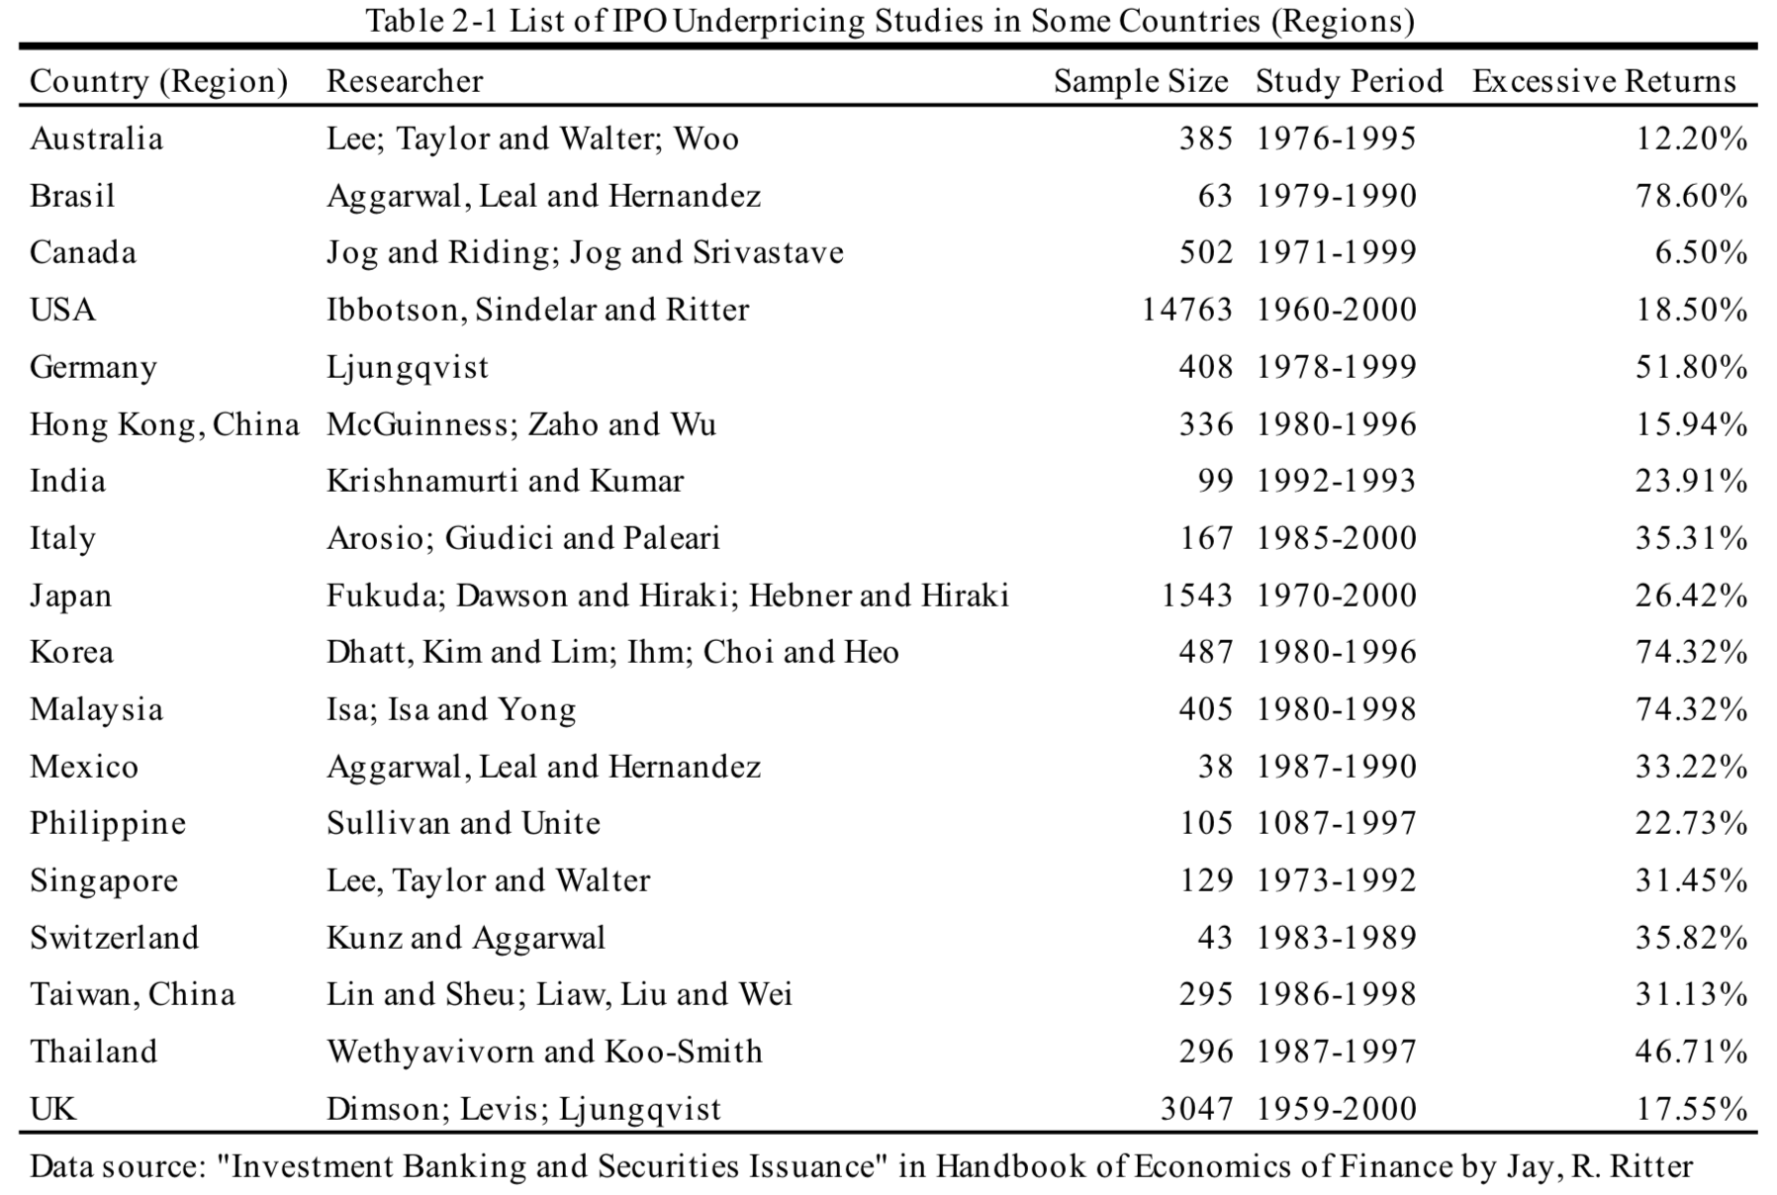
As shown in table 2-1, IPO underpricing exists in securities markets across the world and is particularly salient in emerging markets. The level of underpricing in developed countries and the excessive returns are comparatively lower.
Both overseas and domestic scholars have used a lot of empirical experiments to propose multi-angled explanations for IPO underpricing. Most of them are based on information economics and tempt to provide reason from the primary and secondary market, mainly including Asymmetric Information Theory, Symmetric Information Theory, Signaling Theory and Agency Theory, etc. Below is a summary of these theories.
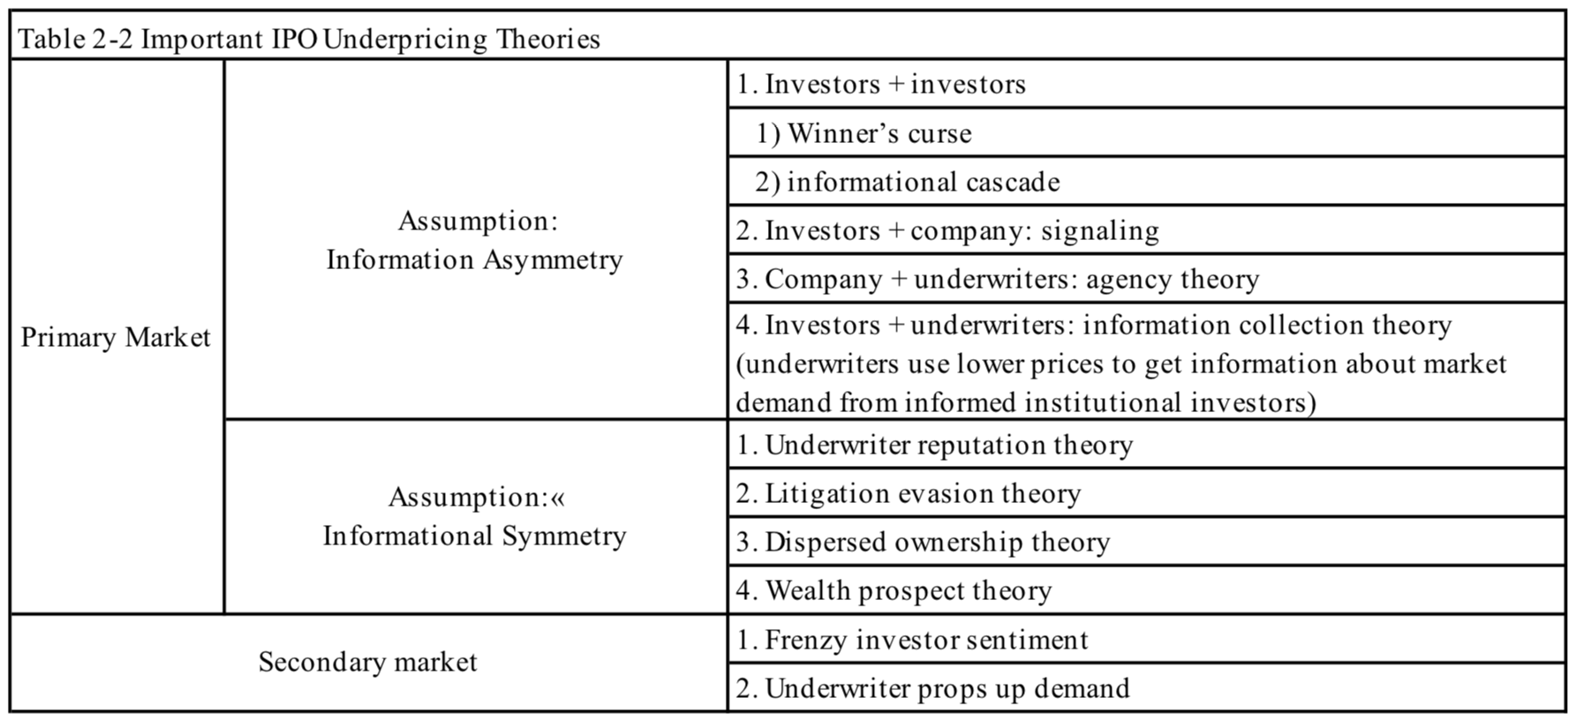

Section 3 - Regulatory Development of IPOs in China
The set of regulatory rules related to the IPO of a company in China includes the approval system, the pricing method and issuance method. Since the establishment of the SSE and the SZSE, the IPO policies in China have gone through several phases, marking the reforms as a path to marketization.
3.1 Development of China’s IPO Regulatory System
New share issuance system can be categorized into the examination and approval system, the approval system and the registration system. The Registration System has the highest level in marketization while the others are under different levels of governmental control. It is the Approval System that is currently employed in China, but authorities are making efforts so that the market can come close to that of the registration system.
In the history of China’s economy, state-owned enterprises have always been the strongest force behind its growth. Since the economic reform commencing in the 1980s, many state-owned enterprises have changed their ownership structure, from the state owning 100% of the right to property and management to being listed in domestic or overseas exchanges. The highlight of this economic reform is the establishment of China’s A-share market, so that these state-owned companies can be listed in the exchanges and therefore obtain a new means of financing. Since China’s own exchanges opened, China’s stock market went on a high-speed lane with more and more companies choosing to be public. By 2012, there were 953 state-controlled companies that went public with a total market capitalization taking up 51% of the entire A-share market.
China’s stock market has its unique “characteristics”:
- To maintain a socialist economic structure, the state must hold around two thirds of the stock of all state-owned enterprises that are public. Before 2005, state-owned shares were not tradable.
- IPO processes are closely controlled and monitored by the authorities, including IPO requirements and pricing determination. Before mid-1999, the government decided which sectors get to benefit from equity financing based on a factual analysis of the sectors or departments that meet the country’s development strategies. At that time, the State Council was in charge of deciding the amount of equity financing among different sectors; the CSRC and provincial governments would work on the quota allocation. This system was officially cancelled in 1999 and investment banks have undertaken the main tasks of an underwriter in confirmation and application of IPOs.
- In the early stages of China’s IPO market, the authorities used administrative methods to help decide IPO prices:
$$IPO price=the {company}^{'}saverage earning for the past three years×a fixed \text{P/E} ratio$$
The fixed P/E ratio is decided by the CSRC. It bases on the assumption that all firms are equal in their business and operation. As this number cannot correctly reflect the current market condition for this particular IPO, the IPO price from this equation is usually largely incorrect, causing a heavy underpricing on the listing day.
To make improvement to the relevant regulations for IPOs, a series of reforms took place. After the equity ownership reform in 1990, the public could purchase and trade shares of state-owned enterprises, laying the grounds for diversifying ownership structure of the companies. To further improve the efficiency of China’s IPO market, two important bills were issued. The first one was the Corporate Law in 1994, setting the rules for systematically issuing and transferring stocks and the standard format and content for pubic companies’ information disclosure. Before this particular law, there was no normative regulations for proper IPO disclosure. The second one was the securities law in 1999, which pushes the marketization of the IPO issuance system. Under the new system, underwriters and issuers have a stronger say in deciding IPO prices and they no longer need to go through authoritative examination and approval. While this way of IPO pricing fits market demand better, it also more accurately reflects the prospective valuation for the issuer company.
Consequently, the samples in the empirical study are divided into four subperiods. In the first period IPO pricing uses a pre-determined P/E ratio. The second period is when IPO pricing uses cumulative auction. The third period uses cumulative inquiry to set IPO prices. The fourth period uses cumulative inquiry where selective groups of institutional investors are actively involved in the pricing process.
3.2 Changes in Pricing Regulations
From 1990 to July 1999, share prices are decided by authorities, including directly set prices and fixed P/E ratios. From July 1999 to June 2001, not only the issuers and underwriter participate in negotiating IPO prices, but institutional investors are involved as well. From July 2001 to early 2005, P/E ratios are closely controlled and set to be no larger than 20. It could be observed that there was a drop in the level of IPO underpricing. Since the early 2005, the inquiry system was put in place. This mechanism has positive effect in pushing marketization, protecting investor benefits and improving new share issuance efficiency.

Section 4 - Theoretical Analysis and Research Design
Looking at the entire history of the development of IPO regulatory policies, the initial P/E ratio was around 12 to 15 times. As marketization progresses, P/E ratio was capped at 30 times from 15. Wang, Binghui (2013) analyzed A-share data from January 2005 to December 2008 and found that despite that there was not a restriction on IPO prices during the implementation of the accumulative inquiry system, the CSRC put constrains on new share prices using implicit methods. The average P/E ratio is an important tactic employed by the CSRC to curb the fanatic attitude towards new share in China’s market. Hu, Xiaolong (2013) selected IPO data during May 2011 and November 2012 and found that an issuance pricing method based on average P/E ratio is useful for helping investor spotting the risks underlying issuing new shares at high P/E ratios. It puts restrains on pricing activities of the issuer and underwriter, guiding new share pricing towards a more rational direction. Geng, Zhaoyuan and Huang, Jiawei (2010) pointed out that the systematic characteristics and the consequent investor behaviors were the reasons behind the high level in underpricing. Liu, Yuhui and Xiong, Peng (2005) found that governmental rent-seeking activities increase the transaction costs for investors in the primary market, causing IPO underpricing. Yu, Fusheng and Wang, Chengfang (2012) found that the ratio of state-owned shares and the level of IPO underpricing have a positive correlation, further proving the regulatory pricing policies’ impact over IPO.
Therefore, this paper intends to use A-share IPO data from SSE and SZSE during 2005 and 2017 to conduct an empirical analysis of the impact of regulatory policy changes over the level of IPO underpricing. Using PET as the metric to systematically the main board, the SME and the GEM based on policy change intervals and IPO pauses.
4.1 Analysis of IPO Regulation Reform and Changes in Level of IPO Underpricing
IPO issuance policies are comprised of three elements: the approval system, the pricing method and the issuance method. Since the SSE and SZSE were established, the China’s IPO policies have gone through multiple reforms, proving that the history of IPO in China is a process of gradual marketization. The IPO Issuance policies have also gone through several phases. From the initial controlled pricing and limited supply to the current pricing method that is more market-oriented, the series of control over new share issuance was a main reason behind IPO underpricing.
In the early stage of the IPO market in China, there were two policies that constitute the reasons behind a high level of IPO underpricing. The first one is the approval system for stock issuance. IPOs were priced based on a fixed P/E ratio, which was pre-decided by the CSRC. The underwriter would collect the financial data of a group of comparable firms as the base for pricing; this was widely applied in the IPO market during that time. The pre-determined P/E ratios could not reflect true market conditions, causing errors in IPO pricing. In 2001 a new system was introduced. New shares were priced by a collective auction online, in order to curb investors’ fanatic attitude towards IPO shares by setting a cap for P/E ratios. However, this method was ignorant of the differences among industries, causing an imbalance in market supply and demand. In January 2005, a cumulative inquiry pricing strategy oriented towards institutional investor came out, marking a further step in marketization. Information of P/E ratios and other financial data from industry comparable firms is incorporated in pricing new shares, drawing the negotiated price of the underwriter and the institutional investors closer to the predicted market value of the company and therefore lowering the level of IPO underpricing.
The second one was the fact that the CSRC imposes a restriction on the number of IPOs. The market monitor has the final say in which companies can go public and which cannot. The quota system could increase the level of IPO underpricing by restricting the number of IPO shares; it was cancelled in 2001.
The data subperiods in this paper include the various policies issued by the CSRC. The monitoring framework has also gone through different phases. The paper assumes, from previous discussion, that the fixed P/E ratio and the quota system could be two important factor affecting IPO underpricing. However, the level of their effect might vary across subperiods.
Over the opening of the SSE and SZSE, China’s stock market has evolved into a multi-layered form that contain the main board, the SME and the GEM. As the scale of the stock market expands, issuance policies change along so as to adapt to each other.
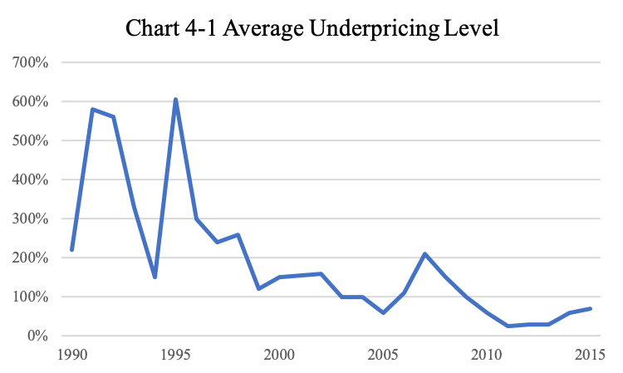

Chart 4-1 provides an intuitive presentation of changes in the level of IPO underpricing. We can observe that in the early stage after the two exchanges were opened, the rate of IPO underpricing was much higher. This was due to the fact that during that time, investors were particularly keen towards investing in the primary market. The high level of underpricing in 1995 was because there were only 28 IPOs that year. Overall, the level of A-share IPO underpricing is gradually decreasing and tend to be flatter since 2000.
4.2 Hypotheses
The popular method in current research is to divide the total sample period into subperiods based on changes in IPO policies for theoretical analysis and empirical experiments. The next step is to analyze changes in the factors affecting IPO underpricing within each subperiod. Though there are much research work done to explain the relationship between regulatory policy and IPO underpricing, existing documents may lack a more accurate measure of policy change. Hardly any scholarly works have found an effective metric to capture the constantly changing IPO policies. Based on analysis of the development of China’s stock market regulations, the paper find that the P/E ratio and its restriction is an important metric in studying new share issuance regulations. In an instructive article published by the CSRC on March 31st, 2012 stressed that the “industry P/E ratio for listed companies” is an important reference for pricing new shares. Therefore, the difference in ratio of P/E between IPO shares and the market (PET) could serve well in measuring the trend in China’s IPO policies. Two hypotheses are therefore raised:
Hypothesis 1: the larger the PET is, the higher the degree of marketization of new share issuance system.
Hypothesis 2: the gradual marketization of new share issuance system helps to reduce the level of IPO underpricing; as the IPO system improves, new share issuance polices’ impact over IPO underpricing weakens.
The Growth Enterprise Market (board) has provided a more convenient financing platform for new and technology firms in China, becoming a strong force in pushing forward innovation. In comparison to the main board and the SME board, GEM is more lenient in requirements for going public, especially regarding the company size and profitability. It focuses more on the company’s prospect and predicted growth potential. As the same time, the GEM board is stricter when it comes to disclosure of company information. This system resembles that of the Nasdaq stock exchange and is closer to the form adopted by more developed markets. Therefore, the level of IPO share underpricing is lower in the GEM board than the other sectors.
Hypothesis 3: in comparison to the main board and the SME board, GEM presents lower level of IPO underpricing and therefore a higher degree of marketization.

Section 5 - Experiment Design and Model
5.1 Sample Choosing and Data Source
This paper selects A-share IPO data from April 1990 to June 2017 to conduct empirical analysis over the three hypotheses, which include 1926 new shares in the A-share market among which 1053 belong to the main board, 591 belong to the SME and 282 belong to the GEM. The data in this paper come from CSMAR database.
Considering the lag after IPO application, this paper has noticed that some IPOs experience much longer lags than others, sometimes as high as 4406 days. The term lag is defined as the number of days between the offering date and the listing date. Some lags are particularly longer because China’s capital market was experiencing a transition from state-owned to privately-owned. In the sample this paper decides to contain only IPOs whose lags are less than 365 days, so the eventual sample size is 1784 IPOs.
5.2 Variable Design
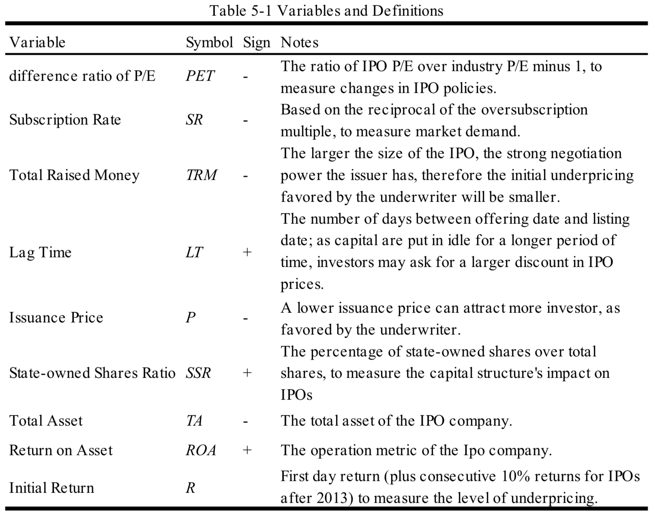
To study the changes in IPO underpricing in the multi-layered capital market of China under different issuance policies, this paper treats the initial return R as the dependent variable, the difference ratio of P/E PET as the independent variable. It also employs variables used by existing paper to be the explanatory variable for IPO underpricing, including subscription rate SR, total raised money TRM, lag time LT, issuance price P, state-owned shares ratio SSR, total asset TA and return on asset ROA.
(1) Initial Return R: for IPOs that happened before the pause in 2013, this number is equal to the first-day return; or those after the pause, this number equals the first-day return plus the sum of subsequent consecutive 10% daily return after, due to a regulatory restriction on single-day returns.
(2) Difference Ratio of P/E PET: at the very beginning, IPO shares in China were priced based on a predetermined fixed P/E ratio by the CSRC, which was set between 13 to 15. This paper intends to use PET to measure the impact from policy changes. It is defined as the ratio of IPO P/E over industry P/E minus 1. The fixed P/E ratio method twisted the market balance. We were expecting to see that the lower the PET, the higher level of IPO underpricing.
(3) Subscription Rate SR: this is diced by the ratio of share issued and subscribed to measure the market demand, or how “popular” this IPO is.
(4) Total Raised Money TRM: there are some studies regarding the relationship between IPO size and the degree of underpricing. Most (e.g. Logue (1973), Ritter (1984), Beatty and Ritter (1986)) of them have found that they are negatively correlated. One possible explanation behind is that the larger the IPO size is, the stronger the issuer’s negotiation power; therefore, the initial underpricing proposed by the underwriter will be smaller.
(5) Lag Time LT: this is a major difference between China’s securities market to a developed one. It is possible that as invested capital is put idle for longer periods of time, investors may ask for a bigger discount to compensate for their cost, causing higher IPO underpricing. A decrease in this number signifies that China’s securities market is becoming more mature. It is defined as the number of days between offering date and listing date.
(6) issuance price P: underwriters may favor a lower issuance price to attract more external investors to the IPO.
(7) State-owned Shares Ratio SSR: capital structure plays an important role in enterprise governing. This is particularly salient in China because most listed companies are state-owned. Khwaja and Main (2005) finds that political connection adds to the wealth of a company. In that model, the government actively participate in activities that promote the economy. They support some companies while oppressing others. There are usually close monetary or familial connections among companies they support.
(8) Total Asset TA: It is defined as the natural logarithm of IPO company’s total asset before the end of a fiscal year.
(9) Return on Asset ROA
The entire sample is divided in to four subperiods based on policy changes. Then this paper conducts multivariate regression for these subperiods to test how regulatory changes serve to explain IPO underpricing. If the regulatory factor is not significant in its impact over underpricing, there would not be obvious difference among the regression analysis statistics among these subperiods.
5.3 Model Construction
The paper divides the sample into four subperiods. Since the SME board was established in 2004, it is added in the third and fourth subperiods. The GEM board was added in the fourth period to compare to the main board. The equation is as follows:
Section 6 - Experiment Results and Discussion
6.1 Data Descriptive Statistics
Table 6-1 contains descriptive statistics of the variables that impact IPO underpricing, divided into four subperiods based on regulatory changes. It considers the impact over IPO underpricing from difference ration of P/E, subscription rate, total raised money, lag time, issuance price, state-owned shares, total asset and return on asset.
From the form we see that the difference ratio of P/E changes from -0.341 to -0.28 as regulatory policies change over time. This indicates that the difference between P/E ratios at IPO and industry P/E is getting smaller, further showing a general decrease in IPO underpricing and an increase in marketization. The subscription rate average changes from 0.54 to 0.823, reflecting the change in market demand for IPO shares. We observe an increase in the success rate in subscription, showing a decrease in IPO underpricing. The total raised money is observed via its natural logarithm and it increases from 5.515 to 5.944, showing an increase in TRM. The lag time decreases from 3.36 to 2.534. This time length is normally set by the authorities based on market condition and can hardly be affected by companies’ own will. During this time, invested capital is in an idle state, increasing the risk on investors and decreasing their liquidity. The logarithm of issuance price increases from 1.365 to 2.366, again showing a relative increase in IPO prices and a decrease in IPO underpricing. The state-owned share ratio decreases from 0.482 to 0.234, showing that shares held the public investors are taking up a higher percentage.
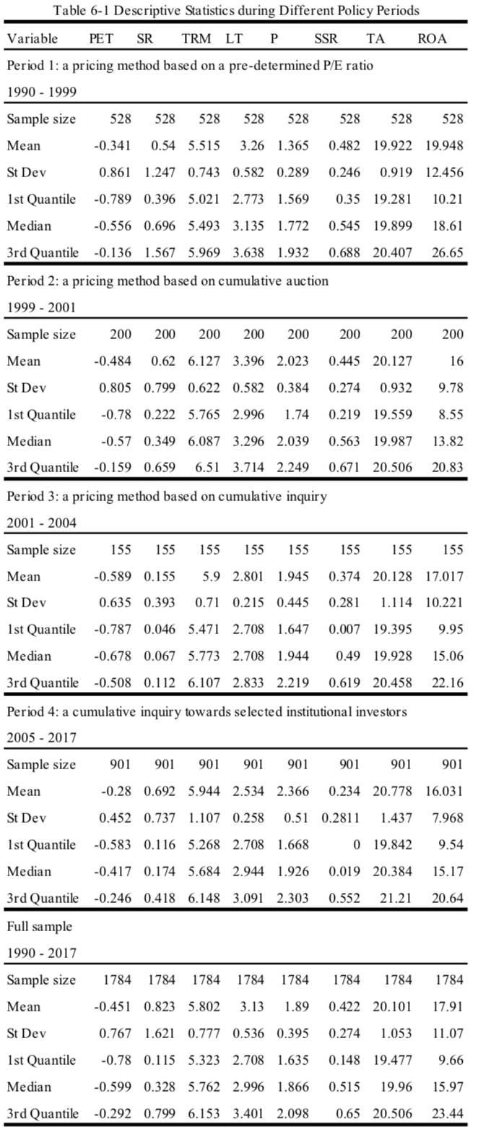
6.2 Multivariate Regression Analysis
China’s IPO market as an emerging economic entity, has its regulatory environments in constant changes and improvements. The administrative framework has gone through several development phases. From controlled pricing and limited supply of new shares to market-oriented pricing method as of now, this series of administrative restriction could serve as an important reason for the high level of IPO underpricing.
6.2.1 Changes in IPO Underpricing under Difference New Share Regulations
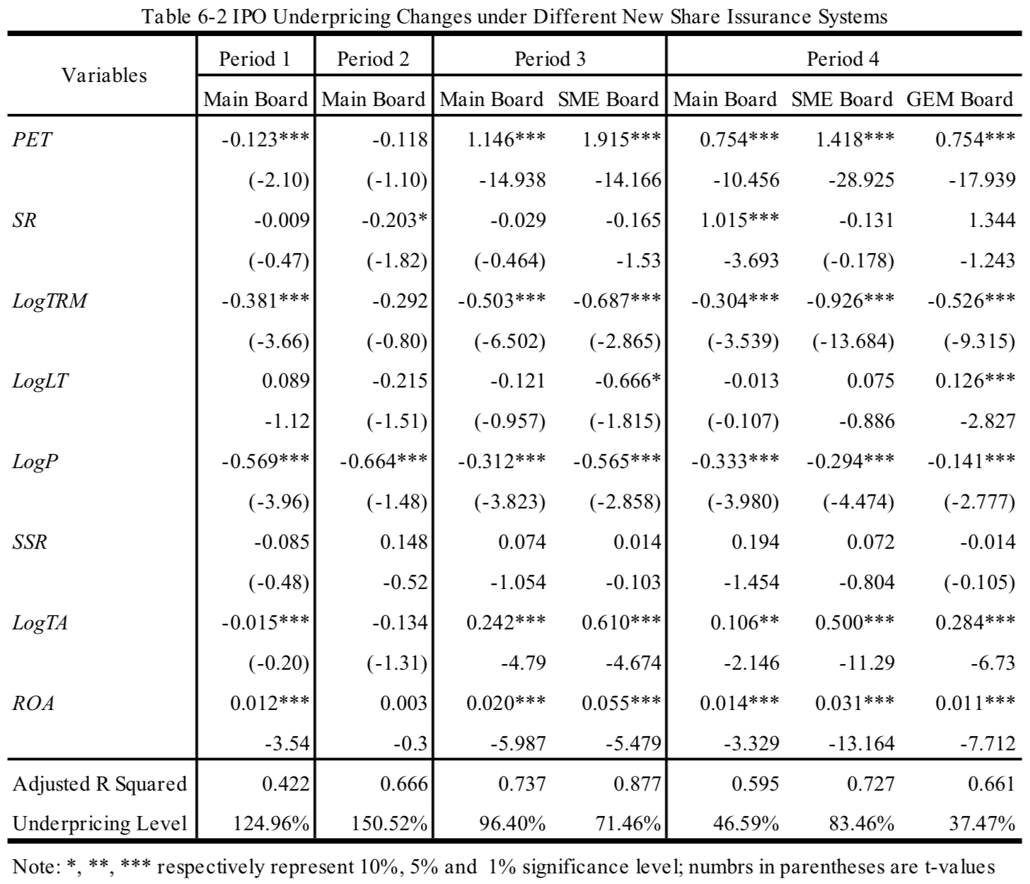
From Table 6-2, we see that the difference ratio of P/E (PET), total raised money (TRM), issuance price (P) and total asset (TA) are negatively correlated with the level of IPO underpricing. As the size of issuance (TRM) increases, the issuer has more negotiation power in setting the price and consequently the underwriter would be less likely to prompt for a bigger underpricing. A lower issuance price (P) will help the underwriter attract more retail investors to subscribe for IPO shares. These phenomena are often seen in China’s new share market. In the third subperiod, the CSRC set a cap for P/E ratio of new shares such that the difference ratio of P/E (PET) decreases to help contain the overly heated new share market. We can see from the table that as the IPO reform progresses, the influence from the difference ratio of P/E (PET) over the level of IPO underpricing decreases, marking a loosening administrative grip on the IPO market. The systematic factor affecting IPO underpricing is gradually losing its strength.
In the first period, the lag time (LT), state-owned shares ratio (SSR) and return on asset (ROA) are positively correlated to IPO underpricing, indicating that as the A-share market is performing well, the level of IPO underpricing will increase with it. The longer lag time signals that the issuer and underpricing are undertaking more risk during the IPO process. As they demand a higher level of returns, there would be a corresponding higher level of underpricing. As the State-owned Shares Ratio is positively correlated with underpricing, it shows how it factors in a company’s financing process, as is consistent across the different periods.
In the first period between 1991 and 1999, the average IPO underpricing level was 124.96%, which is lower than that of the second period. To help ensure a balanced development among public companies as well as to manage different parties’ benefits and concerns, examination and approval system was employed during this time. Companies that satisfy all requirements for going public must obtain sponsorship from their cities or provinces while the sponsorship standards in each city or province was closely controlled by the CSRC through administrative means. The role of various securities institutions in the market was strictly restricted to technical and service support. The actual examination and approval work were in the hands of the administrative office.
In the second period during 1999 to 2001, the average IPO underpricing level was 150.52%, higher than the other three periods. In July 1999, the CSRC introduced the cumulative auction method for IPO pricing, where underwriters set a price range and seek interested investors to bid within this range. Theoretically speaking, this method better reflects market demand as it considers the investors’ opinion regarding the issuer’s evaluation. However, as retail investors make up for the largest part in China’s A-share demographic and they lack the technical skills for equity valuation and investment experiences, they can hardly produce an accurate value for new issued shares. Therefore, the issuance price under cumulative auction found it hard to present the inherent value of issuers, causing a high level of underpricing in this period.
In the third period, the average IPO underpricing level was 83.93%, far lower than that of the last period. In March 2001, the examination and approval system was cancelled; in July in the same year, the CSRC introduced a cap for P/E ratio on the basis of the cumulative inquiry method in order to curb the overheated new share market. The effect was observable as the underpricing level became significantly lower. However, this P/E ratio cap ignored the differences and characteristics among industries and the overall IPO underpricing level was still quite high and very volatile.
In the fourth period, the average IPO underpricing level was 55.84%. in January 2005, the cumulative inquiry method was applied to new share pricing. This method allowed underwriters to seek bids from institutional investors and use the final negotiated price as the issuance price. In comparison to the second period, institutional investors have more initiative and power in pricing rather than retail investors. Institutional investors usually have their proprietary asset evaluation department. While working with underwriters, they are not at complete disadvantage like the retail investors so that they can better balance the interests and benefits between themselves and the underwriters. Not only do institutional investors have pricing initiatives, but they have closer connection to related interest groups. They lean towards IPO companies that are in similar industries as they do therefore take industry features into consideration when they participate in IPO pricing. In this way, the institutional investors reduce market volatility, so that the underpricing level is contained as a relatively low level.
6.2.2 Comparison of IPO Underpricing in the Main Board, SME and GEM
In comparison to the main board and SME board, the GEM board has more lenient requirements for company size and profitability in IPO regulations, laying more focus on development prospect and potential growth capability. At the same time, the GEM board puts more emphasis on disclosure as its monitoring method and has more strict and specific requirements for company information. IPO companies in the GEM board faces more risk. This series of mechanism is closer to the Nasdaq, a more developed and mature market. So even in the early stage of the GEM board, IPO underpricing was already at a relatively low level.
Based on different regulation reforms in the IPO market, the samples are separated into four periods to further explore the multi-layered capital market that is comprised of the main board, the SME board and the GEM board. Through the four rounds of regulation reforms, the level of IPO underpricing decreases in each of the three boards, partly because the issuance and subscription mechanism get improved while pricing inquiry is being conducted towards a bigger crowd of investors. New share pricing method fits better in the actual situation of China’s A-share market; the level of IPO underpricing gradually decreases.
Before the first round of issuance policy reform, the average IPO underpricing in the SME board was 151.01%, which was much higher than 83.08% in the main board. Then, the SME board was at a very early stage. The relevant regulations are still exploring the market condition to find their correct forms so that the underpricing level among SME companies was high since the very beginning. In the first stage of the policy reform, the GEM board in its initial stage was favored by many IPO companies and investors for it provided financing opportunities for small and medium firms with innovative characteristics. When compared to the main board, the GEM board is more lenient in IPO requirements, resembling that of a more mature securities market and has a relatively lower underpricing level since its establishment.
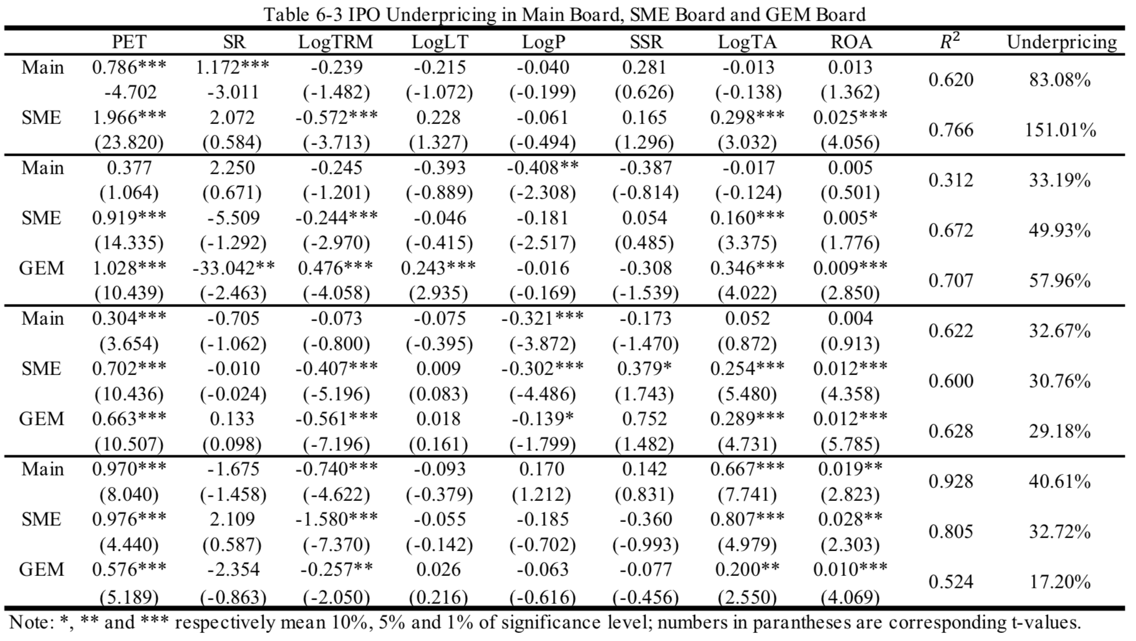
Before the second round of new share issuance regulation reform, there is significance reduction in the level of IPO underpricing across the Main Board, the SME and the GEM, 32.67%, 30.76% and 29.18% respectively. This shows that China’s multi-layered capital market is making progress in promoting information efficiency and incorporating inputs from various interest parties such as the underwriters, the issuers, the investors and the regulatory entities into implementing an IPO and pricing the new shares. Influence from the difference ratio of P/E (PET) is observed to decrease among the three sectors. The GEM sector uses the market mechanism to make effective asset evaluation; its issuance system with higher level of marketization makes its underpricing degree overall lower than that of the Main Board and the SME Board.
During the third and fourth rounds of new share issuance regulation reforms, the IPO underpricing level in the Main Board and the SME Board made small bouncing back. Companies’ demand for IPO financing could not be satisfied due to multiple pauses in IPO processing. Once IPO was resumed, the feverous attitude towards new share subscription caused increases in underpricing. At the same time, the underpricing in the GEM Board made further decrease to around 17.20%, much lower than the other two sectors. This indicated that there continues to be progress in new share subscription and allocation mechanism in the GEM Board to better cope with the uncontrollable factors from investor emotion and market volatility and maintain a relatively lower underpricing level. Comparing the influence from P/E differential over the three sectors, we see that the GEM Board is not in tune with the Main and SME Boards in that it is less influences by changes in new share issuance system, further proving the advantages of its market inclusiveness and flexibility.

Section 7 - Conclusion, Restriction and Implications
  - Research Conclusions
This article is based on previous research and looks into the reasons behind the changes in the underpricing level of China’s A-share IPOs, by constructing a substitute measure of new share policy changes. Also, it divides the sample into sub-samples containing data from the Main Board, the SME board and the GEM board, in order to study the influences of different new share issuance system over China’s multi-layered stock market. Here are some key findings: 1) In the A-share market sample, the average IPO underpricing dropped from 124.96% to 55.84%, indicating the new share issuance system is making proper transition from the examination and approval system to inquiry system so that more market information and investor opinion are included. Institutional investors are gathering power in the new share pricing process so that the final offering price better reflects supply and demand, decreasing the level of IPO underpricing; 2) The P/E differential metric can help measure the progress of new share system reform. Larger PET indicates smaller underpricing and better marketization. From 1991 to 2017 A-share data, the negative relationship between PET and underpricing weakens, showing improvements in new share issuance system; 3) Through the four rounds of policy reforms, the level of IPO underpricing decreases to different extent among the Main Board, the SME Board and the GEM Board. Particularly, the GEM Board presents relatively lower underpricing since opening and is more suitable for trial of the registration system; 4) the articles finds that the relatively larger IPO underpricing level in China’s A-share market is consistent with the research results from literature review and the size of this level varies with sample periods; 5) the article also observes that the level of IPO underpricing is correlated with total raised capital as the issuance size increases, the issuer has stronger negotiation power and the underwriter does not need underpricing as much under the risk of not attracting enough subscription.
This article also intends to provide insights for policy design regarding IPO policies: 1) the examination and approval system is still employed in China’s securities market. It is till the governmental authorities that is in charge of approving IPOs. Issuers lack autonomy in the overall IPO process, which is different from that of a mature capital market. As new rounds of policy reform take place, China’s capital market is making steps towards implementing the registration system. The gradual decrease in IPO underpricing in the A-share market suggests registration system being the destination; 2) regarding the approval of IPOs, the CSRC should transition from emphasizing requirements of profitability level and company sizes, to ensuring completion and accuracy of the disclosure of company report and financials. Innovative companies will get the financing they need at early stages where they are not yet profitable and then letting the market to decide upon the valuation and development prospect of public companies is beneficial for attracting quality companies with potentials to raise capital; 3) gradual decreasing of underpricing across the three boards indicates that the market foundation for eventually implementing the IPO registration system is taking form, especially in the Growth Enterprise Market. It is partly because of the restriction in numbers and sizes of IPOs that supply-and-demand relationship of new shares mismatch and underpricing is high. The gradual implementation of the registration system makes the IPO Quota less scarce, therefore the financing needs of companies with various characteristics are met, the issuance efficiency is higher, and the more lenient financing environment encourages entrepreneurship, further pushing the upgrading and transforming of China’s economy.
After previous analysis, to collect the reasons behind the relatively higher level of IPO underpricing in China, we need to discuss the unique characteristics of China’s securities market itself besides what is covered in this article. Overall, the main reasons behind the phenomenon can be categorized as follows: 1) The total equity in China’s IPO market includes large amount of non-tradable shares such as state-owned shares while equity shares that can be traded freely only take up around a third. Moreover, China’s stock market is yet to be mature and investors still lack sufficient investment methods and products and consequently stocks are a valuable source of investment and market demand exceeds its supply. Large amount of investor capital waiting to enter the market will naturally lead to higher level of IPO underpricing. 2) There are still flaws in the IPO pricing system. The cumulative inquiry system allows more institutional investors to participate in the pricing process but how capable these investors are directly affected whether the final negotiated price can reflect the intrinsic value of the company. Non-compliant behaviors such as deliberately raising bidding price to increase their chance of successful subscription will lead to inaccurate pricing. 3) The investor population in China is special, in that retail investors far exceed the volume of institutional investors. The latter, however, is crucial to stabling the market because they help make pricing more rational and containing volatility. But speculative behavior is prevalent in China’s market. Because retail investors are featured with immature investment mentality, and they vary largely in investment styles and ideas, they tend to be more speculative. This can be shown in the high turnover rate in trading, which also shows that current investors in the market focus more on short-term returns instead of long term. 4) Regulations of the issuance quota and pricing method will distort the matching process of supply and demand in China’s IPO market. Originally, the new share excessive underpricing is systematic, that is, it is the result of government intervening the market. Of course, scholars, domestic or overseas will continue to conduct more comprehensive and deeper research regarding the reasons behind the IPO underpricing phenomenon, of which more factors remain to be discussed.

7.2 Restriction and Subsequent Suggestions
This particle places China’s IPO underpricing phenomenon in the context of policy changes to study the dynamic process of its development, aiming to see how it is influenced by regulatory changes. Using descriptive statistic results, this article analyzes the factors in IPO underpricing and measures policy changes using the P/E differential and placing it with several other factors in a regression model as an empirical study of how the underpricing level is affected by the regulatory factor.
Despite the efforts, there are shortcomings of this paper: 1) There are many more factors affecting IPO underpricing in China. The variables used in the regression model here are selected because they are more recognized and representative. By choosing different variables, the final regression equation will be different and lead to different conclusions. So the conclusions here are subject to the range and variables that were included; 2) the subperiods are divided by discretion; the subperiods are divided based on chosen policy changes so they reflect personal opinions to help study different variables. Therefore, it is possible that disagreeing conclusions can be drawn from dividing samples differently; 3) there should be more detailed and deeper look into regulatory changes, as there are other subjective factors within the regulatory factor that are hard to quantify. In subsequent research, more attention can be paid to conducting a comprehensive collection of the remaining factors.

Section 8 – References
Anderson, A.M., and E.A. Dyl.2008. “IPO Listings: Where and Why?” Financial Management 37(1):23-43.
Allen, Franklin, Gerald E. Faulhaber. “Signaling by underpricing in the IPO market “[J]. Journal of Financial Economics, 1989(23):303-324.
Benveniste, Lawrence M. Paul A. Spindt. “How investment bankers determine the offer price and allocation of new issues” [J]. Journal of Financial Economics, 1989(24):343-362.
Bessler, W. 2014. “Share Repurchases of Initial Public Offernigs: Motives, Valuation Effects, and the Impact of Market Regulation.” European Journal of Finance 20(3):232-263.
Baron, David. “A Model of the Demand of Investment Banking Advising and Distribution Services for New Issues” [J]. Journal of Finance, 1982(37):955-976.
Chemmanur, Thomas J. “The Pricing of Initial Public Offers: A Dynamic Model with Information Production” [J]. Journal of Finance, 1993(48):285-304.
Carter, Richard, Steven Manaster. “Initial Public Offerings and Underwriter Reputation” [J]. Journal of Finance, 1990(45):1045-1067.
Drake Philip D, Michael R. Vetsuypens. “IPO Underpricing and Insurance against Legal Liability” [J]. Financial Management, 1993(22):64-73.
Judge, W. Q., M. A. Witt, A. Zattoni, et al. 2015. “Corporate Governance and IPO Underpricing in a Cross-national Sample: A Multilevel Knowledge-based View.” Strategic Management Journal 36(8):1174-1185.
Ligon, J. A., and H. Liu. 2008. “The Effect of the Trading System on IPO Underpricing: Evidence from the 1997 Order-handling Rules.” Journal of Financial Research 34(1): 103-130.
Loughran, Rim, Jay R. Ritter. “Why don’t Issuers Get Upset about Leaving Money on the Table in IPOs[J]. Review of Financial Studies, 2002(15):413-443.
Meoli, M., S. Paleari, and S. Vismara. 2013. “Completing the Technology Transfer Process: M&As of Science-based IPOs.” Small Business Economics 40(2):227-248.
Neupane, S. , and S. S. Poshakwale. 2012. “Transparency in IPO Mechanism: Retail Investors’ Particiption, IPO Pricing and Returns.” Journal of Banking & Finance 36(7):2064-2076.
Reuer, J. J. , T. Tong, and C. W. Wu. 2012. “A Signaling Theory of Acquisition Premiums: Evidence from IPO Targets.” Academy of Management Journal 55(3):667-683.
Rock, Kevin. “Why New Issues are Uderpriced” [J]. Journal of Financial Economics, 1986(15):187-212.
Stefano, P. , S. Andrea, and V. Silvio. 2014. “How do Underwriters Select Peers When Valuing IPOs?” Financial Management 43(4):731-755.
Tsuji, C. 2006. “Does EVA Beat Earnings and Cash Flow in Japan?” Applied Financial Economics 16（16）：1199-1216.
Tim Loughran, Jay R. Ritter. “Why Has IPO Underpricing Changed Over Time” [J]. Financial Management, 2004(33).
Tinic, Seha M. “Anatomy of Initial Public Offerings of Common Stock” [J]. Journal of Finance, 1998(43):789-822.
Welch, I. 1989. “Seasoned Offerings, Imitation Costs, and the Underpricing of Initial Public Offerings.” Journal of Finance 44(2):421-449.
Zhang, F. 2012. “Information Precision and IPO Pricing.” Journal of Corporate Finance 18(2):331-348.

Variable specification can be found later in section: Variable Design.

