Hotel VAT Fapiao (Special) (酒店住房费用):
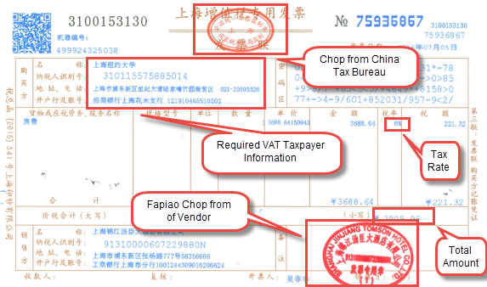
1.Fapiao Page
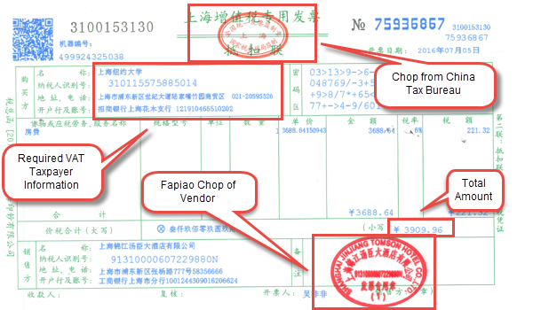
2.Tax Deduction Page

Airfare Tickets (航空运输电子客票行程单)
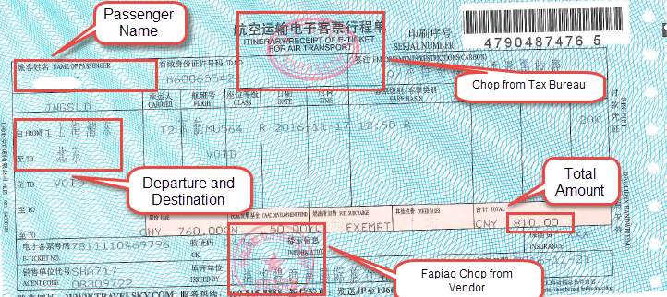

Office Suppliers (办公用品) VAT Fapiao (General)
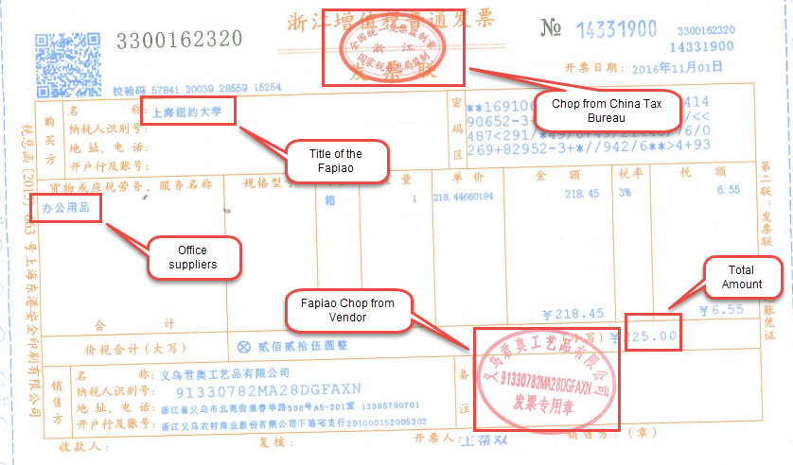

Fuel Expense VAT Fapiao (General)
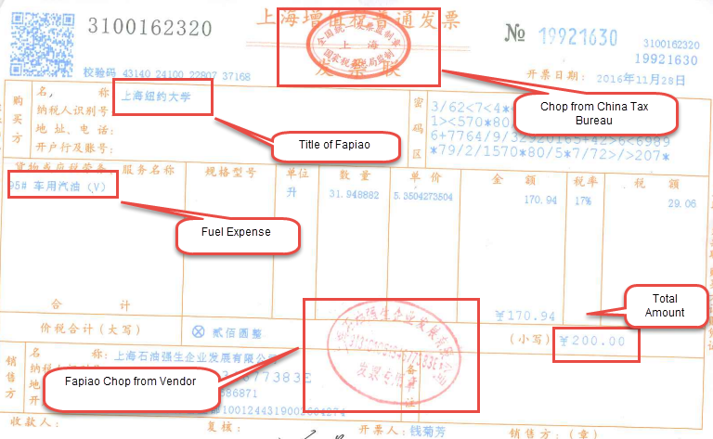

Taxi Fapiao (出租车发票)
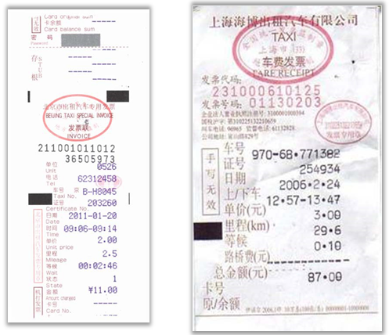
Train Tickets （火车票）
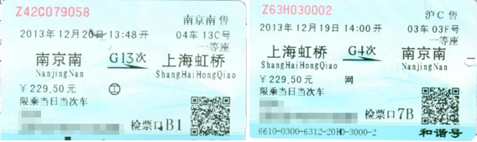

Subway (地铁票)
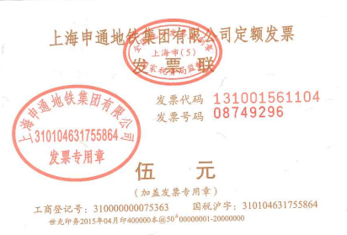
Meal Expense VAT Fapiao (General) (餐费)
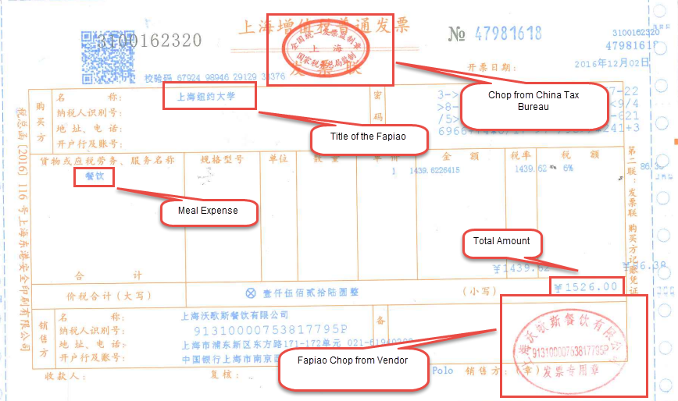

Housing Allowance VAT Fapiao (General) (房租报销)
