Empirical Study on the Optimized Currency Basket
for Aircraft Transaction
Based on the Special Drawing Rights

by

Ke Xu

An honors thesis submitted in partial fulfillment

of the requirements for the degree of

Bachelor of Science

Business and Economics Honors Program

NYU Shanghai

May 2022

Professor Marti G. Subrahmanyam Professor David Yu
Professor Christina Wang
Professor Wendy Jin

Faculty Advisers Thesis Adviser
Abstract
The global aviation industry suffers low profitability due to high costs and changing demand, and aircraft plays a significant role in the cost part of airlines’ financial performance. Given the aircraft prices’ exposure to exchange rate fluctuations, this research aims to provide the aircraft finance industry with empirical evidence and quantitative suggestions for an optimized currency basket for aircraft transactions in this US dollar-dominated industry. Utilizing the OLS regression, GARCH model, and Ridge Regression, the optimized currency basket in this research will help to save the loss of banks when airlines default and to construct more stable financial statements for global operated airlines during this turbulent era.
Keywords: Aircraft finance, risk management, exchange rate hedging, currency basket

Acknowledgement
I would like to express my deepest gratitude to my thesis advisor, Professor David Yu, for his patience, support, and valuable guidance throughout this honors thesis. Also, I want to thank Mr. Nils Hallerstrom for his kind overview of the aircraft finance industry. In addition, I would like to thank Professor Marti Subrahmanyam, Christina Wang, and Wendy Jin for coordinating the Business and Economics Honors Program, and Ms. Xinyi Yang for her dedication to supporting the program. Especially, many thanks to my family and friends for supporting me throughout my undergraduate career at NYU Shanghai and Abu Dhabi.

1. Introduction
The aviation industry is one of the industries with the lowest profitability due to its high fixed and variable costs and high volatility of demand resulting from exogenous factors. Among different fixed costs, aircraft are very expensive pieces of equipment, which range from $90 million to over $400 million each for the list price and still millions of US dollars (“USD”) for the market value according to data published by Boeing [1]. Airlines have to pay for a large loan or lease every year regardless of their business condition. For banks, most of them that offer airline loan financing prefer to denominate the loan in USD with the logic that if the loan is not repaid, the aircraft can be repossessed and sold, and hopefully allow the bank to recover the outstanding balance.
As aircraft are widely considered to be "dollar assets", USD is the dominant reserve currency and the capital markets are far deeper in USD than any other currency. Since the 1970s, when leasing and aircraft-backed finance took off, the United States, where the main aircraft manufacturer Boeing was based, represented over 50% of the value of the world commercial aircraft fleet [2]. Hence aircraft finance is still USD dominated. The norm to use USD for aircraft transactions has caused the problem called “Currency Mismatch” for both banks and global operated airlines according to Mr. Nils Hallerstrom, an aircraft finance expert [2]. When the exchange rate of a non-USD currency to USD has undergone a significant fluctuation, it might cause the bank to be unable to compensate for the loss of the aircraft-based loans by selling aircraft in USD when the airline defaults. Similarly, for global airlines with revenue and costs in different currencies, the mismatch between revenue and cost and that with asset and liability will also take place under currency fluctuations. This research questions whether aircraft should still be denominated in USD as a norm today when the US only represents ~20% of the aircraft market [2].
Therefore, this research aims to find a better substitute currency basket for USD for both sides of the aircraft finance industry to eliminate the risk of currency fluctuations. The optimized currency basket is built on the existing currency basket called Special Drawing Rights (“SDR”). One thing to clarify for this research is that the value used for aircraft is the current market value (“CMV”), which reflects the real market condition and is better than the ideal base value constrained by the supply and demand equilibrium [23]. Based on the fundamental hypothesis that the USD exchange rate to non-USD currencies used for aircraft transactions is correlated with aircraft CMV, this research has run the basic OLS regression analysis to test the significant correlation between aircraft CMV and exchange rates of non-USD currencies to USD based on nearly 162K historical data. Meanwhile, this research has implemented the generalized autoregressive conditional heteroskedasticity (“GARCH”) process to predict the variance of aircraft value converted in different currencies and currency baskets. Bollerslev has extended the ARCH model to the GARCH model to allow the volatility for the current time series to have an additional autoregressive structure within itself, which distinguishes the GARCH model for better financial time series data [3]. The GARCH model also serves as a benchmark for the optimal currency basket to evaluate whether a given basket is possible to eliminate the currency risk on the aircraft value. Lastly, this research has trained a Ridge Regression model to get the calculated optimal weights of currencies in the currency basket using the same currencies as SDR, which will complement the past literature with quantitative suggestions.
This research is significant with respect to the current challenging time faced by the aircraft finance industry. The coronavirus has caused a huge decline in flight demand and cut the market size in half. According to IATA, the global airline industry was estimated to be only 40% of pre-crisis levels in 2021 [4]. In addition, the ongoing Russia-Ukraine conflict has led to a more uncertain future for exchange rates, oil prices, and even route availability, which are all essential for the aviation industry. Therefore, the optimized currency basket proposed in this research might serve as a reference for the industry to eliminate the currency risk on the aircraft value, which is likely to save the loss of banks when airlines default and to construct more stable financial statements for global operated airlines during this turbulent era.
2. Literature Review
2.1 Hedging Used in the Aviation Industry
The aviation industry suffers high fixed and variable costs and a changing business environment, leading to capricious financial conditions. Such conditions result from exogenous factors including the global economic environment, passenger demand, government regulations, and tax policies [5]. Among different fixed costs, aircraft are among the largest costs, which range from $90 million to over $400 million each for the list price according to Boeing [1]. Another major cost airlines have to deal with is jet fuel with volatile price changes over the past years [6]. In addition, for airlines operating globally with revenue and costs in different currencies, currency exchange risk amplifies the volatility of the profits [7]. The most common way to manage those risks is hedging with derivatives.
2.1.1 Jet Fuel Hedging
Since jet fuel plays a critical role in the operation costs of airlines, most hedging literature for the aviation industry focused on jet fuel hedging. Past work has found that fuel costs contribute significantly to airlines' fluctuating financial statements [6,8,9]. Therefore, hedging of future jet fuel supply can positively affect airline firm value although work done by Carter et al. is limited to the period from 1992 to 2003 [8]. The hedging premium calculated in Carter et al.'s work is greater than the 5% documented in the past work and might reach 10%, demonstrating the huge benefits of jet fuel hedging [8]. Common financial instruments used for jet fuel hedging are derivatives including swaps, forward contracts, futures, and options of contracts on kerosene, crude, or other oil products [5].
2.1.2 Exchange Rate Hedging
Global airlines are exposed to exchange rate fluctuations as they operate with revenue and cost in several currencies. However, for exchange rate hedging, the literature shrank. Past work has stated that hedging can lessen airlines’ risks of disadvantageous exchange rate movements and increase cost-effectiveness [7,10]. But such exchange rate hedging is not specifically for aircraft assets. Also, most related literature is case study, which usually focuses on one company or one country. For instance, past work has concluded that currency risk management accounts for 35% of the variability of the profits of airlines in Kenya, while it does not generalize the study to a wider region [11]. Another work has constructed a formal employee and leadership structure for currency hedging, while the study is only based on the field study of one company [12]. The forward contract is the most common over-the-counter derivative tool for currency hedging [13].
Literature regarding the best currency basket for aircraft transactions is also limited, which is the focus of this research. Most existing literature focuses on how to determine the currency basket from a more macroeconomic perspective. Scholars have built operational research models utilizing the Lagrange function and linear regression and taken the differences of adjacent exchange rates in the model to determine the weights of currencies in the basket [14,15]. Other work proposed the weights of currency baskets based on the more macro factors including trade weights of different countries, income elasticity, price elasticity, and inflation rates [16,17,18].
2.1.3 Natural Hedging
Apart from derivatives such as forward contracts, natural hedging is also applied by many global airlines to deal with the exposure to foreign exchange fluctuations [19]. As long as airlines have significant revenues in foreign currencies, it is possible for them to balance the exchange rate exposure on the cost side of their financial statements. From a more macro perspective, the economy can also trigger natural hedging in terms of the declining trend of consumption in a weak economy [8]. Airlines such as Emirates usually combine natural hedging with more active hedging tools for risk management [8].
2.2 Factors Influencing the Exchange Rate
Past work on factors influencing foreign exchange rates provides this research with the support of appropriate variables chosen for further analysis with the exchange rate. The most common factors that drive the foreign exchange rate are inflation, interest rates, trade relationship, and market expectations [20,21]. Among them, inflation and interest rates are closely related and can be easily quantified. Inflation measuring the rising prices of goods and services is closely monitored by the central bank. When inflation rises too fast, the central bank might increase the interest rate which will eventually increase a currency’s value. More importantly, inflation is closely related to aircraft pricing as high inflation will accelerate aircraft leasing through its influence on the currency value [23].
2.3 PURCS Cycle
Aircraft prices are not disclosed publicly when traded regardless of their age. Therefore this research is based on Mr. Nils Hallerstrom’s study on the cyclical behavior of the aircraft finance industry. The dataset used in Hallerstrom’s study is appraised fair market values [2]. The appraiser used is Ascend by Cirium, a London-based appraisal firm that is widely respected and used by many players in the aircraft trading and finance market. Although aircraft market value depreciates with age, mainly due to obsolescence, it varies with supply and demand. The pent-up relative capacity shortage or surplus (“PURCS”) is the factor of cyclical changes in aircraft value compared to an average market [2]. It is a very compelling explanation for the cyclical behavior of aircraft values and airline default, so this research includes this factor in further modeling.
2.4 Special Drawing Rights
As one of the most widely used currency baskets, SDR originally served as the supplementary international reserve asset in the context of the Bretton Woods fixed exchange rate system according to the International Monetary Fund [22]. After the Chinese renminbi (“RMB”) joined the SDR basket in 2015, the SDR has played a critical role in preserving the liquidity of foreign currency reserves. Currencies in SDR have to be issued by the top five world exporters and widely circulated for international trade, which is in line with the need for aircraft finance. Current currencies in SDR are USD 41.73%, Euro 30.93%, CNY 10.92%, Japanese Yen (“JPY”) 8.33%, and Pound Sterling (“GBP”) 8.09% [22]. The mentor of this research, Dr. David Yu, suggests using SDR as a benchmark for currency baskets used for aircraft transactions, especially for the East Asia market [23].
3. Data
The main dataset of this research is public exchange rate data and collected industry data of aircraft CMV. The PURCS cycle data obtained from Nils and inflation data downloaded from the World Bank Databank are also included in the regression analysis [24].
For the exchange rate data, USD serves as the reference and the quarterly USD exchange rates to CNY, JPY, HKD, KRW, GBP, Euro, and SGD from Q3 1979 are contained. The exchange rate data source is the International Financial Statistics [25]. However, as Euro was only effective on January 1, 1999, it was not available before 1999. To find a substitute for Euro, past studies suggest the European Currency Unit (“ECU”) be a good substitute for Euro as it contained the same composition of currencies as the Euro from Q3 1979 to Q1 1999 [26]. The USD exchange rate to currency basket SDR is calculated based on the published composition.
For the aircraft CMV dataset, it contains 2,078 models with quarterly market value in millions of dollars and the launch time ranging from Q3 1979 to Q2 2020. The total number of quarters is 164. In the data set, there are 191 unique models regardless of their ages. For a more general correlation test and volatility test, different aircraft are labeled with “Wide Body”, “Narrow Body” and “Regional” and the arithmetic average of aircraft market value for different types is derived. Figure 1 illustrates the trend of market value change for different categories. For the dataset used for regression analysis, there are 177,871 rows with each data point in the original dataset forming a row. Aircraft age and percentage change of aircraft CMV for the normalization purpose are derived from the original dataset.
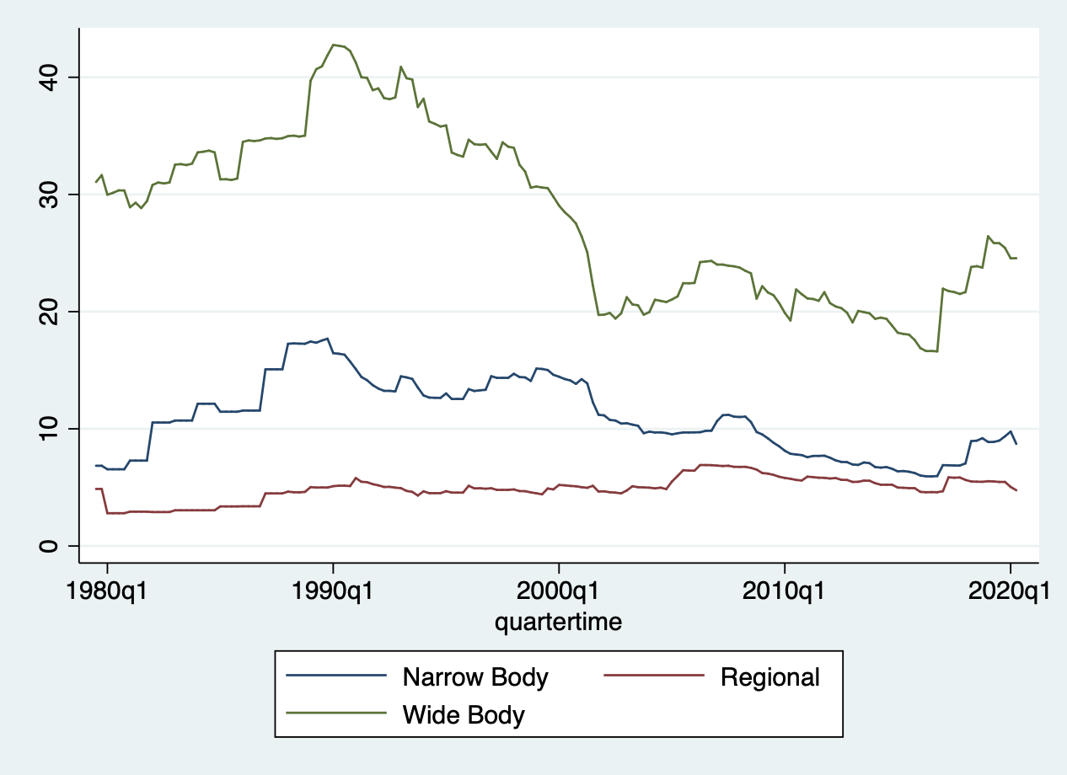
Figure 1 - Categorial Aircraft CMV in millions of USD from Q3 1979
4. Methodology
4.1 Basic OLS Regression
The regression analysis is designed to tell the effect of the appreciation or depreciation of non-USD currencies on the USD value of aircraft, which supports the fundamental hypothesis of this research mentioned in the introduction. It is implemented and tested in Stata with the exchange rate and aircraft CNV data wrangled by Python Pandas. The dependent variable is the percentage change of aircraft CMV, which is calculated based on the equation: current CMV / firstly launched CMV * 100. The independent variables are foreign exchange rate, aircraft age, inflation rate, and the PURCS cycle data. For data transformation, the model took a logarithm on the aircraft age and squares on exchange rates and inflation rates. To avoid the multicollinearity problem, the currency basket is tested separately. Currencies and baskets tested include CNY, Euro, JPY, GBP, and SDR.
The models are listed below:
$$Aircraft USD CMV Percentage Change = β_{0} +β_{1 }{CNY}^{2}+{β_{2 }{Euro}^{2}+β_{3 }{GBP}^{2}}_{}$$
$$+β_{4 }{JPY}^{2}+β_{5 }{CNYInflation}^{2}+β_{6 }{EuroInflation}^{2}+β_{7 }{GBPInflation}^{2}$$
$+β_{8 }{JPYInflation}^{2}+β_{9 }PURCS+β_{10}ln(age)+ε$ (1)
$Aircraft USD CMV Percentage Change = β_{0} +β_{1 }{SDR}^{2} +β_{2 }{SDRInflation}^{2}$
$+β_{3 }PURCS+β_{4}ln(age)+ε$ (2)

4.2 GARCH Model
Another way to test whether the exchange rates will have a significant influence on the aircraft market value is to test the volatility change of aircraft value converted into non-USD currencies. The GARCH model is an important tool in the analysis of time-series data, especially in financial applications [27]. The goal of applying the GARCH model is to analyze and forecast volatility. The GARCH model takes heteroscedasticity into account and is popular for derivative pricing.
By converting the aircraft’s value in USD into different currencies or currency baskets with the historical exchange rates, this research regresses the aircraft CMV in different currencies with the GARCH model to compare different currencies or baskets’ effects on eliminating the volatility of exchange rates. Therefore, the GARCH model serves as the evaluation benchmark for the optimal currency basket that is possible to eliminate the currency risk on the aircraft value.
The GARCH model contains the past volatility and past time series and then forecasts the future volatility of the time series. Bollerslev has extended the ARCH model to the GARCH model to allow the volatility for the current time series to have an additional autoregressive structure within itself [3]. The mathematical model is as follows:
$${u_{t} = σ_{t}ϵ_{t}}_{}$$
where
$σ_{t} = \sqrt{w + \sum_{i=1}^{p}{}α_{i}u_{t-i}^{2} +\sum_{i=1}^{q}{}β_{i}σ_{t-i}^{2} }$
where $σ_{t}$ is the conditional standard deviation of $u_{t}$ given the past values and volatilities of $u_{t-1}$ , $u_{t-2}$ , . . . of this process. $ϵ_{t}$ are the white noise i.i.d. with expectation 0 and variance 1 and are assumed independent from $σ_{t}$ for all k < t.
Similar to the regression analysis, this research tested aircraft values converted in CNY, Euro, GBP, JPY, and SDR. The implementation of the GARCH model is done in Python using the arch package. This research basically set the parameter of GARCH model to be 1, with the implementation of Python code arch_model(trainset, mean='Zero', vol='GARCH', p=1, q=1).fit().forecast(horizon=n_test). The variance of aircraft value in different currencies for the nearest 10 quarters is forecasted as the test set. This research sets the forecast period to be the nearest 10 quarters because the data covers 164 quarters, and the nearest 5% quarters are selected, which is approximately 10 quarters.
Most widely used aircraft in different categories are tested, which is listed in Table 1. They are chosen based on the popularity, manufacturer, and time range of data available. For the manufacturers, Airbus and Boeing have occupied the large jet airliner market as the duo-play from the 1990s [28]. For the wide body category, according to Boeing’s data, Boeing 777-300ER is the most common and best-selling variant of Boeing 777 [29]. The combination of increased capacity and range enabled the Boeing 767-300ER to be the most successful version of the Boeing 767 family [30]. Its main competitor is Airbus A330-200 [31]. In addition, this research also chooses Boeing 747-400, the best seller of the Boeing 747 variants [32]. For the narrow body category, Boeing 737-800NG is the most common variant of the Boeing 737NG and the most widely used narrow-body aircraft [33]. Its primary competitor is Airbus A320-200. In addition, Boeing 757’s original version Boeing 757-200 is included with its long history [34].
Table 1 - Aircraft Models Used for GARCH Forecast
Wide Body Aircraft | Boeing 777-300ER
 | Boeing 767-300ER
 | Boeing 747-400
 | Airbus A330-200
Narrow Body Aircraft | Boeing 737-800NG
 | Boeing 757-200
 | Airbus A320-200

4.3 Regularized Ridge Regression
To find the optimized weight of non-USD currencies in the SDR basket for aircraft transactions to eliminate the currency risk, similar work has introduced a basic model which takes the differences of time series data into account [15,16]. This research develops the basic model with the extension of adding penalties to the loss function by regularization to avoid overfitting when dealing with large datasets. Ridge Regression is utilized in this research with L2 normalization because it is designed to solve the multicollinearity problem in linear regression [35,36]. The basic Variance Inflation Factor (“VIF”) test is done for the following model, verifying that the model does have the multicollinearity problem. The common benchmark is that VIF > 10 indicates multicollinearity [36]. Table 2 presents the result of the VIF test implemented by the Python statsmodels package, the inflation rate of the Euro area and Britain shows VIF > 10, indicating the rationality to apply the Ridge Regression.
$$ln {CMV}_{t} = α_{0} +\sum_{i}^{j}{}βw_{i}{ [ln {ER}_{i,t} -ln {ER}_{i,t-1} ]}^{}$$
$+\sum_{i}^{k}{}β_{i}{ {{Inflation}_{i,t}}^{}+β_{1 }PURCS+β_{2}ln(age)+ε_{t}}^{}$ (1)

$β^{Ridge}={argmax}_{βϵR^{n}} {||y-Xβ||}_{2}^{2}+ λ{||β||}_{2}^{2}$ (2)
Table 2 - VIF Test Result for the Model
Feature | VIF
cnylog_diff | 1.117510
gbplog_diff | 2.042617
eurolog_diff | 2.289302
jpylog_diff | 1.217685
age_log | 3.158811
purcs | 1.245820
CNY_inflation | 2.807105
Euro_inflation | 12.256362
GBP_inflation | 11.613038
JPY_inflation | 1.683412

For the basic equation (1), CMV is the aircraft current market value denominated in millions of USD. ER represents the exchange rate of Euro, CNY, JPY, and GBP to USD. Inflation represents the corresponding inflation rate of the EU, China, Japan, and Britain. Holding the weight of USD in the SDR, weights of non-USD currencies sum to 58.27%. With the regression result of $βw_{i}$, this research calculates $β$ and $w_{i}$ separately, which gives the optimized weight of non-USD currencies in the SDR basket. The optimized currency basket is evaluated by the GARCH model in the next section.
The Ridge Regression is implemented by the Python sklearn.linear_model package and all the data rows containing null and infinite values are removed for operation limitation. The parameter $λ$ can be optimized via the RidgeCV package.
5. Result
5.1 OLS Regression
Table 3 and Table 4 present the regression result based on 161,628 observations. The current result showed that coefficients of foreign exchange rates all had a significant p-value less than 0.1. R squares for two regressions are 0.377 and 0.363. What deserves to be noted is that SDR, Euro, GBP, and CNY all demonstrate significant influence on the aircraft value denoted in USD. This finding builds a reasonable foundation for the hypothesis that aircraft value is actually correlated with exchange rates of non-USD currencies, leading to the exchange rate risk faced by the aircraft finance industry.
For the regression analysis, Euro, SDR, and JPY have a positive influence on the aircraft value when USD depreciates, while CNY and GBP have a negative influence on the aircraft value when USD depreciates. Here the depreciation of the USD means the increasing exchange rate of USD to non-USD currencies. With respect to the magnitude of coefficients, as Euro and GBP present the most significant coefficients, it is in line with the geographical distribution of main aircraft manufacturers which play a critical role in aircraft value. This finding rationalizes the regression result through a realistic application.
The huge difference between the coefficients of SDR and single currencies is interesting, suggesting currency baskets combining those export and freely traded currencies be more efficient to deal with the currency risk.

Table 3 - Linear Regression Result for Model (1)
value | Coef. | St.Err. | t-value | p-value | [95% Confidence Interval]
purcs | .607 | .016 | 39.00 | 0 | .577 | .638
age_log | -18.097 | .075 | -239.84 | 0 | -18.244 | -17.949
cny_square | -.134 | .008 | -17.66 | 0 | -.149 | -.119
euro_square | 15.601 | .623 | 25.03 | 0 | 14.38 | 16.823
gbp_square | -12.968 | 1.181 | -10.98 | 0 | -15.282 | -10.654
jpy_square | .001 | 0 | 28.59 | 0 | .001 | .001
cny_inflation_square | .03 | .001 | 29.64 | 0 | .028 | .032
jpy_inflation_square | .19 | .05 | 3.83 | 0 | .093 | .288
gbp_inflation_square | .274 | .018 | 15.33 | 0 | .239 | .308
euro_inflation_squ~e | .677 | .019 | 35.17 | 0 | .639 | .715
Constant | 71.796 | .702 | 102.26 | 0 | 70.42 | 73.172
*** p<.01, ** p<.05, * p<.1
Table 4 - Linear Regression Result for Model (2)
value | Coef. | St.Err. | t-value | p-value | [95% Confidence Interval]
purcs | .407 | .015 | 26.49 | 0 | .377 | .437
age_log | -18.238 | .077 | -238.21 | 0 | -18.388 | -18.088
sdr_square | 84.787 | 1.181 | 71.81 | 0 | 82.473 | 87.101
sdr_inflation_square | 1.267 | .011 | 119.36 | 0 | 1.246 | 1.288
Constant | 41.133 | .64 | 64.32 | 0 | 39.88 | 42.387
*** p<.01, ** p<.05, * p<.1

5.2 GARCH Model
For all the models selected for the test, SDR, Euro, and GBP have shown much lower volatility than CNY and JPY for the nearest 10 quarters forecasted. Among them, SDR illustrates the possibility for currency baskets to eliminate the currency risk for aircraft. This raises the question of whether there will exist a better currency basket than SDR that can minimize the volatility of aircraft value, which is covered in the next section of ridge regression results.
The following graphs show the GARCH result for selected wide body aircraft:
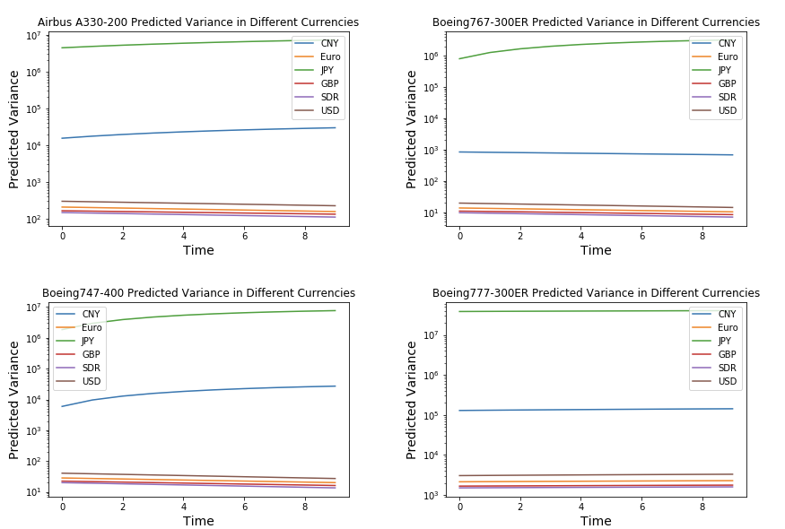
The following graphs show the GARCH result for selected narrow body aircraft:
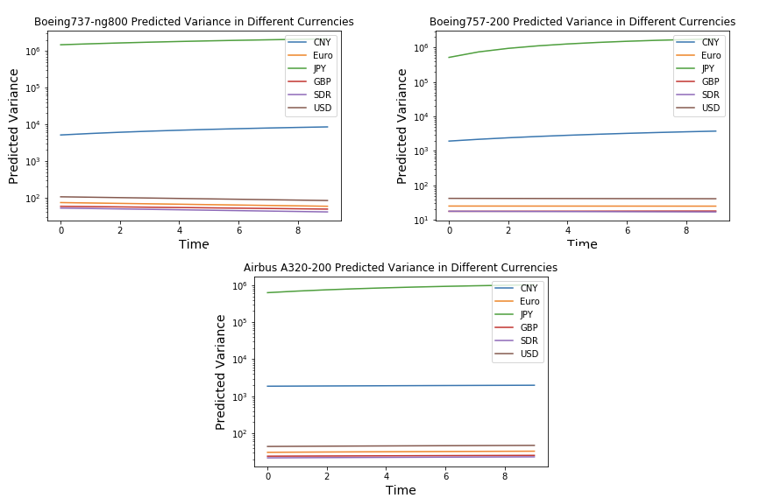
5.3 Regularized Ridge Regression
5.3.1 Initial Ridge Regression Result
The parameter of $λ$ in the Ridge Regression has been tested from 0 to 40 and the optimized $λ$ given by the RidgeCV package is 20 which is added to the penalty term for the loss function. The corresponding $βw_{i}$ for CNY, GBP, Euro, and JPY is 0.6077, -0.1578, 0.4160, and -0.1805. Through the calculation explained in the methodology section, $β$ = 1.1762, and the weights for USD, CNY, GBP, Euro, JPY are 41.73%, 51.66%, -13.42%, 35.37%, and -15.34%.
The negative weights of GBP and JPY are worthy to be noted in the result. It implies the possibility of shorting GBP and JPY in the optimized currency basket rendered by the Ridge Regression. But whether it will perform better than the SDR regarding the variance of aircraft value converted in this new basket needs further evaluation.
5.3.2 Evaluation of the New Currency Basket (“NCB”)
The basic procedure of the evaluation is explained below:
- Set the basic foreign exchange rates of USD to non-USD currencies as the same as the SDR effective on Oct.1, 2016. That is 6.67 for CNY, 0.9 for Euro, 101.08 for JPY, and 0.77 for GBP.
- Given the product of basic USD exchange rates to non-USD currencies and the weights of that currency, the calculated units of currency in the NCB are 3.4457 for CNY, 0.3183 for Euro, -15.50 for JPY, -0.1033 for GBP, and 0.4173 for USD.
- Given the calculated units of currencies in the basket and historical data of exchange rates, according to the IMF definition, the exchange rate of USD to a currency basket is the reciprocal of the sum of the equivalents in USD of currencies in the basket. And the equivalents in USD of different currencies are calculated by dividing the units of currency in the basket by the exchange rate of USD to that currency.
- Convert aircraft CMV into the new basket NCB’s value by the calculated new exchange rate. Implement the same GARCH model and compare the forecasted result with the SDR basket. The benchmark is that if the forecasted variance of aircraft value in NCB is lower than that of SDR, it is an effective currency basket to eliminate the currency risk for aircraft transaction.
For a better comparison of the result, this research also constructs a simpler new currency basket (“SNCB”) with only USD, CNY, and Euro to avoid the short practice of JPY and GBP. Similarly, the optimized $λ$ given by the RidgeCV package for the ridge regression is 11. The corresponding $βw_{i}$ for CNY and Euro is 0.7849 and 0.3790. The corresponding $β$ = 1.9974, and the weights for USD, CNY, and Euro are 41.73%, 39.30%, and 18.97%. Using the same evaluation process, the calculated units of currencies in this simpler SNCB basket are 2.6213 for CNY, 0.3537 for Euro, and 0.4173 for USD. The evaluation result based on the GARCH model is shown below.
The result of the GARCH model shows that for most chosen aircraft, the optimized new currency basket NCB renders a lower variance of converted aircraft value than SDR. It suggests possible benefits of short practice in a currency basket used for aircraft transactions given the fact that the basket SNCB without short practice presents higher variance than SDR. But all currency baskets used in this research are better than single currency USD for aircraft transactions due to the lower variance.
The following graphs show GARCH evaluation results for selected wide body aircraft:

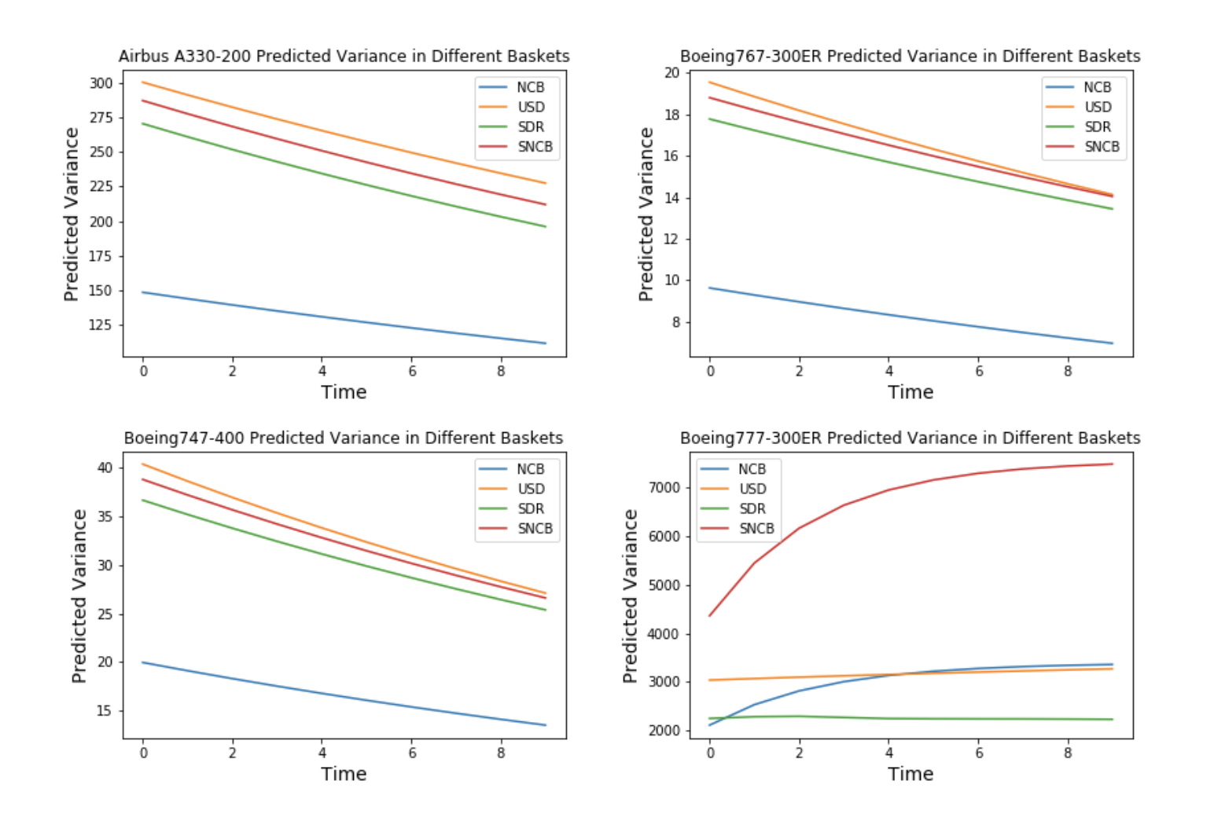

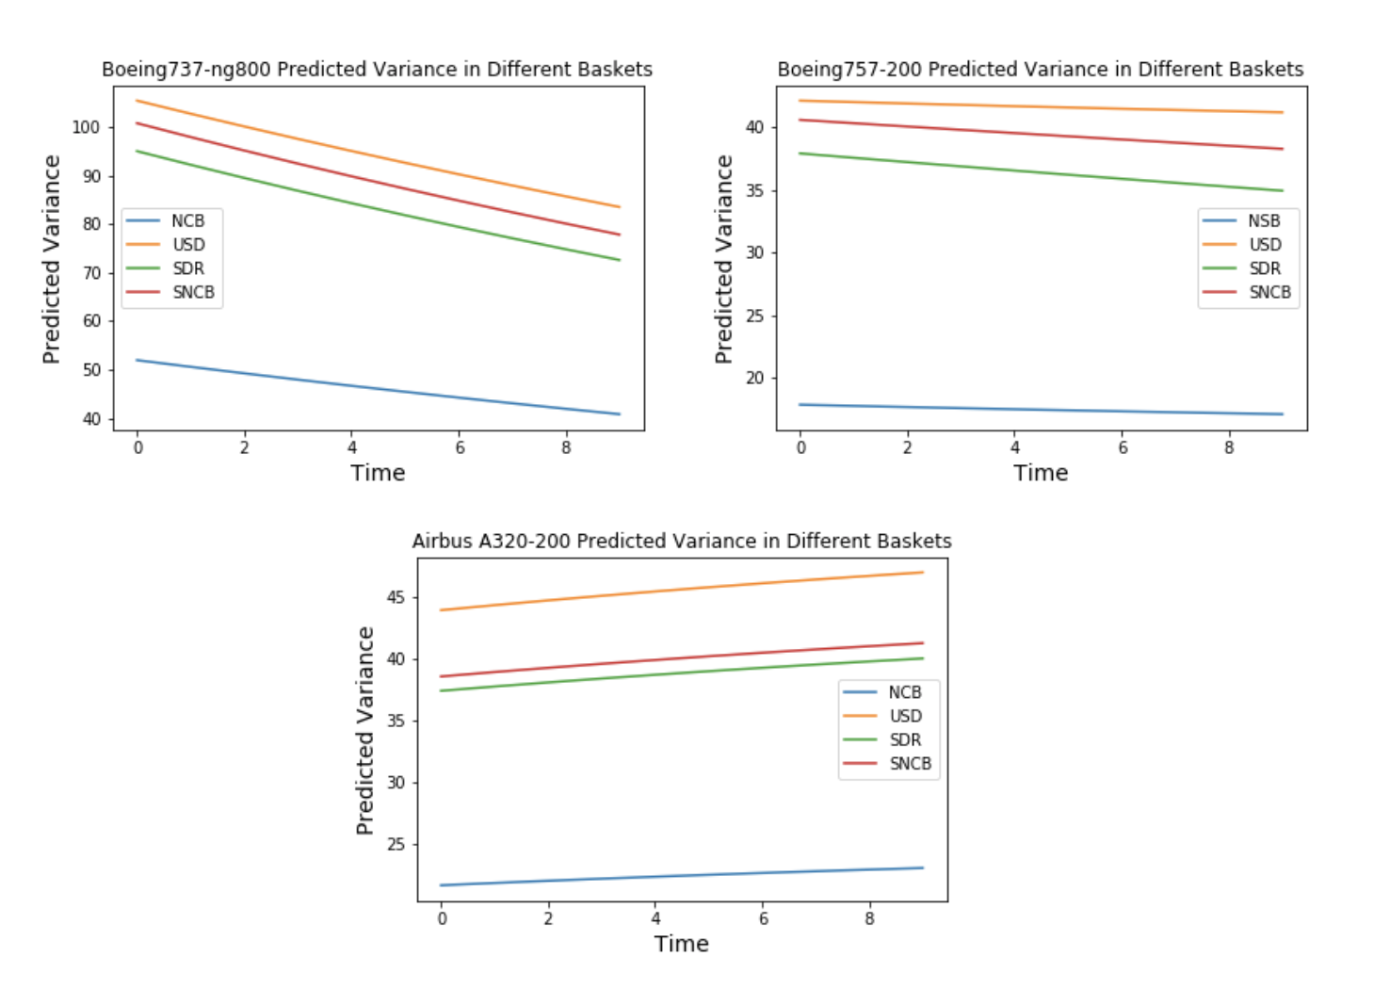
The following graphs show GARCH evaluation results for selected narrow body aircraft:

6. Conclusion
This research aims to propose an optimized currency basket for aircraft transactions. It will help the aircraft finance industry better deal with the currency risk. The fundamental hypothesis is that the USD exchange rate to non-USD currencies used for aircraft transactions is correlated with aircraft current market value, which raises the question of whether it is better for aircraft to be transacted in non-USD currencies or currency baskets. From the OLS regression analysis and the GARCH process, the most commonly used currency basket Special Drawing Rights demonstrates its potential to eliminate the currency risk which is better than single currencies such as USD. Using the same currencies in the SDR, this research proposes a new currency basket which is called NCB based on Ridge Regression. The most interesting finding of this new basket is whether shorting certain currencies in the currency basket will help the airlines and banks to eliminate the loss caused by the exchange rate fluctuations. The evaluation of the NCB basket and the short practice is implemented through the comparison of SDR and the alternative basket SNCB by removing the currencies shorted. The evaluation results show a lower variance of NCB than SDR and SNCB, suggesting an effectively optimized currency basket with the short practice for aircraft transaction.
Findings in this research that actively utilizing the currency basket can eliminate the currency risk is significant in today’s scenario faced by the aircraft finance industry. Firstly, the post COVID period with the recovering flight demand provides the whole industry with the opportunity to recover from the loss in the last two years. More aircraft will be ordered and transacted after 2024 according to the prediction of IATA [4]. But uncertainty still exists regarding the cancellation and postponements of aircraft transactions. Actively holding the currency basket can better prepare airlines and banks for non scheduled aircraft transactions. Secondly, the ongoing Russia-Ukraine crisis brought huge uncertainties to international relations and consequently exchange rates. For example, for airlines based in Russia with Rubles for the revenue and paying USD for the expenses for the aircraft, they might benefit by actively holding the currency basket as the exchange rate of USD to Ruble has undergone a huge fluctuation from February 2022, nearly doubling to 138 from 81.4 in two weeks and then back to 81.5 recently according to Bloomberg [37].
Possible limitations are mainly related to the GARCH model. Because only one time series data can be run by the GARCH model, this research only tests the optimized currency basket on the most popular aircraft. Whether it will be effective in a more general case requires more advanced models. But this research definitely raises a new research question about how the short practice can be included in the currency basket for aircraft transactions.
Further work can be done in adjusting the weights of USD in the currency basket given the fixed weights of USD in this research to make the implementation more efficient and meet the schedule. By choosing a pivot currency other than the five in the SDR and calculating the corresponding exchange rate of that pivot currency to currencies in the basket, it is feasible to add USD into the Ridge Regression, and the sum of the weights will become 1 instead of 0.5827. Then it is possible to get an optimized result with a varying weight of USD. Due to the time limitation, this research does not cover this part. In addition, thanks to Professor Wendy Jin, the PCA algorithm might provide this research with the possibility of selecting the most crucial currencies among a bunch of different currencies to form a new currency basket for aircraft transactions.

References
[1] Boeing. “About Boeing Commercial Airplanes.” https://www.boeing.com/company/about-
bca.
[2] Hallerstrom, Nils. “Modeling Aircraft Loan Lease Portfolios.” Jan. 2020.
[3] Bollerslev, Tim. “Generalized Autoregressive Conditional Heteroskedasticity.” Journal of
Econometrics, vol. 31, no. 3, Apr. 1986, pp. 307-27.
[4] IATA. “Economic Performance of the Airline Industry.” Oct. 2021. https://www.iata.org/en/
iata-repository/publications/economic-reports/airline-industry-economic-performance---
october-2021---report/.
[5] Pyke, David, and Soheil Sibdari. “Chapter 13 - Risk Management in the Airline Industry.”
Finance and Risk Management for International Logistics and the Supply Chain, 2018,
pp. 293-315. ScienceDirect, https://doi.org/10.1016/B978-0-12-813830-4.00012-5.
[6] Borenstein, Severin. “Why Can't US Airlines Make Money?” American Economic Review,
vol. 101, no. 3, May. 2011, pp.233-37. American Economic Association,
https://doi.org/10.1257/aer.101.3.233.
[7] Forsyth, Peter, and Larry Dwyer. "Exchange rate changes and the cost competitiveness of
international airlines: The Aviation Trade Weighted Index." Research in Transportation
Economics, vol. 26, no. 1, 2010, pp. 12-17. ScienceDirect,
https://doi.org/10.1016/j.retrec.2009.10.003.
[8] Carter, David A., et al. "Does Hedging Affect Firm Value? Evidence from the US Airline
Industry." Financial Management, vol. 35, no. 1, 27 Oct. 2008, pp. 53-86. Wiley Online
Library, https://doi.org/10.1111/j.1755-053X.2006.tb00131.x.
[9] Turner, Peter A, and Siew Hoon Lim. “Hedging jet fuel price risk: The case of U.S.
passenger airlines.” Journal of air transport management, vol. 44, 2015, pp. 54-64.
doi:10.1016/j.jairtraman.2015.02.007
[10] Loudon, Geoffrey F. “Financial Risk Exposures in the Airline Industry: Evidence from
Australia and New Zealand.” Australian Journal of Management, vol. 29, no. 2, Dec. 2004,
pp. 295–316. doi:10.1177/031289620402900208.
[11] Wekesa, Mang’oli S. “The relationship between foreign exchange risk Management and
profitability of airlines in Kenya.” University of Nairobi Research Archive, Dec. 2012,
pp.1-34.
[12] Brown, Gregory W. “Managing foreign exchange risk with derivatives.” Journal of
Financial Economics, vol. 60, no. 2-3, May 2001, pp. 401-48. ScienceDirect,
https://doi.org/10.1016/S0304-405X(01)00049-6.
[13] Luo, Hang, and Rui Wang. "Foreign currency risk hedging and firm value in China."
Journal of Multinational Financial Management, vol. 47-8, Dec. 2018, pp. 129-43.
ScienceDirect, https://doi.org/10.1016/j.mulfin.2018.11.002.
[14] Turnovsky, Stephen J. “A determination of the optimal currency basket: A macroeconomic
analysis.” Journal of International Economics, vol. 12, no. 3–4, 1982, pp. 333-54.
https://doi.org/10.1016/0022-1996(82)90044-7.
[15] Peng, Qin. “Aviation industry management model and exchange rate index analysis based
on error correction model and fuzzy mathematics.” Journal of Intelligent & Fuzzy System,
vol. 37, 2019, pp. 6363-75.
[16] Branson, W. H., and Katseli, L. “Currency baskets and real effective exchange rates.”
NBER Working Paper, no. 666, Apr. 1891.
[17] Han, Hsiang-Ling. “Choice of currency basket weights and its implications on trade
balance.” International Review of Economics & Finance, vol. 9, no, 4, 2000, pp. 323-50.
https://doi.org/10.1016/S1059-0560(00)00060-5.
[18] Ogawa, Eiji, and Shimizu, Junko. “Stabilization of effective exchange rates under common
currency basket systems.” Journal of the Japanese and International Economies, vol. 20, no.
4, 2006, pp. 590-611. https://doi.org/10.1016/j.jjie.2006.07.004.
[19] Merkert, Rico, and Hassan Swidan. “Flying with(out) a safety net: Financial hedging in the
airline industry.” Transportation Research Part E: Logistics and Transportation Review,
vol. 127, 2019, pp. 206-19. ScienceDirect, https://doi.org/10.1016/j.tre.2019.05.012.
[20] HSBC. “What drives exchange rates?” https://www.expat.hsbc.com/foreign-exchange/
what-makes-exchange-rates-move.
[21] Hopper, G.P. “What determines the exchange rate: Economic factors or market sentiment”
Journal The Business Review, vol.5, 1997, pp. 17.
[22] International Monetary Fund. “Special Drawing Rights.” https://www.imf.org/en/About/
Factsheets/Sheets/2016/08/01/14/51/Special-Drawing-Right-SDR.
[23] Yu, David. “Aircraft Valuation: Airplane Investments as an Asset Class.” Palgrave
Macmillan, Oct. 2020.
[24] World Bank Databank. “World Development Indicators.” https://databank.worldbank.org.
[25] International Financial Statistics. “Macroeconomic and Financial Data.” https://data.imf.org.
[26] Jamil, Muhammad, et al. “Exchange Rate Volatility and its Impact on Industrial Production,
Before and After the Introduction of Common Currency in Europe.” International
Journal of Economics and Financial Issues, vol. 2, no. 2, Jan. 2012, pp. 85-109.
[27] Engle, Robert. “An Introduction to the Use of ARCH/GARCH models in Applied
Econometrics.” https://web-static.stern.nyu.edu/rengle/GARCH101.PDF.
[28] Datamonitor. “Airlines Industry Profile: United States.” Nov. 2008, pp. 13–4.
[29] Boeing. “Boeing 777: Orders and Deliveries (updated monthly).” Jul. 31, 2020.
[30] Michael, Haenggi. “767 Transatlantic Titan. ‘Boeing Widebodies’ series. Osceola,
Wisconsin: Motorbooks International.” 2003. ISBN 0-7603-0842-X.
[31] Revue, Flug. “Airbus A330-200.” July 18, 2000. Retrieved August 18, 2011.
[32] Max, Jones K. “Chapter closes as Boeing finally delivers last of original 747s.” Flight
International, Dec. 2009.
[33] Alex, Derber. “Inside MRO: Boeing 737-800 Not Expected To Peak Until 2021.” Aviation
Week & Space Technology, Jun. 2018.
[34] Flightglobal. "World Airline Census 2018". Aug. 2018.
[35] Gregory, Schreiber. “Ridge Regression and multicollinearity: An in-depth review.” Journal
Model Assisted Statistics and Applications, vol. 13, no, 4, 2018, pp. 359-65.
[36] Kutner, M., et al. “Applied Linear Statistical Models. 4th.” McGraw-Hill, 2004.
[37] Bloomberg. “USD/RUB Exchange Rate.” https://www.bloomberg.com/quote/
USDRUB:CUR.

