The Impact of Perceived Probability
& Entertainment Utility
in the Chinese Blind Box Economy

by

Ling’er Zhang

An honors thesis submitted in partial fulfillment

of the requirements for the degree of

Bachelor of Science

Business and Economics Honors Program

NYU Shanghai

May 2022

Professor Marti G. Subrahmanyam Professor Wendy Jin
Professor Christina Wang
Professor Wendy Jin

Faculty Advisers Thesis Adviser
Content
Acknowledgement 2
Abstract 3
1 Introduction 6
2 Overview of Blind Box Market 7
3 Literature Review 12
4 Empirical Analysis 15
4.1 Public Second-hand Platform for Blind Box 15
4.1.1 Methodology 15
4.1.2 Empirical Data Analysis 16
4.2 Survey on Blind Box Purchase and Risk Preferences 17
4.2.1 Methodology 17
4.2.2 Empirical Data Analysis 19
5 Conclusion 27
Appendix 31
Appendix A – Survey Questions 31
References 37

Acknowledgement
I would like to first and foremost thank my thesis advisor, Professor Ye (Wendy) Jin, for guiding me through the whole research process throughout the year. Despite a hard time in Shanghai lockdown, she provides me with insights on academic research and gives me valuable suggestions on how to pursue the field of behavioral economics research. I would like to express my sincere gratitude to her for supporting my thesis idea from the very beginning, especially when I changed my research direction from lottery to blind box. It is her support and critical comments that show me another possibility of the future and help me strengthen my ideas. It is my greatest pleasure to study and work under her guidance.
I also want to thank Professor Marti Subrahmanyam, Professor Christina Wang, and Xinyi Yang, the teaching assistant, for organizing seminars and coordinating this program. I also want to thank all the speakers of the seminars, including Professor Guodong Chen, Professor Dengfeng Yan, Professor Sukjoon Lee, Professor David Hunsaker, Professor Ilaf Elard, Professor Yiqing Lv, Professor Renyu Zhang, Professor David Yu, Professor Yu Zhou, Professor Geoff Zheng, Professor Nan Xu, Professor Jiding Zhang, Professor Gus Xia, Professor Grace Haff, and Professor Tao Jiao. Their presentations offer me valuable opportunities to gain insights and learn from leading researchers.
Finally, I want to thank my classmate Paulina Huang, who motivated me to dive into the field of blind box research and kindly support me both academically and emotionally during the hard lockdown time. I also want to thank my family, all my friends, classmates, staff, and faculty at NYU Shanghai for the warmth and support throughout these four years.

Abstract
Chinese blind box economy is developing rapidly and has developed its unique feature of strong senses of surprise, distinct social attributes, and high premium. These characteristics endow blind boxes with a high price premium and this paper mainly focuses on the impact of perceived probability and the entertainment utility on people’s willingness to pay. Prospect theory proposed that people tend to overweight small probabilities that well explained the premium analyzed from both second-hand blind box platforms and anonymous surveys. Recent studies also suggest that entertainment utility plays an important role in people’s decision-making process which is consistent with the analysis of the survey data. Moreover, this paper investigates specific aspects of perceived probability and entertainment utility by contrasting groups with different identifiers, including perceptions of the risky nature of blind box products, gender, and age groups. This study aims to contribute to the research focused on the emerging blind box market in China using behavioral economics models.

Keywords: Perceived probability, Entertainment utility, Blind box, Behavioral economics

List of Graphs
1 China Blind Box Market Size from 2015 to 2020. . . . . . . . . . . . . . . . . . . . . . . . . . . . . . . . . . .8
2 Relationship between release date and perceived probability. . . . . . . . . . . . . . . . . . . . . . . .16
3 T-test analysis of the average perceived probability. . . . . . . . . . . . . . . . . . . . . . . . . . . . . . . .19
4-7 Factor 1-4 Box Plot. . . . . . . . . . . . . . . . . . . . . . . . . . . . . . . . . . . . . . . . . . . . . . . . . . . . . . . . .20
8-10 Factor 5-7 Box Plot . . . . . . . . . . . . . . . . . . . . . . . . . . . . . . . . . . . . . . . . . . . . . . . . . . . . . . . . . .21
11 Independent Sample Test of Factor 7 . . . . . . . . . . . . . . . . . . . . . . . . . . . . . . . . . . . . . .21-22
12 Distribution of entertainment utility . . . . . . . . . . . . . . . . . . . . . . . . . . . . . . . . . . . . . . . . . . . .25
13 Correlation between expected payoffs and perceived probability. . . . . . . . . . . . . . . . . . . . . .26
14 Independent sample test for different gender groups on the perceived probability. . . .26-27

List of Tables
- Probability for each type of blind box assuming a series with 12 normal and
1 hidden edition. . . . . . . . . . . . . . . . . . . . . . . . . . . . . . . . . . . . . . . . . . . . . . . . . . . . . . . . . 10
2 Prices of One Day of Molly series, Unit: RMB, N for normal, H for hidden. . . . . . . . . .10
3 Rating for different factors on how they contribute to blind box purchase decision. . . . . 23

1 Introduction
Blind box market in the Chinese economy is going through rapid development in recent years. From an industry of less than 2.26 billion RMB in 2015, it has experienced a rapid expansion period of six years with an average growth rate of 35.5%. At the end of 2021, the Chinese blind box market has reached the size of 13.9 billion and is predicted to remain the dominant player in the fashion industry. Moreover, given the three unique features of the blind box, namely the strong sense of surprise, distinct social attribute, and high premium, it’s important to understand the economic reasoning behind this emerging market. Using a popular blind box series, One Day of Molly, the result shows there is a high price premium which points to the possible factors contributing to this market: 1) perceived probability of getting a hidden edition is higher than the real probability; 2) prices shown on the second-hand blind box trading platform does not include the long-term social utility for customers, and 3) entertainment utility that is not shown in the equation of price and probability multiplication.
Based on these three factors, this paper mainly looks at the first and third, namely perceived probability and entertainment, and their impact on people’s decision of purchasing the blind boxes. Data used for analysis are from a second-hand platform that provides prices of each type within a blind box series and a survey that collects 200 sample answers. Results showed people have a statistically significantly higher perceived probability, around 7%, and 8%, compared to the real probability of 0.69%. Moreover, the first data set presents a trend that the newly released blind box series is perceived with a higher probability while on the contrary, series released for a longer time tend to be more correctly perceived in terms of the probability of getting a hidden edition. The second data set suggests the perception of whether blind boxes are a risk-embedded product has a statistically significant impact on people's perceived probability. In other words, people who have a better understanding of the nature of blind box products - products with risk and uncertainty - could have a more accurate perception of the probability.
In terms of entertainment utility, the survey answers stressed its importance through the top three factors in a component rating section. Moreover, based on an explicitly stated probability and prices of different blind boxes, the entertainment utility is measured in a quantitative method in which the average number of these 200 participants is positive (4.0). Following is the risk preference section which suggests that the risk preferences are negatively associated with perceived probability with a statistical significance. In other words, people who are more risk-seeking, who would have higher expected payoffs from the lottery ticket, are more likely to perceive the probability realistically. The last part of the results is analyzed from the demographic information which will be discussed in the below analysis.

2 Overview of Blind Box Market
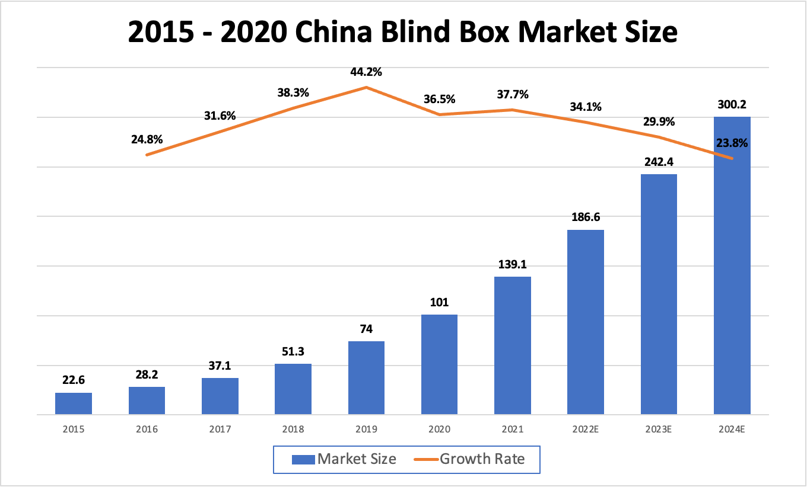
Blind box first came from Japan and was derived from some Japanese cartoon characters. Because the same series of blind boxes have the same appearance, customers cannot tell which type they are buying until they open the box, hence the name “blind” boxes. As a growing market in the Chinese economy, blind boxes were introduced to China in the form of card collections in the 1990s. The cards from Outlaws of the Marsh in the packaged snacks that many thirties or forties remember were the former form of localized blind boxes. In addition, the lipstick dispenser, lucky box, etc., can be regarded as the form of the blind box in different periods, only they did not lead the real trend at that time. Since 2015, the blind box market in China is mainly represented by blind toy boxes and has significantly grown in size. According to MOB research, though the Chinese Blind Box market size was only 2.26 billion RMB in 2015, it has a rapid expansion period of six years with an average growth rate of 35.5% (Graph 1). At the end of 2021, the Chinese blind box market has reached the size of 13.9 billion RMB and become a dominant player in the fashion toy industry with more than 50% market share (MOB Research Institute). Though it’s predicted to lower the expansion pace a bit in the following years, its growing market size, and the important role it played in the fashion industry emphasize the importance of understanding the economic reasoning behind this emerging market.
Graph 1: China Blind Box Market Size from 2015 to 2020
Different from other fashion toys, blind boxes are not expensive to start with, and the method of drawing boxes is more entertaining, with a strong sense of surprise and social attributes attached to the unwrapping process, and when the hidden version with a very low probability of occurrence could lead to higher gains than the value of the goods, which makes blind boxes gradually gain popularity and a large wave of fans. Below is a more detailed analysis of the core competence of blind box products and why people are “addicted” to purchasing.
- Strong sense of surprise
The unique purchase method of blind boxes is that the customer would open the boxes with a strong sense of surprise for the unknown type. This sense of surprise will even be more valuable than the product value itself. In other words, the blind box has a high entertainment utility for its buyers beyond the simple product's expected utility.
- Unique social attribute
The blind box social circle is formed when users buy duplicate types or types that they don't like, thus creating the need to replace and exchange the blind box. Buyers will discuss new blind box styles online and host offline gatherings to showcase rare blind box IPs. This social attribute promotes a sustainable blind box after-sales chain, which stimulates repetitive purchase behavior.
- High premiums
According to classical economic supply theory, scarcity is expensive. The "hidden" blind box, which has a very low probability of occurring, is in short supply on the secondary market and is priced extremely high. When a user draws a "hidden" blind box, he or she can earn several times more than the original price. The purchase of blind boxes has become a new form of investment.
Given the importance of the blind box industry in the Chinese economy and its unique features compared to other fashion toy products, it’s essential to discuss why new research studies should be conducted to reason its economic logic. In other words, why classical economic theory can’t be applied in the context of a blind box economy. And below is an example of a specific blind box series published by Pop Mart, the dominant player in the blind box market, which sheds light on the necessity to conduct research specifically addressing this economy in China. According to its official website, the probability of getting a hidden edition out of a random blind box in a typical series (12 normal types + 1 hidden edition) is 1/144, which is 0.69%. This probability is also available online if there’s no poster shown in the store which implies customers should have access to this authentic probability information if they are willing to know. According to the standard theory, this stated probability is accessible and as people are rational, it should be people’s decision probability and they would conclude that the probability for a normal type is equally spread-out probability after deducting the hidden edition probability. Therefore, the probability for normal type and hidden edition should be the number listed below （Table 1).
 | Normal Type | Hidden Edition
Probability | 8.27% | 0.69%
Table 1: Probability for each type of blind box assuming a series with 12 normal and 1 hidden edition
Given this probability, the series One Day of Molly was chosen for analysis purposes as it’s one of the most famous and widely bought series in the market. To analyze how people’s purchase decisions were not explainable in the classical economic context, I collected the market price for all 13 types on a second-hand platform called Qian Dao (Table 2). This publicly traded price in theory should be the customer’s expected price for each specific type based on the supply and demand theory.
 | N1 | N2 | N3 | N4 | N5 | N6 | N7 | N8 | N9 | N10 | N11 | N12 | H
Price | 68 | 30 | 39 | 56 | 40 | 32 | 38 | 56 | 55 | 70 | 37 | 49 | 188
Table 2: Prices of One Day of Molly series, Unit: RMB, N for normal, H for hidden
Using the price and inferred probability information, the calculated price for one blind box should be around 48 RMB and people should not pay a price higher than that, otherwise, they will not benefit from this consumption decision. However, the market price of this specific blind box series is 59 RMB and there are still plenty of people buying it, which implies the traditional economic theory is not enough for this industry.
Given this context and the unique feature of blind boxes, there are several potential factors that could contribute to the price premium. As the above-calculated price is based on the probability of getting each type and the price of each type from the second-hand platform, possible factors could be: people perceived the possibility of getting each type mistakenly; market price does not reflect real utility people benefit from purchasing; other utility people gain that are not shown by price and possibility. For the first type, though the real possibility information is available, people may lack the willingness to acknowledge this extreme possibility. Perceiving a higher possibility of getting the hidden edition not only means feeling better but also a possible higher expected price for each blind box they purchase. In terms of the second type, although the market price could be a good approximation of economic utility, the utility customers enjoy from the blind box social cycle in the long term might be neglected. As this indirect utility is not visible on the surface in the short run, it’s highly possible the market price on the second-hand platform under-measures the utility. Last but not least, there are also utilities that are not represented using price and possibility - entertainment utility. Entertainment utility is the utility purely derived from the process of unpackaging the unknown blind box. As customers will no longer receive a strong sense of surprise when they purchase from the second-hand platform since types are explicitly stated, such utility would be excluded in the above-calculated price thus contributing to the price premium. In the following section, I'll mainly focus on the first and third factors, namely, perceived possibility and entertainment utility.

3 Literature Review
Under uncertainty, expected utility theory was the dominant normative and descriptive decision-making approach. However, this theory has been called into question in the last few years. There is sizable evidence that decision-makers systematically violate the core principles of the theory, and there is now a broad consensus that the theory does not provide an adequate explanation of individual decisions. A great number of alternative models have been advanced as a response to this empirical challenge. For instance, prospect theory, as a flagship of such alternative models, well explained the major violations of the conventional expected utility theory in scenarios of choices between the risky and small number of outcomes (Kahneman and Tversky, 1979; Tversky and Kahneman, 1986). The two major tenets of this theory are 1) a value function that is concave in the domain of gains, convex in the domain of losses, with the slope being steeper in general for losses than for gains, and 2) a nonlinear probability distribution, in which small probabilities are overweighted and medium and high probabilities are underweighted (Abdellaoui, 2000; Gonzalez & Wu, 1999; Prelec, 1998; Tversky & Wakker, 1995; Wakker, 2003).
To lay the groundwork for the current development, I will first list five fundamental regime-breaking choice phenomena that constitute the threshold to be addressed by any well-developed theory.
- Framing effect. The conventional theory of choice assumes rationality which includes the invariance of choices under different descriptions. In other words, alternative wordings of a choice problem should yield the same ranking of preferences (Arrow, 1982). However, in contrast to this presumption, there is ample evidence that variation in the formulation of choices (e.g., the percentage of use of the terms "profit" or "loss") does lead to consistently contrasting preferences (Tversky and Kahneman, 1986).
- Nonlinear preferences. Under the expectation theory, the utility of a risky outcome is linear in relation to the probability of the outcome. This principle was refuted by the famous Allais example (1953), which showed that the difference between the probabilities of 0.99 and 1.00 is more influential on preference than the difference between 0.10 and 0.11. Later research has also identified non-linear preferences for choices that are subject to uncertain things (Camerer and Ho, 1991).
- Source dependence. It is not only a function of the level of uncertainty but also the source of the uncertainty, whether people are willing to bet on uncertain events. Interestingly, Ellsberg (1961) observed that people prefer to bet on an urn containing equal amounts of red and green balls, as opposed to one that contains those two colors in an unknown proportion. A recent experiment suggests that people prefer to bet on a game in their area of expertise rather than on an equivalent random event, even if the probability of the former is uncertain and the latter unambiguous (Health and Tversky, 1991).
- Risk seeking. It is generally assumed that people are risk-averse in decision-making under uncertainty in economic analysis. However, risk-seeking choices are regularly noted in two kinds of scenarios. 1) Small probability is preferred over the large, expected value in the context of winning a huge prize in the future. One good example is the lottery ticket. 2) people are prone to risk-seeking when they must choose between a certain loss and a substantial probability of a greater loss.
- Loss aversion. Under conditions of risk and uncertainty, a fundamental observation of choice is that losses outweigh gains (Kahneman and Tversky, 1984; Tversky and Kahneman, 1991). Losses and gains are too asymmetric to be explained by income effects or by decreasing risk aversion.
In particular, the cumulative prospect theory predicts a fourfold risk preference model, which illustrates the nonlinear impact of probability on decision-making. (Tversky & Kahneman, 1992). Therefore, due to the overemphasis on small probabilities, both low-probability gains and losses appear to be significant relative to a payoff with the same expected value. Therefore, there is a risk-seeking behavior for gains, and a risk aversion for losses at low probabilities - for example, people are tempted to buy lottery tickets (to seek unlikely gains), and insurance (to avoid unlikely losses). When contrasted to particular payoffs with the same expected value, a similar pattern develops as people underweight moderate and large probabilities, exhibiting contrasting risk aversion for high-probability gains and risk-seeking for high-probability losses.
In terms of entertainment utility, there's no specific research paper discussing how to quantify surprise as utility and how it will affect people’s decision-making process. Yet, there is a paper from Scott Kaplan dealing with the sense of thrill, which revealed preference methods for predicting entertainment demand for non-instrumental information. By investigating the “thrill” associated with the trajectory of an event, which includes both suspense and surprise, and the “skill” of performers in an event, this paper concluded that the sense of “thrill” plays a significant role in affecting the third-quarter game viewership (Kaplan, 2021).

4 Empirical Analysis
Based on the above existing study on both perceived possibility and entertainment utility, we could conclude that both factors deed has an impact on the gained utility of risk-embedded events. Therefore, to better understand whether such an effect is still applicable in the context of blind boxes and in which way this effect impacts the price premium, I conducted an empirical analysis using data from both public second-hand blind box platforms and survey questionnaires. In the below sections, I’ll go through the methodology, data analysis, as well as results & discussion for both data sets.

4.1 Public Second-hand Platform for Blind Box

4.1.1 Methodology
This second-hand platform that I used to collect information about prices is Qian Dao (千岛). This software not only provides various series to purchase but also offers a direct purchase method for specific types, even hidden editions, or rare types. The data analyzed below is chosen from a series in which prices of each type are available. In other words, each type (including hidden edition), are available for purchase other than buying an unknown blind box product. Besides, though the classic blind box series has only one hidden edition, there are some series that have more than one, namely big hidden edition (大隐藏款) and small hidden edition (小隐藏款). The official possibility of getting either big or small hidden editions is not provided by the merchandiser therefore, in the data collection stage, prices of each type within such blind box series is not collected. Given such conditions, I collected 89 sets of data with more than 12 IPs from 2018 to 2021. Using the excel solver, I calculated the perceived possibility of getting the hidden edition using prices of each type within the series. The assumption in this data analysis is that the perceived possibility of getting the normal type is equally spread out after deducting the perceived possibility of getting the hidden edition.

4.1.2 Empirical Data Analysis
Solving the perceived possibility of getting the hidden edition using excel, below is the graph which presents the relationship between the release date and perceived probability (Graph 2).
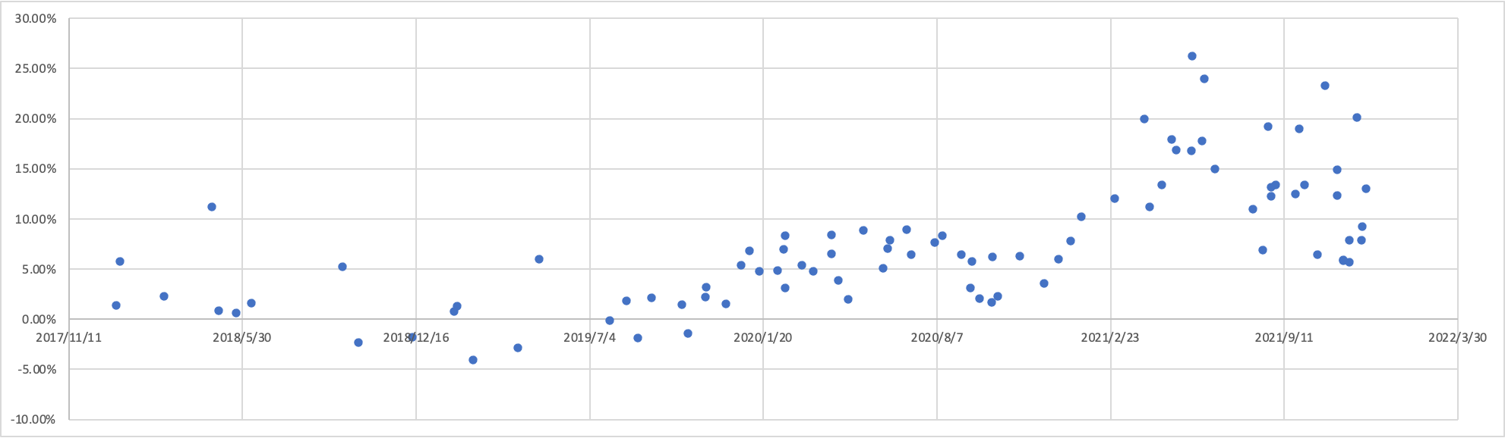
Graph 2: Relationship between release date and perceived probability
The first conclusion is obvious: the perceived probability of getting a hidden edition is significantly higher than the stated real probability. Though the available information implies that the real probability is only 0.69%, the average probability of getting a hidden edition from these 89 sets of series is 7.56%. In other words, based on information from the second-hand platform, people think they are likely to get a rare type if they unpackage 13 blind boxes This also implies that the widely accepted probability within a series is equally spread on this second-hand platform. This is consistent with the previous research paper which concluded that people tend to overestimate small probabilities in risky event.
The second conclusion is that there exists the trend that the newly released blind box series would have a higher perceived probability. To be more specific, the average perceived probability of the 2021 released series is 13.61% based on 34 series in total, the average perceived probability of the 2020 released series is 5.6% based on 30 series in total, the average perceived probability of the 2019 released blind box series is 1.22% based on 15 series, while the 2018 released blind box series has an average perceived probability of 2.54% with 10 available series. Though the longer time one series is released, the closer its perceived probability gets to the real one, all these average probabilities are higher than the real one, 0.69%, which again, supports the first conclusion.
One possible explanation for such a trend is associated with the sense of surprise. Assuming people’s high perceived probability mainly came from the risk embedded in the product blind box, then the longer one series is exposed to potential customers through either social media or blind box social circle, it’s more likely that the expectation of getting the hidden edition is lower. Thus, the probability of getting different types within a series will gradually become an equally spread-out situation. However, even though the already released blind box series may be under-expected in terms of ornamental value, it remains valuable and profitable as an investment opportunity. Therefore, the reasons behind such a trend remain to be discussed.

4.2 Survey on Blind Box Purchase and Risk Preferences

4.2.1 Methodology
To better understand how the perceived probability and the entertainment utility impact people’s decision of purchasing a blind box, a larger size of participants is needed. Though the second-hand platform is accessible to collect more information it’s hard to quantify the entertainment utility without distributing surveys. Therefore, after consulting with my advisor, Professor Wendy Jin, I designed a survey to collect more information about how people with different characteristics perceive the probability of getting a hidden edition and how such perceived probability impacts people’s purchase decisions. Moreover, as I consider other factors such as entertainment utility and risk preference as significant variables in the decision-making process, this survey also measures these variables using quantitative and qualitative methods.
This survey mainly consists of five parts: 1) How do the participants perceive the blind box product? To be more specific, this section measures whether the participants hold a positive or negative attitude towards the blind box product, which would impact their perceived probability and entertainment utility that is measured in the following sections. 2) The importance of various factors that may contribute to participants’ consumption of blind boxes. This section is used for gathering supplementary information on what input customers need in the decision-making process. 3) A scenario-based question, in which the participants are given a scenario in which they are required to make a decision of whether to purchase a blind box with different labeled prices. This section would be used to identify the perceived probability and part of the analysis of entertainment utility. 4) Participants’ risk preferences using quantitative methods. Together with the previous section which measures the perceived probability of getting a hidden edition out of a blind box product, these two variables could be compared to reveal the importance of entertainment utility as risk preferences are measured using pure monetary payoff. 5) Participant’s demographic information. This section could be used as an identifier to categorize the respondents. The number of participants is 200 and this research is submitted and passed IRB review.
This survey is conducted via the online survey platform named Credamo which is one of the world's first one-stop smart research platforms. Subjects are selected based on the below criteria: 1) residents who currently live in China; 2) age groups ranging from 21 to 50 years old; 3) people who have previous experience in blind box purchasing. Moreover, in terms of quality control, I set the bar for respondents' credit scores and historical adoption rates both greater or equal to 70%, which theoretically increases the quality of the respondents and their responses. Subjects are awarded ¥5.5 per survey response with IP address restriction (each IP can only reply once), and detailed survey questions are listed in the appendix (Appendix A).

4.2.2 Empirical Data Analysis
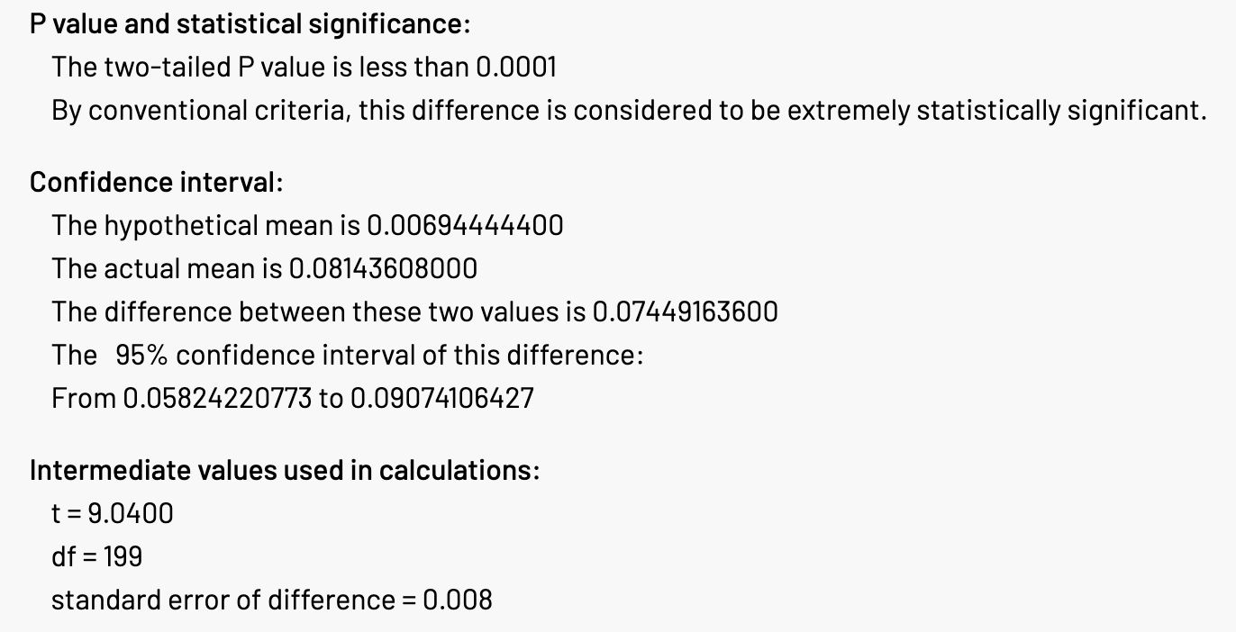
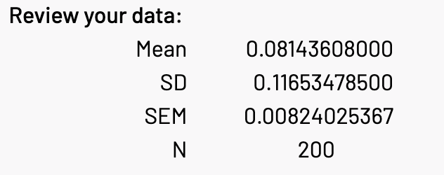
Graph 3: T-test analysis of the average perceived probability
The third section of the survey asked about how many blind boxes one participant purchased; will he/she think there must be a hidden edition. From 200 survey answers, the analysis is shown in the above graph 3. The average perceived probability of getting a hidden edition is 8.14% with a 95% confidence interval from 5.82% to 9.07%. Testing this average perceived probability against the real probability of 0.69% using a t-test, the two-tailed p-value is less than 0.0001. By conventional criteria, this difference is considered to be extremely statistically significant. This result is consistent with the conclusion from both the existing literature and the previous analysis based on second-hand platforms.
Start with the first section in which different opinion-based factors are given for participants to choose from. Below is a quick summary of seven factors and charts of the perceived probability and whether factors are chosen.
- Factor 1: the perception that blind boxes are just a merchandising tool for stores to make money
- Factor 2: the perception that blind boxes are a way to waste money
- Factor 3: the perception that blind boxes are a feasible way of investment tool
- Factor 4: the perception that blind boxes are products with ornamental value
- Factor 5: the perception that blind boxes are an inseparable part of life
- Factor 6: the perception that blind boxes are toys just kids feel fun
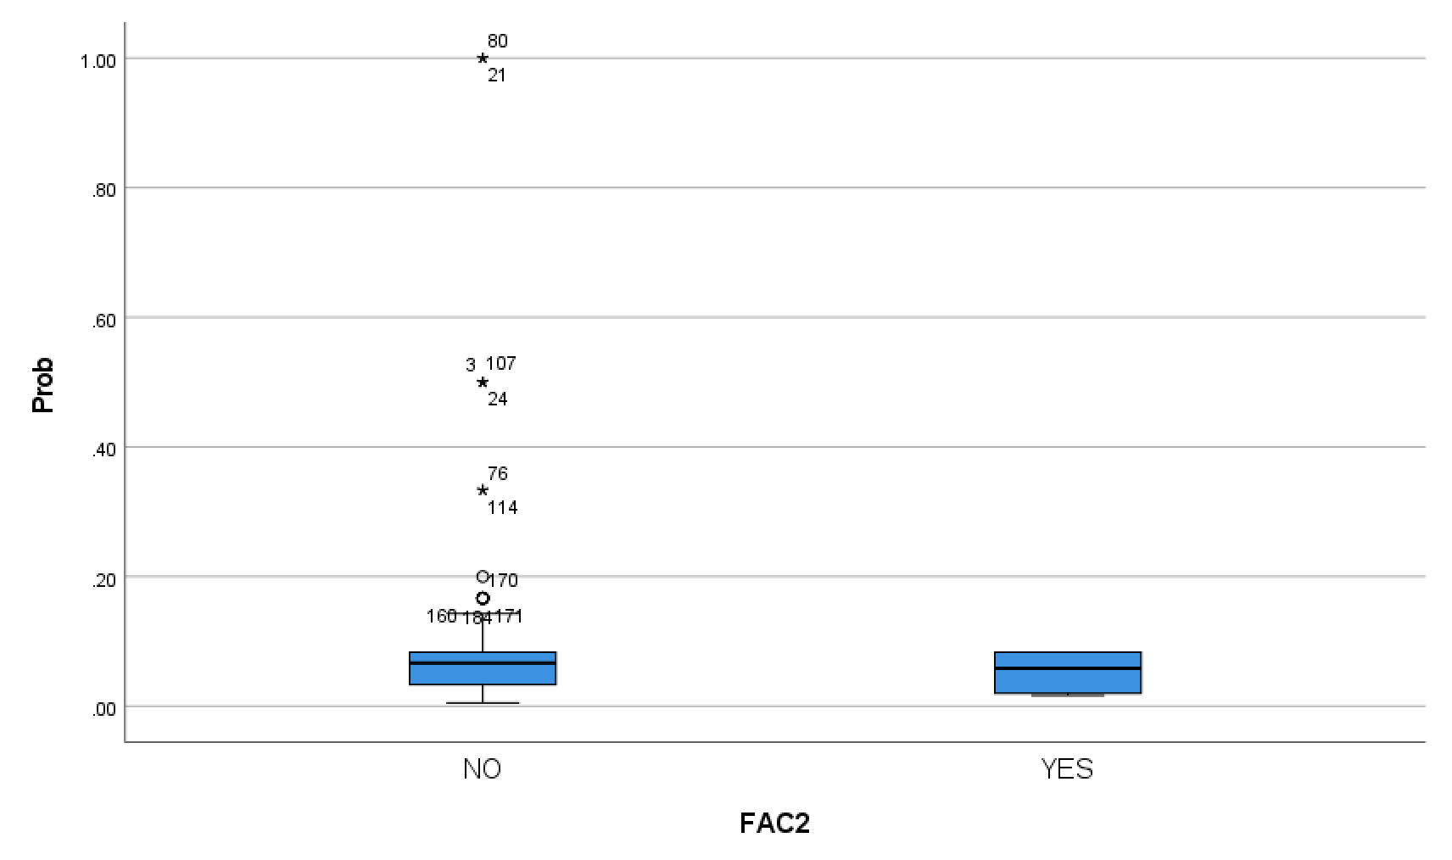
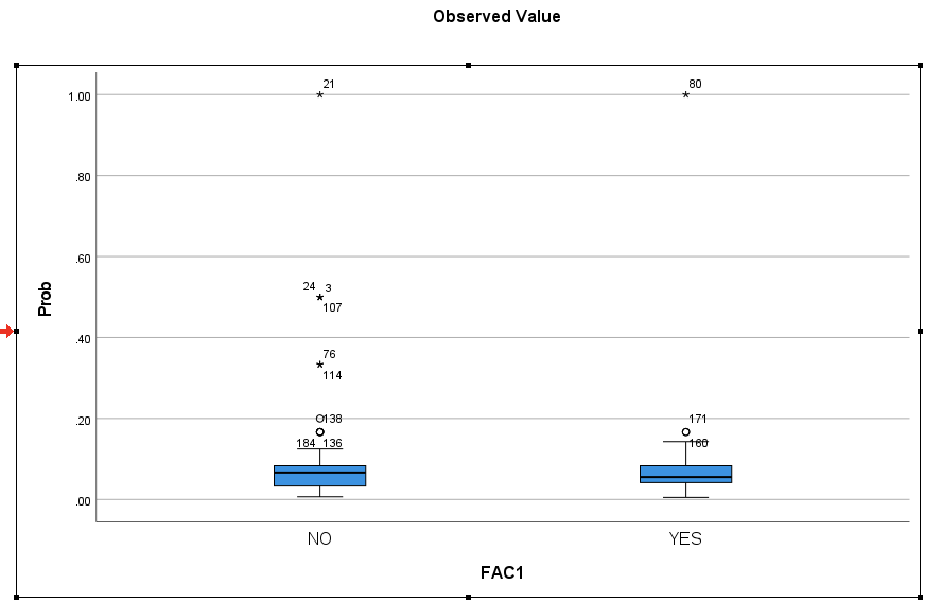
- Factor 7: the perception that blind boxes are risk-embedded product just like lottery
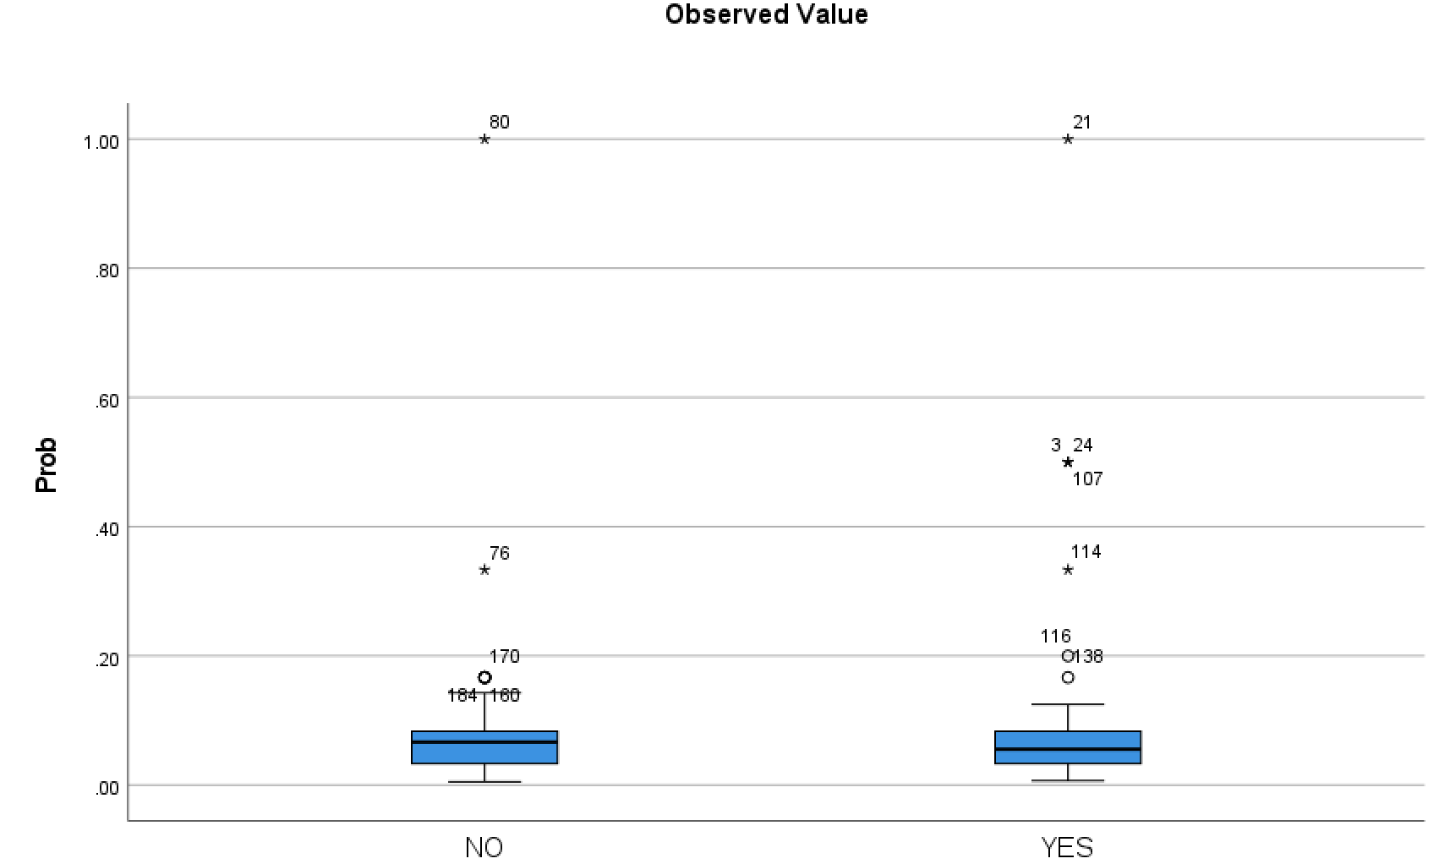
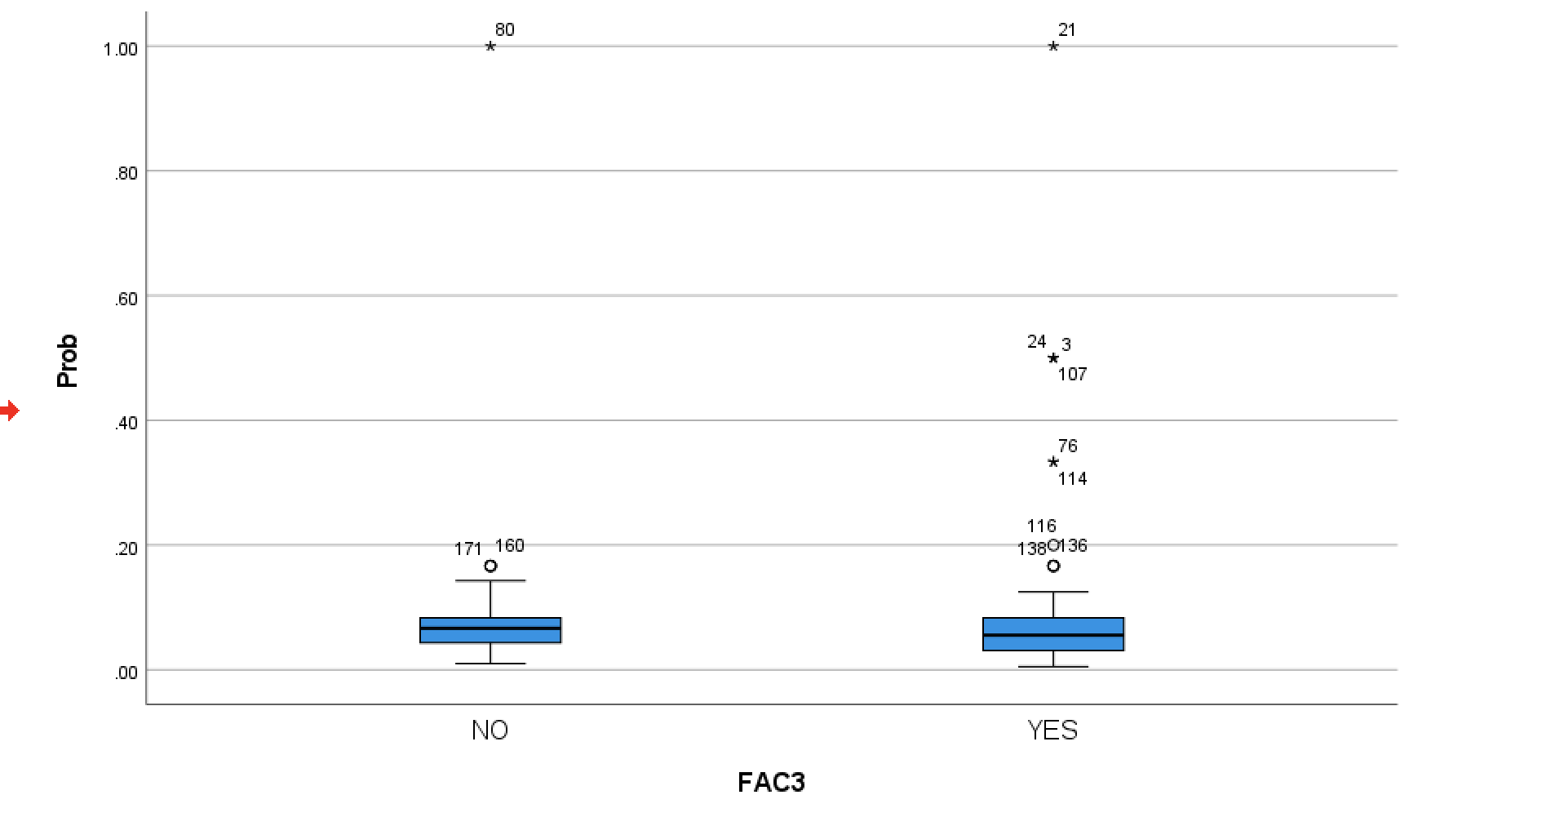
Graph 4: Factor 1 Box Plot Graph 5: Factor 2 Box Plot
Graph 6: Factor 3 Box Plot Graph 7: Factor 4 Box Plot
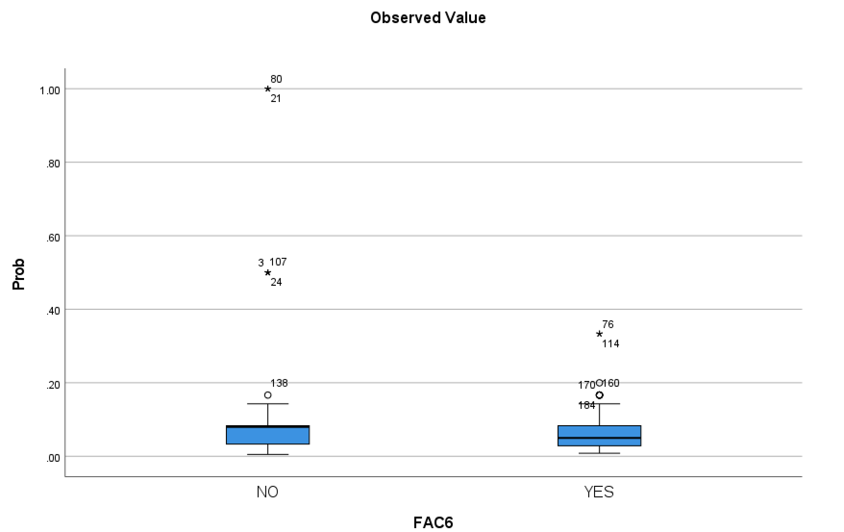
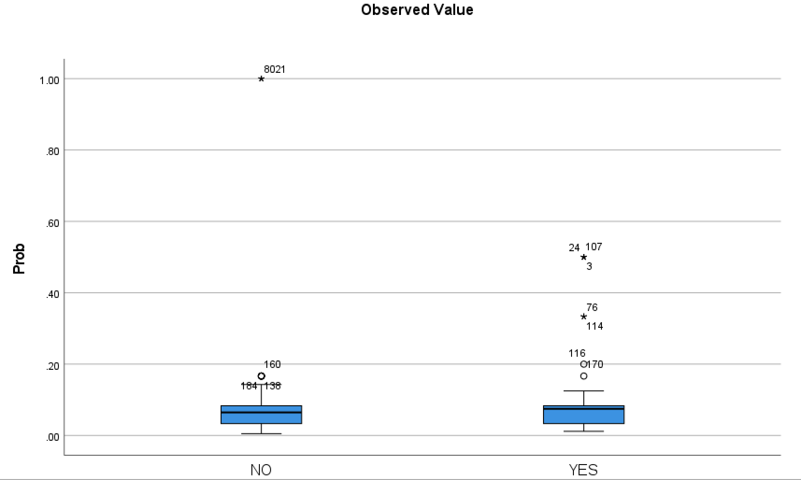
Graph 8: Factor 5 Box Plot Graph 9: Factor 6 Box Plot
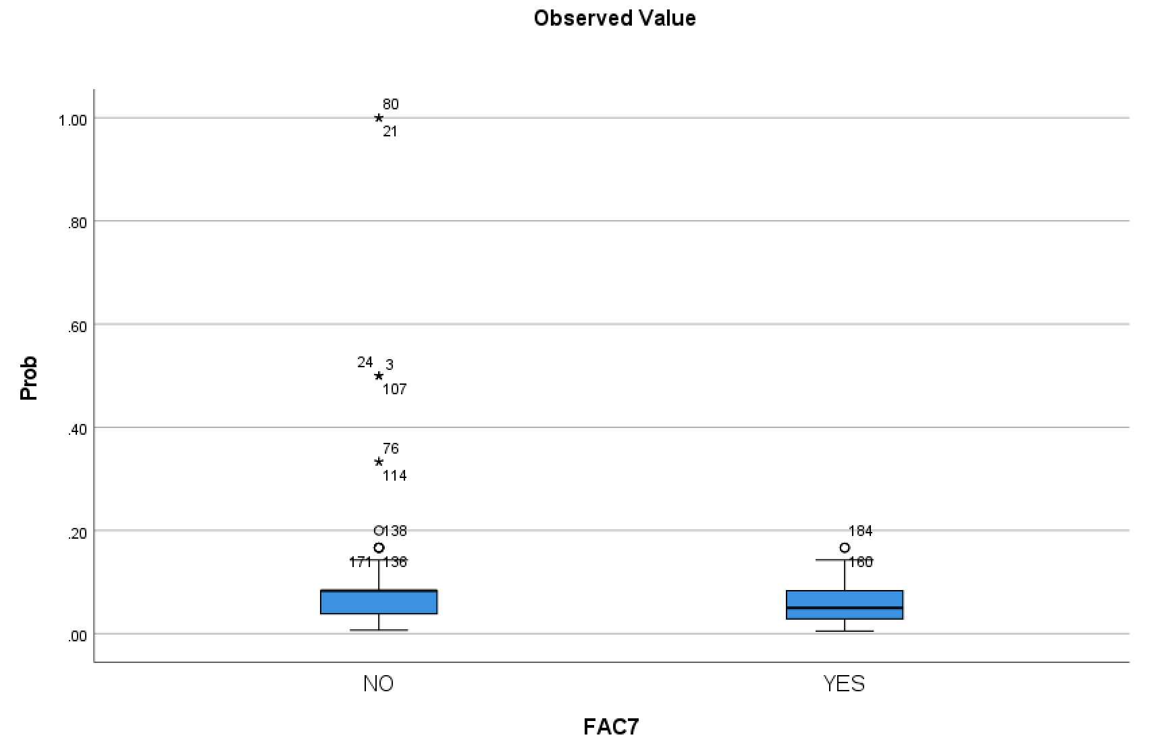

Graph 10: Factor 7 Box Plot
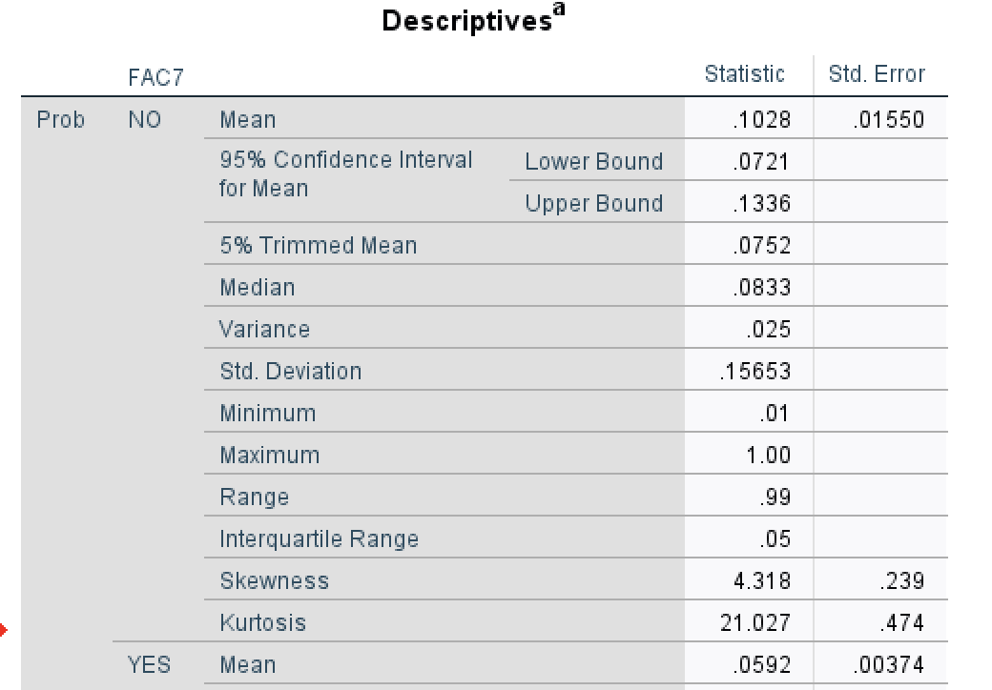
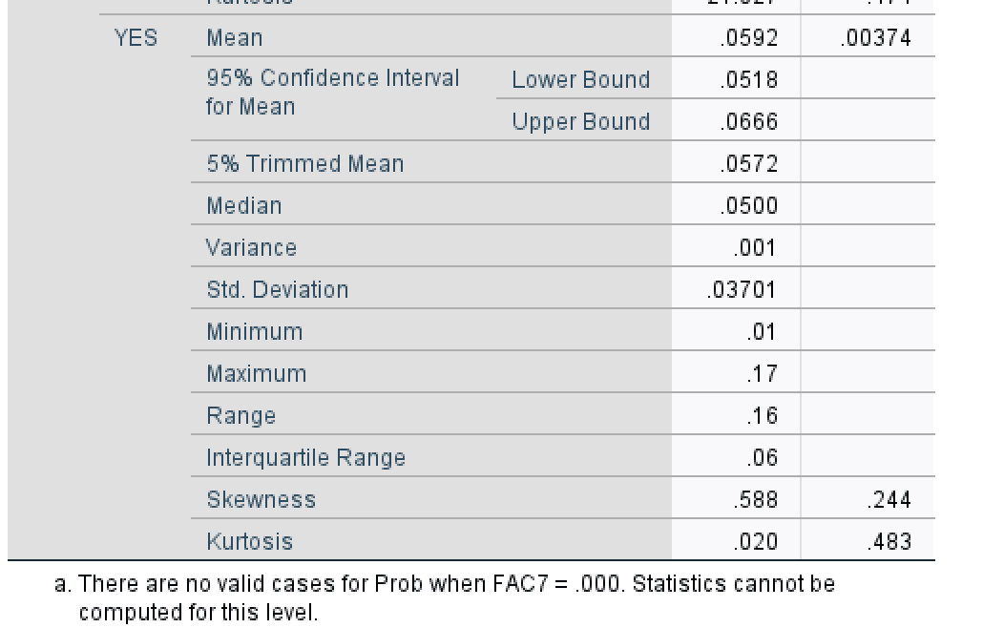
To discuss whether one factor has an impact on people’s perceived probability, I conducted independent sample tests for each factor. All first six factors are neither - have the same variance but not statistically significant mean difference, nor - have different variance but not statistically significant mean difference. Only factor 7, which implies the perception of risk-embedded products, shows a statistically significant mean difference as shown in the below graph (Graph 11).
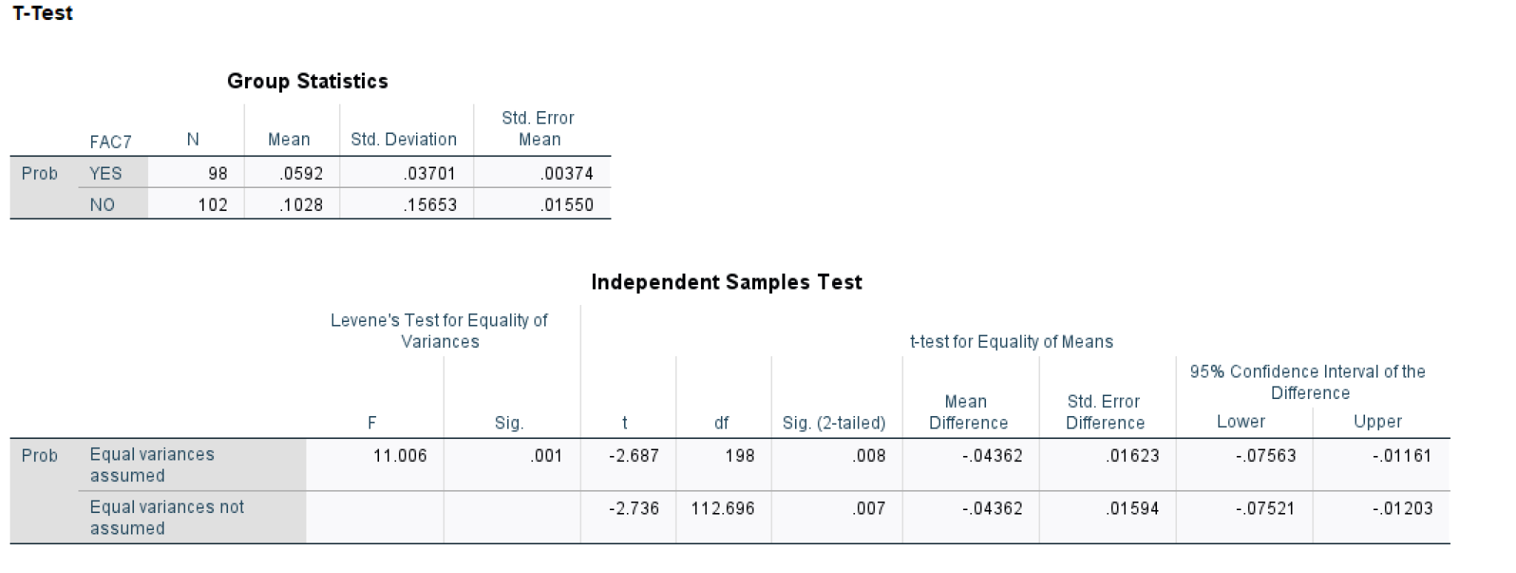
Graph 11: Independent Sample Test of Factor 7
This independent t-test shows that whether people perceive blind boxes as a risk-embedded product does have a significant effect on their probability perception of getting a hidden edition. 98 people agree with this perception while 102 do not think of blind boxes as a risk-embedded product. With the “Yes” group having an average perceived probability of 5.92%, the “No” group has a much higher perceived probability of 10.3%. These two groups have different variances, which is consistent with the significance of Levene’s t-test, which suggests these two groups have statistically distinct variances. Given the different variance, we could conclude the two-tailed p-value significance is 0.007, much lesser than 0.05 which suggests that whether people’s perception of blind boxes as a risk-embedded product does have an important effect on their perceived probability. To be more specific, people who recognize the nature of blind boxes as a lottery-like product will perceive the probability of getting a hidden edition lower, in other words, closer to the real probability, than the other group who do not treat blind boxes as a risk-embedded product. This result extended the existing research that people tend to overweight small probabilities in risky events by adding the comparison between such overweight perception between two groups: though the overweight is universal to both groups, such overweighting is less salient for people who are concerned about the risk of the event they are going through and more salient for the opposite group.
Dive into the second section which covers the rating of several major components that contribute to the blind boxes purchase decision-making process. This rating ranges from 1 to 7 with 7 representing “Very important” while 1 represents “Totally irrelevant” for each factor’s importance when considering whether to purchase a specific blind box series. Nine factors are listed below with the average rating from 200 survey participants shown in table 3.
- Factor 1: Official price per blind box
- Factor 2: The popularity of this blind box series
- Factor 3: the joy from unpackaging the blind box regardless of its type
- Factor 4: the joy from the possibility of getting the hidden edition
- Factor 5: whether you have already purchased other types within this series before (the completion rate of this series)
- Factor 6: the probability of getting the hidden edition
- Factor 7: the ornamental value of the blind box product
- Factor 8: the investment value within the blind box in the long term
- Factor 9: the investment value for getting the hidden edition in the short run
 | Factor 1 | Factor 2 | Factor 3 | Factor 4 | Factor 5 | Factor 6 | Factor 7 | Factor 8 | Factor 9
Rating | 5.285 | 5.92 | 6.26 | 6.27 | 5.715 | 5.835 | 5.76 | 5.21 | 5.24
Table 3: Rating for different factors on how they contribute to blind box purchase decision
This table suggests the most important factor considered by blind box consumers is the joy from the possibility of getting the hidden edition followed by factor 3, which states the joy people get from unpackaging the box regardless of its type. The number three important factor is the popularity of this blind box series which is highly associated with the blind box social circle. This could be explained by the fact that the purchase of a hot blind box product could help gain popularity and status within this circle. These three factors could also be seen as entertainment utility as all of them are relevant to the sense of surprise and the social attribute of blind boxes. Therefore, this result is consistent with the trend analyzed in the previous study which argues that the emotional sense does play an important role in people’s decision-making process.
Then we go to the third section which covers the entertainment utility. This section asked about the possibility of participants being given different official prices of one blind box with information about second-hand platform prices and the real possibility of getting a hidden edition listed in the question. According to classical economic theory, the expected price should be 48 RMB with a 0.69% possibility of getting a hidden edition. Based on the answer, we could get an expected price for each respondent which could be seen as impacted by the entertainment utility only. This is because the probability of getting a hidden edition is explicitly stated and given to participants, which, unlike the real-life situation, such information may not be explicitly shown in the store. Comparing this expected price to the price calculated from the classical economic theory, an entertainment utility could be generated. Below is a graph of the entertainment utility among 200 respondents with the x-axis being the participant number, and the y-axis representing the entertainment utility. The average entertainment utility is 4.0.

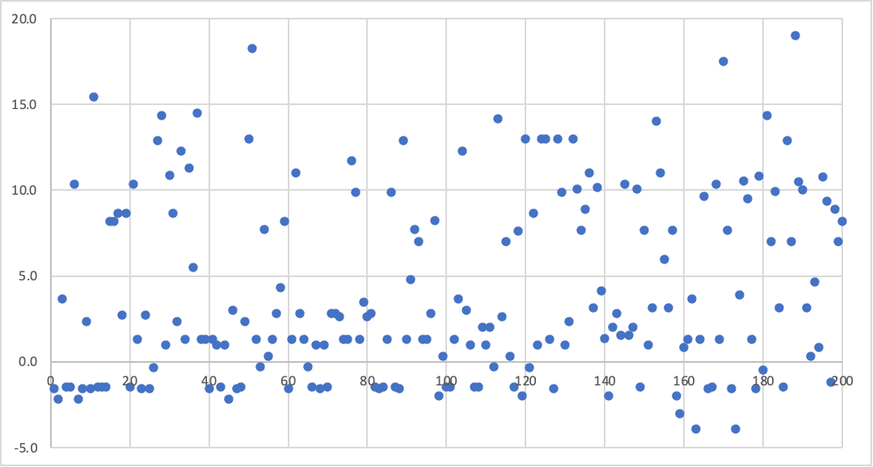
Graph 12: Distribution of entertainment utility
After the entertainment utility section is the section that measures the risk preferences using the quantitative question of the probability of winning a lottery. Comparing their chosen probabilities with the sure reward of 50 RMB, we could better understand their risk preferences and conduct an analysis with perceived probability.
The average payoff from the survey is 61. 6 RMB, much higher than the 100% sure reward which implies overall, the survey respondents are the risk-seeking type of people. Moreover, below is a graph showing the correlation test between the participant’s chosen payoffs and the perceived probability. The result shows that these two variables are negatively correlated with a correlation coefficient of -0.993 which is statistically significant at the 0.01 level of significance. In other words, people who are more risk-seeking, who would have higher expected payoffs from the lottery ticket, are more likely to perceive the probability realistically.
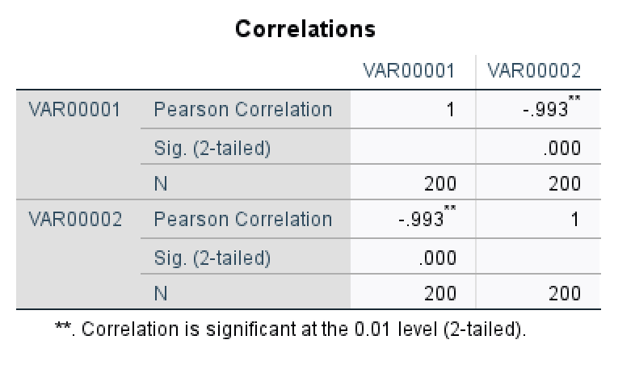
Graph 13: Correlation between expected payoffs and perceived probability
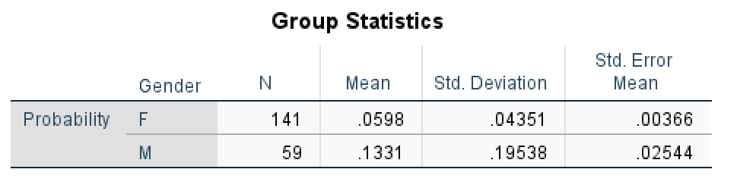
Then the last section covers the demographic information which could be used as identifiers to categorize people and compare the difference. The main information collected here is gender, age group, highest degree, and country/city location. Starting with gender, among 200 survey respondents, 141 of them are female with an average perceived probability of getting a hidden edition of 5.98%. The other group, the male group, has a much higher average perceived probability of 13.31%. Applying an independent sample test, the mean difference is statistically significant given the different variances. In other words, female customers tend to perceive the probability of getting a hidden edition closer to the real situation while overweighting small probabilities is more salient for male customers. Details are shown in the graph below.

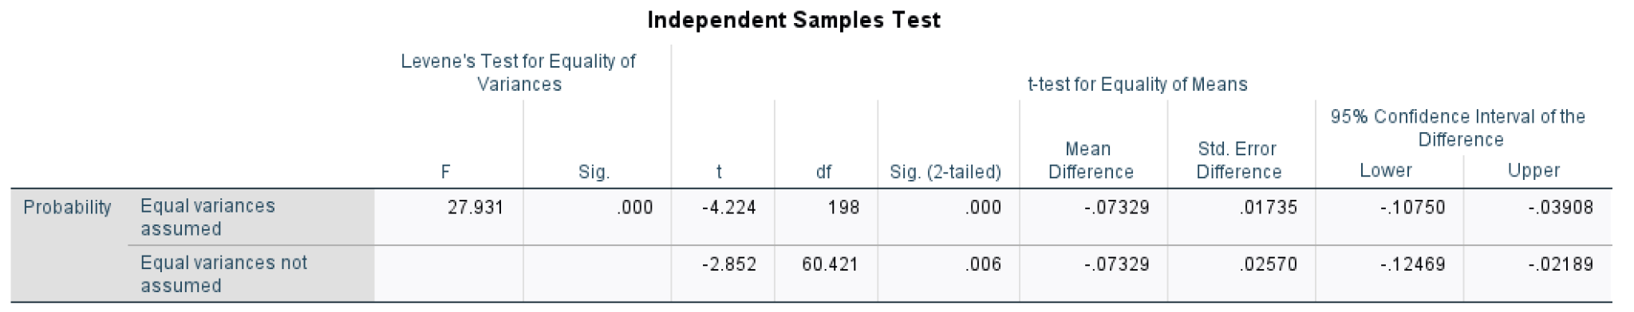
Graph 14: Independent sample test for different gender groups on the perceived probability
Different perceived probabilities for other factors are also analyzed. People whose age range from 21 - 30 years old have an average probability of 9.79%, age range from 31 - 40 years old have an average probability of 7.44%, and people’s age range from 41 - 50 years old have an average probability of 3.96%. This result implies that people who are older tend to better perceive the probability of a risky event - purchasing blind boxes - while younger people are more likely to overweight this probability. This might be one of the reasons that contribute to the craziness of the blind box economy.
As for the highest degree, people with normal high school education have an average perceived probability of 14.17%, people with vocational education have an average probability of 16.73%, the number for people with undergraduate degrees is 7.6%, the number for postgraduate students is 7.08%, and the average perceived probability for doctorate degree holders is 8.33%. The difference between each group is not apparent and needs further analysis.

5 Conclusion
I explore the effect of perceived probability and entertainment utility on people’s purchase decisions in the context of the Chinese blind box market. Consistent with previous research, the perceived probability of getting a hidden edition and the entertainment utility apart from the product itself do impact people’s decision-making process. Data from a second-hand platform that traded specific types of blind boxes suggest the average perceived probability of getting a hidden edition from a typical series (12 normal types + 1 hidden edition) is 7.56%, which is statistically significantly different from the stated probability of 0.69%. Moreover, through the analysis of existing blind box series, there appears to be the trend that the newly released sets of blind boxes tend to have a higher perceived probability while the older series are more likely to be perceived correctly.
The second data set is collected from an online survey with a sample size of 200. With five sections of information, including perceived probability, entertainment utility, and risk preferences, this survey covered a lot of important factors that may contribute to the blind box price premium. To start with, the average perceived probability from this 200-sample pool is 8.14% which is similar to the previous result, which is significantly different from the real probability. Moreover, after conducting a t-test, among seven perceptions that people usually held towards blind box products, we found the perception “think blind box as a risk-embedded product like a lottery ticket” has an interesting result. People who agree with this perception have a statistically significant lower perceived probability of 5.92% compared to the other group of 10.28%. This suggests that people who have a better understanding of the nature of blind box products - products with risk and uncertainty - could have a more accurate perception of the probability. This result extended the existing research that people tend to overweight small probabilities in risky events by adding the comparison between such overweight perception between two groups: though the overweight is universal to both groups, such overweighting is less salient for people who are concerned about the risk of the event they are going through and more salient for the opposite group.
In terms of entertainment utility, the importance of entertainment utility is confirmed in the component rating section in which the top three components rated by participants are within the category of entertainment utility. Moreover, based on an explicitly stated probability and prices of different blind boxes, the entertainment utility is measured in a quantitative method in which the average number of these 200 participants is 4.0. After discussing the entertainment utility, the risk preference sections suggest that the risk preferences are negatively associated with perceived probability with a correlation coefficient of -0.993 which is statistically significant at the 0.01 level of significance. In other words, people who are more risk-seeking, who would have higher expected payoffs from the lottery ticket, are more likely to perceive the probability realistically.
The last part of the results is analyzed from the demographic information which starts with gender. Applying an independent sample test, the mean difference between female and male groups is statistically significant with the average perceived probability for the female group being 5.98%. The other group, the male group, has a much higher average perceived probability of 13.31%. In other words, female customers tend to perceive the probability of getting a hidden edition closer to the real situation while overweighting small probabilities is more salient for male customers. Other results analyzed from the highest education and age groups are more qualitative. For example, younger people have a higher perceived probability while the elderly tend to recognize the extremely low probability correctly.
However, for the last section which discusses the difference in perceived probability among various demographic characteristics, further work needs to be done to test the statistical significance of mean difference. All previous significance was tested using a t-test which is more applicable under the condition of two groups. When the number increases to three or even higher, other test methods like ANOVA are needed. Part of further research is working on this type of testing which mainly covers the age group and education level in the last section. Moreover, I haven’t got a better idea of analyzing the location factor which asked the city the participants constantly live in. Rough idea is to test the mean difference between different tiers of the city. For example, Shanghai, Beijing, and Guangzhou are listed as the first-tier city while Xiamen, Kunming, and Wuxi are on the list of second-tier cities. Another direction would be linking the city with GDP/ income and trying to find the relationship between the per capita income or GDP with the perceived probability of getting a hidden edition.
Finally, it may be an interesting question to explore a model that puts both factors in the analysis. All the above analyses are mostly done independently without a focused discussion on how these two factors interact with each other and how these two factors collectively impact people’s decisions on purchasing blind boxes. I did put effort into finding related existing papers working on such a model but unfortunately, the results are not satisfactory. Therefore, this integrated model would require more time no matter through exploring existing literature or my own work out trying to build a brand-new model. Moreover, as I mentioned in the blind box market section, apart from the two factors of perceived probability and entertainment utility, there’s a third potential factor contributing to this classical theory anomaly, which is the long-term utility people enjoyed from the blind box social circle. Given limited existing study and time, this factor is not included in the above analysis. However, this factor remains important and interesting for further research.

Appendix

Appendix A – Survey Questions

中国盲盒经济背后的的概率认知和娱乐效用

同意书-版块开始

同意书

感谢您参与本次研究。本研究旨在为盲盒经济在中国的发展提供思路。我们预计这项研究将有200名参与者。问卷大约需要5分钟时间完成。您可以选择自愿参与，您的决定不会影响您与研究人员或上海纽约大学的关系。

问卷包括一些有关个人情况的问题。您可以因为任何原因跳过任何问题。参与这项调查的风险极小。我们将记录您对问卷题目的回答,并对您的研究信息保密。数据和记录将存储在有密码保护的计算机和备份驱动器上。只有研究人员和他/她的研究团队的成员可以访问这些信息。研究人员将尽一切可能不让无关人员得到受试者在参与此项研究时所分享的信息。

您可能不会从这项研究中直接受益，但从本次研究中收集的信息可能有助于盲盒经济的可持续发展和相关法律法规完善。

如果您点击“继续”，即表示您同意参与本次问卷,并明白您随时可以退出本次研究。如果您在任何时候希望终止您的参与，您可以退出此问卷，并且不会导致任何罚款或损失您本来有权享有的利益。如果您退出问卷,所收集的数据将不会被保存。针对上海纽约大学的学生，拒绝或参与此次问卷不会影响您的成绩和学术地位。

如果您对本次研究有任何问题，或者发生了可能与本次研究相关的并发症或损伤，请通过 wendyjin@nyu.edu 联系Ye (Wendy) Jin 博士。

如果您想讨论您作为研究参与者的权利，请通过 RCOinfo@nyu.edu 联系上海纽约大学研究合规办公室。

同意书-版块结束

正文-版块开始

请您先阅读并理解“盲盒”的概念：

盲盒，是指消费者不能提前得知具体产品款式的玩具盒子，具有随机属性，只有打开才会知道自己抽到了什么。著名盲盒商家包括：泡泡玛特（PopMart）、Tokidoki、SonnyAngel、阿狸等；著名盲盒系列包括SP密林古堡、Molly的一天、毕奇气球宝宝等。

第一部分：请回答以下问题

您是否购买过盲盒产品？（包括在盲盒专卖店/网络平台/其他销售场所等各类贩卖盲盒的渠道） [单选]
是
否

下面是对于盲盒的一些认识，您认为合适的是？【多选】 [多选]
是商家圈钱的一种方式
就是赔钱，浪费钱
是一种具有观赏价值的产品
是一种可行的投资理财方式
是生活中不可缺少的一部分
是小孩子觉得有趣的玩具
带有博彩性质的一种产品
其它（请注明）

正文-版块结束

rating-版块开始

第二部分：

请您评估以下因素对于您决定是否购买盲盒产品的重要性 [矩阵量表]

 | 1  完全不重要 | 2  不重要 | 3  较不重要 | 4  中等 | 5  比较重要 | 6  重要 | 7  非常重要
单个盲盒产品官方售价
系列的知名度
拆开盲盒过程中的快乐
可能抽中隐藏款带来的快乐
您对该产品系列拥有的完整度（是否已拥有该系列中的某盲盒产品）
抽中该系列隐藏款的概率
如果您正在阅读这个问题，请选择完全不重要
产品的观赏价值
盲盒本身带有的投资价值（长期）
可能抽中隐藏款带来的转卖增值机会（短期）

﻿除了前题中提到的因素外，您决定是否购买盲盒的其他原因有（以下为前题中提到的因素回顾，供您参考）：

单个盲盒产品官方售价，系列的知名度，拆开盲盒过程中的快乐，可能抽中隐藏款带来的快乐，您对该产品系列拥有的完整度，抽中该系列隐藏款的概率，产品的观赏价值，盲盒本身带有的投资价值（长期），可能抽中隐藏款带来的转卖增值机会（短期）。 [填空]

‾ ‾ ‾ ‾ ‾ ‾ ‾ ‾ ‾ ‾ ‾ ‾ ‾ ‾ ‾ ‾ ‾ ‾ ‾ ‾ ‾ ‾ ‾ ‾ ‾ ‾ ‾ ‾ ‾ ‾ ‾ ‾ ‾ ‾ ‾ ‾ ‾ ‾ ‾ ‾ ‾ ‾ ‾ ‾ ‾ ‾ ‾ ‾ ‾ ‾ ‾ ‾ ‾ ‾ ‾ ‾ ‾ ‾ ‾ ‾ ‾ ‾ ‾
显示此问题：
如果 第一部分：请回答以下问题您是否购买过盲盒产品？（包括在盲盒专卖店/网络平台/其他销售场所等各类贩卖盲盒的渠道） 是 已选定

您购买的任何盲盒产品中是否曾抽中过隐藏款？ [单选]
是
否

您认为在同一系列中购买多少个盲盒肯定能拆出一个隐藏款？【回答需为整数】
注：该系列为11个普通款+1个隐藏款 [填空]

请您先阅读并理解以下情况设想：

盲盒产业链下游出现众多以盲盒二手交易的平台和APP，包括千岛（原潮玩族）、超级玩童、着魔、盲盒星球、蛋趣、元气扭蛋、欧拉盲盒等。这些平台除了为盲盒爱好者提供交流讨论的渠道，也提供了购买某个特定盲盒产品（全新未拆）的机会。
你得知在二手交易的平台和APP中某一系列的各个款式价格如一下所示。
普通款1: 45元；普通款2: 35元；普通款3: 60元；普通款4: 80元；普通款5: 10元； 普通款6: 50元
隐藏款：280元 （抽中概率为1%）
按照传统经济学理论，该盲盒的期望价格为49元

以下为该系列盲盒二手市场基本信息：
普通款1: 45元；普通款2: 35元；普通款3: 60元；普通款4: 80元；普通款5: 10元； 普通款6: 50元
隐藏款：280元

请您评估在以下不同官方盲盒售价（单价）的情况下您选择购买官方盲盒的可能性: (价格均为官方渠道） [矩阵量表]

 | 1  完全不可能 | 2  较不可能 | 3  中立 | 4  比较可能 | 5  非常可能
49元以下
49元
50-59元
如果您正在阅读这个问题，请选择完全不可能
60-69元
70-79元
80-89元
90元及以上

rating-版块结束

risk preference-版块开始

现在你有一个机会在有一定中奖几率的彩票和一次确定的收入中选择的机会。如果选择彩票，你有一定概率获得100元，也有一定概率不中奖（0元）。如果选择确定的收入，你可以直接获得50元。两个选择都无需付出任何成本。

请您评估在以下不同中奖几率的情况下您选择彩票的可能性: [矩阵量表]

 | 1  完全不可能 | 2  较不可能 | 3  中立 | 4  比较可能 | 5  非常可能
20%中奖
30%中奖
40%中奖
50%中奖
60%中奖
70%中奖
80%中奖

risk preference-版块结束

Demographic-版块开始

请选择您的性别 [单选]
男
女

请选择您的年龄段 [单选]
21-30岁
31-40岁
41-50岁

请选择您的最高学历 [单选]
小学及以下
初中
普高/中专/技校/职高
专科
本科
硕士
博士

选择你所在城市 [城市]

Demographic-版块结束

结束语-版块开始

您已完成本次问卷，感谢您的时间！

References
Abdellaoui, Mohammed. “Parameter-free Elicitation of Utility and Probability Weighting Functions.” Management Science, vol. 46, no. 11, 2000, pp. 1497–1512., https://doi.org/10.1287/mnsc.46.11.1497.12080.
Allais, M. “Le Comportement De L'homme Rationnel Devant Le Risque: Critique Des Postulats Et Axiomes De L'Ecole Americaine.” Econometrica, vol. 21, no. 4, 1953, p. 503., https://doi.org/10.2307/1907921.
Arrow, Kenneth J. “Risk Perception in Psychology and Economics.” Economic Inquiry, vol. 20, no. 1, 1982, pp. 1–9., https://doi.org/10.1111/j.1465-7295.1982.tb01138.x.
Colin F., Camerer, and Teck-Hua Ho. “Isolation Effects in Compound Lottery Reduction.” 1991.
Ellsberg, Daniel. “Risk, Ambiguity, and the Savage Axioms.” The Quarterly Journal of Economics, vol. 75, no. 4, 1961, p. 643., https://doi.org/10.2307/1884324.
Gonzalez, Richard, and George Wu. “On the Shape of the Probability Weighting Function.” Cognitive Psychology, Academic Press, 25 May 2002, https://www.sciencedirect.com/science/article/pii/S0010028598907101?via%3Dihub.
Heath, Chip, and Amos Tversky. “Preference and Belief: Ambiguity and Competence in Choice under Uncertainty - Journal of Risk and Uncertainty.” SpringerLink, Kluwer Academic Publishers, 1991, https://link.springer.com/article/10.1007/BF00057884.
Kahneman, Daniel, and Amos Tversky. Kahneman, D. and Tversky, A. (1979) Prospect Theory an Analysis of Decision under Risk. Econometrica Journal of the Econometric Society, 47, 263-291. - References - Scientific Research Publishing, 1979, https://www.scirp.org/reference/ReferencesPapers.aspx?ReferenceID=1353123.
Kahneman, Daniel, and Kahneman Kahneman. Rational Choice and the Framing of Decisions - JSTOR. 1986, https://www.jstor.org/stable/2352759.
Kaplan, Scott. “Entertainment Utility from Skill and Thrill.” SSRN, 19 July 2021, https://papers.ssrn.com/sol3/papers.cfm?abstract_id=3888785.
Prelec, Drazen. The Probability Weighting Function. 1998, https://www.jstor.org/stable/pdf/2998573.pdf.
“Report on 2020 Blind Box Economy / 2020盲盒经济洞察报告.” MobTech, https://www.mob.com/mobdata/report/120.
Tversky, Amos, and Daniel Kahneman. “Advances in Prospect Theory: Cumulative Representation of Uncertainty.” Journal of Risk and Uncertainty, vol. 5, no. 4, 1992, pp. 297–323., https://doi.org/10.1007/bf00122574.
Tversky, Amos, and Daniel Kahneman. “Choices, Values, and Frames.” Apa PsycNet, 1984, https://doi.org/10.1037/0003-066X.39.4.341.
Tversky, Amos, and Daniel Kahneman. Loss Aversion in Riskless Choice: A Reference-Dependent Model. 1991, https://www.jstor.org/stable/2937956.
Tversky, Amos, and Peter Wakker. “Risk Attitudes and Decision Weights.” Econometrica, vol. 63, no. 6, 1995, p. 1255., https://doi.org/10.2307/2171769.
Wakker, Peter P. “The Data of Levy and Levy (2002) ‘Prospect Theory: Much Ado about Nothing?’ Actually Support Prospect Theory.” Management Science, vol. 49, no. 7, 2003, pp. 979–981., https://doi.org/10.1287/mnsc.49.7.979.16383.

