Analyzing Social Media Marketing Strategies of
Luxury Brands in China
by
Mi Zhou

An honors thesis submitted in partial fulfillment
of the requirements for the degree of
Bachelor of Science
Business and Economics Honors Program
NYU Shanghai
May 2021

Professor Marti G. Subrahmanyam Professor Dengfeng Yan
Professor Christina Wang
Professor Wendy Jin

Faculty Advisers Thesis Adviser
Table of Contents
Abstract 3
Introduction 4
Research Question 6
Literature Review 9
Data & Methodology 12
Analysis 13
Posting-Related Aspects 13
Content-Related Aspects 15
Interaction Aspects 17
Localization Aspects 17
Conclusions 19
Key Findings & Implications 19
Limitations 20
References 21
Appendix 25

Abstract
With the rapid development of technology, social media platforms provide brands and customers with easy access to each other across various industries. The global pandemic also accelerates the adoption of social media platforms as one primary and essential marketing channel of a brand’s overall marketing strategy. However, the dilemma between the wide accessibility of social media and the exclusivity of luxury brands has hindered many luxury brands from adopting social media marketing. This paper examines how existing luxury brands do social media marketing on WeChat in a way that fits into their established brand images. I collected 10,033 WeChat official account articles from January 2019 to November 2020 of 28 luxury brands and 28 non-luxury brands, and analyzed the two groups from four major aspects (posting-related, content-related, interaction, and localization). The result points out that luxury brands tend to post articles at a lower frequency, with fewer words and more vivid elements (i.e., images, videos, audio). They are more likely to include more informative and persuasive brand-image-related content and conduct a “hybrid-content” strategy, which includes both standard and localized content for the Chinese market. The analysis also shows that luxury brands receive more interactions and engagement from their followers. This paper suggests that luxury brands should incorporate social media marketing into their overall marketing strategies to benefit from synergies across channels, and take the initiative to carefully decide differentiated content for each social media platform based on brand image and target audience.
Keywords: Social media marketing; Luxury brand; Brand image; WeChat official account

Introduction
Visibly but unconsciously, social media have gradually become an indispensable component for many people in their daily lives. As of 2021, there are more than 3.96 billion social media users worldwide, showing an almost 14% increase compared with the previous year (Dean, 2020). Given the phenomenon that people spend an increasing amount of time on social media platforms every day and social media platforms rapidly innovate new features, social media platforms have become more and more attractive to various brands as a new way of communication and marketing (Kumar et al., 2016, p. 7). At the same time, the proliferation of social media platforms has also provided brands with the opportunity to explore new digital marketing strategies and integrate them into their traditional marketing strategies, to increase brand awareness and drive company performance. Dwivedi et al. (2020) state that companies can benefit a lot if they incorporate social media marketing strategies into their business plans nowadays. Previous studies have shown that brands that invest more in social media marketing have better sales performance than those that do not use social media (Wan & Ren, 2017; Kim et al., 2015).
Meanwhile, whether luxury brands should use social media marketing has always been controversial. There is a phenomenon that brands that do better in social media marketing are usually fast-moving consumer goods companies such as Sephora. Luxury brands seem to lag or hesitate in this aspect due to various concerns. For instance, Phoebe Philo, the former designer of Celine, was extremely reluctant to join social media platforms. Bottega Veneta revived with the help of social media and influencers, but closed all its social media platforms recently. If we start from the origin of the word “luxury,” it derives from Latino, meaning distance and excess (Kapferer, 2012). For example, do the mass social media platforms contradict the exclusivity and scarcity of luxury brands? Does the free-sharing culture of social media hurt their brand images?
Even before the outbreak of the global pandemic, Business of Fashion (BoF) and McKinsey & Company predict that one of the ten trends in 2020 is new generations of social media and brands spending more expenditures on new social media platforms in The State of Fashion 2020 (Amed & Berg, 2019). Nevertheless, at that time, the focus was still on looking for the balance between exclusivity and the mass crowd to resolve the conflict. According to The Special Covid-19 Edition of The CMO Survey, social media platforms became a critical and indispensable part of marketing during the pandemic (Moorman & McCarthy, 2021). Some luxury brands were less affected or switched to alternative business models more smoothly because of their “digital know-how” (Gonzalo et al., 2020). Other luxury brands, such as Salvatore Ferragamo, had to reconsider their marketing strategies and decide whether they should emphasize social media marketing, since the traditional in-person shopping experience that luxury brands could offer in the past became unavailable when everyone had to practice social distancing. BoF & McKinsey also state that “the pandemic will accelerate trends that were in motion prior to the crisis, as shopping shifts to digital [platforms]” in their latest The State of Fashion 2021 (Amed & Berg, 2020). The pandemic has also boosted the usage frequency of digital platforms such as online shopping websites and live streaming, which offers more agility and adaptability. If we take a look at countries that have mostly recovered from the pandemic, probably, these “digital spirits” will still be dominant in the foreseeable future and become a post-pandemic new normal.

Research Question
This paper explores the relationship between social media marketing strategies and images of luxury brands. Specifically, it focuses on the following research objective: If luxury brands have to adopt social media marketing, how should they do differently from mass brands to maintain their brand images? I will specifically dig deeper into how luxury brands perform their social media marketing strategies in China, one of the countries that show significant growth potential in the luxury market and have recovered quickly from the pandemic.
A more detailed analysis will be based on WeChat, one of the most popular social media platforms in China with more than 1.2 billion monthly active users (Dean, 2020). WeChat provides brands with official accounts so that brands can make posts as a way of marketing. It also divides official accounts into two categories: subscription accounts and service accounts. Luxury brands usually use subscription accounts to post brand-related informative content and use service accounts to provide better online/offline customer services. Both categories can help brands approach individual consumers or potential consumer base more easily (Fan, 2020). With its seamless integration of other in-app functions such as mini-programs and moments, luxury brands can better promote themselves with innovative marketing strategies, thus enhancing their brand awareness and image and expanding their potential customer base.
McKinsey & Company (2019) states that “Chinese consumers are set to contribute almost two-thirds of global growth in luxury spending” in its China Luxury Report 2019 (p. 4), showing the great potential of the Chinese luxury market. In addition, The State of Fashion 2021 also predicts that the luxury segment will benefit from “a strong recovery in markets like China” since China has been recovering from the pandemic and difficulties to travel abroad may also significantly boost the luxury segment within the China market (Amed & Berg, 2020).
At the same time, with total spending of over $79 billion in 2020, China is the second-largest digital advertising spending country in the world (Digital Advertising - Worldwide | Statista Market Forecast, n.d.). Social media advertising spending accounted for more than 30% of digital advertising in China, reaching about $25 billion in 2020 (Digital Advertising - Worldwide | Statista Market Forecast, n.d.). It also predicts that more than 22% of the digital advertising spending in China in 2021 will be accounted for by the retail industry (Digital Advertising - Worldwide | Statista Market Forecast, n.d.). Asia, especially China, is taking the lead of social media innovation where brands can take advantage of the massive number of potential consumers (Amed & Berg, 2019, p. 37). If luxury brands can identify effective social media marketing strategies, they may benefit from first-mover advantages and launch more customized marketing strategies for different countries and regions. It might also push luxury brands that are less willing to adopt social media marketing strategies to follow the trend as the demonstrated potentials may significantly improve brand performance.
This paper uses an inductive approach and covers both qualitative and quantitative data. Most analysis is based on the data gathered from WeChat official accounts. Other industry data such as market share of luxury brands in China are referred from Passport. After comparing various aspects of how luxury brands perform differently on WeChat, more detailed suggestions on how luxury brands can adopt social media marketing will be provided with reference to prior research on social media marketing and the brand image of luxury brands.
The rest of the paper is organized as follows. Sector 3 provides an overview of previous literature on social media marketing theories, social media marketing strategies of luxury and non-luxury brands, and their potential effects on brand image. Sector 4 explains the criteria of brand selection and data collection. Sector 5 goes deeper into the data to analyze how existing luxury brands do social media marketing differently from non-luxury brands from four various aspects. Sector 6 comprehends the key findings observed, provides suggestions for social media marketing strategies of luxury brands, and briefly discusses the limitations of the paper.

Literature Review
Social media platforms refer to Web 2.0 Internet-based applications such as Instagram and Weibo, where users can generate and post information (Obar & Wildman, 2015). With the proliferation of mobile devices and social media platforms in the recent decade, much emphasis has been put on social media marketing and how it can affect brand equity creation, including, but not limited to, brand awareness and brand image (Godey et al., 2016).
Social media marketing activities can have both, directly and indirectly, positive effects on brand equity and firm performance (Bai & Yan, 2020; Colicev et al., 2018; Dwivedi et al., 2020; Stanko et al., 2019; Zhang et al., 2019). Several papers state that, regardless of the type of content, all kinds of social media content posted by brands can significantly affect followers’ engagement (Lee et al., 2018; Stanko et al., 2019; Wan & Ren, 2017). In particular, posting informative and persuasive content such as brand image-related content can significantly positively affect consumer engagement and sales performance (Colicev et al., 2018; Lee et al., 2018). Building on this conclusion, Bai & Yan (2020) conduct research based on brands from various categories that run Weibo accounts as their social media marketing strategy, and state that firm-generated content on social media platforms in China also impacts firm values and consumer engagement positively. Besides, they also point out that brands that show a more interactive and vivid personality tend to have more likes and comments, highlighting the importance of “value co-creation” between consumers and firms (Bai & Yan, 2020).
Scholars that focus more on social media marketing strategies shed light on various aspects, including content preferences, platform selection, and coherence with overall marketing strategy. Given that building brand image is the priority of many brands that adopt social media marketing, it is essential for brands to carefully filter the content in order to build or enhance emotional connection with consumers (Dwivedi et al., 2020; Moorman & McCarthy, 2021). For instance, Fan advises that including more visual elements such as images and infographics in WeChat articles can effectively engage followers (Fan, 2020). What’s more, brands should also carefully consider the social media platforms that they want to join based on their brand image and target audience. After deciding the platforms, brands also need to develop customized content to take advantage of unique and new features on existing social media platforms (Moorman & McCarthy, 2021). At the same time, it is suggested that social media marketing strategies should be an integrated part of the overall marketing strategies so as to benefit from the synergy between traditional marketing channels and social media platforms (Kumar et al., 2016; Moorman & McCarthy, 2021).
Social media marketing can also positively impact value equity, relationship equity, and brand equity of luxury brands (Godey et al., 2016; Kim & Ko, 2012; Phan et al., 2011). By observing five luxury brands, Godey et al. (2016) conclude that even if luxury brands do not develop region-specific content, social media marketing activities can still positively affect brand image. The rejuvenation of Burberry, one of the earliest luxury brands joining social media marketing, shows that social media platforms can increase brand awareness, acquire potential customers and reposition overall brand marketing focus (Phan et al., 2011). However, Park et al. (2020) point out that the negative backfire of luxury brands doing social media marketing may be overlooked. It is also essential to investigate potential side effects to critically understand luxury brands’ social media marketing strategies (Park et al., 2020). The perception that luxury products and digital channels are incompatible partly hinders luxury brands from making bold attempts on social media platforms (Arrigo, 2018). Given the fact that “luxury brands were inherently psychologically distant than mainstream brands,” luxury brands with higher consumer engagement may lower their value perceptions and hurt their well-established brand images (Park et al., 2020, p. 529).
Prior research, however, mainly focuses on how firm-generated content on social media platforms could affect firm performance and brand value (Bai & Yan, 2020; Colicev et al., 2018; Dwivedi et al., 2020; Godey et al., 2016; Stanko et al., 2019; Zhang et al., 2019). Not much light has been shed on how luxury brands should do their social media marketing in China, or how luxury brands should perform differently from mass brands. Given the fact that social media marketing strategies are not a one-fit-all solution and brands need to develop various social media marketing strategies based on the platform and their target customers, I think it is also worth digging into how existing luxury brands who have joined WeChat, one of the largest social media platform in the most promising country for luxury brands, perform their social media marketing strategies as guidance for latecomers.

Data & Methodology
This paper uses an inductive approach and the majority of the analysis is based on primary data gathered from WeChat articles. 28 personal luxury brands that account for greater than 60% of market shares in China in 2018 and 28 non-luxury brands based on brand shares in China in 2019 are selected for further analysis (Euromonitor International, 2020; Statistics Redesign | Passport, n.d.). In this paper, personal luxury brands refer to apparel and footwear, eyewear, jewelry, leather goods, and super-premium beauty and personal care products. Table 1 in the Appendix includes all the brands selected.
To reduce potential biases of data selection, I selected all the WeChat articles (3302 articles for luxury brands and 6731 articles for non-luxury brands) from January 2019 to November 2020 based on the registration date of WeChat official accounts of each brand. The majority of the analysis focuses on comparing quantitative data (e.g., number of articles posted, post frequency, and average word/image count of each article) of luxury and non-luxury brands. I also look at more detailed parts such as whether the brand interacts with followers and whether it includes localized content. After observing the patterns and differences of luxury and non-luxury brands, key findings and a more general conclusion will be highlighted. Suggestions for luxury brands that want to adopt social media marketing will also be discussed.

Analysis
Building on the literature review, the following sector focuses on four main aspects of social media marketing of luxury brands on WeChat: (a) posting-related, (b) content-related, (c) interaction, and (d) localization aspects. A general conclusion is given for each aspect, and a more detailed analysis is provided by comparing how luxury and non-luxury brands perform and whether they show significant differences in each dimension (see figures 1-8 in Appendix).

Posting-Related Aspects
Number of Articles Posted (Figure 1).
- General conclusion: The average number of articles posted (p-value < 0.05) by luxury brands is about half of that of non-luxury brands.
- Luxury brands: On average, each brand posted 118 articles during the period, which is about 1 article per week. Dior posted significantly more articles than other brands (546 articles). Compared with other categories, fashion brands, on average, post more articles.
- Non-luxury brands: Each brand posted about two articles per week. Fashion and jewelry brands post more articles than other categories.
Number of Times Posted (Figure 1).
- General conclusion: The average post frequency (p-value > 0.05) of luxury brands is slightly lower than non-luxury brands. The overall pattern of post frequency of luxury brands is distributed more evenly across the group.
- Luxury brands: All the brands posted about 97 times on average during the period. The only brand that posted much more frequently is Dior (522 times).
- Non-luxury brands: These brands posted about 116 times on average, which is about 2 articles per time.
Frequency of Posts on Each Date of the Week (Figure 2, 3).
- General conclusion: Both luxury and non-luxury brands post more articles on Thursday and Friday, and fewer articles during the weekend. The result also shows that the number of articles posted on Thursday (p-value < 0.05), Friday (p-value < 0.05) and Saturday (p-value < 0.05) is statistically significant. Taking into consideration that the total number of articles posted by luxury brands is about half of that of non-luxury brands, it also shows that the percentage of articles posted on Wednesday (p-value < 0.05) and Saturday (p-value < 0.05) is statistically significant.
- Luxury brands: Both the total number of articles and percentage of articles show an inverted v-shape, reaching the highest point on Thursday. Luxury brands posted most frequently on Thursday and slightly less frequently on Friday each week. They tend to avoid posting articles during the weekend, and one-fourth of the brands posted no more than 1 article on Sunday.
- Non-luxury brands: They frequently posted on Friday, slightly less frequently on Thursday and the least on Sunday. The post frequency of the rest of the week remains basically the same.
Number of Articles Posted Every Time (Figure 4, 5).
- General conclusion: Luxury brands tend to post fewer articles per time, usually 1 or 2 articles, and no more than 4 articles per time.
- Luxury brands: Luxury brands post only 1 article the majority of the time. About 80% of the time, they only posted 1 article (p-value < 0.05). They posted 2 articles (p-value < 0.05) almost 20% of the time. Hugo Boss and Yves Saint Laurent, Armani and The History of Whoo posted two articles per time more frequently (i.e., more than 30% of the articles were not headlines) than other brands did. The percentage of 3 or 4 articles per post (p-value < 0.05) is also statistically significant. Only 10 brands posted 3 articles per time, and 5 brands posted 4 articles per time. The only outlier here, Armani, posted 3 or 4 articles per time significantly more frequently than others (the “% of 3 articles per post” category accounts for about 21% of all the articles, and the “% of 4 articles per post” is about 5% of all the articles).
- Non-luxury brands: The distribution of the number of articles per time varies a lot compared to luxury brands. Most brands tend to post at least 3 or 4 articles per time, and about half of them post 5 or 6 articles per time frequently. Brands like Chow Tai Fook even once posted 8 articles per time, which is the maximum number of articles that a WeChat official account can post at a time.

Content-Related Aspects
Average Word Count (Figure 6).
- General conclusion: Luxury brands, on average, use significantly fewer words (p-value < 0.05) than non-luxury brands.
- Luxury brands: Average word count per article is about 85 words. Those that include fewer words are mainly jewelry and skincare brands. Givenchy is the only brand that has hugely more words per article (622 words).
- Non-luxury brands: Average word count per article (190 words) is more than twice the number of luxury brands.
Average Image Count (Figure 6).
- General conclusion: Luxury brands, on average, use slightly more images (p-value > 0.05) than non-luxury brands.
- Luxury brands: Average image count per article is about 20, and all brands include more than 10 images per post. Fashion brands tend to include more images in their articles.
- Non-luxury brands: Each article has about 17 images on average. However, the number for each brand fluctuates a lot. Uniqlo has almost 40 images per article, and Innisfree posts less than 10 images per article.
Average Video Count (Figure 7).
- General conclusion: Luxury brands include about twice as many videos (p-value < 0.05) in their articles as non-luxury brands do.
- Luxury brands: The average video count is about 0.6 videos per article, and all of the brands have included videos in their articles. Fashion brands tend to include more videos than other categories do. Dior and Armani have more than 1 video per article on average.
- Non-luxury brands: There are about 0.3 videos in one article. Adidas has the highest video count, which is about 0.7 per article.
Average Audio Count (Figure 7).
- General conclusion: Luxury brands are less likely to include audio in their articles (p-value > 0.05). However, for luxury brands that have used audio or music, they tend to include more frequently than non-luxury brands.
- Luxury brands: Among the 28 brands, only 4 brands (i.e., La Mer, Moncler, Michael Kors and Omega) used audio/music in their articles. The average audio count is 0.06 per article, and La Mer has a relatively higher audio count (0.15 per article) than other brands.
- Non-luxury brands: Even though one-fourth of the brands included audio in their articles, the average count (0.01 per article) is lower than that of luxury brands.

Interaction Aspects
Number of Likes & WoWs (Figure 8).
- General conclusion: Luxury brands usually receive more likes and WoWs (p-value < 0.05) from followers than non-luxury brands.
- Luxury brands: On average, luxury brands receive 108 likes and 266 WoWs per article. Jewelry brands tend to have higher numbers of likes and WoWs compared to other categories. Tiffany & Co. (543) and Cartier (402) received much more likes than other brands, and Tiffany & Co. also had a lot more WoWs (1237).
- Non-luxury brands: The number of likes (34) is about one-third of luxury brands, and the number of WoWs is about one-half (144). Fashion brands receive more likes and WoWs than other categories.

Localization Aspects
Number & Percentage of Localized Content (Figure 9).
- General conclusion: Here localized content includes articles related to Chinese festivals (e.g., Chinese New Years, 520, 618, Chinese Valentine’s Day, Double 11), local brand ambassadors, key opinion leaders, and events (e.g., fashion shows, exhibitions). Even though the absolute number of articles (p-value > 0.05) of luxury brands is only one-half of non-luxury brands, the percentage of localized content (p-value < 0.05) is higher than that of non-luxury brands.
- Luxury brands: About 25% of all the articles are localized content for Chinese consumers. Almost every brand posted articles with localized content during the selected period, except Patek Philippe. Some brands posted many articles with their local ambassadors (e.g., Calvin Klein and Dior), while others focused more on promoting events held in China (e.g., Tiffany & Co. and Cartier).
- Non-luxury brands: 17 local brands (e.g., Li-Ning, Anta, and Chow Tai Fook) are excluded here as most of their content is targeted for the local market, and they sometimes include “globalness” in their posts. Only about 15% of the articles are localized content.

Conclusions

Key Findings & Implications
This paper discusses how luxury brands can apply social media marketing in a way that fits into their brand images on WeChat. Compared with non-luxury brands, luxury brands tend to post shorter articles with more images, videos and audio less frequently. It might also be better to include more informative or persuasive brand image-related content than straightforward sales promotions to receive more likes and WoWs from followers, which resonates with Bai & Yan’s (2020) finding that informative content can have a positive impact on consumer interaction. Just as Kapferer’s (2012) idea of “[g]lobal brands, but local services,” including a proper amount of localized content can also show luxury brands’ empathy with their target customer group, thus creating more emotional connections beyond a direct relationship with consumers and building a larger local brand community (Arrigo, 2018; Yu & Hu, 2020).
It also has managerial implications for luxury brands that have joined or might join social media marketing in the future. To start with, even though the brand image is the perception from consumers’ side, the majority of the information they get on social media platforms is still generated by luxury brands themselves. What matters most is the information delivered by the brand through social media platforms. They can first decide the brand image that they want to deliver to customers, and take the initiative to create relevant content for their core values. Brands can use social media platforms not only as an information distribution platform but also as a channel to collect feedback or new ideas from customers to adjust future content, thus enhancing interactions and value co-creation (Arrigo, 2018). It might even be more effective to use differentiated marketing plans based on the target community even within one social media platform. Unique, diverse and shareable content can add density to the brand and thus improve people’s perception of the brand image. Content that has connections among each other may also be more effective since building a brand image is “not a one-shot action. It has to be produced continually like innovations” (Kapferer, 2012, p. 143).
It also means that luxury brands should take a different mindset when it comes to social media marketing. Instead of ignoring social media platforms to untangle the conflict between exclusivity and accessibility, luxury brands can embrace digital, take advantage of social media’s free-sharing culture and switch their attention to “maintain[ing] a digital presence without damaging the essence of luxury brands” (Arrigo, 2018). Digital is no longer a supplement for traditional business models and, in fact, a complete emerging business model that can boost firm performance (Kotler & Armstrong, 2018). Aligning with their overall marketing strategies, luxury brands can create a strong digital presence with selective social media platforms and individually targeted approaches for each platform in order to create synergies across traditional and digital marketing channels (Kumar et al., 2016; Moorman & McCarthy, 2021).

Limitations
This paper also has limitations that can be further explored in future research. One most significant limitation is that since there are no solid theoretical theories to support the current findings, the pattern observed may not be the best way for luxury brands to adopt social media marketing. Due to data accessibility, it is difficult to conduct more detailed comparisons on the relationship between consumer engagement and brand image perception. Lastly, since social media marketing never has a one-strategy-fit-all solution, suggestions on how luxury brands can do social media marketing on WeChat may not work on other social media platforms. Luxury brands still need to invest much effort to decide their strategies for each social media platform and adjust accordingly based on their target regions or countries.

References
Amed, I., & Berg, A. (2019, November 21). The State of Fashion 2020. The Business of Fashion. http://cdn.businessoffashion.com/reports/The_State_of_Fashion_2020.pdf
Amed, I., & Berg, A. (2020). The State of Fashion 2021 (p. 128). https://www.mckinsey.com/~/media/McKinsey/Industries/Retail/Our%20Insights/State%20of%20fashion/2021/The-State-of-Fashion-2021-vF.pdf
Arrigo, E. (2018). Social media marketing in luxury brands: A systematic literature review and implications for management research. Management Research Review, 41(6), 657–679. https://doi.org/10.1108/MRR-04-2017-0134
Bai, L., & Yan, X. (2020). Impact of Firm-Generated Content on Firm Performance and Consumer Engagement: Evidence from Social Media in China. Journal of Electronic Commerce Research, 21(1), 56–74.
Colicev, A., Malshe, A., & Pauwels, K. (2018). Social Media and Customer-Based Brand Equity: An Empirical Investigation in Retail Industry. Administrative Sciences, 8(3), 55. https://doi.org/10.3390/admsci8030055
Dean, B. (2020, August 12). How Many People Use Social Media in 2021? (65+ Statistics). Backlinko. https://backlinko.com/social-media-users
Digital Advertising—Worldwide | Statista Market Forecast. (n.d.). Statista. Retrieved April 8, 2021, from https://www.statista.com/outlook/dmo/digital-advertising/worldwide
Dwivedi, Y. K., Ismagilova, E., Hughes, D. L., Carlson, J., Filieri, R., Jacobson, J., Jain, V., Karjaluoto, H., Kefi, H., Krishen, A. S., Kumar, V., Rahman, M. M., Raman, R., Rauschnabel, P. A., Rowley, J., Salo, J., Tran, G. A., & Wang, Y. (2020). Setting the future of digital and social media marketing research: Perspectives and research propositions. International Journal of Information Management, 102168. https://doi.org/10.1016/j.ijinfomgt.2020.102168
Euromonitor International. (2020, January). Personal Luxury in China. Passport.
Fan, F. (2020). WeChat Marketing Case Study: How to Use Social Media to Communicate with Virtual Audiences in China. In S. S. Lam (Ed.), New Media Spectacles and Multimodal Creativity in a Globalised Asia: Art, Design and Activism in the Digital Humanities Landscape (pp. 207–225). Springer. https://doi.org/10.1007/978-981-15-7341-5_11
Godey, B., Manthiou, A., Pederzoli, D., Rokka, J., Aiello, G., Donvito, R., & Singh, R. (2016). Social media marketing efforts of luxury brands: Influence on brand equity and consumer behavior. Journal of Business Research, 69(12), 5833–5841. https://doi.org/10.1016/j.jbusres.2016.04.181
Gonzalo, A., Harreis, H., Altable, C. S., & Villepelet, C. (2020). Fashion’s digital transformation: Now or never. 11.
Kapferer, J.-N. (2012). The New Strategic Brand Management: Advanced Insights and Strategic Thinking. Kogan Page.
Kim, A. J., & Ko, E. (2012). Do social media marketing activities enhance customer equity? An empirical study of luxury fashion brand. Journal of Business Research, 65(10), 1480–1486. https://doi.org/10.1016/j.jbusres.2011.10.014
Kim, S., Koh, Y., Cha, J., & Lee, S. (2015). Effects of social media on firm value for U.S. restaurant companies. International Journal of Hospitality Management, 49, 40–46. https://doi.org/10.1016/j.ijhm.2015.05.006
Kotler, P., & Armstrong, G. (2018). Principles of marketing. Hoboken : Pearson Higher Education.
Kumar, A., Bezawada, R., Rishika, R., Janakiraman, R., & Kannan, P. K. (2016). From Social to Sale: The Effects of Firm-Generated Content in Social Media on Customer Behavior: Journal of Marketing. https://doi.org/10.1509/jm.14.0249
Lee, D., Hosanagar, K., & Nair, H. S. (2018). Advertising Content and Consumer Engagement on Social Media: Evidence from Facebook. Management Science, 64(11), 5105–5131. https://doi.org/10.1287/mnsc.2017.2902
McKinsey Greater China’s Apparel, Fashion and Luxury Group. (2019, April). China Luxury Report 2019: How Young Chinese Consumers Are Reshaping Global Luxury. McKinsey & Company. https://www.mckinsey.com/~/media/mckinsey/featured%20insights/china/how%20young%20chinese%20consumers%20are%20reshaping%20global%20luxury/mckinsey-china-l
Moorman, C., & McCarthy, T. (2021, January 19). CMOs: Adapt Your Social Media Strategy for a Post-Pandemic World. Harvard Business Review. https://hbr.org/2021/01/cmos-adapt-your-social-media-strategy-for-a-post-pandemic-world
Obar, J. A., & Wildman, S. (2015). Social media definition and the governance challenge: An introduction to the special issue. Telecommunications Policy, 39(9), 745–750. https://doi.org/10.1016/j.telpol.2015.07.014
Park, M., Im, H., & Kim, H.-Y. (2020). “You are too friendly!” The negative effects of social media marketing on value perceptions of luxury fashion brands. Journal of Business Research, 117, 529–542. https://doi.org/10.1016/j.jbusres.2018.07.026
Phan, M., Thomas, R., & Heine, K. (2011). Social Media and Luxury Brand Management: The Case of Burberry. Journal of Global Fashion Marketing, 2(4), 213–222. https://doi.org/10.1080/20932685.2011.10593099
Stanko, M. A., Ortega, B. I. H., Molina-Castillo, F.-J., Rishika, R., & Franco, J. (2019, December 24). Using Social Media to Connect with Your Most Loyal Customers. Harvard Business Review. https://hbr.org/2019/12/using-social-media-to-connect-with-your-most-loyal-customers
Statistics Redesign | Passport. (n.d.). Retrieved February 5, 2021, from https://www-portal-euromonitor-com.proxy.library.nyu.edu/portal/StatisticsEvolution/index
Wan, F., & Ren, F. (2017). The Effect of Firm Marketing Content on Product Sales: Evidence from a Mobile Social Media Platform. Journal of Electronic Commerce Research, 18(4), 288–302.
Yu, S., & Hu, Y. (2020). When luxury brands meet China: The effect of localized celebrity endorsements in social media marketing. Journal of Retailing and Consumer Services, 54, 102010. https://doi.org/10.1016/j.jretconser.2019.102010
Zhang, H., Zhang, Y., Ryzhkova, A., Tan, C. D., & Li, F. (2019). Social Media Marketing Activities and Customers’ Purchase Intention: The Mediating Effect of Brand Image. 2019 IEEE International Conference on Industrial Engineering and Engineering Management (IEEM), 369–373. https://doi.org/10.1109/IEEM44572.2019.8978520

Appendix
Table 1
Luxury and Non-Luxury Brands Selected
Category | # of Brands | Luxury Brands | Non-Luxury Brands
Fashion | 17 | Armani, Burberry, Calvin Klein, Chanel, Coach, Dior, Ermenegildo Zegna, Fendi, Givenchy, Gucci, Hermes, Hugo Boss, Louis Vuitton, Michael Kors, Moncler, Prada, Saint Laurent | Adidas, Anta, Bosideng, Converse, HLA, Jack & Jones, Jordan, Li-Ning, Fila, Only, Peacebird, Semir, Skechers, Uniqlo, Vero Moda, Zara
Watches | 4 | Longines, Omega, Patek Philippe, Rolex | Casio, Fiyta, Tian Wang, Tissot
Jewelry | 4 | Bvlgari, Cartier, Swarovski, Tiffany & Co | Chow Sang Sang, Chow Tai Fook, Lao Feng Xiang, Lao Miao
Skincare | 2 | La Mer, The History of Whoo | Chando, Pechoin
Makeup | 1 | Yves Saint Laurent | Innisfree

Figure 1
Number of WeChat Articles Posted and Times Posted From Jan. 2019 to Nov. 2020
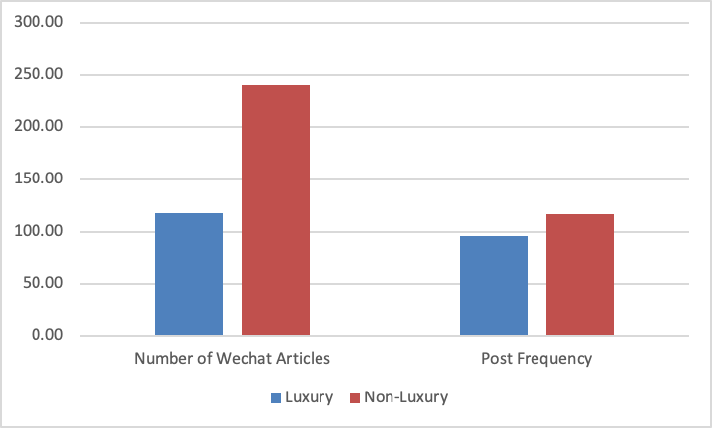
Figure 2
Number of Articles Posted on Each Date of the Week From Jan. 2019 to Nov. 2020
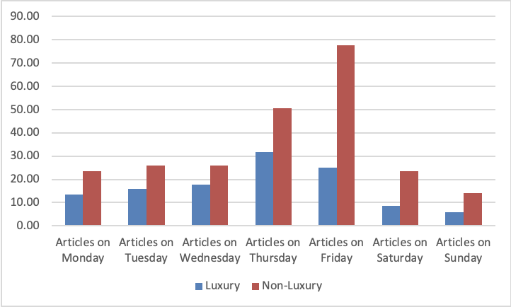

Figure 3
Percentage of Articles Posted on Each Date of the Week From Jan. 2019 to Nov. 2020
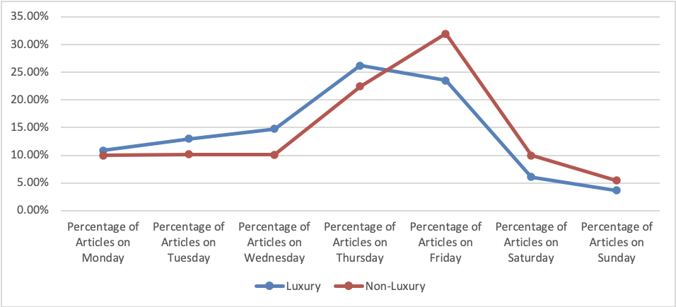
Figure 4
Number of Times Each Article Posted From Jan. 2019 to Nov. 2020
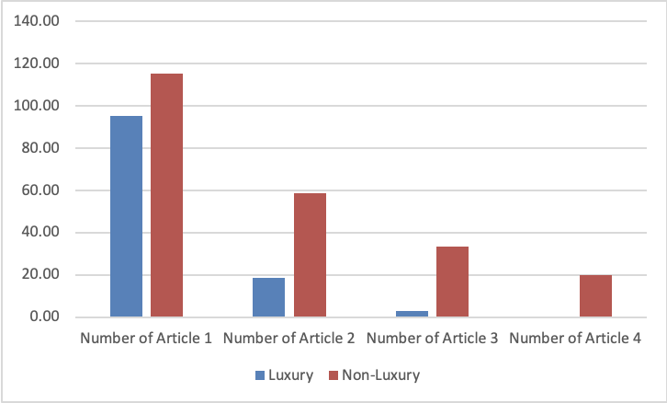

Figure 5
Percentage of Number of Articles Posted Per Time From Jan. 2019 to Nov. 2020
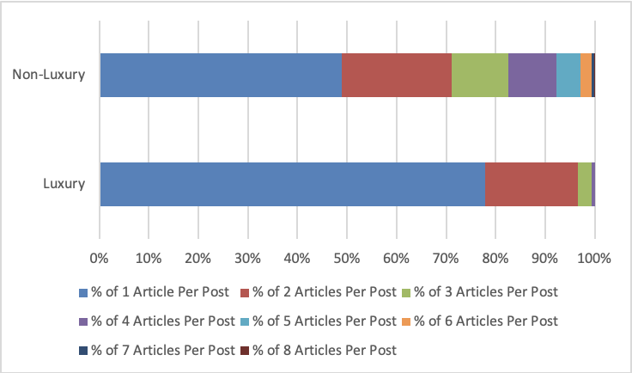
Figure 6
Average Word and Image Count of Each Article From Jan. 2019 to Nov. 2020
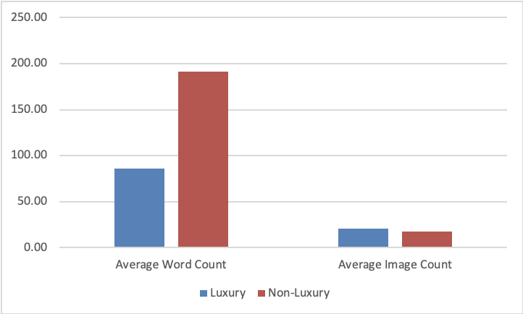

Figure 7
Average Video and Audio Count of Each Article From Jan. 2019 to Nov. 2020
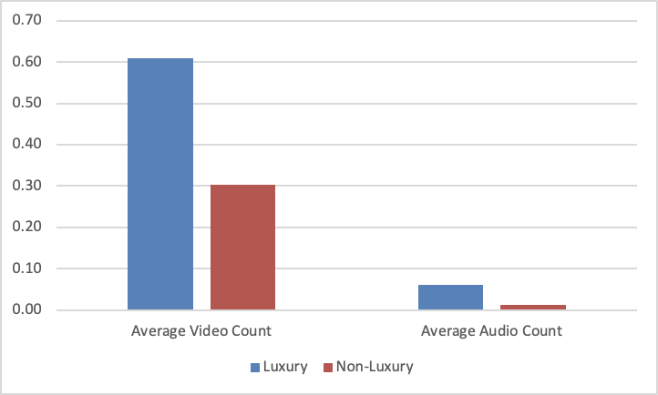
Figure 8
Average Number of Likes and WoWs of Each Article From Jan. 2019 to Nov. 2020
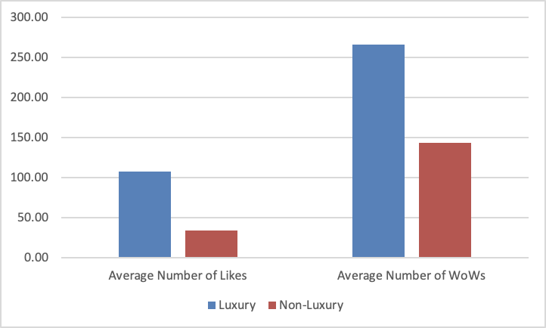

Figure 9
Number and Percentage of Localized Content From Jan. 2019 to Nov. 2020
