The Effect of Environmental Regulation on
Financial Performance of Chinese SOEs

by

Micah Snow

An honors thesis submitted in partial fulfillment

of the requirements for the degree of

Bachelor of Science

Business and Economics Honors Program

NYU Shanghai

May 2022

Professor Marti G. Subrahmanyam Professor Jeffery Wurgler
Professor Christina Wang
Professor Wendy Jin

Faculty Advisers Thesis Adviser

Table of Contents

Abstract 3

Literature Review 4

A. State-Owned Enterprises 4

B. “Bootleggers and Baptists” Regulatory Theory 7

Hypothesis 8

Focus Time Period, Region, and Industry 9
Empirical Design & Results 14
Conclusion and Limitations of this study 22
References 24
Acknowledgement 26

Abstract

In this paper, I will examine the economic effect of the implementation of China’s 2014 2014 revision to its “New Environmental Regulation” on chemical manufacturing companies in Shandong, China. Building on previous theories of economy regulatory theory and corporate governance, this study attempts to prove that the cost of complying with the regulation led to a better financial performance for state-owned enterprises (SOEs) whereas non-SOE companies saw a drop in financial performance. This is because the considerable size, bureaucratic power, and ready access to credit that SOEs boast gives them a natural shield against these types of external shocks. This phenomenon can be seen as an example of the concept of “Bootleggers and Baptists”, an old theory in regulatory economics. The theory states that regulations are often supported both by groups who desire the regulations to work successfully and groups that can profit by undermining the regulations. This theory has been used in the past to study the behavior of firms reacting to environmental regulation. Similarly, the state-owned enterprises in my study support the legislation because they have no choice, but also because their size and advantageous access to credit from state-run financial institutions shields them from the real cost of implementing the regulations. To study this, I collect financial data on a selection of chemical manufacturing companies from Shandong, China during the 2012-2022 timeframe. This paper offers a case study of the impact of these environmental regulations on companies with differing corporate ownership structures.

Keywords: State-owned enterprises, Environmental Regulations, Regulatory Theory

Literature Review
A. State-Owned Enterprises
My research builds on previous literature on state-owned enterprises and regulatory economic theories. Literature studying the effect of environmental regulations on profitability of companies is quite extensive. There are two main schools of thought in this field – many economists focus on how complying with environmental regulations can increase the profitability of a firm by triggering innovation and enhancing competitiveness, offsetting the costs of compliance. This so-called “Porter hypothesis” was named after Professor Michael E. Porter, who, with his colleague Claas van der Linde, first advanced this theory in his paper “Toward a New Conception of the Environment-Competitiveness Relationship”. Another school of thought focuses on the costs of compliance for companies, arguing that imposing environmental regulations mostly decreases profitability (Deng 2). Taking an intermediate approach to this question, researchers Deng Xiang and Li Li argue that financial performance under the imposition of environmental regulations depends on the ownership structure and size of the company. They argue that small and medium-sized companies (SMEs) will find it more difficult to bear with the higher costs of the regulations. These firms are more likely to go out of business than the larger firms, which may actually become more competitive after complying with the regulations. In other words, the cost of complying with environmental regulations is a high sunk cost and a barrier to entry for many firms (Deng 4). Even if the new environmental regulations would eventually increase innovation and profitability for a firm, many smaller firms cannot survive the costly transition.
This theory has important implications in the Chinese business world. It is well known that Chinese state-owned companies (SOEs) are frequently larger than their private counterparts and, in many industries, act as domestic monopolies. In 2015, the OECD reported that the central government owned 51,341 SOEs, together valued at USD 29.2011 trillion, and employing approximately 20.2 million people (OECD 8). Taking a simple average, this results in an average valuation of $568.767651 million per SOE (although this ignores some of the distinctions between central SOEs and local SOEs). These companies often have exclusive control over natural resources, government pricing, and asset monopoly (Reforming China’s Monopolies). These factors imply that SOEs have a higher ability to bear the high costs of complying with environmental regulations. They are therefore more likely to survive and thrive a period of regulatory crackdown.
Chinese SOEs also have preferential access to credit at China’s financial institutions. This further protects them against shocks like environmental regulations or the outbreak of COVID-19 in 2020. This is largely because private enterprises are viewed as “riskier” than SOEs since the government is the owner of SOEs and their perceived likelihood of failing is low. They are also viewed as necessary in achieving authorities’ policy objectives (Bunny 91). Private companies, on the other hand, are usually smaller and rely more on exports, so they are more exposed to downturns in global trade. Access to credit is therefore severely restricted for private companies in China. One clear indicator of this is implied interest rates based on assessments of cost and availability of bank credit:
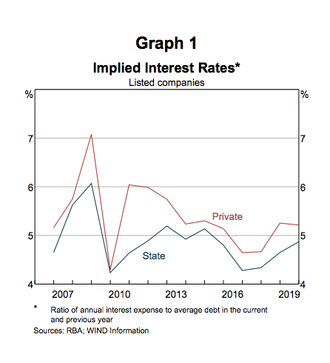
As the graph indicates, there was a tightening of credit that occurred in the 2017-2019 timeframe. As I will discuss later, this trend had clear consequences for the industry in question.
There are various forms of state-owned companies represented, including “local” state-owned companies (地方国有企业) and “central” state-owned companies (中央国有企业). “Local” state-owned companies are overseen by the regulatory agencies of the province where they are located, while “central” state-owned companies are most principally overseen by the central government. Specifically, local SOEs are under the control of the State-Owned Assets Supervision and Administration Commission of Local Governments (SASAC-LG) or other units of local governments. Central SOEs, on the other hand, are under the control of the Ministry of Finance and the State-Owned Assets Supervision and Administration Commission of the State Council (SASAC-SC). One study addressed how this “ownership-innovation nexus” affects innovation and financial performance for different corporate structures. The study found that central SOEs outperform local SOEs and private peers in “innovation creation”, and that this is especially the case for firms with more ESG practices (Lin et al 3). Central SOEs are strongly motivated to engage in innovation creation because their role is to act as the central government’s national policy instruments. Local SOEs, on the other hand, are more profit-driven and innovate primarily for the purpose of promoting local economic development and policy objectives (Lin et al 4). Central SOEs are therefore more motivated to implement the environmental regulations into their businesses than local SOEs. However, the event that my study focuses on, the revision of the New Environmental Protection Law (NEPL) in 2014, emphasized the participation of local governments in the implementation of environmental standards and imposed harsher punishments on officials if they did not comply (Deng 3). The revised NEPL advanced a more expansive and ambitious environmental agenda that required local SOEs to participate. In my study, I will examine whether there remains a significant difference in operational costs (and thereby, financial performance) between the local and central SOEs in the chemical manufacturing industry. I will test whether or not the local SOEs incurred more costs and performed worse than state-owned SOEs.
B. “Bootleggers and Baptists” Regulatory Theory
This study contributes to the general literature of an old principle in economic regulatory theory called “Bootleggers and Baptists”. This theory was first proposed by economist Bruce Yandle who examined the case of prohibition in 1920s America. During prohibition, laws requiring liquor stores to close on Sunday were supported by both alcohol bootleggers and anti-alcohol Baptists. The bootleggers supported the laws because they could eliminate competition for their alcohol on Sundays, while the Baptists supported the laws because they actually disapproved of alcohol use. The theory purports that regulations are often supported by “groups that want the ostensible purpose of the regulation, and by groups that profit from undermining that purpose” (McChesney). When these two groups form a coalition and lobby for a new regulation to this effect, the law becomes easier to administer but may have an anticompetitive effect. This theory has been used in the past to examine the behavior of political groups lobbying for environmental regulations. Yandle himself mentions the example of the “Clean Air Act”: according to the 1977 legislation, expensive “scrubbers” were required to be installed at all newly constructed coal-fired electric plants, regardless of whether or not the plant burned any coal. This measure was supported both by environmentalists and high-sulfur coal production plants. Forcing all firms to implement this costly measure gave high-sulfur coal plants a competitive advantage (Yandle 6).
I believe that this theory is applicable to the current economic regulations in China. The state-owned enterprises support the legislation because they have no choice, but also because their size and advantageous access to credit from state-run financial institutions shields them from the real cost of implementing the regulations. While the environmental situation in China undoubtedly needs to change, this method of implementation could lead to further consolidation of state-owned enterprises in the Chinese economy.
Hypothesis:
Based on Deng Xiang’s research on the high sunk costs of compliance with environmental regulations and research on the significant advantages that SOEs hold in China, I hypothesize that the implementation of the New Environmental Protection Law between 2014 and 2019 resulted in a poor financial performance for the private firms and a better financial performance for the state-owned enterprises (SOEs). To test this hypothesis, I examine the case of chemical manufacturing companies in Shandong province, China. This trend is an example of the “Bootleggers and Baptists” regulatory theory because government-run companies are complying with the environmental regulations knowing that they can survive. I additionally hypothesize that centrally owned SOEs performed better than local SOEs because they bore lower costs of compliance. Financial performance will be measured with a variety of metrics, including Operating Income and Operating Profit Ratios. Other metrics may also be included as the study progresses.
Focus Time Period, Region, and Industry
To narrow the scope of my study, I chose to focus on the financial performance of chemical manufacturing companies in Shandong province after the implementation of the New Environmental Protection Law in 2014-2015. The New Environmental Protection Law was the first major revision of its general Environmental Protection Law and went into place on the 1st of January 2015. The legislation was a watershed moment for environmental regulations in China as it enforced the strictest enforcement measures to date. There was no longer any tolerance for firms guilty of dumping waste, exceeding mandatory emissions caps, or tampering with monitoring equipment. Companies that did not comply with regulators’ suggestions were fined on a daily basis, instead of incurring a one-time fee for the infraction. The law also increased the ability of ordinary citizens to act as plaintiffs in litigation against polluting companies. (Zhang).
What truly distinguished this regulation was its strict and widespread enforcement. The government’s crackdown on cases environmental offenses escalated throughout the 2014-2019 time period, particularly during 2017. Chinese firms accused of violating environmental regulations paid fines totaling 1.02 billion yuan ($154 million USD) in the first 10 months of 2017, a 48% increase from 2016 (Reuters). Local governments were more incentivized to participate than in the past as officials faced tougher penalties (including demotion or dismissal) if they were found responsible for a failure to meet pollution targets. In 2016, at least 1,140 government officials were in some way “held to account” for violating environmental rules and regulations, although most only received a formal reprimand (Reuters). This demonstrates that many local SOEs were forced to comply with the regulations, perhaps for the first time.
The chemical manufacturing industry is an ideal choice for this study because the industry has maintained a relatively balanced mix of state-owned and private enterprises. Choosing an industry already completely dominated by state-owned enterprises would be problematic because private companies in these fields would already face incredibly high barriers to entry. As the following pie chart demonstrates, the majority of state-owned enterprises in China are in finance, transportation, and the primary sectors.
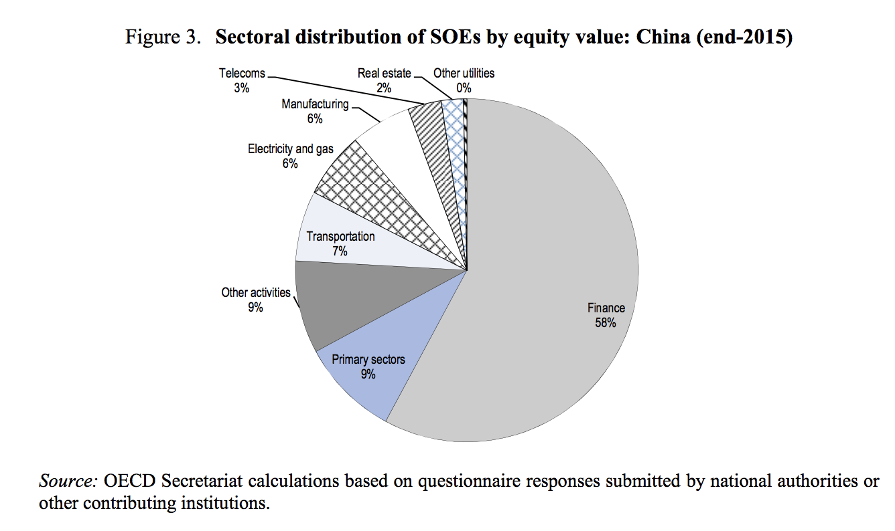
A recent report from IBISWorld on the Organic Chemical Manufacturing industry in China identified that state-owned enterprises currently make up 15.0% of the industry, while private enterprises account for 21.7% of the industry (Organic Chemical Material 12). This trend holds for the chemical manufacturing industry as a whole. The mix of SMEs and SOEs makes this industry ideal for this study. Chemical manufacturing also naturally leads to high levels of pollution due to the nature of the industry. This is a necessary component of the study as firms facing regulations should face significant costs of compliance.
A few general trends in the chemical manufacturing industry must be taken into consideration. The Chinese chemical manufacturing industry has been the largest in the world since 2011, and the industry will continue to grow in the future, albeit at a slower rate than in the past (McKinsey). However, the industry is making a transition towards specialty-chemicals and chemicals needed for high-tech industries. This is due to China’s gradual shift from an industry-driven economy to a consumer-demand driven economy. Specialty chemicals used in products like specialty surfactants and additives, expensive fragrances, and packaging materials will be subject to higher demand in the future. Meanwhile, the Chinese governments’ push for the “Made in China 2025” policy will increase demand for chemicals used in the aerospace, electronics, and electrical vehicle industries (McKinsey). This trend means that companies involved in the production of these chemicals may be more profitable than their peers.
The chemical manufacturing industry has also been subject to China’s new credit tightening that began around 2014, when China’s main bank supervisor announced that investment in “oversupplied” industries would be carefully controls. Chemical manufacturing falls into this category, and banks have begun terminating loans prematurely, refusing to renew loans, and charging chemical companies an above-market-average interest rate. In response, chemical manufacturing companies have cut back on capital expenditures.
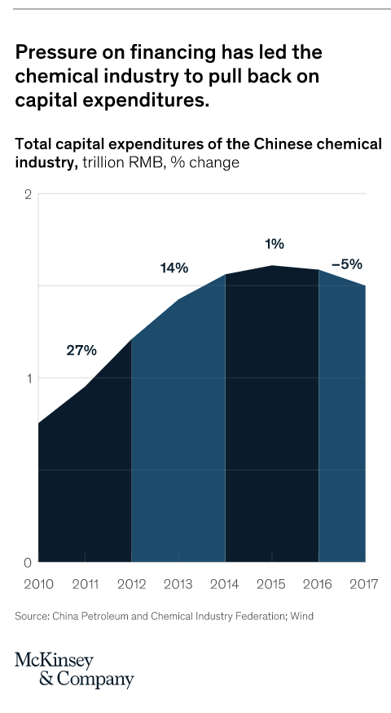
Regulatory agencies have also been cracking down on “shadow banking” practices that private companies often resort to because of their limited access to credit. Chemical manufacturing companies, for example, were engaging in mutual guarantee borrowing schemes where companies could guarantee each other’s loans (McKinsey). This financial tightening puts private chemical manufacturing companies in an extremely difficult situation, which is worsened through the implementation of the environmental regulations.
I chose to focus on the Shandong province because, of the three provinces dominating the chemical manufacturing industry (Shandong, Zhejiang, and Jiangsu), Shandong dealt with the most extreme crackdown in environmental regulations during the 2014-2019 time period. Regulations were already relatively strict in provinces like Zhejiang, Beijing, Shanghai, and Guangdong. Provinces like Hebei, Shandong, Henan, and the northern part of Jiangsu fbexperienced more radical change during this period. The infographic below demonstrates this point, using data from 2016:
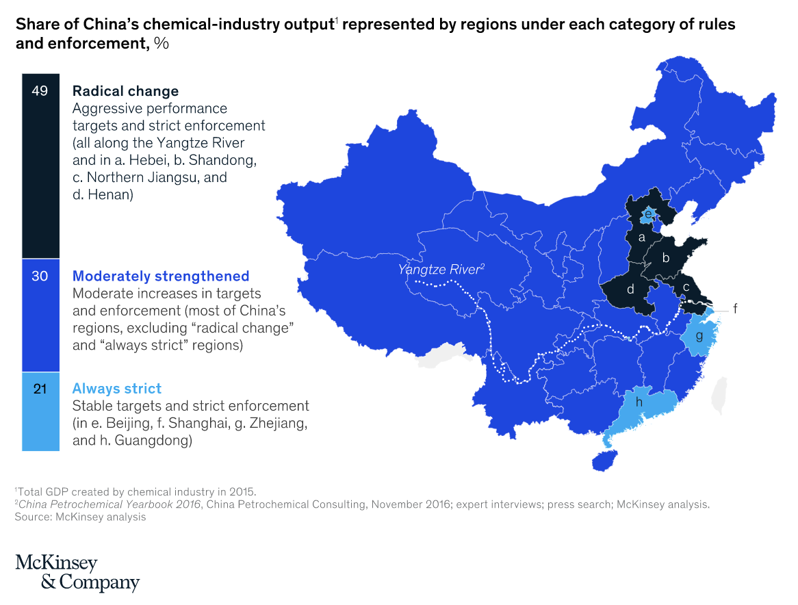
In Shandong province, 25% of all chemical companies were at least temporarily shut down in 2018 by the Chinese regulatory authorities. The effect of the crackdown has been felt most keenly by the smaller, usually privately owned companies in the province (McKinsey). The environmental authorities are expected to continue pushing for further enforcement in the future. This is potentially dangerous for the province as Shandong’s economy is heavily dependent on chemical manufacturing and other resource-oriented “heavy” industries like food processing, oil and coal processing, machinery making, and metals production (The Economist). Part of the economic troubles that Shandong is grappling with is due to their sluggish efforts to adapt to an increasingly consumer-driven economy.
If the results of my study are successful, I may extend my study to run my regression again on chemical manufacturing companies from other provinces like Jiangsu and Zhejiang. If my hypothesis is correct, this trend of SOE consolidation after the implementation of environmental regulations should hold in other provinces as well. However, limiting the scope of my study to one province helps to eliminate some external factors that vary from province to province and would need to be controlled through province-level fixed effects. There are already many external factors that could lead to bias in my results, which I will discuss in the next section.
Empirical Design & Results
The main difficulty of this study was identifying the appropriate data to test my hypothesis. My initial plan for testing this hypothesis was to use various ESG indexes as a measure of compliance with environmental standards (as data on carbon emissions and pollution is completely unavailable). Unfortunately, I soon found that this strategy would be impossible. The use of ESG indexes in China if fairly new and many companies are still not reporting their ESG scores. In the timeframe I am studying (2014-2019), the data on ESG performance is patchy. Additionally, the different indexes are all computed through different methods. They all have different standards for their ranking and the ESG score itself is not incredibly indicative of how well a company is complying (including information on some of the companies from my own dataset).
For this reason, I decided to focus on using metrics of operational cost as the independent variables in my study. My dataset is composed of 43 different Shandong-based companies in the chemical manufacturing industry. I then complied a set of panel data for 2013-2019 on various metrics of profitability, including Operating Income and Gross Profit. If my hypothesis is correct, the increased costs during the time frame studied will lead to a poor financial performance for private firms while state-owned enterprises will actually see their financial performance improve.
The database includes companies with differing corporate ownership structures. This is crucial to my study because my hypothesis focuses on the comparison between state-owned and private enterprises. Among the 43 countries in my dataset, there are two central state-owned companies and 7 local state-owned enterprises. There are also 28 private companies, and the rest are forms of “collective enterprises” (公众企业 and 集体企业). For this study, I excluded the collective enterprises. These companies have a more corporate ownership structure that should be studied independently. After filtering out these collective enterprises, the remaining 41 companies are:
Non-SOEs:
证券代码 | 证券简称 | English Name
300343.SZ | 联创股份 | Lecron Industrial Group Co., Ltd.
002476.SZ | 宝莫股份 | Shandong Polymer Biochemicals Co., Ltd.
600955.SH | 维远股份 | Lihuaiyi Weiyuan Chemical
001207.SZ | 联科科技 | Shandong Link Science and Technology Co., Ltd.
301149.SZ | 隆华新材 | Shandong Longhua New Material Co Ltd.
301069.SZ | 凯盛新材 | Shandong Kaisheng New
301035.SZ | 润丰股份 | Shandong Weifang Rainbow Chemical Co., Ltd.
688087.SH | 英科再生 | Shandong Intco Recycling Resources Co., Ltd.
002470.SZ | ST金正 | Kingenta Ecological Engineering Group Co., Ltd.
002588.SZ | 史丹利 | Stanley Agriculture Group Co.,Ltd.
002408.SZ | 齐翔腾达 | Zibo Qixiang Tengda Chemical Co., Ltd
000677.SZ | 恒天海龙 | CHTC Helon Co., Ltd.
002805.SZ | 丰元股份 | Shandong Fengyuan Chemical Co., Ltd.
300243.SZ | 瑞丰高材 | Shandong Ruifeng Chemical Co., Ltd.
002838.SZ | 道恩股份 | Shandong Dawn Polymer Co.,Ltd.
002768.SZ | 国恩股份 | Qingdao Gon Technology Co., Ltd.
605589.SH | 圣泉集团 | Jinan Shengquan Group Share Holding Co., Ltd.
300848.SZ | 美瑞新材 | Miracll Chemicals Co.,Ltd
002810.SZ | 山东赫达 | Shandong Head Group Co., Ltd.
603639.SH | 海利尔 | Hailir Pesticides and Chemicals Group Co.,Ltd.
300801.SZ | 泰和科技 | Shandong Taihe Water Treatment Technologies Co., Ltd
603086.SH | 先达股份 | Shandong Taihe Water Treatment Technologies Co., Ltd
300121.SZ | 阳谷华泰 | Shandong Yanggu Huatai Chemical Co., Ltd.
300779.SZ | 惠城环保 | Qingdao Huicheng Environmental Technology Co., Ltd.
603217.SH | 元利科技 | Yuanli Chemical Group Co., Ltd.
300821.SZ | 东岳硅材 | Shandong Dongyue Organosilicon Materials Co., Ltd.
300699.SZ | 光威复材 | Weihai Guangwei Composites Co., Ltd.
300285.SZ | 国瓷材料 | Shandong Sinocera Functional Material Co., Ltd.

SOEs (both local and central):
证券代码 | 证券简称 | English Name
600319.SH | *ST亚星 | Weifang Yaxing Chemical Co., Ltd.
002254.SZ | 泰和新材 | Yantai Tayho Advanced Materials Co., Ltd.
300321.SZ | 同大股份 | Shandong Tongda Island New Materials Co.,Ltd.
000822.SZ | 山东海化 | Shandong Haihua Co.,Ltd
000830.SZ | 鲁西化工 | Luxi Chemical Group Co., Ltd.
600727.SH | 鲁北化工 | Shandong Lubei Chemical Co., Ltd.
002643.SZ | 万润股份 | Valiant Co.,Ltd
600309.SH | 万华化学 | Wanhua Chemical Group Co., Ltd.
600426.SH | 华鲁恒升 | Shandong Hualu-Hengsheng Chemical Co., Ltd.

After struggling to access the needed data from Wind Financial Terminal, I turned instead to using Capital IQ. From this platform I collected key metrics on operating expenses, operating income, gross profit, capital expenditures, and return on assets. Ultimately, the most relevant financial metrics that I compiled were related to operating expenses. For each company, I calculated operating expenses as a percentage of total revenue for each quarter. I then took the average of all SOE companies and all non-SOE companies for each quarter. The results are striking – in the 2017-2019 timeframe, the operating expenses (as a percentage of total revenue) increased for the non-SOE companies and decreased for the SOE companies.

According to the anecdotal evidence mentioned in the literature review, the 2017-2019 timeframe saw the most intense crackdown in the environmental regulations. Although there is not enough data available to prove that this trend was caused by the regulatory crackdown, the correlation should at least draw attention to this possibility. The data is suggestive but more research is needed to definitively prove causality. During this same timeframe, the credit tightening policy was also leading to additional financial pressure on chemical manufacturing firms, especially private firms. Disentangling the effects of these two separate trends would require more data on whether or not each company was subjected to the regulations and the amount of funding (if any) they received from financial institutions over time.
To test if the effect of the regulations differed between central and local SOEs, I again scaled operating expenses by dividing by total revenues for each period. There were only two central SOEs in my dataset, so these results are by no means robust. Expanding this study to include chemical manufacturing companies in other provinces would expand the dataset and lead to more robust results.

Although the difference is slighter, it does appear that the average operating expenses as a percentage of revenue were higher for the local SOEs than the central companies in the time period from 2017-2019. However, the data is too noisy to either confirm or deny the hypothesis that local SOEs bear higher costs of compliance than central SOEs.
Looking more closely at the operating expenses of each of the non-SOE companies, we see that the greatest increases in operating expenses occurred for two companies: Zibo Qixiang Tengda Chemical Co., Ltd and Kingenta Ecological Engineering Group Co., Ltd.

Similarly, with the SOE companies, Wanhua Chemical Group, Co. Ltd. is the largest outlier. Wanhua is one of the largest firms in China’s chemical manufacturing industry and is the largest in my dataset with a market capitalization of 306,125,296,035 RMB (as of February 2022). Wanhua is classified as a local SOE and may be partly responsible for the rise in operational expenses for local SOEs in the timeframe studied.

Conclusion and Limitations of this study:
This study has been most severely inhibited by the limited data available. For example, the dataset is composed only of companies publicly listed on either the Shenzhen or Shanghai stock exchange. The effect of environmental regulations would obviously be much greater for smaller companies that are not yet publicly listed, but there is no accessible data on these firms. Another serious limitation of this study is the lack of information about whether each specific company was subject to review by the regulatory agencies enforcing the new environmental regulations. Measuring compliance with the regulation via operational costs is extremely indirect. The categorization of different firms as “private” and “state-owned” is also an imperfect metric. The “collective” enterprises that I omitted, for example, have a more complex corporate ownership structure that may have been affected differently by the regulations. Finally, there are many particular circumstances specific to each company that may affect costs and profitability. Controlling for all these individual circumstances would require more data on each company.
Despite the limitations in the data available, this study contributes to the existing literature by offering a micro-level case study of wider trends occurring in China during this time period. My study was unable to definitively establish the link of causality between environmental regulations and lower financial performance for these chemical manufacturing companies. However, the rise in operating expenses for the companies in my study does coincide with qualitative reports of the regulatory crackdown occurring between 2017 and 2019. It also coincides with the extreme credit tightening that had especially harsh consequences on non-SOE firms. Further research into this topic may be able to reconcile financial data with the anecdotal, qualitative reports being published on the consequences of environmental regulations.

References:
Bunny, Matthew. “Private Sector Financial Conditions in China: Bulletin – September Quarter 2020.” Reserve Bank of Australia, Reserve Bank of Australia, 17 Sept. 2020, https://www.rba.gov.au/publications/bulletin/2020/sep/private-sector-financial-conditions-in-china.html.
Deng, Xiang, and Li Li. “Promoting or Inhibiting? The Impact of Environmental Regulation on
Corporate Financial Performance-An Empirical Analysis Based on China.” International journal of environmental research and public health vol. 17,11 3828. 28 May. 2020, doi:10.3390/ijerph17113828
Hong, Sheng, et al. “China's Chemical Industry: New Strategies for a New Era.” McKinsey & Company, McKinsey & Company, 25 Mar. 2019, https://www.mckinsey.com/industries/chemicals/our-insights/chinas-chemical-industry-new-strategies-for-a-new-era.
Lin, Y., Fu, X., & Fu, X. (2021, February 27). Varieties in state capitalism and corporate innovation: Evidence from an emerging economy. Journal of Corporate Finance. Retrieved January 13, 2022, from https://www.sciencedirect.com/science/article/abs/pii/S0929119921000407
McChesney, Fred S. (1997). Money for nothing: politicians, rent extraction, and political
extortion. Cambridge, Massachusetts: Harvard University Press. ISBN 9780674583306.
OECD (2017), The Size and Sectoral Distribution of State-Owned Enterprises, OECD
Publishing, Paris, https://doi-org.proxy.library.nyu.edu/10.1787/9789264280663-en.
Reforming China’s Monopolies. https://www.hks.harvard.edu/publications/reforming-chinas-
monopolies. Accessed 29 Oct. 2021.
Stanway, David. “China Fines for Environmental Violations up 48 Percent from Jan-Oct: Ministry.” Edited by Richard Pullin, Reuters, Thomson Reuters, 6 Dec. 2017, https://www.reuters.com/article/us-china-environment/china-fines-for-environmental-violations-up-48-percent-from-jan-oct-ministry-idUSKBN1E0089.
Yandle, Bruce. “Bootleggers and Baptists in Retrospect.” Regulation, vol. 22, no. 3, Jan. 1999,
pp. 5–7. EBSCOhost, https://search-ebscohost-com.proxy.library.nyu.edu/login.aspx?direct=true&db=edshol&AN=edshol.hein.journals.rcatorbg22.31&site=eds-live.
Zhang, Laney. “China: Environmental Protection Law Revised.” The Library of Congress,
https://www.loc.gov/item/global-legal-monitor/2014-06-06/china-environmental-protection-law-revised/#:~:text=Article%20China%3A%20Environmental%20Protection%20Law,effect%20on%20January%201%2C%202015.&text=The%20original%2047%2Darticle%20Environmental,been%20expanded%20to%2070%20articles.

Acknowledgement:
I would like to first thank my advisor, Professor Jeffery Wurgler, for his help and encouragement with this project, particularly in deciding how to work with a limited amount of data. I also wish to thank Professor Nan Xu for her advice on how to narrow down the scope of my study to a specific region and industry. Additionally, collaborating my peers within the Business and Economics Honors Program was an invaluable experience this year. I am grateful to my friends Sachi Shetty and Lawrence (Xuyou) Zhang for their support.

Bunny, Matthew. “Private Sector Financial Conditions in China: Bulletin – September Quarter 2020.” Reserve Bank of Australia, Reserve Bank of Australia, 17 Sept. 2020, https://www.rba.gov.au/publications/bulletin/2020/sep/private-sector-financial-conditions-in-china.html.
OECD (2017), The Size and Sectoral Distribution of State-Owned Enterprises, OECD Publishing, Paris, https://doi-org.proxy.library.nyu.edu/10.1787/9789264280663-en.
McKinsey: https://www.mckinsey.com/industries/chemicals/our-insights/chinas-chemical-industry-new-strategies-for-a-new-era
McKinsey: https://www.mckinsey.com/industries/chemicals/our-insights/chinas-chemical-industry-new-strategies-for-a-new-era

