Transportation Costs
of International Trade in COVID-19

by

Muyang Zhang

An honors thesis submitted in partial fulfillment

of the requirements for the degree of

Bachelor of Science

Business and Economics Honors Program

NYU Shanghai

May 2023

Professor Marti G. Subrahmanyam Professor Lawrence White
Professor Christina Wang
Professor Wendy Jin

Faculty Advisers Thesis Adviser

Table of Contents

Abstract 3
Introduction 4
I. Inland transportation 6

Phenomenon

Reasons
II. International transportation 15

Phenomenon

Reasons

III. Specific Example 36

IV. Some possible precautions 37
References 40
Acknowledgments 41

Abstract

My paper is dedicated to investigating how COVID-19 has affected international trade, especially international transportation costs. I divide the international trade transportation process into two parts: domestic (China) and international. Domestically, I focus on analyzing how trucks, the main mode of transportation in China, were restricted during the epidemic. Since China's epidemic policies were much stricter than those of other countries, this paper quantifies the negative correlation between policy and truck traffic and how truckers were affected. Internationally, I dissect the causes of rising transportation costs in terms of supply-demand mismatches, labor allocation challenges, declining international punctuality, and world supply chain shifts.
Following the macro analysis, I analyze the impact of the epidemic on individual companies from a micro perspective using data from a Chinese international zipper company. I conclude my paper with some possible preventive measures that I hope will help companies, especially those that rely on transportation, improve their risk control capabilities.

Keywords: International Trade, COVID-19, Transportation Cost

Introduction

Transportation costs are a critical factor for international companies that engage in importing and exporting goods. These costs affect the price of products and, therefore, directly impact the company's profitability. By reducing transportation costs, companies can improve their competitiveness in the global market, provide better customer satisfaction, optimize their supply chain efficiency, and manage risks better.
Transportation costs directly affect the competitiveness of products in the global market. Companies that can offer lower prices due to reduced transportation costs are more likely to be competitive in the market. Additionally, transportation costs reflect the delivery time and reliability of shipments, and any delays can affect customer satisfaction. Therefore, companies that can optimize their transportation costs and reduce transit times can better manage their inventory, reduce lead times, and improve overall efficiency.
Furthermore, transportation costs can also affect the risk management strategy of a company. For instance, a company that relies on a single mode of transportation or a specific carrier may be more exposed to risks such as delays, strikes, or other disruptions. Therefore, it is essential to diversify transportation modes and carriers to reduce the risks associated with transportation.
Unfortunately, the COVID-19 pandemic had a significant impact on transportation costs for international companies. The pandemic caused disruptions in the global supply chain, with factories and logistics operations shutting down temporarily, resulting in a shortage of shipping containers and a reduction in air and sea freight capacity. As a result, transportation costs for international companies surged due to a combination of factors such as port congestion, equipment shortages, and increased demand for shipping.
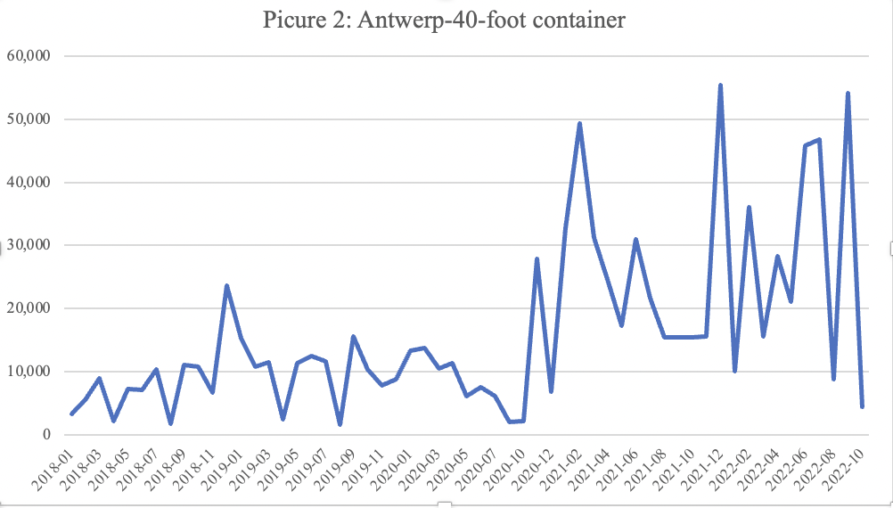
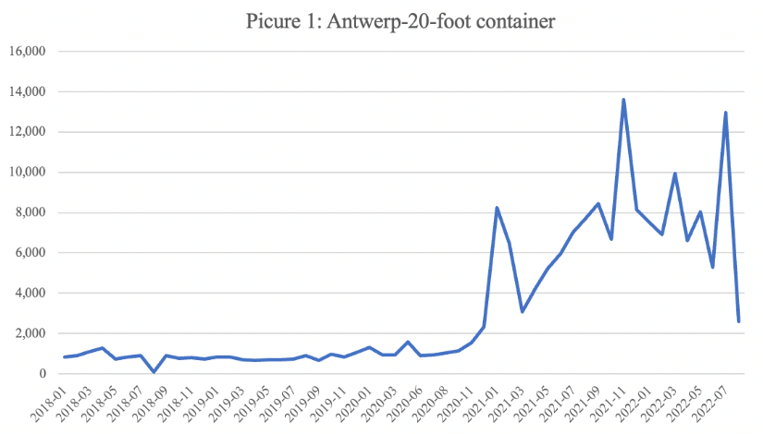
For example, the cost of air freight increased significantly due to the decrease in passenger flights, which led to a reduction in cargo capacity. This shortage of air cargo capacity caused air freight rates to skyrocket, reaching historic highs in some cases. Similarly, the ocean freight market experienced significant disruptions, with rates increasing due to the shortage of containers and available sailings. As a result, international companies were faced with higher transportation costs, which in turn, affected their bottom line. The six figures below are from Sinotrans Limited, also known as Sinotrans, which is one of the largest logistics companies in China. They recorded the freight cost (USD) / per container - median of two sizes of containers exported from China to three of the world's leading ports. It is clear that, apart from individual differences, there is a substantial overall increase and high volatility in international transport costs from the end of 2020 to the beginning of 2022.
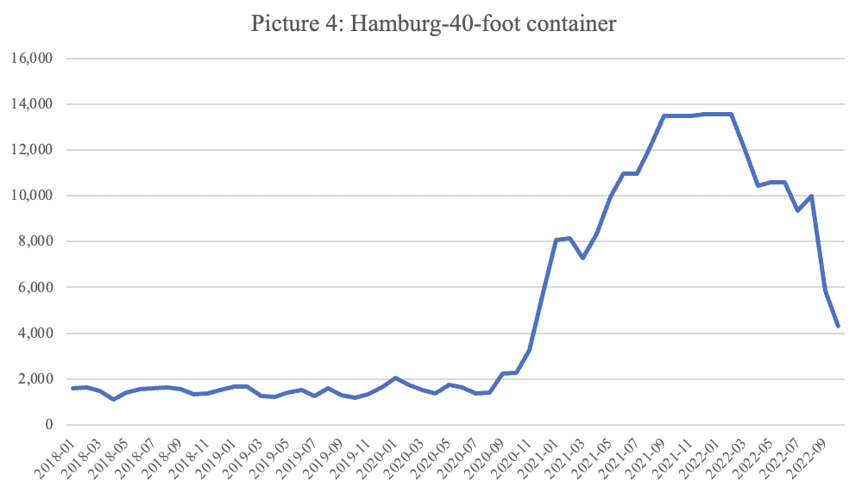
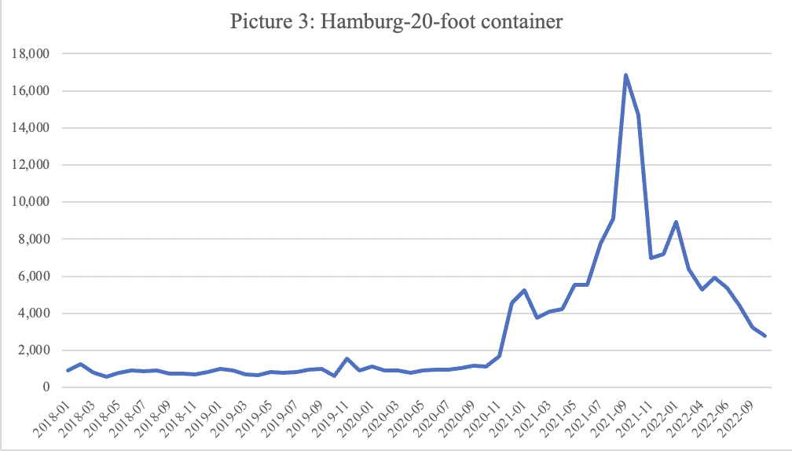
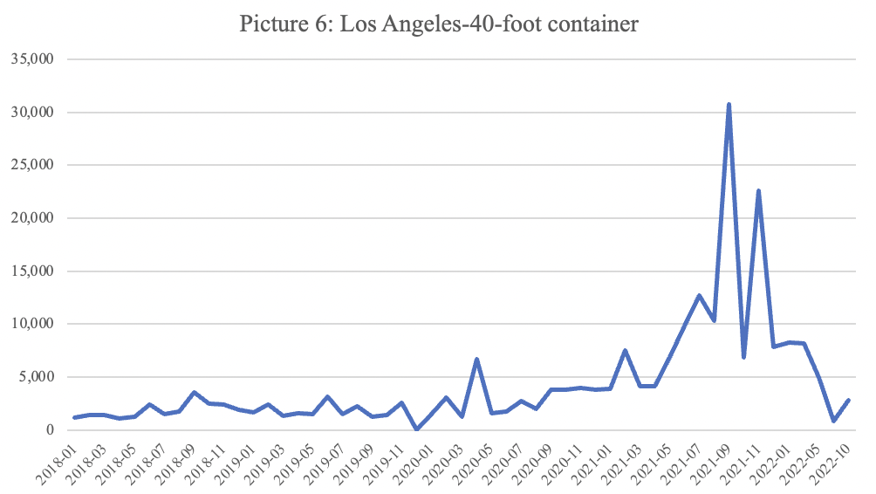
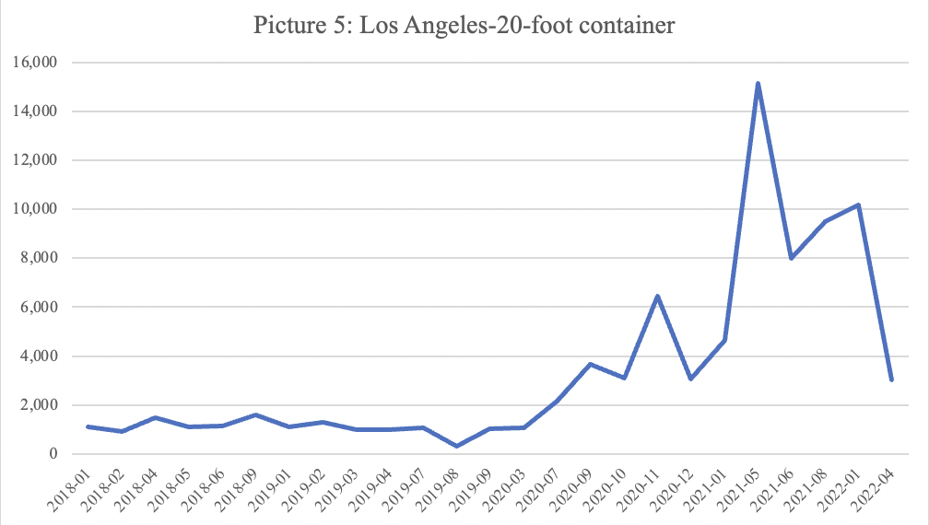

Therefore, this study divides international transportation into domestic and foreign parts and is dedicated to uncovering and analyzing the factors that affect transportation costs. It is hoped that this will provide assistance to international companies involved in importing and exporting products. When the next “black swan” event comes, they may be able to control the rising transportation costs better and avoid unnecessary losses.

I. Inland transportation

Phenomenon

The outbreak of Covid-19 led to an increase in inland transportation costs.

Reasons
Trucking, a significant mode of transportation in inland China, has been severely affected by the epidemic, resulting in higher inland freight rates. Lockdowns and restrictions on movement led to a shortage of truck drivers and increased demand for certain goods, which drove up transportation costs. Additionally, the implementation of health and safety measures, such as social distancing and sanitization, increased the operational costs for transportation providers. In this section, I would like to discuss the challenges and consequences of the epidemic on transportation from four perspectives.
    - Three-quarters of truck drivers were not on the job because of the lockdown
The "China Truck Driver Survey" team of Chuanhua Charity Foundation conducted an electronic questionnaire survey among truck drivers in 28 provinces and cities from 16:00 on February 23 to 16:00 on February 25, 2020, and received 2,742 valid questionnaires. According to the survey, 75.4% of truck drivers stopped working after the outbreak, 18.2% worked "sometimes," and only 6.4% worked "all the time."
This situation is closely connected to China's lockdown policy during the initial phase of the COVID-19 outbreak. After the first outbreak in Wuhan, the Chinese government enforced prevention and control measures, which involved a lockdown of most cities in Hubei province, including the capital city Wuhan. These strict measures were successful, and by April 2020, new cases of COVID-19 had significantly reduced. Consequently, the Chinese authorities have formulated a set of policies, commonly known as the zero-COVID policy, to achieve zero local transmission of COVID-19 cases.
China's zero-COVID policy relies mainly on non-pharmaceutical interventions such as isolation, contact tracing, and testing. Its most notable characteristic is its commitment to imposing stringent lockdown measures to contain even the mildest localized outbreaks. According to a paper by professors Jingjing Chen, Wei Chen, Ernest Liu, Jie Luo, and Zheng (Michael) Song, titled "The Economic Cost of Locking down like China: Evidence from City-to-City Truck Flows∗," they summarize China's epidemic policy based on official explanatory documents:
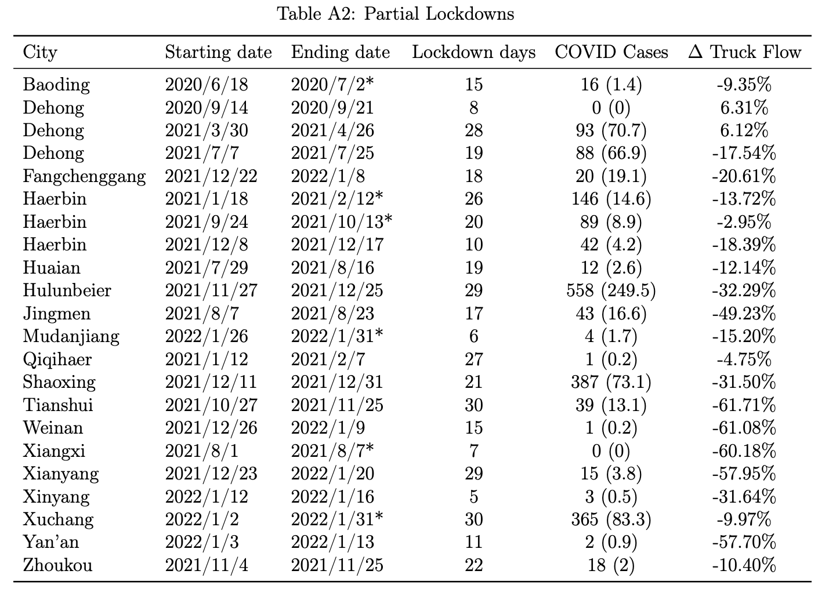
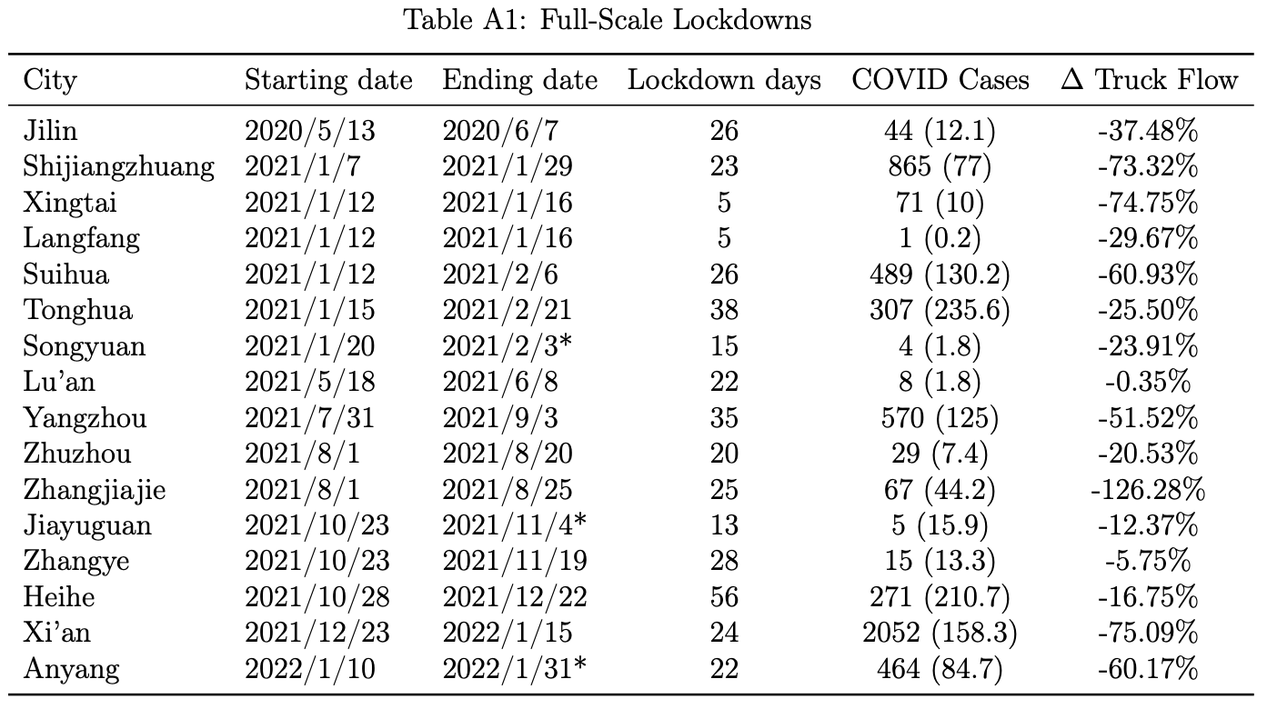
The Chinese government starts its embargo within communities. Communities with ten or fewer positive COVID cases within the past 14 days are classified as "medium risk," while those with more than ten are classified as "high risk." Both medium-risk and high-risk areas are locked down, and residents must stay at home and undergo multiple tests. Vehicles are only allowed to enter these areas if they are carrying essential items. Even if no cases have been reported elsewhere in the area, the county or district to which the affected community belongs is also affected. Controlled areas are subjected to restrictions that are similar to a lockdown, and residents are only allowed to leave their homes once every two or three days to purchase essential items. Communities outside of closed and controlled areas are guarded, and residents cannot leave unless it is necessary, such as for medical treatment, which requires a negative test result within 48 hours. Other measures, such as encouraging remote work, limiting gatherings, closing indoor public spaces, and restricting restaurant dining, are implemented in cordoned-off areas. Such stringent controls prevented truckers from working outside, resulting in a decrease in truck traffic. Table A1, Table A2 and the graph below show the negative effect of lock downs on and truck traffic.
Note: The date marked with an asterisk (*) is deduced from the fact that the lockdown had already ceased seven days before the "clearance" day or the conclusion of the sampling period (January 31, 2022). Note that the number in parentheses in the COVID Cases column stands for "average number of new cases per million people"
Source："The Economic Cost of Locking down like China: Evidence from City-to-City Truck Flows∗ " by Professors Jingjing Chen, Wei Chen, Ernest Liu, Jie Luo, and Zheng (Michael) Song
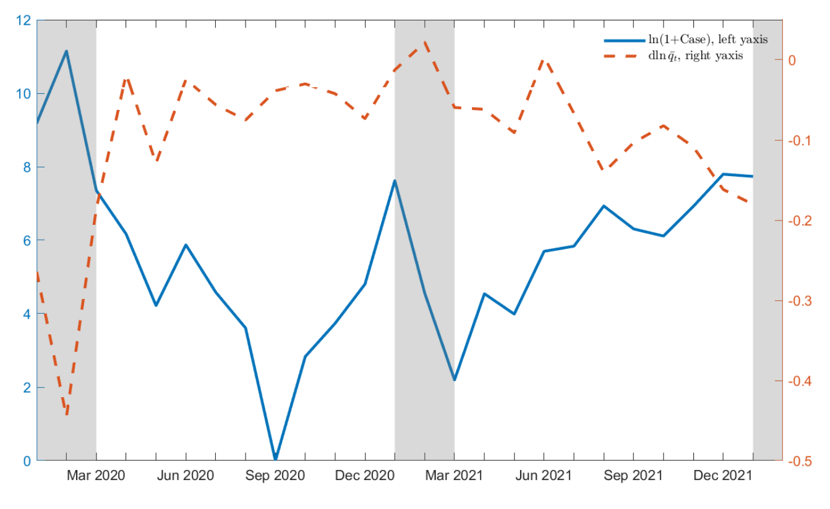
New COVID Cases and Total Truck Flow Change
Note: On the left axis, the solid line indicates the logarithm of new COVID cases reported monthly, while the dashed line (on the right axis) shows the overall detrended alteration in truck flow. The grey shaded regions correspond to the first quarter, and the data lines indicate the cities included in the two tables.
Source："The Economic Cost of Locking down like China: Evidence from City-to-City Truck Flows∗ " by Professors Jingjing Chen, Wei Chen, Ernest Liu, Jie Luo, and Zheng (Michael) Song
    - Some of the drivers who could work were diverted to deliver epidemic prevention supplies
After the epidemic outbreak, a large amount of epidemic prevention materials were needed in various places, which means that truck drivers needed to participate in transporting epidemic prevention materials. According to the "2020 China Truck Driver Survey, " as shown in the chart below, 53.1% of truck drivers had pulled 1-2 trips of epidemic prevention materials after the outbreak. 21.8% had pulled 3-4 trips of epidemic prevention materials, and 25.2% had pulled 5 or more. Some of these drivers were eager to support the suffering areas and contribute to the fight against the epidemic. Some of them obeyed the arrangements of the charity organizations and government departments they worked for. In either case, the resources of drivers left for international companies became very limited, and it was difficult for cargo to be delivered to ports or airports in time.
Drivers participating in the transportation of epidemic supplies

Source: 2020 China Truck Driver Survey
    - The driver's working conditions are exceptionally difficult
Following the epidemic outbreak, truck drivers' health, lives and livelihoods have been adversely affected. China has about 20 million truck drivers, responsible for about 70 percent of the country's freight traffic. Truck drivers travel between cities, transporting essential goods necessary for both daily life and production. As they come into contact with many people and surfaces, they are at high risk of contracting and spreading infections. Therefore, they are a primary target for prevention and control measures in every city. Despite their crucial role in maintaining the flow of goods and services, their well-being and livelihood needs are often overlooked by cities. Several cities have policies that require drivers not to get out of their vehicles while unloading and only after they have left the city. Seals must be posted at the doors on both sides of the vehicle's cab. Anyone with a broken seal in the territory will not be allowed to leave. Drivers had to eat, drink and sleep in their vehicles in order to be able to continue working, or to avoid infecting their families.
Poor food and accommodation aggravate the health burden of drivers. In June 2022, the China Federation of Logistics and Purchasing released the "2021 truck driver survey report," showing that the proportion of "occupational diseases" such as stomach disease, hypertension, and cervical spondylosis due to driving a truck is as high as 86.5%. In some cases, the epidemic will make it difficult for drivers to get timely treatment. On March 31, 2022, a truck driver trapped in a highway service area in Jilin Songyuan City died of a sudden illness. At that time, restaurants and infirmaries in the service area were prohibited from operating. The driver lived in the car and had to rely on living supplies such as instant noodles. Following the event, the local authorities let the truck drivers who were stuck at the service area to proceed to a designated hotel for centralized quarantine. The drivers who did not accept the quarantine had to sign an agreement with the service area, stating that the accident had nothing to do with the service area.
To avoid difficulties caused by epidemic prevention policies, drivers may conceal tracks or tests. However, such behavior is considered illegal and is often condemned by the law and the public. On March 31 2022, the Liaoning Provincial Public Security Department announced that it had cumulatively investigated and imposed penalties on nearly 100 large truck drivers who concealed their trip traces and evaded epidemic prevention inspections. In April, a Shanxi AV studio owner was reported to have falsified 621 nucleic acid test reports for 252 coal truck drivers and was sentenced to one year and six months in prison.
As a result of these circumstances, the already hard-working truck drivers faced severe threats to their lives and health during the outbreak. As a result, many drivers became hesitant to continue in this profession. Roger W. Ferguson Jr. and Upamanyu Lahiri of the Council on Foreign Relations (CFR) write, "Many of these drivers prefer to work in factories, construction sites and warehouses that offer similar wages but without the long hours and harsh working conditions."
Difficulties faced by truck drivers

Source: 2020 China Truck Driver Survey
    - Restrictions on nucleic acid test certificates, trip codes and car license plates
Starting in 2020, almost all cities required 48-hour nucleic acid test certificates and green trip codes for truck drivers traveling across the provinces, and some places even required 24-hour nucleic acid test certificates. However, it takes about 6 or even 10 hours to get the nucleic acid test results, which means the mobility of truck drivers is greatly reduced. Even if the nucleic acid test is done, the trip code with a star (which means passing through a medium to high-risk area) will make the driver unable to pass. According to the questionnaire survey of 1,801 truck drivers conducted by the China Truck Driver Research Group, 60% of drivers currently have a trip code with a star. Since the stars do not disappear until after 14 days or after the downgrading of medium and high-risk areas, and trucks are constantly moving, there is often a problem that one star disappears and another one appears.
To further complicate matters, many areas only recognize the "pass" in addition to the nucleic acid certificate and the green trip code. "Pass" is a paper document that requires the truck driver to go to the traffic police to apply. However, there are many difficulties in applying for a pass:
1. Many places where truck drivers can apply for a pass are prohibited areas for trucks, requiring people to drive a private car or take a taxi to get there;
2. Passes can only be applied for during the working hours of the traffic police;
3. Many traffic police teams only open one service window for the pass, and drivers have to queue for a long time;
4. In addition to individual truck drivers, fleets take longer to apply for a pass because each permit has to fill in much data manually;
5. It is tough to apply for a pass for trucks with uncertain unloading destinations;
6. Some counties also have regulations on truck traffic restrictions. However, there is not even a window for the application of truck passes, so trucks without passes can only accept tickets after being found.
Drivers without a pass risked being strained on the highway for long periods. According to a survey by China Labor Bulletin, about half of truckers were stranded on the road between one and three times in March 2022, and 8 percent were stranded more than ten times. 9.4 percent reported being stranded for up to seven days or more at a time.
In addition to the restrictions on drivers, restrictions on car license plates are also known as a major challenge. Cars that have been to high-risk areas are not allowed to enter a low-risk city. For example, after an outbreak in Shanghai in the summer of 2022, the Shanghai drivers could not enter other cities even after they presented a green trip card, a negative nucleic acid report, and vaccination records. As long as they had Shanghai license plates, they were not given access. This greatly limits the available vehicles.
    - Conclusion
Overall, China's strict policies have controlled the outbreak but severely hampered domestic transportation. Restrictions on truck drivers have left a shortage of transportation labor and led to rising inland transportation cost. At the same time, international shipping costs have started to rise rapidly, as will be discussed in detail in the second part of the study.

II. International transportation

Phenomenon
With the epidemic easing in Europe and the United States, the import demand was rapidly picking up. However, both Chinese and European/American ports were facing insufficient handling capacity, resulting in a backlog of many containers at the ports. Overseas empty container turnover and return was generally slow. Shipping capacity was tight, and freight rates has been continuously rising since September 2020, only beginning to decrease in January 2022. Below is the chart of China Containerized Freight Index (CCFI), which is a relative number reflecting the trend and degree of change in the price of containerized cargo transported for export from Chinese ports. Starting in September 2020, the CCFI rises significantly and does not gradually return to normal until late 2022 (although it began to drop after January 2022.)

Source: Wind EDB
Commissioner Rebecca F. Dye released the final report of her Fact Finding 29, "The Impact of COVID-19 on the U.S. International Maritime Transportation Supply Chain," at the May 18, 2022, meeting of the U.S. Federal Maritime Commission (FMC) and summarized three areas of concern for maritime transportation from 2020 through 2022: 1) increases in maritime transportation prices during the COVID-19 pandemic ; 2) unreasonable demurrage and other fees that continue to be charged by ocean carriers, seaports and marine terminals; and 3) supply chain bottlenecks due to unresolved operational issues. I will analyze the reasons why these issues arose in four ways.

Capacity in short supply
The shortage of global ocean freight capacity is one of the main reasons behind the persistent increase in ocean freight rates between September 2020 and January 2022, as the demand for shipping continued to rise while the capacity was limited. Throughout 2020, the global manufacturing index (PMI), which is an indicator of the economic and trade situation, had been expanding, and the demand for shipping followed suit. However, the global shipping capacity only saw a year-on-year rebound from 2.6% to 4% , which was far below the pace of demand growth.

Source: Wind EDB
Note: A reading above 50 indicates expansion, while a reading below 50 indicates contraction
The Final Report of Fact Findings Investigation 29, released by the Federal Maritime Commission, states that consumer demand has rebounded strongly due to widespread COVID-19 vaccine use and the reopening of the economy. Even as demand for services like dining out, entertainment, and travel has mostly returned to pre-pandemic levels, there has been an ongoing pandemic-driven surge in demand for specific goods. This shift in consumer behavior has led to an unprecedented stay-at-home economy, with people buying items such as electronics, home exercise equipment, and musical instruments instead of going to cinemas, gyms, or concerts. Despite the reopening of businesses and the resumption of spending on services, the demand for goods has continued to rise. The increase has shocked America's international shipping system. By the fourth quarter of 2020, container shipping companies were operating at almost full capacity. Blank voyages (refer to situations in the shipping industry where scheduled or planned voyages of ships are canceled or left unfilled due to various reasons, such as lack of cargo, insufficient demand, or operational adjustments), which accounted for 20.1% of all voyages in February 2020, decreased to 1.9 % in December 2021. In the second half of 2020, the number of shipping containers in circulation was insufficient to meet higher than expected consumer import demand.
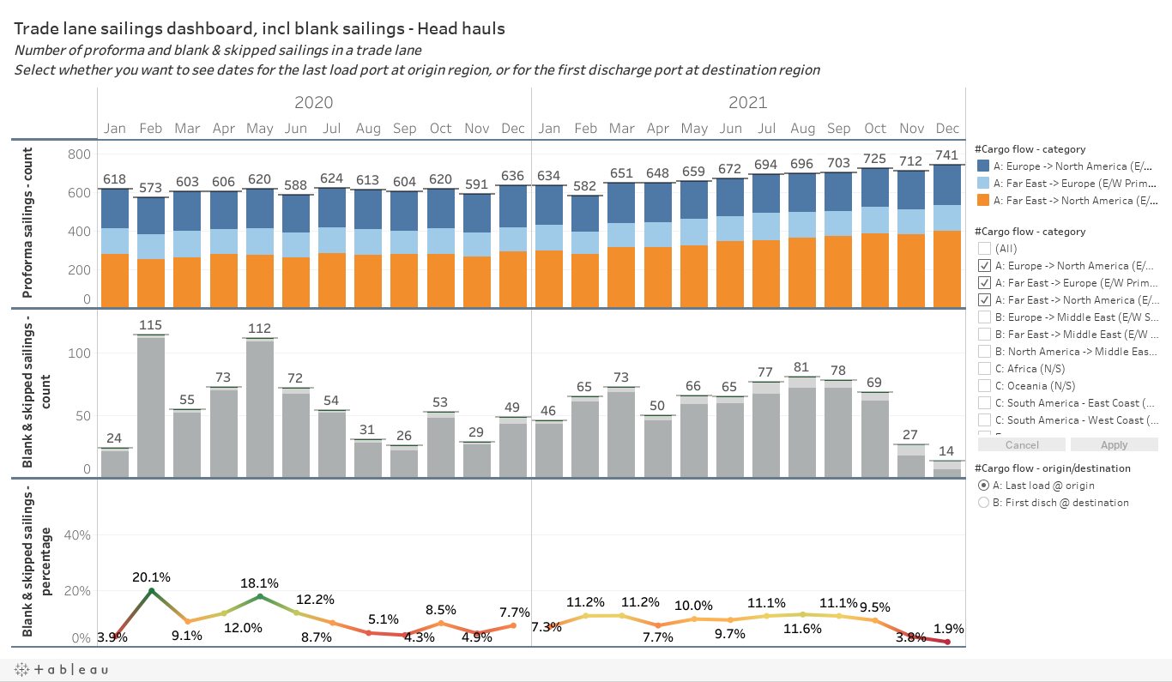
Source: eeSea Blank Sailings Tracker

Available Fleet Growth versus Demand Growth

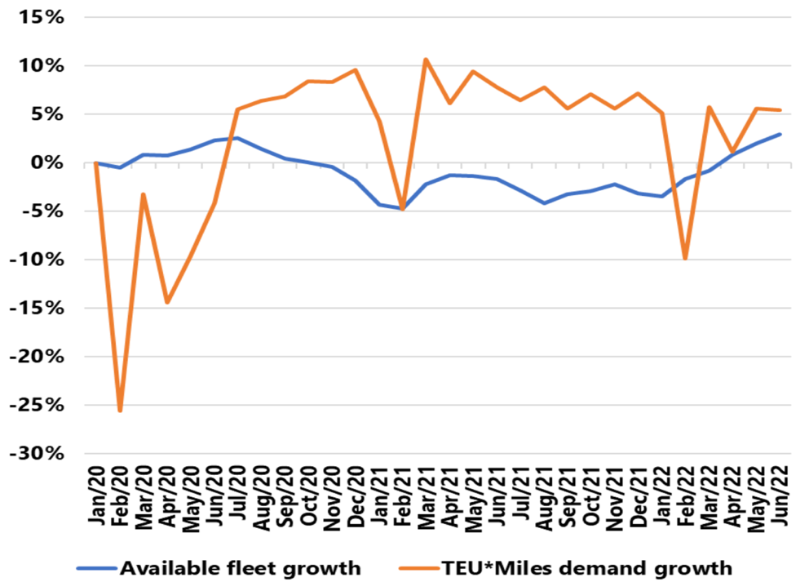

Source: Sea-Intelligence

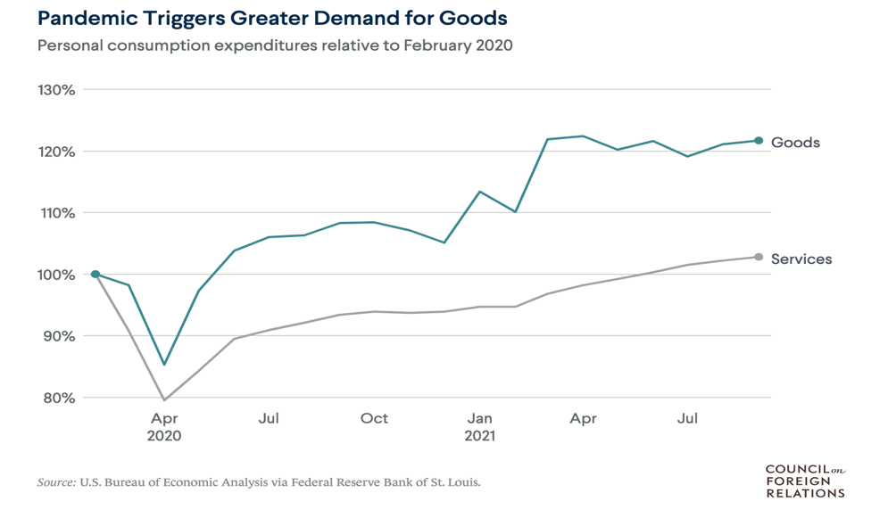
Major U.S. ports experienced record cargo volumes due to soaring demand for commodities. The Port of Los Angeles, the nation's largest port, had its busiest September in 2021 since its establishment 114 years ago, with a cargo volume increase of almost 25% from the previous year. Similarly, the Port of Virginia reported a significant rise of 4.4% in cargo volume in September 2020. However, despite the surge in demand, pandemic-related disruptions and years of infrastructure underinvestment have caused cargo-laden containers to pile up at major ports, and ships waiting weeks to dock. The rise in demand and the lingering effects of pandemic restrictions have also caused ocean transportation costs to escalate sharply throughout most of 2021. Additionally, China's "zero COVID" policy has created further shipping pressure, leading to an all-time high cost of over $20,000 to send a container from China to the U.S. in 2020 and 2021. A. Michael Spence from CFR attributes this to the "pent-up demand" being unleashed before the pandemic was really over, hampering the supply response and resulting in continued pandemic-related disruptions at major ports and manufacturing facilities. Beginning in the fourth quarter of 2020, the U.S. and the world at large face increasing challenges as the COVID-19 pandemic and its effects disrupt the global maritime supply chain. The increased demand has exposed existing problems in the international marine supply chain, leading to extreme congestion at supply chain ports and marine terminals.

2.2.2 Challenge of labor allocation
Introduction：Several ports in the US and Europe have experienced labor shortages. The recurring epidemic has led to a significant reduction in the number of seafarers, further dragging down the release of global shipping capacity.
Seafarers play a crucial role in transporting essential commodities like medical supplies, food, energy, and raw materials, as well as manufactured goods worldwide, with more than 80% of global trade dependent on them. Unfortunately, the COVID-19 pandemic's travel restrictions have stranded many seafarers on ships, causing problems with repatriation and crew changes that have significantly impacted the shipping industry. Since ships frequently depart or arrive at ports located thousands of kilometers away from their homes, seafarers need to travel by air between ships every month. They often fly to their departure ports, live and work onboard for weeks or months, and then fly back home once they reach their destination.
However, the process of seafarers traveling between ships and their countries of residence has been significantly hindered by restrictions and closures due to the COVID-19 pandemic. The limited availability of commercial flights has resulted in higher fares for ship operators and crewing agents, and border closures have prevented some individuals from crossing borders or traveling to airports to return home. Obtaining visas or travel permits to transit countries has also become difficult, while quarantine requirements have added further obstacles to travel. Although some countries have begun to reopen international seaports and airports, many have maintained travel restrictions to curb the spread of the virus, severely limiting seafarers' ability to travel between their workplace and home country. In January 2022, INTERTANKO published precautionary measures for seafarers:
“Precautions with Private Maritime Security Guards or Ship-to-Ship personnel on board
The company, when engaging the services of a Private Maritime Security Company (PMSC) or conducting ship-to-ship (STS) operations, should undertake due diligence and ascertain the steps taken by the PMSC or STS provider to prevent onward transfer of the virus. Prior to joining a ship, the PMSC or STS provider should provide the following for each of their personnel:
• A certificate attesting to a medically supervised negative polymerase chain reaction (PCR) test with a negative result issued 48 hours prior to joining; or
• A certificate attesting to a medically supervised anti-gen test with a negative result issued 48 hours prior to joining; or
• Record of quarantine for 14 days before joining; or
• A vaccination certificate and associated booster dose.
The vessel should follow the same precautions as for Pilots boarding the ship. However, as the personnel will be sailing with the vessel, SSD and cleanliness will be key. After the personnel have disembarked, their accommodation should be thoroughly cleaned.
The company must inform the PMSC or STS provider if any seafarer falls ill with a fever, flu-like symptoms or tests positive for Covid-19 within two weeks of the departure of their personnel. Similarly, the PMSC or STS provider must inform the company if any of their personnel fall ill with a fever, flu-like symptoms or test positive for Covid-19 within two weeks of departing the ship and consequently all seafarers on board should have an anti-gen test at the earliest point.”

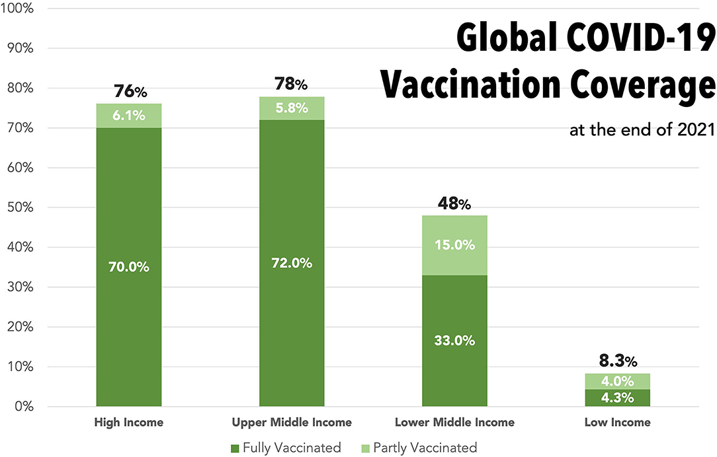
This mandatory vaccination policy for crew members seems reasonable, considering that they have to work closely with each other for long periods in a limited space. To address this issue, the World Health Organization (WHO) suggests prioritizing seafarers as a transportation worker group for COVID-19 vaccination in situations where supply is limited. Nevertheless, there are numerous obstacles to this. For instance, there are ongoing inequalities in the availability of vaccines across countries. During the initial year of COVID-19 vaccine distribution, high-income countries (HICs) attained vaccination coverage of 75-80%, while low-income countries (LICs) had less than 10%. The WHO Director-General reported that as of November 2021, more than 80% of the global vaccine supply went to G20 countries, whereas LICs only received 0.6% of all vaccines. Additionally, work permit validity for vaccination certificates is frequently altered, leading to greater uncertainty and disruption.
Source: World Health Organization

The unavailability of replacement crew has resulted in many seafarers being unable to return home. COVID-19 travel restrictions have made it difficult for seafarers to travel abroad and board ships, exacerbating the challenges of crew replacement. As a result, the International Maritime Organization reports that many seafarers are exceeding the 11-month maximum duration of their contracts, as established by the International Labor Organization. There are approximately one million seafarers working on some 60,000 large cargo ships worldwide at any given time. As of July 2021, it is estimated that around 250,000 seafarers are stranded on merchant ships with expired contracts, and unable to be repatriated.
The professional tasks performed by seafarers necessitate their continuous attention, so extended detentions have a detrimental effect on their physical and mental well-being. A large number of seafarers who are stranded on ships have reported feeling drained, tired, anxious, depressed, and mentally strained. Moreover, seafarers who are exhausted both physically and mentally are more likely to be involved in shipwreck incidents, which poses significant safety concerns for the ships they operate.
Seafarers face significant challenges in accessing emergency medical care ashore, even when they present with symptoms unrelated to COVID-19. Even fully vaccinated crew members have been denied disembarkation, despite testing negative for the virus. Many seafarers struggle to obtain repeat prescriptions for their medications, and some do not receive proper medical assessments for new conditions before receiving primary care on board. This lack of access to healthcare can have a negative impact on crew morale and may discourage new crew members from joining.
2.2.3 Global on-time rate drop
Delays in the production process add pressure to transportation costs, as each delay brings additional overhead. In this section, I will analyze the domestic and international delays in production or transportation together, given that it is a complete and continuous process.
Domestically, COVID-19 has impacted production in China in several ways. First is the disruption of the workforce. As mentioned earlier, in an effort to control the spread of the virus, China implemented strict lockdown and quarantine measures that prevented many workers from traveling to their workplaces. This led to labor shortages and decreased productivity. In addition, factory shutdowns were a major cause of production delays. Many factories in China were forced to shut down temporarily to contain the virus's spread. This led to supply chain disruptions and delays in product production.
At the same time, Chinese factories faced shortages of raw materials and other necessary inputs due to the global supply chain disruptions caused by the outbreak, which further led to the decision to shut down production temporarily. Even for the very few plants allowed to operate, factories were required to implement new health and safety protocols, such as providing personal protective equipment (PPE) and conducting regular temperature checks. All of these measures slowed down production flow and made goods not available in a timely manner.
Figure 1 shows the punctuality of orders from 2019 to 2022 for a zipper company and one of its international customers. When the time difference between Contract Delivery Date and Ex-Works Date is greater than or equal to 3 days, we define the order as delayed because this time difference has an impact on the entire supply timeline. The order delay rates are obtained by dividing the number of delay orders with the number of total orders. The rising trend line obtained by ordinary least squares regression shows the steady increase in order delay rates during the epidemic, reflecting disruptions to the production chain.
A similar trend can be seen in the total number of days of delay. Here we need to limit the comparison to the same months, considering that the data show a clear seasonality. Take April for example. In April 2019, the epidemic is not yet present, and everything is normal. In April 2020, the epidemic severely chokes demand and brings down the number of orders, with a corresponding drop in total delay days. Starting in 2021, demand starts to recover and demand for Chinese exports surges (to be discussed in detail in 2.2.4), leading to an alarming delay rate and total days of delay.

The delay in production has led to a shortage of containers in China and, ultimately, to higher transportation costs. The most immediate reason for the container shortage was that most factories were closed at the time, including those that produced containers. When demand and production gradually recovered, there was a huge backlog of goods waiting to be shipped, leading to a shortage of available containers.
At the same time, trade imbalances also exacerbated this shortage. For a variety of reasons that will be discussed in detail in 2.2.4, China exported more goods than it imported during the epidemic. This has led to a shortage of containers for shipping out of China. This shortage significantly increases container costs and directly leads to higher transportation costs for companies that need to move goods out of China. Companies take longer to secure containers for shipment because they cannot be sure of container availability. This results in longer shipment lead times and increases costs for companies that need to expedite shipments.
The shortage of containers also leads to congestion at ports, as ships have to wait longer to load and unload cargo. Of course, the lack of available labor due to blockades and quarantines is another critical reason.
This extended waiting time imposes additional costs on companies, as they must pay for their cargo storage and handling. More seriously, this has a ripple effect throughout the global supply chain, as delays in one port can lead to delays in subsequent ports, which means more transportation costs.
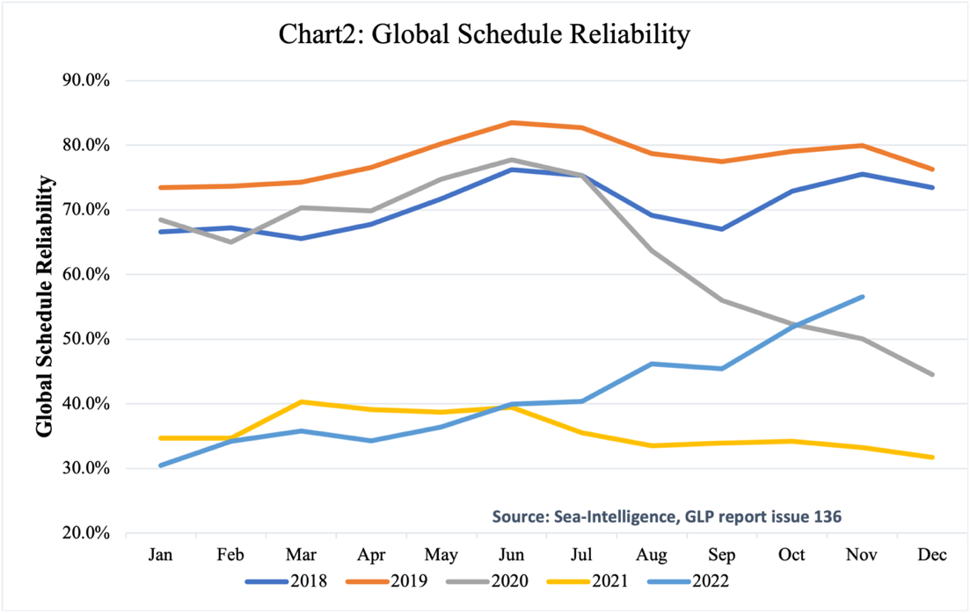
As cargo struggles to leave Chinese ports, declining punctuality in international transportation continues to bring up transportation costs. Let us talk about ocean freight first. Figure 2 and Figure 3 are the reports on Global Schedule Reliability and Global Average Delays for Late Vessel Arrivals provided by Sea Intelligence, a maritime intelligence consultancy. The report covers 34 different shipping routes and more than 60 shipping companies.
Source: Sea-Intelligence

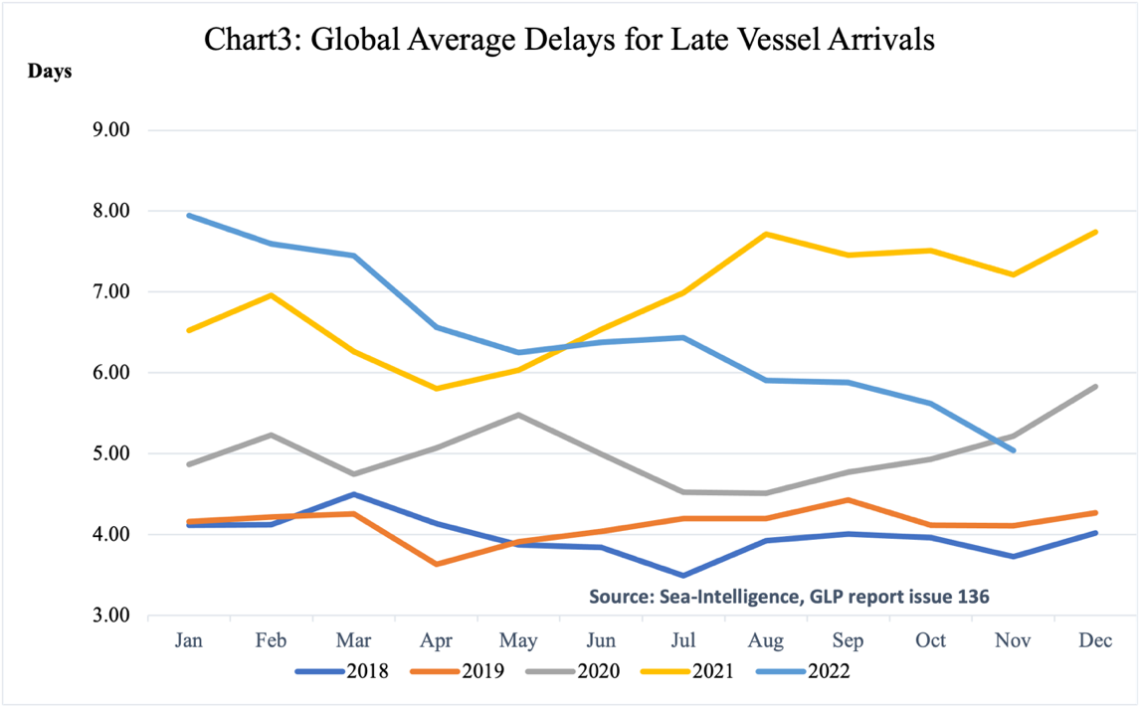
It shows that the shipping industry's on-time rates were inferior due to worldwide port congestion and regional restrictions. This has undoubtedly increased transport costs, which is mainly reflected in three aspects. First is the increased lead times. As the schedule reliability decreases, it becomes harder for companies to predict precisely when their goods will arrive. This uncertainty can lead to longer lead times as companies build in extra time to compensate for potential delays. Longer lead times can result in higher transportation costs as companies may need to pay for expedited shipping or use more expensive modes of transportation to meet their delivery deadlines.
The second part is increased inventory costs. If companies are uncertain about when their goods will arrive, they may need to maintain higher inventory levels to ensure they have enough stock on hand to meet customer demand. This can lead to higher inventory carrying costs and potentially result in higher transportation costs as companies may need to ship larger quantities of goods at once to meet their inventory needs.
The third part is increased operational costs. For example, if a ship is delayed, it may need to spend more time at port, which can result in higher berth fees and other related costs. Similarly, if a shipment is delayed and needs to be rerouted, additional costs may be associated with the change in routing.
In addition to the most common sea freight, there was also a decrease in air freight capacity as countries implemented travel restrictions and canceled flights. This results in higher airfreight prices and longer delivery lead times. For example, in January 2020, China suspended all domestic and international flights in and out of Wuhan, the epicenter of the COVID-19 outbreak. The suspension of all international flights followed this in Beijing in March 2020.
Meanwhile, Australia banned all non-residents from entering the country and required all returning citizens and residents to undergo a 14-day quarantine period. International passenger flights into Australia were also capped at a reduced capacity.
Table 1 summarizes some representative countries' measures to restrict entry and exit. They have created significant impediments to international air transport.
Table 1
Country | Time Period | Measures Taken
China | Jan-20 | Suspended all domestic and international flights in and out of Wuhan, the epicenter of the COVID-19 outbreak.
 | Mar-20 | Suspended all international flights into Beijing.
United States | Jan-20 | Implemented travel restrictions on foreign nationals who had been in China in the previous 14 days.
 | Mar-20 | Banned entry to foreign nationals from certain European countries, including the United Kingdom.
India | Mar-20 | Suspended all international passenger flights into the country for a week.
 | May-20 | Extended the suspension until the end of the month.
 | Jul-20 | Extended the suspension until the end of the month.
Australia | Mar-20 | Banned all non-residents from entering the country, and required all returning citizens and residents to undergo a 14-day quarantine period.
 | Ongoing | International passenger flights into Australia were also capped at a reduced capacity.
Canada | Mar-20 | Restricted entry to foreign nationals who had been in China, Iran, or Italy in the previous 14 days.
 | Mar-20 | Extended the restriction to include all foreign nationals, with some exceptions.
Source: CNN, BBC News, The New York Times, All Jazeera

Due to delays in regular shipping channels, there is an increased demand for courier services, such as FedEx and DHL. This demand has also led to price increases for these services. According to a report by the logistics consulting firm Armstrong & Associates, global air express volume increased by 7.8% in 2020 compared to the previous year. This growth was driven by a surge in e-commerce sales during COVID-19 and the resulting increase in demand for express delivery services, but also because some companies had to switch from sea and air shipments to more expensive express deliveries because of shipping delays. Both FedEx and DHL reported a significant growth in their earnings for the fiscal year 2020, with FedEx reporting a 20% increase in revenue and DHL reporting a 5.5% increase in revenue. These figures show that the increased demand for express delivery services has indeed had a significant impact on the industry and, in turn, reflect the increased transport costs of international companies.

2.2.4 Global supply chain transfer -- China becomes the only major economy in the world to achieve positive growth in trade in goods in 2020
Five to ten years before the COVID-19 outbreak, the global supply chain gradually shifted from China to Southeast Asian countries, such as Myanmar and Indonesia. However, this shift was contained and rapidly reversed in the aftermath of the outbreak. This situation left China to bear the unanticipated export demand and the resulting spike in international trade costs.
Before COVID-19, Western countries had been considering shifting their supply chains out of China. I want to divide the reasons into two main parts. The first is the changes brought about by China's own development. At one time, Western countries were willing to import a large number of products from China because of the low prices associated with China's cheap labor. However, this advantage is gradually disappearing as China's economy grows. China's ratio of younger population divided older population is declining faster than expected. According to the Chinese Academy of Social Sciences, by 2027, China's population of people over 60 is expected to reach 324 million (Chart 1). This lack of a young workforce is causing China's labor costs per capita to rise rapidly, making it difficult to maintain its cost-competitive advantage in labor (Chart 2). Developments in automation and artificial intelligence are also contributing to this trend, causing many companies to look to countries with lower labor costs. At the same time, China has long had a problem with intellectual property theft and counterfeiting. While this problem has improved in recent years, international companies remain concerned that their proprietary technology and designs could be stolen or copied, which could hurt their competitiveness.

Chart 1: Share of population aged 60 and older in China
Source(s): UN DESA; National Bureau of Statistics of China
Chart 2: Average yearly wage in China

Source: National Bureau of Statistics of China
Internationally, tensions between China and the West, particularly the U.S., have raised concerns about supply chain security. The U.S.-China trade war started around 2016 and reached its peak in 2019. The massive tariffs imposed by the Trump administration on Chinese imports have forced U.S. companies to look for alternative manufacturing sources in other countries such as Mexico, Vietnam, and India because of the cost. Meanwhile, other Asian countries, such as Vietnam and Indonesia, have improved their infrastructure and developed their manufacturing capabilities, making them more attractive alternatives to China. Even Japan, which has a long-standing economic relationship with China, has expressed concern about its over-reliance on China as a manufacturing partner and has begun to help companies move their operations from China to other Asian countries. These reasons have led to a gradual shift of the international supply chain away from China toward Southeast Asia, reducing demand for Chinese exports.
As a result, some companies operating in China have seen a decline in demand for their products. This has led some Chinese factories to reduce or close capacity, especially in industries that rely heavily on exports. For example, Foxconn Technology Group, one of the world's largest electronics manufacturers, has cut its workforce and production capacity in China in recent years in response to falling market demand for its products; South Korean electronics company Samsung has reduced its manufacturing operations in China in recent years in response to rising labor costs and increased competition from other countries in the region. In 2019, Taiwanese electronics maker PEGATRON announced plans to shift some of its production capacity out of mainland China in response to trade tensions between the United States and China. Many small and medium-sized factories in China, especially those producing low-technology products such as toys and textiles, were facing increasing competition from other countries in the region and were struggling to maintain profitability. Thus, they had to reduce their production capacity or close their factories. Table 2 shows some famous foreign companies that withdrew from China after Sino-US relations became tense, although it's worth noting that the reasons for these companies withdrawing or reducing their operations in China may vary and may not necessarily be due to economic or political factors. Some of these companies may have encountered difficulties in adapting to the local market or faced competition from domestic firms, while others may have decided to focus on other regions or markets. But in either case, their factories' capacity in China is bound to decline.
Table 2: foreign companies that withdrew from China between 2016 and 2019
Company Name | Industry | Headquarters Country | Exit Year
Marks & Spencer | Retail | United Kingdom | 2016
Uber | Ride-hailing | United States | 2016
HTC | Consumer electronics | Taiwan | 2018
Mattel | Toy manufacturing | United States | 2018
Amazon | E-commerce | United States | 2019 (limited presence)
Samsung | Electronics | South Korea | 2019
General Electric | Multinational conglomerate | United States | 2019
Forever 21 | Fashion retail | United States | 2019
Gap | Fashion retail | United States | 2019
Carrefour | Supermarkets | France | 2019

Reducing capacity and plant size was a wise choice under the circumstances. However, the COVID-19 outbreak brought unpredictable changes to the world landscape. China was the first country to be affected by the epidemic but was also one of the first to recover. The Chinese government took strict measures to control the virus, and as a result, China was able to reopen its factories and resume production earlier than other countries. For example, the Chinese government imposed a strict lockdown early in the pandemic, and residents in some areas were prohibited from leaving their homes. The government also imposed travel restrictions, and some cities and provinces closed their borders to non-essential travel. In outbreak areas, the government would implement mass testing, testing hundreds of thousands of people in a short period. In addition, the Chinese government has implemented a comprehensive contact tracing system, identifying and testing contacts of confirmed cases and implementing body temperature testing in public places, including transportation hubs. For close contacts of confirmed cases or those entering from high-risk areas, the government imposes mandatory quarantine. These measures were initially met with much criticism, particularly in terms of transparency and the initial handling of the Wuhan outbreak. However, the strict measures ultimately helped contain the spread of the virus in China and accelerated the recovery of production.
In contrast, countries where Western countries are looking to move their supply chains to or have moved their supply chains to, such as Indonesia and the Philippines, have struggled to control the spread of the virus. These countries face challenges such as limited healthcare infrastructure, high population density, and lack of resources to implement effective detection and tracking measures. They even have to deal with persistent political instability. As a result, they have had difficulty recovering from the blow of the epidemic as quickly as China. This has forced some Western countries to redirect their supply chains to China. For example, Apple has shifted some of its production back to China due to other countries' supply chain disruptions related to covid-19. The company had previously diversified its supply chain to other countries such as India, Vietnam, and Taiwan, but the outbreak forced it to rely more on Chinese suppliers. Adidas had also diversified its supply chain to countries such as Vietnam, but the outbreak forced it to reassess its sourcing strategy and shift some production back to China in 2020.
In addition to the increased demand for Chinese exports due to supply chain shifts, changes in demand for categories of goods have also increased pressure on Chinese exports. As COVID-19 spread globally, demand for medical supplies such as masks, protective gear, and medical equipment has increased significantly. As a significant producer of these products, China has been able to increase its exports in response to this demand. At the same time, as many countries implement embargoes and work-from-home policies, there is an increased demand for products such as electronics, household appliances, and medical supplies, all of which China is a major producer of. Online shopping has proliferated as more people are forced to stay home worldwide. With a well-developed e-commerce industry, China was able to capitalize on this trend and increase exports through online marketplaces.
With so many favorable conditions, the Chinese government did not waste this opportunity and actively supported the export sector by providing subsidies and tax incentives to exporters. In order to increase export competitiveness and expand market share, China has allowed the yuan to depreciate against the dollar, which makes Chinese goods cheaper for foreign buyers. These policies have further attracted companies to return their supply chains to China.
All of these factors have allowed China's exports to experience unanticipated demand growth, making China the only major economy to achieve positive growth in goods trade in 2020. The excess demand for freight capacity has rapidly increased the cost of international trade transportation.

III. Specific Example
I would like to use shipping data from a Chinese zipper international company to observe the influence of COVID-19 on international shipping costs from a microscopic perspective. By processing more than 10,000 data, I got the following table.
 |  | Mean | Standard Deviation | Coefficient of Variation | Median | Minimum | Maximum
2019 | #Package | 8.6224649 | 19.86342901 | 2.303683371 | 1 | 1 | 232
 | Kilogram | 154.971704 | 394.2841861 | 2.544233398 | 6.5 | 0.1 | 3963
 | Total Cost（¥） | 765.187406 | 3339.967456 | 4.364901236 | 380 | 10 | 124555
2020 | #Package | 7.60211268 | 20.99357548 | 2.761544898 | 1 | 1 | 362
 | Kilogram | 128.605229 | 386.4028659 | 3.004565749 | 2.5 | 0.1 | 5990
 | Total Cost  （¥） | 628.760251 | 1715.062308 | 2.727688821 | 275.795 | 14 | 41488
2021 | #Package | 8.59807074 | 22.67525001 | 2.637248599 | 1 | 1 | 293
 | Kilogram | 147.258447 | 423.9739592 | 2.879114691 | 4 | 0.1 | 5234
 | Total Cost  （¥） | 980.038052 | 5696.001857 | 5.812021118 | 271.34 | 2.04 | 205312

Let's first look at the changes in the average total transportation cost from 2019 to 2021. The transportation cost decreased from 2019 to 2020 due to the significant impact of the global COVID-19 outbreak and response measures on the global economy and trade. By 2021, as the pandemic situation improved, the total transportation cost increased significantly and exceeded the levels of 2019. This was due to the aforementioned factors of COVID-19 restrictions, labor shortages, and insufficient transportation capacity in China and internationally. The standard deviation also reflects this change. From 2019 to 2020, the trough in international transportation resulted in a decrease in the standard deviation. However, in 2021, with a significant increase in international transportation volume, the frequency of unpredictable accidents caused by supply chain instability increased significantly, resulting in a high standard deviation. The average kilograms of packages also showed a similar trend. Moreover, The Coefficient of Variation for "Kilogram" is relatively low across all three years, ranging from 2.544233398 in 2019 to 3.004565749 in 2020 and 2.879114691 in 2021. This suggests that the variability in the weight of kilograms is relatively small compared to the mean, indicating a relatively stable trend.

IV. Some possible precautions
During the COVID-19 pandemic, many international companies faced significant challenges related to increased transportation costs, which had a direct impact on their profitability. To navigate similar situations in the future, there are several key lessons that international companies should consider.
Firstly, diversification of supply chains is crucial. The pandemic highlighted the risks of relying too heavily on a single source or location for supplies. To mitigate these risks, companies should explore alternative sources, locations, and transportation methods, such as local sourcing options, nearshoring, or reshoring strategies. By diversifying their supply chains, companies can reduce their dependence on a single source or route, and minimize the impact of disruptions on transportation costs.
Secondly, agility and flexibility are paramount. The pandemic demonstrated the importance of being able to quickly adapt to changing market conditions, transportation disruptions, and regulatory changes. Companies should focus on building agile and flexible supply chain models by implementing real-time monitoring, leveraging data analytics, and establishing contingency plans. This will enable them to respond rapidly to unforeseen disruptions and mitigate the impact on transportation costs.
Thirdly, risk management should be prioritized. Companies should regularly assess and mitigate risks associated with transportation costs, geopolitical uncertainties, regulatory changes, and other potential disruptions. This may involve reviewing and updating risk management strategies to ensure they are proactive and adaptable to changing circumstances. By having robust risk management practices in place, companies can better anticipate and mitigate transportation cost challenges.
Collaboration and partnerships are also crucial. Companies should foster strong relationships with their suppliers, logistics providers, and other stakeholders, and work closely with them to identify cost-effective transportation solutions, optimize shipping routes, and share information on market changes, regulations, and disruptions. Collaborative efforts can lead to more efficient transportation practices and cost savings.
Additionally, scenario planning and preparedness should be incorporated into supply chain strategies. Developing contingency plans for various scenarios, such as transportation disruptions, changes in demand, or shifts in market dynamics, can help companies be better prepared to respond to unexpected events and minimize the impact on profitability.
Lastly, sustainable transportation practices should be considered. The pandemic has highlighted the need for transportation practices that are resilient to disruptions and environmentally sustainable. Companies should consider incorporating sustainable transportation practices, such as intermodal transportation, use of alternative fuels, and optimization of transportation routes, to minimize costs and reduce environmental impact. This can contribute to long-term profitability and resilience.
In conclusion, the COVID-19 pandemic has underscored the importance of building resilient and adaptable supply chains. International companies should prioritize diversification, agility, risk management, collaboration, scenario planning, and sustainability in their supply chain strategies to mitigate transportation cost challenges and enhance their profitability in a changing global business environment.

References:

Basu, Ron. “Contemporary Global Challenges in Supply Chain Management.” Managing Global Supply Chains, 2023, pp. 45–60., doi:10.4324/9781003341352-5.
Bayram Değer, Vasfiye. “Outbreak Management and Covid-19 Pandemic.” Teamwork in Healthcare, 2021, doi:10.5772/intechopen.96335.
Boin, Riccardo, et al. “Getting the Price Right in Logistics.” McKinsey & Company, McKinsey & Company, 8 Dec. 2020, www.mckinsey.com/industries/travel-logistics-and-infrastructure/our-insights/getting-the-price-right-in-logistics.
“Fact Finding 29.” Federal Maritime Commission, 15 June 2022, www.fmc.gov/fact-finding-29/.
“Frequently Asked Questions about How Covid-19 Is Impacting Seafarers.” International Maritime Organization, www.imo.org/en/MediaCentre/HotTopics/Pages/FAQ-on-crew-changes-and-repatriation-of-seafarers.aspx.
“GRI Shipping: Increases, Surcharges & Fees.” Freightos, 31 Jan. 2023, www.freightos.com/freight-resources/gri-shipping-increase/.
“Joint Statement Urging Continued Collaboration to Address the Crew Change Crisis, Safeguard Seafarer Health and Safety, and Avoid Supply Chain Disruptions during the Ongoing Covid-19 Pandemic.” COVID-19: Joint Statement Urging Continued Collaboration to Address the Crew Change Crisis, Safeguard Seafarer Health and Safety, and Avoid Supply Chain Disruptions during the Ongoing COVID-19 Pandemic, 28 Feb. 2022, www.ilo.org/global/about-the-ilo/newsroom/statements-and-speeches/WCMS_838067/lang--en/index.htm.
Madsen, Niels H. “Schedule Reliability Improves to 40% in June 2022.” Sea, 3 Aug. 2022, www.sea-intelligence.com/press-room/155-schedule-reliability-improves-to-40-in-june-2022#:~:text=Sea%2DIntelligence%20has%20published%20issue,to%20and%20including%20June%202022.
“Outbreak Management Plan: Covid-19 (Version 5).” INTERTANKO.
Remes, Jaana, and Steve Saxon. “What's Going on with Shipping Rates?” McKinsey & Company, McKinsey & Company, 20 Aug. 2021, www.mckinsey.com/industries/travel-logistics-and-infrastructure/our-insights/whats-going-on-with-shipping-rates.
Remes, Jaana, and Steve Saxon. “When Are Shipping Rates Going to Normalize?” McKinsey & Company, McKinsey & Company, 19 Nov. 2021, www.mckinsey.com/industries/travel-logistics-and-infrastructure/our-insights/when-are-shipping-rates-going-to-normalize.
TOK, Volkan, and Nur Jale ECE. “The Impact of Covid-19 on Maritime Trade and Transportation: An Estimation of the Maritime Trade Post-Covid-19.” Mersin University Journal of Maritime Faculty, 2022, doi:10.47512/meujmaf.1200009.
“What Happened to Supply Chains in 2021?” Council on Foreign Relations, Council on Foreign Relations, www.cfr.org/article/what-happened-supply-chains-2021.

Acknowledgement:
I would first like to express my deep gratitude to my advisor, Professor Lawrence White. We started our first conversation in June of 2022. During this year-long study, he showed unparalleled patience and concern. He gave me tremendous support and assistance in the selection of research topics, the analysis of data, the structure of the article, and even the revision of the language. His encouragement made the first research in my life enjoyable, and I believe that what I learned from this experience will benefit me forever. I also wish to thank Professor Nan Xu and Professor Pricila Maziero for their advice on how to narrow down the scope of my study to a specific region and industry. Additionally, collaborating my peers within the Business and Economics Honors Program was an invaluable experience this year. I am grateful to my boyfriend Yanqi (Yancey) Chen for his support.
I would also like to thank my family for encouraging me to apply to the honors program from the very beginning and providing me with comfort every time I felt difficult. They are and will always be my guiding light.

