ALLOCATION OF SOCIAL TRANSFERS:
Evidence from School Feeding in Ghana

Ruike Zhang
submitted in partial fulfillment of the Bachelor of Arts degree

New York University Shanghai
Prof. Torsten Figueiredo Walter, advisor
Prof. Ye Jin, Second Reader

May 2023

Table of Contents
Abstract 3
Preface 4
Chapter 1. Introduction 5
1.1 Motivation 5
1.2 Summary of Paper 6
1.3 Literature and Contribution 7
1.3.1 Effects of School Feeding Programs on Enrolled Children 7
1.3.2 Heterogeneity in School Feeding’s Effect 9
1.3.3 Equity and Efficiency Concerns of Social Transfer Targeting 10
Chapter 2. School Feeding in Ghana 11
Chapter 3. Data 12
3.1 Dataset Description 12
3.2 Household Expenditure 13
3.2.1 Expenditure Data from GLSS7 13
3.2.2 Feature Engineering: Adjust Expenditure for Household Sizes 13
Chapter 4. Descriptive Visualization and Discussion 14
4.1 School Feeding Eligibility 14
4.2 Enrolled But Not Fed, Or Not Enrolled? 15
4.3 Household Expenditure and School Feeding Coverage Rate 15
4.4 School Feeding at Regional Level 16
Chapter 5. Simulation 17
5.1 Simulation Methods and School Feeding by Administrative Region 17
5.2 Simulation Results: Regional Shift 18
Chapter 6. Discussion 19
6.1 Calculating the Gain from Trade-Off 19
6.2 Possible Reasons for the Limited Poverty Differentiation 20
Chapter 7. Conclusion 21
Figures 23
References 26
Acknowledgments 33

Abstract
Empirical studies in many countries have found that school feeding effectively improves recipients’ nutrition status and education outcomes, and such impact is larger for children from disadvantaged backgrounds. This heterogeneous treatment effect shows that school feeding programs have the potential to address educational inequality and raises the question of whether these interventions have been targeting those who need them the most. We use data from the 2016-17 Ghana Living Standards Survey (GLSS7) to examine the Ghana School Feeding Programme (GSFP) coverage for households across different wealth levels. Results show that although the school feeding coverage rate increases as annual household expenditure decreases, more than half of the households with the lowest expenditure are not covered, and one-fifth of upper-middle expenditure households receive feeding. We then simulate counterfactual program allocations that prioritize children from households of lower wealth levels and visualize the program inflows and outflows among administrative regions after the simulation. Finally, this paper discusses several possible explanations for the underperformance of GSFP’s poverty targeting and proposes an approach to estimate the impact of our simulation quantitatively.

Keywords: School Feeding, Social Transfer, Ghana, Simulation

Preface
The motivation for researching social transfer programs stems from summer 2021, during which I read the book Poor Economics: A Radical Rethinking of the Way to Fight Global Poverty, which discussed various anti-poverty interventions worldwide. The authors show that some of these programs’ limited achievement is not because they are poorly designed but poorly targeted and delivered. During my research assistantship for Prof. Walter at NYU Abu Dhabi, I worked with various household surveys that sometimes ask about social transfer programs. With Prof. Walter’s support and encouragement, I began my research on the targeting and delivery of Ghana’s school feeding program.

Chapter 1. Introduction

1.1 Motivation
Many countries around the world have adopted school feeding programs as a form of social transfer that provides better nutrition and lowers barriers for children to attend school. A vast number of studies, empirical research, and meta-analyses included, have shown its effectiveness in improving children’s school attendance, academic achievement, and cognitive development, as well as reducing drop-outs and nutrition deficiencies. In addition, school feeding programs have the potential to improve equity, for studies have shown heterogeneity in impacts of school feeding that it benefits children from disadvantaged backgrounds more.
The past decade has witnessed the fast expansion of school feeding programs worldwide, with low-income countries taking the lead. A report from the World Food Programme shows that at the beginning of 2020, school feeding programs had become the most extensive social safety net around the world, benefitting 338 million, or half of the school children from 163 countries. The report also shows that the percentage of low-income countries that have school feeding increased from 20 percent to 75 percent, indicating a broader recognition of school feeding as an effective educational intervention; moreover, domestic funding of such programs has increased from 17 percent to 28 percent, suggesting a higher level of institutionalization. However, a recent study that examines the micro-evidence of social assistance programs from 123 countries shows that the poorest are left behind. This raises the question that, as an important social assistance concerning education, are school feeding programs reaching those most in need? If not, what are the potential restrictions in reality, and what are the ways the feeding programs can be improved?

1.2 Summary of Paper
This paper examines and proposes an alternative allocation of the Ghana School Feeding Programme (GSFP) across households of different socio-economic statuses. Utilizing data from the 2016-17 Ghana Living Standards Survey (GLSS7), we examine Ghana’s national school feeding program’s coverage for households of different wealth levels and find no significant distinction among these groups in program enrollment. We then simulate a counterfactual program allocation in which the program coverage prioritizes children from lower-income households and calculate the gain and loss of school feeding coverage at the administrative region level. Finally, we propose an approach to quantitatively estimate the improvement in program impact from such redistribution and discuss the likely reasons why Ghana’s school feeding program shows only a mediocre level of poor targeting. This paper contributes to the existing literature on the targeting of social transfer programs by showing the potential gain of school feeding from better poor-targeting.
The rest of this paper is organized as follows. In 1.3, we conduct a literature review on school feeding’s benefits, its heterogeneity effect on children of different backgrounds, and the equity-efficiency trade-off debate concerning social transfer programs. Chapter 2 presents the institutional background and basic information of Ghana’s school feeding program. Chapter 3 introduces the GLSS7 dataset. Chapter 4 presents and discusses a series of data visualizations as well as tests on eligible households’ expenditure levels and the corresponding school feeding coverage rate. Chapter 5 conducts the simulation and discusses school feeding’s regional inflows and outflows after the simulation. Chapter 6 proposes an approach to quantitatively estimate the impact of simulation and discusses several explanations for GSFP’s mediocre poverty targeting. Chapter 7 concludes this study.

1.3 Literature and Contribution
1.3.1 Effects of School Feeding Programs on Enrolled Children
School feeding mainly benefits targeted children in two aspects: education and nutrition. Researches conducted in various low- and middle-income countries show that school feedings improve academic achievement, lower drop-out and truancy rates, improve cognitive functioning, and boost school attendance rates. The nutritional benefits school feeding brings to targeted children include reduction in anemia and growth stunting, reduced iodine and vitamin deficiencies, as well as gain in height and weight. Besides improvements in academics and nutrition, another study in Burkina Faso showed that school feeding shifted enrolled children away from both on-farm labor and off-farm productive tasks, possibly because these tasks are less compatible with school hours.

1.3.2 Heterogeneity in School Feeding’s Effect
There is a growing number of studies that show school feeding’s benefits on children of different demographics, background, age, and socio-economic status are heterogenous. Oftentimes, the benefit is greater for the more disadvantaged group. A study on Ghana’s school feeding shows that school meals improved the height-for-age (HAZ) scores significantly for 5-8 years old program recipients, and the treatment effect was nearly twice as large for those living below the national poverty line compared with all the recipients within that age range. A study on a daily milk program in Iran shows that the program increased weight and improved grade-point averages among girls enrolled in the program; however, such an improvement is not significant among boys who were considered more advantaged. A study conducted in China found that access to school feeding increases the household’s education expenditure on that child, and that such a multiplier effect of increasing education spending is larger on children who come from households with lower income, parents received less education, and children who are left behind in rural areas while parents work in the cities. Besides the direct influence on students’ height and academic achievement, a study in India discovered the intergenerational effect of school feeding that children born to mothers who are fully covered by free lunch programs have higher HAZ scores (+0.40 SD) compared with those born to mothers not covered. These studies suggested that school feeding, as a type of social transfer, has the potential to reduce educational inequality and providing greater upward mobility for disadvantaged children for generations to come.

1.3.3 Targeting of Social Transfer Programs: Equity or Efficiency?
Equity and efficiency are two major concerns when deciding the target group of social transfers. Those who prioritize equity argue that social transfer programs should target those most in need. Empirical studies examining the extent social transfer programs address inequality found that their poverty alleviation effects were insufficient and that sometimes the interventions even benefit the better-off groups more. In a study on 122 anti-poverty interventions in 48 countries, Coady et al. find that the median program transfers 25% more to the poorer half compared with universal allocation, yet 25% of these programs are regressive, meaning that the better-off half receives more transfer. In a more recent study, Parekj and Bandiera find that although social assistance programs across 123 countries have reached 2.7 billion people across the world and lifted 7% of them out of poverty, they failed to reach the poorest in low-income countries, especially in sub-Saharan Africa and South Asia.
Another stream of studies argued that social transfer programs should be targeted at those who have the most potential to utilize the resource instead of “the poorest of the poor.” According to their analysis, the most disadvantaged groups might lack the skills and knowledge to utilize the transfer, thus making these transfers inefficient. An example of this can be found in the research of Haushofer et al., in which they examine the equity and efficiency trade-off of an unconditional cash transfer program in rural Kenya. They found that, on average, the “most impacted” has a 67% higher treatment effect than the “most deprived” group, thus casting doubts on the common practice of solely focusing on the “most deprived” group. However, this is not the case for Ghana’s school feeding program, as Gelli et al.’s research show that the school feeding height gain for 5-8 years old children living below the national poverty line is larger than the general population who receives it. Therefore, our simulation, which has a heavier leaning towards households of lower financial status, will improve GSFP in the aspects of both equity and efficiency.

Chapter 2. School Feeding in Ghana
Launched in 2005, the Ghana School Feeding Programme (GSFP) is a multi-sectoral effort that aims at increasing food security and reducing poverty by providing school children in the poorest areas with one hot, nutritious meal made from locally grown foodstuffs every school day. Its immediate objectives include “reduce hunger and malnutrition, increase school enrolment, attendance and retention, and boost domestic food production in deprived communities of the country.” With around one-third of the funding coming from external donors in its first five years, GSFP has become fully funded by the Ghanaian government by 2016. GSFP partially provides funding to build catering facilities, such as kitchen and storage rooms, and directly makes contracts with local caterers who are responsible for purchasing, processing, and distributing food at school. The GSFP national office adopts a single implementation framework that determines a public school’s eligibility based on an integrated deprivation criterion that considers community poverty ranking and the degree of food insecurity; once a school is selected, all children attending the school will receive free school meal. According to the program website, GSFP has benefitted over 26 million primary school students in about 9000 schools across all metropolitan, municipal, and district assemblies of Ghana. A cost-benefit analysis conducted by the World Food Programme shows that every 1 Ghanaian Cedi invested in GSFP yields 3.3 Cedis economic return to the program recipients over their lifetime.

Chapter 3. Data

3.1 Dataset Description
The dataset we use is the seventh round of the Ghana Living Standards Survey (GLSS7), which was conducted between Oct 2016 and Oct 2017 by the Ghana Statistical Service (GSS). This survey is nationally representative and contains survey results from 14009 households. The household expenditure questionnaire has a two-month recall period, thus accounting for seasonal differences. Each household answers questions about education for their children who attended school in the past 12 months for the education module (Section 2, Part A), and question 24 collects data on school feeding coverage.
Given that the original data files are in DTA format, we use STATA to access them and transform them into CSV files. These files are then imported to Google Colab for cleaning, processing, and visualizing with Python. STATA was also used in later stages for its ease in running tests.

3.2 Household Expenditure
3.2.1 Expenditure Data from GLSS7
The survey defines household expenditure as “the sum of the value of goods and services purchased by households, consumed from own production, received as gifts and payments in kind”. The enumerators visited each household surveyed six to seven times over the survey year and asked respondents to recall their expenditure on items such as food, utilities, and transportation in the past two months; durable goods, such as furniture and clothing, are surveyed only once (twelve months recall period). The collected data were later adjusted based on regional prices and aggregated to the household level.

3.2.2 Feature Engineering: Adjust Expenditure for Household Sizes
We adjust the calculated annual expenditure according to household sizes since, given the same expenditure level, the larger the household is, the tighter the budget constraint it faces. The model we adopted was proposed by the Pew Research Center (Kochhar and Cilluffo 2018). It recognizes the economies of scale that household expenditure does not grow linearly as its size increases.
$$Adjusted Household Expenditure= \frac{Household Expenditure}{\sqrt{Persons_in_Household}}$$

Chapter 4. Descriptive Visualization and Discussion

4.1 School Feeding Eligibility
To draw a graph of school feeding distribution on households of different expenditure levels, we need to exclude households that are not eligible for the school feeding program. As noted in Chapter 2, GSFP targets primary school children enrolled in public schools. This provides us with two eligibility standards:
School age. Gelli et al. surveyed Ghanaian households with children aged between 2 to 15 years old as baseline data in 2013. In 2016, they repeated the survey but only on primary school-aged children, which is what GSFP is targeting. Following this approach, our study excluded households without any children ages between 5 and 12 years old since Ghana’s primary school education is 6 years.
Attendance at public school. Based on the reported school type of each recent school attenders in the education module, we excluded the household without any child attending public school.
We identify 4628 eligible households after applying these two standards. Additionally, we define a household as “enrolled in school feeding” if one or more of their school-age children report GSFP enrollment.

4.2 Enrolled But Not Fed, Or Not Enrolled?
The eligibility standard above poses a potential problem for exploring school feeding coverage from the perspective of household expenditures. Given that we only consider households with children currently enrolled in school, there might be children who do not receive school feeding because they are not enrolled in school. We identified all 5-12 years old children in the dataset and found that out of 13010 school-age children, 11302 of them are enrolled in school while 1708 are not, representing an 86.9% primary school enrollment rate. Of the 11302 children enrolled in school, 2686 of them receive school meals while 8616 children do not, representing a 23.8% school feeding coverage rate for those enrolled in school. Therefore, it’s more likely that children are enrolled in school but not covered by the school feeding program (8616 children) rather than they’re not covered by the school feeding program because they are not enrolled in school (1708 children).

4.3 Household Expenditure and School Feeding Coverage Rate
Graph 1 shows school feeding’s distribution on households with adjusted household annual expenditure between 0 and 20,000 Ghanaian Cedis (20 households with annual expenditures above 20,000 Cedis are not shown in the graph). As the widening 95% confidence interval (orange shade) shows, the majority of households have an annual expenditure below 8,000 Ghanaian Cedis. We can also observe that GSFP has some level of poor targeting (represented by the steepness of the black line’s slope) that as household expenditure decreases, the school feeding coverage rate increases. However, the differentiation across households with varying levels of expenditure is limited in the sense that more than 50% of households with annual expenditure below 2,000 Cedis are not covered by GSFP, and around 20% of households whose annual expenditure is between 4,000 and 8,000 Cedis receive school feeding. In section 4.4, we examine this distribution described above at a regional level.

4.4 School Feeding at Regional Level
As introduced in Chapter 2, GSFP targets schools instead of individuals. Therefore, it is likely that most children who attend a certain GSFP-covered school live in the same neighborhood. To examine whether this approximation is legitimate, we will need a variable that represents each neighborhood. The survey dataset used in this study, GLSS7, adopts a two-stage stratified sampling design that takes enumeration areas (EA) drawn from the 2010 Population and Housing Census as the primary sampling unit, and each EA consists of 100-200 households. Therefore, EA is an ideal candidate to represent an area in which the residents share a similar natural environment, access to infrastructures and public services, including schools. We validate our choice of EA to represent various neighborhoods through the following two approaches.
Statistically, we use STATA to conduct a linear regression with multiple fixed effects (reghdfe) to examine the enumeration area’s fixed effect on GSFP’s coverage. To put it in another way, how much of the variation in school feeding is explained by the EAs in which people live? After dropping 103 households that are the sole observation in their respective EAS, the regression result is based on 4525 households in 824 enumeration areas. The adjusted R-square stands at 70%, suggesting that 70% of the variation observed in GSFP coverage is explained by the EA in which people live. In other words, whether eligible households get school feeding or not can mainly be explained by the village they live in.
Graphically, we calculate and visualize the school feeding coverage rate for each enumeration area (number of covered households / number of eligible households) in Graph 2. The distribution exhibits a bimodal tendency in which the school feeding coverage for the majority of urban and rural EAs is clear: out of the 927 EAs with households eligible for school feeding, 710 EAs, or 76.5% have below 10% or above 90% coverage rate. For the remaining 217 EAs with coverage rates between 10% and 90%, 137 EAs have only one household whose feeding status does not align with others. In other words, households in most EAs have the same school feeding status; this result confirms the results in our statistical test that the variation in program receipt is largely driven by households residing in different EAs rather than other within-EA factors such as their household expenditure. Therefore, enumeration areas would be an ideal candidate for approximating an area in which most children attend the same school.

Chapter 5. Simulation

5.1 Simulation Methods and School Feeding by Administrative Region
For the 927 EAs with eligible households, 559 EAs are not covered by school feeding, 139 are fully covered, and 229 are partially covered. In the first simulation scenario, we treat these partially covered EAs as fully covered (368/927 EAs covered). In the second simulation scenario, we treat them as not covered (139/927 EAs covered). Section 4.4 shows that location difference is the main driver of variation in school feeding coverage. Therefore, we are interested in seeing the changes in school feeding coverage brought by simulation at the regional level. Keeping the same number of EAs covered in the two scenarios, we allocate school feeding to the poorest EAs across the country. The distributions of covered enumeration areas before and after the simulation are shown in the Graphs 3 and 4 below.
Ghana is divided into 10 administrative regions at the time of this survey (see Map 1). The wealthiest is the Central region, and the poorest is the Upper East region, with wealthier regions clustered in the South. During the survey year, the Upper West and Upper East region has the highest school feeding coverage rate (85.9% and 65.3%), the Western region receives the lowest coverage (14.9%) while the rest of the regions have coverage between 20% and 40% (see Map 2).

5.2 Simulation Results: Regional Shift
Based on their school feeding status before and after the simulation, we characterize each enumeration area into four categories: feeding before and after, no feeding before and after, receiving feeding after simulation, and losing feeding after simulation. We then calculate the percentage of change in school feeding coverage for each region after the simulation, and these changes are mapped in Map 3 and 4.
Map 3 shows the changes in school feeding rate if we take those 229 partially covered EAs as covered. The northern region’s coverage rate has increased by 28.1% in the simulation, and that in the Greater Accra region has decreased by 27.4%, making them the regions with the most school feeding inflow and outflow. Other better-off regions, such as Ashanti and Eastern, have moderate school feeding outflows of 6.8% and 7.1%.
Map 4 shows the changes in school feeding rate if we take those 229 partially covered EAs as not covered. In this map, we can observe a general pattern that the simulated school feeding flows from the south, where better-off regions are clustered, to the north, where worse-off regions are clustered. The Northern region remains to be the region with the largest increase in school feeding coverage rate (17.7%), while the most outflows come from the Greater Accra and Ashanti regions (13.7% and 10.8%).

Chapter 6. Discussion

6.1 Calculating the Gain from Trade-Off
In Chapter 5, we simulate a situation in which the current school feeding scale is redistributed to the poorest neighborhoods (EAs) across the country. The rationale behind this is the empirical evidence discussed in 1.3.2 that children from more disadvantaged backgrounds benefit more from receiving school feeding. Considering the resource constraints, if countries can better target the school feeding program to worse-off regions, then with a similar amount of schools covered, the overall improvement in children’s height would be greater.
There is another planned step in the original design of this study, which is to measure the improvements from the simulated redistribution quantitatively, yet as our research proceeds, we found it infeasible with the data and studies we could find. Only a few studies provide numerical standards (exact amount of income or expenditure) for categorizing households based on their socio-economic conditions. While Gelli et al.’s research was about GSFP, and the household expenditure data they collected was very similar with that of GLSS 2017, the paper only presented school feeding’s impact on HAZ of the 5-8 age cohort for two groups: all children and children from “poor” households: households with an annual expenditure below the 1314 Cedis national poverty line. Because our simulation is shifting GSFP coverage from households with higher expenditure to those with lower expenditure, without knowing the HAZ improvement on children from “non-poor” households above the poverty line, we could not calculate the program efficiency improvement from our simulation. Should future researchers wish to quantitatively evaluate the improvement from better poverty targeting, they could reach out to the authors of this paper to inquire about the data.

6.2 Possible Reasons of Mediocre Poor-Targeting
In this section, we will discuss two factors, community characteristics and program implementation framework, that might have contributed to GSFP’s limited differentiation of poverty status regarding program coverage. For community characteristics, the lack of infrastructure is one straightforward material constraint for GSFP to reach the poorest regions. Besides food insecurity and socio-economic vulnerability, GSFP requires some basic cooking infrastructure at the target school (either pre-existing or built with community contribution), for the program only partially funds infrastructure building. Besides physical infrastructure, GSFP also requires “high communal spirit and/or community management capability,” mainly in the sense that the School Management Committee and Parents and Teachers Association are required to be involved in monitoring and evaluating the feeding program throughout its implementation. These two requirements can explain why GSFP did not reach many of the poorest regions, as these communities might lack the financial as well as institutional capacity required for GSFP. Extra effort and resources are needed in order to conquer the obstacles these factors bring to deliver school feeding to children in most dire need, who also respond to the feeding with the largest improvement in height.

Another factor contributing to GSFP’s limited differentiation of poverty status is the program’s implementation framework, which feeds all students enrolled in targeted schools regardless of their socio-economic status. Children from more affluent households will receive the meal, along with children who depend on this meal to attend school. Essuman and Bosumtwi-Sam’s interviews of GSFP-fed children discussed this inefficiency: children from better-off households tend to choose not to eat their portion of the prepared meals. They argue that individualized targeting experience in South Africa, Chile, and Mexico might provide helpful insights into improving GSFP’s targeting efficiency. However, this alternative way also faces challenges such as stigmatization towards beneficiaries; as Bundy et al. reported in Chile’s case, children receiving school feeding were marginalized by those who did not receive it.

Chapter 7. Conclusion
In this study, we utilized the 2016-17 Ghana Living Standards Survey to examine Ghana’s national school feeding program’s coverage for households of different household expenditure levels. We found that GSFP has limited differentiation of poverty status in terms of the households it covers, and that location is the major factor in determining whether a household receives feeding or not. Based on the empirical findings that children from worse-off households acquire larger height gain from school feeding, we simulate an alternative program allocation and discuss regional inflow and outflows. Building on our simulation, future research could quantitatively estimate the magnitude of height gain should the program be delivered to the poorest regions. Such practices can also be expanded to other countries so that there can be a comparison among states in terms of their capabilities to implement social transfer programs.

FIGURES
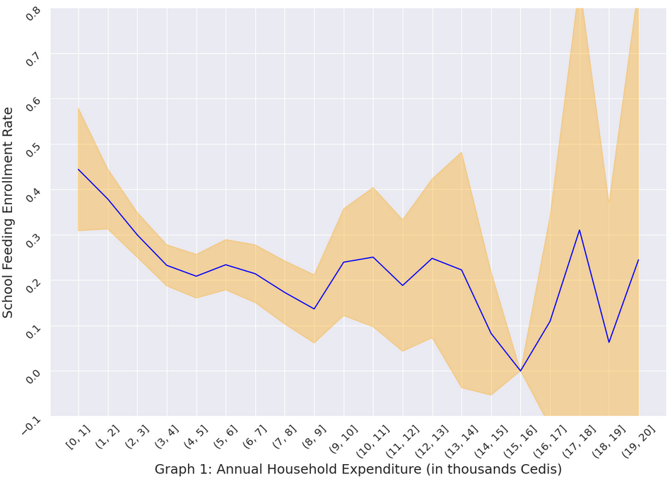

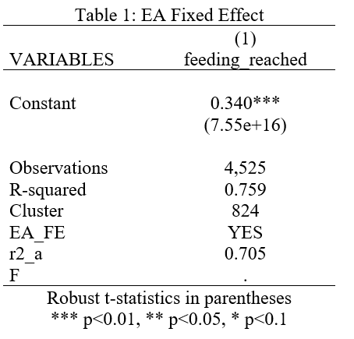

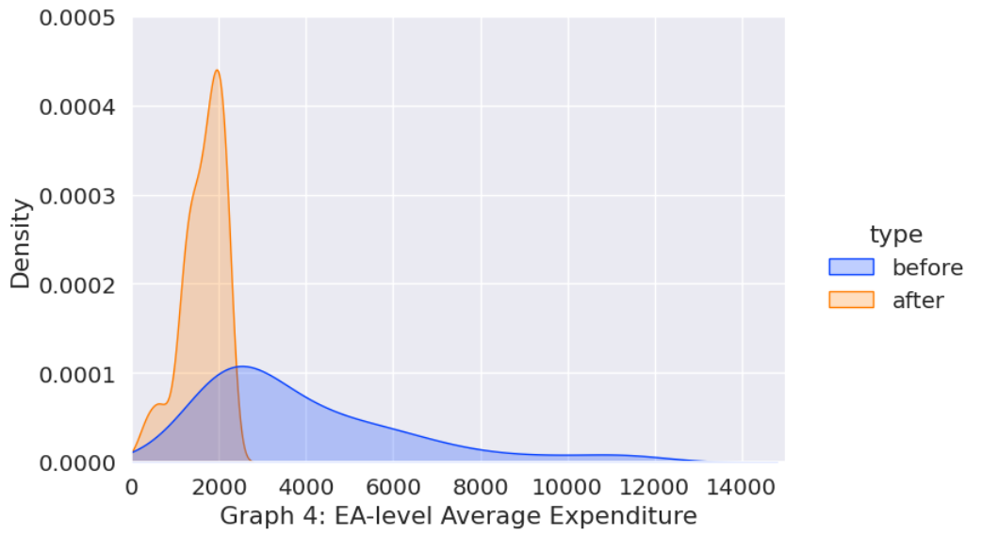
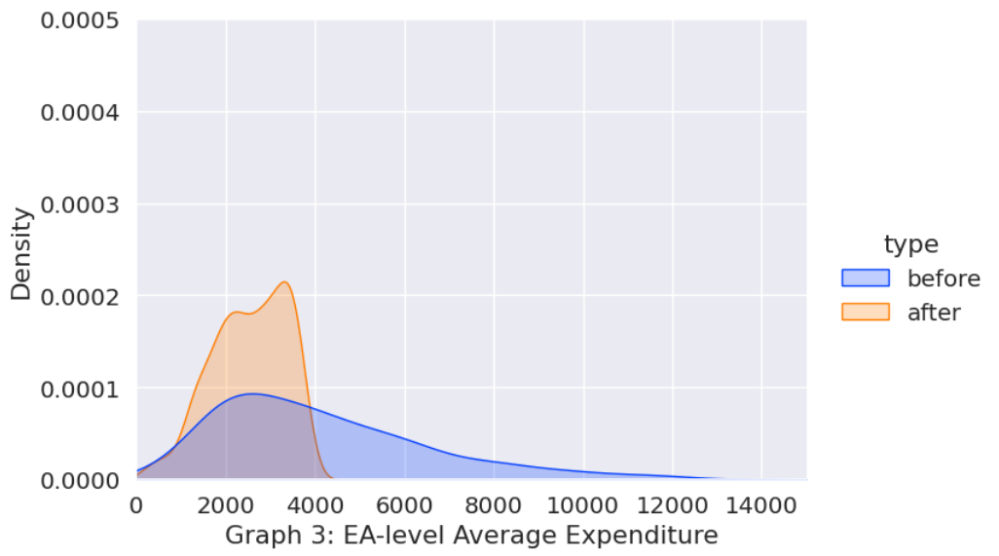
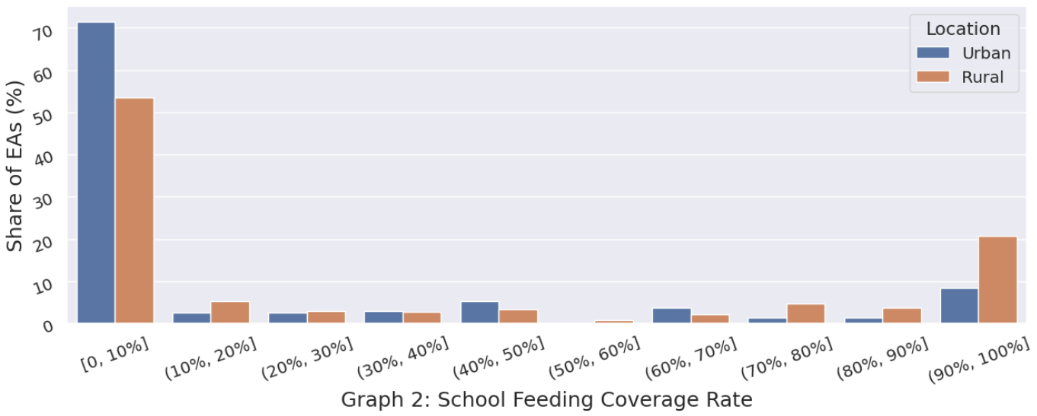

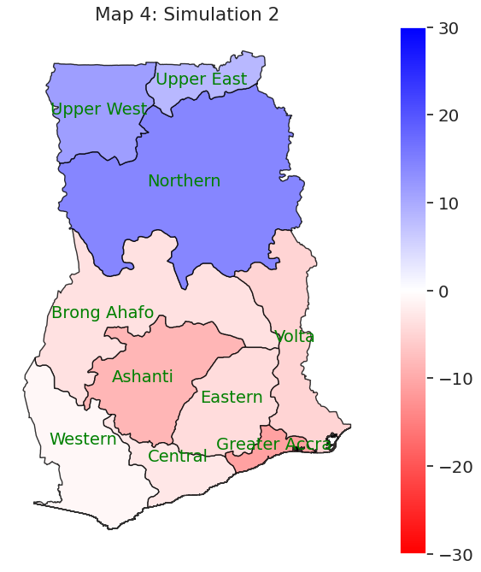
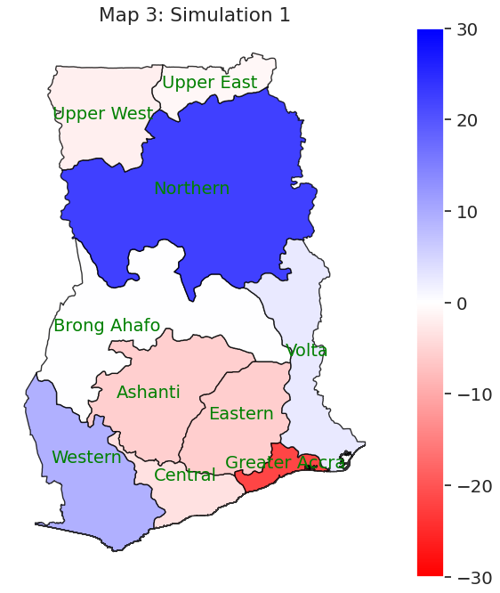
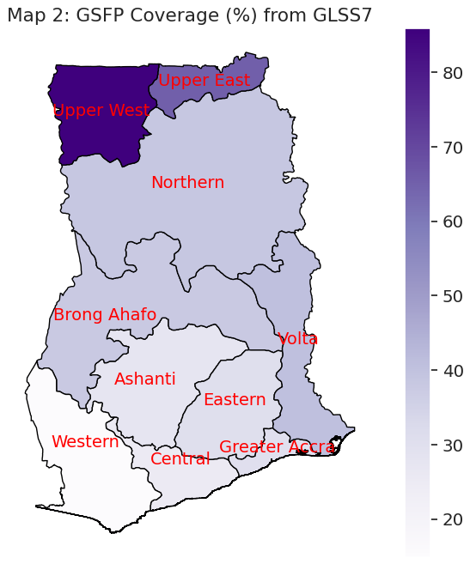
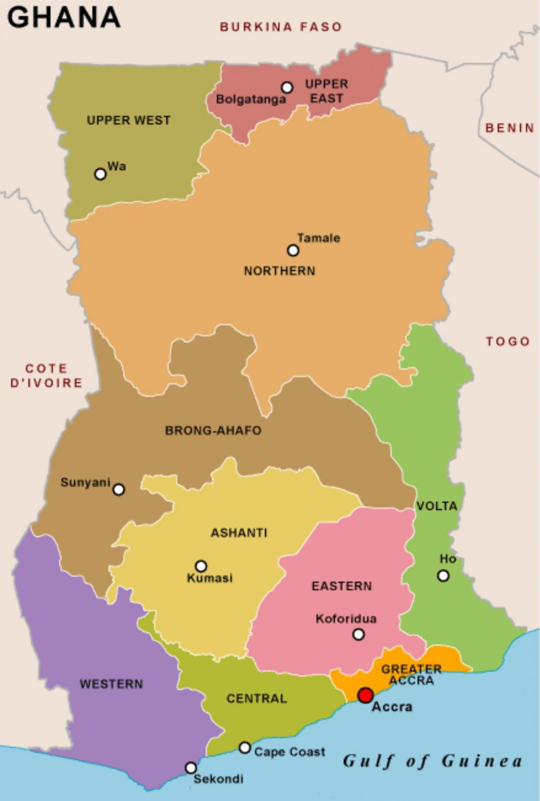
Map 1: Administrative Regions

REFERENCES

Acham, Hedwig et al.. “Breakfast, midday meals and academic achievement in rural primary schools in Uganda: implications for education and school health policy.” Food & Nutrition Research, Vol. 56, (February 2012): 1-12, https://doi.org/10.3402/fnr.v56i0.11217.

Adams, Alayne M. et al.. “Impact of Fortified Biscuits on Micronutrient Deficiencies among Primary School Children in Bangladesh.” Edited by Marly Augusto Cardoso, PLOS ONE, Vol. 12, No. 4, (2017): e0174673, https://doi.org/10.1371/journal.pone.0174673.

Ahmed, Akhter U.. “Impact of Feeding Children in School: Evidence From Bangladesh.” International Food Policy Research Institute, (2014), https://documents.wfp.org/stellent/groups/public/documents/liaison_offices/wfp121947.pdf.

Alderman, Harold, Daniel O. Gilligan, and Kim Lehrer. “The Impact of Food for Education Programs on School Participation in Northern Uganda.” SSRN Electronic Journal, (January 2013), https://doi.org/10.2139/ssrn.2207796.

Anitha, Seetha et al.. “Acceptance and Impact of Millet-Based Mid-Day Meal on the Nutritional Status of Adolescent School Going Children in a Peri Urban Region of Karnataka State in India.” Nutrients, Vol. 11, No. 9 (2019): 2077, https://doi.org/10.3390/nu11092077.

Appiah, Francis et al.. “Association between Hunger and Truancy among Students in Liberia: Analysis of 2017 Global School-Based Student Health Survey.” BioMed Research International, (January 2022): 1-8, https://doi.org/10.1155/2022/4785238.

Buhl, Amanda. 2010. “Meeting Nutritional Needs Through School Feeding: A Snapshot of Four African Nations.” Global Child Nutrition Foundation, 2010.

Bundy, Donald et al. “Rethinking School Feeding: Social Safety Nets, Child Development, and the Education Sector.” The World Bank, 2009, https://openknowledge.worldbank.org/entities/publication/04cfcad6-c7d6-59a9-b488-6e8ab065ad5f.

Chakrabarti, S. et al. “Intergenerational nutrition benefits of India’s national school feeding program.” Nature Communication, Vol. 12, No. 4248 (2021): 1-10, https://doi.org/10.1038/s41467-021-24433-w.

Coady, David, Margaret Grosh, and John Hoddinott. “Targeting Outcomes Redux.” The World Bank Research Observer, Vol. 19, No. 1 (Spring 2004): 61-95, https://www.jstor.org/stable/3986493.

Cooke, Edgar, Sarah Hague, and Andy McKay. “The Ghana Poverty and Inequality Report.” UNICEF, March 2016, accessed May 12, 2023, https://www.unicef.org/ghana/media/531/file/The%20Ghana%20Poverty%20and%20Inequality%20Report.pdf.

Cueto, Santiago, and Marjorie Chinen. “Educational impact of a school breakfast programme in rural Peru.” International Journal of Educational Development, Vol. 28, (March 2008): 132–148, https://doi.org/10.1016/j.ijedudev.2007.02.007.

Desalegn, Tsion A. et al.. “The Effect of School Feeding Programme on Class Absenteeism and Academic Performance of Schoolchildren in Southern Ethiopia: a Prospective Cohort Study.” Public Health Nutrition, Vol. 24, No. 10, (July 2021): 3066-3074, https://doi.org/10.1017/S1368980021000501.

Diagne, Abdoulaye et al.. “Evaluation of the Impact of School Canteen Programs on Internal Efficiency of Schools, Cognitive Acquisitions and Learning Capacities of Students in Rural Primary Schools in Senegal.” SSRN Electronic Journal, (2014), https://doi.org/10.2139/ssrn.3167973.

Essuman, Ato, and Cynthia Bosumtwi-Sam. 2013. “School Feeding and Educational Access in Rural Ghana: Is Poor Targeting and Delivery Limiting Impact?” International Journal of Educational Development, Vol. 33, No. 3, (2013): 253–262. https://doi.org/10.1016/j.ijedudev.2012.09.011.

Gelli, Aulo et al.. “A School Meals Program Implemented at Scale in Ghana Increases Height-for-Age during Midchildhood in Girls and in Children from Poor Households: A Cluster Randomized Trial.” The Journal of Nutrition, Vol. 149, Iss. 8 (August 2019): 1434–1442, https://doi.org/10.1093/jn/nxz079.

Ghana Statistical Service. “Ghana Living Standards Survey (GLSS) 7 Main Report.” Republic of Ghana, June 2019, accessed May 12, 2023, https://www.statsghana.gov.gh/gssmain/fileUpload/pressrelease/GLSS7%20MAIN%20REPORT_FINAL.pdf.

Ghana Statistical Service. Ghana Living Standards Survey (GLSS VII) 2016-2017. Ref. GHA_2016_GLSS_v01_M. Dataset downloaded from https://www2.statsghana.gov.gh/nada/index.php/catalog/97/study-description.

Government of Ghana, “Ghana School Feeding Programme: Programme Document 2007-2010.” Government of Ghana, September 2006, accessed May 12, 2023, GSFP_Programme_Document_2007_2010 (schoolfeeding.gov.gh).

Grillenberger, Monika et al.. “Food Supplements Have a Positive Impact on Weight Gain and the Addition of Animal Source Foods Increases Lean Body Mass of Kenyan Schoolchildren.” The Journal of Nutrition, Vol. 133, No. 11 (2003): 3957S3964S. https://doi.org/10.1093/jn/133.11.3957s.

Haushofer, Johannes, and Jeremy Shapiro. “The Short-Term Impact of Unconditional Cash Transfers to the Poor: Experimental Evidence from Kenya.” The Quarterly Journal of Economics, Vol. 131, No. 4 (2016): 1973–2042. https://doi.org/10.1093/qje/qjw025.

Haushofer, Johannes et al.. “Targeting impact versus deprivation.” NBER Working Papers, National Bureau of Economic Research, (2022): 30138, RePEc:nbr:nberwo:30138.

Hochfeld, Tessa et al.. “Does school breakfast make a difference? An evaluation of an in-school breakfast programme in South Africa.” International Journal of Educational Development, Vol. 51, (July 2016): 1-9.

Hulett, Judie L. et al.. “Animal source foods have a positive impact on the primary school test scores of Kenyan schoolchildren in a cluster-randomised, controlled feeding intervention trial.” British Journal of Nutrition, Vol. 111, (October 2014): 875-886, https://doi.org/10.1017/S0007114513003310.

Jacoby, E R, S Cueto, and E Pollitt. “When Science and Politics Listen to Each Other: Good Prospects from a New School Breakfast Program in Peru.” The American Journal of Clinical Nutrition, Vol. 67, No. 4 (1998): 795S797S, https://doi.org/10.1093/ajcn/67.4.795s.

Jomaa, Lamis H, Elaine McDonnell, and Claudia Probart. “School Feeding Programs in Developing Countries: Impacts on Children’s Health and Educational Outcomes.” Nutrition Reviews, Vol. 69 No. 2 (2011): 83–98. https://doi.org/10.1111/j.1753-4887.2010.00369.x.

Kazianga, Harounan; de Walque, Damien; Alderman, Harold. “Educational and Health Impacts of Two School Feeding Schemes : Evidence from a Randomized Trial in Rural Burkina Faso.” World Bank Policy Research working paper, no. WPS 4976 (2009), https://openknowledge.worldbank.org/handle/10986/4187.

Kochhar, Rakesh, and Anthony Cilluffo. “Methodology.” Pew Research Center’s Social & Demographic Trends Project, July 12, 2018, accessed May 12, 2023, https://www.pewresearch.org/social-trends/2018/07/12/methodology-15/.

Kristjansson, Betsy et al. “School Feeding for Improving the Physical and Psychosocial Health of Disadvantaged Students.” Cochrane Database of Systematic Reviews, (January 2007), https://doi.org/10.1002/14651858.cd004676.pub2.

Neumann, Charlotte G. et al.. “Meat supplementation improves growth, cognitive, and behavioral outcomes in Kenyan children.” The Journal of Nutrition, Vol. 137, No. 4, (April 2007): 1119-1123, PMID: 17374691.

Nkhoma, Owen W. et al.. “Early-Stage Primary School Children Attending a School in the Malawian School Feeding Program (SFP) Have Better Reversal Learning and Lean Muscle Mass Growth Than Those Attending a Non-SFP School.” The Journal of Nutrition, Vol. 143, Iss. 8, (August 2013): 1324-1330, https://doi.org/10.3945/jn.112.171280.

Parekh, Nidhi and Oriana Bandiera. “Do social assistance programmes reach the poor? Micro-evidence from 123 countries.” IGC Growth Brief, (June 2020), accessed May 12, 2023, https://www.theigc.org/wp-content/uploads/2020/06/Parekh-and-Bandiera-2020-Growth-Brief.pdf

Rahmani, Khadijeh et al.. “Effects of daily milk supplementation on improving the physical and mental function as well as school performance among children: results from a school feeding program.” J Res Med Sci, Vol. 16, No. 4 (April 2011): 469-476, PMID: 22091261; PMCID: PMC3214350.

Stuijvenberg, M Elizabeth van et al.. “Effect of Iron-, Iodine-, and β-Carotene–Fortified Biscuits on the Micronutrient Status of Primary School Children: A Randomized Controlled Trial.” The American Journal of Clinical Nutrition, Vol. 69, No. 3 (1999): 497–503. https://doi.org/10.1093/ajcn/69.3.497.

Wall, Caitlin et al.. “The Impact of School Meal Programs on Educational Outcomes in African Schoolchildren: A Systematic Review.” International Journal of Environmental Research and Public Health, Vol. 19, No. 6 (2022): 3666. https://doi.org/10.3390/ijerph19063666.

Wang, Dongqing et al.. “Impacts of School Feeding on Educational and Health Outcomes of School-Age Children and Adolescents in Low- and Middle-Income Countries: A Systematic Review and Meta-Analysis.” Journal of Global Health, Vol. 11 (September 2021), https://doi.org/10.7189/jogh.11.04051.

Wang, Haining, and Zhiming Cheng. “Kids eat free: School feeding and family spending on education.” Journal of Economic Behavior & Organization, Vol. 193 (2022): 196-212, https://doi.org/10.1016/j.jebo.2021.11.023.

World Food Programme, “State of School Feeding Worldwide 2020.” World Food Programme, accessed May 12, 2023, https://www.wfp.org/publications/state-school-feeding-worldwide-2020.

ACKNOWLEDGEMENTS
I would like to thank Prof. Torsten Figueiredo Walter for his insights in the study of social transfer programs and development economics, his patience, and his helpful feedback and comments during the completion of this thesis. I would like to thank my mom for her unconditional love and support that got me through the university years. I would also like to thank my friends for their company and inspiration. A special toast to the ten months I spent in Abu Dhabi, UAE, where I was indulged with the kindness of people from all over the world and realized that the world is so much more beyond “China” and “the West”.

Caitlin Wall et al., “The Impact of School Meal Programs on Educational Outcomes in African Schoolchildren: A Systematic Review,” International Journal of Environmental Research and Public Health, Vol. 19, No. 6 (2022): 3666. https://doi.org/10.3390/ijerph19063666; Lamis H Jomaa, Elaine McDonnell, and Claudia Probart, “School Feeding Programs in Developing Countries: Impacts on Children’s Health and Educational Outcomes,” Nutrition Reviews, Vol. 69 No. 2 (2011): 83–98. https://doi.org/10.1111/j.1753-4887.2010.00369.x; Dongqing Wang et al., “Impacts of School Feeding on Educational and Health Outcomes of School-Age Children and Adolescents in Low- and Middle-Income Countries: A Systematic Review and Meta-Analysis,” Journal of Global Health, Vol. 11 (September 2021), https://doi.org/10.7189/jogh.11.04051; Judie L. Hulett et al., “Animal source foods have a positive impact on the primary school test scores of Kenyan schoolchildren in a cluster-randomised, controlled feeding intervention trial,” British Journal of Nutrition, Vol. 111, (October 2014): 875-886, https://doi.org/10.1017/S0007114513003310; Tsion A. Desalegn et al., “The Effect of School Feeding Programme on Class Absenteeism and Academic Performance of Schoolchildren in Southern Ethiopia: a Prospective Cohort Study,” Public Health Nutrition, Vol. 24, No. 10, (July 2021): 3066-3074, https://doi.org/10.1017/S1368980021000501.
Aulo Gelli et al., “A School Meals Program Implemented at Scale in Ghana Increases Height-for-Age during Midchildhood in Girls and in Children from Poor Households: A Cluster Randomized Trial,” The Journal of Nutrition, Vol. 149, Iss. 8 (August 2019): 1434–1442, https://doi.org/10.1093/jn/nxz079; Khadijeh Rahmani et al., “Effects of daily milk supplementation on improving the physical and mental function as well as school performance among children: results from a school feeding program,” J Res Med Sci, Vol. 16, No. 4 (April 2011): 469-476, PMID: 22091261; PMCID: PMC3214350; Haining Wang, and Zhiming Cheng, “Kids eat free: School feeding and family spending on education,” Journal of Economic Behavior & Organization, Vol. 193 (2022): 196-212, https://doi.org/10.1016/j.jebo.2021.11.023.
World Food Programme, “State of School Feeding Worldwide 2020,” World Food Programme, accessed May 12, 2023: 4, https://www.wfp.org/publications/state-school-feeding-worldwide-2020.
Ibid., 4.
Ibid., 9.
Nidhi Parekh, and Oriana Bandiera. “Do social assistance programmes reach the poor? Micro-evidence from 123 countries,” IGC Growth Brief, (June 2020), accessed May 12, 2023, https://www.theigc.org/wp-content/uploads/2020/06/Parekh-and-Bandiera-2020-Growth-Brief.pdf.
Ghana Statistical Service, Ghana Living Standards Survey (GLSS VII) 2016-2017, Ref. GHA_2016_GLSS_v01_M. Dataset downloaded from https://www2.statsghana.gov.gh/nada/index.php/catalog/97/study-description.
Charlotte G. Neumann et al., “Meat supplementation improves growth, cognitive, and behavioral outcomes in Kenyan children,” The Journal of Nutrition, Vol. 137, No. 4, (April 2007): 1119-1123, PMID: 17374691; Hedwig Acham et al., “Breakfast, midday meals and academic achievement in rural primary schools in Uganda: implications for education and school health policy,” Food & Nutrition Research, Vol. 56, (February 2012): 1-12, https://doi.org/10.3402/fnr.v56i0.11217; Hulett et al. “Animal Source Foods,” 2014; Desalegn et al. “Class Absenteeism,” 2021.
Santiago Cueto, and Marjorie Chinen, “Educational impact of a school breakfast programme in rural Peru,” International Journal of Educational Development, Vol. 28, (March 2008): 132–148, https://doi.org/10.1016/j.ijedudev.2007.02.007; Francis Appiah et al., “Association between Hunger and Truancy among Students in Liberia: Analysis of 2017 Global School-Based Student Health Survey,” BioMed Research International, (January 2022): 1-8, https://doi.org/10.1155/2022/4785238
Owen W. Nkhoma, et al., “Early-Stage Primary School Children Attending a School in the Malawian School Feeding Program (SFP) Have Better Reversal Learning and Lean Muscle Mass Growth Than Those Attending a Non-SFP School,” The Journal of Nutrition, Vol. 143, Iss. 8, (August 2013): 1324-1330, https://doi.org/10.3945/jn.112.171280; Abdoulaye Diagne et al., “Evaluation of the Impact of School Canteen Programs on Internal Efficiency of Schools, Cognitive Acquisitions and Learning Capacities of Students in Rural Primary Schools in Senegal,” SSRN Electronic Journal, (2014), https://doi.org/10.2139/ssrn.3167973.
Harold Alderman, Daniel O. Gilligan, and Kim Lehrer, “The Impact of Food for Education Programs on School Participation in Northern Uganda,” SSRN Electronic Journal, (January 2013), https://doi.org/10.2139/ssrn.2207796; Desalegn et al. “Class Absenteeism,” 2021; Akhter U. Ahmed, “Impact of Feeding Children in School: Evidence From Bangladesh,” International Food Policy Research Institute, (2014), https://documents.wfp.org/stellent/groups/public/documents/liaison_offices/wfp121947.pdf.
Seetha Anitha et al.. “Acceptance and Impact of Millet-Based Mid-Day Meal on the Nutritional Status of Adolescent School Going Children in a Peri Urban Region of Karnataka State in India,” Nutrients, Vol. 11, No. 9 (2019): 2077, https://doi.org/10.3390/nu11092077; Tessa Hochfeld et al.. “Does school breakfast make a difference? An evaluation of an in-school breakfast programme in South Africa,” International Journal of Educational Development, Vol. 51, (July 2016): 1-9; ER Jacoby, S Cueto, and E Pollitt, “When Science and Politics Listen to Each Other: Good Prospects from a New School Breakfast Program in Peru,” The American Journal of Clinical Nutrition, Vol. 67, No. 4 (1998): 795S797S, https://doi.org/10.1093/ajcn/67.4.795s.
M Elizabeth van Stuijvenberg et al., “Effect of Iron-, Iodine-, and β-Carotene–Fortified Biscuits on the Micronutrient Status of Primary School Children: A Randomized Controlled Trial,” The American Journal of Clinical Nutrition, Vol. 69, No. 3 (1999): 497–503. https://doi.org/10.1093/ajcn/69.3.497; Alayne M. Adams et al., “Impact of Fortified Biscuits on Micronutrient Deficiencies among Primary School Children in Bangladesh,” Edited by Marly Augusto Cardoso, PLOS ONE, Vol. 12, No. 4, (2017): e0174673, https://doi.org/10.1371/journal.pone.0174673.
Monika Grillenberger et al.. “Food Supplements Have a Positive Impact on Weight Gain and the Addition of Animal Source Foods Increases Lean Body Mass of Kenyan Schoolchildren,” The Journal of Nutrition, Vol. 133, No. 11 (2003): 3957S3964S. https://doi.org/10.1093/jn/133.11.3957s; Betsy Kristjansson et al., “School Feeding for Improving the Physical and Psychosocial Health of Disadvantaged Students,” Cochrane Database of Systematic Reviews, (January 2007), https://doi.org/10.1002/14651858.cd004676.pub2.
Harounan Kazianga, Damien de Walque, Harold Alderman, “Educational and Health Impacts of Two School Feeding Schemes : Evidence from a Randomized Trial in Rural Burkina Faso,” World Bank Policy Research working paper, no. WPS 4976 (2009), https://openknowledge.worldbank.org/handle/10986/4187.
Gelli et al. “Implemented at Scale in Ghana,” 2019.
Rahmani et al. “Daily Milk Supplementation,” 2011.
Wang and Cheng, “Kids Eat Free,”, 2022.
Suman Chakrabarti et al, “Intergenerational nutrition benefits of India’s national school feeding program,” Nature Communication, Vol. 12, No. 4248 (2021): 1-10, https://doi.org/10.1038/s41467-021-24433-w.
David Coady, Margaret Grosh, and John Hoddinott, “Targeting Outcomes Redux,” The World Bank Research Observer, Vol. 19, No. 1 (Spring 2004): 61-95, https://www.jstor.org/stable/3986493.
Parekj and Bandiera, “Do Social Assiatance Programmes Reach The Poor?” 2020.
Johannes Haushofer, and Jeremy Shapiro, “The Short-Term Impact of Unconditional Cash Transfers to the Poor: Experimental Evidence from Kenya,” The Quarterly Journal of Economics, Vol. 131, No. 4 (2016): 1973–2042. https://doi.org/10.1093/qje/qjw025.
Johannes Haushofer et al.. “Targeting impact versus deprivation,” NBER Working Papers, National Bureau of Economic Research, (2022): 30138, RePEc:nbr:nberwo:30138.
Gelli et al. “Implemented at Scale in Ghana,” 2019.
Ato Essuman, and Cynthia Bosumtwi-Sam, “School Feeding and Educational Access in Rural Ghana: Is Poor Targeting and Delivery Limiting Impact?” International Journal of Educational Development, Vol. 33, No. 3, (2013): 253–262. https://doi.org/10.1016/j.ijedudev.2012.09.011.
Government of Ghana, “Ghana School Feeding Programme: Programme Document 2007-2010,” Government of Ghana, (September 2006): 21, accessed May 12, 2023, GSFP_Programme_Document_2007_2010 (schoolfeeding.gov.gh).
Government of Ghana, “Programme Document 2007-2010,” 47.
Gelli et al. “Implemented at Scale in Ghana,” 2019.
Gelli et al. “Implemented at Scale in Ghana,” 2019.
Essuman and Bosumtwi-Sam, “Is Poor Targeting and Delivery Limiting Impact?” 2013; Gelli et al. “Implemented at Scale in Ghana,” 2019.
World Food Programme, “State of School Feeding Worldwide 2020,” 2023.
Ghana Statistical Service, “Ghana Living Standards Survey (GLSS) 7 Main Report,” Republic of Ghana, June 2019, accessed May 12, 2023, https://www.statsghana.gov.gh/gssmain/fileUpload/pressrelease/GLSS7%20MAIN%20REPORT_FINAL.pdf
Ibid., 198.
Gelli et al. “Implemented at Scale in Ghana,” 2019.
Ghana Statistical Service, “Ghana Living Standards Survey (GLSS) 7 Main Report,” 2019.
Edgar Cooke, Sarah Hague, and Andy McKay, “The Ghana Poverty and Inequality Report,” UNICEF, March 2016, accessed May 12, 2023, https://www.unicef.org/ghana/media/531/file/The%20Ghana%20Poverty%20and%20Inequality%20Report.pdf.
Gelli et al. “Implemented at Scale in Ghana,” 2019.; Chakrabarti et al. “Intergenerational Nutrition Benefits,” 2021)
Gelli et al. “Implemented at Scale in Ghana,” 2019.
Government of Ghana, “Programme Document 2007-2010,” 19.
Government of Ghana, “Programme Document 2007-2010,” 18.
Essuman and Bosumtwi-Sam, “Is Poor Targeting and Delivery Limiting Impact?” 258.
Ibid., 259.
Donald Bundy et al, “Rethinking School Feeding: Social Safety Nets, Child Development, and the Education Sector,” The World Bank, (2009): 15, https://openknowledge.worldbank.org/entities/publication/04cfcad6-c7d6-59a9-b488-6e8ab065ad5f.

