The Impact of the 2021 Notice on Online Mobile Games:
An Event Study Perspective
by
Sirui (Ray) Bao

An honors thesis submitted in partial fulfillment
of the requirements for the degree of
Bachelor of Science
Business and Economics Honors Program
NYU Shanghai
May 2024

Professor Marti G. Subrahmanyam Professor Abdul G. Noury
Professor Christina Dan Wang
Professor Wendy Jin
Faculty Advisors Thesis Advisor
Contents
Abstract 3
Acknowledgement 4
Introduction 6
Literature Review 8
Methodology 9
Data 11
i. Data Source 11
ii. Game-based Data 12
iii. Stock Price Data 15
Event Study 16
i. Level Term 16
ii. First Difference in Log 20
iii. Stock Return 22
Result 23
i. Level Term 23
ii. First Difference in Log 25
iii. Stock Return 25
Limitation 25
Conclusion 27
Appendix 1 User Identity Verification Systems in Different Mobile Games 29
Appendix 2 Statistics Table for Data 31
Appendix 3 Results for Level Effect 35
Appendix 4 Results for First Difference in Log 41
Appendix 5 Results for Stock Return 46
Reference 47

Abstract
The Notice on Further Strictly Regulating and Effectively Preventing Online Video Gaming Addiction in Minors (“2021 Notice”), imposing stricter measures to restrict minors’ playtime in video games, significantly affected the Chinese gaming industry. This research employs MacKinlay’s event study method to analyze changes in daily download volumes of Chinese mobile games and stock price return of Chinese video game companies pre- and post-Notice.
Findings indicate statistically significant effects in the treatment group, but divergence arises from the different magnitudes of the compliance of the policy. The 2021 Notice had a negative impact of decreased daily download volume of mobile games on the strong-compliant treatment group during the event window, but a positive effect on the weak-compliant group. Nevertheless, no significant impact on financial investments in the Chinese video game sector was observed.
Key word: Chinese video game industry, event study

Acknowledgement
I would like to thank my advisor, Professor Abdul Noury, for his continuous support and guidance in this research project. I learned the essentials of academic research when I took Econometrics with him, and it has been my great honor to have Professor Noury guide me in this project. He has been immensely kind in offering advice on my research, always responding to my questions timely, explaining things clearly and patiently, arranging the meetings with me despite the schedule differences in the Abu Dhabi and Shanghai campuses. I genuinely appreciate his efforts in this project and helping me improve in my academic journey.
I would like to express my appreciation to Professor Marti Subrahmanyam, Professor Christina Wang, and Professor Ye Jin for their efforts in organizing the weekly seminars and their coordination of Business and Economics honors program; Teaching Assistant Xinyi Yang for facilitating the smooth run of the program and kind reminder of the deliverables.
I thank Sara Niroobakhsh, for her encouragement. When I expressed my passion in researching about the video game industry, her kind words gave me the determination of proposing the topic as my thesis paper. Boiling a bowl of water using only one candle, it is.
Catherine Journeaux has been a great teacher, friend, music lover, and listener. Sharing my academic journey and experience during my undergraduate years with her has immensely benefited me and allowed me to grow as a person. And thanks for the continuous support of the performing arts; please continue to do so.
I want to thank all the professors I’ve taken classes with and/or worked with in the business finance and economics departments of NYU Shanghai. Their dedication and teaching inspired me to continue my learning in academia.
My friends, Alex, Lee, Yvonne, Emma, Zizi, Robin, and Karna, are the people who witnessed all my struggles, goods, and bads, and went through this journey with me. I wish them the best for their future studies and careers.
Many thanks to my family, and I hope you are/were proud of the person I am.
Lastly, to a friend, who allows me to see the very possibility of starting this research project. I want to express my sincere gratitude for all the conversations, laughs, encouragements, inspirations, passion, and love for video games and music.

Introduction
Video game today is not merely a new way of entertainment. In China, the number of players reached a new height of 668 million up to June, 2023, which means about half of the Chinese population are video gamers, and the revenue of Chinese video game industry was 144.263 billion yuan (China Audio-video and Digital Publishing Association, 2023). Yet, the negative impression of addictive gaming behaviors still lingers, and young people are deemed the greatest victims of video game addiction. Video game has long been standing on the tenuous ground between entertainment and “spiritual opium” (Haldane, 2021), and policies are shaping the unique landscape of Chinese video game industry.
On August 30th, 2021, the National Press and Publication Administration of the People’s Republic of China published “the Notice on Further Strictly Regulating and Effectively Preventing Online Video Gaming Addiction in Minors” (“2021 Notice”), and on September 1st, the notice becomes effective. The 2021 Notice is an update on the 2019 Notice, which restricts the minor’s (Chinese citizens under the age of 18) time spent on video games daily and during weekends (National Press and Publication Administration, 2019). In the 2021 Notice, minors are only allowed to play video games between 20:00 and 21:00 on Fridays, Saturdays, Sundays, and public holidays. To ensure the enforcement of the regulation, all users need to verify their personal identifications to gain access to the games. Furthermore, video game companies (including online platforms) who provide gaming services to unidentified users will be penalized according to the 2021 Notice.
Online games mentioned in the 2021 Notice are those who require Internet access when providing the services, but video games falling under the new regulation are not limited to this scope. To name a few, publishers and companies who want to successfully publish their games in the Chinese video game industry have adopted the user identity verification system even though their games doesn’t require Internet access.
Nevertheless, the age verification system is not uniform across the Chinese video game industry. There are two mainstream age verification system. The first system is mostly employed by well-established video game publishers, like Tencent and NetEase, and the system allows the user to log in the games using social media accounts, such as WeChat, which have already verified with the user’s ID and age (Appendix 1 Image 1). In China, most of the social media accounts have records of user’s personal information like identification number, birthdate, and phone number, and it’s difficult to modify the information once a user registers the account. The other prevailing verification system adopted by game publishers is to have the user provide their personal information upon login into the games, and the backend database, if appliable, will check if the user is underage.
The 2021 Notice has suggestions for practical implementation, but potential loopholes exist. One loophole lies in the verification system. Although accessing the game requires verification of personal identification, minors can use their parents or other adult’s identification to pass the verification, and facial recognition hasn’t been widely adopted by video game companies (Xiao, 2021). The other loophole results from the vagueness in the definition of online video games. The typical video games that fall under the regulation of the 2021 Notice are the games with online services offered by Chinese companies. Online games operating on foreign servers and can be accessed through virtual private networks (VPN) are not regulated by the Notice (Xiao, 2021). Online games published by foreign companies tend to have weak compliance of the 2021 Notice, and one example is Kingdom Rush Frontier, published by Uruguay developers Ironhide Game Studio. (Appendix 1 Image 2) Although the game initially requires the user to enter their birth date and read through some application policies, no other personal identification information is further required and the user can easily enter a false date. The compliance issues will be discussed more in the Data section.

Literature Review
Although the 2021 Notice has a profound impact on the gaming behaviors of minors in China and the ecosystem of Chinese video game companies, few research works focus on the quantitative analysis of the Notice’s impact. Previous research papers on the Chinese video game industry mainly focus on the psychological effects of gaming and the technical issues of developing video games in China.
Research conducted by Zendel et al. (2023) has examined the compliance of the 2021 Notice from the aspect of the hours played per gamer before and after the Notice became effective. The research focuses on the mean weekly playtime for a randomly selected account and the total installations of games pre- and post-regulation. In conclusion, the researchers found no evidence of reduction in heavy gaming following the 2021 Notice, but the compliance level of the regulation remains unclear because the identification behind the user account cannot be verified in the research. Additionally, the dataset used in their research was based on Unity, a video game engine that provides services globally and is not directly regulated by the 2021 Notice.
Xiao (2023) studied the video game companies’ compliance with the self-regulation of labeling the presence of in-game loot box. Loot box refers to the in-game transaction that requires the user to pay the real-world currency and get random in-game items, and loot box has been long accused of luring users to overspend in games. Nevertheless, the loot box mechanism does not strictly resemble gambling and therefore it is not banned from video games but needs to be properly notified to the users before they play the games. Xiao found that 71% of the games examined did not properly label the presence of loot box in games, and thus the compliance rate of the regulation was concerning. This finding stresses the issue of proper compliance on the game service provider’s side, and thus this research work aims to take into consideration of checking the game’s compliance with the 2021 Notice.
The attempt of regulating video game industry has been seen in other countries as well. The Swiss Youth and Media Act attempted to provide a legislative framework for video game use, and the necessity for the general public to get to know the video game industry arises. Lisher et al. (2022) studied features and business models of the video game industry and provided a framework for the general audience to assess the video games’ potential harm to player’s health.
Globally, measures to safeguard minors from detrimental gaming habits are gaining momentum, with the 2021 Notice emerging as one of the most stringent regulations imposed on the video game sector to date. Analyzing the implications of this notice could inform future regulatory endeavors and offer valuable lessons on successful implementation strategies for such policies.

Methodology
There are three research hypotheses in this research. Hypothesis H₀ is to test if the 2021 Notice has a significant impact on the games that strictly comply with the regulation, and hypothesis H₁ is to test the if similar impact exists in the games that have weak compliance. Hypothesis H₂ focuses on the financial performance of the video game companies and H₃ is to test the 2021 Notice’s impact on the daily stock return of the affected video games firms.
The methodology of this research is based on the event study method proposed by MacKinlay (1997). This research aims to study the immediate effect of the 2021 Notice on the video game industry, and the event window selected is 41 days centered around the event day. To evaluate the long-term effect of the policy, alternative approaches like difference in difference are more suitable than the event study method.
The first step of the event study is to determine the event window, which usually includes the day of the event and several days before and after the event. During the event window, the impact of the event is represented by the abnormal return of the company’s security, which is the revenue of selected company in this study. The abnormal return is written as:
$${AR}_{i, t}= R_{i}-E\left(R_{i,t}\right|X_{t})$$
Where $R_{i}$ is the actual revenue, $E\left(R_{i,t}\right|X_{t})$ is the estimated return during the event window, $X_{t}$ is the conditioning information for the normal return model. This research will focus on two ways of estimating returns during the event window, as proposed by MacKinlay: the constant mean return model and the market model.
The constant mean return model is described as:
$R_{i,t}= μ_{i}+ ε_{i,t}$,
where $μ_{i}$ is the mean of asset i and disturbance term $ε_{i,t}$ has the properties as
$E\left(ε_{i,t}\right)=0 Var\left(ε_{i,t}\right)= σ_{ε_{i}}^{2}$.
And the market model is described as:
$$R_{i,t}=α_{i}+β_{i}R_{m,t}+ε_{i,t}$$
$E\left(ε_{i,t}\right)=0 Var\left(ε_{i,t}\right)=σ_{ε_{i}}^{2}$,
where $R_{m,t}$ is the market return during the time period t, and $α_{i}$, $β_{i}$ are the OLS regression coefficients.
Other properties of abnormal return used in this research include average abnormal return (AAR) and cumulative abnormal return (CAR). These are the aggregated results of abnormal return, and AAR is defined as
$AAR_{i,t}=\frac{1}{N}\sum_{i}^{N}{AR_{i,t}}$,
and CAR is defined as
$CAR_{i}\left(t_{1},t_{2}\right)=\sum_{t=t_{1}}^{t_{2}}{AR_{i,t}}$.
The limitation of this research is that the main variable studied in this research is different from MacKinlay’s original paper. Instead of calculating the daily change or return rate, the main variable studied in this research are the daily download volume of video games, which is the level term of the variable, and the day-to-day change in the variable are not as stationary as the stock return, and therefore the constant mean model may not be the best estimation model for the event study in this research. Although the first difference in log, or the daily changing rate, of the main variable is analyzed in this research, the results are not statistically significant. As a result, the event study model may have limited explainability in this research. More assumptions and details about the variables will be discussed in the following section.

Data

Data Source
Three major data sources are used in this research. The game-based data used in this research is from Qimai, a Chinese database providing the data of mobile apps on the two major mobile operating system iOS and Android, and Steam Database, a third-party database tracking information about video games published on the digital distribution platform Steam. Due to the data availability, the main variables studied in this research are the daily download volume of online mobile games in the treatment group and daily number of players in the control group. The stock price data of mobile game companies is from Yahoo! Finance.

Game-based Data
- Treatment Group
For the treatment group, the variable studied is the daily download volume of mobile apps, which tracks how many times an app is downloaded by users on a specific date. The user only needs to download the game once for multiple playing sessions until the user manually deleted it from the device, and the download volume can be seen as an approximation of number of new and returned players of a game. The assumption in this research is that mobile games can expect a stable number of new and returned players until being disrupted by the 2021 Notice.
Due to the compliance issues arising from the age verification system, the treatment group is split into strong-compliant treatment group and weak-compliant treatment group.
For the strong-compliant group, the games selected are among the top 50 mobile games from the best-seller game leaderboard of App Store on the date 2021/9/1, when the 2021 Notice became effective. All games selected in this group are published and operated by Chinese game publishers, and they require a strict age verification system when logging into the games. (Table 1 Appendix 2)
For the weak-compliant treatment group, the games selected are from the paid game leaderboard on the date of 2021/9/1. Some of the selected games in this group were removed from App Store after the 2021 Notice and are no longer available in the Chinese iOS App Store today, so it was too costly to verify if the games deployed an age verification system before it was removed from App Store. To mitigate the problem of lack of verification, the games selected in the weak-compliant treatment group has to meet one of the following conditions: 1) the game is identified as imported game, which is not developed by Chinese companies but published by a Chinese agency; 2) the game does not have an official record of publishment in China and does not deploy an age verification system as required, consequently such game is very likely to be unavailable today; and 3) the game does not require access to Internet and has a weak age verification system that can be easily manipulated. (Table 2 Appendix 2)
The time series data of the first 10 samples in both treatment groups are plotted below.
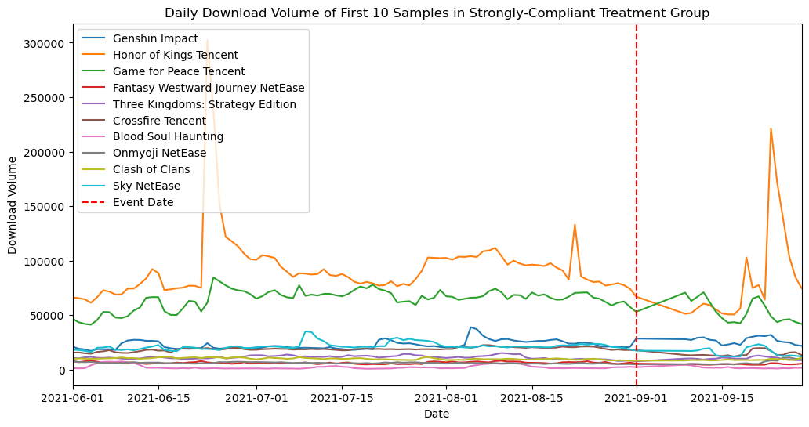
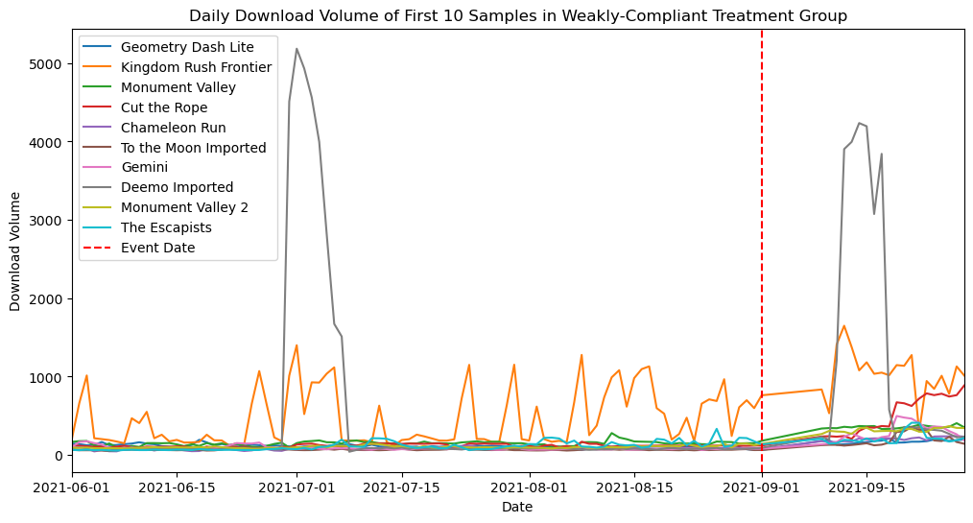
Source: Qimai Data. "iOS Chinese Mobile Game Leaderboard."
- Control Group
For the control group, the variable studied is the daily player of the game, which is the number of users started a gaming session of the selected game at a specific date. The games are selected from the category of free-to-play online multiplayer games available on the international digital video game distribution platform Steam. These games are not regulated by the 2021 Notice and are therefore chosen to be the control group. The games selected for this group have well-established Chinese player community and are among the top 50 online games that have the most active daily players on Steam. However, the limitation in this group is that the daily number of players counts for all playing session globally, including regions outside China. So this data will have noise and due to the limited information provided by the database, it is not feasible to filter out the daily number of players in China. (Table 3 Appendix 2)
The time series data of the control group is plotted below.
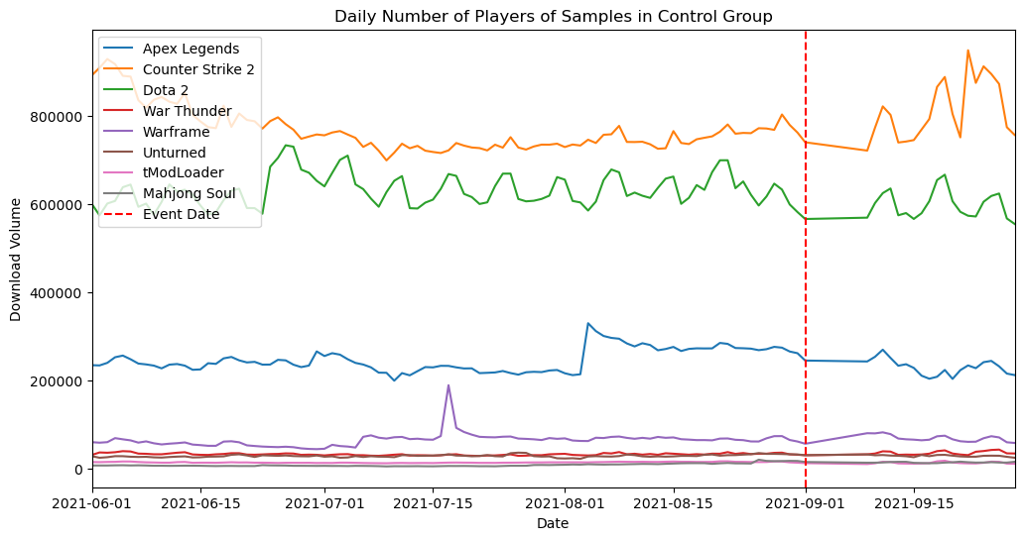
Source: Steam Database.
For the game-based data analysis, the estimation period is selected to be from 2021/6/1 to 2021/8/11, and the event window is from 2021/8/12 to 2021/9/1 and 2021/9/9 to 2021/9/28. In total, there are 71 days in the estimation period and 41 days including the event day in the event window. For each of the sample studied, there will be 112 observations. The matrix size is 112x41 for the strong-compliant treatment group, 112x19 for weak-compliant treatment group, 112x8 for the control group.

Stock Price Data
The stock price data is collected from Yahoo Finance. The treatment group consists of four Chinese public video game companies: Tencent, NetEase, G-bits, and Perfect World Pictures, and one synthesized video game market stock labeled “Total”. (Table 4 Appendix 2) To apply the market model in event study, this research synthesized a video game stock price benchmark consisting of 15 public video game companies curated by Yahoo Finance. (Table 5 Appendix 2)
The daily stock price of four Chinese public video game companies and synthesized video game market stock are plotted below.
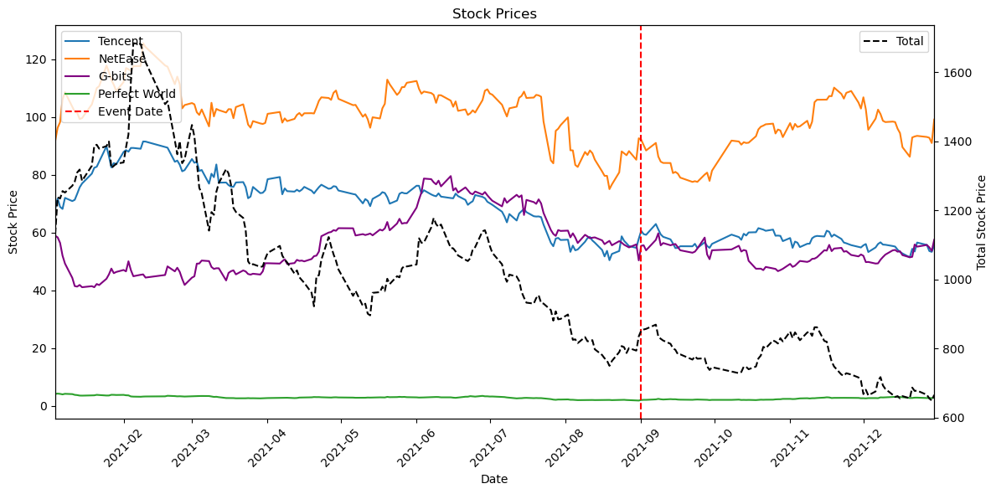
Source: Yahoo! Finance.
The estimation window is from 2021/4/27 to 2021/8/11, in which there are 71 valid trading days. The event window is from 2021/8/12 to 2021/10/19, in which there are 41 valid trading days. The stock prices in other currencies are converted to US dollar based on the daily exchange rate. The matrix size for the stock price is 112x5, including the synthesized market benchmark.

Event Study
The event study part of this research is split into three parts. The first part is analyzing the level effect of the variables, the second part is analyzing the first difference in log of the variables, and the third part is the stock return event study.

Level Term
- Strong- and weak-compliant treatment group
By performing the Augmented Dickey-Fuller Test, including a constant and a trend, less than half of the samples selected in the treatment group appear to be stationary during the estimation window (2021/6/1 – 2021/8/11).
After taking the mean of daily download volume of the samples as expected value during the estimation window, the abnormal daily download volume of each sample is calculated by subtracting the expected value from the actual daily download volume during the event window (2021/8/12 – 2021/9/1, 2021/9/9-2021/9/28). Then, the average abnormal volume and cumulative abnormal volume of each sample during the event window are calculated accordingly by the formulas defined before. Lastly, the t-test is performed to check the statistical significance of the average abnormal return against the null hypothesis ($H_{null}: {\hat{AAR}}_{i}=0)$.
In the strong-compliant treatment group, 16 samples are stationary during the estimation window, and 33 out of 41 samples have statistically significant average abnormal daily download volumes during the event window. (Table 1 & 2 Appendix 3) In the weak-compliant treatment group, 15 samples are stationary during the estimation window, and 17 out of 19 samples have statistically significant average abnormal daily download volumes during the event window. (Table 3 & 4 Appendix 3)
The trends of abnormal daily download volume during the event window for the first 10 samples in both of the treatment groups are plotted below.
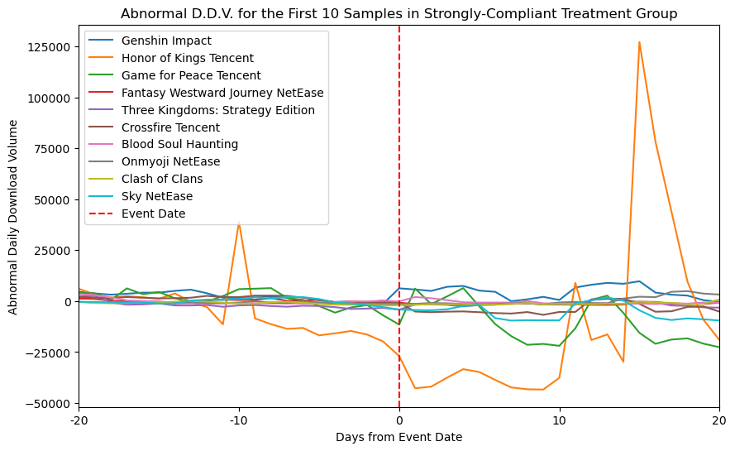
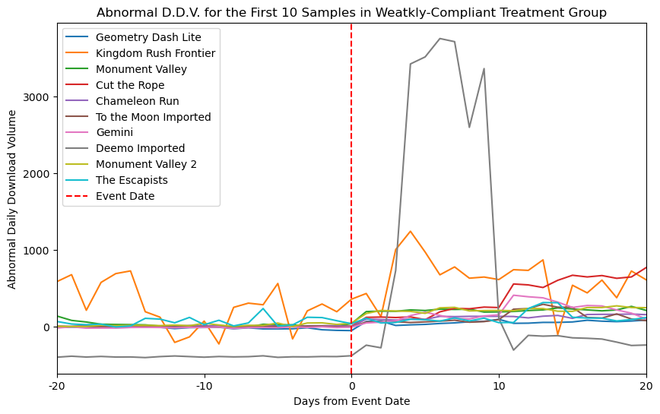
- Control group
By performing the Augmented Dickey-Fuller Test, the daily number of players of most samples selected in the control group do not appear to be stationary during the estimation window (2021/6/1 – 2021/8/11).
After taking the mean of daily number of players as expected value during the estimation window, the abnormal return of each sample is calculated by subtracting the expected value from the actual daily number of players during the event window (2021/8/12 – 2021/9/1, 2021/9/9-2021/9/28). Then, the average abnormal daily number of players and cumulative abnormal daily number of players of each sample during the event window are calculated accordingly by the formulas defined before. Lastly, the t-test is performed to check the statistical significance of the average abnormal return against the null hypothesis ($H_{null}: {\hat{AAR}}_{i}=0)$.
In the control group, 4 samples are stationary during the estimation window, and 6 out of 8 samples have statistically significant abnormal daily number of players during the event window. (Table 5 & 6 Appendix 3)
The trend of abnormal daily download volume during the event window for the first 5 samples in the control group are plotted below.
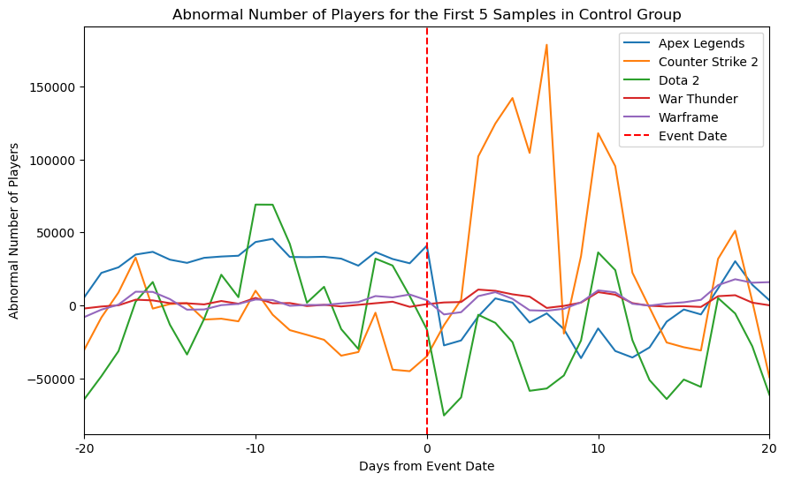

First Difference in Log
- Strong- and weak-compliant treatment group
By taking the first difference in log of the variables, this section is trying to analyze the changing rate of the variables during the event window. Due to the missing values of some dates in the data, the event window is modified accordingly when taking the first difference in log of the variables. The event window selected for this section is from 2021/8/12 to 2021/9/1 and 2021/9/10 to 2021/9/29, while the estimation window remains from 2021/6/1 to 2021/8/11. The rest of the procedure is the same as the previous section of level term.
The Augmented Dickey-Fuller test shows that most samples in the treatment group are stationary during the estimation period by taking the first difference in log. However, the average abnormal first difference in log appears to be insignificant for most of the samples in the control group.
In the strong-compliant treatment group, after taking the first difference in log, 41 out of 41 samples are stationary in the estimation window, but only 2 out of 41 samples have statistically significant average abnormal changing rate in the event window. (Table 1 & 2 Appendix 4) In the weak-compliant treatment group, 19 out of 19 samples are stationary during the estimation window, but none of the samples has statistically significant average abnormal changing rate of daily download volume in the event window. (Table 3 & 4 Appendix 4)
The trends of abnormal changing rate in daily download volume during the event window for the first 10 samples in both of the treatment groups are plotted below.
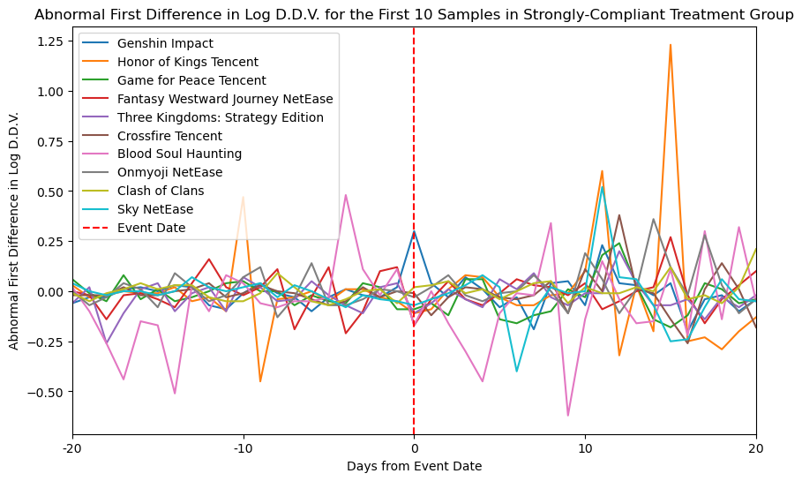
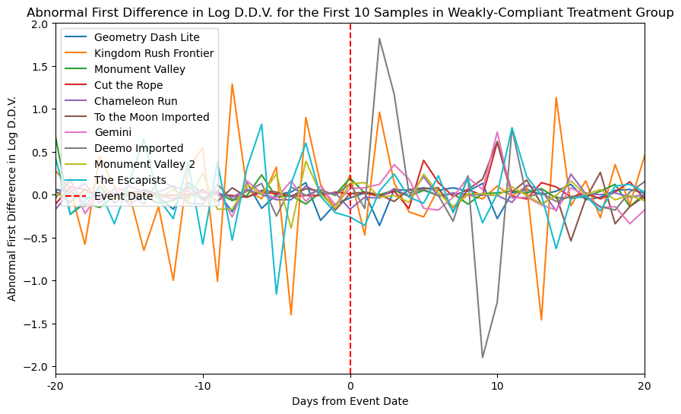
- Control group
Similar procedure is adopted to the control group.
In control group, by taking the first difference in log, 8 out of 8 samples are stationary during the estimation window, but none has statistically significant abnormal changing rate in daily number of players during the event window. Detailed results are listed in Table 5 & 6 in Appendix 4.
The trends of abnormal changing rate in daily number of players during the event window for the first 5 samples in control group are plotted below.
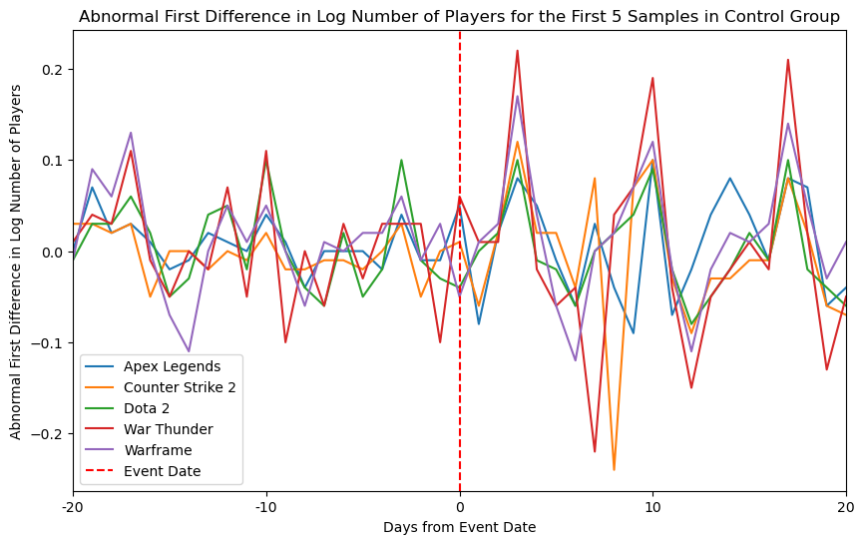

Stock Return
The event study of stock return is based on the market model. After converting daily stock price into daily stock return, a linear regression of the sample stock return against market return is applied to get the coefficients. The coefficients are used to estimate the expected sample stock return based on the market benchmark return, and the abnormal sample stock return is calculated by subtracting the expected sample return from the actual return during the event window.
All the sample stock return are stationary during the estimation window, but none exhibits statistically significant average abnormal return during the event window. (Table 1 & 2 Appendix 5)
The trends of abnormal stock return during the event window are plotted below.
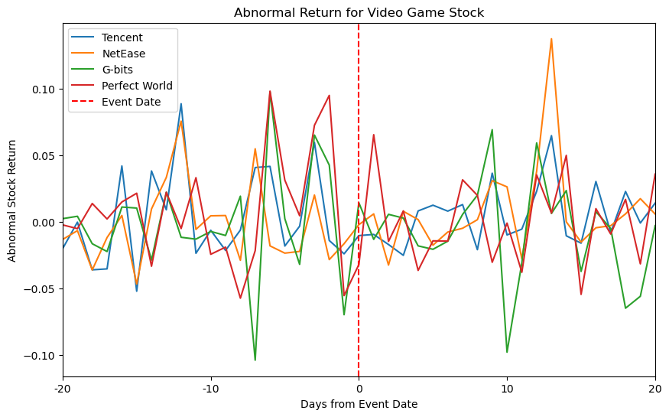

Result

Level Term
On the level-term, most of the samples from the treatment groups had exhibited statistically significant abnormal daily download volumes during the event window at 95% significance level, but are not stationary during the estimation window.
For the strong-compliant treatment group, the average abnormal daily download volume for each mobile game can be positive or negative depending on different mobile games, but the mean average abnormal daily download volume in the treatment group is -43,288.89, and the group mean is at 99% significance level against the null hypothesis. The result implies that, one average, the mobile games in the strong compliant group have a decrease in their daily download volume due to the impact of 2021 Notice. Additionally, although the abnormal daily download volume was negative after the Notice became effective, about 10 days later, there is a surge in the numbers spotted for the mobile game Honors of Kings, which was the top 1 mobile game on iOS App Store leaderboard when the Notice became effective. This game has been popular among minors even nowadays, and this rebound in abnormal daily download volume may indicate the policy was effective in the short run but failed to make the minors comply in the long run.
For the weak-compliant treatment group, the majority of samples had a positive average abnormal daily download volume, implying that users may turn to the mobile games that have not implemented the age verification system during the event window period. And the trend of abnormal daily download volume indicates that the users were actively turning to the weak-compliant mobile games after the 2021 Notice became effective.
For the control group, the samples selected generally have a statistically significant and positive average abnormal number of players during the event window, implying more players might seek for the games that are not regulated by the 2021 Notice. Due to the limitation of not knowing the demographic distribution of players, the results may not yield concrete implications for the unregulated games.
The results for the level basis are summarized in the following table.
 | Strong-Compliant Treatment | Weak-Compliant Treatment | Control
Number of Samples | 41 | 19 | 8
Stationary in Estimation Window | 16 | 15 | 4
Statistically Significant AAR at 95% level | 33 | 17 | 6
Group Average AAR | -43,288.89*** | 3,423.55* | 129,759.58
Group Average CAR | -1,055.83*** | 83.50* | 3,164.87
*** stands for 99% significance level, ** for 95%, * for 90%

First Difference in Log
On the first different in log term, the stationarity of both treatment and control groups are restored, but the average abnormal variables become statistically insignificant.
The results for the first difference in log are summarized in the following table.
 | Strong-Compliant Treatment | Weak-Compliant Treatment | Control
Number of Samples | 41 | 19 | 8
Stationary in Estimation Window | 41 | 19 | 8
Statistically Significant AAR at 95% level | 2 | 0 | 0
Group Average AAR | -0.35*** | 0.154 | 0.061
Group Average CAR | -0.0086*** | 0.00377 | 0.0015
*** stands for 99% significance level, ** for 95%, * for 90%

Stock Return
For the stock return event study, no statistically significant results are found. Although all samples are stationary during the estimation window, none of the samples has statistically significant average abnormal return during the event window. Yet, the insignificant results may indicate that the financial investors of mobile game stocks not as affected as the video game players, who include the minors being greatly restricted by the policy.

Limitation
- Variable
The variables studied in this research are not the best measurement of the impact of 2021 Notice, as the major change happens in the gaming hours for minors. Due to the data availability, such data is generally confidential inside video game companies, and a more thorough and insightful research can be done if such data is available for public. For the daily download volume, since the regular players are not likely to download the games multiple times when they play the games, the variable may fail to capture the changes in gaming behaviors of the minors.
The limitation for the control group is that the player number includes users from other regions besides China and therefore may not be able to properly represent the changes in Chinese players’ behaviors during the event window.
- Methodology
From the perspective of policy evaluation, a difference in difference analysis can better examine if the 2021 Notice has a long-term permanent change in the video game industry than the event study, which focuses on the short run variations from day to another. Also, the difference in the way of processing the variable, the original event study paper focuses on return rate but this research focuses on level term, curtails the explainability of the results. The lack of stationarity of the level term may raise the problem of using the constant model to estimate the expected value in the event window, but due to the lack of a market benchmark, the compromises are made in this research.
- Control Variables
The lack of control variables may curtail the explainability of the results. The control variables of interest may be the features of selected video games, (single player or multiplayer, action games, role-play games, etc.), number of updates during the event window, the types of game developers, etc. Since there is no free database integrating all the information about video games, manual collection may require more labor and efforts.
- Measurement Error
The days between 2021/9/2 and 2021/9/8 are not selected in this research because of missing values from the database. There are multiple reasons for the missing data during this period. One explanation can be the measurement error in the database, as the database service provider failed to collect the data during this period. The other plausible explanation is because of the enforcement of the 2021 Notice. After the enforcement, most of the mobile games immediately upgraded their game version to incorporate the age verification system, and during the upgrade period, the service provider might have suspended the download from App Store to prevent minors from playing the games in prohibited times.

Conclusion
The 2021 Notice on Minor Video Game Addiction Prevention has a great impact in the online games in the Chinese industry and enforced the video game companies to adopt a verification system to prevent minors from addictive gaming. This research analyzes the daily download volumes of the games that comply with the new regulation and attempts to take into account the compliance issue arising from the verification system. Also, the research studies the stock return changes before and after the 2021 Notice became effective.
By applying the event study method to study the short run impact of the 2021 Notice, results show that the daily download volume of the strong-compliant treatment group received a negative impact from the 2021 Notice, indicating less new or returned users are downloading the games and less playing session accordingly. The games in the weak-compliant group had more daily download volumes than estimated, as the policy may unintentionally direct the minors to play the mobile games that deploy a weak verification system, which the minors can easily manipulate and evade the policy’s restriction. Specifically, for the top 1 mobile game Honors of King, players might have found ways to evade the verification system about 10 days after the 2021 Notice became effective, which was represented by the rebound in daily download volume 10 days after the event. Additionally, no evidence is found in the Notice’s impact on the stock return, which implies the financial investment in the Chinese video game companies are not affected by the 2021 Notice, since the financial investors are different parties of interest compared to the minors who are mainly affected by the 2021 Notice.
To further study the long-term permanent impact of the 2021 Notice on the Chinese video game industry, a difference-in-difference model can be applied and more control variables can be studied to validify the results. The 2021 Notice has been very influential and serves for an example for future regulations in the video game industry, and more insightful results may be discovered if the data of player’s gaming behavior can be publicly accessible.

Appendix 1 User Identity Verification Systems in Different Mobile Games
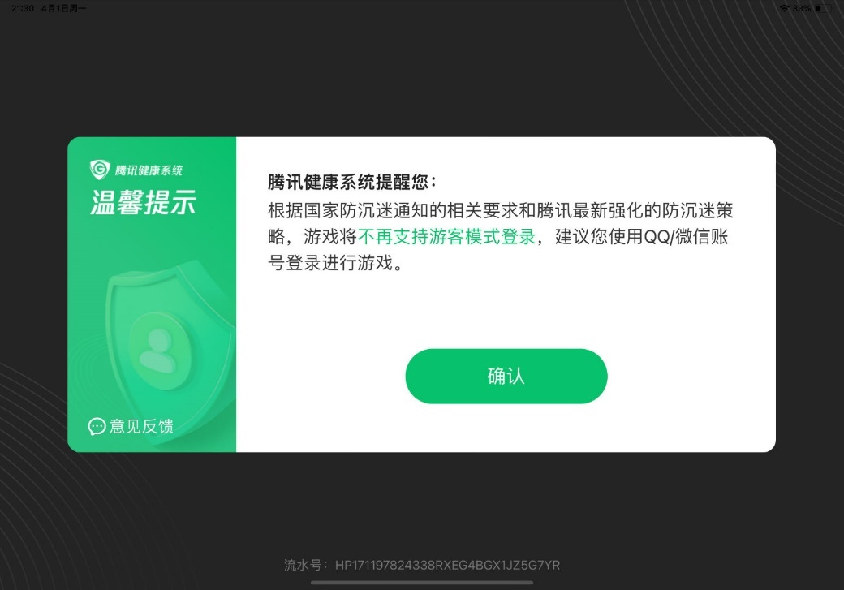
Image 1: age verification system adopted by Tencent.
Translation of text in the image: Tencent’s health system kindly reminds you that according to the government’s notice and Tencent’s updated policies of preventing game addiction, the game will no longer offer visitor’s account to log in the game (which doesn’t require the user to verify their age and ID), and you’re advised to use your QQ/WeChat (*author’s note: social media run by Tencent) accounts to log into the game.
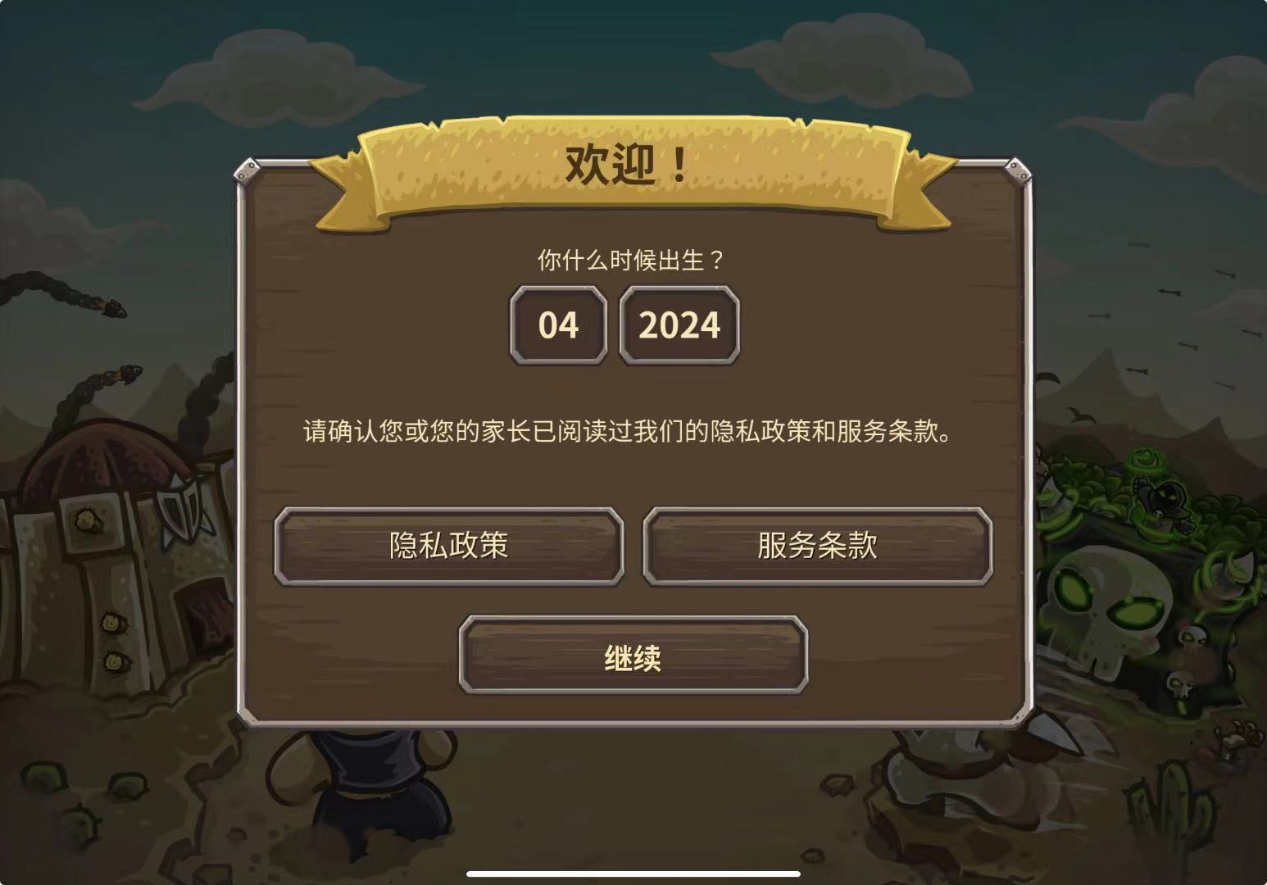
Image 2: age verification system used by Kingdom Rush Frontier.
Translation of the text in the image: Welcome! When were you born? (User can choose their birth month and year truthfully or falsely.) Please make sure you or your parent has read our privacy policy and terms of service. (The left middle button is the game’s privacy policy and the right middle button is the terms of service. The bottom button is to proceed into the game, and the user is not compelled to read the policies or terms before proceeding.)

Appendix 2 Statistics Table for Data
Table 1 Statistics of strong-compliant treatment group
Game name | count | mean | std | min | 25% | 50% | 75% | max
Genshin Impact | 112 | 23453.39 | 4172.572 | 17211 | 19992 | 22210 | 26456 | 38929
Honor of Kings Tencent | 112 | 91033.26 | 34066.54 | 50607 | 74905 | 84871 | 101378 | 302708
Game for Peace Tencent | 112 | 62786.57 | 10031.88 | 41270 | 56165 | 65962 | 69488 | 84563
Fantasy Westward Journey NetEase | 112 | 6075.133 | 944.2391 | 4470 | 5214 | 6027 | 6735 | 8242
Three Kingdoms: Strategy Edition | 112 | 11200.39 | 1559.719 | 7639 | 10090 | 11093 | 12266 | 15280
Crossfire Tencent | 112 | 18158.2 | 2433.844 | 11895 | 17265 | 18763 | 19871 | 22550
Blood Soul Haunting | 112 | 2289.593 | 1696.081 | 800 | 1219 | 1464 | 2561 | 7548
Onmyoji NetEase | 112 | 6231.593 | 1070.271 | 4681 | 5622 | 6040 | 6532 | 11225
Clash of Clans | 112 | 9868.558 | 895.1147 | 8092 | 9031 | 9872 | 10453 | 11703
Sky NetEase | 112 | 20589.09 | 3990.918 | 12063 | 18702 | 20809 | 21784 | 35107
Journey to the West NetEase | 112 | 1393.761 | 467.8693 | 780 | 1077 | 1243 | 1590 | 3188
eFootball NetEase | 112 | 6074.062 | 2360.723 | 3835 | 4492 | 4948 | 6967 | 17855
Xian LTGames | 112 | 9460.381 | 2377.206 | 5890 | 7937 | 8874 | 10605 | 17566
X5 Tencent | 112 | 4518.319 | 578.2718 | 3195 | 4109 | 4459 | 4906 | 6478
The Magic Blade Tencent | 112 | 5388.097 | 1501.632 | 3974 | 4603 | 4872 | 5375 | 10813
JJ Doudizhu | 112 | 11559.16 | 773.423 | 9766 | 11107 | 11411 | 12239 | 13238
One Piece: The Bloodline | 112 | 10991.14 | 4445.268 | 4954 | 7880 | 10549 | 14192 | 24619
Naruto Tencent | 112 | 12482.47 | 1875.973 | 8944 | 11185 | 12346 | 13402 | 18386
Infinite Borders NetEase | 112 | 3051.274 | 701.6665 | 1829 | 2429 | 2917 | 3782 | 4325
Rise of Kingdoms | 112 | 8193.619 | 1738.839 | 5908 | 7287 | 7931 | 8793 | 18864
Huan Tang Zhi | 112 | 1260.15 | 869.2348 | 600 | 786 | 888 | 1081 | 3822
Speed Drifters Tencent | 112 | 25278.57 | 3917.112 | 16885 | 22730 | 26359 | 27908 | 33944
Happy Poker Tencent | 112 | 28940.66 | 1879.786 | 24893 | 27498 | 28737 | 30535 | 33211
Way of Tao | 112 | 2305.894 | 747.3057 | 1204 | 1826 | 2045 | 2548 | 4149
Happy Eliminating | 112 | 35057.69 | 2508.461 | 29091 | 33547 | 35093 | 36382 | 43208
Sichuan Mahjang | 112 | 19747.63 | 4277.62 | 9791 | 16945 | 19432 | 21249 | 33110
Fishing Arena | 112 | 5108.088 | 1777.305 | 1477 | 4177 | 4990 | 6198 | 8892
Fate of Empress | 112 | 9427.451 | 1256.386 | 6716 | 8393 | 9565 | 10258 | 11993
AFK Arena | 112 | 1063.681 | 544.8716 | 467 | 607 | 864 | 1408 | 2669
Hearthstone | 112 | 4803.593 | 615.1289 | 3758 | 4448 | 4645 | 5106 | 7358
Life After NetEase | 112 | 11054.02 | 7337.543 | 5025 | 7293 | 8339 | 11734 | 39247
A Chinese Ghost Story NetEase | 112 | 2324.292 | 1288.035 | 1048 | 1465 | 1811 | 2681 | 6608
Yooku Arcade Fishing | 112 | 3053.425 | 1000.785 | 1522 | 2068 | 2903 | 3948 | 5773
Three Kingdoms Fantasy | 112 | 2421.451 | 1920.905 | 1144 | 1396 | 1862 | 2510 | 14405
Perfect World Tencent | 112 | 1292.655 | 533.6922 | 649 | 871 | 1086 | 1594 | 2562
Strike of Kings Tencent | 112 | 1156.602 | 810.2199 | 452 | 736 | 883 | 1225 | 4351
Call me the big shopkeeper | 112 | 11492.7 | 5148.996 | 4222 | 8121 | 11002 | 13369 | 34516
FC Football World Tencent | 112 | 5708.664 | 2796.369 | 2257 | 3765 | 4648 | 7157 | 16375
Ninja Must Die 3 | 112 | 7903.805 | 5243.197 | 3634 | 4476 | 5428 | 8339 | 25025
Top War | 112 | 11927.51 | 7955.192 | 3007 | 5365 | 11402 | 14658 | 36883
The Demi-Gods and Semi-Devils Tencent | 112 | 1621.062 | 418.7055 | 918 | 1440 | 1553 | 1705 | 3939

Table 2 Statistics of weak-compliant treatment group
Game name | count | mean | std | min | 25% | 50% | 75% | max
Geometry Dash Lite | 112 | 123.1327 | 31.37916 | 63 | 105 | 112 | 138 | 210
Kingdom Rush Frontier | 112 | 566.9646 | 404.9406 | 120 | 191 | 522 | 967 | 1649
Monument Valley | 112 | 186.469 | 83.783 | 96 | 141 | 152 | 178 | 406
Cut the Rope | 112 | 188.2743 | 182.7198 | 69 | 107 | 120 | 145 | 886
Chameleon Run | 112 | 103.5221 | 50.87451 | 46 | 77 | 85 | 100 | 242
To the Moon Imported | 112 | 90.15929 | 58.47352 | 51 | 63 | 67 | 91 | 358
Gemini | 112 | 122.4159 | 91.28309 | 64 | 76 | 84 | 123 | 498
Deemo Imported | 112 | 568.4336 | 1264.34 | 42 | 76 | 83 | 96 | 5184
Monument Valley 2 | 112 | 141.3628 | 84.2917 | 80 | 93 | 100 | 125 | 368
The Escapists | 112 | 132.1947 | 70.82396 | 56 | 74 | 108 | 176 | 412
Sheltered: Survival Imported | 112 | 141.2212 | 91.82337 | 62 | 91 | 112 | 175 | 764
Agent A | 112 | 141.2212 | 91.82337 | 62 | 91 | 112 | 175 | 764
Cytus Imported | 112 | 58.25664 | 26.1236 | 34 | 45 | 48 | 52 | 136
Ice Lakes | 112 | 71.82301 | 25.85717 | 51 | 56 | 61 | 68 | 152
Clash of Warlords | 112 | 50.69027 | 19.31694 | 25 | 35 | 50 | 60 | 116
PopStar! | 112 | 58.15044 | 47.97958 | 19 | 37 | 39 | 49 | 194
Fighters Run | 112 | 9933.558 | 2178.599 | 5844 | 8252 | 9752 | 11875 | 14417
Cytus II Imported | 112 | 1466.611 | 1857.403 | 0 | 115 | 153 | 3674 | 5756
Muse Dash | 112 | 141.6726 | 46.3231 | 110 | 112 | 115 | 175 | 294

Table 3 Statistics of control group
Game Name | count | mean | std | min | 25% | 50% | 75% | max
Apex Legends | 112 | 244490.9 | 25536.72 | 200149 | 224897 | 237471 | 266344 | 330509
Counter Strike 2 | 112 | 776375.5 | 54893.66 | 699940 | 736982 | 759183 | 793807 | 949817
Dota 2 | 112 | 625896.1 | 37713.49 | 555891 | 601098 | 619753 | 652226 | 734277
War Thunder | 112 | 33803.63 | 2993.462 | 29413 | 31830 | 33197 | 34992 | 43814
Warframe | 112 | 66277.54 | 14755.61 | 44851 | 60423 | 66488 | 70841 | 189837
Unturned | 112 | 29429.95 | 2627.102 | 22919 | 27820 | 28950 | 31157 | 36896
tModLoader | 112 | 14629.45 | 1401.939 | 10990 | 13740 | 14479 | 15774 | 18540
Mahjong Soul | 112 | 10055.07 | 3764.413 | 5672 | 6811 | 8548 | 13054 | 20920

Table 4 Statistics of stock price data
Stock Name | count | mean | std | min | 25% | 50% | 75% | max
Tencent | 112 | 67.19447 | 10.70407 | 50.42253 | 56.84028 | 68.14641 | 74.66931 | 91.50839
NetEase | 112 | 99.59091 | 9.740908 | 75.02247 | 93.86182 | 101.0127 | 106.5618 | 125.4906
G-bits | 112 | 55.56343 | 9.242698 | 41.0834 | 49.13525 | 53.83995 | 59.6956 | 79.53761
Perfect World | 112 | 2.818979 | 0.524356 | 1.872205 | 2.365774 | 2.812353 | 3.10643 | 4.274704
Total | 112 | 986.2263 | 235.5163 | 649.0395 | 800.5281 | 961.1025 | 1122.56 | 1684.224

Table 5 Statistics of 15 stocks used for market benchmark
Ticker | count | mean | std | min | 25% | 50% | 75% | max
OTGLY | 112 | 12.50615 | 2.368025 | 9.748171 | 10.97796 | 11.65425 | 12.83194 | 22.14105
BILI | 112 | 95.57335 | 24.92318 | 42.57 | 75.405 | 101.06 | 111.925 | 156.37
TTWO | 112 | 175.6379 | 13.91958 | 145.25 | 167.255 | 173.82 | 183.87 | 213.34
EA | 112 | 136.6472 | 5.767868 | 118.4985 | 133.8235 | 138.3484 | 140.6712 | 146.2945
NTDOY | 112 | 13.43782 | 1.689278 | 10.678 | 11.825 | 14.024 | 14.77 | 16.32
SGAMY | 112 | 3.690797 | 0.369471 | 2.96 | 3.34 | 3.66 | 4.035 | 4.42
UBSFY | 112 | 13.87299 | 3.002565 | 9.05 | 11.85 | 13.81 | 15.525 | 21.24
GRVY | 112 | 115.1832 | 31.77149 | 66.5 | 95.21 | 105.35 | 129.585 | 216.82
SOHU | 112 | 19.0141 | 2.222975 | 15.13 | 17.4 | 18.56 | 20.715 | 24.49
MYPS | 112 | 7.5151 | 2.70293 | 3.72 | 4.68 | 7.42 | 10 | 11.78
BRAG | 112 | 12.18487 | 4.600981 | 5.15 | 8.635 | 11.07 | 16.25 | 24
SKLZ | 112 | 343.6622 | 161.7119 | 143.8 | 221 | 305.6 | 425.3 | 874.4
GMGI | 112 | 2.537677 | 0.346163 | 1.96 | 2.25 | 2.47 | 2.86 | 3.4
BHAT | 112 | 8.880876 | 3.326023 | 4.04 | 6.325 | 8.05 | 11.55 | 17.2
GAME | 112 | 29.19219 | 10.89766 | 11.44 | 18.2 | 31 | 38.528 | 52.6

Appendix 3 Results for Level Effect
Table 1 Constant mean model results on level effect for strong-compliant treatment group
Mobile Game | CCR | AAR | Significance Level (at 95%) | T value | P value
Genshin Impact | 138531.96 | 3378.828293 | Significant | 7.058309081 | 1.56E-08
Honor of Kings Tencent | -333126.48 | -8125.036098 | Not Significant | -1.570861165 | 0.124093
Game for Peace Tencent | -199741.79 | -4871.750976 | Significant | -3.15320251 | 0.00306
Fantasy Westward Journey NetEase | -22660.47 | -552.6943902 | Significant | -3.749804132 | 0.00056
Three Kingdoms: Strategy Edition | -68412.21 | -1668.590488 | Significant | -7.292178581 | 7.37E-09
Crossfire Tencent | -51604.08 | -1258.636098 | Significant | -2.443997034 | 0.01903
Blood Soul Haunting | -14761.02 | -360.024878 | Not Significant | -1.979499715 | 0.054671
Onmyoji NetEase | -9242.99 | -225.4387805 | Not Significant | -0.867526327 | 0.390829
Clash of Clans | -43903.28 | -1070.811707 | Significant | -10.73644628 | 2.39E-13
Sky NetEase | -115267.15 | -2811.393902 | Significant | -4.518532793 | 5.41E-05
Journey to the West NetEase | 13222.25 | 322.4939024 | Significant | 3.328243464 | 0.001884
eFootball NetEase | -103642.25 | -2527.859756 | Significant | -64.59609354 | 4.47E-42
Xian LTGames | 122046.88 | 2976.753171 | Significant | 7.342310535 | 6.29E-09
X5 Tencent | 12291.86 | 299.8014634 | Significant | 3.635186212 | 0.000784
The Magic Blade Tencent | -47072.47 | -1148.109024 | Significant | -15.96575678 | 5.97E-19
JJ Doudizhu | -44576.24 | -1087.225366 | Significant | -14.9087926 | 6.29E-18
One Piece: The Bloodline | -222906.16 | -5436.73561 | Significant | -14.57099773 | 1.37E-17
Naruto Tencent | -90634.14 | -2210.58878 | Significant | -13.76897261 | 9.12E-17
Infinite Borders NetEase | 31391.73 | 765.6519512 | Significant | 10.18906113 | 1.12E-12
Rise of Kingdoms | -13807.21 | -336.7612195 | Not Significant | -1.771998861 | 0.084012
Huan Tang Zhi | 39949.99 | 974.39 | Significant | 5.184655525 | 6.56E-06
Speed Drifters Tencent | -168390.75 | -4107.091463 | Significant | -6.261121481 | 2.03E-07
Happy Poker Tencent | -79078.27 | -1928.738293 | Significant | -8.37871595 | 2.44E-10
Way of Tao | 33660.59 | 820.99 | Significant | 6.281642797 | 1.9E-07
Happy Eliminating | -70440.46 | -1718.06 | Significant | -3.944824582 | 0.000314
Sichuan Mahjang | -10518.11 | -256.5392683 | Not Significant | -0.621544861 | 0.537768
Fishing Arena | 111464.12 | 2718.637073 | Significant | 16.60775386 | 1.51E-19
Fate of Empress | -69626.01 | -1698.195366 | Significant | -11.02705723 | 1.07E-13
AFK Arena | 21617.42 | 527.2541463 | Significant | 7.665935317 | 2.26E-09
Hearthstone | -25923 | -632.2682927 | Significant | -11.27525029 | 5.43E-14
Life After NetEase | 94791.85 | 2311.996341 | Significant | 2.546685837 | 0.014828
A Chinese Ghost Story NetEase | 39962.76 | 974.7014634 | Significant | 4.371982572 | 8.53E-05
Yooku Arcade Fishing | 60377.49 | 1472.621707 | Significant | 30.14924973 | 4.01E-29
Three Kingdoms Fantasy | -11870.5 | -289.5243902 | Not Significant | -1.830830673 | 0.074583
Perfect World Tencent | 32844 | 801.0731707 | Significant | 10.70997022 | 2.58E-13
Strike of Kings Tencent | 31901.11 | 778.0758537 | Significant | 4.372966705 | 8.51E-05
Call me the big shopkeeper | -62366.01 | -1521.122195 | Not Significant | -1.253202549 | 0.217408
FC Football World Tencent | -147327.04 | -3593.342439 | Significant | -39.350449 | 1.33E-33
Ninja Must Die 3 | -103666.61 | -2528.453902 | Significant | -11.65104124 | 1.97E-14
Top War | -429362.38 | -10472.25317 | Significant | -44.42675815 | 1.16E-35
The Demi-Gods and Semi-Devils Tencent | 1028.64 | 25.08878049 | Not Significant | 0.347813824 | 0.729804

Table 2 Stationarity and AAR results for constant mean model on strong-compliant treatment group
Game Name | Stationary in Estimation | AAR Significant
Genshin Impact | Yes | Yes
Honor of Kings Tencent | Yes | No
Game for Peace Tencent | No | Yes
Fantasy Westward Journey NetEase | No | Yes
Three Kingdoms: Strategy Edition | No | Yes
Crossfire Tencent | No | Yes
Blood Soul Haunting | No | No
Onmyoji NetEase | Yes | No
Clash of Clans | No | Yes
Sky NetEase | Yes | Yes
Journey to the West NetEase | No | Yes
eFootball NetEase | No | Yes
Xian LTGames | No | Yes
X5 Tencent | No | Yes
The Magic Blade Tencent | No | Yes
JJ Doudizhu | Yes | Yes
One Piece: The Bloodline | No | Yes
Naruto Tencent | No | Yes
Infinite Borders NetEase | No | Yes
Rise of Kingdoms | Yes | No
Huan Tang Zhi | No | Yes
Speed Drifters Tencent | No | Yes
Happy Poker Tencent | No | Yes
Way of Tao | Yes | Yes
Happy Eliminating | Yes | Yes
Sichuan Mahjang | No | No
Fishing Arena | No | Yes
Fate of Empress | Yes | Yes
AFK Arena | No | Yes
Hearthstone | Yes | Yes
Life After NetEase | No | Yes
A Chinese Ghost Story NetEase | No | Yes
Yooku Arcade Fishing | No | Yes
Three Kingdoms Fantasy | No | No
Perfect World Tencent | Yes | Yes
Strike of Kings Tencent | No | Yes
Call me the big shopkeeper | Yes | No
FC Football World Tencent | No | Yes
Ninja Must Die 3 | No | Yes
Top War | No | Yes
The Demi-Gods and Semi-Devils Tencent | Yes | No
Total Positive Observations | 13 | 33

Table 3 Constant mean model results on level effect for weak-compliant treatment group
Game Name | CAR | AAR | Significance Level | T value | P value
Geometry Dash Lite | 633.27 | 15.44561 | Significant | 2.292469 | 0.027217
Kingdom Rush Frontier | 18185.77 | 443.5554 | Significant | 8.17935 | 4.52E-10
Monument Valley | 4750.37 | 115.8627 | Significant | 7.457953 | 4.35E-09
Cut the Rope | 7973.89 | 194.4851 | Significant | 4.779684 | 2.38E-05
Chameleon Run | 2610.78 | 63.67756 | Significant | 6.362296 | 1.46E-07
To the Moon Imported | 2400.28 | 58.54341 | Significant | 4.449185 | 6.72E-05
Gemini | 3592.58 | 87.6239 | Significant | 4.28079 | 0.000113
Deemo Imported | 10561.23 | 257.591 | Not Significant | 1.230828 | 0.225576
Monument Valley 2 | 4755.52 | 115.9883 | Significant | 7.137827 | 1.21E-08
The Escapists | 3586.14 | 87.46683 | Significant | 7.704726 | 2E-09
Sheltered: Survival Imported | 1515.79 | 36.97049 | Significant | 4.906501 | 1.59E-05
Agent A | 1515.79 | 36.97049 | Significant | 4.906501 | 1.59E-05
Cytus Imported | 1372.49 | 33.47537 | Significant | 6.341184 | 1.57E-07
Ice Lakes | 1284.14 | 31.32049 | Significant | 5.888383 | 6.78E-07
Clash of Warlords | 548.97 | 13.38951 | Significant | 3.351786 | 0.001763
PopStar! | 2035.26 | 49.64049 | Significant | 4.731579 | 2.77E-05
Fighters Run | 21653.87 | 528.1432 | Not Significant | 1.639399 | 0.108973
Cytus II Imported | -25867.7 | -630.92 | Significant | -2.68609 | 0.010476
Muse Dash | 1939.09 | 47.29488 | Significant | 5.105217 | 8.46E-06

Table 4 Stationarity and AAR results for constant mean model on weak-compliant treatment group
Game Name | Stationary in Estimation | AAR Significant
Geometry Dash Lite | Yes | Yes
Kingdom Rush Frontier | Yes | Yes
Monument Valley | Yes | Yes
Cut the Rope | Yes | Yes
Chameleon Run | Yes | Yes
To the Moon Imported | Yes | Yes
Gemini | Yes | Yes
Deemo Imported | No | No
Monument Valley 2 | Yes | Yes
The Escapists | No | Yes
Sheltered: Survival Imported | Yes | Yes
Agent A | Yes | Yes
Cytus Imported | Yes | Yes
Ice Lakes | Yes | Yes
Clash of Warlords | Yes | Yes
PopStar! | Yes | Yes
Fighters Run | Yes | No
Cytus II Imported | No | Yes
Muse Dash | No | Yes
Total Positive Observations | 15 | 17

Table 5 Constant mean model results on level effect for control group
Game Name | CAR | AAR | Significance Level | T value | P value
Apex Legends | 477876.87 | 11655.53341 | Significant | 2.977905165 | 0.004911205
Counter Strike 2 | 563476.46 | 13743.32829 | Not Significant | 1.568276767 | 0.124694404
Dota 2 | -600523.63 | -14646.9178 | Significant | -2.531156993 | 0.015403415
War Thunder | 93736.9 | 2286.265854 | Significant | 4.428432996 | 7.16474E-05
Warframe | 135656.36 | 3308.691707 | Significant | 3.500994168 | 0.001154414
Unturned | 67855.14 | 1655.003415 | Significant | 4.562457892 | 4.71823E-05
tModLoader | 16260.04 | 396.5863415 | Not Significant | 1.304950317 | 0.199367342
Mahjong Soul | 283738.49 | 6920.450976 | Significant | 19.94395534 | 2.15984E-22

Table 6 Stationarity and AAR results for constant mean model on control group
Game Name | Stationary in Estimation | AAR Significant
Apex Legends | Yes | Yes
Counter Strike 2 | No | No
Dota 2 | No | Yes
War Thunder | Yes | Yes
Warframe | Yes | Yes
Unturned | Yes | Yes
tModLoader | No | No
Mahjong Soul | No | Yes
Total Positive Observations | 4 | 6

Appendix 4 Results for First Difference in Log
Table 1 Constant mean model results on first difference in log for strong-compliant treatment group
Game Name | CAR | AAR | Significance Level | T value | P value
Genshin Impact | -0.33 | -0.00804878 | Not Significant | -0.601303408 | 0.551030658
Honor of Kings Tencent | -0.26 | -0.006341463 | Not Significant | -0.154247674 | 0.878190094
Game for Peace Tencent | -0.9 | -0.02195122 | Not Significant | -1.646092084 | 0.107580915
Fantasy Westward Journey NetEase | -0.26 | -0.006341463 | Not Significant | -0.424405666 | 0.67354404
Three Kingdoms: Strategy Edition | -1.09 | -0.026585366 | Significant | -2.244323936 | 0.030412076
Crossfire Tencent | -0.43 | -0.010487805 | Not Significant | -0.726910547 | 0.471513769
Blood Soul Haunting | -2.67 | -0.065121951 | Not Significant | -1.900579735 | 0.064580662
Onmyoji NetEase | 0.64 | 0.015609756 | Not Significant | 0.997010529 | 0.324752779
Clash of Clans | 0.15 | 0.003658537 | Not Significant | 0.44320351 | 0.660006452
Sky NetEase | -0.58 | -0.014146341 | Not Significant | -0.728388055 | 0.470619061
Journey to the West NetEase | 0.3 | 0.007317073 | Not Significant | 0.20408116 | 0.839324882
eFootball NetEase | -0.17 | -0.004146341 | Not Significant | -0.700889408 | 0.487429503
Xian LTGames | 0.12 | 0.002926829 | Not Significant | 0.163265306 | 0.871131648
X5 Tencent | -0.21 | -0.005121951 | Not Significant | -0.810937755 | 0.422200472
The Magic Blade Tencent | -0.26 | -0.006341463 | Not Significant | -0.789711974 | 0.434352594
JJ Doudizhu | 1.73472E-17 | 4.23103E-19 | Not Significant | 5.8979E-17 | 1
One Piece: The Bloodline | -0.38 | -0.009268293 | Not Significant | -0.787651468 | 0.435543339
Naruto Tencent | -0.08 | -0.00195122 | Not Significant | -0.221170917 | 0.826084522
Infinite Borders NetEase | -0.39 | -0.009512195 | Not Significant | -0.777948919 | 0.441176552
Rise of Kingdoms | 1.07 | 0.026097561 | Not Significant | 1.818476536 | 0.076484763
Huan Tang Zhi | -0.44 | -0.010731707 | Not Significant | -0.474958748 | 0.637399551
Speed Drifters Tencent | -0.35 | -0.008536585 | Not Significant | -1.322686714 | 0.193452247
Happy Poker Tencent | -0.11 | -0.002682927 | Not Significant | -0.59093684 | 0.55788735
Way of Tao | 0.68 | 0.016585366 | Not Significant | 0.658321284 | 0.51410318
Happy Eliminating | 0.08 | 0.00195122 | Not Significant | 0.353225843 | 0.72577396
Sichuan Mahjang | -0.76 | -0.018536585 | Not Significant | -1.668115312 | 0.103103825
Fishing Arena | -0.52 | -0.012682927 | Not Significant | -1.07659071 | 0.288113707
Fate of Empress | -0.13 | -0.003170732 | Not Significant | -0.325846263 | 0.746239251
AFK Arena | -0.55 | -0.013414634 | Not Significant | -0.380396546 | 0.705663696
Hearthstone | -0.27 | -0.006585366 | Not Significant | -0.795029428 | 0.431288724
Life After NetEase | -2.04 | -0.049756098 | Significant | -3.508154264 | 0.001130963
A Chinese Ghost Story NetEase | -0.13 | -0.003170732 | Not Significant | -0.11716396 | 0.907316454
Yooku Arcade Fishing | -0.47 | -0.011463415 | Not Significant | -1.025038515 | 0.31150428
Three Kingdoms Fantasy | 0.07 | 0.001707317 | Not Significant | 0.094247998 | 0.925382695
Perfect World Tencent | 0.78 | 0.01902439 | Not Significant | 0.455599238 | 0.651141892
Strike of Kings Tencent | -1.43 | -0.034878049 | Not Significant | -0.584026278 | 0.562481971
Call me the big shopkeeper | -1.56 | -0.03804878 | Not Significant | -1.454647419 | 0.15356977
FC Football World Tencent | 0.08 | 0.00195122 | Not Significant | 0.110534779 | 0.912538017
Ninja Must Die 3 | -0.92 | -0.022439024 | Not Significant | -1.559445235 | 0.126768893
Top War | -0.76 | -0.018536585 | Not Significant | -0.994020476 | 0.326188299
The Demi-Gods and Semi-Devils Tencent | 0.03 | 0.000731707 | Not Significant | 0.023095859 | 0.981688643

Table 2 Stationarity and AAR results for weak-compliant treatment group
Game Name | Stationary Estimation | AAR Significant
Genshin Impact | Yes | No
Honor of Kings Tencent | Yes | No
Game for Peace Tencent | Yes | No
Fantasy Westward Journey NetEase | Yes | No
Three Kingdoms: Strategy Edition | Yes | Yes
Crossfire Tencent | Yes | No
Blood Soul Haunting | Yes | No
Onmyoji NetEase | Yes | No
Clash of Clans | Yes | No
Sky NetEase | Yes | No
Journey to the West NetEase | Yes | No
eFootball NetEase | Yes | No
Xian LTGames | Yes | No
X5 Tencent | Yes | No
The Magic Blade Tencent | Yes | No
JJ Doudizhu | Yes | No
One Piece: The Bloodline | Yes | No
Naruto Tencent | Yes | No
Infinite Borders NetEase | Yes | No
Rise of Kingdoms | Yes | No
Huan Tang Zhi | Yes | No
Speed Drifters Tencent | Yes | No
Happy Poker Tencent | Yes | No
Way of Tao | Yes | No
Happy Eliminating | Yes | No
Sichuan Mahjang | Yes | No
Fishing Arena | Yes | No
Fate of Empress | Yes | No
AFK Arena | Yes | No
Hearthstone | Yes | No
Life After NetEase | Yes | Yes
A Chinese Ghost Story NetEase | Yes | No
Yooku Arcade Fishing | Yes | No
Three Kingdoms Fantasy | Yes | No
Perfect World Tencent | Yes | No
Strike of Kings Tencent | Yes | No
Call me the big shopkeeper | Yes | No
FC Football World Tencent | Yes | No
Ninja Must Die 3 | Yes | No
Top War | Yes | No
The Demi-Gods and Semi-Devils Tencent | Yes | No
Total Positive Observations | 41 | 2

Table 3 Constant mean model results on first difference in log for weak-compliant treatment group
Game Name | CAR | AAR | Significance Level | T value | P value
Geometry Dash Lite | -0.26 | -0.006341463 | Not Significant | -0.347309398 | 0.730179719
Kingdom Rush Frontier | 0.01 | 0.000243902 | Not Significant | 0.002707633 | 0.997853083
Monument Valley | 0.36 | 0.008780488 | Not Significant | 0.411956213 | 0.682570879
Cut the Rope | 1.34 | 0.032682927 | Not Significant | 1.667519455 | 0.103222902
Chameleon Run | 0.13 | 0.003170732 | Not Significant | 0.229189226 | 0.819889699
To the Moon Imported | -0.04 | -0.00097561 | Not Significant | -0.037555292 | 0.970229062
Gemini | 0.43 | 0.010487805 | Not Significant | 0.369480034 | 0.713718842
Deemo Imported | 0.32 | 0.007804878 | Not Significant | 0.095435602 | 0.924445358
Monument Valley 2 | 0.52 | 0.012682927 | Not Significant | 0.59803902 | 0.553185155
The Escapists | 0.18 | 0.004390244 | Not Significant | 0.072930191 | 0.94222514
Sheltered: Survival Imported | -0.77 | -0.018780488 | Not Significant | -0.459144597 | 0.648615813
Agent A | -0.77 | -0.018780488 | Not Significant | -0.459144597 | 0.648615813
Cytus Imported | 0.42 | 0.010243902 | Not Significant | 0.655358608 | 0.515988549
Ice Lakes | 0.02 | 0.000487805 | Not Significant | 0.0235409 | 0.981335861
Clash of Warlords | -1.16 | -0.028292683 | Not Significant | -0.620560029 | 0.538409086
PopStar! | 1.47 | 0.035853659 | Not Significant | 0.631467418 | 0.531327279
Fighters Run | 0.55 | 0.013414634 | Not Significant | 0.910591034 | 0.36796581
Muse Dash | 0.03 | 0.000731707 | Not Significant | 0.047202848 | 0.96258645

Table 4 Stationarity and AAR results for weak-compliant treatment group
Game Name | Stationary Estimation | AAR Significant
Geometry Dash Lite | Yes | No
Kingdom Rush Frontier | Yes | No
Monument Valley | Yes | No
Cut the Rope | Yes | No
Chameleon Run | Yes | No
To the Moon Imported | Yes | No
Gemini | Yes | No
Deemo Imported | Yes | No
Monument Valley 2 | Yes | No
The Escapists | Yes | No
Sheltered: Survival Imported | Yes | No
Agent A | Yes | No
Cytus Imported | Yes | No
Ice Lakes | Yes | No
Clash of Warlords | Yes | No
PopStar! | Yes | No
Fighters Run | Yes | No
Muse Dash | Yes | No
Total Positive Observations | 19 | 0

Table 5 Constant mean model results on first difference in log for control group
Game Name | CAR | AAR | Significance Level |  | T value | P value
Apex Legends | 0.3 | 0.007317073 |  | Not Significant | 1.018735922 | 0.314450748
Counter Strike 2 | -0.18 | -0.004390244 |  | Not Significant | -0.481027288 | 0.633118003
Dota 2 | 0.09 | 0.002195122 |  | Not Significant | 0.288260244 | 0.774636005
War Thunder | 0.11 | 0.002682927 |  | Not Significant | 0.196668596 | 0.845082748
Warframe | 0.58 | 0.014146341 |  | Not Significant | 1.428662437 | 0.16086408
Unturned | -0.05 | -0.001219512 |  | Not Significant | -0.136533563 | 0.892084373
tModLoader | 0.16 | 0.003902439 |  | Not Significant | 0.232614415 | 0.817246978
Mahjong Soul | -0.52 | -0.012682927 |  | Not Significant | -0.696241964 | 0.490303468

Table 6 Stationarity and AAR results for control group
Game Name | Stationary Estimation | AAR Significant
Apex Legends | Yes | No
Counter Strike 2 | Yes | No
Dota 2 | Yes | No
War Thunder | Yes | No
Warframe | Yes | No
Unturned | Yes | No
tModLoader | Yes | No
Mahjong Soul | Yes | No
Total Positive Observations | 8 | 0

Appendix 5 Results for Stock Return
Table 1 Stock return event study results
Company Name | CAR | AAR | Significance Level | T Statistic | P Value
Tencent | 0.164713198 | 0.004017 | Not Significant | 0.861762 | 0.393956
NetEase | 0.120624768 | 0.002942 | Not Significant | 0.580259 | 0.564995
G-bits | -0.17796503 | -0.00434 | Not Significant | -0.69127 | 0.49339
Perfect World | 0.194980738 | 0.004756 | Not Significant | 0.813804 | 0.420576

Table 2 Stationarity and AAR results for stock return
Company Name | Stationary Estimation | AAR Significant
Tencent | Yes | No
NetEase | Yes | No
G-bits | Yes | No
Perfect World | Yes | No
Total Positive Observations | 4 | 0

Reference
China Audio-video and Digital Publishing Association. "The official release of the 'Report on China's Gaming Industry for January-June 2023' (《2023年1-6月中国游戏产业报告》正式发布)." China Audio-video and Digital Publishing Association, 28 Jul. 2023, http://m.cadpa.org.cn/3277/202307/41611.html.
Haldane, Matt. “China vs Video Games: Why Beijing Stopped Short of a Gaming Ban, Keeping Tencent and NetEase Growing amid Crackdown.” South China Morning Post, 19 Nov. 2021, www.scmp.com/tech/big-tech/article/3156540/china-vs-video-games-why-beijing-stopped-short-gaming-ban-keeping.
Lischer, Suzanne, et al. “Response to the regulation of video games under the Youth Media Protection Act: A public health perspective.” International Journal of Environmental Research and Public Health, vol. 19, no. 15, 29 July 2022, p. 9320, https://doi.org/10.3390/ijerph19159320.
MacKinlay, A. Craig. “Event Studies in Economics and Finance.” Journal of Economic Literature, vol. 35, no. 1, 1997, pp. 13–39. JSTOR, http://www.jstor.org/stable/2729691. Accessed 8 May 2024.
National Press and Publication Administration. “Notice on the Prevention of Online Gaming Addiction in Juveniles.” National Press and Publication Administration, Oct. 25, 2019, https://www.nppa.gov.cn/xxfb/zcfg/gfxwj/201911/t20191119_4503.html.
National Press and Publication Administration. “Notice on the Prevention of Online Gaming Addiction in Juveniles.” National Press and Publication Administration, 30 Aug. 2021, https://www.gov.cn/zhengce/zhengceku/2021-09/01/content_5634661.htm. A translated version: https://lawinfochina.com/display.aspx?id=36612&lib=law.
Qimai Data. "iOS Chinese Mobile Game Leaderboard." Qimai. Accessed May 7, 2024. https://www.qimai.cn/rank/index/brand/all/device/iphone/country/cn/genre/6014/date/2021-09-01.
Steam Database, “Database of Everything on Steam.”, SteamDB, https://steamdb.info/. Accessed May 7, 2024.
Xiao, Leon Y. “Beneath the Label: Unsatisfactory Compliance with ESRB, PEGI and IARC Industry Self-Regulation Requiring Loot Box Presence Warning Labels by Video Game Companies.” Royal Society Open Science, vol. 10, no. 3, Mar. 2023. EBSCOhost, https://doi-org.proxy.library.nyu.edu/10.1098/rsos.230270.
Xiao, Leon Y. “People’s Republic of China Legal Update: The notice on further strictly regulating and effectively preventing online video gaming addiction in minors (published August 30, 2021, effective September 1, 2021).” Gaming Law Review, vol. 25, no. 9, 1 Nov. 2021, pp. 379–382, https://doi.org/10.1089/glr2.2021.0026.
Yahoo! Finance, “Curated Stock Watch Lists & Categories (Video Game).”, Yahoo! Finance, https://finance.yahoo.com/u/yahoo-finance/watchlists/video-game-stocks/. Accessed 9 May 2024.
Zendle, David, et al. “No evidence that Chinese playtime mandates reduced heavy gaming in one segment of the video games industry.” Nature Human Behaviour, vol. 7, no. 10, 10 Aug. 2023, pp. 1753–1766, https://doi.org/10.1038/s41562-023-01669-8.

