Is the Industry Index Fund Telling the Truth?

——A Study on the Aging Industry Stock Index in China

by

Wenyu Xu

An honors thesis submitted in partial fulfillment

of the requirements for the degree of

Bachelor of Science

Business and Economics Honors Program

NYU Shanghai

May 2022

Professor Marti G. Subrahmanyam Professor Matthew Richardson
Professor Christina Wang
Professor Wendy Jin

Faculty Advisers Thesis Adviser

Abstract
According to plenty of statistical evidence, China's aging industry has a huge development space. Many investors have started to pay more attention to the trends in this industry and want to invest more effectively in this area. However, due to the unscientific way of index stock selection, sometimes industry indexes do not represent the industry trends and cause a resource mismatch in the stock market.
This paper digs into the case of the Chinese aging industry. It analyzes a Chinese aging industry index called the CSI Old-Age Industry Index, a significant industry indicator in China. It reconstructs a Chinese aging industry index with better performance in the industry measurement. The whole process can be divided into three stages: Firm Selection, Index Construction, and Evaluation.
Keywords: industry index, Chinese aging industry, index optimization

Acknowledgement
I would like to first give my sincerest gratitude to my thesis advisor, Professor Matthew Richardson, for guiding me in setting up the research framework at the beginning of the project and giving me valuable suggestions throughout the research process. Many thanks for accepting me as your advisee for the Business and Economics Honors Program and sharing your expertise and resources with me. It has been a great honor and pleasure working with you. Thank you so much for your encouragement and patience throughout the whole year.
I am deeply grateful to have all faculty advisers, Professor Marti G. Subrahmanyam, Professor Christina Wang, and Professor Wendy Jin. I could not have had such a great research experience without your effort to build and coordinate this program with great learning resources from all guest speakers. I want to show my special gratitude to Professor Christina Wang. Your encouragement made me believe in myself and join the program. You always offered me help without hesitation, making me feel supported during the research process.
I also appreciate the dedication of Xinyi Yang, the teaching assistant of the program. Thank you for organizing the seminars and building a bridge for professors and students to communicate.
Finally, I want to say a huge thank you to my family and my friends. It is you who make me feel loved and supported all the time, especially in the current pandemic lockdown period. It is a great challenge for everyone in Shanghai, and I hope things will get better soon. We are Shanghai!

Table of Contents
- Introduction ……………………………………………………………………………… 5
- Research Background ……………………………………………………………………. 6
- Current Situation of China’s Aging Industry………………………………………… 6
- Further Explanation on the Current Stock Selection Method…………………………8
- Potential Significance and Practical Relevance……………………………………… 9
- Research Methodology…………………………………………………………………...10
- Keyword Selection………………………………………………………………..… 11
- Relevant Industry Selection………………………………………………………… 13
- Model Development…………………………………………………………………13
- Evaluation…………………………………………………………………………... 17
- Conclusion……………………………………………………………………………… 25
Reference……………………………………………………………………………………..… 27
Appendix……………………………………………………………………………………..… 29

- Introduction
The aging industry is a set of production activities providing various elderly care and related products (goods and services) for the public. China's aging industry has a huge development space. The aging industry in developed countries such as Europe and the United States accounts for more than 20% of GDP, while the current proportion in China is only 7%. From 2014 to 2050, the consumption potential of China's elderly population is expected to increase from about 4 trillion yuan to about 106 trillion yuan, accounting for 33% of GDP from 7%. Compared with the global aging industry, the aging industry in China is a blue ocean market with a huge potential to grow.
Because of the huge potential of the aging industry in China, many investors have started to pay more attention to the trends in this industry and want to invest more effectively in this area. However, resource mismatches happen due to the unscientific industry index stock selection. According to the paper When Mutual Fund Names Misinform written by Anne-Florence Allard, Jonathan Krakow, and Kristien Smedts (2018), many mutual funds have inaccurate names. For example, a mutual fund's name is not aligned with the actual investment style, causing a worse risk-return tradeoff because of increased idiosyncratic risk. Inspired by this paper, I realize this kind of resource mismatch problem also happens to the industry index fund due to the unscientific way of constructing the industry index. In other words, investors do not have a big clear picture of the industry because some industry indexes do not represent the industry but just use the name to attract more capital. Moreover, the existing industry indexes cannot reflect the influence of industry trends brought by industry policies in different periods, which somehow misleads the public investment decision and their sensitivity to the aging industry.
Therefore, in the paper, I want to look closely at the Chinese aging industry index called the CSI Old-Age Industry Index a major industry indicator in China, and reconstruct a Chinese aging industry index with better performance in the industry measurement. The whole process can be divided into three stages: Firm Selection, Index Construction, and Evaluation.

- Research Background
- Current Situation of China’s Aging Industry
There are two important patterns of Chinese society: aging and the falling population of children. These two characteristics indicate that the era of moderate aging is approaching in China, and the aging industry is becoming more and more critical and is taken more seriously by both the government and the public:

China's Birth Rate and Population Natural Growth Rate Entered a Period of Decline After the 1990s

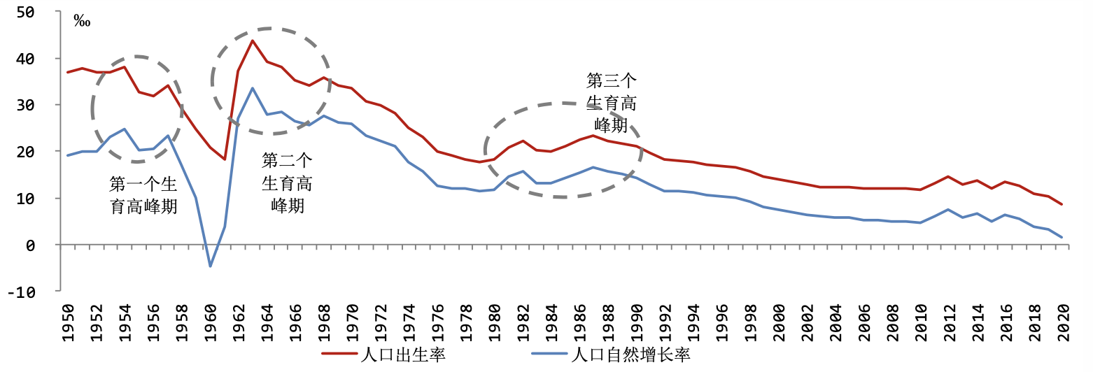
Population Natural Growth Rate
Birth Rate
The third baby boom
The second baby boom
The first baby boom
Source: World Bank database, China National Bureau of Statistics, Southwest Securities

- Aging: Since the 1990s, the improvement of medical treatment and average life expectancy has made the proportion of the elderly population in the total population continue to rise. According to the seventh national Census, in 2020, people aged 60 and above accounted for 18.70 percent of China's total population. People aged 65 and above accounted for 13.50 percent of the total population, higher than the world average of 9 percent. Although the data is lower than the level of major developed countries, the degree of population aging is further deepening. In 2022, the population born at the highest reproductive age after the founding of the People's Republic of China will enter old age, and China's aging will accelerate.

Over the Past Two Decades, the Proportion of China’s Population aged over 65 has risen rapidly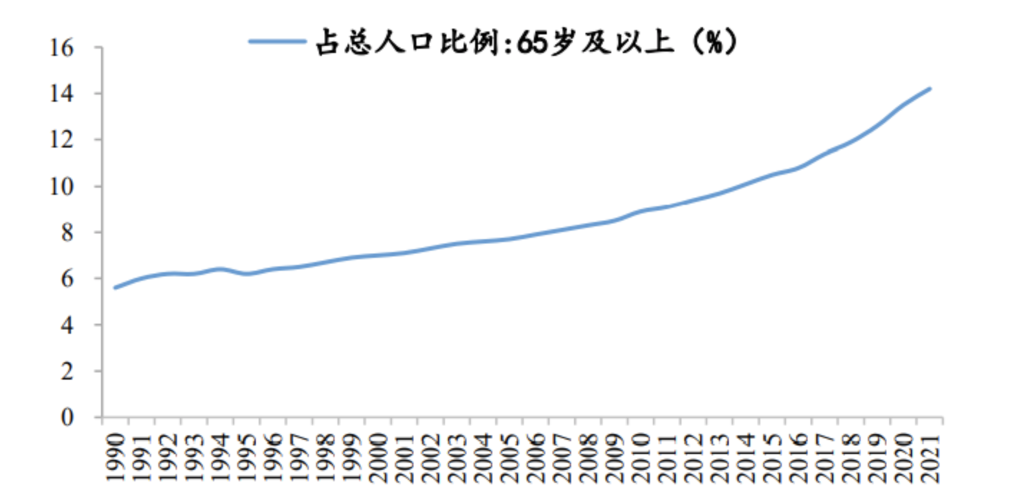
Proportion of population: above 65 years old
Source: WIND, Zepinghongguan

- The falling population of children: The flip side of aging is the falling population of children. China’s total fertility rate continues to fall, triggering concerns about future population trends and numerous adjustments to the fertility policy. The universal “two-child policy” was officially implemented on January 1, 2016, but the “two-child” effect began to weaken in 2018. According to the seventh national Census (2021), China had 12 million new births in 2020, which is 18 percent lower than 2019. The total fertility rate in 2020 is 1.3, which is at a low level. In addition, according to the statistical yearbook of 2021, the birth rate in 2020 was 8.52 per thousand, while the natural growth rate was only 1.45 per thousand, the lowest since 1978. In 2021, the policy of encouraging three children was gradually introduced.

- Further Explanation on the Current Stock Selection Method
China's aging industry is a new concept. As the population ages, more and more people pay attention to the aging industry. However, after reviewing the relevant comments in the public stock forum, I found the existing stock selection method of the current aging industry index in the market is not scientific, and many people are complaining about it, especially for CSI Old-Age Industry Index (“Is the Investment in the CSI Old-Age Industry Index Really Investing in This Industry?” 2021). This index is one of the most influential aging industry indexes now, and it is an equally weighted index including 80 constituent stocks. The selection rule is as follows:
- Consumer electronics, leisure goods, hotel tourism, education, culture and media, drug retail, dairy products, household goods, medicine and health, life insurance, Internet software, and other industries belong to the aging industry. From each sub-industry, they pick the stock with the largest market value as the constituent stock. So there are around a dozen stocks.
- Then select the stock with the largest market value in sequence from the remaining related industries as the component, until the stock number reaches eighty.
An obvious problem with such stock-picking rules is that constituent stocks have little to do with the actual aging industry. The leading stock of each related sector did not necessarily participate in the aging industry business. Instead, it is more scientific to choose index stocks based on their participation in the aging industry sector. For example, Aojiahua (Chinese: 奥佳华 (002614)) is not the leading stock in the electrical machinery & equipment manufacturing industry. However, it is China’s most significant elderly massage equipment production and manufacturing service provider. It has a more significant correlation with the aging industry than any other leading stock in the same industry, so it should be considered in the aging industry index, instead of only choosing the leading stock.
Selecting the leading stocks in each relevant industry cannot represent the performance of the aging industry in China. Instead, these big-name stocks only make the index more stable and attract more capital, making people who really want to invest in the aging industry unable to put their money into the right industry.

- Potential Significance and Practical Relevance
By selecting companies that actually participate in the aging industry, we can build indices more representative of the sector. By considering the relevant available information, including public information and relevant industry information, we try to verify and conclude a better model to explore and predict the price trend of the constructed aging industry index.
(1) For stock investors, they can put their money in the right place. Also, a more accurate stock market trend prediction is directly related to the acquisition of profits. The more precise the forecast is, the more certain the risk prevention will be.
(2) For listed companies, the stock index reflects the company's operating situation and future development trend, affecting the benefit of the whole company. It is the main technical index for the analysis and research of the industry.
(3) For the financial world, it shows the industry index mismatch problem and proposes a feasible solution.
(4) For the national economic development, the stock forecast research also plays an important role by showing the performance of the aging industry. Therefore, the aging industry index reestablishment has theoretical significance and application prospects.

- Research Methodology
The main part is to reconstruct a stock index, which can be divided into three stages: Firm selection, Index construction and Evaluation.
First, we need to select the firms whose core business is highly related to the aging industry. I will narrow down the range of target firms based on the definition of related industries to the aging industry issued by the Chinese government, for example, paying more attention to the industries such as real estate, automobile, health care, etc. By doing so, I created a firm pool for selection. Then by examining the keywords in the core business description from existing target firms’ annual reports, I plan to calculate the relevance of the firms from the selection pool and select the ones truly belonging to the aging industry. I’ll observe the list of aging industry concept stocks in China provided by DingNiuGu, a Chinese stock data query website created by a group of stock enthusiasts. I will make the existing target firm list to select the proper target keywords from their core business description according to these concept stocks.
Second, I need to create an index based on the firms selected. Some traditional construction methods include equally weighting or relying on the market value. Preliminarily, by examining their capitalization on Wind or Bloomberg, I may use the corresponding capitalization proportion to construct an index to measure the aging industry performance. Also, more precisely, I will adjust the weights based on the relevance of the firm to the aging industry, as calculated in the first stage.
Finally, I need to evaluate and compare the new industry index and the existing one, which is the CSI Old-Age Industry Index in aspects of industry measurement. Basically, we analyze it from the public information and market performance. We can check the pension policy issued by the government and the corresponding release time through the search engine or the national website. And then, we can see how well the indexes measure the trend respectively.

- Keyword Selection
First of all, I searched the list of concept stocks in the Chinese aging industry provided by DingNiuGu (http://www.dingniugu.com/gegujiexi/yanglaogainian.html). There are 77 stocks in this set, and the dataset of concept stocks is updatable. The data I used was updated on 2021-12-06, and it is still in use now. I collected the business description related to their core business of each from their annual report and applied NLP word cloud analysis to see which words appear most often in the text. After removing many meaningless words, I kept the top 15 words with the most occurrence frequency, since those words beyond the 15 occur less frequently and the nouns have little meaning. So the outcome is as follows:

Keyword | Meaning | Frequency | Proportion
'养老' | Elderly Care | 139 | 0.243007
'健康' | Health | 72 | 0.1258741
'服务' | Service | 59 | 0.1031469
'护理' | Care | 31 | 0.0541958
'医疗' | Medical Treatment | 30 | 0.0524476
'社区' | Community | 29 | 0.0506993
'康复' | Recovery | 29 | 0.0506993
'产业' | Industry | 29 | 0.0506993
'产品' | Product | 27 | 0.0472028
'管理' | Management | 26 | 0.0454545
'智慧' | Intelligence | 22 | 0.0384615
'机构' | Institution | 22 | 0.0384615
'居家' | Home-based | 21 | 0.0367133
'提供' | Provide | 18 | 0.0314685
'生活' | Life | 18 | 0.0314685
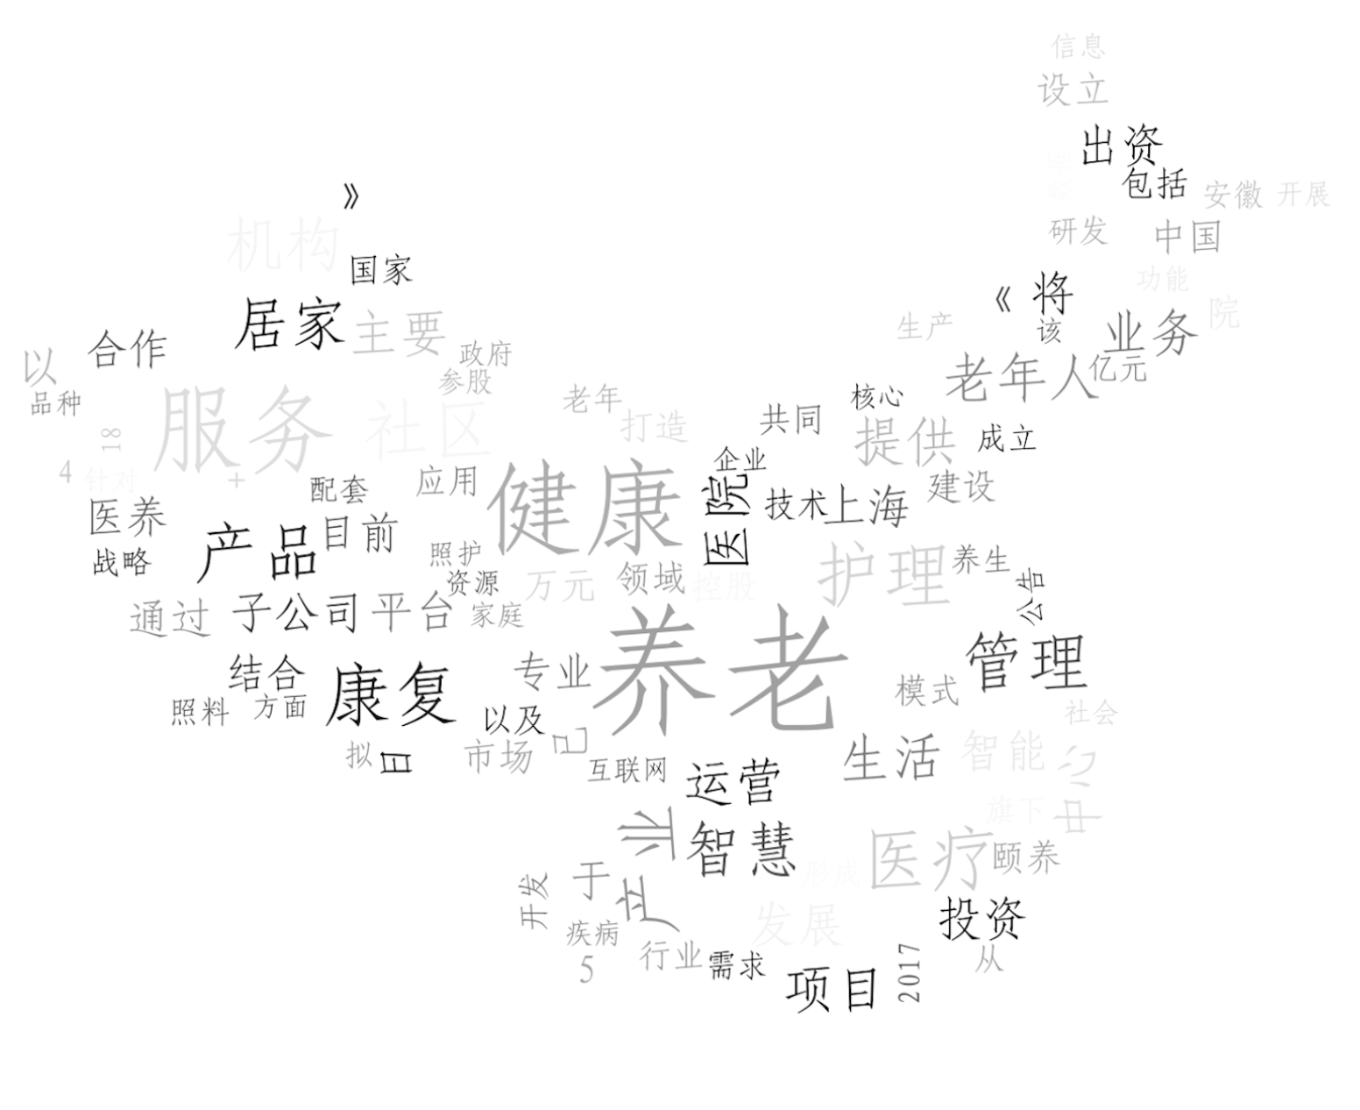
From the outcome above, we can see ‘养老’ (Yang Lao), which means elderly care, ranks first, and 健康 (Jian Kang) comes second, etc. The word cloud is shown above. Then I calculated the proportion of each to see their weights in the total word pool, as shown in the fourth column. After getting a list of keywords that can be applied as the filter to select the relevant firms, the next step is to create a potential stock pool that we want to investigate.

- Relevant Industry Selection
According to the Statistical Classification of Elderly Care Industry published by the Chinese national government in 2020, the industries related to the aging industry may include Medicine, Biology, Healthcare, Real estate, IT, Insurance, Beverage, etc. I would select the top 10 stocks with relatively large market shares in each industry provided by WIND to create the potential stock pool. That’s not enough since it would still ignore some firms with smaller market shares but are involved in the aging industry. So I also include around 100 aging industry concept companies listed by various institutions for the supplement. Therefore, we get a potential pool of more than 200 firms.

- Model Development
Given the potential firm pool, I started the selection process. I calculated the corresponding frequency for each keyword listed above based on each firm’s annual report. More specifically, inspired by the paper Text-Based Industry Momentum (Hoberg 2018), I use part three in the annual report, that is, Main Business Introduction. This part of the business description is updated and representative of the current business, according to the Standards on the content and format of information disclosure of publicly issued securities published by the Chinese government (2001). The sample data is as follows, where n_{j} is the total word in the document:
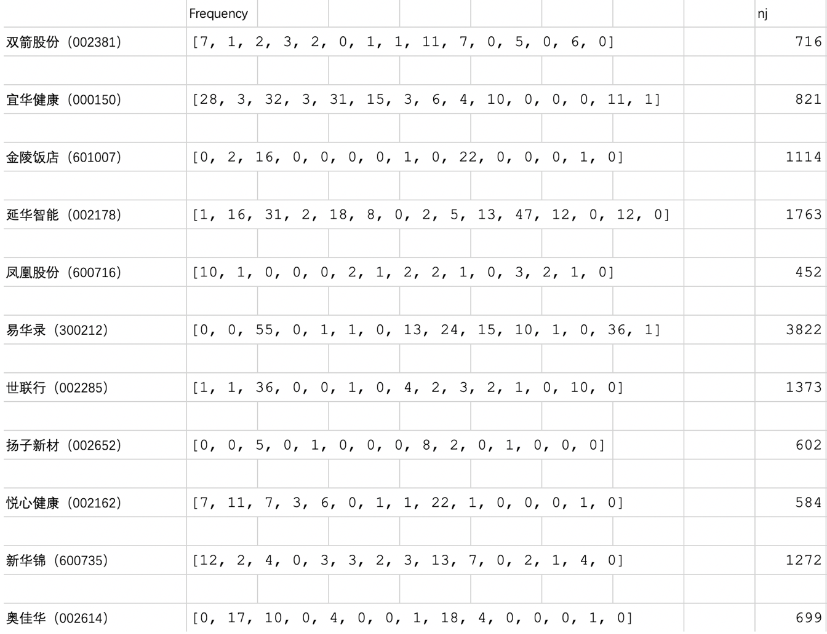
After getting the frequency, we need to transform it into the relevance parameter to further select the firms. Intuitively, we can develop the formula like this:
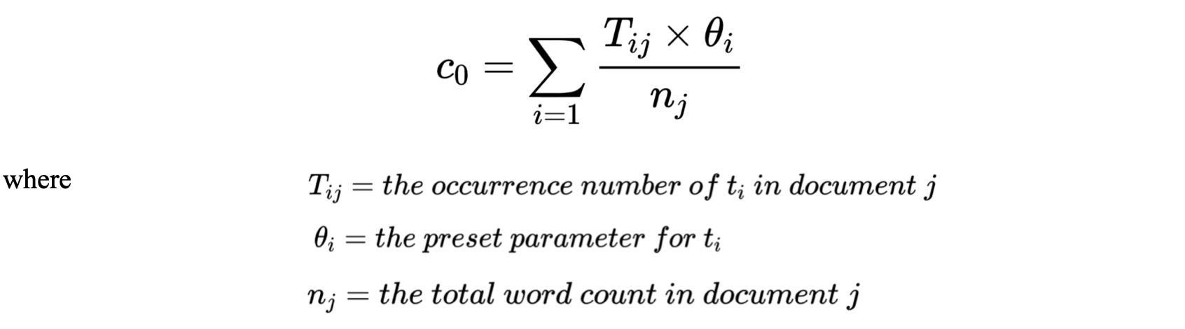
However, a problem exists——It does not eliminate the effect of common words on parameters. For example, if almost every firm contains the word “industry,” the frequency of firm A is ten, and that of firm B is thirty, given the same number of total words in each document. Would it be rational to say that B firm is more relevant to the aging industry? Of course not. Since the word “industry” is ubiquitous in the business description, its absolute occurrence frequency cannot distinguish it from others.
To solve this problem, inspired by the paper Text-Based Industry Momentum, here I introduce the TF-IDF model. TF-IDF (term frequency-inverse document frequency) is a statistical measure that evaluates how relevant a word is to a document in a collection of documents. This is done by multiplying two metrics: how many times a word appears in a document, and the inverse document frequency of the word across a set of documents, which is shown as follows:
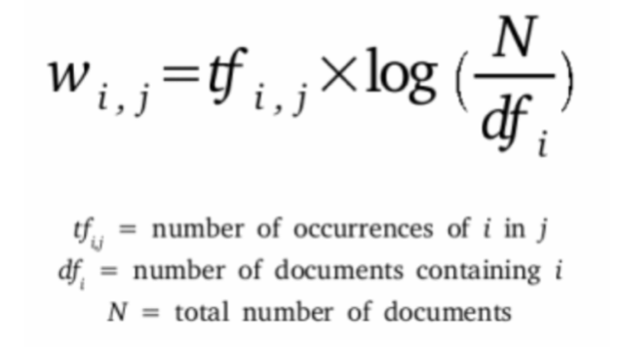
The key point here is that if the number of documents containing a term is smaller, the IDF is larger, then the term has good categorization ability. So combining the concept of the TF-IDF model, I add new parameters:
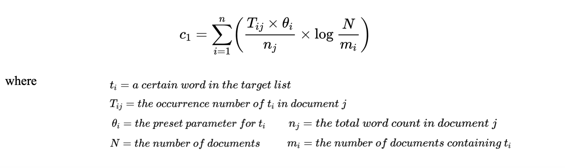
It looks fine, but there is another potential problem. In practice, sometimes, if a term frequently appears in the documents of a certain class, it is a good representation of the character of that class. So it should be given a high weight and selected as the feature of that class to distinguish it from other kinds of documents, and this is where the shortcoming of IDF is. In the case of this paper, it exists. For example, if almost every firm contains the word “Yang Lao”, which means the elderly care, the frequency of firm A is ten while that of firm B is fifty, given the same amount of total words in each document. Would it be rational to say there is no difference between firms A and B regarding how they are related to the aging industry? My answer would be no because “Yang Lao” (elderly care) is the keyword in the aging industry, which is different from the “relatively meaningless” word such as “industry” or “product.” Therefore, it is essential to consider how often this word appears in the business description.
As a result, I combine the way of calculating c₀ and c₁ together. Here comes the equation. Basically I exclude the key word “养老”(elderly care) from the c₁ calculation method.
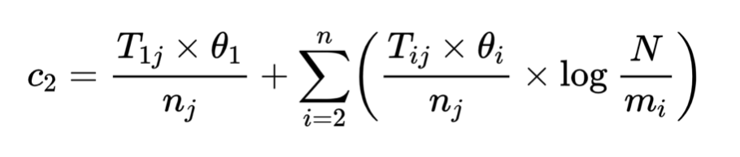
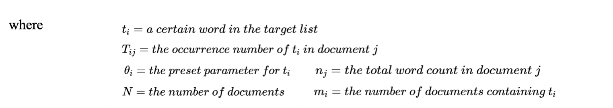
After excluding stocks with very low weights (close to zero) or short time to be on the market, I got 107 target companies and their weights, and drew the monthly trend of the constructed index since 2016, as shown below.
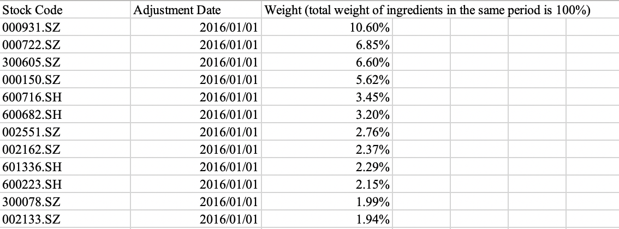
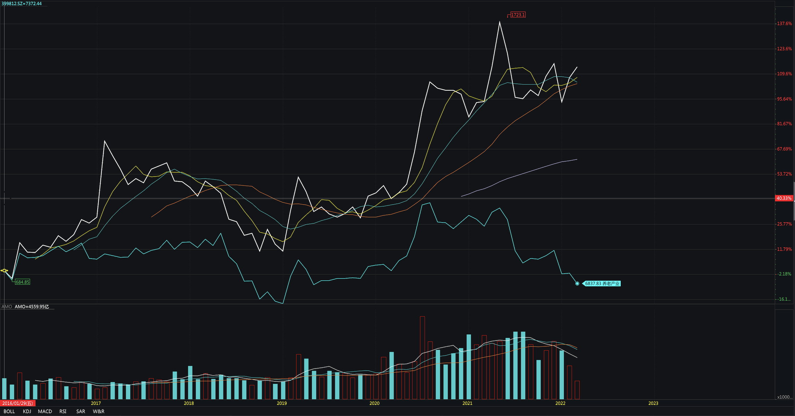
Source: WIND
More information about the constructed index can be found in the appendix (the constructed index is in white and the CSI Old-Age Industry Index is in blue).

- Evaluation
After obtaining the index, we can see the pattern of the constructed index and the CSI Old-Age Industry Index. In general, their trend is similar, reflecting the macro direction of the aging industry, which also confirms the validity of the constructed index. But at some points, we can see the difference between them. By selecting key nodes and referring to relevant policies, we can evaluate which index is more in line with macro industry trends.
For reference, here I list all the relevant aging policies that are good indicators for the industry and their announcement time.

Announcement Time | Policy Name
2016.11 | 《关于支持整合改造限制社会资源发展养老服务的通知》
2016.12 | 《关于全面放开养老服务市场提升养老服务质量的若干意见》
2017.2 | 《关于印发“十三五”国家老龄事业发展和养老体系建设规划的通知》
2017.2 | 《智慧健康养老产业发展行动计划（2017-2020年）》
2017.6 | 《服务业创新发展大纲》
2017.6 | 《关于制定和实施老年人照顾服务项目的意见》
2017.8 | 《关于运用政府和社会资本合作模式支持养老服务业发展的实施意见》
2017.11 | 《关于确定第二批中央财政支持开展居家和社区养老服务改革试点地区的通知》
2018.9 | 《完善促进消费体制机制实施方案（2018-2020年）》
2019.9  2020.1 | 《关于进一步扩大养老服务供给 促进养老服务消费的实施意见》  《关于实施康养职业技能培训计划的通知》
2020.2 | 《关于印发〈养老机构新型冠状病毒感染的肺炎疫情防控指南（第二版）〉的通知》
2020.2 | 《关于确定第五批中央财政支持开展居家和社区养老服务改革试点地区的通知》
2020.4 | 《关于做好2020年养老院服务质量建设专项行动工作的通知》
2020.7 | 《关于加快实施老年人居家适老化改造工程的指导意见》
2020.9 | 《养老机构管理办法》
2020.11 | 《关于切实解决老年人运用智能技术困难实施方案的通知》
2020.12 | 《关于推动物业服务企业发展居家社区养老服务的意见》
2020.12 | 《关于开展医养结合机构服务质量提升行动的通知》
2020.12 | 《关于建立健全养老服务综合监管制度促进养老服务高质量发展的意见》
2021.2.10 | 《防范和处置非法集资条例》
2021.2.28 | 《中国统计年鉴2021》
2021.3.12 | 《中华人民共和国国民经济和社会发展第十四个五年规划和2035年远景目标纲要》
2021.3.31 | 《养老机构服务标准体系建设指南、养老机构生活照料服务规范、养老机构老年人健康档案管理规范、养老机构社会工作服务规范四项行业标准》
2021.4.7 | 《互联网网站适老化通用设计规范》
2021.4.7  2021.4.29  2021.5.8  2021.5.8 | 《关于服务“六稳”“六保”进一步做好“放管服”改革有关工作的意见》  《中华人民共和国乡村振兴促进法》  《社会资本投资农业农村指引（2021年）》  《关于开展专属商业养老保险试点的通知》
2021.5.11 | 第七次全国人口普查公报
2021.5.17 | 《关于养老领域非法集资的风险提示》
2021.5.24  2021.6.2 | 《“十四五”民政事业发展规划》  《关于科学绿化的指导意见》
2021.6.15 | 《关于实施进一步便利老年人就医举措的通知》
2021.6.16 | 《关于印发加快推进康复医疗工作发展意见的通知》
2021.6.17 | 《“十四五”积极应对人口老龄化工程和托育建设实施方案的通知》
2021.6.26 | 《关于优化生育政策促进人口长期均衡发展的决定》
2021.7.16 | 《长期护理失能等级评估标准（试行）》
2021.9.2  2021.10.9 | 关于加强城镇老旧小区改造配套设施建设的通知  《“十四五”电子商务发展规划》
2021.10.10 | 《国家标准化发展纲要》
2021.10.20  2021.11.5 | 《智慧健康养老产业发展行动计划（2021-2025年）》  《提升全民数字素养与技能行动纲要》
2021.11.11 | 《关于推进养老机构“双随机、一公开”监管的指导意见》
2021.11.15 | 《关于开展老年医疗护理服务试点工作的通知》
2021.11.18 | 《关于加强新时代老龄工作的意见》
2021.11.26 | 《关于“十四五”期间利用开发性金融支持养老服务体系建设的通知》
2021.11.30 | 《全国林下经济发展指南（2021-2030年）》
2021.12.14 | 《关于进一步明确城镇老旧小区改造工作要求的通知》
2021.12.30 | 宣布《养老机构服务安全基本规范》于2022年1月1日起正式实施
2021.12.30 | 涉及防跌倒、防噎食、污染织物清洗消毒处置及各类细项服务规范等共计8项行业标准

Now let’s look at the performance of each index. Annually, we can observe that after 2020, CSI Old-Age Industry Index (in blue) has a trend of decline, while the constructed index (in white) has an upward trend. In this aspect, the constructed index is more in line with the industry trend, because, as shown above, the Chinese government issued a large number of relevant policies in 2021 to support the aging industry in China. Therefore, from 2020 onwards, the whole industry, including public opinion, should have a steady upward trend, rather than a sharp decline.

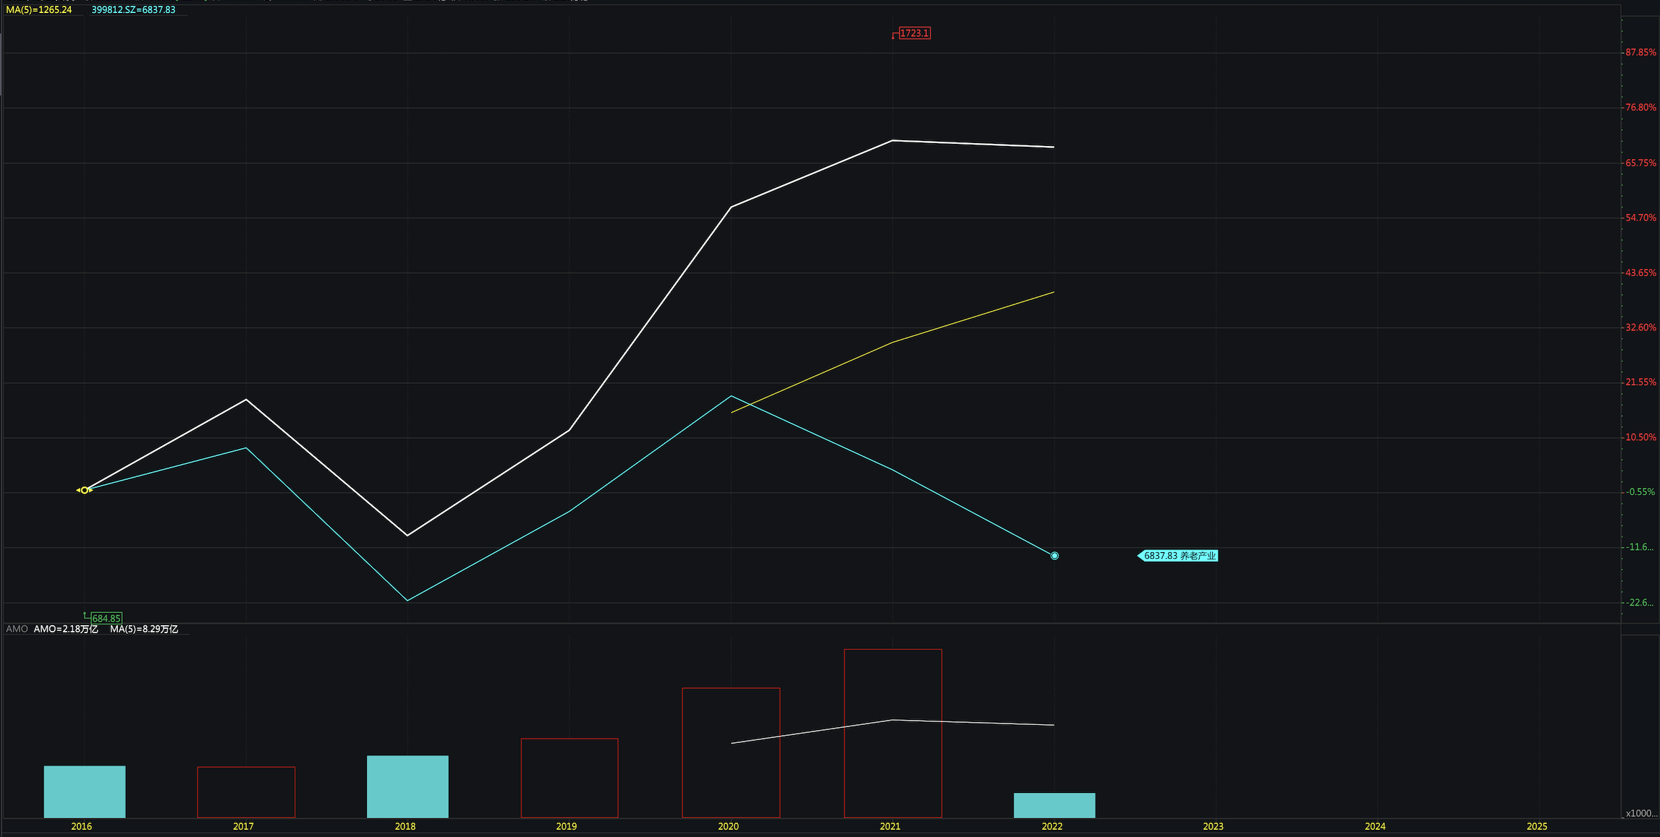
Source: WIND
More specially, from the semi-annual window, from the second half of 2021, the CSI Old-Age Industry Index declined significantly, while the constructed industry index changed little.

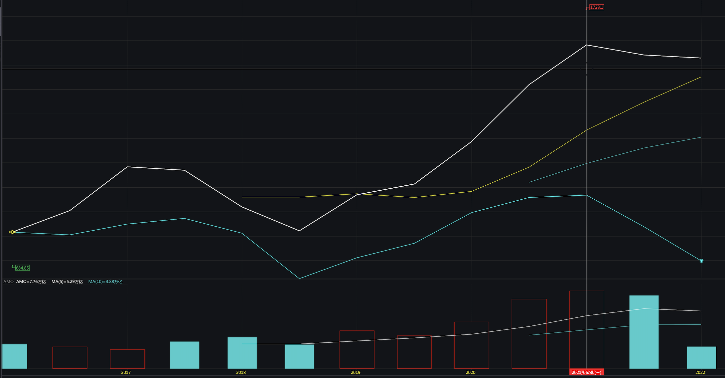
Source: WIND
Let’s look at what happened. In the second half of 2021, there is big news in Chinese society. Starting from June 2021, China’s education industry has seen an enormous shock. The Ministry of Education and the local education authorities had severely regulated the education and training industry many times. In July 2021, the Chinese government introduced a new education policy called the “double reduction” policy to deal with the excessive academic burden on primary and middle school students, leading to a significant blow to the entire education industry.
As discussed above, the CSI Old-Age Industry Index selects 80 stocks with the largest market capitalization in leisure goods, hotel tourism, education and culture, medicine retail, dairy, home products, medicine and health, life insurance, and other related industries. Among all sectors, education has a place, so the decline in education has brought a significant drop in the CSI Old-Age Industry Index. However, in fact, favorable policies for the Chinese aging industry have always been announced, which leads to the deviation between the CSI Old-Age Industry Index and the actual aging industry trend.

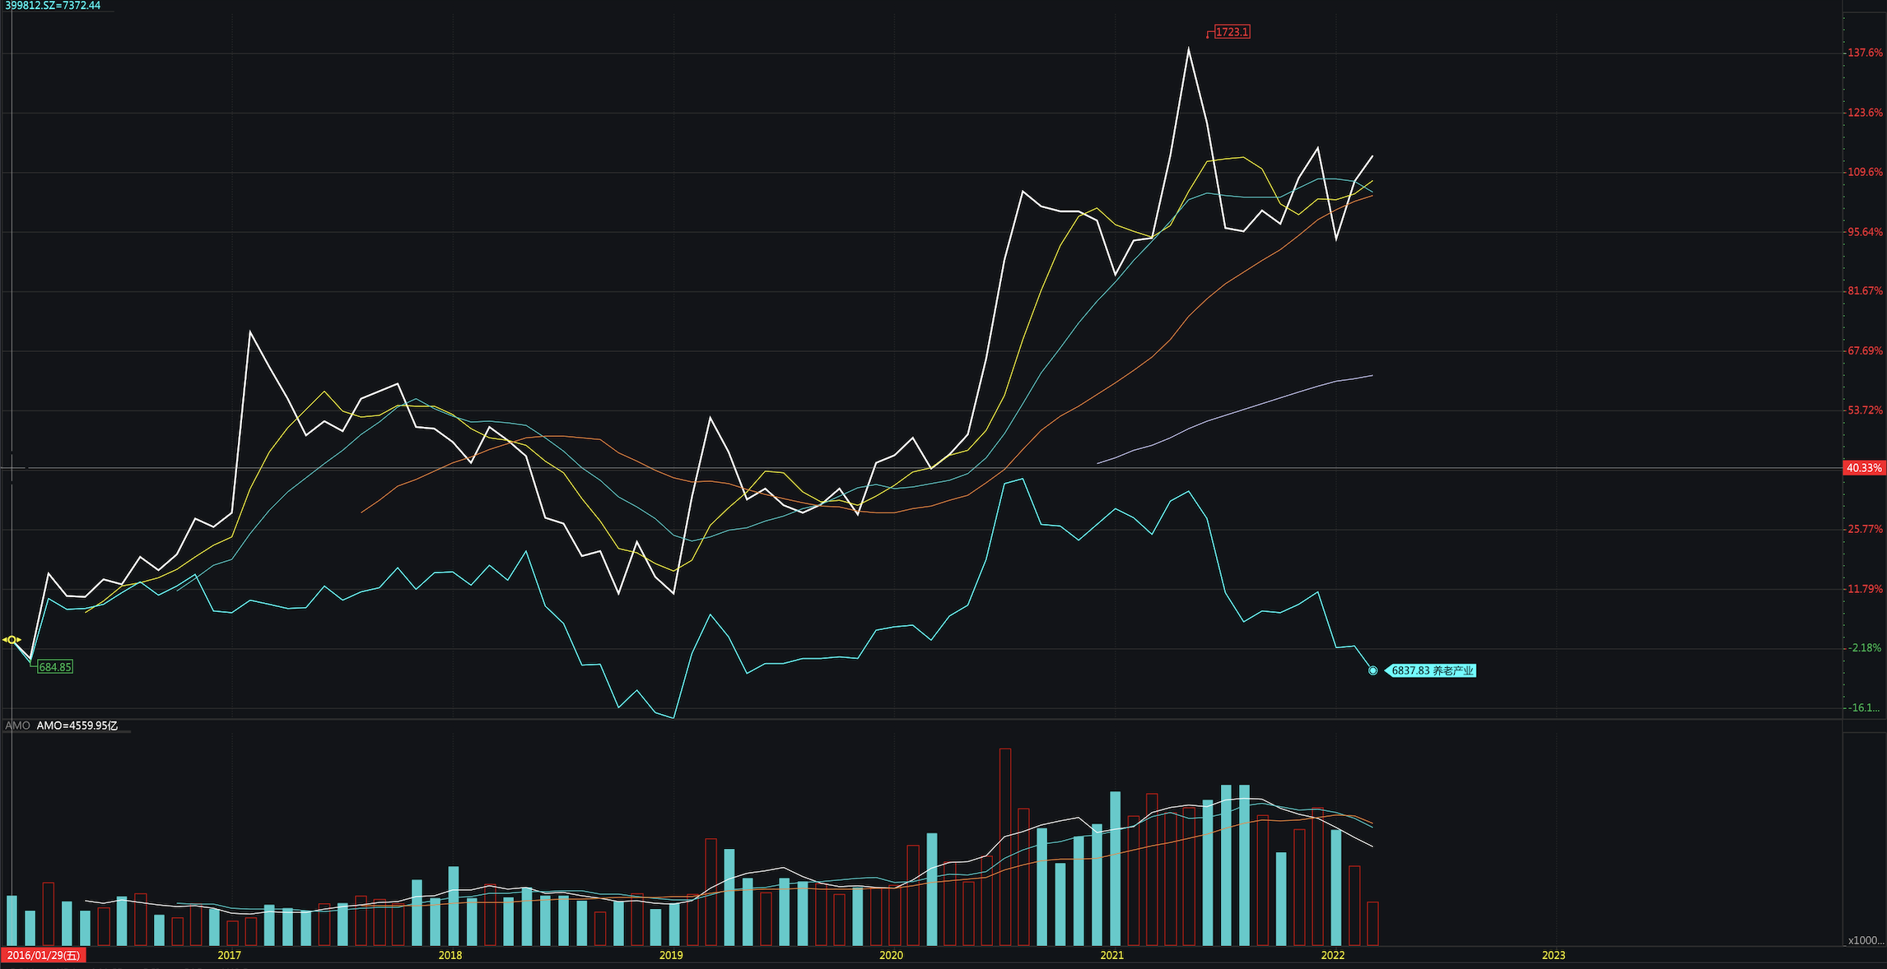
Source: WIND

Analyzing from a monthly window, we still find a similar overall trend. But some data points still verify that the constructed index has a better performance in terms of industry trend measurement. For example, one of the major differences is that the constructed index had a peak in March 2017, while the CSI Old-Age Industry Index was relatively stable and even had a downward trend. In fact, in February 2017, the government issued the Notice on the Issuance of the 13th Five-Year Plan for the Development of the National Aging Cause and Pension System Construction Plan and Smart Health Aging Industry Development Action Plan (2017-2020), sending a positive signal to the aging industry. For example, the State Administration of Traditional Chinese Medicine stipulated that all secondary and above traditional Chinese medicine hospitals should cooperate with senior care institutions, which greatly stimulated the growth of the aging industry (State Administration of Traditional Chinese Medicine 2017).

But for other industries, the story is different. At the 15th meeting of the Central Leading Group for Financial and Economic Affairs on February 28, 2017, the government announced regulations on the real estate sector. That’s why the CSI Old-Age Industry Index showed a downward trend due to the decline of the real estate industry at that time. Therefore, this once again proves that the new constructed Index has a better ability to measure the trend of the Chinese aging industry.
Now let’s look at the two indices from a quantitative perspective. By calculating the mean and volatility of the two indices around the news dates on aging, we again verify that the new constructed index performs better than the CSI Old-Age Industry Index. For instance, starting from 06/15/2021 till the end of June, the government issued a series of good news related to the aging industry, as shown below.

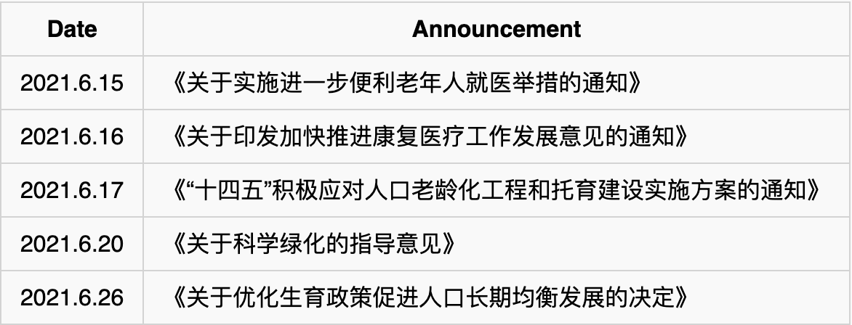

During that period, the mean of the new index return is -0.33%, and that of the CSI Old-Age Industry Index is -1.15%. According to those beneficial policies toward the aging industry, the higher index return makes more sense, which is the new index. Taking a close look at what happened on June 21st: the return of the new index is 1.39%, while that of the CSI index is -2.91%. The positive return reflected the actual industry trend triggered by the beneficial policies, while the negative return made no sense from the macro perspective. Therefore, we can see that the new constructed index performs better than the CSI Old-Age Industry Index.
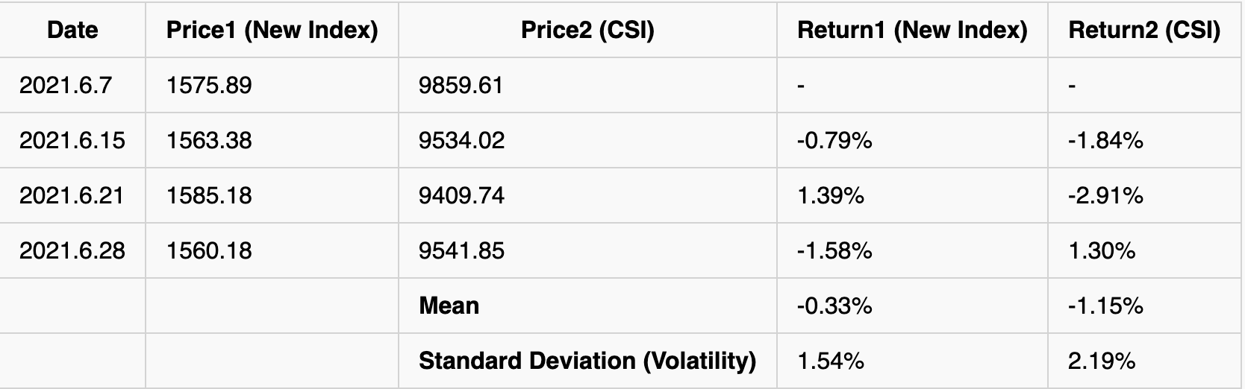
Here is the list of data that can be traced about the mean and volatility of the two indices around the news dates on aging. We can see that around the news dates, the mean of the new index return tends to be higher than that of the CSI return under the influence of beneficial policies, which again verifies our assumption that the new index has better performance in terms of industry measurement. Also, as for the standard deviation (volatility), in general, the standard deviation of the new index return tends to be lower than that of the CSI return, which indicates that the CSI return is not as stable as the new index return since it is affected by many other industries.
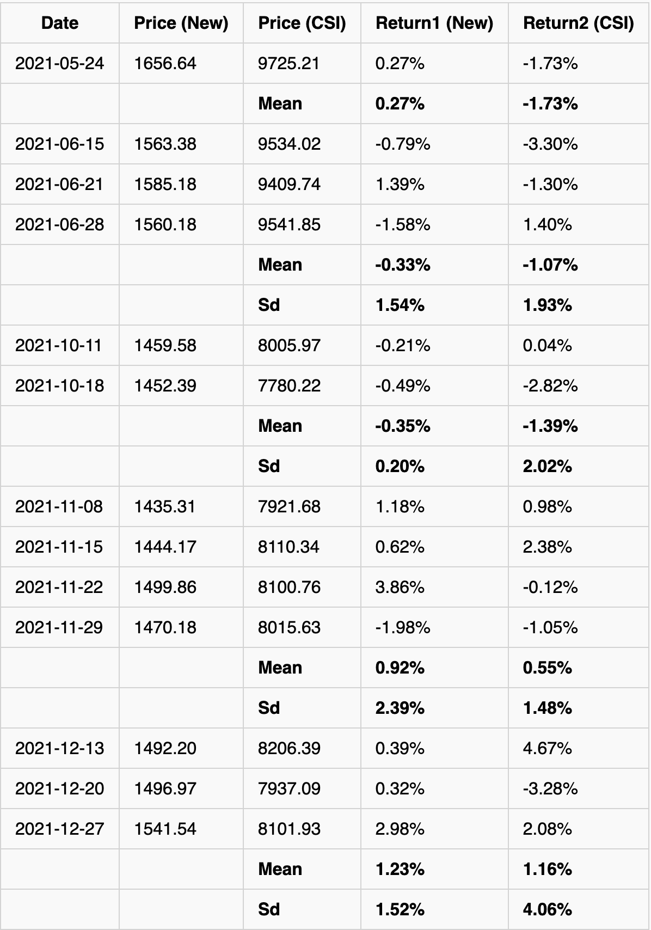

- Conclusion
As China’s aging crisis is approaching, the future aging industry is a huge opportunity for investors in the stock market. However, the current selection method of the CSI Old-Age Industry Index is unscientific. It selects 80 stocks with the largest market capitalization in other related industries as sample stocks and is weighted with equal weight. It is actually a leading stock index of people’s livelihood, including food, clothing, housing, eating, and drinking, rather than the aging industry index.
CSI Old-Age Industry Index Constitution
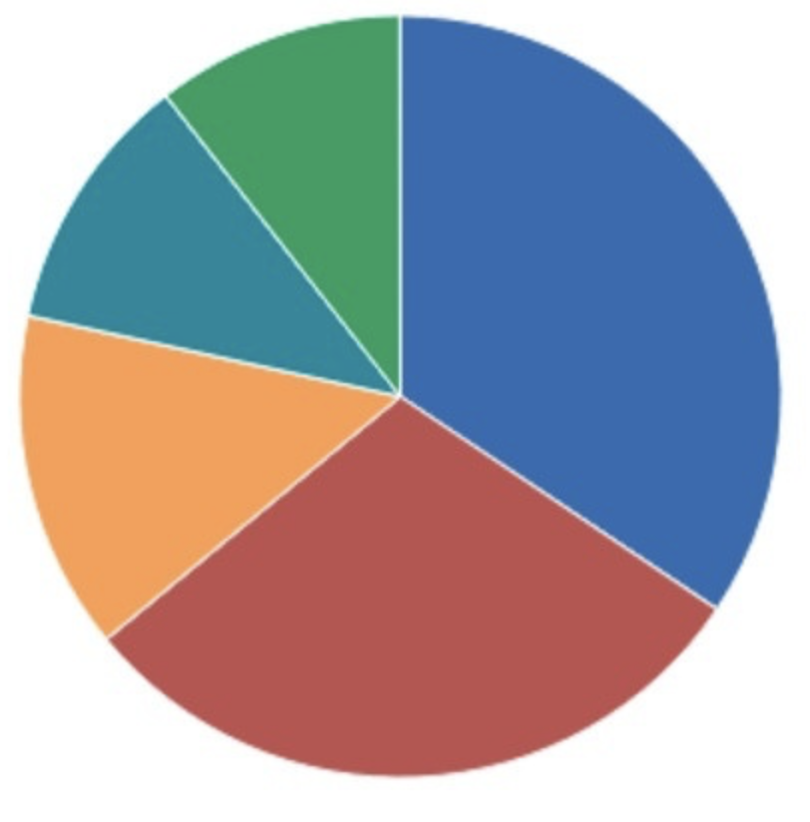
Healthcare 34.42%
Consumer Discretionary 29.61%
Information Technology 14.39%
Daily Consumption 11.05%
Finance 10.54%

With the development of the aging industry in China, there are more and more firms that really focus on the aging industry itself, so it is very necessary and important to construct relevant indexes.
Related companies can be screened and measured based on the keywords of existing concept stocks. By creatively applying TF-IDF and weighting formula, we eliminate the influence of excessive words while considering the weight of some special words, constructing a new index that can represent the Chinese aging industry. Finally, compared with the existing CSI Old-Age Industry Index the new index has a better performance in measuring the industry trend proven by the relevant policy. The conclusion verifies this industry index method’s feasibility and has reference value for future investors and related research.
One might be skeptical that the construction of the industry using keywords might be noisy since firms don’t change their business or industry drastically from period to period. So the constructed index is somehow stable and hard to update in a short period of time. And it is a limitation of the method, which is updated based on the annual reports. But as long as a firm adjusts its business towards elderly care related business or there exists a new firm working on the related business, this method can include it into the industry index and consider it as one factor of the overall market trend, which is hard to achieve by the current CSI Old-Age Industry Index.

Reference
Allard, Anne-Florence, et al. “When Mutual Fund Names Misinform.” SSRN Electronic Journal, 2020, https://doi.org/10.2139/ssrn.3628293.
China Statistical Yearbook 2021. National Bureau of Statistics of China, Sept. 2021, http://www.stats.gov.cn/tjsj/ndsj/2021/indexch.htm.
Hoberg, Gerard, and Gordon M. Phillips. “Text-Based Industry Momentum.” Journal of Financial and Quantitative Analysis, vol. 53, no. 6, 2018, pp. 2355–2388., https://doi.org/10.1017/s0022109018000479.
In 2020, China's Birth Population Will Be 12 Million. CHINANEWS, 11 May 2021, https://baijiahao.baidu.com/s?id=1699432768461856919&wfr=spider&for=pc.
“Is the Investment in the CSI Old-Age Industry Index Really Investing in This Industry?” Zhihu, Renzhen De Tianma, 4 Aug. 2021, https://zhuanlan.zhihu.com/p/399642238.
“Standards on the Content and Format of Information Disclosure of Publicly Issued Securities .” Central People's Government of the People's Republic of China, 10 Dec. 2001, http://www.gov.cn/gongbao/content/2002/content_61795.htm.
“State Administration of Traditional Chinese Medicine: Secondary and above Traditional Chinese Medicine Hospitals Should Cooperate with Elderly Care Institutions.” Zhuyitai, 21 Mar. 2017, http://news.zhuyitai.com/17/0321/3c10e5d51a454f9e9684bcf9992f5b1a.html.
“Statistical Classification of Elderly Care Industry (2020).” Central People's Government of the People's Republic of China, 4 Feb. 2020, http://www.gov.cn/gongbao/content/2020/content_5503559.htm.

Appendix
Weekly Trend since 2016 (In White):

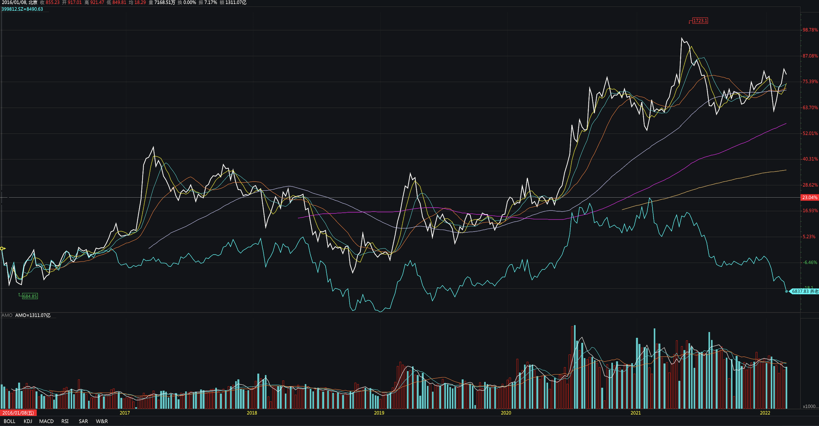

Monthly Trend since 2016 (In White):

Semi-annual Trend since 2016 (In White):

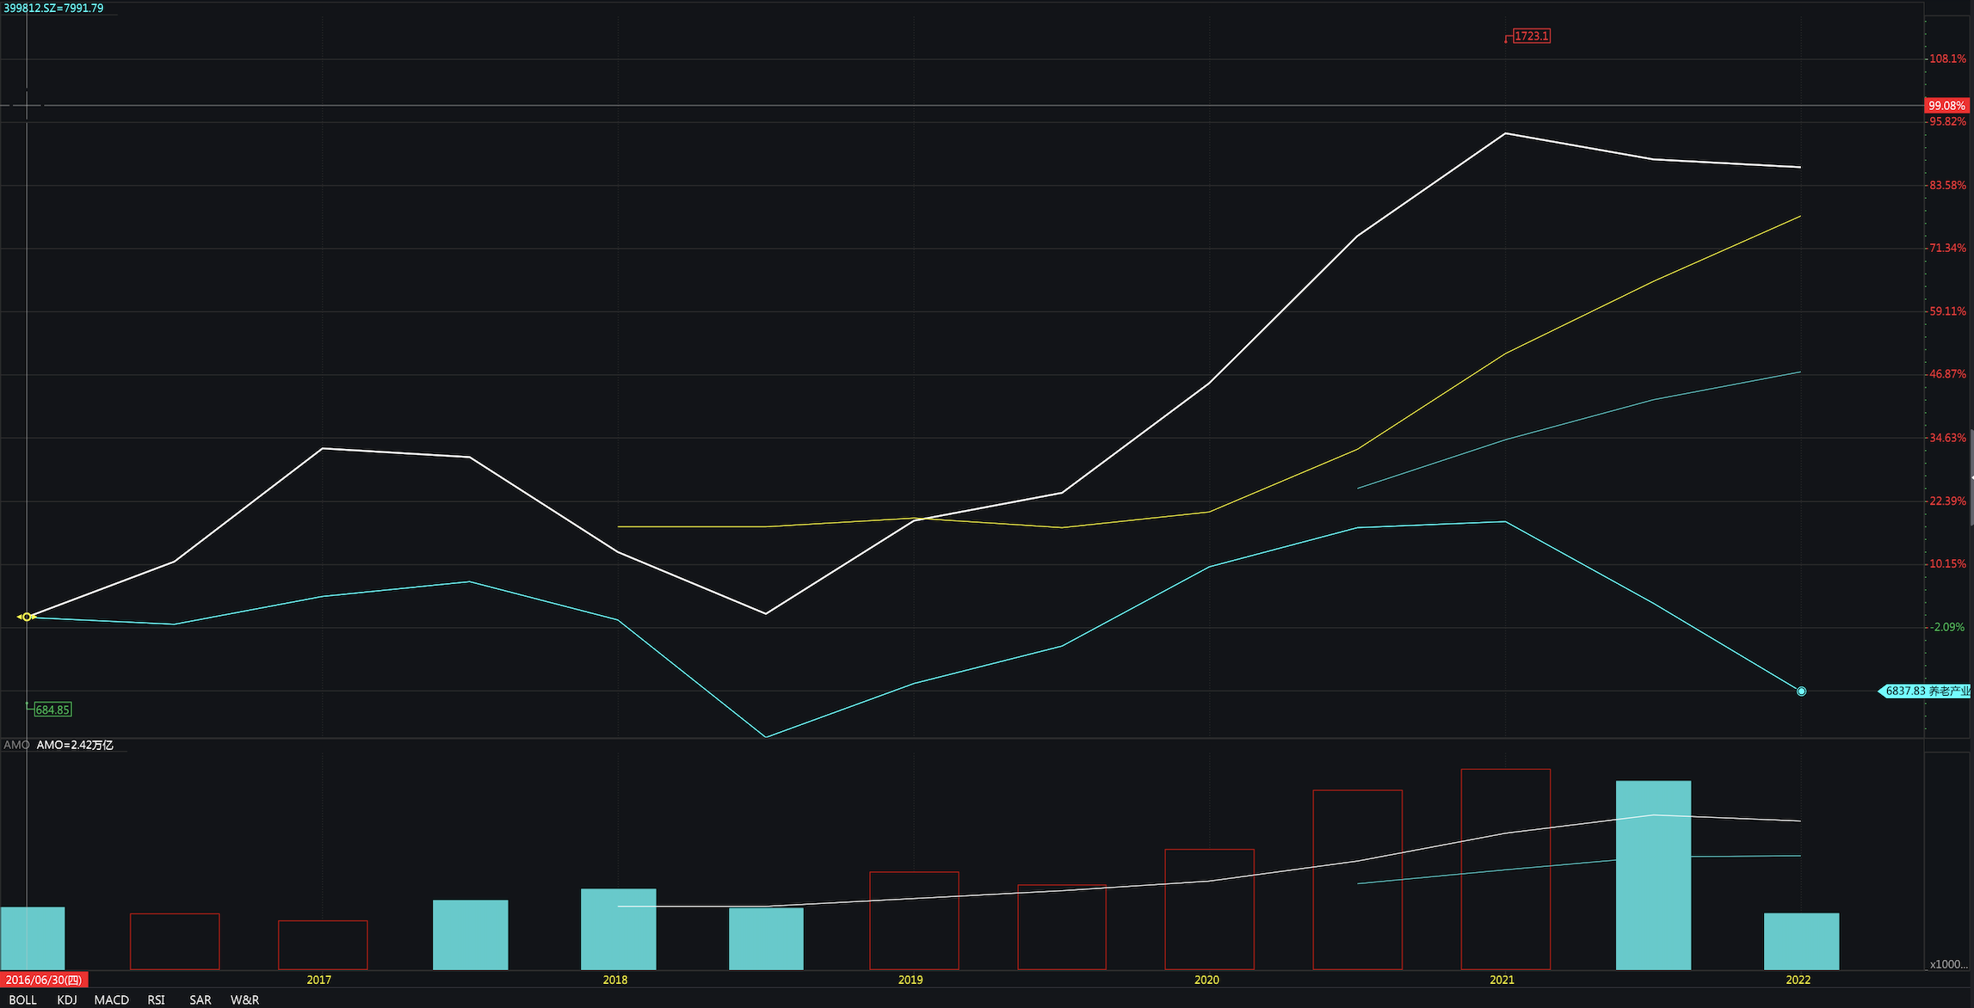

Annual Trend since 2016 (In White):

