Merrill Lynch Option Volatility Estimate Index and Short-Term Yield Curve Analysis:

Empirical Evidence

by

Xilin Chen

An honors thesis submitted in partial fulfillment
of the requirements for the degree of
Bachelor of Science
Business and Economics Honors Program

NYU Shanghai
May 2022

Professor Marti G. Subrahmanyam Professor Menachem Brenner
Professor Christina Dan Wang
Professor Wendy Jin

Faculty Advisors Thesis Advisor

Abstract
Merrill Lynch Option Volatility Estimate (MOVE), as a measurement of implied volatility, subsumes the market expectation of short-term interest. The paper assume that MOVE index has explanatory and predictive power for the dynamics of the short-term yield curve structure, and uses correlation and regression analysis to provide an evaluation of the contemporaneous and intertemporal relationship between and the treasury yield spread.
The paper shows that the explanatory power of MOVE index for the treasury yield spread is statistically significant, resonating with the Durham’s decomposition of treasury yield spread, especially for the spread between 6 month and 3 month treasury yield. However, the lag-1 prediction power of MOVE index is widely overlapped with the autoregressive model, while the intertemporal correlation reflects the dynamics of investors’ decision between equity and bond market (“flight to safety”) in response to the financial crisis and monetary policies.

Acknowledgement
I would like to thank the thesis advisor, Professor Menachem Brenner, for introducing this field and offering concise instructions.

I would like to express my gratitude to I would like to thank Prof. Christina Wang for bringing me into the world of the research in volatility modeling and financial econometrics, and for offering me kind instructions in data processing, event analysis and statistical analysis during the thesis writing. Together with Prof. Wang, I would also like to thank Professor Marti G. Subrahmanyam and Professor Jin (Wendy) Ye for coordinating the speaker series and offering the research-related resources.

Last but not least, I would like to extend my gratitude to the speakers in the Business and Economics Honors Program, who shared with me the insights of their fields, and all my fellow students, who shared their constructive suggestions with me and introduced the methods and discoveries in their research and studies to help me improve my work.

Content
1. Introduction and Literature Review 6
1.1. Merrill Lynch Option Volatility Estimate (MOVE) 6
1.2. Decomposition of Treasury Yield Spread 7
1.3. Contemporaneous correlation between implied volatility and underlying returns 7
1.4. Information spillover and subsumption 8
2. Methodology 9
2.1. Contemporaneous Relationship 9
2.2. Intertemporal Relationship 9
2.3. Comparative benchmark 10
3. Data 11
3.1. Data Scope and Source 11
3.2. Data Cleaning 11
3.3. Regimization 12
3.4. Calculation of the treasury yield spread 13
4. Empirical Analysis: Contemporaneous Relationship 14
4.1. Descriptive Statistics 14
4.2. Contemporaneous Correlation 15
4.3. Regression Analysis 16
5. Empirical Analysis: Intertemporal Relationship and Prediction 18
5.1. Intertemporal Correlation: Lag-1 Indices 18
5.2. Regression 19
6. Conclusion 21
Appendices 22
Works Cited and References 27

- Introduction and Literature Review
  - Merrill Lynch Option Volatility Estimate (MOVE)
Merrill Lynch Option Volatility Estimate (MOVE), which is now called “ICE BofA MOVE Index” after being acquired by Intercontinental Exchange, is the first implied interest rate volatility index, available since 1988 (Fassas and Siriopoulos 309). Due the resemblance to the most famous implied volatility index VIX, MOVE has been widely referred to as the “VIX for bonds,” and has also been considered as one of the investor fear gauge (or “index of fear”) due to its tendency to increase sharply during the financial turmoils like VIX (Whaley 12-17). Similar to VIX, MOVE captures the medium- and long-term yields over a short-term horizon, which is 1 month for the conventional MOVE, and 3 months and 6 months for its variants, MOVE3M and MOVE6M, respectively, whilst MOVE has a focus on the interest rate volatility while VIX focuses on the equity market volatility.
However, except for the functional resemblance between MOVE and VIX in industry practice, the derivation of MOVE is not the same to the current formulation of CBOE VIX based on a series of essays provided by Brenner and Galai since 1989. The MOVE index is a weighted average of the implied volatilities of the Over-the-counter (OTC) at-the-money (ATM) options on 2-year, 5-year, 10-year, and 30-year US Treasury bonds:
IV of 2-year OTC US Treasury bonds | 20%
IV of 5-year OTC US Treasury bonds | 20%
IV of 10-year OTC US Treasury bonds | 40%
IV of 30-year OTC US Treasury bonds | 20%

respectively, reflecting the proportion of trading volumes in the over-the-counter market, formulated based on the Black's (1976) method (Black 177-181), which reflects the market expectations of the volatility of the medium-term and long-term yields over an one-month horizon. Different from the model-free construction of VIX that directly takes the option price as its inputs, the Black (1976) style of formulation of MOVE have the implied volatility of each interest rate option as its input, which makes it not tradable, and since MOVE is constructed on the interest rate options traded in the OTC market, the implied volatility is computed with the quotes instead of the price (García 15-16).

  - Decomposition of Treasury Yield Spread
Term spread can be decomposed into four factors expected future real rate, expected inflation premium, inflation risk premium and forward rate risk premium in a linearly additive relationship, where the later two combine to be the term premium (Durham 3), in which implied interest rate volatility is a measurement of the forward rate risk premium, and thus the model indicates a contemporaneous impact of MOVE on the treasury yield. Considering the horizon of MOVE, this paper assume it to work better in shorter-term interest curve monitoring.

  - Contemporaneous correlation between implied volatility and underlying returns
The contemporaneous relation between implied volatility and underlying returns is tend to be asymmetrically negative for both equity market (Black 177-181; Campbell and Hentschel 281-318) and interest rate market (Chan et. al.1209-1227) in stable periods, where a negative return has a stronger impact on the volatility in comparison to a positive return with the same magnitude. However, the impact of its level on the spread of its underlying greets with less unified answers, and that is why this research is exploring such potential.

  - Information spillover and subsumption
Evidences are that VIX can predict MOVE in the short term, especially during the risky periods. A typical example is the safety flight. A shock to the VIX will lead to a concomitant rise in the MOVE through the transmission of the investors’ flight to safer assets (Mallick et. al. 9). This implied a bi-directional information spillover effect in short horizons, while such phenomena do not but not in long-term phenomena since the safety flight is a short-term behavior (Zhou 217). When using as predictive inputs, VIX and MOVE are very likely to lead to co-linearity problem, since a linear model of one can usually fits the other pretty well in a short horizon.
Besides, some research indicate that the dynamic of VIX index has a stronger effect on other variables than MOVE index. For instance, an innovation to the MOVE leads to little or no change in the term premium, while an innovation to the VIX has a significant opposite-sign effect on the term premium (Mallick et. al. 9-21). For instance, an unexpected change to the MOVE has little effect on the term premium and yield spread, whereas an innovation to VIX has a significant opposite-sign effect on the them, no matter before or after the 2007-2008 global financial crisis (Mallick et. al. 9-21). Therefore, when researching on the predictive power of MOVE, VIX is an essential benchmark to introduce, especially in short-term and middle-term analysis.

- Methodology
  - Contemporaneous Relationship
In the paper, we evaluate the contemporaneous relationship between MOVE index and the short-term treasury spreads in two manners.
First, this paper will analyze the feature of contemporaneous correlation between MOVE and each treasury yields, following the research convention in implied volatility.
ϱ^{contemp.} = Corr(MOVE _{t} , Spread _{t}) | Regime _{i}
Second, this paper will create a linear regression model that use the value of MOVE index to predict the treasury yield at the same period:
Spread _{t} = α·MOVE _{t} + ε_{t}
and evaluate the explanatory power of the MOVE index for its contemporaneous spread with the R-square and residual analysis of the regression.

  - Intertemporal Relationship
First, this paper will analyze the feature of contemporaneous correlation between MOVE and different treasury yields, following the research convention in implied volatility indices.
ϱ^{intertemp.} = Corr(MOVE _{t-1} , Spread _{t}) | Regime _{i}
Second, this paper will create a linear regression model that use the value of MOVE index to predict the treasury yield at the same period:
Spread _{t} = α·MOVE _{t-1} + ε_{t}
and evaluate the explanatory of the MOVE index with the R-square and residual analysis.
Due to autocorrelation of interest rate spread, the paper will also introduce a AR(m) process of the spreads and evaluate whether MOVE index may have any predictive power alongside the AR(m) through the regression models. Evaluating the spread data in Part 4, the paper choose m = 1 as the uniform configuration for each stable regime.

    - Predict the residual of the AR(1) model
The paper will evaluate the net increase explanatory power of MOVE index by using it to exploit the residual of AR(1) model:
Spread _{t} = β·Spread _{t-1} + ε_{t}
ε_{t} = α·MOVE _{t-1} + e_{t}

    - Predict the spread with an AR(1) model
The paper will evaluate the multicolinearity of the 1-step backward Spread and MOVE index through the variance inflation factor (VIF) in the following multiple linear regression problem to track the multicolinearity:
Spread _{t} = α₁·Spread _{t-1} + α₂·MOVE _{t-1} + ε_{t}

  - Comparative benchmark
As explained in 2.4. Information spillover and subsumption, VIX is introduced as the benchmark for the performance of MOVE.

- Data
  - Data Scope and Source
The paper uses the daily data of MOVE index and VIX index are downloaded from Yahoo Finance, and the time scope of 19 years, from the beginning of January 2003 to the end of December 2021. The daily data 4-week / 3-month / 6 month Treasury Yield (denoted as DTB1, DTB3, DTB6) of the same period are downloaded from the Treasury Bills database of FRED Economic Data by Federal Reserve Bank of St. Louis.

  - Data Cleaning
The data of MOVE index and VIX index share the same date column, and the data of DTB1, DTB3, and DTB6 share a different date column with more day points. The date column of the merged table are matched in accordance with the date of the DTB1, DTB3 and DTB6. All missing data are interpolated by backfilling to avoid the leakage of temporally subsequent information which will lead to false observations in the prediction analysis. The cleaned data set included 4958 data points. The visualization is as following (see Figure 1), with left axis for the three DTBs and the right axis for the two indices.
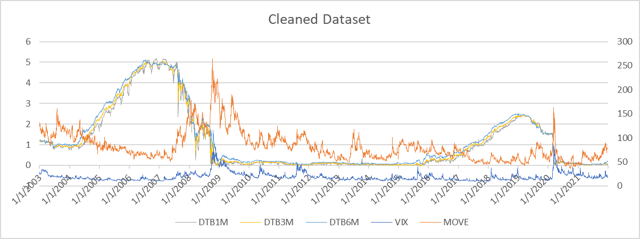
Figure 1: Cleaned and interpolated data set (size = 4958)

  - Regimization
The selected time scope includes three major spikes of MOVE index, beneath which there are two significant market-level crashes (i.e. Global Financial Crisis 2007-2008, and Coronovirus market crash in March 2020) and a Taper tantrum in 2013.
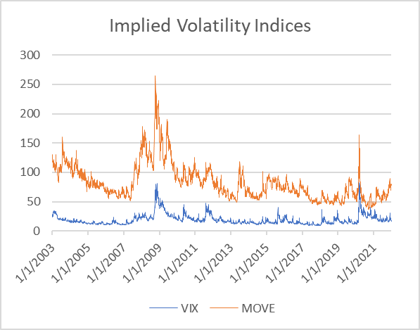
Figure 2: Localization of the spikes and the corresponding event periods
Therefore, the paper separates the data set into 7 regime subsets to separate the characteristic of data in the relatively stable periods for the regression analyses, in which three subsets subsume the fluctuating time around the spikes (based on the milestone timeline of each event), denoted as V1, V2, V3:
Volatile Periods | Start | End | Months | Data Size | Event
V1 | 5/1/2007 | 2/26/2010 | 34 | 739 | Global Financial Crisis 2007-2008
V2 | 5/1/2013 | 10/31/2013 | 6 | 132 | Taper tantrum in 2013
V3 | 1/1/2020 | 4/30/2020 | 4 | 87 | 2020 Coronovirus market crash
Total data size in volatile periods |  |  |  |  | 958 (19.3% of the total data set)

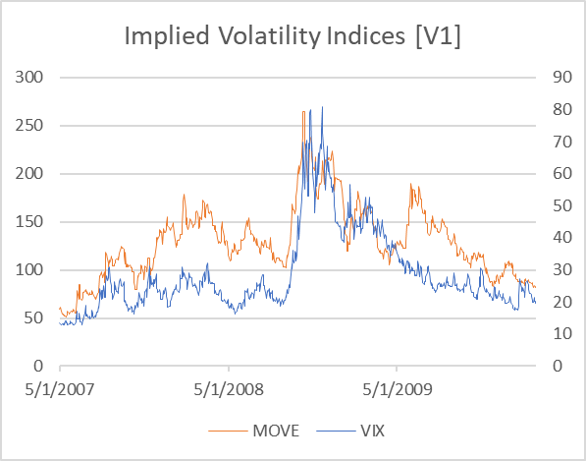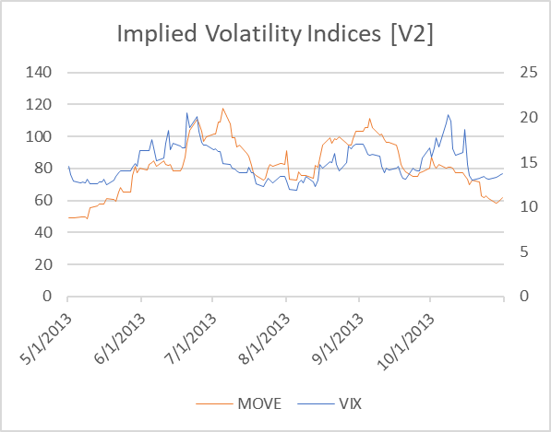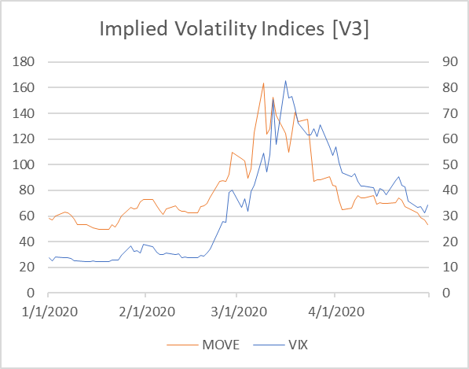
Figure 3: Time series plots of high volatility periods

Please note that the unit of time and MOVE value on the axis in the diagrams above are not unified (similarly hereinafter). And the other four subsets cover the stable periods:
Stable Periods | Start | End | Months | Data Size
S1 | 1/1/2003 | 4/30/2007 | 52 | 1129
S2 | 3/1/2010 | 4/30/2013 | 38 | 827
S3 | 11/1/2013 | 12/31/2019 | 74 | 1608
S4 | 5/1/2020 | 12/31/2021 | 24 | 436
Total data size in stable periods |  |  |  | 4000  (81.7% of total)

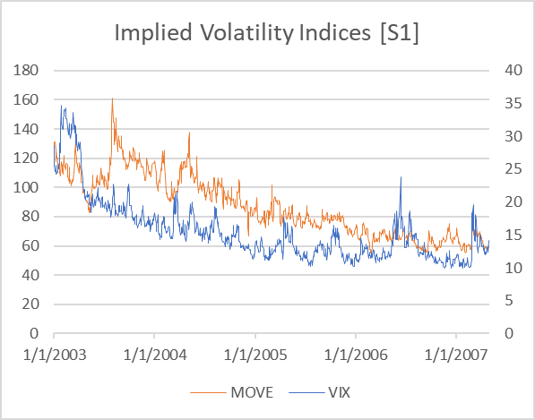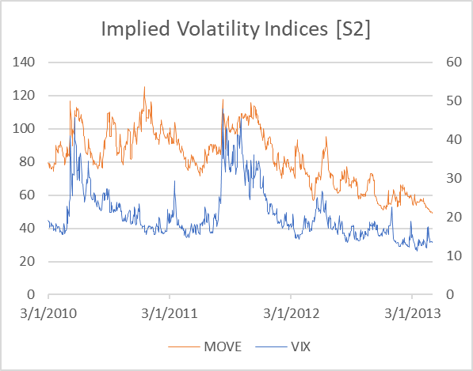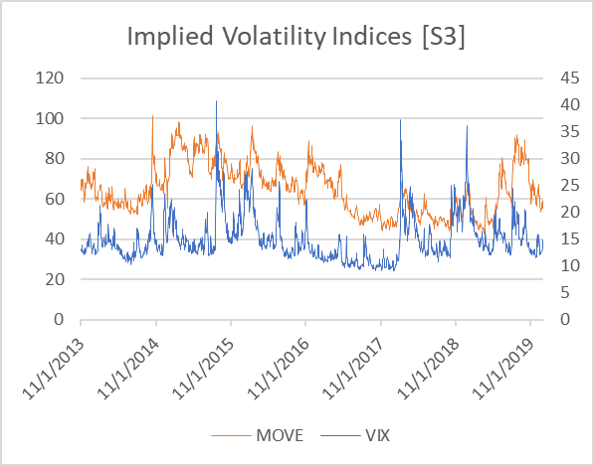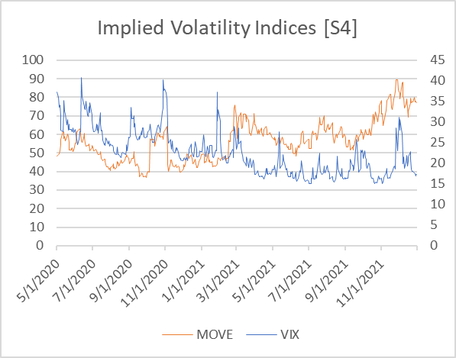
Figure 4: Time series plots of stable periods

  - Calculation of the treasury yield spread
This paper focuses on the spreads between 1-month, 3-month, and 6-month Treasury Bill Secondary Market Rates, which are:
6-month-3-month spread: 6m3m_{t} = DTB6_{t} － DTB3_{t}
6-month-1-month spread: 6m1m_{t} = DTB6_{t} － DTB1_{t}
3-month-1-month spread: 3m1m_{t} = DTB3_{t} － DTB1_{t}

- Empirical Analysis: Contemporaneous Relationship
  - Descriptive Statistics
The descriptive data indicates persistent positive positive skewness and excessive kurtosis of VIX and a slightly negative excessive kurtosis of MOVE for each stable regime, meaning that MOVE and its changes have thinner tails a flatter peak, while VIX is leptokurtic even during the stable periods.
Regime | Variable | Skewness | Excess Kurtosis
S1 | VIX | 1.79 | 3.52
 | MOVE | 0.47 | -0.71
S2 | VIX | 1.40 | 1.59
 | MOVE | -0.05 | -0.92
S3 | VIX | 1.65 | 4.07
 | MOVE | 0.40 | -0.69
S4 | VIX | 0.80 | 0.15
 | MOVE | 0.56 | -0.07

However, the kurtosis of MOVE increase rapidly during the global financial crisis (2007-2008) and the coronavirus market crash (March 2020) and thus make it slightly leptokurtic distribution in the full time scope. This indicates the importance to consider the regime shift.
Regime | Variable | Skewness | Excess Kurtosis
V1 | VIX | 1.63 | 2.46
 | MOVE | 0.55 | 0.43
V2 | VIX | 0.85 | 0.21
 | MOVE | -0.12 | -0.55
V3 | VIX | 0.63 | -0.66
 | MOVE | 1.39 | 1.24
Full | VIX | 2.57 | 1.62
 | MOVE | 6.46 | 0.71

You may find the full descriptive data form in the Appendix 3.
  - Contemporaneous Correlation
During the stable periods, the correlation between VIX and the spreads are usually negative, showing its opposite-sign effect on the spread. However, the correlation between MOVE and the spreads can be positive or negative without a clear behavior beneath.
In the pre-crisis stable period (S1), the rise of MOVE indicates a higher volatility in the horizon of a month, which narrowing the gap between 1-month yield and a slightly longer-term yield, and thus left a negative correlation with 3m1m and 6m1m. However, in the early post-crisis stable period (S2), the MOVE has a same-sign effect on all three spreads. This indicates the the mechanism behind the rise of interest rate volatility has complicated impact to the bond yields.
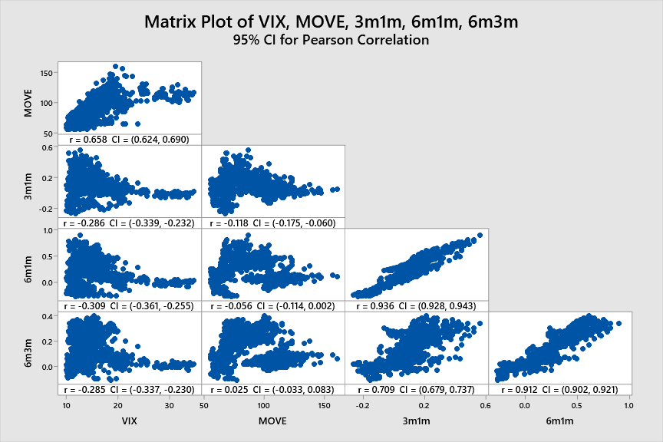 | 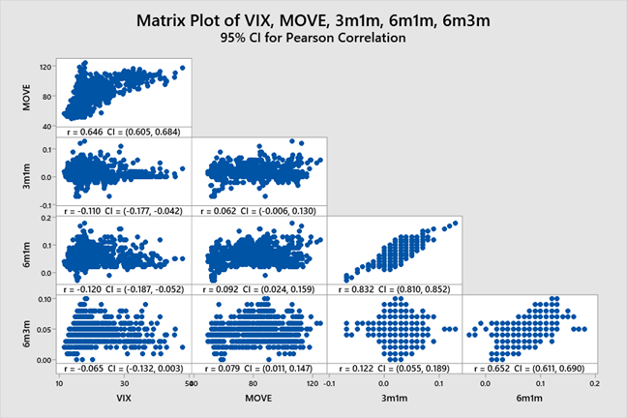
Correlation Matrix of S1 | Correlation Matrix of S2
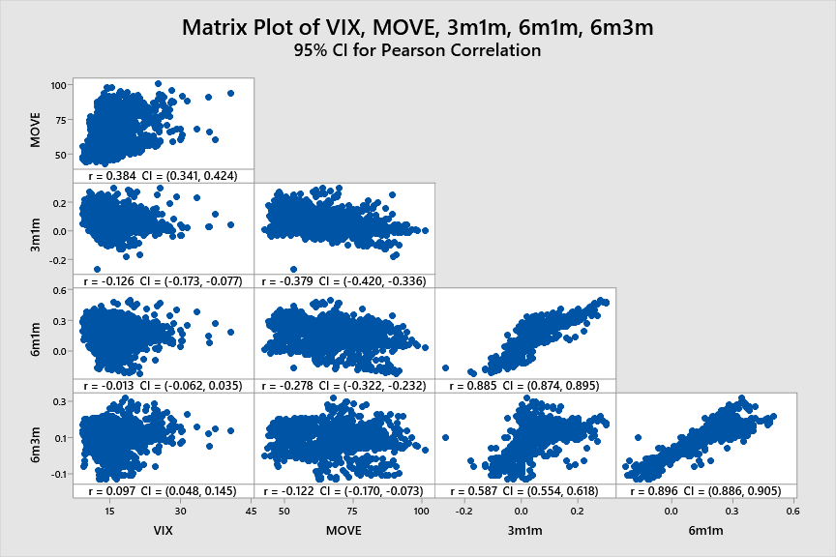 | 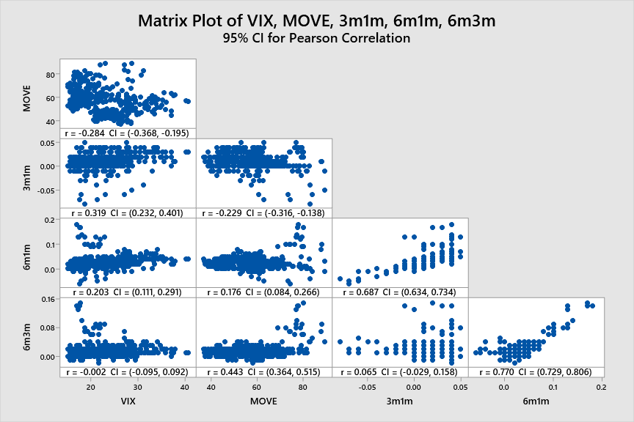
Correlation Matrix of S3 | Correlation Matrix of S4

During the highly volatile periods, however, the correlation between interest rates and implied risks will tend to become positive due to the rise of systematic risk that cannot be diversified through safety flight.
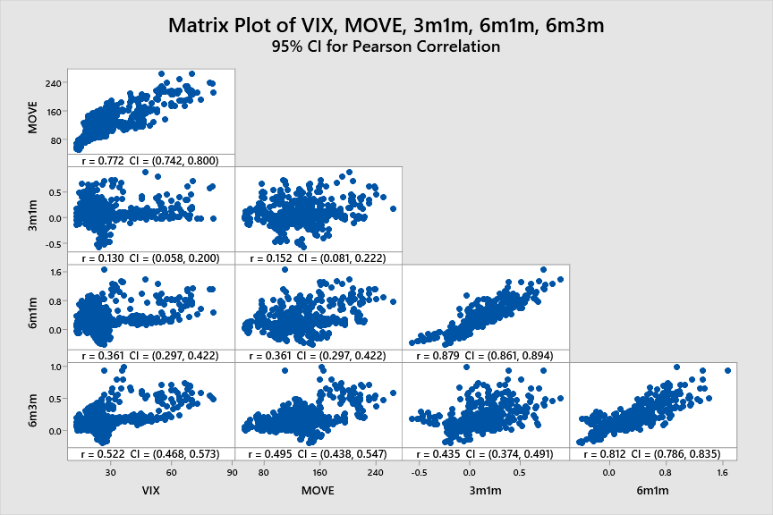 | 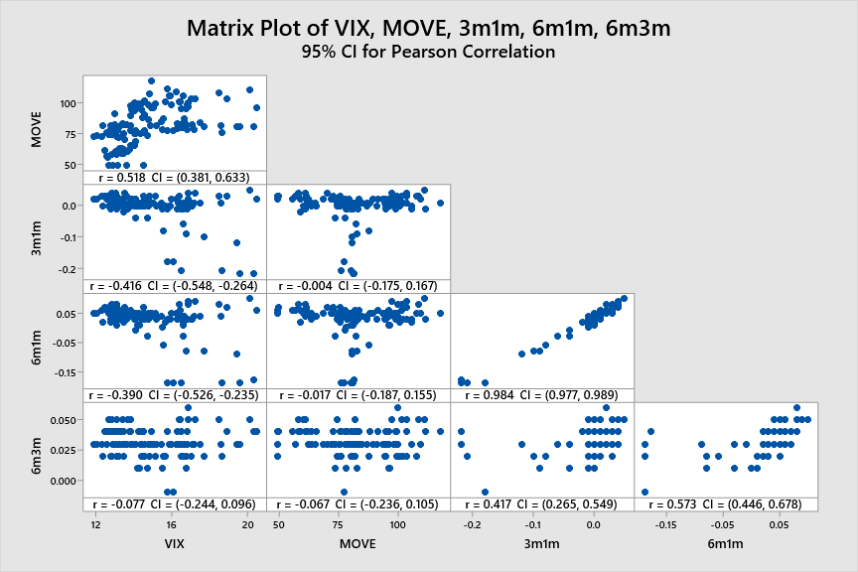
Correlation Matrix of V1 | Correlation Matrix of V2
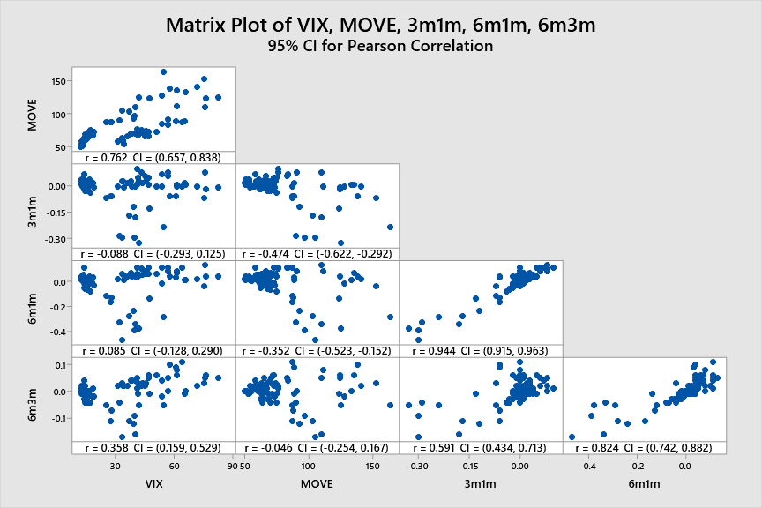
Correlation Matrix of V3

Please find the contemporaneous correlation matrices in the Appendix 4.

  - Regression Analysis
The linear regression indicates that MOVE has some explanatory power on the treasury yield spread, and both implied volatility indices tends to explain the spread of the slight further horizons, such as 6m3m, better, in comparison to the explanation of 3m1m. In the comparison between MOVE and VIX, MOVE wins in 7 out of 8 tasks. Besides, the observation shows that a larger correlation with the spread may lead to a larger R².
MOVE
 |  | ϱ^{contemp} | R² | Residual
S1 | 6m3m | 0.025 (+) | 53.73% (***) | Null State  (Bimodal distribution)
 | 3m1m | -0.118 (-) | 28.74% (***) | Null State  (Bimodal distribution)
S2 | 6m3m | 0.079 (+) | 85.22% (***) | Not significantly heteroskedastic  Statistically Normal
 | 3m1m | -0.062 (-) | 34.09% (***) | Not significantly heteroskedastic
S3 | 6m3m | 0.122 (-) | 55.80% (***) | Not significantly heteroskedastic  (Right-skewed)
 | 3m1m | -0.379 (-) | 26.00% (***) | Null State  (Right-skewed)
S4 | 6m3m | 0.443 (+) | 47.63% (***) | Null State  (Right-skewed)
 | 3m1m | -0.229 (-) | 18.92% (***) | Null State
VIX
 |  | ϱ^{contemp} | R² | Residual
S1 | 6m3m | -0.285 (-) | 43.76% (***) | Null State  (Bimodal distribution)
 | 3m1m | -0.286 (-) | 23.10% (***) | Null State  (Bimodal distribution)
S2 | 6m3m | -0.065 (-) | 58.42% (***) | Null State  (Left-skewed, heavy tail)
 | 3m1m | -0.110 (-) | 28.27% (***) | Null State  (Right-skewed, heavy tail)
S3 | 6m3m | 0.097 (+) | 38.34% (***) | Null State  (Bimodal distribution)
 | 3m1m | -0.126 (-) | 26.00% (***) | Null State  (Left-skewed)
S4 | 6m3m | -0.002 (-) | 38.34% (***) | Null State  (Left-skewed, heavy tail)
 | 3m1m | 0.392 (+) | 28.47% (***) | Null State
* p-value ≤ 0.05 ** p-value ≤ 0.01 *** p-value ≤ 0.001 (all p-values are for the slope coefficient)

- Empirical Analysis: Intertemporal Relationship and Prediction
  - Intertemporal Correlation: Lag-1 Indices
Intertemporal correlation between the lag-1 MOVE and nearer-term spread is more tend to be negative, while the correlation between lag-1 MOVE and 6m3m or 6m1m varies across the regimes. The change of the pattern may show the impact of crashes on the investors.
In the pre-crisis regime (S1), the rise in lag-1 MOVE and lag-1 VIX will lead to a decrease in the 3m1m and 6m1m spread, while only the rise of lag-1 VIX has a clear negative impact on the 6m3m. The impact of VIX shows the opposite-sign impact feature of the safety flight, and the correlation between VIX and the spreads are stronger than MOVE, showing the relevant insensitivity of the investors to the bond interest volatility. However, in the early post-crisis regime (S2), the opposite-sign impact is smaller. After the taper in 2013 (S3), a rise in bond interest volatility will lead to a decrease for 3m1m and 6m1m, while their impact on 6m3m is less significant, showing the increase sensitivity in the 1-month after the taper tantrum. And from the limited observation after the coronavirus market crash (S4), the negative sign impact of the implied volatility may fade for both MOVE and VIX due to the stimulus or diversification needs.
The observations shows that the early period after crises show a decrease in the aggregate opposite-sign effect. The observations also indicate that stimulus will reduce the aggregate opposite-sign impact of implied volatilities on the spreads, and taper tend to increase the aggregate effect. However, the observations are also contaminated by the impact of the monetary policies and market sentiment, and this need further research to separate the effect of the implied volatility.

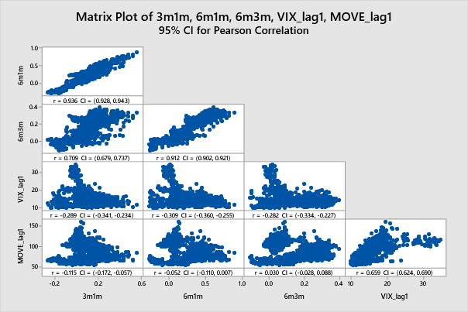 | 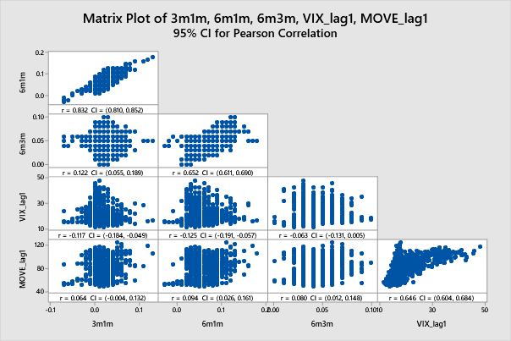
Correlation Matrix of S1 | Correlation Matrix of S2
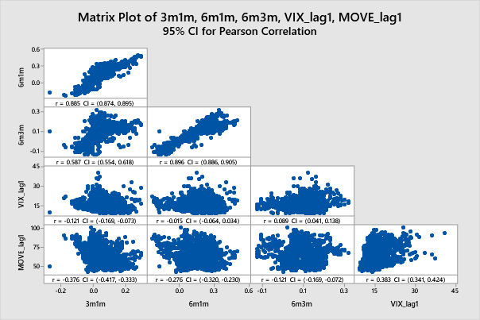 | 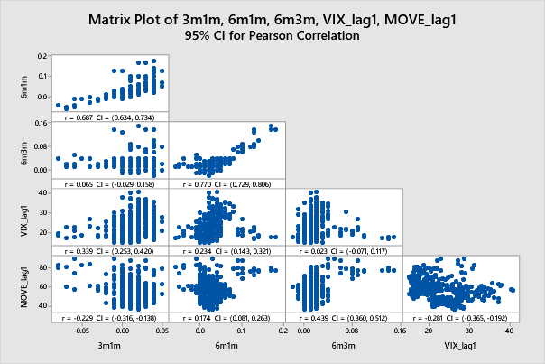
Correlation Matrix of S3 | Correlation Matrix of S4

  - Regression
The intertemporal regression shows that MOVE index has a moderate prediction power for tomorrow’s spread value, with a R² similar to contemporaneous the has statistically significant yet tiny prediction power beyond AR(1). However, especially when the absolute value of R² of is large in the simple linear model, the colinearity increase significantly, showing the high explanatory power in regime S2 overlaps with the autocorrelation.
MOVE
 |  | ϱ^{intertemp} | R²_{SLR} | R² _{AR(1) Residual} | VIX_{with AR(1)}
S1 | 6m3m | -0.285 (-) | 53.85% (***) | 0.16% | /
 | 3m1m | -0.286 (-) | 28.77% (***) | 0.52% (**) | 1.40
S2 | 6m3m | -0.065 (-) | 85.22% (***) | 0.85% (**) | 6.77
 | 3m1m | -0.110 (-) | 18.92% (***) | 2.66% (***) | 1.52
S3 | 6m3m | 0.097 (+) | 55.79% (***) | 0.26% (*) | 2.26
 | 3m1m | -0.126 (-) | 26.02% (***) | 0.88% (*) | 1.35
S4 | 6m3m | -0.002 (-) | 47.52% (***) | 1.29% (*)
 | 3m1m | 0.392 (+) | 28.47% (***) | 0.34% (*)

VIX
 |  | ϱ^{intertemp} | R²_{SLR} | R² _{AR(1) Residual} | VIX_{with AR(1)}
S1 | 6m3m | -0.285 (-) | 53.85% (***) | 0.16% | /
 | 3m1m | -0.286 (-) | 28.77% (***) | 0.52% (**) | 1.40
S2 | 6m3m | -0.065 (-) | 85.22% (***) | 0.85% (**) | 6.77
 | 3m1m | -0.110 (-) | 18.92% (***) | 2.66% (***) | 1.52
S3 | 6m3m | 0.097 (+) | 55.79% (***) | 0.26% (*) | 2.26
 | 3m1m | -0.126 (-) | 26.02% (***) | 0.88% (*) | 1.35
S4 | 6m3m | -0.002 (-) | 47.52% (***) | 1.29% (*)
 | 3m1m | 0.392 (+) | 28.47% (***) | 0.34% (*)
* p-value ≤ 0.05 ** p-value ≤ 0.01 *** p-value ≤ 0.001 (all p-values are for the slope coefficient)

- Conclusion
The paper shows that MOVE index has statistically significant explanatory and predictive power as a single predictor of the treasury yield spreads, while it performs better in the 6m3m in comparison to 3m1m and 6m1m which match closely with its horizon. In terms of R², the lag-1 prediction power of MOVE index is close to the explanatory power of the contemporaneous regression model, while AR(1) with MOVE can provide only a significant yet tiny extra prediction power beyond pure AR(1), and the VIF analysis show a clear colinearity with the AR(1) when the R² is large for the slope in the single linear regression using MOVE as the regressors. However, the intertemporal correlation reflects the dynamics of the opposite-sign effect of implied volatility and the investors’ decision between equity and bond market (“flight to safety”) in response to the financial crisis and monetary policies, while the net effect of MOVE in such scenarios call for further research.

Appendices
Appendix 1: Time Series Data Plot (Stable Periods)
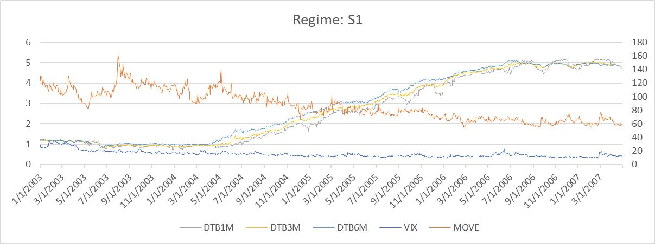
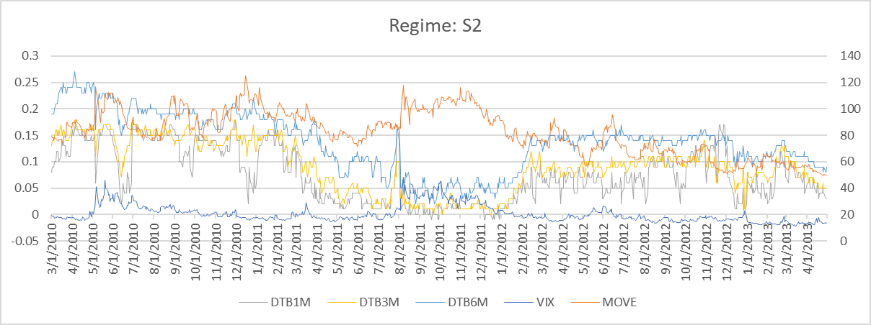
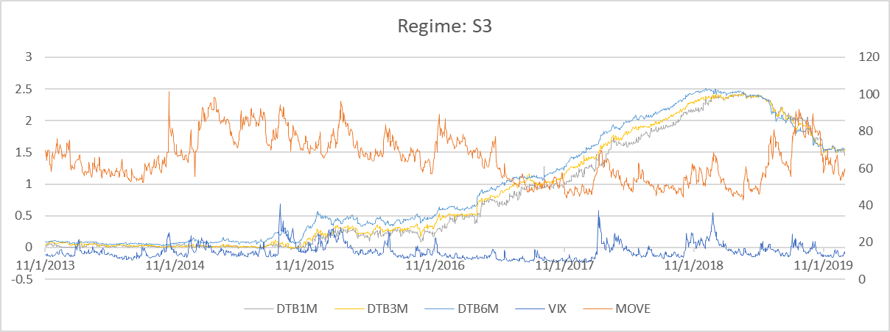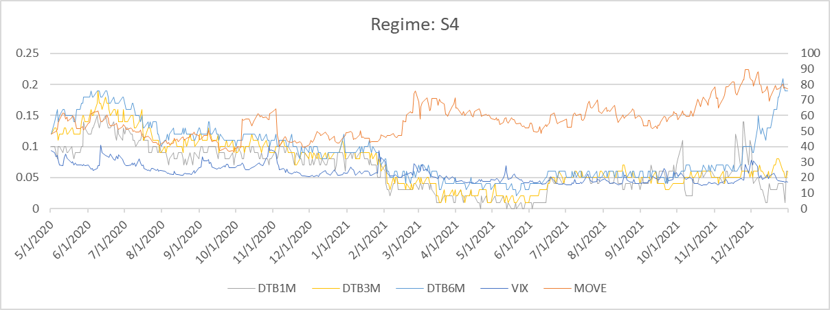
Appendix 2: Time Series Data Plot (Highly Volatile Periods)
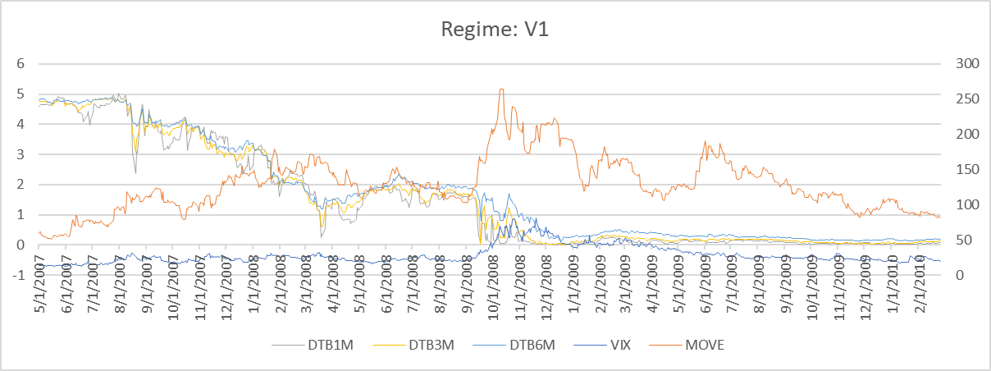
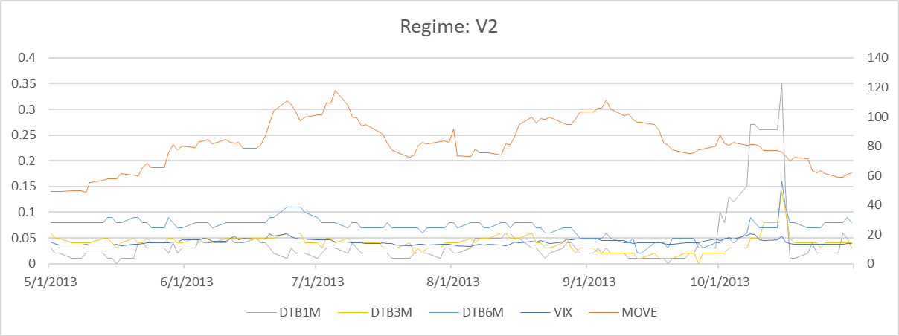
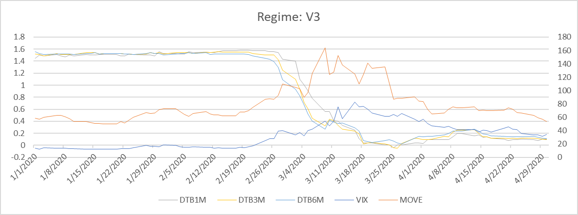

Appendix 3: Descriptive Statistics (of each regime)
Regime | Variable | Mean | StDev | Skewness | Excess Kurtosis
S1 | VIX | 15.514 | 4.797 | 1.79 | 3.52
 | MOVE | 87.078 | 21.258 | 0.47 | -0.71
 | 3m1m | 0.09322 | 0.13255 | 0.22 | 0.39
 | 6m1m | 0.22245 | 0.22789 | 0.15 | -0.54
 | 6m3m | 0.12923 | 0.11386 | 0.27 | -1.02
S2 | VIX | 20.668 | 6.620 | 1.40 | 1.59
 | MOVE | 82.283 | 17.110 | -0.05 | -0.92
 | 3m1m | 0.016747 | 0.023178 | 0.23 | 2.91
 | 6m1m | 0.06224 | 0.03034 | 0.45 | 0.35
 | 6m3m | 0.045490 | 0.016949 | 0.45 | 0.14
S3 | VIX | 14.943 | 4.044 | 1.65 | 4.07
 | MOVE | 64.914 | 12.452 | 0.40 | -0.69
 | 3m1m | 0.04950 | 0.06982 | 0.66 | 0.70
 | 6m1m | 0.13924 | 0.12733 | -0.05 | -0.40
 | 6m3m | 0.08974 | 0.07312 | -0.22 | 0.05
S4 | VIX | 22.583 | 5.344 | 0.80 | 0.15
 | MOVE | 56.634 | 11.052 | 0.56 | -0.07
 | 3m1m | 0.010069 | 0.018314 | -1.28 | 4.71
 | 6m1m | 0.02727 | 0.02865 | 1.77 | 6.80
 | 6m3m | 0.017202 | 0.020866 | 3.27 | 14.81
Regime | Variable | Mean | StDev | Skewness | Excess Kurtosis
V1 | VIX | 28.575 | 12.564 | 1.63 | 2.46
 | MOVE | 128.99 | 38.11 | 0.55 | 0.43
 | 3m1m | 0.07767 | 0.19264 | 0.68 | 2.81
 | 6m1m | 0.2480 | 0.2972 | 1.16 | 2.25
 | 6m3m | 0.17028 | 0.15755 | 1.64 | 4.10
V2 | VIX | 14.832 | 1.934 | 0.85 | 0.21
 | MOVE | 81.63 | 16.11 | -0.12 | -0.55
 | 3m1m | -0.00189 | 0.05066 | -3.14 | 9.96
 | 6m1m | 0.03008 | 0.05620 | -2.86 | 8.47
 | 6m3m | 0.031970 | 0.011082 | -0.71 | 2.13
V3 | VIX | 33.19 | 19.82 | 0.63 | -0.66
 | MOVE | 78.92 | 26.13 | 1.39 | 1.24
 | 3m1m | -0.01356 | 0.08445 | -2.27 | 5.32
 | 6m1m | -0.0138 | 0.1203 | -2.05 | 4.05
 | 6m3m | -0.00023 | 0.04920 | -0.95 | 2.34

Appendix 4: Contemporaneous Correlation Matrices (of each regime)
Correlation Matrix of S1 | Correlation Matrix of S2
Correlation Matrix of S3 | Correlation Matrix of S4
Correlation Matrix of V1 | Correlation Matrix of V2
Correlation Matrix of V3

Appendix 5: Intertemporal Correlation Matrices (of each stable regime)
Correlation Matrix of S1 | Correlation Matrix of S2
Correlation Matrix of S3 | Correlation Matrix of S4

Works Cited and References
Bansal, Ravi, and Hao Zhou. "Term structure of interest rates with regime shifts." The Journal of Finance 57.5 (2002): 1997-2043.
Black, Fischer. "Studies of stock market volatility changes." Proceedings of the American Statistical Association, Business and Economic Statistics Section (1976), pp. 177-181.
Brenner, Menachem, and Dan Galai. “New Financial Instruments for Hedge Changes in Volatility.” Financial Analysts Journal, vol. 45, no. 4 (1989): 61–65.
Campbell, John Y., and Ludger Hentschel. "No news is good news: An asymmetric model of changing volatility in stock returns." Journal of Financial Economics 31.3 (1992): 281-318.
Carr, Peter, and Liuren Wu. "Variance risk premiums." The Review of Financial Studies 22.3 (2009): 1311-1341.
Chan, Kalok C., et al. "An empirical comparison of alternative models of the short‐term interest rate." The Journal of Finance 47.3 (1992): 1209-1227.
Choi, Hoyong, Philippe Mueller, and Andrea Vedolin. "Bond variance risk premiums." Review of Finance 21.3 (2017): 987-1022.
Cremers, Martijn, Matthias Fleckenstein, and Priyank Gandhi. "Treasury yield implied volatility and real activity." Journal of Financial Economics 140.2 (2021): 412-435.
Durham, J. Benson. "An Estimate of the Inflation Risk Premium Using a Three-Factor Affine Term Structure Model." Finance and Economics Discussion Series Divisions of Research & Statistics and Monetary Affairs, Federal Reserve Board (2006).
Fassas, Athanasios P., and Costas Siriopoulos. "Implied volatility indices–A review." The Quarterly Review of Economics and Finance, 79 (2021): 303-329.
García, Raquel López. Construction and Analysis of Fixed-Income Volatility Indices. Diss. Universidad de Castilla-La Mancha, 2014, pp. 15-22.
Mallick, Sushanta, Madhusudan S. Mohanty, and Fabrizio Zampolli. "Market volatility, monetary policy and the term premium." BIS Working Papers (2017): 15-22.
Whaley, Robert E. "The investor fear gauge." The Journal of Portfolio Management 26.3 (2000): 12-17.
Zhou, Yinggang. "Modeling the joint dynamics of risk-neutral stock index and bond yield volatilities." Journal of Banking & Finance, 38 (2014): 216-228.

Remark of Data Accessibility in the event of Force Majeure: Merrill Lynch started to publish daily value of MOVE since 1988, and the data is accessible on Bloomberg. However, due to the lockdown in Shanghai, the author cannot access the Bloomberg terminal in the library, and thus the time availability for the data is undermined and thus the research turns to focus on the data since 2003.
null state: residuals are heteroskedastic, self-correlated, and not normal.

