Stepping into the Post-Covid Era: What’s Next?
An Industry Analysis of Chinese Pre-Made Food Industry

By

Xin Lyu

An honors thesis submitted in partial fulfillment

of the requirement for the degree of

Bachelor of Science

Business and Economics Honors Program

New York University Shanghai

May 2023

Professor Marti G. Subrahmanyan Professor Jiawei Zhang
Professor Christina Wang
Professor Wendy Jin

Faculty Advisors Thesis Advisor

ACKNOWLEDGEMENTS
As I approach the conclusion of my undergraduate studies, I would like to express my heartfelt gratitude to those who have been instrumental in my journey.
First and foremost, I would like to express my deepest gratitude to my thesis advisor, Professor Jiawei Zhang. Your guidance, support, and unwavering encouragement have been invaluable not only throughout this honors thesis program, but also in other aspects of my academic and personal life. Your invaluable advice and insightful feedback shaped me as a person and a scholar, and I feel so honored and privileged to have had you as my mentor throughout my senior year.
I am incredibly grateful for the exceptional education provided by NYU Shanghai, a community that values inclusivity, respect, and diversity of perspectives that shaped who I am today. I am proud to have been part of such a wonderful community, and I will always cherish the memories and experiences that I gained during my time at NYU Shanghai.
I would also like to thank every faculty advisor in this honors research program: Professor Marti G. Subrahmanyan, Professor Christina Wang, and Professor Wendy Jin, for having me in this honors research program and providing me with the opportunity and resources to explore my passion for food studies. I am also grateful for the meaningful seminars that were organized throughout the year with the participation of various distinguished speakers, which have broadened my knowledge and enriched my academic experience.
Finally, I would like to thank my family, friends, and my boyfriend for their unconditional love, unwavering support, and constant encouragement throughout my undergraduate journey. Even when we couldn't be together, your presence and belief in me have been a constant source of strength and motivation.

ABSTRACT
Pre-made food refers to a variety of dishes that are pre-cooked and packaged for easy consumption, ranging from frozen dumplings and rice bowls to vacuum-sealed meat and vegetable dishes. The pre-made food industry in China has experienced significant growth over the past few decades, especially during the COVID-19 pandemic. Access to fresh food was limited during related lockdowns, resulting in an increase in demand for pre-made food in China. The pre-made food industry has become a significant contributor to China's food industry supply chain, with a diverse range of players from small local businesses to multinational corporations vying for a share of the market. However, with the easing of the pandemic and the return to more normal food purchasing patterns, the pre-made food industry in China may face challenges in sustaining the level of demand seen during the COVID-19, making it essential for industry players to strategize for long-term growth. Therefore, this essay aims to explore the sustainability of the pre-made food industry in China by utilizing secondary sources such as academic articles, industry reports, and news articles to gain insights. The analysis will be structured into four main sections: market analysis, consumer analysis, strategic recommendations, and conclusions. By examining these sources, key trends and patterns in the industry can be identified, as well as the challenges and opportunities facing in the post-COVID era. Based on these insights, the essay will provide strategic recommendations to sustain the industry's growth, which is meaningful for different stakeholders such as business owners, policymakers, and consumers.

Keywords: Pre-made Food; Market Analysis; Consumer Analysis; Strategic Recommendations; Supply Chain Management

CHAPTER 1. MARKET ANALYSIS

1.1 Market Definition
Pre-made food refers to finished or semi-finished food products made from raw ingredients sourced from agriculture, livestock, poultry, and aquatic products. These raw materials undergo preparation, such as washing, chopping, stirring, salting, molding, and seasoning. This definition is widely recognized by both research organizations and industry players. According to the degree of processing and the convenience of eating, pre-made food can be divided into four segments: Instant-preparing food, Instant-cooking food, Instant-heating food, and Ready-to-eat food (Table 1). With the sequence shown from instant-preparing food to ready-to-eat food, the processing procedure becomes increasingly complex. For consistency with the references used in this research, we will exclude the category of Ready-to-eat food from our analysis.
Table 1: Pre-made food categories
Category | Characteristics & Examples | Sample Enterprises
Instant-preparing | Sterilized vegetables that were washed, cut, and packed | Hema
Instant-cooking | Food that requires simple cooking before eating (Meal kits, Refrigerated meat, etc.) | Wei Zhi Xiang
Instant-heating | Food that needs to be heated before eating (Frozen dumplings, instant noodles, etc.) | Tingyi (Cayman Islands) Holding Corp
Ready-to-eat | Food that is ready to eat (canned food, beef jerky, etc.) | Yinlu, Jinzai Food Group

1.2 Development Process
According to Xie and Zhu, the pre-made food industry in China emerged in the 1990s with the introduction of freshly sterilized vegetables, which are vacuum-packed products processed in a sterile environment after undergoing certain steps such as removing inedible parts, cutting, washing, and sterilizing. In the early stages, pre-made food in China took the form of frozen food and vacuum-packed cooked food, and for quite some time, the industry developed at a slow pace. However, in the early 2000s, there was a surge of pre-made food enterprises in East China that specialized in producing semi-finished food dishes. In the early 2000s, pre-made food enterprises emerged in East China. Improvements in cold storage and logistics technologies allowed pre-made food enterprises to overcome supply-side challenges, leading to more efficient production, storage, and delivery of semi-finished dishes to customers. As a result, pre-made food enterprises established themselves as a viable option for the food industry in East China.
In recent years, the pre-made food industry in China has gradually started to develop. The growth of the food delivery industry in 2014 played a pivotal role in expanding the fast-food meal kit market. Additionally, since 2015, the self-heating food category, including self-heating rice, self-heating hot pot, and self-heating noodles, has emerged and gradually covered the end-consumer market. The emergence of these products coincided with the gradual coverage of the pre-made food industry in the consumer market.

1.3 Market Size and Growth Trend Estimation
In early 2020, the outbreak of the COVID-19 pandemic had a significant impact on the restaurant industry and consumer dining habits. Lockdowns and restrictions during the COVID-19 pandemic led to increased demand for pre-made food as a safe and convenient meal option. The trend of pre-made food gained widespread attention in early 2022, coinciding with the strictest period of lockdown and control measures in China, when even major cities such as Shanghai were subject to extended lockdowns lasting up to three months in Spring 2022. This was reflected in the sharp increase in the search volume for the keyword "pre-made food" on Baidu, China's largest search engine. According to Baidu's data, this keyword had appeared in headlines less than 1,000 times before 2022, yet it reached a peak of 7,000 times in February 2022 (as shown in Chart 2), indicating a significant rise in public interest and demand for pre-made food. In this context, it is crucial to conduct a comprehensive market analysis of the pre-made food industry to gain a better understanding of the market landscape.
Chart 2: The Frequency of the Word “Pre-Made Food” Appearing in the Headlines of Related News on Baidu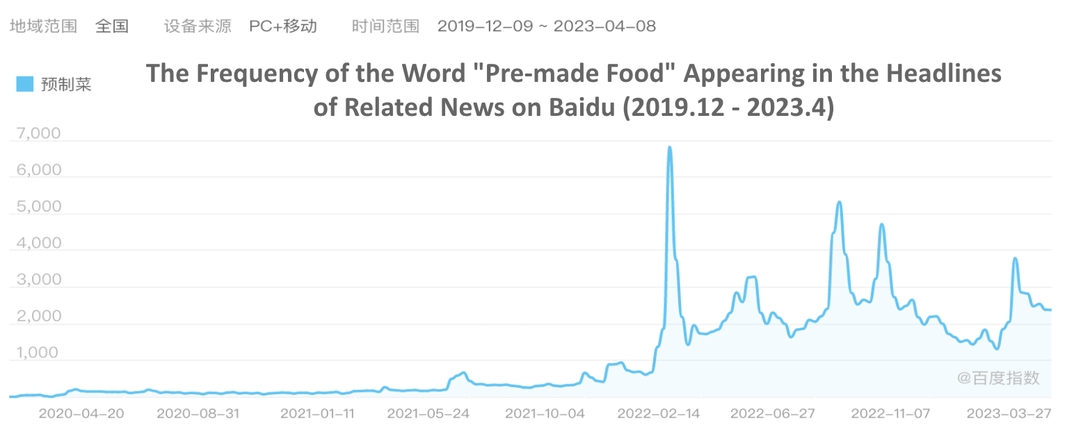

1.1.1 Method
My research into the market size of the Chinese pre-made food industry has revealed varying estimates from different securities, consulting, and technology firms. For instance, Guotai Junan Securities and the Alibaba Group rely on data from NCBD, a large-scale data research and evaluation organization in the catering industry. Meanwhile, the Forward Industry Research Institute (FIRI) uses data from Deloitte, and industry player Wei Zhi Xiang’s Annual Report uses iiMedia Research’s estimation. The conclusions drawn from these sources vary by as much as 57%, equivalent to 236.4 billion RMB. Therefore, to arrive at my own estimation for verification, I utilized the Bottom-Up Method and referred to survey results on pre-made food consumers conducted by both the FIRI and iiMedia Research. To estimate the market size, I calculated the average purchase frequency and consumption amount of consumers in terms of monetary values, and then multiplied this figure by the estimated number of consumers. After comparing the reliability, timeliness, and effectiveness of the different companies' estimations, I combined my own estimation with this analysis and ultimately decided to adopt the 2021 market size data provided by NCBD in my thesis.

1.1.2 Result
According to NCBD, the Chinese pre-made food market reached a staggering 313.67 billion RMB in 2021, representing a year-on-year growth of 24.12%. The growth rates are subject to varying estimations from different sources. Deloitte's estimation of the compound annual growth rate (CAGR) for the years 2017-2021 and 2021-2026 are 16% and 13% respectively. In contrast, NCBD's estimation for the years 2021-2025 is 28%, showing a significant discrepancy in the two estimations. With these varying estimates in mind, I applied a two-stage valuation model to make my own estimation (Table 3). I projected a CAGR of 30% from 2021-2023, followed by a CAGR of 15% from 2023-2026. The pre-made food industry market share would grow to 700 billion RMB in 2025 (Chart 4). This model takes into account the potential for continued growth in the pre-made food market, as well as the need for a more conservative estimate given the varying predictions of other sources.

Table 3: Pre-made Food Industry Market Sizing Estimates (in Billion RMB)
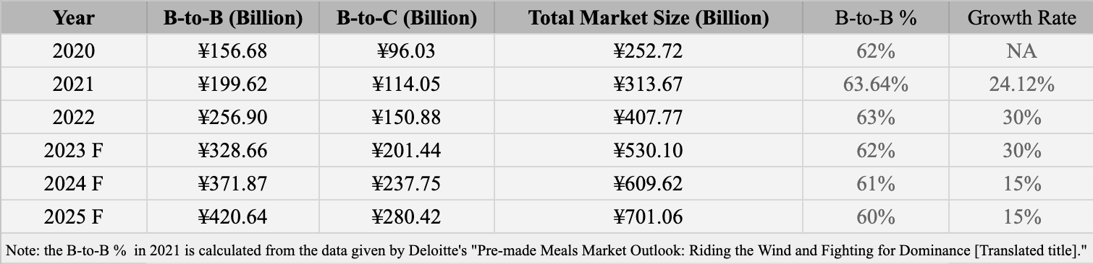

Chart 4: Pre-made Food Industry Market Sizing Estimates (in Billion RMB)
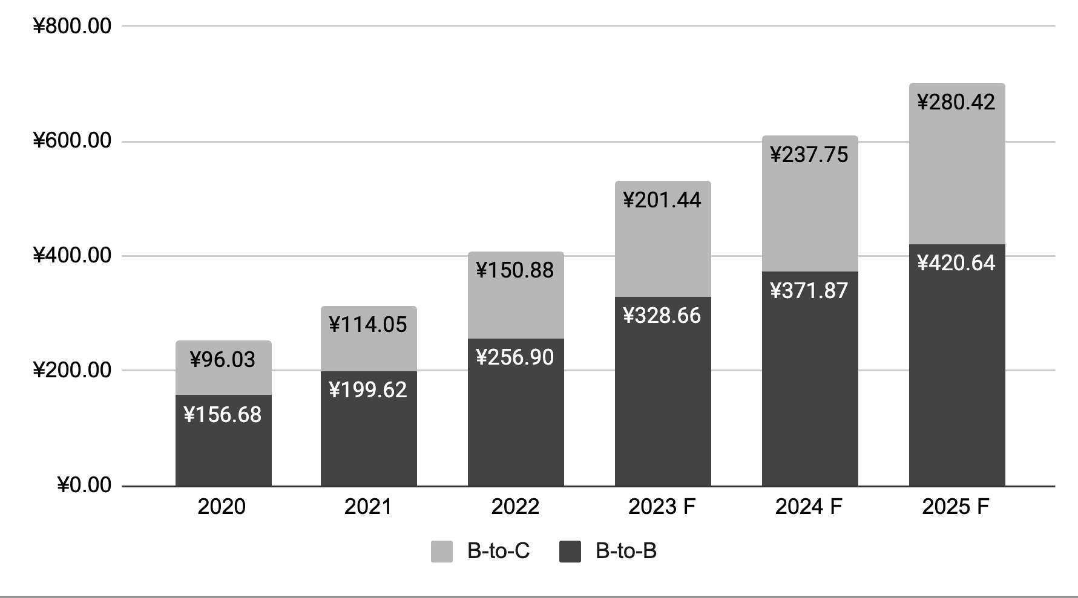

1.4 Competition Landscape Overview
The pre-made meals industry in China is a highly fragmented market, with many small-scale players entering the industry due to its low barriers to entry. In 2022, the industry saw a rapid development with 164 new pre-made food companies registered within the year, and among them, 52% of companies had a registered capital of less than 1 million RMB (Chart 5). The concentration of the industry is very low, and even the first pre-made meals company to be listed on the stock market, Wei Zhi Xiang, only accounts for 0.20% of the market (calculated by dividing Wei Zhi Xiang's 2022 revenue of 0.798 billion by the market size of pre-made meals industry in 2022 of 407.77 billion RMB).
We can take another example of Anjing Food, the top-ranked company in the Foodtalk's 2022 pre-made food enterprise rankings. Anjing Food specializes in the research and development, production, and sales of frozen foods. Based on revenue reported in the annual report 2022, Anjing reports its revenue of 12.183 billion RMB. After deducting the overseas revenue segment of 108 million RMB, the number 12.075 billion RMB is used for further calculations. Since the annual report did not disclose the breakdown of categories, even if we assume that all revenue comes from the pre-made meal sector, the market share is only 2.96%.
The geographical distribution of the pre-made meals industry in China is generally consistent with the overall economic development of the country, with a concentration of enterprises in the eastern regions. However, the provinces with the strongest development are not necessarily those with the strongest economies, but rather are mainly concentrated in Shandong and Guangdong provinces. As of February 16, 2023, there were approximately 301 pre-made food enterprises in China, with 77 and 66 registered in Shandong and Guangdong provinces, respectively, representing more than one third of the entire market. The uneven development among provinces can be attributed to factors such as the large consumer base, regional climate conditions, government policy support, and the entrepreneurial atmosphere in the food industry.

Chart 5: Registered Capital of Chinese Pre-Made Food Enterprises, 2016-2022
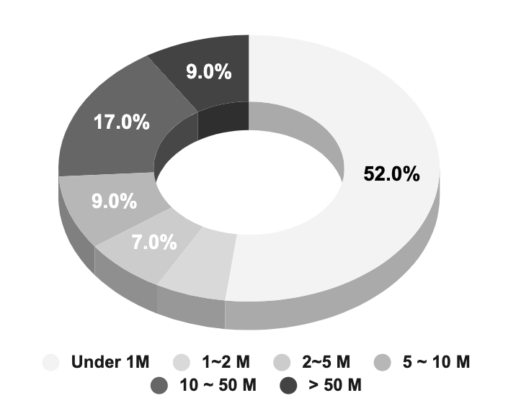
- Data Source: Forward Industry Research Institute; Originally from Qichamao (See FootNote 17)
- Search Logic: Searched for "Pre-made food" and related terms in the company name, business scope, company profile, and other aspects on Qichamao, filter out companies that are operating and existing.
- The above information is only valid until February 20, 2023

Graph 6: Regional distribution of Mainland China Pre-made Food Companies in 2023
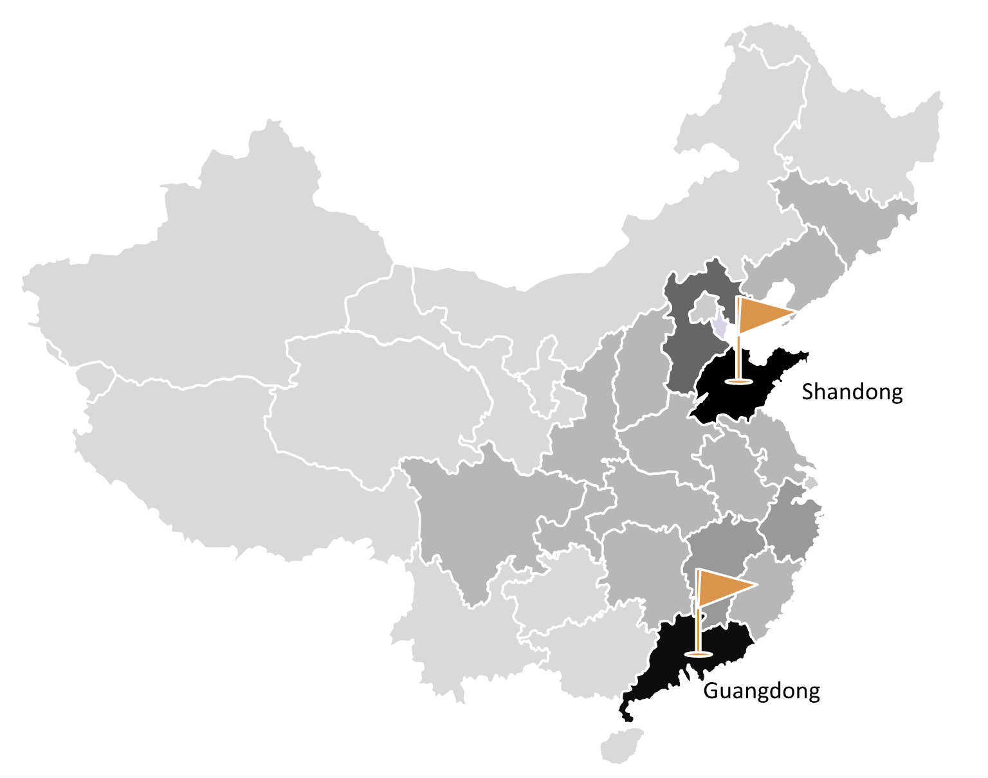
- Data Source: Forward Industry Research Institute; Originally from Qichamao (See FootNote 17)
- Search Logic: Searched for "Pre-made food" and related terms in the company name, business scope, company profile, and other aspects on Qichamao, filter out companies that are operating and existing.

Chart 7: Number of Pre-Made Food Enterprises Established in China, 2016 - 2023

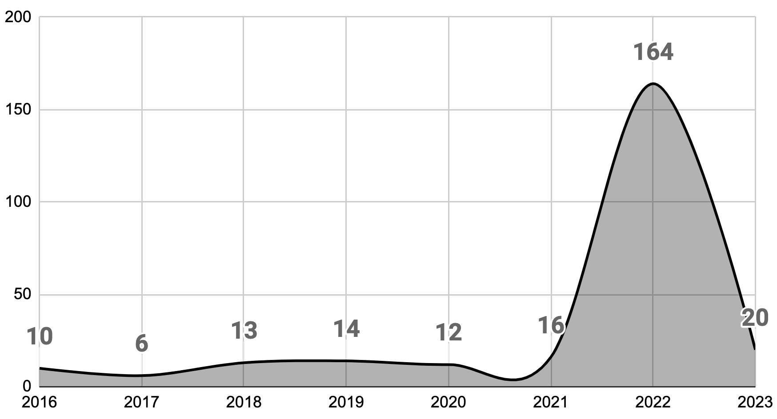
- Data Source: Forward Industry Research Institute; Originally from Qichamao (See FootNote 17)

1.5 Value Chain Overview
The pre-made food industry is a vital part of the upstream traditional catering industry value chain, which involves similar participants (as shown in Diagram 8). The upstream mainly includes raw materials, primary processing, food packaging, and manufacturing. Specifically, raw materials consist of grains, edible oils, condiments, meats, vegetables, and other ingredients.
The midstream production and processing involve in-house and outsourced production. The main participants in the Chinese pre-made food industry are catering enterprises, food processing enterprises, agricultural and animal husbandry enterprises, retail enterprises, as well as professional pre-made food enterprises. These participants are all part of the pre-made food industry chain and possess relevant social resources for the development of pre-made food. They have corresponding resources and industry chain advantages when transitioning their business to pre-made food.
Finally, pre-made food products are sent to both B-TO-B and B-TO-C markets through various channels. The downstream consumer end mainly includes large chain supermarkets such as Hema and Walmart, emerging e-commerce platforms such as Dingdong Maicai, catering enterprises such as Guangzhou Restaurant and Jinling Hotel, and convenience stores such as FamilyMart and Lawson. Food transportation enterprises play a vital role in the entire pre-made food industry chain.

Diagram 8: Value Chain of Pre-Made Food Industry

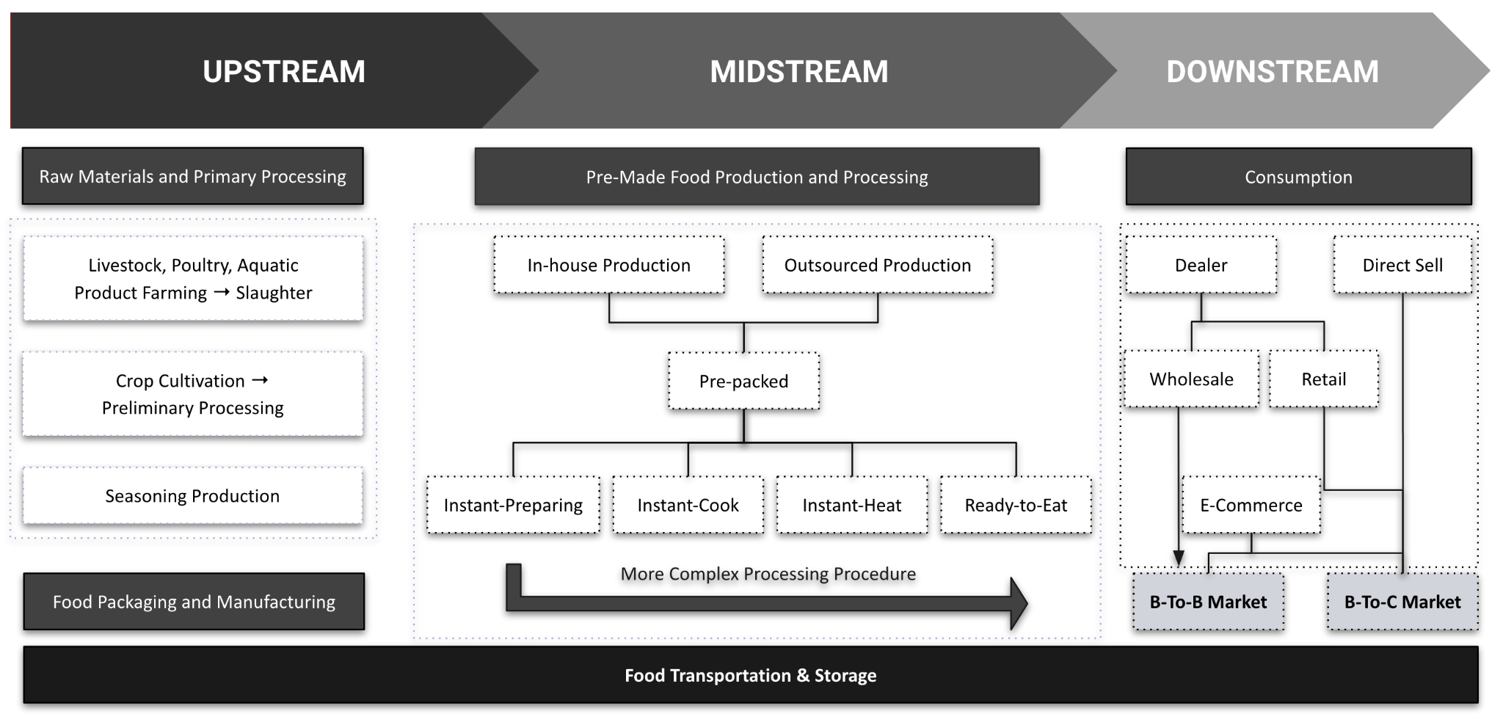
Note: This value chain diagram is a modified version based on reports from FIRI (See FootNote 3), iiMedia Research (See FootNote 2), and Guotai Junan Securities (See FootNote 7)

CHAPTER 2. CONSUMER ANALYSIS

2.1 B2B Market: Cost Optimization Advantages
The business-to-business (B2B) market in China is currently dominating the pre-made food market, accounting for 64% of the entire industry, calculated by using the estimated market size from Deloitte. Major chain restaurants in China, such as Xiao Nan Guo, Ji Ye Jia, and Xi Bei You Mian Cun, have already adopted pre-made food in their supply chain, with over 80% of their food being pre-made, according to CITIC Securities. The shift towards pre-made food is to enable catering businesses to remain competitive in the market, bringing four benefits as follows.
Adopting pre-made food in the supply chain allows restaurants to improve their cost structure by reducing the number of back-end staff, for example professional chefs. This is particularly important in an environment where labor costs are increasing due to rising minimum wages and a shortage of skilled workers. Moreover, pre-made food can also help reduce the time and effort required to train new staff. As pre-made food products are standardized and come with clear instructions, new staff can easily understand how to prepare and serve them, reducing the need for extensive training.
In addition to reducing labor costs, pre-made food also allows restaurants to lower PPE (property, plant, and equipment) costs. Specifically, pre-made food eliminates the need for elaborate cooking stations and equipment, which can significantly reduce the space required for a kitchen. This reduction in space requirements translates into lower rental costs and a smaller investment in equipment, as the restaurant can operate with fewer and simpler tools. Moreover, by relying on pre-made food, restaurants can shift the responsibility of equipment replacement and investing in new cooking technology to the pre-made food suppliers. This enables restaurants to focus their resources on other areas of the business, such as marketing, customer service, and menu development, without the added burden of maintaining and upgrading their kitchen equipment.
Additionally, pre-made meals provide consistency of taste and processing speed, leading to improved quality control. This consistency helps to build brand recognition and loyalty, as customers know they can expect the same high-quality food each time they visit the restaurant. Pre-made food also allows for faster processing times, as it can be prepared in advance and quickly assembled when an order is received. This helps to reduce wait times and increase customer satisfaction.
The quantitative data further supports the benefits of adopting pre-made food in the B2B market in China, highlighting the significant impact it can have on a restaurant's cost structure and net profits (Shown in Chart 9). As demonstrated in a cost structure comparison between traditional restaurants and those using pre-made food, by reducing labor and equipment costs, pre-made food can significantly optimize the cost structure of traditional restaurants, leading to a remarkable increase in net profits by 7%. This increase is particularly noteworthy given that the industry's average profit margin is only around 20%, meaning that pre-made food can potentially increase a restaurant's profits by more than a quarter. The data also reveals that the adoption of pre-made food leads to a rebalancing of cost categories, with labor costs decreasing from 22% to 12%, while raw materials and utility costs slightly increase by 5% and decrease by 2%, respectively. This rebalancing indicates that pre-made food enables restaurants to shift their resources from labor-intensive activities to more strategic areas, enabling them to remain competitive in a highly dynamic industry.

Chart 9: Cost Structure Comparison: Traditional v.s. Pre-Made Food User Restaurants
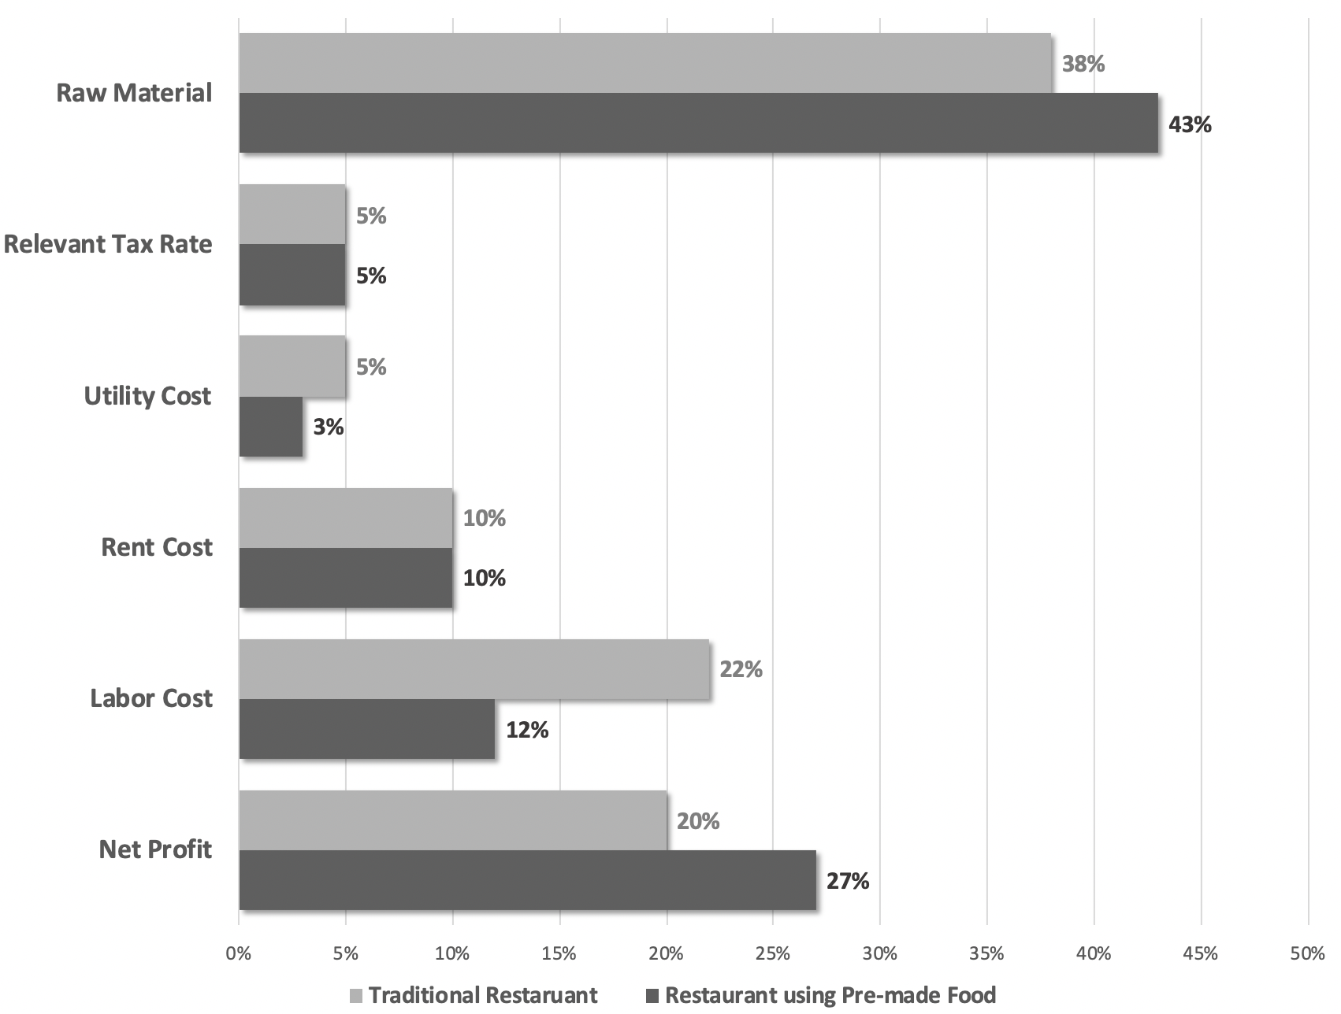
Note: This chart is given by Deloitte’s Report (See FootNote 11)

2.2 B2C Market: Consumer Profile Mapping
The data utilized in this section of business-to-consumer (B2C) analysis were the most up-to-date results obtained from two surveys conducted by iiMedia Research and FIRI. Despite the variations in sample size and survey timing, both surveys employed similar research methods and the results were found to be highly correlated and reliable. This section aimed to provide better understandings into consumer demographics by combining the results of both surveys, with a slightly greater emphasis on the more comprehensive data from the FIRI survey.
To begin with, female consumers make up a slightly higher proportion of the pre-made food market than male consumers, at around 59.4% (calculated by taking the average gender ratio of the above survey results). However, the overall gender ratio is not significantly different, indicating that pre-made food is not only appealing to women but also to men. Although there were slight differences in the age structure of the two surveys, both identified a similar trend of younger consumers being the main consumer group. iiMedia's survey found that the largest proportion of consumers, at 46.9%, were aged 31-40. Meanwhile, according to the FIRI survey, the largest consumer group was aged 25-31, accounting for 39.27%, with the 32-42 age group accounting for around 21.12% (Chart 9).
The results of both surveys showed striking similarities in terms of consumer city distribution. According to iiMedia's survey, the proportions of pre-made food consumers in first-tier, new first-tier, and second-tier cities were all around 25% (24.5%, 24.9%, and 28.7%, respectively). Similarly, the FIRI survey reported that 42.9% of consumers were in first-tier cities (both first-tier and new first-tier), while 27.2% were in second-tier cities. Notably, the total proportion of consumers in first-tier cities was nearly 50%, indicating that these urban areas remain the core market for pre-made food. However, I believe the second-tier cities have significant potential for growth and expansion in the pre-made food market due to their fast development pace and opportunities for tapping into the lower-tier markets.
Chart 10: Gender Structure of Pre-Made Food B-To-C Consumers in China
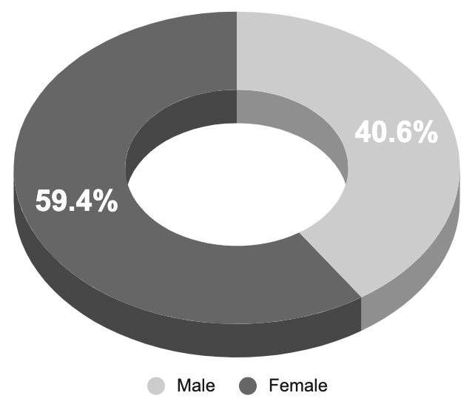
Note: This chart is made by referencing the data from FIRI (FootNote 32) and iiMedia Research (FootNote 31)

Chart 11: Age Structure of Pre-Made Food B-To-C Consumers in China

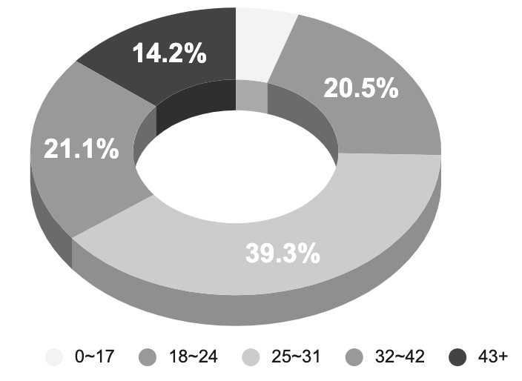

Chart 12: City Distribution of Pre-Made Food B-To-C Consumers in China
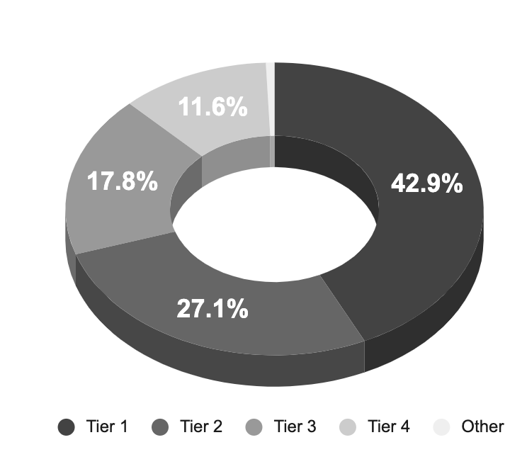
Note: Chart 11 and 12 are presented in the FIRI Report (See FootNote 3)

CHAPTER 3. STRATEGIC RECOMMENDATIONS
This chapter presents a series of strategic recommendations for the pre-made food industry, based on the insights gained from the market analysis in Chapter 1 and consumer analysis in Chapter 2. These recommendations aim to address the development issues of the pre-made food industry and provide practical solutions for companies operating in this sector. The recommendations focus on optimizing product structure, prioritizing the B-to-C market, and mitigating supply shock risks. We begin by analyzing the needs of end-consumers and propose solutions to tailor product offerings accordingly. Next, we discuss the importance of prioritizing the B-to-C market and provide strategies to effectively target this segment. Finally, we explore ways to mitigate supply chain risks and ensure a stable supply of ingredients. By implementing these recommendations, pre-made food companies can enhance consumer satisfaction, adapt to changing market trends, and improve their competitiveness in the market. With a focus on sustainable growth, these recommendations aim to help pre-made food companies stay ahead of the curve and thrive in this rapidly evolving industry.

3.1 Identifying Need of End-consumers and Optimize Product Structure
Understanding the needs and preferences of end-consumers is crucial for the success of any business, including the pre-made food industry. Such understanding can lead to increased sales in both the business-to-consumer (B2C) and business-to-business (B2B) markets, as catering companies and restaurants are more likely to purchase pre-made meal products that are in high demand from their customers. To provide high-quality pre-made meal products that meet these demands, insights from consumer surveys can be used to inform decision-making.
Instant-preparing and instant-heating foods are currently sharing a similar market share, calculated based on data provided by Deloitte. China underwent numerous lockdowns throughout the COVID-19 pandemic, leading a considerable number of consumers to opt for instant-heating food, possibly due to the unpredictability and abruptness of the lockdown measures. Instant-heating food has the advantage of requiring a low storage environment and having a long shelf life, making it an appealing option for those who are uncertain about when they will be able to leave their homes. With the decline of stockpiling demand caused by the COVID-19 pandemic, companies could pivot their attention towards providing instant-cooking food options that boast fresher, more flavorful ingredients and higher nutritional value.
Currently, the pre-made food market in China is evenly split between instant-preparing and instant-heating foods, according to data from Deloitte. However, I believe the balance is unlikely to persist due to the loss of an important growth factor, namely lockdowns.
During the COVID-19 pandemic in China, many consumers turned to instant-heating foods due to the unpredictability and suddenness of lockdown measures. Instant-heating foods have the advantage of requiring minimal storage space and having a long shelf life, making them an attractive option for those uncertain about their ability to leave their homes. As the pandemic subsides and the demand for stockpiling decreases, I believe that the demand for instant-heating foods will decline. This presents an opportunity for companies in the pre-made food market to shift their focus towards providing instant-cooking food options with fresher, more flavorful ingredients and higher nutritional value.
Based on a survey conducted by iiMedia Research in 2022 to determine the structure of pre-cooking products, Sichuan cuisine was found to be the most popular cuisine type among consumers, accounting for 60.8% of preferences. Shandong cuisine came in second with 36%, followed closely by Hunan cuisine at 35.4%. The survey also found that dinner was the most common time for pre-made food consumption, with 76.6% of respondents reporting this as their preferred mealtime, followed by lunch at 64.4% and late-night snacks at 26.3%.
In light of these findings, I believe that pre-made food companies should increase the availability of options with rich flavors, such as Sichuan cuisine, to cater to consumers' cravings for comfort food, especially at night. The survey also showed that consumers purchase pre-made food not only for convenience but also for their delicious taste and the experience of trying something new, accounting for 46.7% and 36% of total consumers, respectively. Therefore, it is recommended that pre-made food companies increase their investment in Research & Development to create new dishes that are innovative in taste, nutritional value, and other dimensions.This approach not only meets consumers' desires for tasty and novel flavors but also optimizes ingredient structure through R&D, which can help mitigate supply chain risks, as discussed in section 3.3.

3.2 Prioritizing the B2C Market
In order to fully capitalize on the immense growth potential in the pre-made meals market, it is crucial to prioritize the B2C segment and leverage consumer behavior research to tap into untapped opportunities. In this section, we will begin by estimating the penetration rate of the pre-made food B-to-C market in China (3.2.1). By understanding the current level of market saturation, we can identify areas where further expansion is possible. Subsequently, we will delve into an insightful comparison of the pre-made meals market in China and other countries, particularly focusing on per capita consumption rates (3.2.2). This analysis will provide valuable insights into the potential growth trajectory of the market. By leveraging consumer behavior research, businesses can strategically position themselves to unlock the untapped growth potential within the B2C segment.

3.2.1 Penetration Rate Estimation
Based on the results of the 7th National Population Census in 2021, the number of urban households in China was 494 million. Assuming a conservative estimate of 4 purchases per week with an average spending of 40 RMB per purchase, the estimated pre-made food market size could reach up to 948.48 billion RMB. This is a significant potential market size compared to the current estimated market size of 150.88 billion RMB, indicating a low penetration rate of only 15.9% for the pre-made food B-To-C market. Therefore, there is a significant potential for growth in the pre-made food industry.

3.2.2 Overseas Market Comparison
A comparison with overseas markets can also highlight the growth potential of the pre-made food industry in China. According to iiMedia Research, the average annual consumption of frozen foods per capita in the US, Europe, and Japan reached 60, 35, and 23 kg, respectively, in 2019. Among these countries, Japan is a more suitable benchmark for China due to similarities in dietary habits and other factors. CITIC Securities conducted a research study that indicated China's macroeconomic landscape and the factors driving the pre-made food market are akin to those that existed in Japan during the 1980s (as depicted in Table 13). After several decades of development, Japan now has a highly developed pre-made food market with a wide range of options available in supermarkets and convenience stores. The per capita consumption of frozen foods in Japan increased from 0.1 kg in 1961 to 23.1 kg in 2021, indicating a significant potential for growth. In contrast, the per capita consumption of pre-made meals in China was only 9 kg in 2021. Therefore, the pre-made meals market in China presents a significant opportunity for businesses to capitalize on.

Table 13: Similarities between China's Macroeconomic Landscape and Driving Factors of Pre-Made Meals Market and Japan in the 1980s
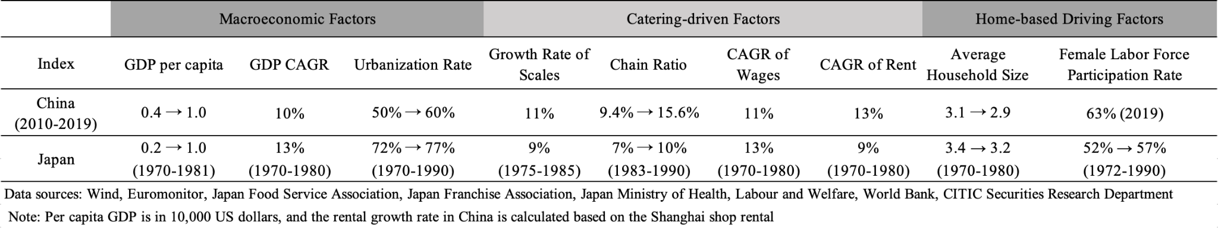
Note 1: This table is presented in CITIC Securities’ Report (FootNote 27)
Note 2:The figures are based on sources from:Wind, Euromonitor, Japan Food Service Association, Japan Franchise Association, Japan Ministry of Health, Labour and Welfare, World Bank, CITIC Securities Research Department
Note 3: Per capita GDP is in 10,000 US dollars, and the rental growth rate in China is calculated based on the Shanghai shop rental

3.3 Mitigating Supply Shock Risks
Pre-made food companies face significant risks due to their heavy reliance on a single ingredient, meat. Using Wei Zhi Xiang’s cost structure as an example, we see that direct material costs amount to 549 million RMB, accounting for 91.51% of all costs spent in the year 2022 (as depicted in Chart 14). This figure has increased by 6.86% from the previous year, indicating an even stronger reliance on meat as a primary input. Within Wei Zhi Xiang's direct material costs, meat accounts for 86.83% of total costs.
While relying on meat as an input can offer advantages, such as consistent taste and quality, it also exposes companies to risks related to supply chain disruptions, price volatility, and changing consumer preferences. These risks are exacerbated by the concept of a single point of failure, which refers to any component in a supply chain that, if disrupted, could have a significant impact on the entire supply chain. In the pre-made food industry, such disruption could cause a ripple effect throughout the entire supply chain, impacting production, inventory, and ultimately, customer satisfaction. Moreover, China faces tremendous supply pressure due to the rapid increase in meat consumption and population growth. According to data from the National Bureau of Statistics of China, China has been reliant on meat imports to meet the growing domestic demand, and over the past three years, China has consistently imported over 700 million tons of meat, indicating a significant supply-demand gap in the domestic market (as depicted in Chart 15). Therefore, the pre-made food industry is vulnerable to supply shocks, such as sudden disruptions in the meat supply chain, leading to supply shortages and price hikes. Furthermore, since most of the companies in the industry are on a small scale, they have much less bargaining power over suppliers.
In this following section, I will suggest three strategies to address these challenges: Supply Chain Vertical Integration Strategy, Supply Chain Diversification, and Collaborating with other companies to enhance bargaining power.

Chart 14: 2022 Cost Structure of Wei Zhi Xiang

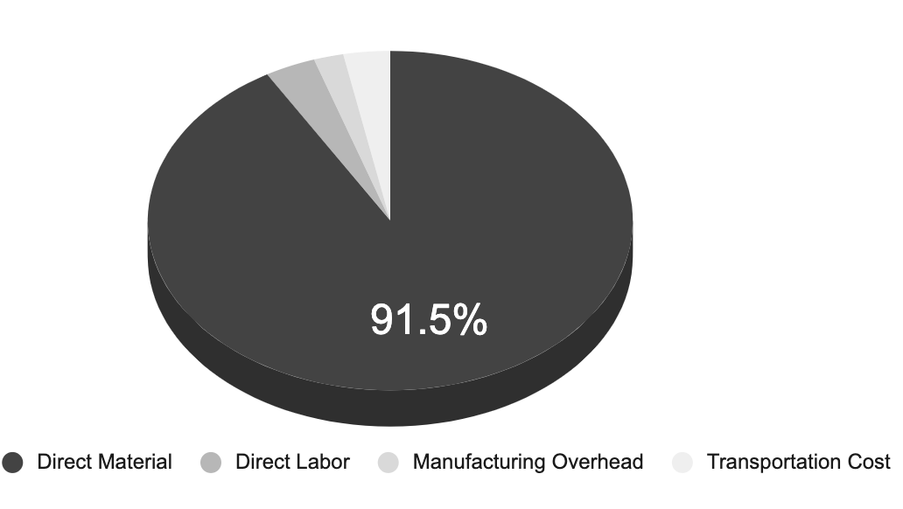
Data Source: See FootNote 1

Chart 15: 2018-2022 Meat Production and Import in China (Million Tons)

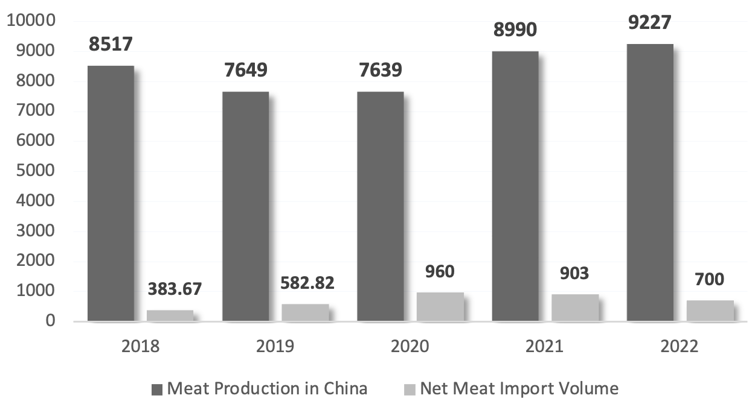
Data Source: See FootNote 40

3.3.1 Supply Chain Vertical Integration Strategy

Pre-made food companies can adopt a supply chain vertical integration strategy to mitigate the supply shock risks by expanding their supply chain to include upstream and downstream operations. By owning or controlling the operations involved in the production and distribution of their products, companies can better manage their supply chains and reduce their dependence on external suppliers. This approach has been successfully implemented by Haidilao, a popular Chinese restaurant chain that operates its own farms to grow vegetables and raise livestock, which ensures a stable supply of fresh ingredients for its restaurants and reduces their exposure to supply chain risks.
Similarly, pre-made food companies can adopt a similar approach by establishing their own farms, production facilities, and distribution channels, which can provide them with greater resilience and agility in the face of unexpected events such as supply chain disruptions and price volatility. For example, a pre-made food brand has already adopted the strategy, as presented in Deloitte's Report. Specializing in meat products, the company has extended its supply chain from upstream raw materials to downstream pre-made food production, ensuring stable raw material quality and supply, especially during fluctuations in pork prices due to African swine fever and the pandemic. This brand has also actively expanded into the hot pot ingredient market, leveraging its strong and stable supply chain to establish partnerships with chain hot pot restaurants.
It's worth noting, however, that implementing a vertical integration strategy requires careful consideration and evaluation. Companies need to assess whether the benefits of vertical integration outweigh the costs, which may include significant investments in infrastructure, technology, and personnel. They also need to ensure that they comply with relevant regulations and implement food safety measures to meet industry standards.

3.3.2 Supply Chain Diversification
Wei Zhi Xiang's cost structure highlights the potential risk of heavy reliance on a limited number of suppliers. In 2022, the company's top five suppliers accounted for 31.39% of its total procurement, equivalent to a procurement amount of 170,613.4 million RMB (Chart 15). Such concentration exposes the company to supplier-related risks, as any disruption or failure to supply materials or services by any of these suppliers could significantly impact the company's operations and production.

Chart 15: Top-5 Suppliers by Procurement Cost of Wei Zhi Xiang, 2022
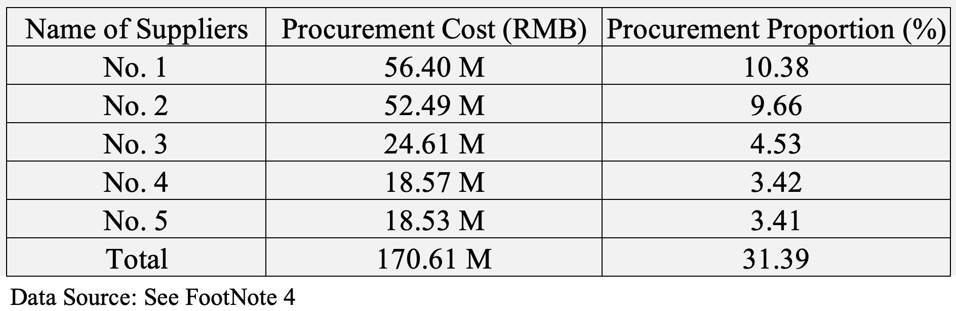
Data source: See FootNote 1

To mitigate the impact of supply chain disruptions, pre-made food companies can diversify their supply chains and reduce their dependence on a single supplier or region. This can be achieved by establishing relationships with alternative suppliers and developing contingency plans to reduce their reliance on any one supplier or region. Additionally, clear communication of the diversification strategy to suppliers is crucial to ensure they have the necessary capacity and capabilities to meet the company's needs. Ongoing monitoring, evaluation, and continuous improvement are also essential to maintain long-term resilience and sustainability.
However, diversifying supply chains can present challenges such as increased procurement costs, time-consuming establishment of relationships with new suppliers, regulatory hurdles, and logistical issues. To strike a balance between cost efficiency and supply chain resilience, companies need to carefully evaluate the trade-offs between cost and risk management when diversifying their supply chains. Investment in supplier relationship management (SRM) tools and practices can also be helpful in monitoring and evaluating supplier performance, identifying potential risks, and promoting continuous improvement for long-term resilience and sustainability.

3.3.3 Forming Alliances to Improve Bargaining Power
Another key strategy in supply chain management is to focus on enhancing bargaining power with suppliers. One approach that companies can adopt is to establish strategic partnerships or become members of industry associations. Such alliances can help firms negotiate more favorable prices and stable contracts, thereby mitigating the impact of price fluctuations and supply chain disruptions.
In several industries, firms have already formed alliances to bolster their bargaining power with suppliers. For instance, the International Air Transport Association (IATA) represents approximately 300 airlines worldwide, accounting for about 83% of global air travel. By pooling their purchasing power for items like fuel and aircraft parts, airlines can negotiate better prices and contract terms with suppliers. In the coffee industry, Fairtrade International is a non-profit organization that sets standards for Fair Trade and certifies Fair Trade products. It works with small-scale coffee farmers to help them improve their farming practices, negotiate better prices for their products, and access new markets.
Learning from the experiences of other industries can provide valuable insights for supply chain management. Establishing strategic partnerships or joining industry associations is an effective way for companies to enhance their bargaining power with suppliers, negotiate better prices and contracts, and collaborate on risk management strategies. This enables them to reduce their reliance on any one supplier and enhance the overall resilience of their supply chains.

CHAPTER 4. CONCLUSION
In conclusion, this paper has demonstrated the significant potential for growth in the pre-made food industry in China, driven by increasing demand for convenience food, particularly in the context of the COVID-19 pandemic. By analyzing the market landscape, competition, and consumer behavior, this paper has provided valuable insights into the industry and its prospects for sustainable growth. The strategic recommendations offered can help businesses navigate the challenges of the post-pandemic era and sustain growth in a rapidly evolving market.
The implications of this study extend beyond the business community to a range of stakeholders. Investors can use the analysis to make informed decisions and identify investment opportunities, while policymakers can use the insights to develop regulatory policies that support the industry's growth while safeguarding consumer interests. Consumers also stand to benefit from a more diverse and high-quality range of pre-made food options that cater to their needs and preferences.
To further expand on the research, additional studies could delve into other strategies that were not explored in this study, such as the utilization of China's unique e-commerce sales channels, leveraging policy support, and developing a comprehensive logistics cold chain, etc. These areas represent interesting opportunities for further research and may provide valuable insights into the pre-made food industry in China. A more in-dept cost and benefit analysis of these strategies could provide businesses with valuable insights into their potential for success and help them identify areas for improvement.
While the recommended strategies hold great potential, it is important to note that their effectiveness may vary depending on the specific circumstances and contexts in which they are implemented. Therefore, ongoing research and data analysis will be required to monitor changing consumer needs and preferences, and evaluate the impact of the proposed strategies. By identifying appropriate metrics, stakeholders can track progress and make adjustments accordingly. Nonetheless, the insights and recommendations presented in this paper provide a unique perspective on the pre-made food industry in China, and can serve as a valuable resource for those seeking to understand and succeed in this rapidly growing market.

References
.
- Alibaba New Service Research Center & Tmall Fresh Produce Industry. (2022). 2022 China Pre-made Food Digital Consumption Report [Translated title]

- Anjing Food Co., Ltd. (2022). Anjing Food 2022 Annual Report [Annual report]. Shanghai Stock Exchange. Retrieved from http://www.sse.com.cn/assortment/stock/list/info/announcement/index.shtml?productId=603345

- Baidu Index. (n.d.). Retrieved [2023.04.08] from https://index.baidu.com/

- Fairtrade International. (n.d.). About Fairtrade. Retrieved from https://www.fairtrade.net/about-fairtrade.html

- FoodTalks.cn. (April 3, 2023) “Top 50 list of 2022 ready-to-eat dishes released. Anjing Food, Sanquan Food, and Dacheng Group ranked in the top three.” Retrieved May 7, 2023, from https://www.foodtalks.cn/news/43218.

- National Bureau of Statistics of China. (2023, February 2). Retrieved from http://www.stats.gov.cn/sj/sjjd/202302/t20230202_1896736.html

- NCBD. (2021). Development Report of China's Pre-made Food Industry 2021-2022 [Translated title].

- iiMedia Research. (2021, October 12). Analysis Report on Chinese Prefabricated Vegetable Industry in 2021 [Translated tile].

- iiMedia Research. (2022, June 6). Analysis Report on Development Trend and Commercial Layout of China's Pre-made Food Industry in 2022-2023.

- International Air Transport Association (IATA). (n.d.). About IATA. Retrieved from https://www.iata.org/en/about/

- Li, Y., Shi, L., Wang, Y., Peng, Y., & Song, Y. (2022). Deloitte 2022 Pre-made Meals Market Outlook: Riding the Wind and Fighting for Dominance [Translated title]. Deloitte.

- Meng, Z., Li, Z., Xu, Y., & Li, M. (2023, February 12). Evergreen Track, Turning Point Revealed: Special Report on the Catering Supply Chain Industry [Translated title]. Guotai Junan Securities.

- Qichamao. (2023, Apr 8). Search results for "Pre-Made Food" [Translated title] [Web page]. Retrieved from
https://www.qichamao.com/search/qy/%e9%a2%84%e5%88%b6%e8%8f%9c?o=0

- Supply Chain Game Changer. (2021, March 28). The Single Point of Failure in Supply Chain – The Suez Crisis. Retrieved from https://supplychaingamechanger.com/the-single-point-of-failure-in-supply-chain-the-suez-crisis/#:~:text=A%20single%20point%20of%20failure%20is%20some%20singular%20element%20which,entire%20operation%20to%20cease%20performing.

- Wei Zhi Xiang Co., Ltd. (2022). Wei Zhi Xiang 2022 Annual Report [Annual report]. Shanghai Stock Exchange. Retrieved from http://www.sse.com.cn/assortment/stock/list/info/announcement/index.shtml?productId=605089

- Xie, B., & Zhu, Q. (2023). China Pre-made Meals Industry White Paper 2023 [Translated title]. Forward Industry Research Institute.

- Xue, Y., & Gu, X. (2023, February 15). Food and Beverage Industry Pre-made Meals Sub-industry In-depth Report: Big Business on the Tip of the Tongue [Translated title]. CITIC Securities.

Wei Zhi Xiang Co., Ltd. (2022). Wei Zhi Xiang 2022 Annual Report [Annual report]. Shanghai Stock Exchange. Retrieved from http://www.sse.com.cn/assortment/stock/list/info/announcement/index.shtml?productId=605089
iiMedia Research Analysis Report on “Chinese Prefabricated Vegetable Industry in 2021 [Translated tile]”, published October 2021.
Forward Industry Research Institute Analysis Report on “China Pre-made Meals Industry White Paper 2023 [Translated title]’, published 2023.
Wei Zhi Xiang Co., Ltd. (2022). Wei Zhi Xiang 2022 Annual Report [Annual report]. Shanghai Stock Exchange. Retrieved from http://www.sse.com.cn/assortment/stock/list/info/announcement/index.shtml?productId=605089
See FootNote 2
Baidu Index. Retrieved [2023.04.08] from https://index.baidu.com/
Meng, Z., Li, Z., Xu, Y., & Li, M. (2023, February 12). Evergreen Track, Turning Point Revealed: Special Report on the Catering Supply Chain Industry [Translated title]. Guotai Junan Securities
Alibaba New Service Research Center & Tmall Fresh Produce Industry. (2022). 2022 China Pre-made Food Digital Consumption Report [Translated title].
NCBD. (2021). Development Report of China's Pre-made Food Industry 2021-2022 [Translated title].
See FootNote 3
Li, Y., Shi, L., Wang, Y., Peng, Y., & Song, Y. (2022). Deloitte 2022 Pre-made Meals Market Outlook: Riding the Wind and Fighting for Dominance [Translated title]. Deloitte.
See FootNote 1
See FootNote 2
See FootNote 9
See FootNote 11
See FootNote 9
See Note 3; Original Data Source: Qichamao. (2023, Apr 8). Search results for "Pre-Made Food" [Translated title]. Retrieved from https://www.qichamao.com/search/qy/%e9%a2%84%e5%88%b6%e8%8f%9c?o=0
See FootNote 3
See FootNote 1
FoodTalks.cn. (April 3, 2023) “Top 50 list of 2022 ready-to-eat dishes released. Anjing Food, Sanquan Food, and Dacheng Group ranked in the top three.” Retrieved May 7, 2023, from https://www.foodtalks.cn/news/43218.
Anjing Food Co., Ltd. (2022). Anjing Food 2022 Annual Report. Shanghai Stock Exchange. Retrieved from http://www.sse.com.cn/assortment/stock/list/info/announcement/index.shtml?productId=603345
See FootNote 3
See FootNote 17
See FootNote 3
See FootNote 3
See FootNote 11
Xue, Y., & Gu, X. (2023, February 15). Food and Beverage Industry Pre-made Meals Sub-industry In-depth Report: Big Business on the Tip of the Tongue [Translated title]. CITIC Securities.
See FootNote 11
See FootNote 11
See FootNote 11
iiMedia Research. (2022, June 6). Analysis Report on Development Trend and Commercial Layout of China's Pre-made Food Industry in 2022-2023. Sample Size N = 1452, conducted in 2022.05.
See FootNote 3; Sample size N = 951, conducted in 2022.10.
See Footnote 11 for the 2021 market sizing graph, which shows the market share of 260 billion for instant-cooking food and 280 billion for instant-heating food.
See FootNote 31
See FootNote 31
See FootNote 27. Original Data Source: the Japan Frozen Food Association
See FootNote 31
See FootNote 1
Supply Chain Game Changer. (2021, March 28). The Single Point of Failure in Supply Chain – The Suez Crisis. Retrieved from https://supplychaingamechanger.com/the-single-point-of-failure-in-supply-chain-the-suez-crisis/#:~:text=A%20single%20point%20of%20failure%20is%20some%20singular%20element%20which,entire%20operation%20to%20cease%20performing.
National Bureau of Statistics of China. (2023, February 2). Retrieved from http://www.stats.gov.cn/sj/sjjd/202302/t20230202_1896736.html
See FootNote 9
International Air Transport Association (IATA). (n.d.). About IATA. Retrieved from https://www.iata.org/en/about/
Fairtrade International. (n.d.). About Fairtrade. Retrieved from https://www.fairtrade.net/about-fairtrade.html

