Empirical Evidence for Fintech’s Influence
on Economic Development of China
by

Xinyu Wang

An honors thesis submitted in partial fulfillment

of the requirements for the degree of

Bachelor of Science

Business and Economics Honors Program

NYU Shanghai

May 2021

Professor Marti G. Subrahmanyam Professor Yiqing Lv
Professor Christina Wang
Professor Wendy Jin

Faculty Advisers Thesis Adviser

Acknowledgements

First, I would like to express my gratitude towards my thesis supervisor, Professor Lv Yiqing, for her guidance and support during the whole research process. She gave me a lot of insights into the explanation of data and raised many practical suggestions.
Also, I would like to thank Professor Marti Subrahmanyam, Professor Christina Wang, and Professor Ye Jin for coordinating this Business and Economics Honors program at NYU Shanghai. I am grateful to have the opportunities of getting to know so many interesting research topics throughout the year. Additional thanks for Xinyi’s help on arranging the wonderful series and the support for us on every Friday morning.

Table of Contents
- Abstract
- Introduction
- Literature review
3.1 Current situation of China’s financial system
3.2 Fintech as a viable solution
  - Adoption and impact of such novel technology
- Data and Methodology
  - Data collection
  - Sample selection
  - Modeling
- Preliminary result
- Interpretation of the preliminary regression results:
6. 1 Positive impact on GDP
6. 2 Basic access is more valued in less developed areas
  - Stronger impact on the tertiary sector
- Further regression within the tertiary sector and its implications
- Potential limitations of the model
- Policy implications

- Abstract
China’s leading position in fintech developments have opened it up to infinite new opportunities, such as reforming its traditional financial system and promoting financial inclusion in less developed areas. This paper aims to provide empirical evidence and theoretical analysis for how various aspects of fintech exert influence in different areas and which sectors of the economy respond the most to such changes. The deconstruction of this development trajectory helps us recognize the important role that these emerging fintech companies play and their significant impact on the tertiary sector, which provides some implications for policy makers.

Keywords: Fintech, economic development, less developed areas

- Introduction
With the advancement of technologies such as big data, cloud computing and artificial intelligence in recent years, fintech has become an aspect that cannot be ignored in terms of economic development. With its integration of finance and technology, fintech demonstrates advantages of high efficiency, speed, low cost, and low threshold. And China is the largest Fintech market in the world in terms of volume and transactions. The mobile payment transaction volume alone has reached 347 trillion yuan in 2019, and financing for small and medium enterprises from online channels has also grown significantly.
Given the leading position of its fintech development, China has proactively leveraged the distinguished features of fintech to promote digital financial inclusion, thus boosting the overall economic growth. Thanks to the cross-border integration of digital technology and financial services, the practice of inclusive finance in China has gone from the initial public welfare microfinance has gradually expanded into comprehensive financial services with multiple businesses such as payment and credit, since fintech could largely overcome the geographical and scalability problem encountered by the traditional financial institutions.
There is further evidence showing that fintech development would have an even stronger impact on the long tail population. This aspect is very crucial, since about 40% of the population of China are still in rural areas, of which most are inside this long tail. If this is the case, fintech could be an important means of relieving poverty and tapping the full potential of further economic growth. Internet e-commerce giants, Alibaba and JD.com, have used e-commerce as their entry point to deploy rural markets and develop agricultural-related financial services. In support of such development, State Council has also issued guidelines to promote the implementation of “Internet + modern agriculture + financial service”, which clearly clarifies the important position of fintech in the advancement of rural financial reforms.
Nevertheless, empirical evidence and theoretical analysis of fintech development’s impact on real economy is rather scant and anecdotal, especially in what way and to what extent the fintech development could benefit this long tail group as well as the whole population. The deconstruction of fintech’s impact on economic development through more quantitative analysis should shed some new light on the understanding of how different aspects of fintech exert influence and which sectors of the economy respond the most to such changes. The unique trajectory could provide further insights for future decision-making and precious lessons for other countries worldwide, which are also exploring the applications of fintech.

- Literature review
3.1 Current situation of China’s financial system
According to the report released by people’s bank of China, there are mainly problems existing in the current financial system in terms of following three aspects:
- Traditional financial service could not meet the increasing demands of real economy. Especially with the transformation and upgrade of various industries, demands for financial services have been incredibly diversified. Therefore, the mismatch between supply and demand has become even more prominent.
- In the less developed areas, the trailing infrastructure development make the financial service hard to access. There are an increasing number of underserved SMEs in the bank-dominated financing model. “Credit” has always been a significant problem that hinders the development of these less developed areas.
- The supervision system is still incomplete and immature. Financial supervision failed to manage risks and the institutional mechanism design caused serious moral hazard problems. Moreover, the emerging fintech platforms further intensify the underlying financial risks.
Fintech development brings both challenges and opportunities for addressing the above issues (Yang 2019). In addition, the gap between rural financial service and its urban counterpart cannot be ignored. Historically, financial systems are designed differently in urban and rural areas because of the limitation of infrastructure and different level of risks involved. Most rural areas in my country have suffered from financial exclusion for a long time, and regional financial development is extremely uneven (Tian Jie et al., 2011).

3.2 Fintech as a viable solution
The mechanism design of fintech is supposed to help address the internal problem of Chinese financial system to some extent. Li and He proposed that Fintech realized its value by improving financial availability, affordability, and sustainability (2019). With the advancement of Internet digital technology, such as online lending, online wealth management, and big data management, the boundaries of financial services have been expanded and costs of information asymmetry and credit intermediary have been reduced (Zhang & Bai, 2018). Beside the basic and primary function of promoting financial inclusion, fintech also helps in stimulating demands, thus realizing further economic development (Wang et al., 2017). In addition, the government holds a supportive attitude towards fintech development with efforts in the construction of a more mature supervision system (Yang & Zheng, 2019). They propose that traditional financial institutions should work with fintech companies proactively to find new ways of constructing the financial service system. In this way, fintech should be able to realize its full potential of promoting comprehensive financial inclusion and stimulating demands, thus ultimately achieving the goal of poverty alleviation and economic growth.

3.3 Adoption and impact of such novel technology
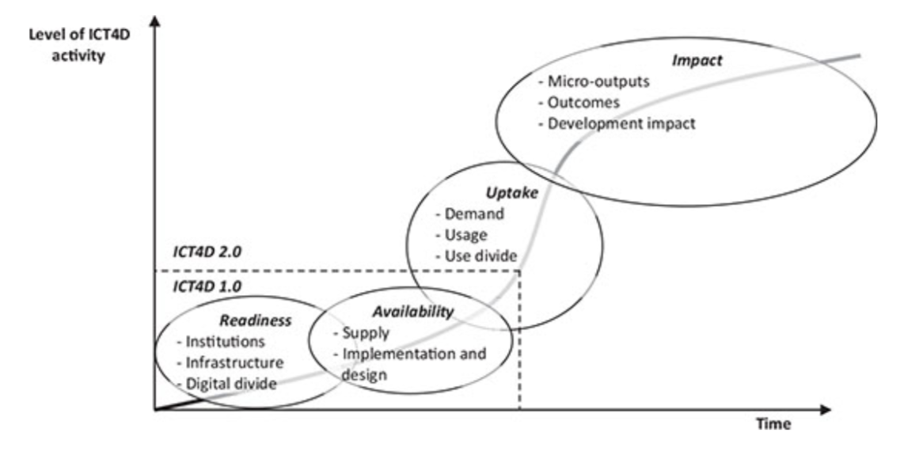
ICT4D is defined as the application of any entity that bridge the digital divide and aid economic development by ensuring equitable access to up-to-date communication technologies. And fintech is an emerging technology that has huge potential to bring socio-economic development to underserved population, which is an important new topic for the ICT4D framework. Existing fintech-related literatures disproportionately focus on the adoption of the technology with wide reference to Rogers’s diffusion of innovation theory or other theories of acceptance, which is still in the initial stage of Readiness and Availability (Heeks, 2017). Even within the limited number of literatures on its Usage and Impact, researches are mainly established in terms of the case in South Africa (M-PESA) and India (Aker, J. C., & Mbiti, I. M. , 2010). Although these cases are strong evidence that fintech, specifically mobile payment, has the benefits of local usefulness and cost affordance (Abhipsa et al., 2020), the scope and socio-economic background of China’s fintech development are very different. Result on the impact phase of China’s fintech applications is still largely incomplete in the field of academia, given the scarcity of available datasets and its dynamic changing nature.
- Data and Methodology:
  - Data collection:
Data are mainly collected with regard to two aspects, macroeconomic development and fintech development. Economic indicators (GDP, Employment, Average Salary) are collected from CEIC database on both city and county level, however, more specified indicators, such as GDP of different sectors, are only available on a city level. In terms of fintech development, data is rather difficult to retrieve, since it is still emerging and there is a scarcity of available public data. Therefore, fintech measurement in this research is based on the sophisticated Findex calculated by Institute of Digital Finance of Peking University, in cooperation with Chinese fintech giant, Ant Financials. This set of Findex is calculated based on three aspects of coverage breadth, usage depth, and digitalization level. (Appendix1)
Coverage breadth:
The measurement is quite different from the traditional way of counting physical bank branches, instead, it is calculated based on the digital account ownership, since it is the gateway to the financial services online.
Usage depth:
It is measured in terms of 6 different financial services provided by Alipay, namely Payment Service, Bond Service (Yuebao), Loan Service, Insurance Service, Investment Service, Credit Service. Each of them is evaluated based on user base, the number of transactions, and also the total amount of these transactions.

Digitalization level:
It captures the benefits that fintech brings along with, such as mobility, convenience, the lower interest rate that people could borrow with, and the ease of credit usage. These characteristics are the major factors for people to decide whether to use fintech in the first place.
The methodology used to compile these three aspects is called analytical hierarchy process (AHP), in which related factors are categorized into different levels. This hierarchical structure allows for the construction of different judgement matrices to find the maximum eigenvalue. In this way, the weight of each factor could be allocated based on the corresponding eigenvector. As a result, a compounded Findex figure is calculated based on coverage breadth, usage depth, and digitalization level (Appendix 2), which also solves the potential correlation problem of these three variables.

  - Sample selection:
Samples are collected on a city-level, including 4 direct-administered municipalities and 293 prefecture-level cities. And it is an eight-year timeframe, from 2012 to 2019. Geographically, they should capture a whole picture of china’s development in the recent decade. In addition, these samples are further categorized into subsample groups based on their economic development (GDP per capita) and the percentage of tertiary sector in GDP. The sub-sample analysis enables us to have a better understanding of fintech development on regions with different characteristics and test the hypothesis of whether fintech development has a stronger impact on more developed areas or tertiary sector intensive areas. It is also notified that these samples have endogenous difference, which will be controlled in the model.

  - Modelling
Two-way fixed effect OLS regression model is used to measure the influence on the panel data set, controlling for unobserved heterogeneity of both individual and time. The mathematical expression of the model deployed is listed as follows:
$$Y_{it}= β_{0}+ β_{1}X_{it-1}+α_{i}+ t_{i}+ u_{it}$$
Where:
Dependent variable: the economic indicator (GDP)
Independent variables: Findex (coverage breadth, usage depth, digitalization level)
$α_{i} :$Individual fixed effect
$t_{i}$: Time fixed effect
$u_{it}:$Error term
Control variables are then included to mitigate spurious correlation or stochastic trends.
$$Y_{it}= β_{0}+ β_{1}X_{it-1}+ β_{2}controls+α_{i}+ t_{i}+ u_{it}$$
Where:
Control variables: CPI, FDI, lag GDP

- Preliminary result:
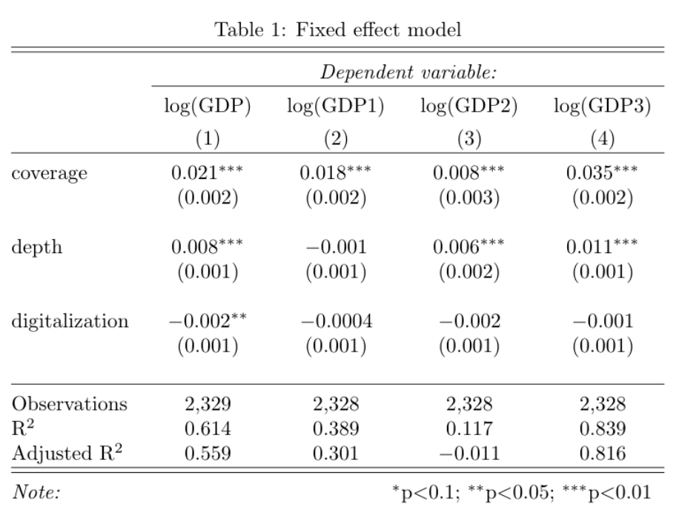
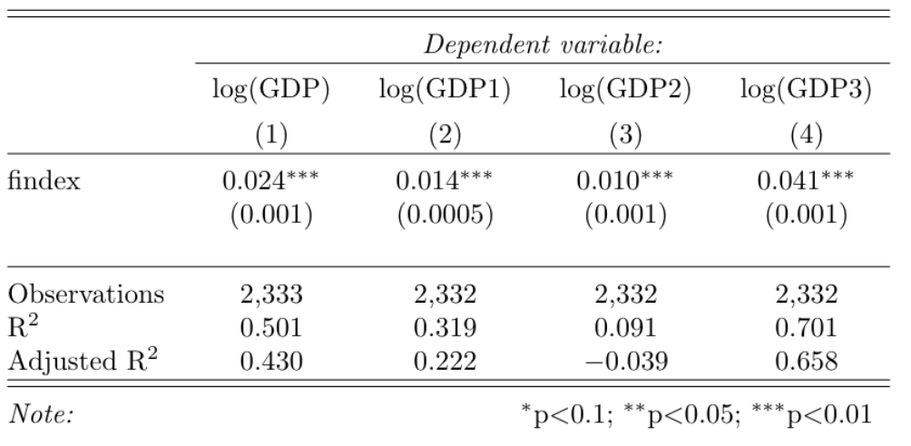
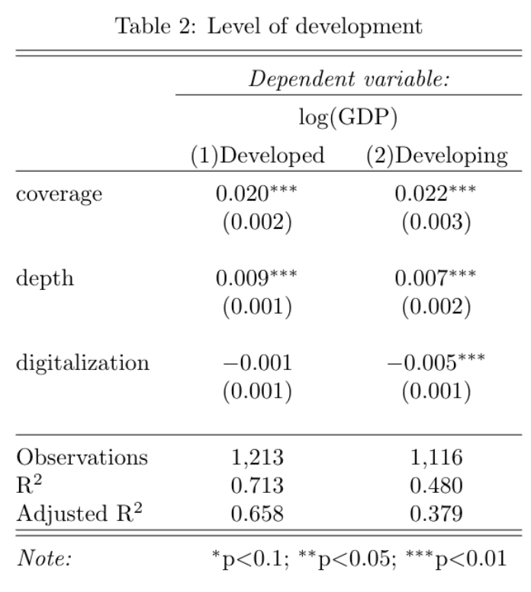
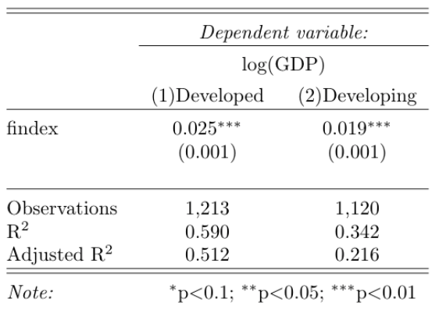
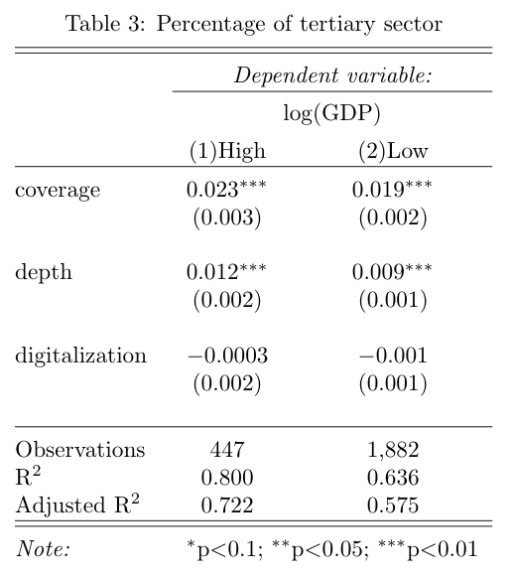
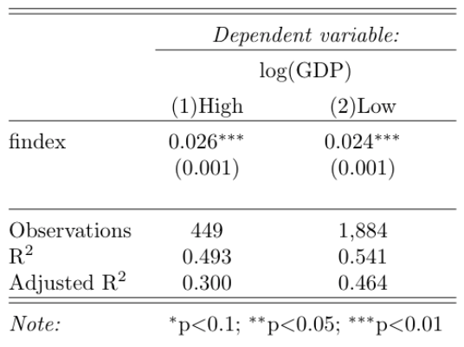

- Interpretation of the preliminary regression results:
6. 1 Positive impact on GDP
In terms of fintech’s impact of GDP, coverage breadth and usage depth both have positive impact with rather great significance level. And despite digitalization level has a minor negative effect, it is rather insignificant. The negative sign might be attributed to correlation between these three variables (Table 1). Although fintech development has a more significant impact on more developed areas in general, different indicators of fintech development behave differently in those areas. For example, coverage breadth is more important in less developed areas, while usage depth is valued in more developed areas (Table 2).
6. 2 Basic access is more valued in less developed areas
In the hope of leveraging fintech development to help with poverty alleviation, what we could learn from the result is that basic access to fintech (high coverage breadth) might help promote financial inclusiveness, which have a stronger impact in pulling economic growth in these less developed areas.
The result could be further explained from two theoretical perspectives. The positive influence of fintech development on these less developed areas could be supported by the classical rural finance theory, while the limitation of the impact could be attributed to the insufficient infrastructure construction and low financial literacy among these areas.
Historically, less developed areas have received subsidies from the government and adopted a low interest rate. The financial institutions, such as the Rural Credit Cooperative (RCC), the Agricultural Bank of China (ABC), were largely policy led and state controlled. It turns out that these institutions only function as disbursement window, rather than full-service agencies (Guo 2009). And the recipients of these discounted loans usually run into financial issues and cannot manage the repayment, which resulted in a large volume of bad credit. This incomplete market mechanism prevented these areas from reaching its optimal efficiency, as the operations are not adjusted according to the market demand and the system is never liberalized (Ma 2020). In fact, government has already realized the problem and has been working on reforming the rural financial system. They aim to break the monopoly of rural credit cooperatives and lower the barriers for eligible institutions to provide financial service. Within this process, fintech development is a nonnegligible catalyst that push forward the liberalization progress. For example, the wide coverage of fintech applications enable people to have easier access to financial service, which helps solve the long-lasting problem of information asymmetry and allows for better allocation of these financial resources. Fintech applications becomes a powerful tool that the government could deploy to realize the marketization of rural finance, thus adhering to the basic orientation of “market leadership and policy guidance”. And with such a self-sufficient market mechanism, the financial service is more likely to develop in a healthy and sustainable manner instead of purely relying on temporary government subsidies.
However, in order to tap the full potential of fintech applications, the insufficient infrastructure construction and low financial literacy in less developed areas are still huge barriers. Although the internet penetration rate has reached 46.2% in 2019, it is still 30% less than its urban counterparts. (China internet network information center 2019). And it is striking to note that only a small portion of bank accounts are actively in use in left-behind areas and only 6 percent have used a credit card in the past year despite that the opened accounts reached 3.91 per capita (People’s Bank of China 2017). It is mainly attributed to the insufficient supply of financial service and also the fact that people don’t know how to use the financial service properly. For example, in terms of loan service, more than 75% of the households that borrowed from a nonbank sector were rural ones, which is more than 3 times the rate of the urban counterparts (Survey and Research Center for China Household Finance 2012). And the top three reasons for them not to apply is that “may be declined,” “the process is too complex,” and “don’t know how to apply” (which implies the lack of financial literacy).
6.3 Stronger impact on the tertiary sector
Another significant finding from the regression result is the different influence that fintech development has on different sectors. The impact is weakest on the secondary sector, while it is strongest on the tertiary sector. Using an alternative approach to examine the finding, we could see that fintech development does have a more significant impact on the areas with more focus on tertiary industry (Table 3). There might be two underlying reasons to explain the stronger impact, one is the unique development model of digital economy, while the other is the spillover effect of primary and secondary industries.
Different from the experience in reform and opening-up period, instead of focusing on the agricultural sector to raise the production, digital economy stimulates the demand side first. Momentum is generated in the tertiary sector and then translated into higher production level in both primary and secondary sectors (Jia 2016). Moreover, the development of primary and secondary sectors may have some spillover effect on the tertiary sector. To prove the potential effect, we further conduct regression on lagged value of economic performance of these three sectors (Table 4). We could observe a strong positive correlation between the growth of primary sector and the growth of tertiary sector. It corresponds to the developmental trajectory we have mentioned, in which supply increases to meet the demand, thus creating value in both sectors.
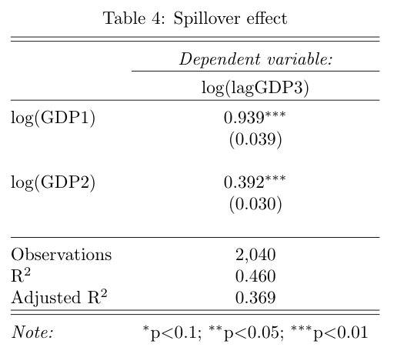

- Further regression within the tertiary sector and its implications
Based on the preliminary regression result, we concluded that fintech development has a more salient impact on pulling the growth of tertiary sector, so that we conduct further regression on different segments within the tertiary sector to better understand the impact. From the result (Table 5), we could observe that the coefficient of retail and finance segments are the largest.
In terms of retail business, it is inferred that the growth comes from the rapid development of e-commerce, which enables more convenient and frequent movement of goods. And it is further proven that fintech development has a strong positive impact on export, which largely belongs to tertiary sector as well. The growth in export indicates greater market outreach, which in return justifies the growth in retail segment.
Another segment that benefits a lot from the fintech development is the financial sector, which refers the conventional financial services, such as banking, insurance, and securities. It means that fintech is not in a competitive position towards the traditional financial industry, rather, it facilitates the inclusion and strengthens the functionalities of financial institutions. Moreover, it is said that financial development depends on the growth of real economic sectors. Therefore, the growth in financial sector is a natural outcome of real economic growth.
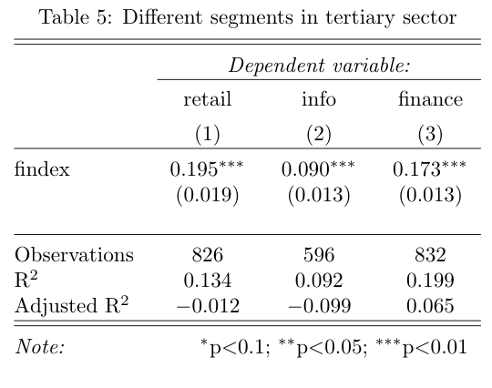
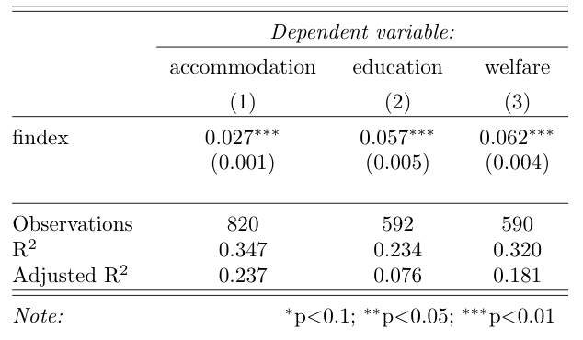
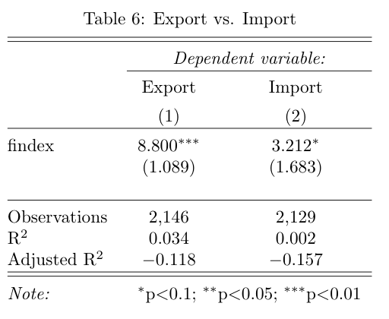

- Potential limitations of the model:
The model may also be subject to endogeneity bias, as the areas with more advanced economic development are more likely to emphasize their fintech development. However, it might not be the case in our study, as the samples selected include areas at different development stages. And in our subset analysis, different groups give a similar result, which indicates that the original position of these areas is not a determining factor regarding to the impact of fintech development on cities’ economic performance. Moreover, potential endogenous bias may be further eliminated through instrumental variable approach. However, a variable that is correlated to fintech and associated with economic development only through its effect on fintech is not easy to be found. Instead, we have been using alternative approaches to test out the validity of our results from different perspectives. In this sense, we could say that the result in this research is not subject to potential endogeneity bias to a large extent.

- Policy Implications
Fintech development has salient impact on pulling economic performance by promoting financial inclusion, especially for those less developed areas. Therefore, traditional financial institutions should work with fintech companies to provide better financial service accessibility with lower cost to the underserved groups, which could improve China’s financial market mechanism and credit infrastructure.
To realize the benefit of fintech, government should keep continuous effort in the construction of basic infrastructure, such as access to internet, which serves as the foundation for further fintech development. In addition, government could also encourage public departments, non-governmental organizations, and other stakeholders to play a more active role in the dissemination of financial technology information and the necessary financial education for people in less developed areas to improve their understanding of the nature and characteristics of these financial tools, thus narrowing the digital divide.
More specifically, government should recognize the leading role that tertiary sector plays in such a digital economy. Instead of suppressing the flexibility of such fintech companies, more regulations should be amended to guide the operations and protect the consumers. It has already become an indispensable part in China’s economy and should be leveraged to pull up the demand, which ultimately leads to high production level and real economic growth.

Appendix 1
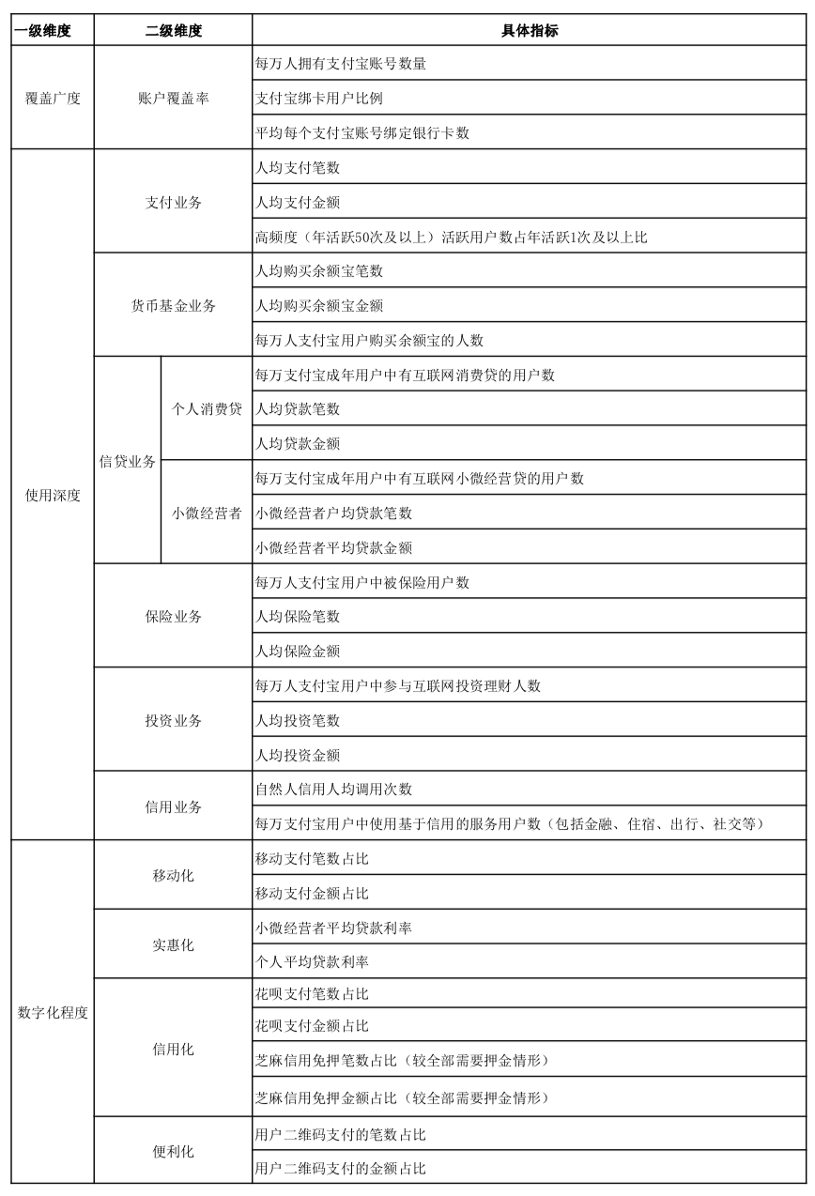

Appendix 2

Appendix 3
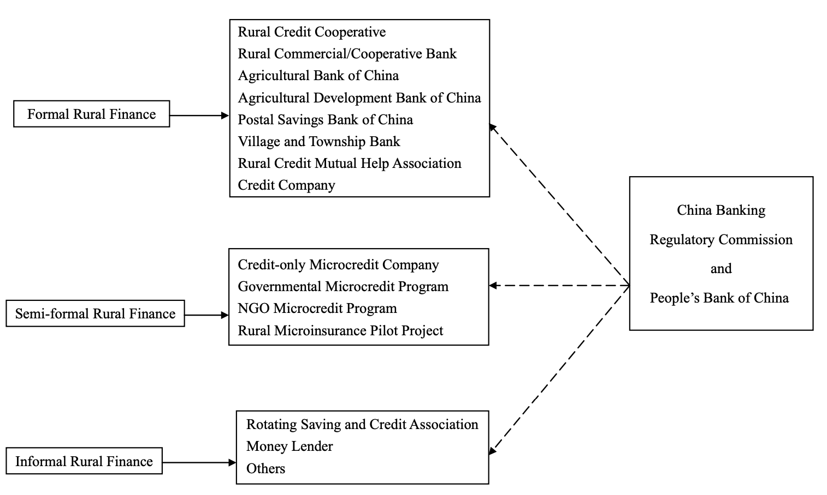

Appendix 4

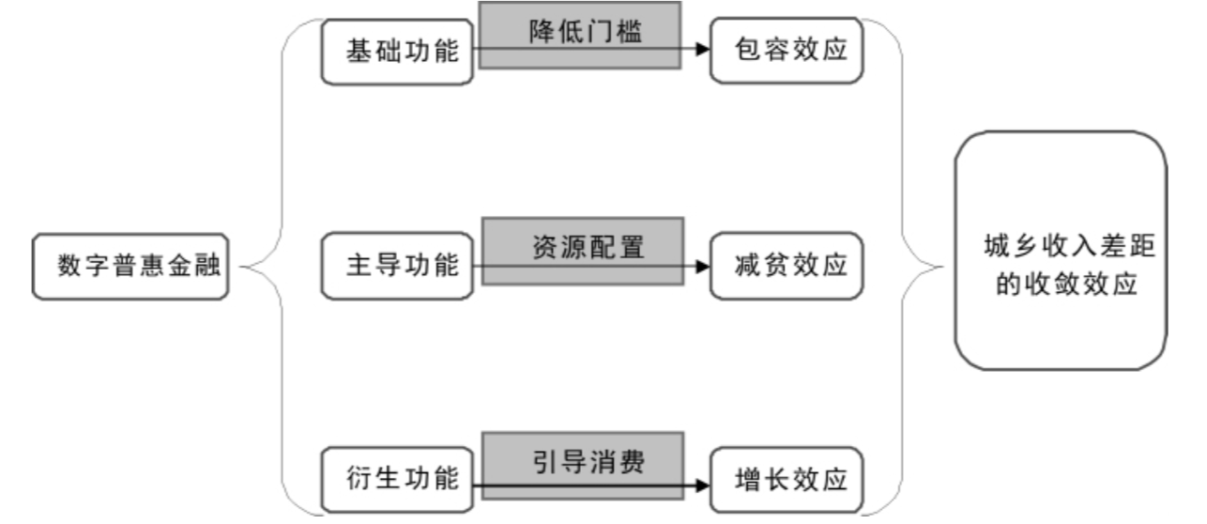

References
Aker, J. C., & Mbiti, I. M. (2010). Mobile phones and economic development in Africa. Journal of Economic Perspectives, 24(3), pp. 207– 232.
Guo,Pei guo & Jia, Xiangping. (2009). “The structure and reform of rural finance in China”, China Agricultural Economic Review, Emerald Group Publishing Limited, Vol. 1 No. 2, pp. 212-226.
Heeks, R. (2017) Information and Communication Technology for Development (ICT4D). Routledge.

Li, Mingxian., & He, You., (2019). “农村普惠金融目标下金融科技的工具价值及实现困”. Journal of South China normal University (Social Science Edition), 51(1): 59-65.
Ma, Jiujie et al. (2020). “农村金融机构市场化对金融支农的影响：抑制还是促进?”，中国农村经济, pp. 79-96.
Pal, A., De, R. & Herath, T. (2020). “The Role of Mobile Payment Technology in Sustainable and Human-Centric Development: Evidence from the Post-Demonetization Period in India”, Inf Syst Front 22, pp. 607–631.
Sun, G.F. (2018). “The current situation, prospect and policy suggestions of China's consumer finance”, Finance Forum.
Tian, Jie., & Tao, Jianping., (2011). “农村金融排除对城乡收入差距的影响———来自我国 1578 个县( 市) 面板数据的实 证分析”. 中国经济问题，(05):56-64.

Wang, Xiaohong., & Liu, Naxin., (2017). “金融服务站+互联网+农村电商”扶贫模式探析——基于湖南省炎陵县扶贫实践”. 武汉金融 .

Yang, Xin et al. (2019). “Studies on the Effect of Fintech on Chinese Economy and Its Development Path”, Economics and Management Research (ICEEMR 2019), Atlantis Press, pp. 31- 34.
Yuan, Y., & Jin, M. (2017). “Financial literacy in China: Priorities and a direction” (CSD Working Paper No. 17-37). St. Louis, MO: Washington University, Center for Social Development.
Zhang, H. X., & Loubere, N. (2015). “Rural Finance and Development in China: The State of the Art and Ways Forward”, Rural Livelihoods in China: Political Economy in Transition, London and New York: Routledge, pp. 151–174.
Zhang, He., & Bai, Qinxian., (2018). “数字普惠金融减小了城乡收入差距吗？———基于中国省级数据的面板门槛回归分析”. 经济问题探索, 39(10): 122-129.

