Comparative analysis of the influence of different levels of corporate governance on capital structure

by
Xinyuan Zheng

An honors thesis submitted in partial fulfillment
of the requirements for the degree of
Bachelor of Science
Business and Economics Honors Program
NYU Shanghai
May 2024

Professor Marti G. Subrahmanyam Professor Guodong Chen
Professor Christina Wang
Professor Ye Jin

Faculty Advisors Thesis Advisor

Abstract
Previous literature has respectively explored the specific parties, including CEOs, institutional investors, and boards of directors, and their influences based on different roles. However, none of the studies tried to combine these three parties as three distinct attributes together and compare their influence on the capital structure. Our research aims at discovering which part of the governance party is driving the decision on the capital structure. Therefore, our study compares the influence of CEOs, institutional investors, and the board on capital structure. We also try to figure out the difference in their weights between the SOEs and non-SOEs, and among different industries so as to help the corporates have a better strategy.
To construct a comprehensive index for the power of the three parties, we selected important features based on domain knowledge and applied statistical methods as well, including PCA and FA. Using a sample of 618 Chinese A-listed firms over the period from 2011 to 2022, we find that CEOs and Institutional Investors have a larger impact on capital structure, compared with BODs. Furthermore, the results also show that the influences of CEOs and Institutional Investors on corporate leverage are in contrast and CEOs display a greater power, indicating their conflicts of interest and an agency problem. Regarding the differences among industry groups, some industries with low tangibility and high growth value showed strong firm characteristics that favor equity, such as IT. Moreover, focusing on the comparison between SOEs and non-SOEs, the firm ownership structure makes a difference in the relationship between CEOs, BODs, and Institutional Investors. Specifically, BODs own more power in capital structure in SOEs and the standpoint of Institutional Investors also varies from two different ownership structures. Our findings are robust to diverse estimation methods. The shareholders and policymakers could leverage our findings to pay more attention to different parties during the capital structure decision-making process.

1. Introduction
Capital structure determines the financial foundation of a firm’s operations. Essentially, it involves the ratio of debt to equity used to finance a firm’s operations and growth. Capital structure may affect a firm’s cost of capital, risk management, market perception, and financial flexibility. It is therefore critical to a firm’s financial health and its ability to achieve long-term growth and sustainability.
Prior literature has thoroughly examined the relationship between a firm’s capital structure and various attributes at the industry and firm levels. However, firms with similar underlying characteristics often employ different leverage strategies (Cronqvist, Makhija, and Yonker, 2012). This variation has prompted recent research on individual attributes at the corporate governance level, including the influence of executives on financial decisions (Cronqvist et al., 2012), how directors and boards advise firms (Kim et al., 2014), and the external influence of institutional investors (McCahery et al., 2014). However, few studies have focused on comparisons among these three governance parties. The basic theory of capital structure was proposed by Modigliani and Miller in 1958, who argued that in an ideal capital market, capital structure does not matter. However, later theories have refuted this view, emphasizing the important role of market imperfections and frictions in shaping corporate capital structure decisions. Specifically, the trade-off theory (Miller, 1977) maintains that since debt would bring companies both bankruptcy costs and tax benefits, a company would determine its capital structure by weighing these costs and benefits. The pecking order theory (Myers & Majluf, 1984) focuses more on the cost of financing, namely asymmetric information that the issuance of debt signifies the confidence of the board, and thus suggests that managers and the board would prefer debt over equity to obtain the positive signaling effect. The following theories also include the market timing hypothesis theory (Baker & Wurgler, 2002), and the Brusov-Filatova-Orekhova (BFO) theory (Brusov, Peter, et al., 2011). Among these theories, one of the well-supported theories is the agency theory (Jensen & Meckling, 1976), which has been strongly tested in empirical studies (Jiraporn et al., 2012). The theory argues that capital structure decisions are affected by agency costs, which arise from the conflict of interests between internal parties, CEOs, and other stakeholders, including the board and institutional investors.
To empirically study the engagement of the three parties in capital structure, we created three indexes indicating CEO power, BOD power, and Institutional Investor power. We first selected the features follow the prior research studying CEO, BOD, and Institutional Investors. After feature selection, PCA and FA were applied to combine the multi-dimensional variables into a one-dimensional index. Specifically, PCA could afford loadings to each of the variables based on the variance contribution in the data, and FA would figure out a potentially lower number of unobserved variables to describe variability among observed, correlated variables. We then eventually determined the index based on the domain knowledge. This is more accountable than entirely manually weighing.
We then employed pooled ordinary least squares (OLS), fixed effects (FE), and random effects (RE) techniques for regression analysis. Our empirical results display a power hierarchy based on our panel data. Two parties, CEOs and Institutional Investors, have a larger impact on capital structure than BODs. Specifically, the CEOs and Institutional Investors are in contrast to corporate leverage decisions, and CEOs have a greater power. The result indicates the conflicts of interest and an agency problem. Focusing on different industry groups, due to a limit of observations for some industries, we only select the ones with over 100 observations. The results indicate that for some industries with typical characteristics, such as the low tangibility and high growth value of the IT industry, this industry feature would play an important role in capital structure, and thus we cannot observe significant conflicts of interest among three parties. Moreover, the firm ownership structure, SOEs and non-SOEs, also makes a difference in the relationship between CEOs, BODs, and Institutional Investors. Specifically, BODs in SOEs own more power in capital structure, and the standpoint of Institutional Investors also varies from two different ownership structures.
The main contributions of our study are as follows: First, this paper enriches the research on the determinants of corporate capital structure. Our pioneering study combines three important aspects and compares the weights of the three parties, trying to intuitively show the conflict between the principal (institutional investors and the board of directors) and the agent (CEO). Second, our study also opens up new avenues for future research, such as, in addition to capital structure, what are the differences in the focus of institutional investors in state-owned enterprises and private enterprises; for example, in what other investment behaviors does this difference manifest itself? Is the comparison of the power of CEOs, boards of directors, and institutional investors also reflected in other aspects of corporate governance? Are their behaviors consistent, or are there significant differences? Third, our study also provides policymakers with a new perspective to compare state-owned enterprises and non-state-owned enterprises. Specifically, does the distribution of power and the social and political goals of state-owned enterprises lead to the relatively slow development momentum of state-owned enterprises relative to non-state-owned enterprises, and how to formulate policies to achieve a better balance of power and promote development? In addition, our findings enable all parties in governance, including investors and managers, to understand which parts really work. Therefore, when they encounter similar situations in the future, they can make better investment decisions to improve overall performance.
The rest of this paper is organized as follows: Section 2 describes the institutional background related to our study. Section 3 reviews previous studies and proposes hypotheses. Section 4 summarizes the data sources and the methods used. The empirical results are analyzed in Section 5. Finally, Section 6 summarizes the conclusions and limitations of the study.

2. Institutional Background

2.1 CEO roles in Chinese listed companies
In China, CEOs’ roles are significantly affected by the ownership structure. The differences lie in their interest and power. State-owned enterprises (SOEs) carry substantial policy responsibilities that are pivotal to the national economy and thus aim at supporting governmental objectives. Managed under the oversight of the State-owned Assets Supervision and Administration Commission (SASAC), SOEs focus not only on economic performance but also on fulfilling sociopolitical goals set by the government, such as job creation and social welfare. This dual focus places CEOs of SOEs in a position where their actions are guided by governmental policies and SASAC directives, diluting the impact of their motivations on firm strategy and innovation. (Bruton et al., 2015, Bai et al., 2006). Consequently, there's a tendency for SOE executives to engage in activities that enhance their political standing, potentially at the expense of innovation and long-term firm performance​.
Regarding their power, in China, it’s possible that the same individual simultaneously holds CEO and Chair positions. This dual capacity is considered an indicator of enhanced discretionary power. However, when the two positions are held by different people, the delineation of power between these two roles, however, varies markedly across different types of ownership. Specifically, in SOEs, the Chair of the Board of Directors (BOD) often assumes a leading role in governance, mirroring the substantial influence of state ownership on these organizations. This centralization of authority within SOEs starkly contrasts with the situation in Non-State-Owned Enterprises (Non-SOEs), where power tends to be more dispersed, granting these entities greater autonomy in their governance (Jiang & Kim, 2015). This difference underscores the nuanced impact of ownership structure on corporate governance in China, highlighting the distinct operational dynamics between SOEs and non-SOEs. Therefore, it’s worth analyzing the CEO power in capital structure under different ownership structures in Chinese listed companies.

2.2 BOD roles in Chinese listed companies
Theoretically, independent directors are positioned not only to monitor company management but also to provide valuable advice and guidance (Kim et al., 2014). In China, following the establishment of the Shanghai Stock Exchange (SHSE) and the Shenzhen Stock Exchange (SZSE), Company Law was implemented in December 1993 and introduced a dual-board governance structure, consisting of a Board of Directors (BOD) and a Supervisory Board (SB). Within this framework, the BOD owns more power and is somehow directly tasked with the firm's management, including strategic decision-making, whereas the SB is designed to monitor the BOD. Therefore, in our research, we focus more on BOD.
Another point worth mentioning is that in China, since 1997, independent directors have been included on their boards to oversee management activities and protect the interests of minority shareholders. In 2001, the China Securities Regulatory Commission (CSRC) introduced specific regulations for independent directors to bolster their effectiveness and independence: (1) Independent directors and their close family members must not be employed by or hold a substantial shareholding in the company, (2) They are prohibited from owning a significant portion of any business owned by the company's main shareholders, (3) They cannot offer consultancy services to the company, and (4) At least one independent director is required to possess qualifications in accounting. These measures have reportedly enhanced the functionality and effectiveness of boards in China. On April 14, 2023, The State Council decided to further optimize the independent director system of listed companies. According to the circular, independent directors should take up more than one-third of the BOD. For SOEs, external directors, including independent directors, should predominate.

2.3 Institutional Investors roles in Chinese listed companies
Institutional investors are typically seen as investors who either possess informational advantages or are large investors with sufficient capital to influence asset prices. The inception of China's institutional investor growth was marked by the 1997 "Interim Measures for the Management of Securities Investment Funds." This led to the establishment of the first closed-end fund in 1998, introducing professional institutional investment. By 2001, efforts were made to leverage these investors for market stabilization, notably with China's inaugural open-end fund. The QFII program commenced in 2002. The National Social Security Fund entered the stock market in 2003, a year also notable for the enactment of the "Securities Investment Fund Law," which provided a regulatory structure. The private fund sector saw rapid expansion beginning with the first sunshine private equity fund in 2004, followed by insurance companies' stock market investments in 2005. Since 2006, the institutional investment landscape in China has entered a rapid development phase, evolving into a diverse structure led by securities investment funds. This structure integrates various institutional investors, including securities companies, trust companies, insurance companies, Qualified Foreign Institutional Investors (QFII), social security funds, and corporate annuities. With the expanding number of institutional investors, the increasing scale of investments, and the overall enhancement in quality, the institutionalization of the securities market's investment entities has become increasingly pronounced.

3. Literature Review and Hypotheses development
Capital structure choice has long been an issue that intrigues diverse theories to explain and predict. The reason lies in the fact that there are different positions, including managers and shareholders, that would have different interests, resulting in different optimal choices for the firm’s leverage ratio. In the past decades, various theories have been carried out to explain the firm’s financing decisions, including the free-cash-flow theory (Jensen & Meckling, 1976), the trade-off theory (Miller, 1977), the pecking order theory (Myers & Majluf, 1984), the market timing hypothesis theory (Baker & Wurgler, 2002) and the Brusov–Filatova–Orekhova (BFO) theory (Brusov, Peter, et al., 2011). In our research, we would focus on the free cash flow theory, which can also be called the agency cost theory, to explain the relationship between the agency and the capital structure.
Specifically, agency costs arise from the conflicts between the shareholders and the managers. The managers may make use of the asymmetric information to take actions that enhance their own utility at the cost of the shareholders’ interest, and thus cause damage to firm value. According to Jensen, one prescription to mitigate agency costs is increasing debts (Jensen, 1986). Leverage could be considered as a tool to help prevent managers from investing in unprofitable projects, ensure their payout promise, and motivate organizational incentives. Thus, standing in the position of shareholders, the theory gives out an ex-ante optimal leverage ratio that would maximize the value of the firm, namely the shareholders’ wealth. However, this optimal leverage ratio fails to take the management discretion into consideration. More leverage may contribute to high bankruptcy costs, which is against the managers’ interest. Since the corporate governance body has power over deciding the leverage ratio out of the asymmetric information, as long as the corporate governance body is in a safe position, he would place his own interest over that of shareholders.
Understanding the conflicts that existed in the capital structure of different parties, previous literature has respectively focused on one specific party and tried to discover the relationship between that party and the capital structure. The main three parties involved the CEO, the board of directors (BOD), and institutional investors.

CEO power
Firstly, using the underlying agency theory, Gormley et al. (2016) studying the United States and China markets independently, figured out a hump-shaped association between CEO power and leverage, which is consistent with the aforementioned logic. When CEOs have less power, a firm may leverage more to mitigate the agency cost. However, when CEOs boast a high power that exceeds the threshold point, they tend to lower the leverage level to reduce bankruptcy and debt financing risk.

Board of directors
The board of directors has been regarded as the paramount governance mechanism. Previous literature mostly focuses on the board size and the board independence as two major attributes when measuring the power of the board. Specifically, prior research suggested that smaller boards tend to boast more efficient governance mechanisms. For instance, Guest and Paul (2009) found that large boards would experience more communication and coordination difficulties. According to Jensen (1993), “When boards get beyond seven or eight people, they are less likely to function effectively and are easier for the CEO to control”. However, given that the two principal functions of the board are monitoring and advising, small boards may lack broad expertise and diverse connections with the external environments (Guest, 2009). Besides, small boards may also be less independent (Boone et al., 2007; Saeed et al., 2016), which is the second attribute of the board power. Besides, the board independence is ambiguous too. The effectiveness of board independence is highly related to the cost of information. If the cost of information is low, in other words, it’s easy for outside directors to get the corporate information and monitor, the higher board independence contributes to better monitor power. (Duchin et al., 2010; Wintoki et al., 2012)

Institutional investors
Over the last several decades, the market has witnessed the rising power of institutional investors. According to Hirschman (1970), institutional investors would have two choices when they are unsatisfied with their portfolios. They can either choose to effect change by engaging with the management or exit the firm by selling their shares. In a survey of institutional investors, McCahery, Sautner, and Starks (2014) found that institutional investors were more likely to execute the latter choice, which is to engage in management and make a difference. In this case, their influence on capital structure cannot be underestimated.
Therefore, since all three parties would somehow exert some influence on the capital structure, if we combine them to compare their impact, on the basis of historical theoretical arguments and following our empirical findings to date, we expect the following hypotheses.
H1: The CEO power would adjust the leverage ratio lower while the BOD and Institutional Investors would expect a higher leverage ratio to achieve better shareholder wealth.
H2: The influence of the CEO would be larger than the other two parts because of the asymmetric information.

4. Data & Methodology

4.1 Data Selection
In order to generate an overall view of the Chinese market, the sample data of our study would focus on all the Chinese A-listed firms over the period from 2011 to 2022. The year-end of our sample data is December 31, 2022.
Moreover, we omit firms designated with special treatment (ST and *ST) status, as well as entities operating within the financial sector. The rationale behind this decision is twofold. Firstly, ST and *ST firms typically face financial or operational difficulties, which could skew the results due to these underlying issues. Secondly, firms in the financial sector, including banks, trusts, insurance companies, and financial management firms, exhibit significantly distinct balance sheet structures compared to their non-financial counterparts. Additionally, to ensure the integrity of our analysis, we have excluded companies with any missing data variables for the period from 2011 to 2022.
The data are sourced from two platforms. Data for financial statistics of firms and institutional investors are collected from WIND. Data for CEO and BOD (Board of Directors) characteristics are obtained from CSMAR. After deleting the companies that had just gone public in 2011, since we need the data in 2010 to calculate the investment stability of institutional investors, as a result, the final sample includes a panel of 7,405 firm-year observations, representing 618 firms.

4.2 Variable Description

4.2.1 Variable Definition

4.2.1.1 Dependent Variable
Our dependent variable is capital structure. We define capital structure as the book value-based leverage ratio. The reasons are as follows. Initially, existing research indicates that managerial financial decisions are predominantly influenced by book values (Graham & Harvey, 2001). Furthermore, book value leverage tends to exhibit less fluctuation compared to market value leverage, making it a more stable option for guiding a company’s financial framework (Graham & Harvey, 2001; Florackis & Ozkan, 2009). Additionally, the inefficiency of the Chinese stock market might introduce a considerable amount of irrelevant data to decisions regarding capital structure, diminishing the effectiveness of market value leverage (Chang, Chen, & Liao, 2014).

4.2.1.2 Independent Variables
Our independent variables are indicators for CEO power (CEO), Board of Directors power (BOD), and Institutional Investor power (II). For each indicator, we have chosen several variables, including continuous and discrete variables, and we would build the three indicators through principal component analysis (PCA) and factor analysis (FA) correspondingly.

CEO power
Since CEO power has long been an important variable, many previous studies have already established it. Following Finkelstein, 1992, CEO power can be broken down into four aspects, which are structural power, ownership power, expert power, and prestige power (Finkelstein, 1992). However, it’s still challenging for us to directly observe these powers. To empirically measure CEO dominance in financial decision-making, based on the four aspects, in this study, a CEO's power is conceptualized as their ability to consistently shape the financing choices of their organization. We construct a power index based on the following five CEO-related variables.

BOD power
A robust board structure could mitigate the discretion of CEOs by monitoring. Based on prior studies, the power of BOD is closely related to the size and the number of independent directors. Specifically, Fama and Jensen (1983) emphasize the board's advisory role, asserting that independent directors are more effective in providing essential business insights and resources. Guest (2008) further advocates for increasing both the size of the board and the number of external directors to augment the advice and information available to the CEO, thereby promoting better-informed decision-making processes. Thus, we construct a power index based on the following three BOD-related variables.

Institutional Investors power
Institutional investors have two ways to show their dissatisfaction with a firm, including “direct intervention”, which is to engage directly with management to initiate change, or “voting with their feet”, which is to opt to sell their shares (Hirschman, 1970). This indicates that an institutional investor could discipline their management power through both direct voting and this threat of exit can. Therefore, regarding institutional investors as an indispensable part of monitoring the whole capital structure decision-making progress, we dived into three aspects to measure their power, including the stability of their proportion in the whole investment, the concentration of the top one investor and also their activeness based on their fiduciary duties. Specifically, we define active investors as those who have a business relationship with the firms and thus, they are more likely to participate in the corporate decision-making process, though they may also be more vulnerable to corporate management pressure. Since investors, including QFII, public pension funds, and foundations, are less likely to engage in firm management, we would focus on the rest of the institutional investors. (Bushee, 1988; Brickley et al., 1988). Therefore, we assume that the more active investors are, the higher the overall power of institutional investors would be.
We have also considered some more indicators for institutional investor power. Specifically, we have tried to figure out the stability (INSTA) based on the change in the proportion of institutional investment and also the concentration based on the ratio of share ownership of the top institutional investor. However, since we cannot have access to the exact investors’ information, which means we cannot track the investors about their behavior, but only have a snapshot of overall investor data for the company, these two metrics fail to represent the power we want. Besides, we also cannot have any voting data from the investors’ meeting for companies. Therefore, at last, we construct a power index based on their activeness.

4.2.1.3 Control variables
In addition to the CEO, institutional investors, and the board of directors, there are also other factors determining the capital structure of the company. Therefore, we group them together as firm-specific features, covering the aspects of corporate size, profitability, and tangibility.

4.3 Descriptive Statistics and Correlation Matrix
Panel A shows the statistics for CEO power. There are five measures in total, and we report them separately. Over half of CEOs (54.70%) have at least a master's degree, with a left-skewed distribution indicating an overall high-education background. The data further suggests that 54.30% of CEOs have positions in other companies. The average natural logarithm of tenure of CEOs is 1.68, which is approximately 48 months, suggesting that CEOs typically hold their positions for no more than half a decade. It shows that the duality situation, where the chair and the CEO position are held by the same individual, occurs in 42.81% of observations, indicating that the CEO-Chairman function is highly concentrated in China-listed firms. Regarding the variable of ownership power, only 13.26% of CEOs hold more than 10% of firm shares, suggesting that there may be some limitations and a majority of Chinese listed firms chose other manager compensation approaches rather than equity incentives. However, the distribution is right-skewed, indicating that a few CEOs have high shareholdings. This may also result from the nature of companies that SOEs would restrict the CEO’s share ownership.
Panel B shows the statistics for BOD power. The mean of board size is 8.79 with a relatively small standard deviation of 1.75, suggesting that the board size doesn’t vary significantly among firms. Further, the independent directors on average account for 37.27%, with a right-skewed distribution implying that some firms have a significantly high percentage of independent directors. The shareholdings of the board are around 29.83%.
Panel C shows the statistics for Institutional Investors power. Considering the fiduciary duties, the proportion of active investors is nearly 94% on average. Panel D shows the control variables. We take the 10-base logarithm of three data.
In order to generate a better overview of the cross-sectional data, we also divided our sample into 16 industries based on the China Securities Regulatory Commission Industry Classification. It shows that there are some differences between average leverage across different industries. Industries such as Real Estate (65.4%), Construction (67.37%), Utilities (60.5%), and Leasing & Business services (61.75%) have the highest leverage, which is in line with the idea that the industries owning more tangible assets have higher leverage capability. On the other hand, we observe that the IT and information industry and Technical Services industry have the lowest leverage 35.92% and 17.36% respectively. As has been shown in Figure 1, by selecting these typical industries, the discrepancies among different industries are clear.
Furthermore, we also divided our sample into SOEs and non-SOEs to determine how the firm nature would influence the leverage. In general, SOEs have a higher leverage than non-SOEs, but non-SOEs have some significant outliers. If we exclude the upper-bound outliers, the average leverage of non-SOEs would be rather smaller. The result can also be obtained from Figure 2.
Table 1
Panel A: CEO Power
 | Obs | Mean | Std | Min | Median | Max | Skewness | Kurtosis
CDEG | 7405 | 0.547062795 | 0.49781378 | 0 | 1 | 1 | -0.189128995 | -1.964760954
CCON | 7405 | 0.543011479 | 0.498180217 | 0 | 1 | 1 | -0.172721025 | -1.970699783
CTEN | 7405 | 1.68363702 | 0.394742236 | -0.301029996 | 1.740362689 | 2.394451681 | -0.737177866 | 0.59384123
CDUA | 7405 | 0.42812289 | 0.480253077 | 0 | 0 | 1 | 0.291163308 | -1.853369404
CSWP | 7405 | 0.132635607 | 0.334486515 | 0 | 0 | 1 | 2.167047488 | 2.758091647
Panel B: BOD Power
 | Obs | Mean | Std | Min | Median | Max | Skewness | Kurtosis
BDN | 7405 | 8.795813639 | 1.749556949 | 0 | 9 | 18 | 0.868255653 | 2.831182441
BIND | 7405 | 0.37269299 | 0.056562367 | 0 | 0.3333333 | 0.8 | 1.697758324 | 4.465254211
BSWP | 7405 | 0.298311951 | 0.457548033 | 0 | 0 | 1 | 0.881842002 | -1.222684988
Panel C: Institutional Investor Power
 | Obs | Mean | Std | Min | Median | Max | Skewness | Kurtosis
IACT | 7405 | 0.94201771 | 0.088692083 | 0.129962 | 0.978848 | 1 | -2.775766762 | 10.30139118

Panel D: Control
 | Obs | Mean | Std | Min | Median | Max | Skewness | Kurtosis
SIZE | 7405 | 9.748013509 | 0.557938207 | 7.018780906 | 9.670146667 | 12.42372142 | 0.697049174 | 1.044660004
ROA | 7405 | 3.955112419 | 13.87968711 | -143.1568 | 3.64955 | 710.8938 | 23.75697645 | 1121.485691
TANG | 7405 | 0.433949031 | 0.280982463 | -7.259939 | 0.4315375 | 1.194698 | -7.357118423 | 162.5511924
Industry

 | Obs | Mean | Std | Min | Median | Max | Skewness | Kurtosis
Agriculture | 96 | 0.491358458 | 0.199960031 | 0.128862 | 0.493782 | 0.980071 | 0.478546209 | -0.228452134
Mining | 132 | 0.482200811 | 0.186091263 | 0.020274 | 0.531578 | 0.953082 | -0.53221378 | 0.13687069
Manufacturing | 4968 | 0.412665343 | 0.203770513 | 0.007521 | 0.4069565 | 2.848743 | 0.833687506 | 5.664166899
Utilities | 180 | 0.604999289 | 0.215283351 | 0.057358 | 0.607227 | 2.394002 | 2.903254617 | 26.20794418
Construction | 168 | 0.673720732 | 0.174786707 | 0.077405 | 0.7237955 | 0.994367 | -1.53036947 | 2.452504687
Retailing | 336 | 0.56041936 | 0.268959689 | 0.051592 | 0.575588 | 3.645301 | 4.7624217 | 53.28685004
Transportation | 168 | 0.471577304 | 0.173883675 | 0.119883 | 0.4495455 | 0.897709 | 0.332988406 | -0.632646484
Hoteling | 24 | 0.357162167 | 0.136201806 | 0.19484 | 0.3416405 | 0.703131 | 1.074240895 | 0.976282354
IT & Information | 576 | 0.359269882 | 0.45977162 | 0.021371 | 0.328361 | 8.256422 | 13.39181074 | 212.9611816
Real Estate | 348 | 0.654143391 | 0.152023235 | 0.14803 | 0.676696 | 0.954899 | -0.704429707 | 0.339408438
Leasing & Business Services | 120 | 0.617529442 | 0.626906731 | 0.09125 | 0.5164885 | 4.995245 | 5.385289103 | 33.21412976
Technical Service | 12 | 0.173621417 | 0.070934884 | 0.041141 | 0.16639 | 0.284401 | -0.315939807 | -0.444564639
Infrastructure | 96 | 0.55921201 | 0.737982273 | -0.194698 | 0.4678735 | 7.034338 | 7.57583229 | 64.56675553
Social Service | 36 | 0.416382306 | 0.151495584 | 0.177638 | 0.405619 | 0.679528 | 0.055811888 | -1.031344631
Entertainment | 108 | 0.344315333 | 0.150521036 | 0.021841 | 0.340751 | 0.726068 | 0.349238961 | 0.264706222
Others | 48 | 0.510566271 | 0.144165381 | 0.100147 | 0.492858 | 0.752266 | -0.610655094 | -0.023097716
Ownership Structure
 | Obs | Mean | Std | Min | Median | Max | Skewness | Kurtosis
Non-SOEs | 4500 | 0.408918879 | 0.29715754 | -0.194698 | 0.3945925 | 8.256422 | 10.89959395 | 233.1007789
SOEs | 2916 | 0.500729021 | 0.20961921 | 0.022383 | 0.507666 | 2.290134 | 0.265908456 | 1.894150756
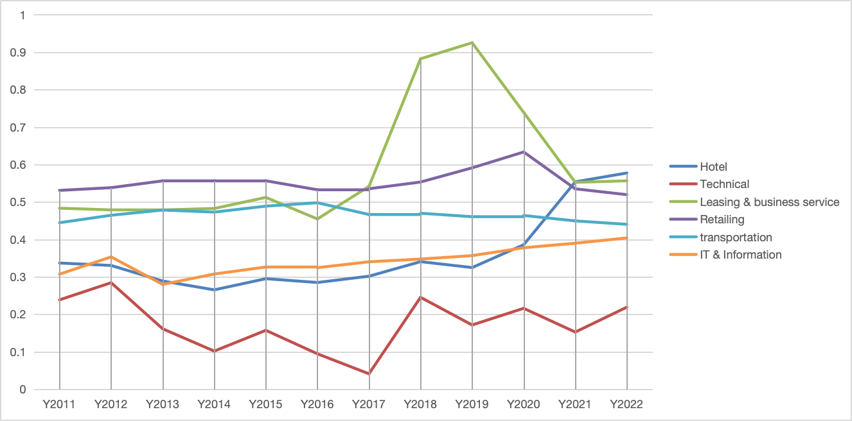
Figure 1. Leverage Ratio for Typical Industries
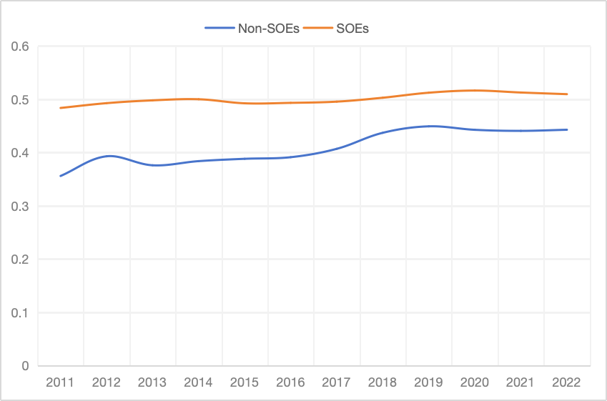
Figure 2. Leverage Ratio for SOE v.s. Non-SOEs

Based on the correlation matrix, we can see that factors indicating CEO power, including CCON, CTEN, CDUA, and CSWP, are negatively related to LEV (leverage ratio), suggesting that higher CEO power leads to a lower leverage ratio. As for the indicators for BOD and institutional investors, BDN, BIND, and INTOP1 are positively correlated with the leverage, which aligns with our hypothesis. However, factors including BSWP, INSTA, and IACT are negatively correlated. Since correlation analysis may overlook some important factors, further research is necessary for us to get a more convincing result.
Generally, the correlation among selected variables is not that high, indicating that the multicollinearity would not be the problem in our further regression analysis and they should work efficiently with one another for our future regression. Besides, we would also apply principal component analysis, thus reducing the multicollinearity between the factors for CEO and BOD. However, we would still pay attention to the potential issue and check for multicollinearity.
Table 2
Correlation Matrix
 | CDEG | CCON | CTEN | CDUA | CSWP | BDN | BIND | BSWP | IACT | SIZE | ROA | TANG | LEV
CDEG | 1.000
CCON | 0.067 | 1.000
CTEN | 0.051 | 0.181 | 1.000
CDUA | 0.005 | 0.170 | 0.234 | 1.000
CSWP | 0.025 | 0.069 | 0.175 | 0.367 | 1.000
BDN | 0.053 | -0.012 | -0.050 | -0.151 | -0.166 | 1.000
BIND | 0.028 | 0.026 | 0.026 | 0.132 | 0.103 | -0.443 | 1.000
BSWP | -0.017 | 0.097 | 0.116 | 0.194 | 0.598 | -0.179 | 0.052 | 1.000
IACT | -0.031 | -0.045 | -0.061 | -0.070 | -0.119 | -0.052 | -0.011 | -0.147 | 1.000
SIZE | 0.114 | 0.012 | -0.007 | -0.088 | -0.203 | 0.250 | 0.089 | -0.257 | 0.072 | 1.000
ROA | 0.011 | 0.027 | 0.050 | 0.027 | 0.023 | 0.016 | -0.007 | 0.033 | 0.165 | -0.004 | 1.000
TANG | -0.052 | 0.054 | 0.121 | 0.095 | 0.175 | -0.090 | -0.027 | 0.217 | 0.083 | -0.319 | 0.264 | 1.000
LEV | 0.018 | -0.057 | -0.109 | -0.091 | -0.176 | 0.079 | 0.040 | -0.242 | -0.109 | 0.306 | -0.276 | -0.927 | 1.000

4.4 Construction of index

4.4.1 Primary Component Analysis
By applying the PCA Analysis, we can reduce the dimensionality of our original data by figuring out a new set of variables that are orthogonal and ordered so as to explain as much variation present in our original variables as possible (Maćkiewicz et al., 1993).
For the CEO index (Figures 3 and 4), in order to explain at least 50% of the original variance, we need to preserve two components. And also based on the factor loading matrix, we can get that for the two primary components, the feature CDUA (duality), CSWP (share ownership), and CDEG (degree) are closely related.
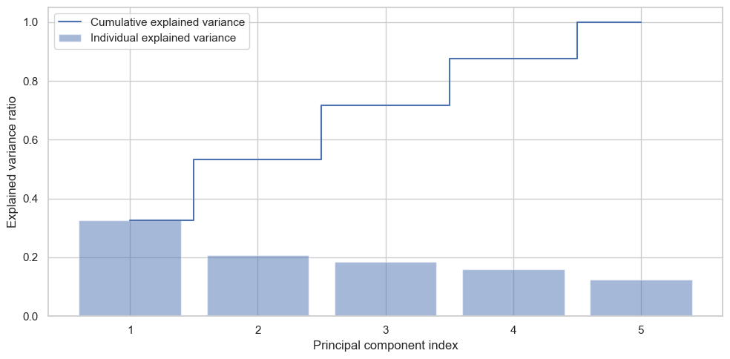
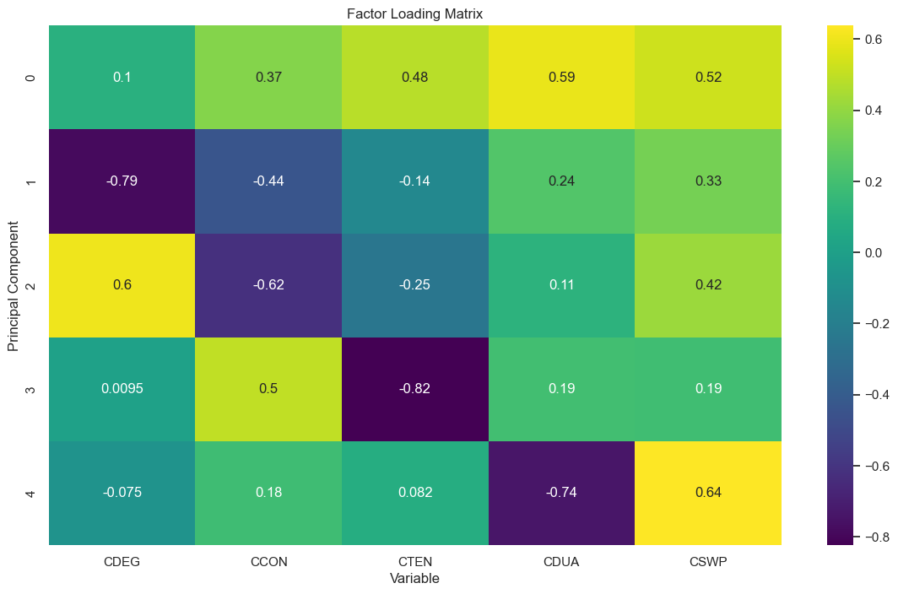
For the BOD index (Figures 5 and 6), we also need to preserve two components to gain a 50% explanation of the variation. Based on the factor loading matrix, we can see that for the two primary components, all three features have been embodied.
Figure 3. Explained variance for five components of CEO Figure 4. Factor loading Matrix for CEO features
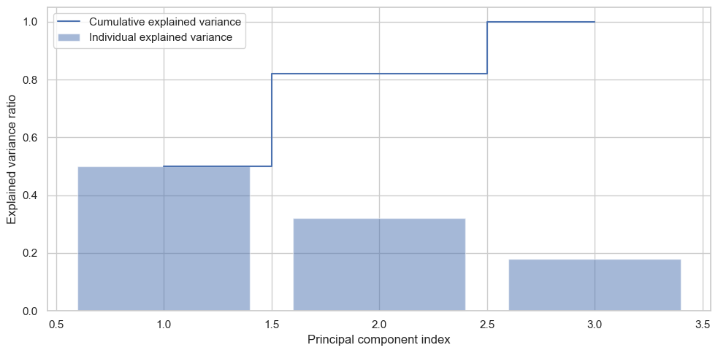
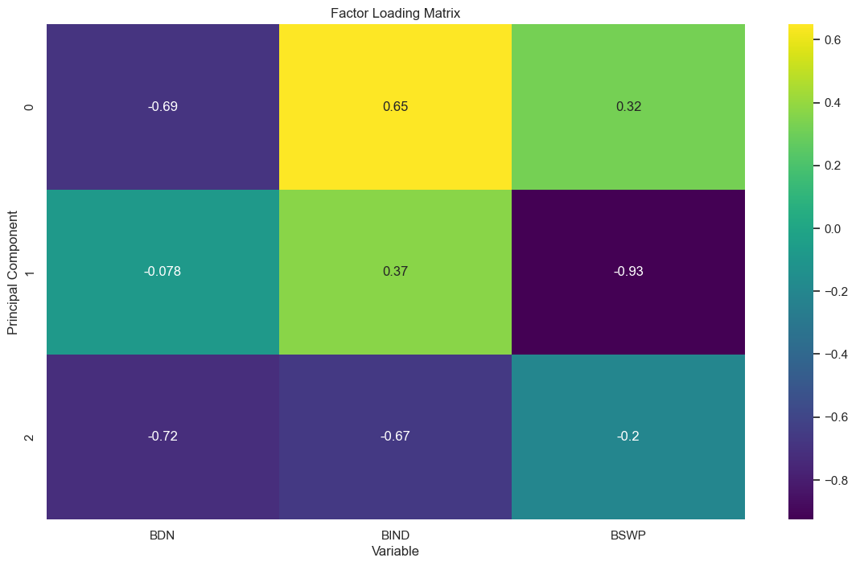
Figure 5. Explained variance for five components of BOD Figure 6. Factor loading Matrix for BOD features

4.4.2 Factor Analysis
Since there may be some unobserved variables related to these features of each level, we also applied FA (Factor analysis) analysis to reduce our dimensionality, a statistical method used to describe variability among observed, correlated variables in terms of a potentially lower number of unobserved variables (Rummel, 1988). Based on our results, according to Kaiser (1960), only the factor with an eigenvalue larger than 1 would be considered meaningful, for the CEO index, we still need 2 factors, which is a similar result as PCA. For the BOD index, FA recommends only one factor while institutional investors need two factors.
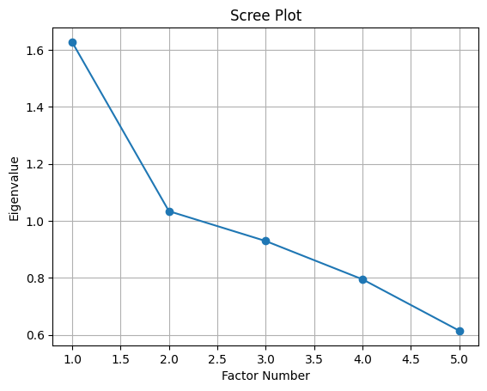
Figure 9. Eigenvalues of factor analysis for CEO
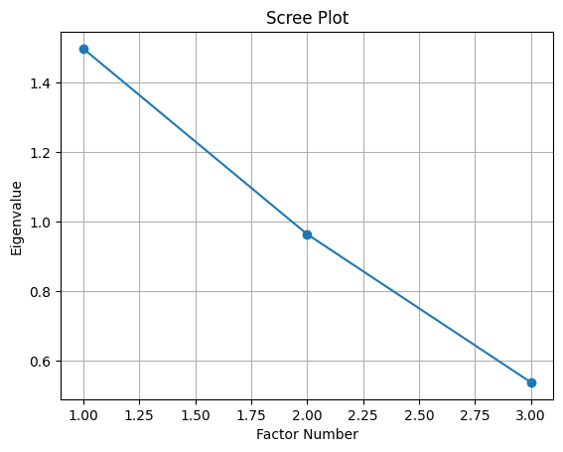
Figure 10. Eigenvalues of factor analysis for BOD
Therefore, based on our PCA, since both CEO power and Institutional Investor power need two factors to illustrate, we would conduct the regression analysis and preserve the statistically significant ones.

Table 3
Panel A: Principle component weight for CEO power
Principal component | Eigenvalues | % of variance | Cumulative %
1 | 1.627 | 0.325 | 0.325
2 | 1.035 | 0.207 | 0.532
3 | 0.929 | 0.186 | 0.718
4 | 0.795 | 0.159 | 0.877
5 | 0.615 | 0.123 | 1.000
Variable | Factor loading
 | CEO1 | CEO2
CDEG | 0.104 | -0.784
CCON | 0.368 | -0.442
CTEN | 0.482 | -0.147
CDUA | 0.589 | 0.239
CSWP | 0.525 | 0.333

Panel B: Factor component weight for BOD power
Factor component | Eigenvalues
1 | 1.498
2 | 0.964
3 | 0.538
Variable | Factor loading
BDN | -0.999
BIND | 0.440
BSWP | 0.169

Panel C: Principal component analysis and Factor analysis descriptive statistics
 | Mean | Std | Min | Median | Max | Skewness | Kurtosis
CEO1 | -1.3108E-05 | 1.275435606 | -3.302431751 | -0.212779798 | 3.330343687 | 0.519632428 | -0.376044777
CEO2 | -0.0001911 | 1.01760945 | -1.7213839 | -0.0364331 | 3.11873859 | 0.20372721 | -0.8154004
BOD1 | 0.00040413 | 0.99956119 | -5.2677888 | -0.1070861 | 5.07872848 | -0.8759112 | 2.85971733

4.5 Empirical Model and Estimation Method

4.5.1 Empirical Model
To investigate the relationship between CEO power, BOD power, Institutional Investor power, and firm capital structure, we develop the following empirical model:
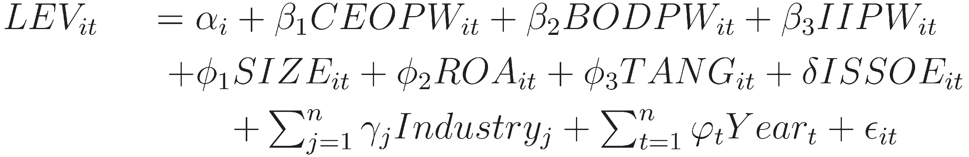
where subscripts and denote firm ( = 1,2, …, 618) and time ( = 2011,2012, …, 2022), respectively. , , 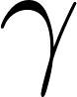, , and are the parameters to be estimated. 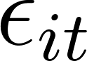 is the idiosyncratic error term which is used to capture all the other unobserved effects. The definitions of all the variables are summarized above.

4.5.2 Estimation Method
Our initial step is to employ a pooled OLS methodology, which is typically utilized in cross-sectional regression analyses. However, this method may overlook the unobservable heterogeneity and endogeneity, thus leading to biased estimates of the relationship. Given that the final sample comprises panel data, we also need to adopt estimation methods specifically designed for panel data utilization. Fixed effects (FE) estimation is introduced to mitigate the issue of unobserved time-specific and firm-specific traits. Yet, though we have a relatively long time span (12 years in this case), as we have a large number of firms (618 firms), FE estimation would consume degrees of freedom and may produce unreliable outcomes, as noted by Baltagi (2005). Consequently, our study also incorporates Random Effects (RE) estimation as an alternative approach to FE estimation. It includes the year, industry-specific, and IS_SOE dummies in the regression models. Following Petersen (2009), it's recommended that all regressions be calculated with robust standard errors, clustered by firm, to address potential serial correlation and heteroscedasticity in the dataset.

5. Results & Discussion

5.1 Baseline regression results
After constructing the power index that we want, in this section, we examine the results from our regression. Three models are applied based on our Eq.(1) in our study to investigate the relationship between CEO power, BOD power, Institutional Investor power, and leverage ratio, which are:
- An OLS model
- A fix-effects model
- A random-effects model
As we can see from Table 4, three regression specifications illustrate that CEO power is a statistically significant variable, with negative coefficients of 0.006 under OLS and around 0,004 when we control the time and individual effects under the fix-effects model and the random-effects model. This result reveals that the influence of CEOs matters during the capital structure choice process. Based on our previous PCA, this result indicates that the educational level of the CEO (CDEG) has a relatively large effect on the leverage ratio. The higher the degree that the CEO obtained, the lower the CEO would adjust the leverage ratio. This could be supported by some prior research studying the relationship between CEOs’ educational levels with their management styles. CEOs with higher educational levels might exhibit a higher degree of risk aversion and may possess stronger capabilities in strategic planning and setting long-term goals, so they may be more cautious in utilizing the leverage and prefer more conservative strategies (King et al., 2016). Besides, another reason why they favor financing by equity lies in their signaling effect, as they are perceived as more capable and trustworthy, enabling the company to attract investment at a lower cost (Chemmanur & Paeglis, 2005; Chemmanur, Paeglis, & Simonyan, 2010).
We now turn to the institutional investors. Based on the regression result, the coefficient of IACT is also statistically significant and is around 0.09 under OLS and around 0.026 when the time and individual effects are controlled under the fix-effects model and the random-effects model. The outcome indicates that the institutional investors would also have effects on capital structure. As IACT directly represents the percentage of active investors, we can confirm our proposition that institutional investors would prefer higher leverage to maximize the shareholders’ wealth.
Besides, based on our regression results, the coefficient of IS_SOE is statistically significant, with a positive value of around 0.013. This reveals that the SOEs are more likely to have a higher leverage ratio, which can also be supported by previous studies. The leverage ratio of SOEs in China is significantly higher than that of private enterprises due to vertical industrial structure characteristics, more solid enterprise qualification, and implicit government guarantees (Wang et al., 2018).
However, based on our results from three regression models, the factor of BOD is not statistically significant. This reveals that BOD, especially in China, may not have a considerable effect on capital structure. This can be explained by several factors based on prior studies. Basically, the BODs don’t have great initiatives and ability to manage the agency's problems, especially in preventing the over-investment of the CEOs. Specifically, it’s hard for the BODs to identify and confirm the over-investment behavior of the CEOs because of the asymmetric information (Liu et al., 2012). Moreover, Adams and Ferreira (2007) also theoretically proved that the effectiveness of the BODs’ oversight crucially depends on whether the management discloses internal company information to them. Besides, the legal risks for BODs brought about by managers' excessive investment are smaller, as the law would not deem operational failure because of over-investment as an illegal act. Thus, they also don’t have strong motivation. These may result in BODs not displaying a strong effect on the capital structure, especially relative to the influence of CEOs and intuitional investors.
Therefore, based on our results, both CEO and Institutional Investors exert an influence on the capital structure choice while the impact from BOD appears to be not significant.

Table 4
 | OLS | Fixed Effects | Random Effects
 | LEV(1) | LEV(2) | LEV(3)
CEO2 | 0.00595*** | 0.00425*** | 0.00435***
 | (5.09) | (3.67) | (3.87)
BOD1 | 0.00107 | -0.00199 | -0.00295**
 | (-0.35) | (-1.32) | (-2.1)
IACT | 0.0917256*** | 0.0277908*** | 0.0255**
 | (6.84) | (2.58) | (0.44)
SIZE | 0.0107*** | -0.0630*** | -0.0471***
 | (4.63) | (-20.86) | (-17.08)
ROA | -0.000595*** | -0.000548*** | -0.000525***
 | (-6.72) | (-9.15) | (-8.77)
TANG | -0.876*** | -0.908*** | -0.907***
 | (-191.52) | (-227.42) | (-230.47)
IS_SOE | 0.0130255*** |  | 0.0258201***
 | (5.12) |  | (4.03)
CON | 0.637*** | 1.430*** | 1.276***
 | (23.24) | (47.10) | (44.90)
N | 7405 | 7405 | 7405
adj. R² | 0.8624 | 0.887
Industry Fe  Firm Fe | No  No | Yes  Yes
Year Fe | No | Yes
t statistics in parentheses
* p < .1, ** p < .05, *** p < .01
To further compare the influence of CEOs and Institutional investors, we conduct hypothesis testing. Based on the result shown in Table 5, the influence of the CEO is significantly larger than that of institutional investors, which is aligned with our primary hypothesis. Though active investors own more participant power than passive ones, they are more vulnerable to CEOs’ influence. Proxy contesting exists that institutional investors may vote with management to avoid penalty (Pound, 1988). However, based on our results, institutional investors persisted in their interest in maximizing shareholders’ wealth, but this influence may be smaller than that of CEOs.
Table 5
H0: CEO2 - IACT = 0
Coef. | Std. Err. | t | P>|t| | [95% Conf. Interval]
-.0235389 | 0.0108501 | -2.17 | 0.030 | -0.0448085 | -0.0022693

5.2 Comparisons in Different Industry Groups
In this section, we try to figure out the cross-sectional differences in the influence of the three parties. We only select the groups with over 100 observations to make our regression results accountable. Based on the results shown in Table 6, comparing the IT industry with the Manufacturing industry, all three parties in the manufacturing industry display greater power over the capital structure. One potential explanation is that for high-tech companies, their particular firm characteristics, low tangibility, and high growth value, make equity a better choice for them over debt, and thus their firm features account for a huge percentage of capital structure choice, rather than the internal governance power. However, for traditional industries, such as the manufacturing industry, their firm characteristics don’t show a specific preference between debt and equity and thus don’t limit the capital structure choice of the three parties.

Table 6
 | Mining | Manufacturing | Utilities | Retailing | Transportation | IT | Real Estate | Leasing & Business Service
 | LEV(4) | LEV(5) | LEV(6) | LEV(7) | LEV(8) | LEV(9) | LEV(10) | LEV(11)
CEO2 | -0.0357** | 0.00480*** | 0.0153** | -0.00898** | -0.0007 | 0.00618 | 0.0114*** | 0.0035
 | -0.0156 | -0.00111 | -0.00698 | -0.00426 | -0.00695 | -0.00603 | -0.00422 | -0.0112
BOD1 | -0.0224* | -0.00265** | -0.00689 | 0.0216*** | 0.00957** | -0.0045 | -0.00263 | -0.00528
 | -0.0113 | -0.00127 | -0.00452 | -0.00409 | -0.0045 | -0.0069 | -0.00425 | -0.0172
IACT | 0.223 | 0.0616*** | -0.163 | 0.0291 | -1.071*** | 0.101* | 0.0702 | 0.388***
 | -0.168 | -0.0135 | -0.262 | -0.0412 | -0.239 | -0.0568 | -0.0645 | -0.0946
SIZE | -0.0135 | 0.0255*** | 0.0135 | -0.0322*** | 0.0152 | -0.0692*** | 0.0326*** | 0.00354
 | -0.0239 | -0.00266 | -0.0132 | -0.00812 | -0.0133 | -0.0132 | -0.0089 | -0.0205
ROA | -0.00744*** | -0.00138*** | -0.00577*** | -0.00233*** | -0.0204*** | 0.000409 | -0.000446 | -0.000500**
 | -0.00157 | -0.000157 | -0.00111 | -0.000555 | -0.00189 | -0.000714 | -0.000799 | -0.000231
TANG | -0.550*** | -0.811*** | -0.667*** | -1.027*** | -0.279*** | -0.942*** | -0.813*** | -0.938***
 | -0.0876 | -0.00636 | -0.0381 | -0.0183 | -0.0256 | -0.0125 | -0.0378 | -0.0216
CON | 0.548* | 0.501*** | 0.816*** | 1.198*** | 1.554*** | 1.357*** | 0.475*** | 0.452*
 | -0.321 | -0.0312 | -0.313 | -0.0902 | -0.307 | -0.135 | -0.13 | -0.229
N | 131 | 4,959 | 180 | 336 | 168 | 576 | 347 | 120
R-squared | 0.505 | 0.852 | 0.826 | 0.938 | 0.757 | 0.917 | 0.737 | 0.954
t statistics in parentheses
* p < .1, ** p < .05, *** p < .01

5.3 Comparisons in Different Ownership Structures
In this section, we will focus on whether the influence of the CEO, the BOD, and the Institutional Investors on capital structure differs among different ownership structures. To this end, our sample is split into SOEs and non-SOEs. A firm is identified as an SOE if it is ultimately controlled by the government and other governmental institutions. The rest of A-list companies would be classified as Non-SOEs. The results have been summarized in Panel A of Table 7.
As we can see from our means test, SOEs exhibit a higher leverage ratio, relative to non-SOEs, which we have already observed in our previous regression results. We then perform the multivariate regression based on OLS and FE estimation using samples of SOEs and non-SOEs respectively. The influence of the CEOs in non-SOEs is much stronger than that in SOEs, consistent with Firth et al. (2006) and Ruan et al. (2011) that the CEO power in non-SOEs on average is higher. It can also be explained by the fact that CEOs in SOEs are faced with weaker performance threats (Kato and Long, 2006).
The coefficient of institutional investors varies a lot between non-SOEs and SOEs, which is positive in non-SOEs and negative in SOEs. This reveals that the standpoint of intuitional investors differs in different firm structures. Compared with non-SOEs, intuitional investors in SOEs pay more attention to long-term goals and policy orientation. Thus, their investment objectives may extend beyond merely seeking financial returns, focusing instead on long-term social and economic goals such as fostering the development of strategic national industries, supporting employment, or achieving regionally balanced development (Bo and Wu, 2009; Brandt and Li, 2003; Aharony et al, 2000).
Another point worth mentioning is that the influence of BODs on capital structure in SOEs is statistically significant. This indicates that BODs of SOEs may have more power, compared with those in non-SOEs. This is relevant to the special political focus of SOEs, as the board members of SOEs are mainly government officials or government-appointed representatives to ensure that the company's decisions align with the national economic and social objectives. Prior studies found that when the controller is of a state-owned nature or the local government, the governance effect of the non-actual controllers, BODs, becomes more significant (Lu et al, 2019). Besides, the party organization has also integrated into BODs to participate in corporate governance in SOEs (Liu et al, 2020).
Table 7
Panel A: Means Test
 | Non SOEs |  |  | SOEs |  |  | Means Test
 | N | Mean | SD | N | Mean | SD | Diff | T-value
LEV | 4,494 | 0.409 | 0.297 | 2,911 | 0.501 | 0.210 | -0.0921 | -15.621
CEO2 | 4,494 | 0.093 | 1.047 | 2,911 | -0.144 | 0.952 | 0.2375 | 10.074
BOD1 | 4,494 | 0.190 | 0.866 | 2,911 | -0.293 | 1.115 | 0.483 | 10.074
IACT | 4,494 | 0.935 | 0.097 | 2,911 | 0.953 | 0.073 | -0.0187 | -9.477
SIZE | 4,494 | 9.630 | 0.508 | 2,911 | 9.930 | 0.583 | -0.2997 | -22.723
ROA | 4,494 | 4.328 | 16.967 | 2,911 | 3.374 | 6.716 | 0.9535 | 3.38
TANG | 4,494 | 0.469 | 0.306 | 2,911 | 0.380 | 0.227 | 0.088 | 14.177

Panel B
 | Non-SOEs |  | SOEs
 | LEV(11) | LEV(12) | LEV(13) | LEV(14)
CEO2 | 0.0080832*** | 0.0055095*** | 0.0049055*** | 0.0018087
 | (5.39) | (3.37) | (2.69) | (1.25)
BOD1 | -0.003148* | 0.0005323 | 0.0068937*** | -0.0054843***
 | (-1.74) | (0.24) | (4.29) | (-3.00)
IACT | 0.1207304*** | 0.0434472*** | -0.0540573** | -0.0574555***
 | (7.51) | (3.21) | (-2.13) | (-3.32)
SIZE | 0.0020633*** | -0.0754138*** | 0.0293434*** | -0.0120637**
 | (0.64) | (-19.29) | (8.70) | (-2.63)
ROA | -0.000386*** | -0.0004616*** | -0.0031226*** | -0.0022867***
 | (-4.12) | (-6.90) | (-10.36) | (-11.82)
TANG | -0.9043686*** | -0.9300946*** | -0.7623183 *** | -0.7498694***
 | (-169.11) | (-200.19) | (-83.35) | (-83.86)
CON | 0.7013693*** | 1.531642*** | 0.5644059*** | 0.9671877***
 | (18.99) | (39.26) | (13.00) | (20.97)
N | 4,494 | 4,494 | 2,911 | 2,911
adj. R² | 0.8812 |  | 0.8039
Industry Fe  Firm Fe | No  No | Yes  Yes | No  No | Yes  Yes
Year Fe | No | Yes | No | Yes
t statistics in parentheses
* p < .1, ** p < .05, *** p < .01

5.4 Discussion

5.4.1 Multicollinearity Test
In this section, we applied the Variance Inflation Factor (VIF) test to detect the multicollinearity level of independent variables we have utilized in our regressions. As the results shown in Table 8, the VIF of the variables are all closely around 1, indicating that there is nearly no correlation among my independent variables. Therefore, my regression results can survive from the multicollinearity.
Table 8
Variable | VIF | 1/VIF
CEO1 | 1.06 | 0.943396226
CEO2 | 1.04 | 0.961538462
BOD1 | 1.09 | 0.917431193
IACT | 1.03 | 0.970873786
SIZE | 1.21 | 0.826446281
ROA | 1.1 | 0.909090909
TANG | 1.23 | 0.81300813
Mean VIF | 1.11

5.4.2 Endogeneity and capital structure dynamics
In this section, we will discuss the potential endogeneity problems that lie in my independent variables. Basically, there may be two types of endogeneity. Firstly, there may be a reverse causal relationship between CEO power, BOD power, Institutional Investor power, and leverage. In other words, leverage choices may lead to the strong or weak power of the three parties. Specifically, increased leverage may lead to higher monitoring pressure on CEOs from the creditors, thus decreasing the autonomy of CEOs. Decreased leverage may also lead to higher significance of equity investors, including institutional investors, as they become a more important major capital funding source for the company. Besides, there may be some unobservable relationships between the three parties, such as trust, communication, or other informal agreements. These possibilities add to the complexity of the dynamic power balance between these three parties.
We could apply an advanced econometrics model to address this endogeneity problem in the future study. As the leverage, our dependent variable, exhibits dependency across different periods, a two-step system Generalized Method of Moments (sys-GMM) would be a good choice. Specifically, we could introduce the lagged value of the leverage as instrumental variables, and also apply two-step estimation to mitigate the endogeneity.

6. Conclusion
The findings of my research elucidate significant power dynamics among three parties, the CEOs, the BODs, and the institutional investors, of their impact on capital structure across different corporate entities and industries within China. Our study reveals that CEOs and institutional investors exert considerable influence on the financial leverage decisions of firms. Their conflicts of interest and the agency problem because of asymmetric information also have been revealed. Moreover, their roles are more pronounced in non-SOEs, which underscores the complexities of governance in varying ownership structures and economic contexts. On the other hand, BODs, while showing a lesser impact in non-SOEs compared with the other two parties, are influential in SOEs, highlighting the need for a tailored approach in governance practices. Besides, the position of institutional investors varies between different ownership structures, exerting a negative influence on leverage in non-SOEs and a positive influence in SOEs. Besides, there are variations among different industry groups. For those groups displaying typical industry-level characteristics, the observation of the diverging impact from the three parties is not obvious. These insights not only advance our academic understanding of corporate finance but also serve as a guide in practice for enhancing governance structures to align with the strategic financial objectives of companies. Moving forward, it is imperative for scholars and practitioners alike to consider these dynamics when designing governance systems that effectively balance authority and accountability, thereby promoting sustainable performance.

Acknowledgment
I would first like to extend my sincere and deep gratitude to my advisor, Professor Guodong Chen. We had our first meeting in the summer of 2023. Throughout my one-year program, he provided me with unparalleled expert guidance and valuable support during my topic selection, data analysis, final presentation and also paper structuring. His encouragement made this first research in my life enjoyable and I have reaped substantial benefits from this program.
I also wish to thank all the faculty advisors, Professor Marti G. Subrahmanyam, Professor Christina Wang and Professor Ye Jin. They supported me with great patience and care at every important point during this year-long program.
Last but not least, I am grateful to all my peers in the program and my family who supported me mentally and helped me survive the harsh periods throughout the whole study!
Appendix A. Variables Definitions
Variables | Definition
Panel A: Capital Structure
Book-value based leverage (BLVE) | The book value of total debts divided by total assets
Panel B: CEO Power
Duality (CDUA) | If the CEO is also the chairman of the board = 0, otherwise 1
Share ownership (CSWP) | If the CEO owns more than 10% of shares = 1, otherwise 1
Tenure (CTEN) | The 10-base logarithm of the month tenure starting from the date the one works as the CEO
Degree (CDEG) | If the CEO owns a master's degree or above = 1, otherwise 0
Outside service (CCON) | If the CEO serves on other firms’ boards = 1, otherwise 0
(* If there is more than one CEO, we take the average.)
Panel C: BOD Power
Size (BDN) | The number of people on board
Independence (BIND) | The ratio of outside independent directors on the board
Share ownership (BSWP) | The ratio of share ownership
Panel D: II Power
Activeness (IACT) | The proportion of active institutional investors
Panel E: Control Variables
SIZE | Firm size, calculated as the natural logarithm of total assets
TANG | The natural logarithm of the ratio of tangible assets over total assets
ROA | The ratio of share ownership

References:
Adams, R. B. (2007). A theory of friendly boards. The Journal of Finance, 62(1).
Aharony, J., Lee, C. J., & Wong, T. J. (2000). Financial packaging of IPO firms in China. Journal of Accounting Research.
Bai, C.-E., Lu, J., & Tao, Z. (2006). The multitask theory of state enterprise reform: Empirical evidence from China. American Economic Review, 96(2), 353-357.
Baker, M., & Wurgler, J. (2002). Market timing and capital structure. Journal of Finance, 57(1), 1–32.
Baltagi, B. H., & Baltagi, B. H. (2008). Econometric analysis of panel data (Vol. 4, pp. 135-145). Chichester: Wiley.
Bo, X., & Wu, L. (2009). The governance effect of state ownership and institutional investors: A perspective from earnings management. Economic Research, 2(8).
Boone, A. L., Field, L. C., Karpoff, J. M., & Raheja, C. G. (2007). The determinants of corporate board size and composition: An empirical analysis. Journal of Financial Economics, 85(1), 66-101.
Brandt, L., & Li, H. (2003). Bank discrimination in transition economies: Ideology, information or incentives? Journal of Comparative Economics, 31, 387-413.
Brickley, J. A., Lease, R. C., & Smith, C. W., Jr. (1988). Ownership structure and voting on antitakeover amendments. Journal of Financial Economics, 20, 267-291.
Brusov, P., et al. (2011). Weighted average cost of capital in the theory of Modigliani–Miller, modified for a finite lifetime company. Applied Financial Economics, 21(11), 815-824.
Bruton, G. D., Peng, M. W., Ahlstrom, D., Stan, C., & Xu, K. (2015). State-owned enterprises around the world as hybrid organizations. Academy of Management Perspectives, 29, 92–114. doi: 10.5465/amp.2013.0069
Bushee, B. J. (1998). The influence of institutional investors on myopic R&D investment behavior. Accounting Review, 305-333.
Chang, C., Chen, X., & Liao, G. (2014). What are the reliably important determinants of capital structure in China? Pacific-Basin Finance Journal, 30, 87-113.
Chemmanur, T., & Paeglis, I. (2005). Management quality, certification, and initial public offerings. Journal of Financial Economics, 76, 331-368.
Chemmanur, T., Paeglis, I., & Simonyan, K. (2010). Management quality and equity issue characteristics: A comparison of SEOs and IPOs. Financial Management, 39, 1601-1642.
Coles, J. L., Daniel, N. D., & Naveen, L. (2008). Boards: Does one size fit all? Journal of Financial Economics, 87(2), 329-356.
Cronqvist, H., Makhija, A. K., & Yonker, S. E. (2012). Behavioral consistency in corporate finance: CEO personal and corporate leverage. Journal of Financial Economics, 103(1), 20-40.
Duchin, R., Matsusaka, J. G., & Ozbas, O. (2010). When are outside directors effective? Journal of Financial Economics, 96(2), 195-214.
Fama, E. F., & Jensen, M. C. (1983). Separation of ownership and control. The Journal of Law and Economics, 26(2), 301-325.
Finkelstein, S. (1992). Power in top management teams: Dimensions, measurement, and validation. Academy of Management Journal, 35(3), 505-538.
Firth, M., Fung, P. M., & Rui, O. M. (2006). Firm performance, governance structure, and top management turnover in a transitional economy. Journal of Management Studies, 43(6), 1289-1330.
Firth, M., Fung, P., & Rui, O. (2007). Ownership, two-tier board structure, and the informativeness of earnings: Evidence from China. Journal of Accounting and Public Policy, 26, 463-496.

Florackis, C., & Ozkan, A. (2009). Managerial incentives and corporate leverage: Evidence from the United Kingdom. Accounting Finance, 49(3), 531–553.
Gormley, T. A., & Matsa, D. A. (2016). Playing it safe? Managerial preferences, risk, and agency conflicts. Journal of Financial Economics, 122(3), 431-455.
Government of China. (2023, April 14). China to reform independent director system. Retrieved March 24, 2024, from https://english.www.gov.cn/policies/latestreleases/202304/14/content_WS64394060c6d03ffcca6ec4a4.html
Graham, J. R., & Harvey, C. R. (2001). The theory and practice of corporate finance: Evidence from the field. Journal of Financial Economics, 60(2), 187–243.
Guest, P. M. (2008). The determinants of board size and composition: Evidence from UK. Journal of Corporate Finance, 14(1), 51-72.
Hirschman, A. (1970). Exit, voice, and loyalty: Responses to decline in firms, organizations, and states. Cambridge, MA: Harvard University Press.
Jiang, F., & Kim, K. A. (2015). Corporate governance in China: A modern perspective. Journal of Corporate Finance, 32, 190-216.
Jensen, M. C., & Meckling, W. H. (1976). Theory of the firm: Managerial behavior, agency costs, and ownership structure. Journal of Financial Economics, 3(4), 305–360.
Jensen, M. C. (1993). The modern industrial revolution, exit, and the failure of internal control systems. The Journal of Finance, 48(3), 831-880.
Kaiser, H. F. (1960). The application of electronic computers to factor analysis. Educational and Psychological Measurement, 20, 141-151.
Kato, T., & Long, C. (2006). Executive turnover and firm performance in China. American Economic Review, 96, 363-367.
Kim, K., Mauldin, E., & Patro, S. (2014). Outside directors and board advising and monitoring performance. Journal of Accounting and Economics, 57, 110-131.
King, T., Srivastav, A., & Williams, J. (2016). What's in an education? Implications of CEO education for bank performance. Journal of Corporate Finance, 37, 287-308.
Liu, H., Wu, L., & Wang, Y. (2012). State-owned enterprise reform, board independence, and investment efficiency. Journal of Financial Research, 9, 127-140.
Liu, X., Kong, X., & Wang, K. (2020). Governance of party organizations in state-owned enterprises and board dissent—Evidence based on voting of board resolutions in listed companies. Management World, 36(5), 116-133.
Lu, D., Huang, D., & Yang, D. (2019). Board power of non-actual controllers in state-owned enterprises and merger efficiency. Management World, 35(6), 119-141.
Maćkiewicz, A., & Ratajczak, W. (1993). Principal components analysis (PCA). Computers & Geosciences, 19(3), 303-342.
McCahery, J., Sautner, Z., & Starks, L. (2016). Behind the scenes: The corporate governance preferences of institutional investors. The Journal of Finance, 71(6), 2905-2932.
Miller, M. H. (1977). Debt and taxes. Journal of Finance, 32(2), 261–275.
Myers, S. C., & Majluf, N. S. (1984). Corporate financing and investment decisions when firms have information that investors do not have. Journal of Financial Economics, 13(2), 187–221.
Petersen, M. A. (2009). Estimating standard errors in finance panel data sets: Comparing approaches. Review of Financial Studies, 22(1), 435-480.
Pound, J. (1988). Proxy contests and the efficiency of shareholder oversight. Journal of Financial Economics, 20, 237-265.
Ruan, W., Tian, G., & Ma, S. (2011). Managerial ownership, capital structure, and firm value: Evidence from China's civilian-run firms. Australasian Accounting, Business and Finance Journal, 5(3), 73–92.
Rummel, R. J. (1988). Applied factor analysis. Evanston, IL: Northwestern University Press.
Wang, Y., Ma, X., & Zhou, J. (2018). Monetary policy and heterogeneous corporate leverage—From the perspective of vertical industrial structure. Journal of Financial Research, 455(5), 47-64.
Wintoki, M. B., Linck, J. S., & Netter, J. M. (2012). Endogeneity and the dynamics of internal corporate governance. Journal of Financial Economics, 105(3), 581-606.

