Weakness and Instability of Stablecoin Exposed by Market Turmoil from 2022 to 2023:

Case Study Analysis

by

Yanqi Chen

An honors thesis submitted in partial fulfillment
of the requirements for the degree of
Bachelor of Science
Business and Economics Honors Program

NYU Shanghai
May 2023

Professor Marti G. Subrahmanyam Professor David L. Yermack
Professor Christina Dan Wang
Professor Wendy Jin

Faculty Advisors Thesis Advisor
Abstract
Since the introduction of the first generation of stablecoins BitUSD and NuBits in 2014, stablecoins have become the essential medium of exchange in the decentralized financial system because of their low volatility. However, the occasional instability and weakness of stablecoin were exposed by the market turmoil between May 2022 and May 2023 in both the traditional and decentralized financial markets.

This article analyzes the factors that caused the price fluctuation of stablecoin during the four turmoil cases from 2022 to 2023, including failure and complexity of algorithm, non-independent operations among De-Fi institutions, collateral deposit’s reliance on traditional banking, and strict governmental regulation. The four cases studied are (1) the collapse of stablecoin UST and cryptocurrency LUNA prices, (2) the bankruptcy of cryptocurrency exchange FTX leading to stablecoin Tether below $1 peg and USD Coin above $1 peg, (3) the bankruptcy of commercial bank Silicon Valley Bank leading to USD Coin below $1 peg (4) regulators NYDFS and SEC ordering fintech company Paxos to permanently stop issuing stablecoin BUSD on the grounds of unregistered securities. The volatility of stablecoin prices during market turmoil created possibility of arbitrage. So, this paper also presents arbitrage simulation result to examine the profitability of the arbitrage strategy.

Acknowledgement
I want to thank my research advisor, Professor David L. Yermack, for leading me into stablecoin research. As an expert in the cryptocurrency field, he patiently taught me hard concepts of stablecoin. In addition, Professor Yermack paid close attention to the abnormality of stablecoin market and reminded me at the first opportunity. When I encountered obstacles in selecting research topics and methods, Prof. Yermack showed me the way with his wisdom and erudition.

I would also like to thank Prof. Marti G. Subrahmanyam, Prof. Christina Wang, and Prof. Wendy Jin for referring me to Prof. Yermack and helping us establish contact upfront. They generously gave me critical advice and helped me progress during my research.

Last but not least, I would like to thank every speaker in the Honors Program Seminars for selflessly sharing insights into their areas of research. In addition, I would like to thank all my classmates in the program for sharing their research findings and methods.

Content
1. Introduction 6
2. Methodology 7
2.1. Case Study 7
2.2. Arbitrage Simulation 7
3. Introduction to Stablecoin 8
3.1. Definition 8
3.2. Classification 8
3.3. Purchase and Redemption of Stablecoins, Minting and Destruction Mechanisms 11
4. Case Study: Terra's UST and LUNA Price Collapse 14
4.1. Terra 14
4.2. UST and LUNA 14
4.3. Anchor 15
4.4. Event History 16
4.5. Risks and Insights 18
5. Case Study: FTX Bankruptcy Led to USDT De-peg 20
5.1. FTX 20
5.2. Alameda Research 20
5.3. Tether (USDT) 21
5.4. USDT and FTX, Alameda’s Relationship 21
5.5. Event History 22
5.6. Risks and Insights 24
6. Case Study: SVB Bankruptcy Led to USDC De-peg 27
6.1. SVB 27
6.2. USDC 27
6.3. Relationship between USDC and SVB 27
6.4. Event History 28
6.5. Risks and Insights 29
7. Case Study: BUSD Stop being Issued 31
7.1. Binance 31
7.2. Paxos 31
7.3. BUSD 31
7.4. Event History 32
7.5. Risks and Insights 33
8. Arbitrage Simulation: Arbitrage on Stablecoins Lose Dollar Peg 35
8.1. Test Methods 35
8.2. Test Outcomes 35
8.3. Risk Involved 36
9. Limitation 37
10. Conclusion 38
References 40

- Introduction
This paper analyzes the instability and weakness of stablecoin based on case studies of four market turbulences between 2022 and 2023. The study highlights the severe consequences of failures in complex algorithmic stablecoin models and the risks associated with non-independent operations in the intertwined relationships among De-Fi institutions. In addition, the study highlights the reliance of stablecoin on the traditional financial system for the liquidity of collateral assets stored in traditional banks, and the increasingly strict regulation of the stablecoin market by government agencies. The paper argues that it is essential for investors to understand the actual operation of stablecoins and their dependence on the traditional financial system to reduce the risk of severe losses.

The paper first describes the methodology used for the study, including case studies and arbitrage simulation. The paper then describes the definition, classification, purchase and redemption, and minting and destruction mechanisms of stablecoins. After that, the paper presents the results of the case studies, analyzing the course and impact of four stablecoin market turbulences, comparing features of different types of stablecoins, and exposing the corresponding risks that stablecoin investors should pay attention to. In the next part, the paper presents the results of the arbitrage simulation, analyzing the feasibility and risks of the arbitrage strategy. In the final section, the paper discusses the limitations of the research.

- Methodology
  - Case Study
This research uses the case study methodology to gain insight into the organizations involved in the four market turmoil related to stablecoin and to analyze the vulnerability and instability of stablecoin in detail by sorting through the events and comparing media reports. In critical situations, this paper's assessment of the decisions, actions, and outcomes of multiple stablecoin-related parties helps investors understand the underlying logic of stablecoin market behavior and the risks implicit in stablecoins.

  - Arbitrage Simulation
Arbitrage simulation is a financial analysis method to evaluate arbitrage opportunities and risks. In this approach, this study uses historical market data of stablecoins to simulate the effects of arbitrage trading strategies to determine the feasibility and potential returns of investing in stablecoins that lose their peg to the U.S. dollar.

- Introduction to Stablecoin
  - Definition
A stablecoin is a cryptocurrency whose value remains stable relative to some real currency or asset. Unlike other cryptocurrencies with high price volatility, stablecoins rely on a stabilization mechanism that usually does not experience significant price fluctuations. The high volatility of cryptocurrencies like Bitcoin attracts speculators to the market, which further increases volatility. Cryptocurrencies with unstable values lead to trading risks and a decrease in willingness of market participants to trade. Stablecoins were created to address the pain points of other high-volatility cryptocurrencies. Stablecoins are needed for the growth of digital assets and the blockchain economy because they can help reduce the price volatility of digital assets and cryptocurrencies, and increase the liquidity of these assets. Stablecoins enable market participants to take less transaction risk and more easily determine the value of digital assets, thereby driving the growth of the blockchain economy. (Bullmann, Klemm, and Pinna，2019, 3).

  - Classification
Stablecoins rely on price stabilization mechanisms to maintain minimal price volatility. The price stabilization mechanism can classify stablecoins into fiat-collateralized, crypto-asset-collateralized, commodity-collateralized, and algorithmically stabilized categories (Moin, Sirer, and Sekniqi, 2019, 3).

    - Fiat-collateralized
A fiat-backed stablecoin is a stablecoin that is pegged to the value of a fiat currency, such as the U.S. dollar, the euro, or the Japanese yen. Stablecoin issuing companies or organizations typically hold a reserve of an equal amount of fiat currency for each unit of a stablecoin in circulation. This reserve is intended to ensure that the stablecoin maintains a stable value and allows investors to redeem the underlying fiat currency with the stablecoin at any time. The most significant advantage of fiat-backed stablecoins is stability. Because they are pegged to fiat currencies, they are less susceptible to influences that could cause price fluctuations in other types of cryptocurrencies. However, fiat-backed stablecoins can also raise external concerns due to the lack of transparent reserve audit disclosure. In addition, since the stability of fiat-collateralized stablecoins depends on the strength of the collateralized fiat currency, the value of the collaterals can be affected by factors such as inflation or economic instability. The major fiat-collateralized stablecoins in the market include Tether (USDT), USD Coin (USDC), and True USD (TUSD).

    - Crypto-asset-collateralized
This stable currency maintains a peg to the U.S. dollar using digital assets such as cryptocurrencies as collateral. The issuing company holds different crypto assets in a smart contract on a decentralized blockchain. Stablecoins backed by multiple crypto-assets can be more decentralized than fiat-backed stablecoins. The value of crypto-asset-backed stable coins is maintained by smart contracts and protocols scattered across blockchains. However, fluctuations in the value of cryptocurrencies used as collateral can lead to high risks, such as instability in the value of stablecoins. The market's major crypto asset collateral-based stablecoins include Dai (DAI) and sUSD (SUSD).

    - Commodity-collateralized
A commodity-backed stablecoin is a stablecoin backed by a physical asset, such as gold or silver, which means that the stablecoin issuing company or organization typically holds a reserve of physical commodities of equal value for each unit of the stablecoin in circulation. Commodity-backed stablecoins use the stability of physical assets and blockchain technology to stabilize price fluctuations at low levels. However, commodity-backed stablecoins also have weaknesses because of changes in the value of collateralized commodities, which can affect the stability of the stablecoin. In addition, potential issues with physical warehousing and logistics can add additional risk for investors. Major commodity-collateralized stablecoins include Tether Gold (XAUT) and Paxos Standard (PAXG).

    - Algorithmically stabilized
Algorithmic stablecoins are backed not by physical assets or fiat currency but by algorithms. Issuers use a complex system of incentives and penalties to adjust the supply of stablecoins in circulation to maintain a stable value. The most common algorithmic stablecoin is the "Seigniorage style," which changes the supply according to market demand. When the market demand increases, the algorithm will create new tokens, which may lead to inflation and token depreciation. When market demand decreases, the algorithm will destroy tokens, which may lead to deflation and a token premium. The advantages of algorithmic stablecoins are decentralization, security, transparency, and independence from changes in the value of collateralized assets. But because algorithmic stablecoins are entirely dependent on the correctness of the algorithm, vulnerabilities can cause the algorithm to fail to accurately adjust the money supply promptly or, in more severe cases, directly cause the stablecoin to lose stability or even fail. Algorithmic stablecoins that have failed include Terra, and Empty Set Dollar (ESD), whose price dropped from a dollar to under a cent. The major algorithmic stablecoins currently on the market are partially backed by collateral, including Frax (FX) and Dai mentioned above (DAI).

Many of the stablecoins in the market cannot be classified as one of the above categories, as they are backed by a mix of fiat, securities, crypto assets, physical, and algorithm. Fiat collateral-based stablecoins are the most stable, while algorithmic stablecoins are the riskiest.

  - Purchase and Redemption of Stablecoins, Minting and Destruction Mechanisms
    - Purchase
Binance, Coinbase, Kraken, and other cryptocurrency exchanges are the leading platforms for purchasing stablecoins. Registered users of the exchanges need to deposit fiat or cryptocurrency into their exchange accounts, then select the number of stablecoins they want to buy, and finally confirm the transaction and can transfer the purchased stablecoins to a more secure user's digital wallet.

    - Redemption
Investors need first to contact the issuer of the stablecoin and inform them of their desire to redeem the stablecoin. The issuer will usually provide instructions on the redemption process. Investors may be asked to submit application forms and identification documents during redemption. In addition, the issuer may also require the investor to meet other specific qualifications or conditions. Ultimately, the investor must transfer the stablecoin to a designated address or wallet. Then the issuer will transfer the equivalent amount of fiat or cryptocurrency to the investor's asset account.

    - Minting Mechanism
Minting is the activity of creating new units of a stablecoin. The issuing company is responsible for monitoring the stability of the stablecoin after it is minted and maintaining its value of the stablecoin by adjusting the amount of collateral or repurchasing when necessary. The issuing company deposits collateral such as fiat currency or cryptocurrency into a smart contract, and this contract creates new tokens in exchange for the deposited collateral. A smart contract is a computer program that automatically executes the terms of an agreement when predetermined conditions are met, and it needs to run on a decentralized blockchain network (Jain, Tripathi, Chandra, and Chinnasamy, 2021, 1).

    - Destroying Mechanism
The process of destroying a stablecoin is also called burning, which refers to the permanent destruction of a stablecoin by sending it to an address or smart contract that is programmed to hold and never release it. When a stablecoin’s supply becomes too large, resulting in token or collateral devaluation, the issuing company must maintain price stability by destroying the coin.

- Case Study: Terra's UST and LUNA Price Collapse
  - Terra
Terra is a decentralized blockchain platform. It was launched in 2018 by a South Korean blockchain company called Terraform Labs. The native cryptocurrency of the Terra blockchain was known as LUNA. Terra created a stablecoin called TerraUSD (UST), pegged to the US dollar and stabilized by an algorithm. Terra used the Delegated Proof of Stake (DPoS) consensus mechanism, which involved a set of validators who were responsible for verifying transactions and generating new blocks. These validators were elected by LUNA token holders and participated in the production and governance of blocks on the Terra blockchain (Cho, 2023, 28).

  - UST and LUNA
TerraUSD (UST) is a stablecoin issued by Terraform Labs, pegged to the value of the US dollar at a ratio of 1:1. The Terra blockchain used its native cryptocurrency called LUNA as collateral to issue USTs. Terra's stablecoin algorithm helped manage the supply of UST by burning or minting LUNA on demand to maintain price stability. As the cryptocurrency bull market kicked into high gear, LUNA soared to $115 in April 2022. By June 2022, the LUNA token was trading below $5 (see Figure 1).
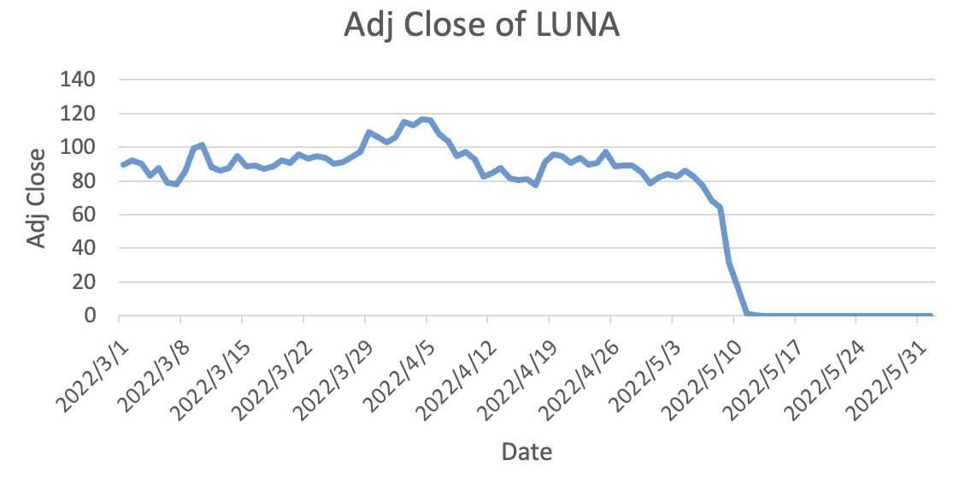
Figure 1: Adjusted Close of LUNA from 2022/3/1 to 2022/5/31
Source: Yahoo Finance

  - Anchor
Anchor (ANCT) was a cryptocurrency and financial platform built on the Terra blockchain, which aimed to provide users with a stablecoin savings platform with a high yield. As part of the Anchor protocol, users could deposit USTs into the savings platform and receive interest. These assets were then available for borrowers to borrow, and Anchor offered market-leading annual yields of up to 20% to users who deposited USTs on the platform (Wintermeyer, 2022). Anchor lending agreements operated on the blockchain and used smart contracts to automate lending and borrowing transactions without the need for intermediaries such as banks. Anchor lending agreements typically used algorithms to determine interest rates and lending/borrowing terms based on supply and demand dynamics within the lending pool. Fourteen billion of the $18 billion total outstanding supply of USTs was locked up in Anchor before the USTs decline on May 7, 2022 (Kessler, and Young, 2022). Most investors bought stablecoins for the sole purpose of getting super high savings returns. Anchor's high yield was allegedly unsustainable and dependent on the artificial support of Terraform Labs (TFL) and its backers. When profits fell, UST savers looked elsewhere for higher returns.

  - Event History
From February 22 to April 11, 2022, Luna Foundation Guard (LFG), the newly established UST peg maintainer, bought numerous Bitcoin reserves for UST through the sale of LUNA. Terra's LUNA token price rose dramatically during the same period, with UST jumping to the third largest stablecoin. The LUNA price spike was driven by market sentiment. Because Terra kept approaching its goal of purchasing $10 billion in Bitcoin reserves for UST and claimed that UST had entered the Ethereum blockchain and became part of the global payment system.

Crypto whale tracker Curve Whale Watching monitored a transaction that swapped $85 million UST for USDC. Users on Twitter expressed their incomprehension as to why USTs with annualized deposit rates as high as 20% were being dumped and speculated whether there was a problem with USTs resulting in insider trading. Meanwhile, short sellers and panic mongers were dumping numerous UST on Terra's Anchor protocol and the stablecoin exchange protocol Curve. The price of the UST began to fall below the dollar anchor price, reaching $0. 985.

Savings on the Anchor Platform plummeted from $14 billion to $9 billion on May 9 (see figure 2) as UST holders could not stand that the UST repeatedly reverted to a dollar and then dropped below a dollar. After Terra signaled that LFG's bitcoin reserves were about to run out, LUNA's price drop caused its market cap to fall below that of UST. UST was below the dollar anchor price due to the lack of full LUNA collateral. Terra minted more LUNA to meet the UST exchange demand. Severe LUNA oversupply caused the price to fall further, so that eventually, both UST and LUNA prices were down to a few cents. Thus, despite LFG's large purchase of bitcoin reserves for UST, Terra failed to meet the demand for user redemption funds. Anchor's offer of super-high deposit rates was attractive. However, it was in fact a deadly deception, and it was very likely that Anchor was using a Ponzi scheme to take in new users' funds to pay out interest on old customers' deposits. In addition, the Terra algorithm was utterly unable to counter the intensive selling pressure by adjusting the token supply under the selling pressure.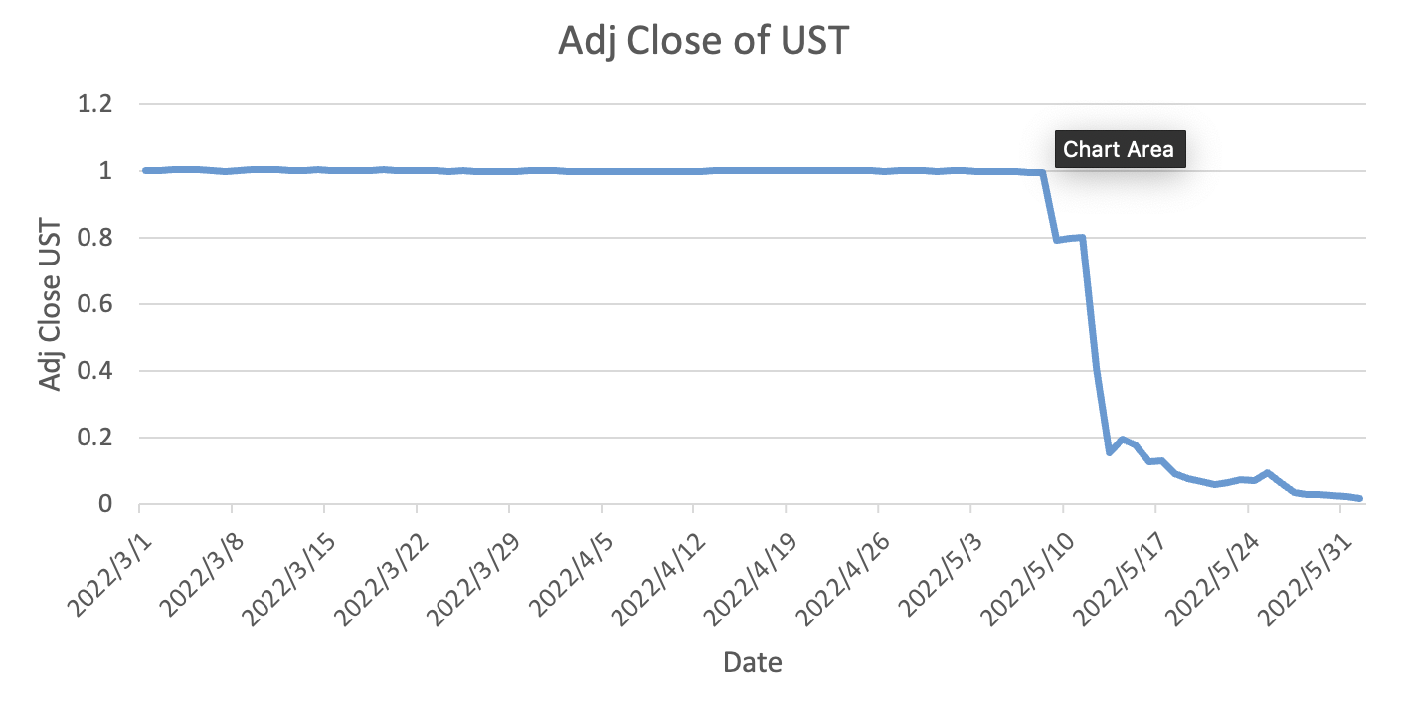
Figure 2: Adjusted Close of UST from 2022/3/1 to 2022/5/31
Source: Yahoo Finance

  - Risks and Insights
Terra's collapse exemplifies the lack of a uniform regulatory framework and standards to protect investors in the stablecoin market. UST was not tied to any non-cryptocurrency collateral. Instead, it relied on the consensus mechanism of a weak, manipulable sister token system. Sister token systems often attract investors with high deposit yields, but how the issuing company maintains a very high yield is the important question. In the case of Terra's failure, a number of investors took a chance and deposited their funds in Anchor Platform to earn a yield and thought they could escape before disaster struck. But the fact is that once a run starts to occur, it will be difficult for investors to get their money back from an under-collateralized stablecoin project. after Terra's failure, investors will be wary of the high interest rates on stablecoin deposits. Stablecoins play almost the same role in decentralized finance as fiat currencies do in traditional finance. So, if a stablecoin company promises much higher interest rates on savings than traditional banks without disclosing its balance sheet, investors should be reminded of Terra's failure.

Stablecoin, as a digital currency, is intended to provide a relatively stable investment option in the digital asset market by achieving stable value through a low-risk asset reserve. The stability of a stable currency is closely related to the adequacy of its collateral assets and whether the total assets of the issuing company are greater than its total liabilities. However, stablecoins such as UST (TerraUSD) use an algorithmically managed synthetic fiat model where the underlying asset is uncollateralized and high-volatility cryptocurrency. As a result, investors will have more confidence in an algorithmic stablecoin that is backed by a sufficient amount of highly liquid assets. In the future, algorithmic stablecoins may be backed by more assets such as fiat treasury bonds. However, algorithms will continue to face challenges as a tool to balance supply and demand.

Creating a stablecoin that can rely on an algorithm to maintain an anchor price in the face of extreme selling pressure is a complex technology. For instance, Terra has experienced system crashes twice during extreme selling pressure and rapid devaluation of UST and LUNA (Wintermeyer, 2022). The operation of algorithmic stablecoins requires complex algorithms and smart contract mechanisms to maintain the stability of their value. Once the algorithms and contracts are flawed or hacked, the value of the stablecoin can be severely impacted. Although algorithmic stablecoins are the most decentralized of all stablecoin types, investors' inherent doubts about the reliability of algorithmic stablecoins may cause the market for algorithmic stablecoins to shrink in the future.

Although Terra was once a popular stablecoin with a high market share, its collapse did not lead to the collapse of the stablecoin system, which should be attributed to a diversified stablecoin system. A system that avoids reliance on a single stablecoin can better cope with risk. So as more stablecoins flood into the market in the future, the systemic risk will gradually decline.

- Case Study: FTX Bankruptcy Led to USDT De-peg
  - FTX
FTX was a cryptocurrency exchange and trading platform offering products and services related to cryptocurrencies and digital assets. FTX was founded by Sam Bankman-Fried and Gary Wang in 2017 and was based in Hong Kong. FTX offered spot trading, futures trading, leveraged tokens, options trading, and other financial products related to cryptocurrencies. FTX offered Leveraged Tokens which enabled traders to take leveraged positions without managing the leverage themselves (Poloniex, 2022). FTX also launched its native token, FTT (FTX Token), for multiple uses on the platform, such as fee discounts, voting rights, and liquidity incentives.

  - Alameda Research
Alameda Research was a US-based cryptocurrency quantitative trading firm founded in 2017, co-founded by Sam Bankman-Fried and Yihan Wu. Alameda Research used algorithms and automated trading strategies to trade in various global cryptocurrency markets. Alameda Research also provided market liquidity to multiple trading platforms and cryptocurrency programs as a market maker. There was a close working relationship between Alameda Research and FTX. Alameda Research invested in FTX and provided technical and liquidity support for it. In addition, Alameda Research and FTX collaborated on product and ecosystem building. For example, Alameda Research's hedge fund FTX Alameda Fund traded on FTX. In addition, FTX also worked with Alameda Research to launch a series of derivatives products, such as index-based futures contracts (Goldstein, Stevenson, Farrell, and Bellany, 2022). Both FTX and Alameda Research are in bankruptcy proceedings in the U.S. federal courts in New York.

  - Tether (USDT)
Tether (or USDT) is a stablecoin designed to maintain a stable value like traditional currencies such as the U.S. dollar. Tether was initially launched in 2014 by iFinex Inc., the parent company of the Bitfinex crypto trading platform. Tether began with the Omni protocol as its primary issuance and trading platform and has since launched other protocols such as Ether (ERC20), Bitcoin Cash (BCH), and Litecoin (LTC). Tether claimed that each USDT maintains a 1:1 anchoring relationship with its equivalent in U.S. dollars. However, Tether was sued by the New York attorney general and admitted not having adequate reserves. Tether is now required to disclose its reserves quarterly pursuant to its settlement of the New York litigation.

  - USDT and FTX, Alameda’s Relationship
FTX differed from other large exchanges in its choice of stablecoin. While most large cryptocurrency exchanges chose their proprietary stablecoins, such as Gemini's GUSD, Binance's BUSD, and Coinbase's USDC, FTX primarily used Tether (USDT) on its trading platform instead of launching its own proprietary stablecoin. Sam Bankman-Fried launched FTX Exchange on May 7, 2017, and at the same time, Tether (USDT) started a fundraising round with plans to raise $1 billion. This coincidence sparked speculation about a connection and collaboration between FTX and Tether.

Protos, a cryptocurrency research and investment firm, publicly disclosed information about the close relationship between Tether and FTX. Protos' investigation revealed that Alameda Research was Tether's second largest customer who had a track record of large purchases of Tether. The Protos investigation also revealed that Alameda Research helped FTX better operate its market by providing liquidity to the USDT pairs. More than $36 billions of USDT had been transferred to Tether by October 2021, representing 30% of the total USDT issuance (Protos, 2021).

Ryan Salame, Head of OTC at Alameda Research, admitted extensive Tether minting experience in May 2021. He stated that he had been minting and redeeming USDT on an institutional scale for over three years at multiple counters. (Protos, 2022).

  - Event History
On November 6, 2022, Binance announced that it would sell its entire FTT token position - approximately 23 million FTT tokens worth roughly $529 million - based on risk management factors.

On November 7, FTX experienced a liquidity crisis, with clients demanding to withdraw $6 billion worth of funds. Bankman-Fried began looking for additional funds from venture capitalists. The value of FTT fell by more than 80% in two days.

On November 8, Binance announced an agreement to acquire FTX's non-U.S. business but called it off the following day after due diligence revealed that FTX had misused its funds. On November 10, Research Director Eliézer Ndinga said Alameda used USDT to borrow at least 1 million USDT on the decentralized liquidity pool Aave and then immediately sold USDT for USDC on other liquidity pools. It was possible that Alameda shorted Tether either because its trading account was hacked or because it hoped to make a profit by shorting Tether to pay off some of its debt. Later that day, Sam Bankman Fried admitted on Twitter that FTX's non-U.S. exchanges did not have enough funds to meet customer withdrawal demand and announced that Alameda Research would phase out trading. He explained that the source of the problem was FTX's miscalculation of leverage and liquidity. Enormous selling pressure driven by market panic about the close relationship of FTX and Tether caused Tether to lose its dollar peg.

Since Tether began to lose the dollar peg, panic selling had prompted about $16 billion in redemptions from Tether. Tether's market value went below $70 billion, down 16% from its peak of about $83 billion. Fortunately, Tether still met the capital requirements for redemptions, restoring the $1 peg. By contrast, Tether's most significant stablecoin rival USD Coin (USDC), benefited from the FTX turmoil. Since the FTX exchange began to collapse around November 7, USDC had witnessed over $2 billion in inflows and was priced above one dollar. A similar scenario was seen in May when LUNA and UST collapsed. The USDC's more transparent and trustworthy reporting of collateralized asset reserves contributed to this flight to quality. Most of the investors who moved money out of Tether bought other more trusted stablecoins like USDC instead of keeping genuine dollar. The mirror image (see figure 3). of Tether and USDC prices illustrated that users' concerns about Tether stem primarily from Tether's relationship with FTX and Alameda, rather than the stablecoin system as a whole.

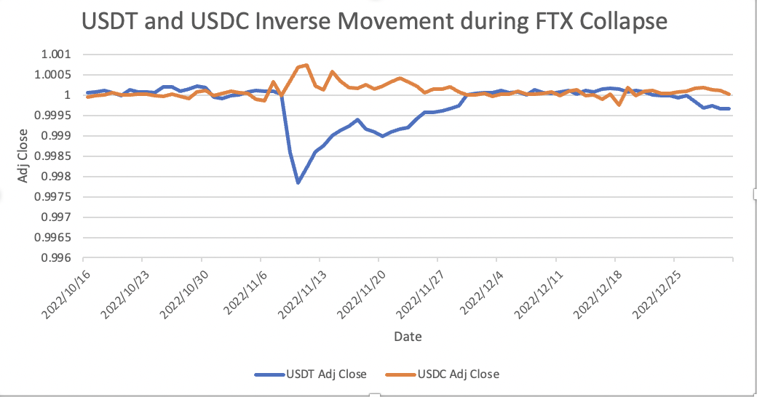
Figure 3: USDT and USDC Inverse Movement during FTX Collapse
Source: Yahoo Finance

  - Risks and Insights
The mirror image of Tether and USD Coin prices during the FTX turmoil indicated a very strong willingness of investors to move funds from Tether to USDC. when FTX, which was closely tied to Tether, went bankrupt, investors were more concerned than ever about all the negative news about the opaque condition of Tether's assets, and worried that Tether's collateralized assets had been affected by the failure of FTX. As a result, investors couldn't wait to move their money to USDC, even causing its price to exceed one dollar. USDC's more transparent collateral asset disclosure exemplified the effect of boosting investor confidence. Therefore, in the future, stablecoin issuing companies will try as much as possible to make investors aware of the collateral assets to consolidate the market share of the project, which is very beneficial for the development of the stablecoin system.

The close ties and cooperation between FTX, Alameda, and Tether remind investors to be wary of the risks associated with the intertwined relationships between crypto exchanges, market makers, and stablecoin issuers. USD payments from Alameda purportedly backed the USDT issued by Tether. Since the USD-backed funds paid by Alameda were not disclosed on its balance sheet, it was difficult to confirm whether Alameda paid the total amount of USD to back its USDT issuance. These issues raised concerns about the relationship between Tether and Alameda and the proper backing of the stablecoin. Reddit users suspected that some of the USDT received by Alameda were obtained by FTX (Alameda's parent company) through the theft of customer deposits.

The fact that Tether regained its one-dollar peg price indicated that Tether's collateral assets were sufficient to withstand the redemption pressure. But its relationship with FTX resulted in a loss of market share and reputation. While the issuance and circulation of stablecoins require the support of market makers and exchanges, stablecoin issuers are less likely to suffer market share losses and price instability due to the failure of one partner if they have a more diverse set of partners.

In addition, many institutional and individual investors engaged in risky long and short trades amidst the collapse of Terra and the FTX turmoil. Long traders expected de-pegged stablecoins to preserve their value and short traders expected the stablecoins continue to fall. Many of these traders suffered huge losses. In the cryptocurrency market, where high risk and volatility are common, investors must be aware of market sentiment and risk and make adequate risk management and investment decisions.

- Case Study: SVB Bankruptcy Led to USDC De-peg
  - SVB
Silicon Valley Bank (SVB) was a commercial bank focused on serving the innovation economy. It was founded in 1983 and headquartered in Santa Clara, California. SVB provided banking and financial services to technology and life science companies, venture capital and private equity firms. SVB was known for its expertise in serving the needs of startups and growth-stage companies.

  - USDC
USDC (USD Coin) is a stablecoin with a 1:1 peg to the US dollar developed and managed by Circle, a US payments company, and Coinbase, a cryptocurrency exchange. As an ERC-20 token, it is built on the Ethereum blockchain and features transparency and compliance. Each USDC should have equivalent USD reserves to maintain its stable value for a wide range of applications in digital transactions, including remittances and payments. USDC is audited frequently to ensure proper support of reserves and has built-in compliance features to meet anti-money laundering and know-your-customer regulations.

  - Relationship between USDC and SVB
USDC's issuer, Circle, was a depositor with Silicon Valley Bank. In a statement dated March 11, 2023, Circle acknowledged that it had $3.3 billion held in Silicon Valley Bank, representing approximately one-third of USDC's cash collateral reserves and 8% of all collateralized funds (Sandor, 2023).

  - Event History
On March 8, 2023, Silicon Valley Bank sold approximately $21 billion of its loss-making securities portfolio and suffered a $1.8 billion loss, which exposed the bank's profound asset-liability mismatch and illiquidity. After the problem was revealed, the stock price of parent company Silicon Valley Bank Financial Group plunged more than 60% on the 9th, fell 68% on the 10th, and entered a trading halt.

As the situation at Silicon Valley Bank worsened, depositors made a run on the bank. Circle disclosed that it began trying to transfer its SVB deposits on the 9th but had yet to receive the funds by the time the bank closed on the 10th. SVB was taken over by state and federal regulators on the morning of the 10th and was shut down later that day by the California Department of Financial Protection and Innovation for "illiquidity and insolvency." Subsequently, investors in USDC began to demand token redemption, which caused USDC to fall significantly below its anchor price to $0.88 by the morning of the 11th (see figure 4).
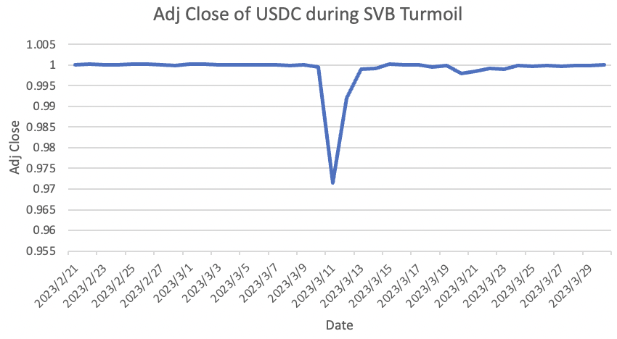
Figure 4: Adjust Close Price of USDC during SVB Bankruptcy
Source: Yahoo Finance

After federal banks and financial regulators said on the 12th that all depositors at Silicon Valley Bank would be reimbursed on the 13th, Circle issued a statement claiming that $3.3 billion in USDC reserves would be fully funded on the 13th. The USDC regained its peg to the U.S. dollar (De, 2023).

  - Risks and Insights
In March 2023 alone, the cryptocurrency industry lost three of its largest banking service providers, Silvergate, Signature, and SVB. The banking crisis sparked by Silicon Valley Bank revealed that some heavily regulated, dollar-backed stablecoins, such as USDC, were less stable than cryptocurrency advocates claimed and also suffered when relying on poorly managed counterparties.

Circle CEO Jeremy Allaire expressed gratitude for the underwriting bailout by the government and financial regulators that saved the company from the collapse of the Silicon Valley bank. The issuance and circulation of stablecoins like USDC, which rely on bank accounts as a repository for backed assets, depend on banks' support and cooperation. And as a client of a traditional bank, such stablecoin issuers and managers need to cooperate with the bank's identity verification and compliance procedures, such as anti-money laundering (AML) and know-your-customer (KYC). Thus, while stablecoins may seek decentralization and independence by design, their actual operation and compliance requirements often rely on government action and the cooperation of regulators (Markovitz, 2023). It was frustrating for investors to see the stablecoin system negatively impacted by malignant events in the traditional financial system, which also severely undermined investor confidence in decentralized finance. The SVB incident is likely to lead to a technology that solves the problem of depositing large amounts of collateralized assets in stablecoins.

- Case Study: BUSD Stop being Issued
  - Binance
Binance is a global cryptocurrency exchange platform that allows users to buy, sell and trade various cryptocurrencies. It was founded in 2017 and has grown to become one of the largest cryptocurrency exchanges in the world in terms of trading volume and user base. Binance offers many features and services, including spot trading, futures trading, betting, savings, etc. Binance also has its native cryptocurrency, Binance Coin (BNB), a utility token on the Binance platform. Users can use BNB to pay transaction fees, participate in token sales and receive rewards through various projects on the Binance platform.

  - Paxos
Paxos is a financial institution based in New York, USA, overseen by the New York Department of Financial Services and focused on cryptocurrency and blockchain. Founded in 2012, Paxos is one of two dozen companies to receive a BitLicense, while New York was the first state to license a cryptocurrency company in 2014. Known for its focus on regulatory compliance and rigorous financial standards, Paxos uses blockchain technology to tokenize and settle traditional assets such as gold and real estate. In addition, Paxos provides enterprise-grade blockchain solutions for institutions such as PayPal, Interactive Brokers, Mastercard, MercadoLibre, Nubank, Bank of America, Credit Suisse, and Société Générale.

  - BUSD
Binance USD (BUSD) is a stablecoin issued by Binance in partnership with Paxos, a financial institution approved and regulated by the New York State Department of Financial Services. It is valued at a 1:1 ratio to the U.S. Dollar (USD) and is designed to provide stability and serve as a reliable medium of exchange within the Binance ecosystem. Paxos claims that 100% of BUSD's reserves are backed by two forms of assets: fiat cash held in a dedicated consolidated account at a U.S.-insured bank and U.S. Treasury bills. Binance creates a Binance-pegged BUSD on another blockchain and freezes the corresponding Paxos-issued BUSD as a backing reserve.

  - Event History
February 13, 2023, the Wall Street Journal reported that the SEC planned to sue Paxos for issuing BUSD unregistered as a security after other cryptocurrency companies, including Gemini, Genesis, and Kraken, were also sued for the same reason. Paxos contended that BUSD did not meet the definition of security under the federal securities laws and said it would engage with the SEC and take legal action to fight back if necessary. On the same day, Paxos announced it would terminate its relationship with BUSD, while Binance founder Changpeng Zhao tweeted that Paxos would stop issuing new Binance USD.

According to CryptoQuant, approximately $52 million of BUSD was transferred to the exchange within 24 hours of this series of events, indicating that users wanted to redeem the collateral assets. As of February 21, Paxos stopped issuing new BUSD tokens as directed by the New York Department of Financial Services (NYDFS). Paxos announced that it would continue supporting BUSD fully and allow existing customers to redeem until at least February 2024. New and existing Paxos customers can redeem their funds in USD or convert their BUSD tokens into Pax Dollar (USDP), a regulated USD-backed stablecoin.

According to a March 4 Coindesk report, investors had redeemed $7 billion worth of BUSD since regulators put pressure on Paxos, and on March 9, the decentralized autonomous group of the decentralized lending protocol Aave voted to delist BUSD by raising lending costs and reducing lending revenues, as the supply of BUSD in circulation would over time tends to zero.

  - Risks and Insights
The New York Department of Financial Services and SEC lawsuit against Paxos and the BUSD cease-and-desist underscores regulators' growing concern about the stablecoin industry. Regulators are considering actions to regulate and charge stablecoins that may involve securities to ensure compliance and investor protection. This event foreshadows the expansion of governmental regulation and intervention in stablecoin projects. While stricter regulation will limit the profitability of stablecoin issuers, not all companies will see this as a negative sign. Because regulation also provides a channel for peers to monitor each other, companies that operate properly and legally can report improper operations by their peers, which helps create a safer stablecoin system.

The purpose of regulation is complex, as it is not only to protect investors' money from illegal stablecoin projects, but also to protect the traditional financial system from being weakened by decentralized finance. the implications of the BUSD incident are far-reaching. The SEC's compliance requirements and regulatory attitude toward Paxos could have a precedent-setting effect on the stablecoin market because any other stablecoin issuer may need to register or prepare for legal action with the SEC.

- Arbitrage Simulation: Arbitrage on Stablecoins Lose Dollar Peg
  - Test Methods
Stablecoins can lose their dollar peg during market turmoil but usually revert to the anchor price after a few days, which attracts investors' attention to potential arbitrage opportunities. To verify how much profit can be made by buying a stablecoin and selling it a few days later when its price is significantly lower than the anchor price, I simulated the process of this arbitrage strategy using historical data.

Since small cap stablecoins are not liquid enough to support fast trading and are prone to bankruptcy due to their inability to withstand the selling and redemption pressures, my sample is the top 7 stablecoins in the market cap. Since the stablecoin market is changing rapidly and my research focuses on market turmoil from 2022 to 2023, I collected historical price data on Yahoo Finance from January 1, 2022, to May 1, 2023.

For stablecoins, a price drop of more than 1% is already a relatively obvious decoupling situation, so I set the maximum price to buy a stablecoin at $0.99. I buy a stablecoin when its price is below 99 cents. Since a decoupled stablecoin will resume its anchor price in fewer days under normal circumstances, I will set the holding period to 3 days. After three days of buying a stablecoin, I will sell it. I recorded the number of trades, average return, and variance of return for each stablecoin under this strategy.

  - Test Outcomes
The following table shows the results obtained from arbitrage simulations:

Stablecoin | Number of Times Price Went below $0.99 | Return Mean | Return Std
USDT-USD | 2 | 3.5% | 1.8%
USDC-USD | 3 | 6.7% | 5.2%
BUSD-USD | 0 | NA | NA
DAI-USD | 3 | 5.6% | 4.1%
USDP-USD | 17 | 0.4% | 1.0%
TUSD-USD | 1 | 0.8% | 0.0%
GUSD-USD | 120 | 0.4% | 0.9%

As we can see from the table, the strategy's return is higher for some stablecoins and lower for others. The important point is that the fees for stablecoin trading are usually in the range of 1%-3%. So, transaction fees are the most critical factor that prevents investors from profiting from arbitrage.

  - Risk Involved
The logic of an arbitrage strategy is to be bullish on the return to normalcy of the price of a de-pegged stablecoin. While the results of arbitrage simulations suggest that, in some cases, this strategy can be profitable for investors, in reality, there is significant bailout risk associated with this strategy. Reasons for falling stablecoin prices include falling demand and the inability of issuing companies to meet redemption demand. During market turmoil, panic can further amplify selling pressure, leading to severe price declines. However, arbitrageurs should pay attention to bailout risk, as almost no institution will bail out a stablecoin in crisis. Terra provides a good example.

- Limitation
Despite the research's best efforts to maintain rigor, evidence to support particular views could not be found in certain areas, such as the actual state of Tether's reserve assets and how stablecoins are traded between Alameda Research and Tether. These unsubstantiated views make it difficult for investors to know the truth. Therefore, investors should remain vigilant and conduct more in-depth research on potential issues to avoid being influenced by speculation that lacks evidence.

In addition, because the subject of research is so new, media reports and commentary are the primary source of research. However, the media often provide only superficial or simplified views that need more depth and sophistication. Media journals may also be politically or ideologically biased, leading to a one-sided understanding of events.

- Conclusion
In conclusion, the evolving stablecoin market presents more opportunities and challenges. Terra's failure reminds investors to be cautious of the high deposit returns promised by sister token systems and algorithmic stablecoins that have flaws in adjusting the supply/demand balance. In addition, a diversified stablecoin system that avoids reliance on a single stablecoin can better address risk.

The price mirroring of USDT and USDC during the FTX turmoil underscores the importance of enhanced disclosure of collateralized assets by stablecoin issuers. In addition, FTX's relationship with Tether could prompt stablecoin issuers to diversify their partnerships to reduce the risk of market share loss and reputational damage.

The SVB failure highlights the urgency of developing new technologies that should address the preservation of stablecoin companies' large, collateralized assets and minimize the risks associated with traditional finance. Going forward, the cryptocurrency industry must continue to strive to build a more resilient and sustainable ecosystem to withstand external shocks and inspire investor confidence.

The BUSD event reveals the growing concern of regulators over the stablecoin industry. While stricter regulation may limit the profitability of stablecoin issuers, it also provides an opportunity for peers to monitor and report misconduct to each other, creating a safer stablecoin system. However, the purpose of regulation is complex, as it is not only to protect investors' money, but also to protect the traditional financial system from being weakened by decentralized finance.
In the future, regulators and industry participants will work together to ensure the integrity and stability of the stablecoin system, while balancing the need for innovation and growth.

References
Bullmann, D., Klemm, J., & Pinna, A. (2019, September 3). In search for stability in crypto-assets: Are Stablecoins the solution? SSRN. Retrieved May 2, 2023, from https://papers.ssrn.com/sol3/papers.cfm?abstract_id=3444847
Canellis, D. (2022, August 9). Tether papers: This is exactly who acquired 70% of all USDT ever issued. Protos. Retrieved May 2, 2023, from https://protos.com/tether-papers-crypto-stablecoin-usdt-investigation-analysis/
Cho, J.-H. (1970, January 1). A token economics explanation for the de-pegging of the algorithmic Stablecoin: Analysis of the case of Terra: Semantic scholar. Ledger. Retrieved May 2, 2023, from https://www.semanticscholar.org/paper/A-Token-Economics-Explanation-for-the-De-Pegging-of-Cho/da975038c3d73724ce07b2ca77ed1ee00f3b0a90
De, N. (2023, March 13). USDC Stablecoin regains dollar peg after Silicon Valley Bank-induced chaos. CoinDesk Latest Headlines RSS. Retrieved May 2, 2023, from https://www.coindesk.com/business/2023/03/13/usdc-stablecoin-regains-dollar-peg-after-silicon-valley-bank-induced-chaos/
FTX Leveraged Tokens FAQ – poloniex. (n.d.). Retrieved May 1, 2023, from https://support.poloniex.com/hc/en-us/articles/360045644653-FTX-Leveraged-Tokens-FAQ
Goldstein, M., Stevenson, A., Farrell, M., & Yaffe-bellany, D. (2022, November 30). FTX's sister firm, Alameda Research, was central to collapse. The New York Times. Retrieved May 2, 2023, from https://www.nytimes.com/2022/11/30/business/dealbook/ftx-almeda-research-sam-bankman-fried.html
Krisztian Sandor and Ekin Genç. (2022, December 22). The Fall of Terra: A timeline of the meteoric rise and crash of UST and luna. CoinDesk Latest Headlines RSS. Retrieved May 2, 2023, from https://www.coindesk.com/learn/the-fall-of-terra-a-timeline-of-the-meteoric-rise-and-crash-of-ust-and-luna/
Markovitz, L. (2023, March 14). SVB banking crisis shows USDC Stablecoin is still wildly unstable. Forbes. Retrieved May 2, 2023, from https://www.forbes.com/sites/digital-assets/2023/03/13/svb-banking-crisis-shows-usdc-stablecoin-is-still-wildly-unstable/?sh=29f174e27b77
Moin, A., Sirer, E. G., & Sekniqi, K. (2019, September 18). A classification framework for Stablecoin designs. arXiv.org. Retrieved May 2, 2023, from https://arxiv.org/abs/1910.10098
Sam Kessler and Sage D. Young. (2022, May 12). The Luna and UST crash explained in 5 charts. CoinDesk Latest Headlines RSS. Retrieved May 2, 2023, from https://www.coindesk.com/layer2/2022/05/11/the-luna-and-ust-crash-explained-in-5-charts/
Sandor, K. (2023, March 14). Circle confirms $3.3B of USDC's cash reserves stuck at failed Silicon Valley Bank. CoinDesk Latest Headlines RSS. Retrieved May 2, 2023, from https://www.coindesk.com/business/2023/03/11/circle-confirms-33b-of-usdcs-cash-reserves-stuck-at-failed-silicon-valley-bank/
Smart contract enabled online examination system based in blockchain ... (n.d.). Retrieved May 1, 2023, from https://www.semanticscholar.org/paper/Smart-Contract-enabled-Online-Examination-System-in-Jain-Tripathi/8889517eb7ca622e6aacdf473bc10f0d332887ae
Wintermeyer, L. (2022, October 12). From Hero to zero: How terra was toppled in crypto's darkest hour. Forbes. Retrieved May 2, 2023, from https://www.forbes.com/sites/lawrencewintermeyer/2022/05/25/from-hero-to-zero-how-terra-was-toppled-in-cryptos-darkest-hour/?sh=15daa59d389e
Wise, A. (2022, November 29). Was tether at the center of Sam Bankman-Fried's empire? Protos. Retrieved May 2, 2023, from https://protos.com/was-tether-at-the-center-of-sam-bankman-frieds-empire/

