Sustainable Transformation of Traditional Chinese Music Industry
by
Yanru Zhu

An honors thesis submitted in partial fulfillment
of the requirements for the degree of
Bachelor of Science
Business and Economics Honors Program
NYU Shanghai
May 2022

Professor Marti G. Subrahmanyam Professor Adam Brandenburger
Professor Christina Wang
Professor Wendy Jin

Faculty Advisers Thesis Adviser

TABLE OF CONTENTS
Ⅰ. ACKNOWLEDGEMENT 3
Ⅱ. ABSTRACT 4
Ⅲ. INTRODUCTION OF TRADITIONAL CHINESE MUSIC INDUSTRY 5
Ⅳ. METHODOLOGY 7
Ⅴ. CURRENT SITUATION: INDUSTRY IN STRATEGIC INFLECTION POINT 8
Ⅵ. CURRENT SITUATION: VALUE NET OF THE INDUSTRY 11
Ⅶ. PROPOSED TRANSFORMATION: CREATOR AND AUDIENCE 18
Ⅷ. PROPOSED TRANSFORMATION: AN ECOSYSTEM 23
Ⅸ. CONCLUSION 28
Ⅹ. BIBLIOGRAPHY 30
Ⅺ. APPENDIX I: ANALOGIES COLLECTION 3131

Ⅰ. ACKNOWLEDGEMENT
When I first touched the string of Erhu in my kindergarten age, I didn’t know that I would fall in love with this instrument and the culture behind. From learning and practicing instrument with Mrs. Cai since primary school, to attending Xiamen Youth Palace Chinese Music Ensemble and Xiamen Foreign Language School Chinese Music Club, then to establishing NYU Shanghai Qilin Chinese Music Ensemble. The music I listened and played reflects who am I and how I did I grow up.
I always want to use what I have learned in school to contribute to what I love, and it’s the Business Honor Seminar that gives me this chance to develop and research the traditional Chinese music through the lens of business thinking methodology. Throughout this whole year of developing thesis, it gives me a comprehensive understanding of the whole industry and current culture dynamics. This enriching learning journey would not have been possible without the warmest guidance and support from my thesis adviser Professor Adam Brandenburger. Thank you Professor Brandenburger! Besides, I would also like to extend my deepest gratitude to all stakeholders who kindly shared their thoughts and views of traditional Chinese music industry with me (in alphabetical order): Mr. Chenglin Cai, Mrs.Guoyu Cai, Ms. Ninglan Chen, Mr. Deyue Dai, Ms. Qingyao Liu, Ms. Xiaoyou Tang, Professor Xing Wei, Professor Yi Zhang, Mr. Jintai Zhu, and Mr. Liyue Zhu. In the end, special thanks to my best friends who created a cool undergraduate journey together: Yile Xu and Yayuan Zheng.
My journey with NYU Shanghai has come to an end. Although after graduation I will work in consulting where there’s no much connections with the music, however, I firmly believe that the music will always accompany me and someday I will return to my root and contribute traditional Chinese music.
Ⅱ.ABSTRACT

The project finds that traditional Chinese music industry is at a strategic inflection point and the whole industry needs an sustainable transformation in order to achieve growth at this point. To understand what transformation should be implemented, the project conducted secondary source research including analogies collection and data collection, it also conducted stakeholder interview as primary source to further confirm and guide the design of transformation plan. In the end, the project argues that audience-creator relation, creator content strategy, creator operation strategy, and industry ecosystem cooperation are four important steps for industry to transform.

Keywords: traditional Chinese music, culture industry, transformation, value net

Ⅱ. INTRODUCTION OF TRADITIONAL CHINESE MUSIC INDUSTRY
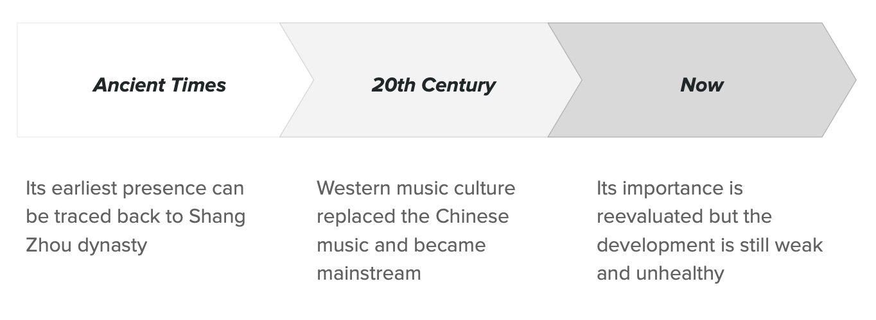
Figure 1: Diagram of traditional Chinese music history
Traditional Chinese music refers to music that is played by traditional instruments or music that contains strong Chinese characteristics. Erhu, Guqin, Guzheng, and Zhudi are some of the typical traditional Chinese instruments. Mo Li Hua (Jasmine Flower), Butterfly Lovers, and Reflections of the Moon on Erquan are typical traditional Chinese music pieces. Although current academic research hasn’t reached a final definition of music because of its complicated history (Hong, 2020), the above definition is provided for the convenience of this research.
The earliest traditional Chinese music can be traced back to the Shang Zhou dynasty, see Figure 1. As China continuously exchanged with foreign cultures during ancient times, its instruments and music also developed and evolved throughout the time, and the music was respected as the mainstream music in China.
The key turning point for traditional Chinese music is during the 20th century when China opened its borders to other countries, and western culture became mainstream because Chinese people were seeking ways to reform the whole nation. Therefore, western music culture replaced Chinese music and became mainstream music in China. After the establishment of the People's Republic of China, the value of traditional Chinese music was reconsidered. The nation started to rescue the music by inviting artists to produce new music pieces and inviting professionals to reproduce the damaged instruments. Many classic pieces were composed at that time and lasted until now.

Ⅲ. METHODOLOGY
Figure 2: Project methodology chart
The project aims at finding an ideal traditional Chinese music industry model that is sustainable. Therefore, it starts with understanding the industry situation using value nets to understand key players inside and outside the industry. After building the value net structure, more information and data within each sector are needed to enrich understanding. With the understanding of the industry, it then needs rule models that inspire the transformation. Therefore, analogies of transformation are collected throughout the project. During the process, it’s found that the secondary source information is not enough to understand the industry fully; therefore, primary source information collection will be conducted through interviews. The interviews invite key stakeholders in the traditional Chinese music industry and it will use interviews to collect their opinions on the current industry and how could the whole industry transform together. Interviews involve the “Design Thinking” methodology invented by Stanford d.school to guide stakeholders to think through the whole industry rather than only focusing on their own sector. Understanding the industry and its dynamics enables us to choose institutions or sectors that are more likely or have more potential to transform. Then based on the specific status quote of selected sectors, this research will propose an ideal operation model and transformation action plan.

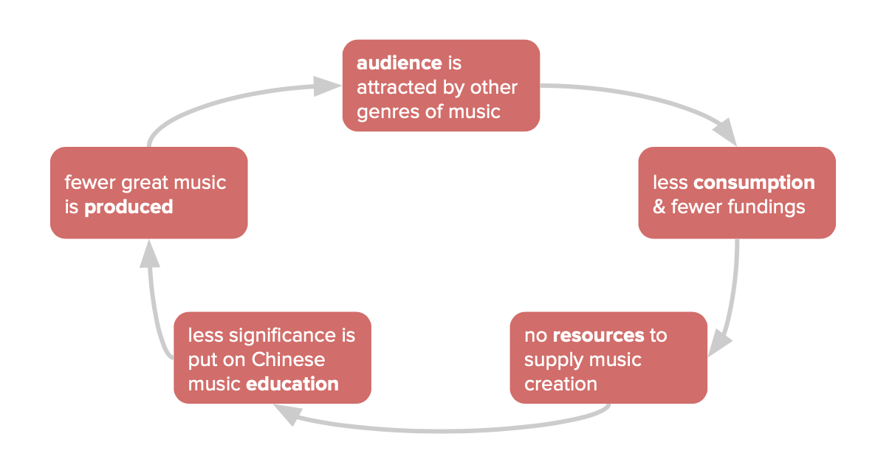
Ⅳ. CURRENT SITUATION: INDUSTRY IN STRATEGIC INFLECTION POINT
Figure 3: Vicious circle of bad content creation process
Even though traditional Chinese music was recovered and reevaluated since the establishment of the People’s Republic of China, the current status of the music was still not ideal. It falls into a vicious circle that the audience is more attracted by other genres of music, so there’s less consumption and fewer fundings for traditional Chinese music. Less funding leads to fewer resources to supply music creation, the effort put into Chinese music education is also lighter. Fewer music pieces can be produced so that the audience will listen to less traditional Chinese music and turn to other music.
Luckily, traditional Chinese music is at a strategic inflection point right now. It’s a concept invented by Intel's co-founder Andy Grove in his book “Only the Paranoid Survive”, and it refers to an event that results in a significant change in the progress of an organization or industry, and it’s a turning point that marks the start of significant change (Grove, 1999). Traditional Chinese music now faces the positive forces that drive the industry to go up and also the negative forces that drive the industry to go down. Decisions at this point would strongly influence the industry’s future development.
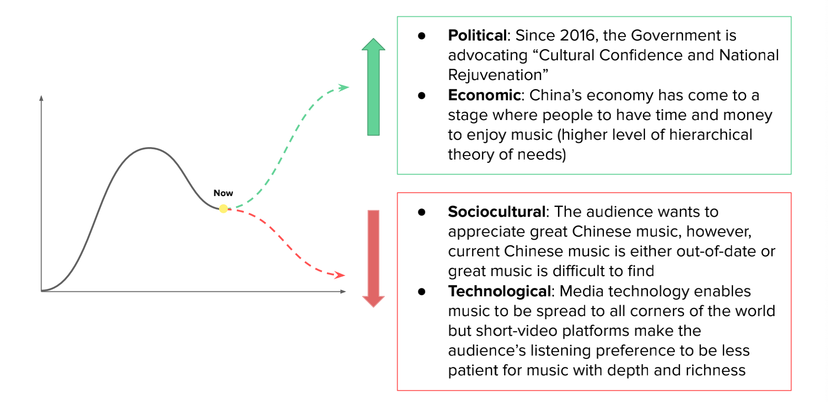
Figure 4: Traditional Chinese music at strategic inflection point with external forces
Political and economic forces would drive the industry to go up. Since 2016, the government is advocating “Culture Confidence and National Rejuvenation”, it advocates “creating more inspiring and classical works to revive the nation” (Chen, 2016). The Culture Confidence then became a buzz word and it’s been restated and reemphasized again and again in recent years. This policy trend helps traditional Chinese music to have an encouraging environment to grow. Besides, due to the continuous growth in China’s economy, people in China tend to have more resources and attention for higher hierarchical needs such as enjoying music and culture. This also serves as a positive force for growing traditional Chinese music.
However, technological and socio-cultural factors would most probably have a negative impact on the industry. Media technology enables music to be spread to all corners of the world through online music apps such as Spotify and Netease Cloud Music. However, the occurrence of short content platforms, for example TikTok, incentivizes users to get most information within a short amount of time, which results in the increasing impatience when appreciating cultural content that requires more time to digest. People start to appreciate popular music more while finding it hard to appreciate traditional Chinese music. What’s more, in order to attract users to stay on their platforms, platforms’ recommendation algorithm tends to provide more and more homogenized content; thus people who previously don’t express any interests in related fields are less likely to come across traditional Chinese music content.
All of those forces play significant roles in the development of the traditional Chinese music industry, and they form a unique position for the industry with opportunities to grow or fall. Therefore, in the following sections, the current situation of the industry and the transformation among each industry will be discussed to help the industry growing in this strategic inflection point.

Ⅴ. CURRENT SITUATION: VALUE NET OF THE INDUSTRY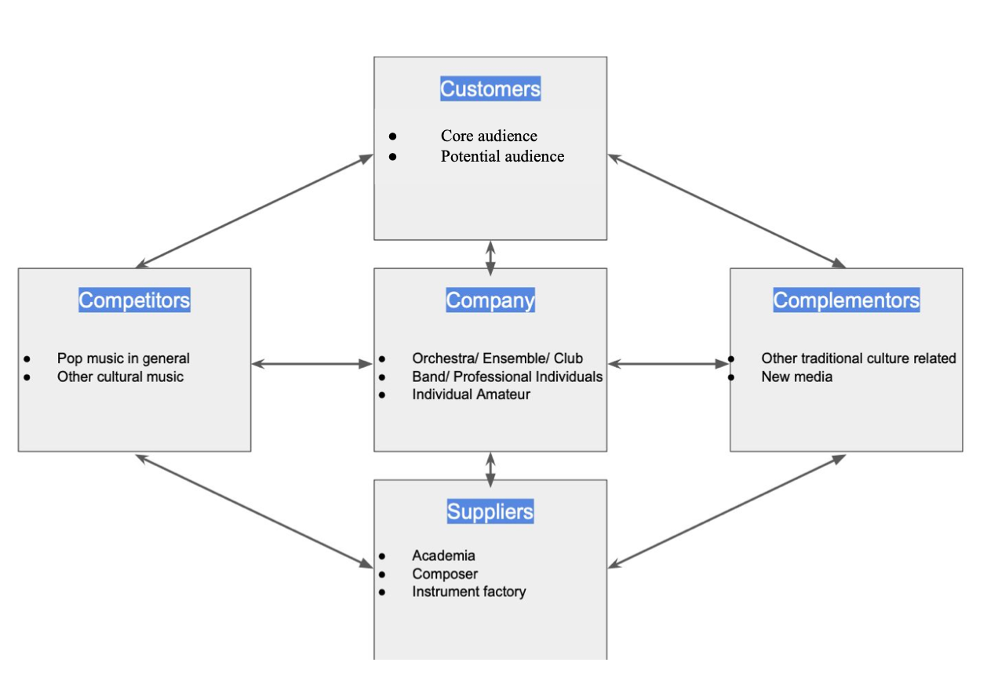
Figure 5: Value net of traditional Chinese music industry
Value net provides an analytic view of multiple players in the industry. As common music listening behavior shows that people tend to consume not only single genres of music, the competition and complementation naturally play an important role in the industry, and the value net helps the traditional Chinese music industry to identify situations and opportunities not only within the industry but also outside the industry (“co-opetition”).
- Company
Company in the traditional Chinese music industry refers to those groups or individuals performing or directly producing music. It’s categorized into the following three components:
  - Music Orchestra & Ensemble & Club
Modern orchestra originated in the early 20th century when musicians and educators sought to standardize and improve the myriad Chinese regional musical traditions and instruments by adapting traditional Chinese instruments and music to modern western musical scales, notation, and theory. Typical orchestras are China National Traditional Orchestra, China Broadcasting Chinese Orchestra, and Shanghai Chinese Orchestra.
Ensembles refer to any form of instrument collection regardless of instrument sections, so the size can be smaller than an orchestra. It appears more in amateur fields.
Clubs occur more in academic institutions such as junior high schools or universities, and they are normally formed by students. Most clubs would form an ensemble for music playing and they would also host extra music-related events. Typical clubs are Peking University Chinese Orchestra and NYU Shanghai Chinese Music Ensemble.
  - Band & Professional Individuals
Emerging in recent two decades, bands or individual professional musicians have become more and more popular. With flexibility in terms of size and also creativity, bands and individuals are able to explore wider genres of music, such as experimenting with electronic music and adapting to pop aesthetics.
Younger bands and individuals tend to use more digital platforms (social media and video platforms) to more effectively reach out to a younger and wider range of audiences. A typical example of the band is the 12-Girl Band and A-Play China.
  - Individual Amateur & Learners
Different from the bands and professional individuals who tend to share their music with a wider population, there's also a huge amount of individual amateurs who play music to themselves or to a small scale of people in the house or in some casual public spaces (e.g., parks and streets) or in their own private spaces. Because of the emerging use of the technology, there exist digital KTV platforms where individual instrumental musicians also utilize it as a sharing platform.
Learners of the traditional Chinese music industry are mostly children at a young age (5-15). Their purposes of learning are parents' expectations of music education and also the bonus of school entrance. It’s also worth noticing that the number of Chinese instrument learners is far less than the western one.
- Customers
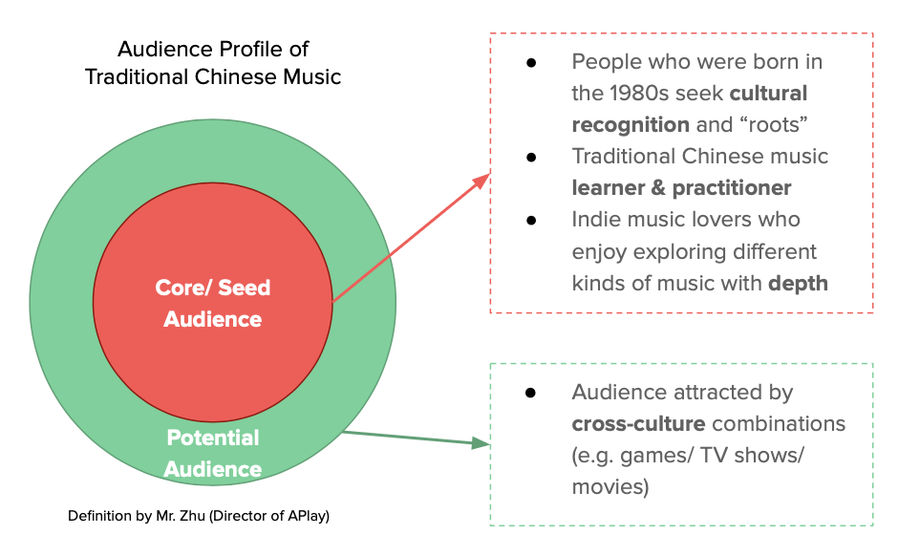
Customers in the traditional Chinese music industry refer to listeners who consume the music content. A rough segmentation is dividing customers by their familiarity with the music: the core audience who regularly consumes traditional Chinese music content, and the potential audience who might be attracted by cross-culture combinations.
Figure 6: Audience profile of traditional Chinese music
- Core audience
According to the observation by an experienced music industry producer Jintai Zhu from APlay, the core audience can be divided into three segments. The first segment is learners and practitioners of traditional Chinese music. They are the main audience of the music. Their interest in the music urges them to listen to more and practice more. The second segment is the group of people who were born in the 1980s and seek cultural recognition and “roots” through listening to traditional Chinese music. They are using traditional Chinese music as a bridge to reflect their identity in relation to the culture. The third segment of the traditional Chinese music audience is indie music lovers. There are more and more small indie bands with traditional Chinese music characteristics and indie music lovers are gradually attracted to them because they want to pursue more deep listening experiences and traditional Chinese music can meet their needs.
Figure 7: Qingyao Liu’s Bilibili Follower Age Profile
Follower’s age profile from Qingyao Liu, the Bilibili video creator also provides evidence for the core audience profile: followers whose age exceed 40 are those core audience who were born in 1980, and followers whose age range from 16 to 25 are the potential audience attracted by cross-culture combinations. Since Qingyao Liu’s video is on Bilibili, a video platform with many cross-cultural combinations, the potential audience of traditional Chinese music is a bit more than the core audience.
- Potential audience
Besides the core audience who actively listens to traditional Chinese music, there are potential audiences who might be interested in traditional Chinese music through cross-culture combinations. As current media works often combine traditional Chinese music into content such as games and movies, some of the audience might start their interest in the music through this combination of works. Once they accumulate their interests, there’s a chance that they would transform into a core audience.
- Suppliers
Suppliers in the traditional Chinese music industry are producers that support music content production through education, composition, and manufacturing.
- Academia/ Conservatory of Music
Conservatories of music is the main origin of the production. It recruits students through university entrance tests and performance examinations, and develops students' professional performing and composing skills in school. The exit opportunities for students are 1. Staying in a conservatory and teaching professional students 2. Starting their own small teaching studios and teaching amateur students locally. 3. Joining a big orchestra as a performer 4. Other opportunities include starting its own band, and other administrative occupations. A graduate can have multiple roles at the same time, for example, an Erhu musician can have a private teaching studio, work in a city orchestra, and also teach in universities.
- Composer
Composers are mainly graduates from conservatories and they are mostly affiliated with conservatory or big orchestra institutions. They are often appointed by the orchestra for new performances and music compositions.
- Instrument factory
The instrument production is quite centralized within several major factories, and most of them are government-owned. They produce instruments of different quality and also innovate with new instruments. A typical case of an instrument factory is Shanghai No.1 Traditional Instrument Company, which was a previously nation-owned factory but transformed into a limited company in 2021/07 to "Improve governance, strengthen incentives, highlight main business, and improve efficiency". Currently, instrument factories are also seeking extension of the industrial chain, from single manufacturing to service platforms including “music teaching and distribution platform, intangible cultural heritage platform, testing, and appraisal platform, and international cultural exchange platform.”
- Competitors
Competitors in the traditional Chinese music industry refers to other genres of music that current customers listen to. Currently, especially among young audiences, pop music is dominating their playlists as audiences find that pop music has rhythms that cater to modern listening preferences and its theme is more relevant to the audience's daily living lives. The dynamics between traditional Chinese music and other genres of music are not simply binary, instead, there lies a huge opportunity for traditional Chinese music to leverage its cultural foundation as a way to collaborate with other genres.
- Complementors
Complementors in the traditional Chinese music industry consist of three parts: related Chinese culture, other pop culture, and modern media technology. Related Chinese culture refers to other related Chinese cultural components such as traditional opera, Chinese chess, calligraphy, Chinese painting, Chinese heritage, etc. With the combination of those cultural elements with music, the creativity of production can be elevated to the next level, and customers would have a better experience of the music. Other pop culture refers to cultures that are trendy and popular such as ACG culture and gaming culture. Combining traditional Chinese music with those pop culture would attract more audiences from different backgrounds and interests. Modern media technology such as social media, films, and interactive media arts can also augment the listening experience.

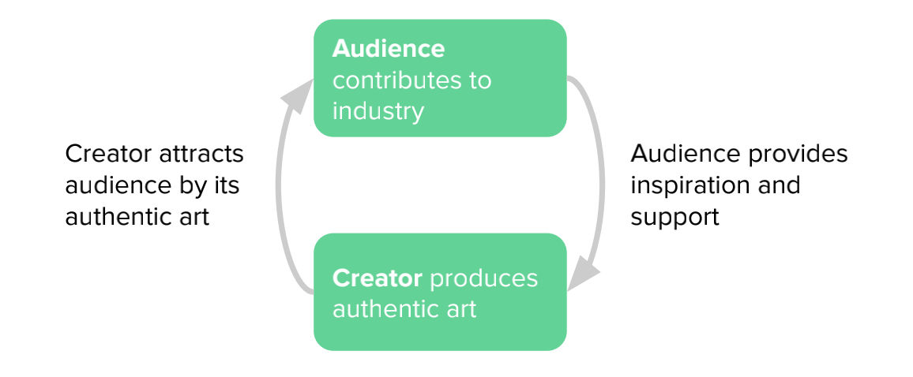
Ⅵ. PROPOSED TRANSFORMATION: CREATOR AND AUDIENCE
Figure 7: Essential virtuous circle of art creation
An essential notion of art creation is a virtuous circle between audience and creator, see Figure 7. Creators produce authentic art expressing their own feelings and sensation, and audiences who share similar feelings or find this artwork interesting will be attracted. Audiences then contribute to the creative process by either providing inspiration or supporting creators such as buying music and attending concerts. Creators with inspiration and support will then continue to produce authentic art.
Unlike the commercial business practice where companies have their target audience and produce suitable goods or services tailored to their target audience with a clear intention of earning revenue, it’s worth noting that the relationship between creator and audience is not completely audience-focused. Artists cannot completely rely on the audience's taste or preference to make art, and artists should follow their own understanding to produce the art they think it’s of quality.
However, it’s also important to stay connected with the audience. Among the interviews, it’s discovered that many stakeholders think that they are too far away from the audience’s daily living environment, which makes it hard to create artworks that can be related to the audience. An anonymous Erhu soloist commented that: “I feel that I’m too far away from my audience, and I don’t know what audience feel about themselves and what they feel about my music. I just realized that I was too focused on the performing techniques while disconnected from the audience and their lives.” Even though artists should follow their own thoughts when creating their artworks, it’s important to stay connected with the audience and the current society.
Therefore, the first transformation proposed for the industry is to understand its audience and find a balance between seeking inspiration from the audience and humoring the taste of the audience. With that in mind, it would be of great help in maintaining the essential virtuous circle art creation process.
With the great balance between the creator’s self-creativity and the audience’s inspiration, creators then can think about their creative portfolio in the industry. Viewing the industry as a whole, the current content creation portfolio challenges are: There are creators who purely focus on difficult performing techniques and there are creators who just follow what’s trendy on the internet. The former might achieve high quality of artwork but it might also get a lower number of people who can appreciate the music because of the high aesthetic barrier. The latter one would get a large pool of audience because of its easy-to-understand and popular characteristics; however, its challenge is that this kind of content tends to lack of “depth of expression” and it’s easily out-of-date, the audience would be easily attracted by another pop content and forget the last one. Therefore, to solve this problem, an awareness of forming a pyramid-shaped portfolio structure would be beneficial.

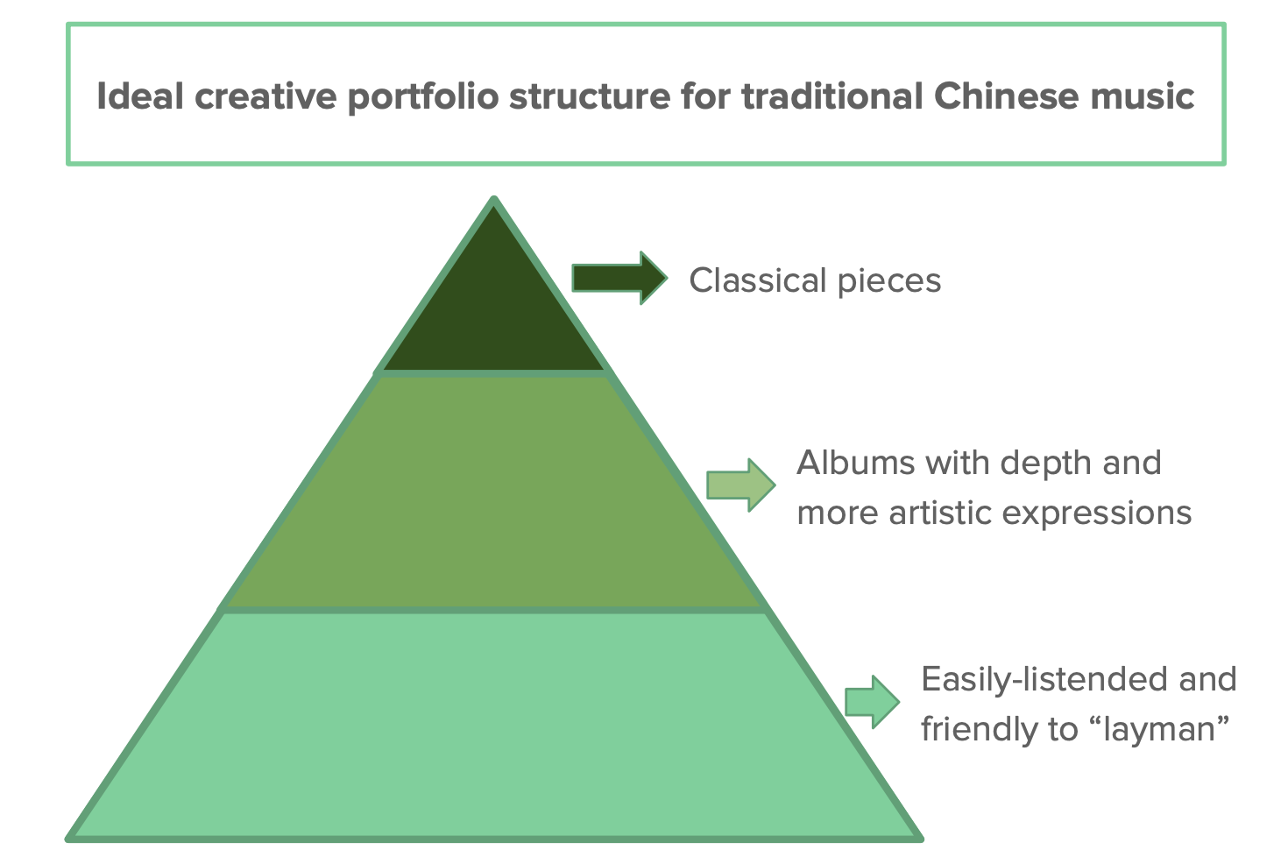
Figure 8: Ideal creative portfolio structure for traditional Chinese music industry
In the pyramid-shaped portfolio structure, see Figure 8, from bottom to top, the size of each segment represents the relative pool of audience each segment in the industry might get. On the bottom, an artwork that is “easily-listened” and friendly to “layman” is most likely to approach the most audience, which would be a great starting point for accumulating audiences. Then with enough accumulation, the artwork with more depth and more artistic expressions would also attract attention. Finally, when all the artwork of an artist is accumulated throughout the time, some of the artwork would become classical pieces that are more serious and experimental.
Creators do not necessarily need to follow the path of choosing to create which kind of work in the portfolio, instead, the portfolio structure can serve as a reminder for creators to think about what kind of work they might be able to create in order to achieve different creation and commercial objectives.
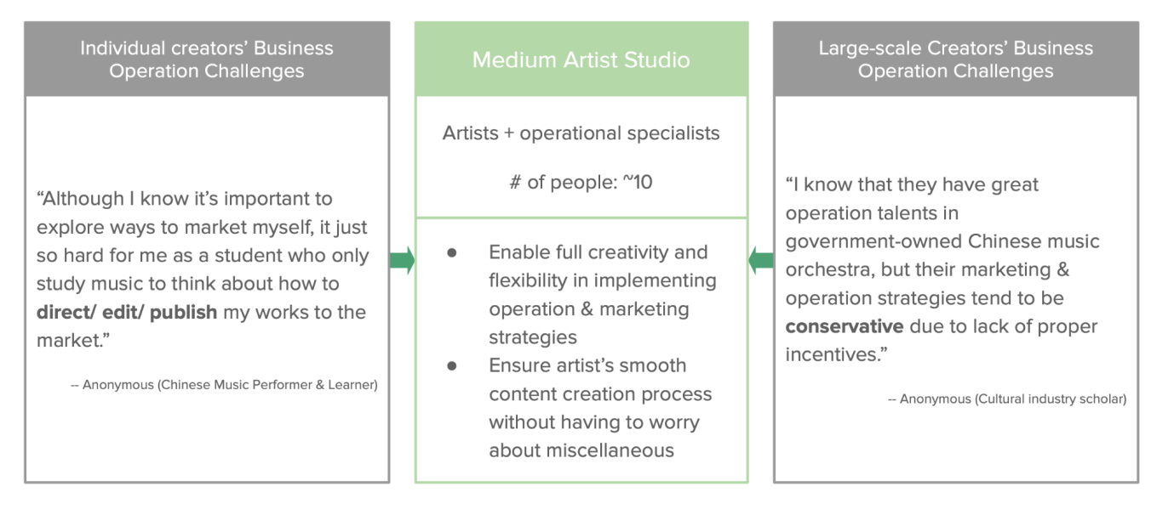
Besides the content creation transformation, creators can also transform their operation practice. Current challenges for creators when they operate their business are different depending on creators’ size: For small or individual creators, they feel overburdened by owning too many other works other than performing and composing. Because they don’t have additional support externally, small-scale creators need to grab all operational skills such as how to market themselves and how to maintain their business. It’s especially challenging for those musicians who spent most of their time focusing on playing music. Oppositely, the challenge for large-scale creators such as orchestras is that even though they have the talent and resources to operate the business efficiently and innovatively, big organizational structures tend to make it hard to innovate. Because the decision-making process is longer and more conservative in a big organization, operation tends to have fewer incentives for creativity.
Figure 9: Current situation of creator business operation organization in different sizes
A medium-size artist studio might be a direction for the creator’s business operation transformation. It would be a team of around 10 people, consisting of artists and operational specialists. With this medium-size team, artists can have a smooth content creation process because they don’t need to worry about the miscellaneous; and it can at the same time enable those operational specialists to have better operation strategies since it’s more flexible in implementation. A famous chamber choir group called Rainbow Chamber Singers implemented a similar operational strategy with the form of an artist studio. According to their ex-operational specialist, the flexibility of the medium-size studio structure is one of the reasons why both their artwork and operational practice are successful.
Therefore, to keep a good virtuous circle of art creation, creators can transform through balancing their relationship with audiences, building their content portfolio structure, and innovating their operational organization structure.

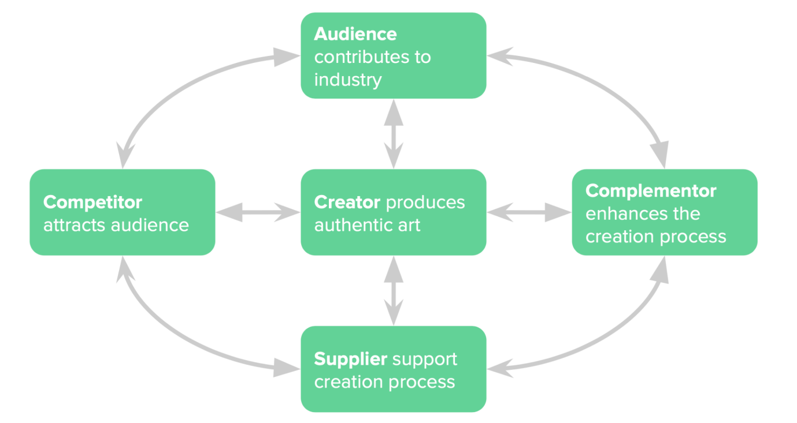
Ⅶ. PROPOSED TRANSFORMATION: AN ECOSYSTEM
Figure 10: Ecosystem of traditional Chinese music industry
Sustainable growth of the traditional Chinese music industry not only require the transformation within the creator, but it also requires the industry to build up an ecosystem and implement transformation within the ecosystem. Therefore, suppliers, complementors, and competitors should be considered when taking transformation.
Suppliers play an important role in the process of art creation. One of its most important segments is music education. Music education enables creators to broaden their horizons and unlock their potential in music, and most musicians nowadays receive music education through academia. However, a current challenge in conservatories of music in China is that students can only learn their performing techniques while ignoring the knowledge of music culture and things beyond music. Mr. Dai from Xinyi Chinese Music Ensemble found that currently, many music players don’t have a comprehensive understanding of music culture, and that ultimately leads to low quality of production. Lacking liberal arts education in conservatories of music results in less creativity potential and fewer career opportunities for graduates.
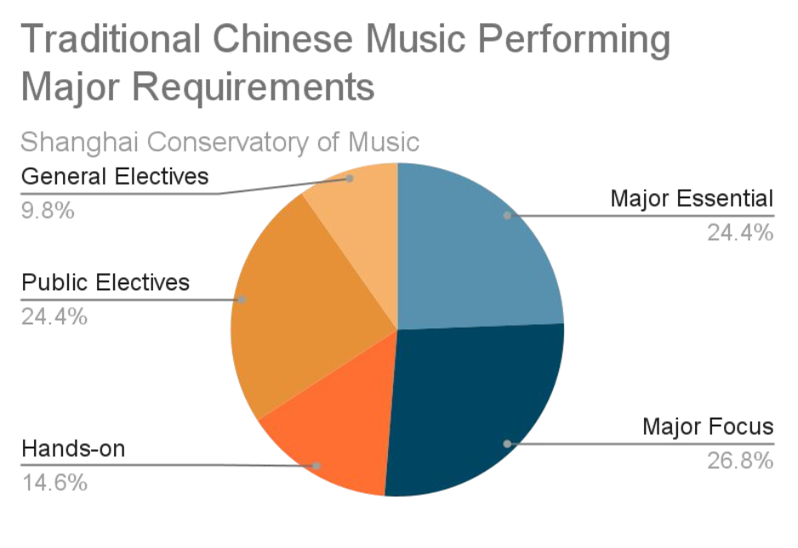
Mr. Cai, a student from Xinghai Conservatory of Music claims that even though he wanted to learn more things beyond his major, he had solely no chance to get a minor or electives because the school places top priority on teaching techniques while ignoring other perspectives. Cai says that when he stepped out of the school and seek for some professional opportunities such as an internship in an opera house, he found that it not only requires students to have great performing skills, it also requires students to be equipped with wider knowledge and skills. Although Cai gradually learned more and more knowledge by himself, he still thinks that it would be better if schools can provide liberal arts education so that students like him can explore more things at an early stage.
Figure 11: Graduate Requirement from Shanghai Conservatory of Music
In terms of liberal arts education in conservatories of music, the Shanghai Conservatory of Music is an excellent example. From the course quality evaluation statistics on its website, electives and hands-on class take up almost half of a student’s workload, see Figure 11. Besides, according to Professor Zhang at the Shanghai Conservatory of Music, he says that students are immersed in an open environment where taking courses outside of their own major is encouraged. “Even though they are not available to register for the courses they are interested in, they are still welcome to come to those classes”, he also comments that he had many students who found their interests from elective courses and had further developed them as a career. Therefore, in order to cultivate more creators and their creative potential, a liberal arts education transformation within music academia is urgently needed.
Aside from the suppliers, complementors can also help the growth of the industry. Complementors can help traditional Chinese music to approach a wider group of audiences and enhance the artwork’s viewing experience by combining it with traditional Chinese music. A popular example is Zi De Guqin Studio which successfully combines traditional painting with traditional Chinese music, and it creates a viewing experience where the audience feels like the musicians are playing in an unfolding painting. Other popular cultures such as games also start to use traditional Chinese music as a game character’s main theme.
However, this kind of combination then often raised new concerns. According to Mr. Zhu who has experience collaborating with multiple cross-culture projects, he says that few of the cross-cultural combinations succeeded because creators tend to arbitrarily piece of multiple cultures together without considering too much cultural background and characteristics. Therefore, for the next step of creators’ transformation towards complementors, it’s advisable to advocate more cross-culture collaboration for more trial and error while paying attention to cultural fitting when collaborating.
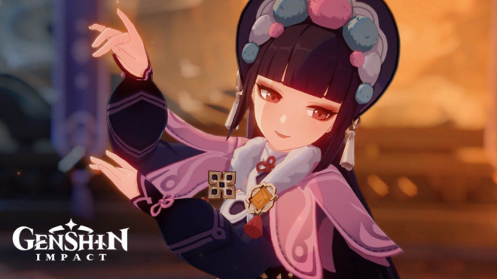
Figure 12: Yun Yin from Genshin Impact
Genshin Impact x Peking Opera is a great analog of complementor collaboration where the culture is well respected and presented. Last winter, the trending mobile game Genshin Impact collaborated with Shanghai Jingju Theatre Company to create a new game character Yun Jin, see Figure 12. It’s a character who sings a beautiful piece of Peking opera. It fits both the gaming context and opera culture because of its originality and creativity. Its lyrics successfully combine and apply folklore, poetry, and drama to portray traditional cultural rhythms while remaining understandable to a wide audience. It has received over 30 million views and triggered re-creations among Peking opera and traditional Chinese music creators.
Besides complementors, creators should also pay attention to their competitors. Currently, there are polarized opinions among traditional Chinese music toward other music genres. Some think that traditional Chinese music is outdated and we should learn everything from other music. They think that seeking full adaptation to a more “advanced” music culture is the only way to improve traditional Chinese music. However, the other group of people thinks that traditional Chinese music is the best music genre and we should be absolutely confident without learning anything from other genres. These two polarized opinions make the development of traditional music less space to grow because they both consider the competition among music genres is a zero-sum game where there could be only one music genre that leads. However, due to the unique characteristics of music, the competition between music genres is not a zero-sum game, instead, the competition can boost creativity if the creators can have the mindset of learning everything best from each other.
Hamilton, the musical is a perfect example of successfully utilizing the competition to boost creativity. Previously people might think that hip hop raps and musicals are competitors because hip hop takes away all the young audience from the musicals. However, the success of Hamilton shows that competitors can also work together. The show was made more relevant to a younger audience by combining hip-hop raps and musicals. It uses modern language to tell a wonderful historical story that utilizes both strengths of hip-hop raps and musicals. As a result, it broadened the possible audience to include people who aren't often exposed to mainstream music.
Figure 13: Hamilton Musical
Learning from Hamilton’s case, we can conclude that for traditional Chinese music creators, we should encourage more collaborative perspectives with a healthy competition mindset. Meanwhile, we should advocate more collaborations where competitors can learn from each other to make up for deficiencies.

CONCLUSION
Traditional Chinese music industry is at strategic inflection point, and following 4 parts of the transformation can be implemented to help the industry to grow in a more sustainable way.
Balancing audience-creator relation is the first transformation. Unlike the conventional commercial business practice, content creation is not completely audience-focused. Artists should not completely rely on the audience's taste or preference to make art, but artists need to stay connected with the audience for inspiration.
Secondly, creators can consider their content strategy in a pyramid-shaped structure. Creators can have the work ranging from “easily-listened” to “experimental”, depending on what audience and what creativity exploration they would like to achieve. This portfolio structure is not necessarily guiding creators on what to create, instead, it serves as a reminder to help them find a suitable position in order to achieve different artistic creation and commercial objectives.
Thirdly, besides content creation, creators should also operate their business in a professional and flexible way. Creators with limited resources can consider starting medium-size artist studios to ensure flexible business operation with specific talents and to enable a smooth content creation process.
Last but not least, supplier, complementor, and competitor together with audience and creator form a sustainable ecosystem for the industry. Suppliers, especially academia, should advocate liberal arts education for cultivating musicians into an all-rounded artist instead of purely a performer who knows how to play instruments. Besides, the industry should advocate more collaboration and co-opetition for creator, complementor, and competitor. More cross-culture collaborations would boost creativity and also attract a larger pool of audience.
Transformation proposed above is mainly based on what the industry should do in a logical sense. However, what should be noted is that the content creation industry is more uncontrollable and unpredictable than the common commercial industry as one cannot predict when and what creator would produce a work that will be remembered by the world, and this is what makes art so attractive and beautiful.

Ⅷ. BIBLIOGRAPHY
Chen, J. (2016). Xi: Build China’s cultural confidence. https://www.chinadaily.com.cn/china/2016-12/01/content_27532284.htm
Grove, A. (1999). Only the Paranoid Survive.
Hong, X. (2020). The Terminology of National Music. 10.27684/d.cnki.gxndx.2020.002555

Ⅸ. APPENDIX I: ANALOGIES COLLECTION
During the research, transformation analogies are collected to inspire the traditional Chinese music industry’s transformation. Cases involve traditional Chinese arts and cover arts and culture from other genres and countries. The following is a list of currently collected analogies:
Name | Type/ Genre | Description | Reference
Dunhuang x Tencent | Chinese Tangible Heritage | In addition to the preservation of historical sites in material form, Dunhuang culture, which has stretched for thousands of years, as an art form also needs to attract younger audiences in order to be truly inherited. Therefore, on December 29, 2017, Dunhuang Academy and Tencent reached a strategic cooperation for cross-category development and inheritance in the form of games, music, animation, and cultural products. | Tencent And Dunhuang Research Institute Commemorate Cultural Heritage With NFTs | Jing Culture and Commerce  从敦煌动画剧透视腾讯的文化IP心法  腾讯案例复盘！「云游敦煌」小程序背后的产品故事
Palace Museum | Chinese Tangible Heritage | In recent years, the Palace Museum has made every effort to develop cultural and creative undertakings, and has gradually embarked on a unique development path through a variety of methods:  1. Various forms of cooperation to expand the product system  2. Extend cultural and creative products along with the exhibition to extend the connotation of the exhibition  3. Brand licensing cooperation, cross-industry integrated development | Application of New Media in the Marketing and Promotion of Cultural and Creative Products in Museums  行业资讯｜故宫文创的守正创新之路
Zhang's Kun Opera Group | Chinese Kun Opera | Zhang Jun has been committed to the popularization and promotion of Kunqu opera for a long time: Since 1998, Zhang Jun has planned and hosted more than 300 interactive performances of "Kun Opera Approaching Youth" and "I am a Xiaosheng" interactive lectures; in addition, he Through cross-border cooperation with various art categories, we have also expanded the channels for the dissemination of Kunqu opera. We have successively cooperated with Chinese musician Tan Dun and other artists across borders, creating the possibility for Kunqu opera to gain young audiences and spread across the world.  Shanghai Zhang Jun Kunqu Opera Art Center is currently the only private professional Kunqu Opera Troupe in China. | Bringing old art form to new viewers
Netease music | Music | NetEase Music is such a “social platform” with excellent UGC (User Generated Content), that more than 300 million of the huge user base gather here to interact, exchange music. | 【NetEase】 A Chinese Music Streaming + Chinese Social Media Platform?
Chayan Yuese | Chinese Tea | Founded in 2013 in Changsha, Hunan Province, Chayan Yuese store has become a must-visit place for tourists in Changsha, and tourists even come to Hunan purely wanting a drink of Chayan Yuese milk tea. What differentiates Chayan Yuese from other giant milk tea brands (such as HeyTea) are its strong connection to Hunan local culture, high quality and strong taste.  It elaborates and connects Changsha’s local culture in its branding, packaging, and merchandising. | Chayan Yuese: A Low-Key New Tea Player  茶颜悦色深圳撤店：输出长沙文化“闪”后即走？数字化与人力或仍是掣肘  靠自黑出圈，茶颜悦色还有机会吗？
Shanghai Dance Theatre | Chinese Dance | Shanghai Dance Theatre has produced multiple dance shows that go viral: The Eternal Wave (永不消逝的电波)、Crested Ibis (朱鹮). By using strong narratives and multimedia stage setting, it tells a story of Li Bai, an underground member of the Shanghai Communist Party during the Anti-Japanese War. | 舞剧《永不消逝的电波》是如何诞生的？
SANYOU | Chinese Baijiu | As one of the most famous traditional Chinese alcohol, Baijiu (white liquor) didn't win the young customer's heart because it was castigated as a drink because it is mostly consumed in mature business meals where drinks are not relaxation but only a tool for business social. There are stakeholders including Baijiu companies and bars that experiment to bring Baijiu to a wider audience in a more acceptable and attractive way. SANYOU, a bar in Guangzhou, uses traditional spirits "white liquor" as the theme and "base spirit", the cocktail is fused into the new style to create more possibilities. | Hope & Sesame team’s new baijiu cocktail bar SanYou is the first of its kind
TwoSetViolin | Music | TwoSet Violin is a comedy duo consisting of Australian violinists Brett Yang and Eddy Chen. The pair are best known for their musical comedy on their YouTube channel. Their video content focuses on classical music and experience of practicing and performing. It’s popular because it’s "making classical music relevant to the modern generation through fun, humour and simplicity”. | 獨樂不如眾樂 古典音樂界黃子華Twoset Violin：失敗事小 無火事大  INTERVIEW: TwoSet Violin with TIRADE WORLD — TIRADE WORLD
Hamilton | Musicals | Hamilton has become an entirely new type of musical. A combination of hip hop and rap songs made the music more relevant to a younger audience. “Lin-Manuel Miranda had taken a historical piece and made it modern — and relevant. It opened up the potential audience to those outside the regular mainstream musical audience. It also captured the consumers most prone to using social media, ensuring viral marketing opportunities.” | Hamilton: An American Musical - Case - Faculty & Research  Why “Hamilton” Became a Success. A great product combined with diversity… | by Ash Jurberg
New Oriental Chinese Music Scene | Music | Produced by Shanghai Chinese Orchestra, the show combines ancient musical instruments with large-scale modern Chinese orchestra, and the audience can see or hear the dialogue between Chinese music and traditional Chinese opera, calligraphy and diverse cultures from around the world. | 《海上生民乐》：民乐要让人坐得下来听得进去_文艺范
Sleep No More | Drama (Shakespeare) | Punchdrunk reproduced Shakespeare’s Macbeth into an immersive drama experience where audiences are put in a building called McKittrick hotel and are allowed to freely explore in the space. Through the exploration, they have the opportunities to interact with characters and be part of the story. | Sleep No More, Immersive Theatre, and the Boundaries of Perception  Sleep No More: from avant garde theatre to commercial blockbuster
Shanghai Rainbow Chamber Singers | Music | <elaborate in following paragraphs> | Why this choir is a huge hit with China's stressed out millennials
Andrew Rieu | Music | <elaborate in following paragraphs> | André Rieu

- Andrew Rieu
  - Summary
What the classical music industry is facing nowadays is similar to what the traditional Chinese music industry is experiencing, including the aging of the audience, competitive forces from other cultures, and also failure to profit by itself. Rieu's case gives us a perspective of what can be developed to cater to the mass music listening preference, which is a large portion of the audience in the market.
  - Background
Classical music is dying because of the decline of audience, strong competition, and low profitability. Previous core audience is now aging, while new generations of listeners are less appreciating classical music as a result of arts education collapse. Young audiences are also attracted by pop music as pop music has a lower barrier of “listening” and pop music is more relatable to the audience’s daily living lives. In terms of profitability, the revenue declines because online streaming technology leads to less audience going to the concert hall and less tickets sold. In addition, huge employee costs, high conductor appointment fees, and educational programs are three reasons for higher costs.
  - Transformation
Rieu’s transformation consists of both inside-performance and outside-performance parts. In the performance, it transforms in five aspects: target audience, music selection, audience interaction, stage setting. Outside the performance, it transforms by increasing revenue and reducing costs.
Performance transformation starts with a unique target audience selection. Instead of targeting highbrow loyal listeners of classical music, Rieu targets "a vast demographic that is overlooked by both the pop and classical music industries". They are typically purely seeking joy and enjoyment in the music, just like the younger pop music fans who go to the live house. With the target audience defined, based on the audience, Rieu selects music that is not “heavy and solemn genre of classical music”. Instead, he chooses to play waltz because waltz has a lower barrier of listening and everyone can enjoy and dance with it. Besides, he also combines "well-known classical pieces, pop songs, and movie themes" to make it more acceptable for the general audience.
After audience and music selection, Rieu then starts to design the performance to be highly interactive and friendly. In the performance, the audience is not required to dress formally and remain distant and quiet during the performance. They are encouraged to "dance, clap, sway, and even whistle to the music", and conductors and musicians are oftentimes interacting with the audience during the performance. What’s more, the audience even has the chance to co-create with the orchestra e.g. through accompanying the music with a plastic cup. Performance stage setting is also creating a friendly and interactive atmosphere. It uses amplification and sound reinforcement equipment to enhance the listening experience and it also utilizes technology and other forms of arts such as panoramic backdrop, fireworks, smoke, explosions, dove launches, ballet, and opera to make the performance also a feast of eyes.
Beyond the performance itself, Rieu’s business model outside the performance is also transformed to be a more sustainable business. Since Rieu has a huge population of audience, the location of his performance tends to be that large-scale auditorium which is multiple times as the traditional classical music performance. Also in the ticket pricing strategy, it provides a range of ticket pricing and service from basic tickets to VIP seats that you can meet with Rieu. Alongside the pricing strategy, Rieu’s merchandising also helps it to grow revenue. It sells diversified merchandising such as "posters, calendars, perfumes, and recordings", and those are distributed in multiple channels such as broadcast and cinema to increase the popularity and higher the chance of attending the concert and buying merchandise.
Aside from strategies to grow revenue, Rieu also found ways to reduce costs. Rieu keeps the small and simple size of members in the orchestra thanks to the simplicity of music pieces and amplification. Moreover, Rieu hosts a talent program to recruit talented professional musicians and secure them to stay so that the staffing cost is lower. Besides, the huge size of the audience leads to the economics of scales so that the average cost of each audience is lower than the traditional orchestra.
- Shanghai Rainbow Chamber Singers
- Summary
Choral music, which is highly correlated with classical music, is experiencing a similar situation. However, Rainbow Chamber Singers opens its market through innovation in the performance and also outside the performance in China.
- Transformation
In the performance, it targets young audiences and creates unique choral music from those audiences. It targets the young audience who are typically attracted by pop music as pop music often provides narratives that are highly relatable to the audience. The conductor Jin then tried to reflect on his own life experiences and write his original music pieces instead of singing classical choral music.
First, it was known by the public because of a song called "Where On Earth Did You Leave the Key, Zhang Shichao?". The song tells a story that Jin himself was locked away from his dorm because his roommate Zhang was not in the dorm and the door key was missing. The colloquial lyrics and funny sunglasses on every serious singers' face bring the audience closer to the storytelling. Because of the funny and relatable storytelling with contradiction to people's common perception of the choir, it went viral and received ~5 million views (Youtube + Bilibili) online. Later Jin created more songs that have been word of mouth because of their light-heartedness and humor, especially in the theme of young people's daily lives (such as working overtime/ failing to lose weight/ etc.)
After establishing the identity of the young and funny choral group, what's more surprising is that Jin later managed to break through: He experimented to create more albums that are a bit more serious but also still interesting, and seeks the balance of easier listening and also the depth of the music. The audience loves those albums and comes to watch their concert because Jin has become a guarantee of making excellent and listenable choral music. What's more, Jin also held a "special concert" this summer, introducing the classical pieces of choral music in history with easily understood explanations of the pieces. That marks Jin's moves of also providing a higher level of pieces for the audience who are attracted and want to learn more about the choral music.
Therefore, in summary, Jin created a music “portfolio” for Rainbow Chamber Singers to attract and satisfy different audiences’ listening needs: 1. The most easily-listened and closely related funny music pieces. 2. Series of albums with a bit more depth and more artistic expression. 3. An experiment in introducing classical pieces to a higher level of the audience.
Aside from the performance, Rainbow Chamber Singers also uses merchandising to enhance the audience's experience and grow profit. Its merchandising varies from playbill to clothes, with highly related content and correlated to the performance pieces.

