Investigating the Regional Differences

In the Chinese Birth Rate

During Population Policy Transitions

by

Yuxuan Wang

An honors thesis submitted in partial fulfillment

of the requirements for the degree of

Bachelor of Science

Business and Economics Honors Program

NYU Shanghai

May 2022

Professor Marti G. Subrahmanyam Professor Simon Bowmaker

Professor Christina Wang Professor Wendy Jin

Faculty Advisers

Thesis Adviser

Contents

Abstract

3

Preface 4

1 Introduction 5

2 Literature Review 9

3 Data and Methodology 11

3.1 Data Description . . . . . . . . . . . . . . . . . . . . . . . . . . . . . 13

3.2 Description of Policy Changes . . . . . . . . . . . . . . . . . . . . . . 16

3.3 Model Setup . . . . . . . . . . . . . . . . . . . . . . . . . . . . . . . . 17

4 Results 18

4.1 Main Results . . . . . . . . . . . . . . . . . . . . . . . . . . . . . . . 18

4.2 Robustness Checks . . . . . . . . . . . . . . . . . . . . . . . . . . . . 23

5 Conclusion 25

References 27

A Additional Analysis 30

Acknowledgement 33

2

Abstract

In response to the worsening aging society problem, China introduced three new population policies in the 2010s that have received systematically different reactions on a regional scale. This empirical study analyzed a panel dataset of
31 mainland provinces from 2007 to 2019. The result of a two-way fixed effect model identifies the important factors influencing birth rate in this period: Per Capita GRP, increase of CPI, housing-price-to-income ratio, the working-age percentage, urban population density, sex ratio and the relative growth of CPI against average wage. These factors are consistent with previous literature that the more economically-developed central and eastern provinces have exhibited stronger reaction to policy shifts. The introduction of new policies, especially the universal two-child policy and the relaxed partial two-child policy, have a significant effect on increased birth rate. Moreover, this period in China is special to demographic study in the way that it both conforms to the findings of existing literature and also suggests new trends in the interaction between fertility and other factors under special circumstances of policy shifts.

Key Words: Birth Rate, Population Control, Policy transition

3

Preface

The motivation for investigating regional changes of Chinese birth in recent years rate stems from my personal observation that pressure in life is building up, especially in competitive environments like big cities. As it becomes harder to sustain oneself, how would people in different regions react to multiple shifts of population policies that relax birth control. With the help of my advisor in the Department of Arts and Sciences, I collected public statistical data and performed empirical study on the relationship between birth rate and other factors in the economic, demographic and social aspect. Afterwards I provide explanation for my result by linking it to previous literature.

4

1 Introduction

Family planning and population control policies have long been a characteristic of China. In the 1970s, the first population control policy called the one-child policy was initiated to limit the rapid population growth. Under the policy, all the couples are only allowed to have one child, with very few exceptions in the rural area due to labor demand of farming. Those who violate the population policy are subject to fines based on the local economic status and specific household earning. The one-child policy was then implemented for over three decades until a series of policy shifts in the 2010s. In 2011, the policy was replaced with the original partial two-child policy, which allows couples to have two children on the condition that the couples are both only child in their respective family. Subsequently in 2013, the partial two-child policy was relaxed. The new condition only requires one of the couple to be the only child of the family. Shortly afterwards, another policy shift took place in 2015 that all couples can have two children. This universal two-child policy was widely advertised by the government and received considerable attention on social media. Concurrently, we observe an increase in the Chinese birth rate, but it quickly fade away in the following years. Without further policy intervention, The Chinese birth rate of 2020 dropped to a record-low 8.52‰ since 1960s, leading to the announcement of the three-child policy in May 2021. Similar to its predecessor, the three-child policy allows all couples to have three children.

Looking back at the development of the Chinese population policies, the 2010s that have witnessed three policy shifts marks an important period for Chinese de- mographics. As a result, the time scope of this study is from 2007 to 2019, which covers data from the last few years of the one-child policy period to the latest data from the universal two-child policy period. Figure 1 depicts the trend of birth rate

5

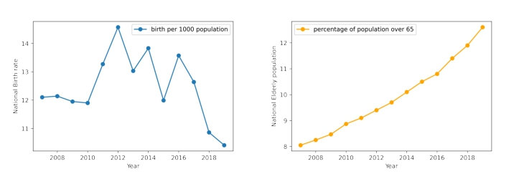

Figure 1: Birth rate and age structure of China from 2007 to 2019

and the percentage of population over 65 in China from 2007 to 2019. With the three population policy shifts in 2011 to 2015, the Chinese birth rate have increased and fluctuated. However, from 2017 onward, the Chinese birth rate have gone through a worrying drop. Meanwhile, we observe a worsening of the aging society problem in China. Despite the positive changes in birth rate, the percentage of population over
65 is steadily increasing throughout the period of this study, with an acceleration in recent years where the birth rate is low. In 2019 the percentage of Chinese population over 65 is 12.6%, almost twice the UN’s threshold of 7% for classifying a country as an aging society.

The seriousness of the aging society problem illustrates on the purpose behind the high frequency of population policy shifts in the 2010s, that it is urgent for China to stimulate consumption and to increase the size of labor force in the future. To better address the issue, it is important to review and analyze previous policy shifts. Correspondingly, this study aims to identify the main factors influencing the change of Chinese birth rate during this period, attempting to provide an overview of the characteristics of Chinese birth rate by incorporating variables from multiple aspects of economics and demographics. More importantly, although the policies are applied

6

nation-wide, literature review in Section 2 has suggested a clear distinction in the regional responses to population policy shifts, that the wealthy and urban population has contributed to most of the increased growth in birth rate. In this regard, I check with the existence of such regional difference below.

Region | Birth Rate (2007) | Birth Rate (2019)
North China | 11.47 | 9.42
Northeastern | 7.40 | 6.12
East China | 11.20 | 11.00
Central China | 11.70 | 11.75
Southwest | 11.11 | 11.73
Northwest | 13.01 | 10.36

Table 1: Weighted average Chinese birth rate in 2007 and 2019 by region

Table 1 provides the birth rate of six Chinese regions in 2007 and 2019. The segmentation of these regions is a widely adopted classification that can be found in the National Bureau of Statistics. A clear distinction here is that all of the three northern regions displayed a significant decline in birth rate, while the birth rate of the other regions approximately stayed on the same level. This suggests a systematically different reaction on the regional level to the population policy shifts that calls for detailed analysis.

Figure 2 visualizes the regional difference of Chinese birth rate level in 2007 and 2019 with 10-quantile. Darker colors represent relatively higher levels of birth rate. These dark-colored regions are geographically scattered in 2007, but they are clustered in central and southern China in 2019. Figure 3 and Figure 4 in Appendix depicts the detailed transition of this phenomenon, and the clustering effect is most significant in Figure 4 that shows the distribution from 2015 to 2019. These figures support the observation of a systematically different reaction on the regional level to

7

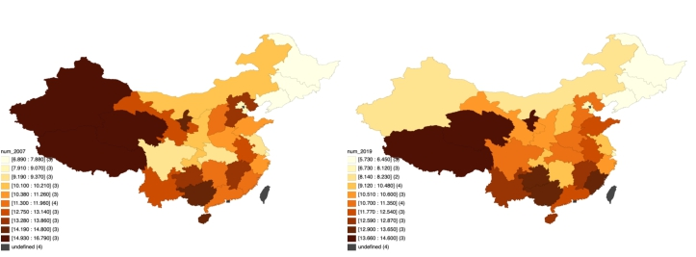

Figure 2: 10-Quantile Map of Chinese birth rate in 2007 and 2019

the population policy shifts proposed above.

To further investigate the issue, I conducted an empirical study on a panel dataset of 31 mainland provinces from 2007 to 2019. With a two-way fixed effect economet- ric model that includes various social-economic and demographic variables, I identify the important factors influencing birth rate in this period: Per Capita GRP, increase of CPI, housing-price-to-income ratio, the working-age percentage, urban population density, sex ratio and the relative growth of CPI against average wage. These fac- tors are consistent with Table 1 and Figure 2 that the more economically-developed central and eastern provinces have exhibited stronger reaction to policy shifts. The introduction of new policies, especially the universal two-child policy and the relaxed partial two-child policy, have a significant effect on increased birth rate. Moreover, this paper showcases how this period in China is special to demographic study in the way that it both conforms to the findings of existing literature and also sug- gests new trends in the interaction between fertility and other factors under special circumstances of policy shifts.

The remainder of the paper is organized as follows. Section 2 summarizes the

8

literature. The data and model are discussed in Section 3. Section 4 reports the results together with robustness checks, and Section 5 concludes. The result of robustness checks are relegated to Table 6 in Appendix.

2 Literature Review

This section first provides literature review on the characteristics of the effect of Chinese population policies, especially the positive correlation between birth rate and income that is also documented on a global scale by other works. These works are crucial for the discussion of results in section 4, where more literature on the relationship with birth rate and the model variables is offered. This section ends with comparing the approach of this study with previous literature.

Goodkind (2017) argues that the Chinese population policies have achieved as- tonishing effect on birth control, that most mothers would have had two children If the population policies are absent during the last quarter century. In addition, the recent low fertility trend has arrived two or three decades too soon for China, compared with the international norms of fertility and income. With the population policy shifts releasing the limitation on child bearing, Chen and Xu (2021) found that the partial and universal two-child policy mainly encouraged the wealthy urban population to have a second child. These households have the financial resources to raise a second child and ensure proper investment in their cultivation. Moreover, their willingness was most suppressed due to the strong implementation of previous policies in cities and the higher amount of fines brought by higher average wages in cities. They found that introducing the universal two-child policy has almost no effect on altering the birth rate of the first child, which has largely remained the same for

9

the past decade. The increase in the total birth rate comes almost solely from the increase in the birth rate of the second child that can be attributed to the wealthy urban populations. The finding of Li et al. (2019) supports these arguments that under the effect of the universal two-child policy, women giving birth have been more likely to be multiparous, and more likely to be aged 35 and over. This matches with Chen and Xu (2021) that the second child from the wealthy urban population is the driving force behind increased births.

Moreover, the trend of positive correlation between income and fertility has also been documented on an international level. Greulich and Theveno (2014) conducted analysis on OECD countries from 1960 to 2007. They found that the negative cor- relation between GDP per capita and fertility no longer holds for high levels of per capita economic output, that after a certain threshold of economic development the correlation would turn positive. An explanation for the positive correlation is that wealth helps overcome the rising living cost and child investment problems that are common on a global scale. Ohinata and Varvarigos (2020) come to the same result from a demographic transition perspective. They state that the negative correlation between income and fertility occurs at the intermediate stage where parents engage in a child quantity–quality trade-off. As the economy moves to later stages, however, economic growth generates sufficient resources for households to have more children while still providing for an adequate level of investment. Similarly, Bar et al. (2018) investigates how rising inequality leads to greater differential fertility between rich and poor. They show that the negative relationship between income and fertility has flattened in the US, due to the high income families increasing their fertility in this period of rising inequality.

10

The common feature of the literature mentioned above is that they investigate the relationship between birth rate and one specific variable, or the trend of birth rate in one specific aspect. This differs from my approach that attempts to establish a relationship between birth rate and multiple variables describing different aspects of an economy. The objective of Yang (2021) is similar, but the study was conducted on a micro level by analyzing survey data. The author found that the severe cost of childbirth and the development of children are the main factors influencing the willingness of the sampled female employees to bear children. In detail, these factors are marital factors, birth and support costs, growth environment, family conditions and external conditions. This study has a similar aim to find relevant factors, but on a regional level by analyzing official statistical data of mainland provinces.

3 Data and Methodology

I perform analysis with a balanced panel dataset from 31 mainland provinces over the 2007 to 2019 period to investigate the empirical relationship between birth rate and regional changes of demographic and social-economic status. The dataset covers the entirety of the original partial two-child policy period, the relaxed partial two- child policy period, the up-to-date universal two-child policy data, as well as the last few years from the one-child policy period. Regression models were estimated with outcome of birth rate as a function of regional demographic status (female education level as the percentage of females who have at least a college degree, percentage of working age as the percentage of population between 15 and 64, male to female population ratio), regional macroeconomic condition (Gross Regional Product, CPI increase), regional social-economic status (urban unemployment rate, wage increase rate, housing price to income ratio, population density), and four dummy variables

11

indicating which policy period does the observations belong to. In total, 9 regional level variables and 4 dummy policy variables are used. Table 2 displays the descriptive statistics of these control variables. All the dependent variables are either derived from or directly from various issues of the Chinese Statistical Yearbook and the 6th National Population Census provided by the National Bureau of Statistics.
All of the variables are delayed for one year considering the natural lagged reaction of birth rate. People who are encouraged by the policies and the other factors to have more children will have to go through planning and pregnancy for the change to be manifested in the birth rate, which takes approximately a year or more. Moreover, the timing of the announcement of new policies also makes it favorable to delay policy variables for one year. This paper involves the analysis of three policy shifts, from one-child policy to original partial two-child policy in November 2011, the relaxation of partial two-child policy in November 2013 and from partial two-child to universal two-child in December 2015. All the announcements of new policies were at the end of the year, making it a good fit for the discrete series break approach in population policy. Taking into account the delay of one year, I assign 2017 and later years to the universal two-child policy period. Similarly, 2015 and 2016 are assigned to the relaxed partial two-child policy period, 2013 and 2014 are assigned to the original partial two-child policy period, and earlier years are assigned to the one-child policy period.

12

Variable | Mean | Std | Min | Max
Female education | 0.11 | 0.07 | 0.01 | 0.49
Urban unemployment | 3.45 | 0.66 | 1.20 | 5.10
Per Capita GRP (log) | 4.52 | 0.26 | 3.79 | 5.18
CPI increase | 1.33 | 0.15 | 1.05 | 1.83
Wage increase | 2.69 | 1.09 | 1.07 | 5.55
Housing price to income ratio | 0.33 | 0.09 | 0.16 | 0.85
Population density | 0.04 | 0.07 | 0.00 | 0.39
Urban population density | 2.76 | 1.23 | 0.52 | 6.31
Working-age percentage | 0.74 | 0.04 | 0.64 | 0.84
Sex ratio | 1.04 | 0.04 | 0.95 | 1.20

Table 2: Descriptive Statistics

3.1 Data Description

Regional Demographic Status. For regional demographic status, I include female education, percentage of working age population and sex ratio as control variables. Female education here stands for the percentage of females who have at least a college degree. They have better access to higher education and better opportunities for career advancement, and it is more likely for them to pursue self improvement through these channels at the opportunity cost of reproduction, hence I predict a negative correlation between female education level and birth rate.
The working-age population refers to people between 15 and 64. The concept is closely related to the dependency ratio that reflects the economic burden faced by the working-age as they are responsible for their families and general social welfare. In reality, differences in dependency ratio may lead to regional differences in security plans and taxation. The relationship between birth rate and the percentage of the working-age is dynamic and their correlation is subject to other aspects of an economy. While initially the correlation could be negative, population aging could in the long run weaken or even reverse the previous correlation. Given that the low birth rate has

13

only recently become a problem in China, I predict a negative correlation between

these two variables.

The sex ratio stands for the population of males divided by the population of females. For the majority of the observations in the dataset, this ratio is above one, meaning there are more males than females. A higher sex ratio gives females more freedom and opportunities in finding life partners, so I predict that it has a positive relationship with birth rate.

Regional Macroeconomic Conditions. For regional macroeconomic conditions, I include Per Capita Gross Regional Product taken to the natural log and CPI in- crease. GRP measures the final market value of all goods and services produced by the region, and it is a critical indicator of the activeness of economic activities. I adopt a common technique in econometrics to take a natural log on Per Capita GRP to reduce the gaps among different regions to prevent this variable from disrupting the model with an excess of variation. Although there is an abundance of literature documenting a negative correlation between Per Capita GDP and fertility rate, con- sidering the fact that this study concerns the relaxation of birth control in China that mainly benefits the wealthy population, I predict a positive correlation between Per Capita GRP and birth rate.
The CPI increase variable records the cumulative increase of the regional Con- sumer Price Index. The regional CPI is provided as an annual growth rate figure in the data source, and the variable is calculated by multiplying this annual growth rate until the baseline year of 2000. In other words, this term expresses how much the expense of standard consumption has increased compared with that in 2000. I predict a negative correlation between birth rate and CPI increase since higher expense of normal consumption undermines the general living standard.

14

Regional Social-economic Status. For regional social-economic status, I include the wage increase rate, urban unemployment rate, housing price to income ratio and population density. Similar to how the CPI increase variable is designed, my wage increase variable is calculated by multiplying the annual growth rate of average wage until the baseline year of 2000. This term expresses how much the average wage has increased compared with that in 2000. I predict a positive correlation between birth rate and wage increase because the latter helps improve the general living standard.
The unemployment rate variable is presented in its urban version because the overall unemployment rate and the further segmentation in age group or gender are not publicly available. I predict the relationship between birth rate and unemploy- ment should be consistent with the common belief that unemployment harms the living standard and discourages people from reproduction.
The housing price to income ratio is inspired by the phenomenon of surging house prices in China in recent years, and the specific setup of the variable is referenced from the work by Yin and Su (2021). The ratio is calculated as the average price of commercial housing divided by the average disposable income. In the reference work, the authors also multiplied this by the average area of commercial housing, and unfortunately this information is not publicly available for my study. I predict that this ratio will have a negative correlation with birth rate since housing is a common problem for normal households in my observation.
For the population density variable, I have prepared two versions of it to be tested in regression. One version is the official urban population density, and the other is my own calculation of the total population divided by the total land area for each province. The relationship between population density and birth rate is ambiguous, as both positive and negative correlation are possible and intuitions exist for both directions. An explanation for a negative correlation is when the population density is

15

high, a more competitive environment is demanding in the performance of people and requires a higher level of cultivation for children. On the other hand, an explanation for a positive correlation is that there could be pairing problems for people to find their partners if the population density is low. Therefore I have no clear prediction about the sign of the coefficient and both results could provide insights on how the population density influences birth rate in China.

Type | Variable | Coefficient Prediction
Regional | Female education | negative
 | Urban unemployment | negative
 | Per Capita GRP (log) | positive
 | CPI increase | negative
 | Wage increase | positive
 | Housing-price-to-income ratio | negative
 | Population density | negative/positive
 | Working-age percentage | negative
 | Sex ratio (male to female) | positive
Dummy | Universal two-child | positive
 | Relaxed partial two-child | positive
 | Original partial two-child | positive

Table 3: Predictions of Correlation

3.2 Description of Policy Changes

Apart from the regional variables, four dummy policy variables are also included in the model and they are delayed for one year as described in the above text. In Section 4 the dummy for one-child policy is neglected because of collinearity, and I predict positive correlation between the dummies and birth rate as they gradually lift the limit on reproduction behavior. Here I offer a brief history of the Chinese population policies. The one-child policy was introduced in the 1970s to constrain population growth. Under the policy, all the couples are only allowed to have one child, with very few exceptions in the rural area due to labor demand of farming. The

16

penalty of violation is fines based on the local economic status and specific household earning. It was not until November 2011 when the policy was replaced with the original partial two-child policy, which allows couples to have two children on the condition that the couples are both only child in their respective family. Subsequently in November 2013, the relaxed partial two-child policy only requires one of the couple to be the only child. At last, in December 2015 the universal two-child policy was implemented that all couples can have two children.

3.3 Model Setup

Econometric methodology: the data used in the analysis are a panel of 434 ob- servations which includes 31 Chinese mainland provinces during the period of 2007 to 2019. Since the data have geographical and time-series differences, we incorporate a two-way fixed effect model that controls for both regional-specific and year-specific characteristics. The regional fixed-effects control for time-invariant differences across different provinces that may have arisen due to historical and institutional differences of those regions. The time-fixed effects control for region-invariant differences that uniformly affects all regions over the years. These may include periodic changes of economic conditions or profound social changes that occur on a national level. For instance, the 2008 financial crisis will serve as a time-specific and universal impact to all the provinces. The Hausman test for endogeneity was performed to determine whether the assumptions of random effect models or fixed effect models better suit the dataset. The resulting p-value is significant and the null hypothesis is rejected in favor of the alternative hypothesis, meaning fixed effect models better explains the interaction between the variables of our dataset, and random effect models are not appropriate for this study.

17

The following model was estimated through Ordinary Least Squares estimation:

birthrateit = β0 + β1Xit−1 + β2Xt−1 + β31universal−two−child + β41partial−two−child−relaxed + β51partial−two−child−original + β61one−child + βi + ϵit

For province i, its birth rate in year t is dependent upon other regional factors of the province in year t − 1. βi and Xit−1 captures the province-specific features and the time-specific features in year t − 1. The four dummy variables indicate which policy period does year t − 1 belong to. β0 and ϵit represent intercept and error term respectively .

4 Results

4.1 Main Results

Table 5 reports the estimation results of my regression models. I start with the most basic setting in model 1 where only macroeconomic conditions and the policy dummies are included. From model 2 to model 5, I gradually add in social-economic conditions and demographic status. By varying the inclusion of the variables across different models, we could check if the signs and the significance of these variables would be influenced by the inclusion of other variables. In model 4 and 5, I compare the two versions of the population density variable and construct an additional term defined as CPI increase divided by the wage increase to express their relative scale of growth. The idea behind this constructed term comes from the phenomenon that rather than evaluating their wage increase in its absolute term, people tend to evaluate their wage increase in its relative term as how it would benefit their purchasing power, which involves the comparison with how fast CPI has increased. In addition, the

18

Model 1 Model 2 Model 3 Model 4 Model 5

universal-two-child 0.660∗∗∗ 1.541∗∗∗ 1.387∗∗∗ 1.355∗∗∗ 1.269∗∗∗

(0.246) (0.340) (0.360) (0.361) (0.363)

partial-two-child-relaxed 0.724∗∗∗ 1.032∗∗∗ 0.902∗∗∗ 0.829∗∗∗ 0.763∗∗∗

(0.215) (0.246) (0.256) (0.258) (0.260)

partial-two-child-original 0.491∗∗∗ 0.563∗∗∗ 0.478∗∗ 0.429∗∗ 0.386∗∗

(0.181) (0.183) (0.187) (0.187) (0.188)

Per Capita GRP (log) 4.799∗∗∗ 7.568∗∗∗ 8.276∗∗∗ 6.865∗∗∗ 6.842∗∗∗

(0.973) (1.153) (1.197) (1.409) (1.336)

CPI increase
−8.798∗∗∗ −6.931∗∗∗ −7.360∗∗∗ −5.746∗∗∗ −5.674∗∗∗
(1.491) (1.480) (1.500) (1.935) (1.869)

wage increase
−1.010∗∗∗ −1.082∗∗∗
(0.228) (0.230)
0.355
(0.857)
0.383
(0.813)

urban employment 0.256 0.225 0.138 0.129

(0.170) (0.170) (0.175) (0.174)

housing-price-to-income ratio
−2.666∗∗
(1.202)
−3.459∗∗∗ −3.801∗∗∗ −4.088∗∗∗
(1.245) (1.256) (1.259)

working-age percentage
−4.005
(3.763)
−6.050
(3.835)
−6.394∗
(3.826)

sex ratio 3.587∗∗ 3.484∗∗

(1.661) (1.605)

population density 17.891∗∗ 5.559

(8.205) (9.501)

urban population density
0.156∗
(0.090)

CPI increase/wage increase
−0.844∗
(0.507)
−0.856∗
(0.482)

R2 0.093 0.163 0.175 0.195 0.201

Adj. R2 0.007 0.075 0.084 0.099 0.106

Num. obs. 403 403 403 403 403

∗∗∗p < 0.01; ∗∗p < 0.05; ∗p < 0.1
Note: all the models are two-way fixed effect models that incorporate time specific and regional
specific terms. The dummy for one-child policy is omitted due to col-linearity

Table 4: Regression Results

constructed term also fixes a flaw that the coefficient is negative for wage increase when this term is not included as in model 2 and 3.

From the report we observe that most of the variables are statistically significant and the results are consistent with my prediction in Table 3. Per Capita GRP, CPI increase, housing-price-to-income ratio, the working-age percentage, urban population

19

density, sex ratio, the policy variables and the constructed term are all significant factors influencing birth rate in China during the period of this study. Among those important factors, Per Capita GRP, CPI increase, housing-price-to-income ratio, the universal two-child policy and the relaxed partial two-child policy are significant at 1% level. The significance level and coefficient of the policy variables appropriately reflects the nature of the three policy shifts, that they all lead to increased birth rate with the latter two shifts exerting a bigger impact.

It is important to note that the coefficient of Per Capita GRP, urban population density and sex ratio may seem nontraditional to the consensus from previous liter- ature. This discrepancy emerges from the special background of my study. While the general consensus of fertility is based on data collected from people who are free in their birth decisions, my study is based on a particular period in China where people experienced a series of relaxation of birth control policies that had previously constrained their birth decisions for decades. The characteristics of this period have been documented by the literature in Section 2. Chen and Xu (2021) have revealed that the increased births mainly come from rich urban populations having a second child, meanwhile the birth rate of the first child remains steady before and after policy shifts. The special contribution of the rich urban populations to fertility will inevitably impact some variables in my regression model, leading to the discrepancy discussed above. In the case of population density, Rotella et al. (2020) discovered both positive and negative correlation between birth rate and population density. They argued that in dense and safe environments, a lower birth rate and an increase in investment and cultivation could better accommodate children to the competition of the society. However, in countries with tough conditions like poverty, inequality and crime, the connection between population density and lower fertility was either

20

diminished, absent, or sometimes reversed. In comparison, we observe that in model

5 and model 6, both versions of population density exhibit positive coefficients, with urban population density being more significant. The discrepancy can be attributed to the characteristics of my study illustrated above. The fact that wealthy urban pop- ulations have made considerable contributions to increased birth in China will favor a positive relationship between population density and birth rate in regression estima- tion. It also explains why the urban population density variable is more significant than its counterpart version of the whole province.

Moreover, the discrepancies can actually find their roots in literature that de- scribes situations where the consensus of birth rate may not apply to a certain econ- omy. Regarding GRP, recent literature has documented a potential reversal of the negative correlation between GRP and birth rate on a sub-national level. Fox et al. (2019) found evidence for a positive relationship between fertility and economic development in wealthy European regions. Taking into account how wealthy regions in China have contributed to increased birth in my study, a positive correlation be- tween Per Capita GRP and birth rate could be expected. For sex ratio, Chipman and Morrison (2013) found that a more female-biased sex ratio has different implications for regions with different economic status. In rich regions, the females would adopt a slow life-history strategy and delay reproduction, whereas in poor regions the females would adopt a fast life-history strategy and give birth early. This supports the posi- tive correlation between sex ratio and birth rate in my result, that when sex ratio of male to female decreases, birth rate also decreases.

In a similar approach, the results of the other significant variables also relate to

previous literature. Yin and Su (2021) found that the housing-price-to-income ratio

21

works as a threshold variable that comes with two different weights depending on its value. When the ratio is low, the burden for housing is universally low for everyone. When the ratio is high, however, the situation benefits those wealthy households with relatively more real estate assets, while putting more pressure on the regular households who have little or no investment in real estate. Considering that China has a relatively serious inequality and its Gini index is above 46 for all the years covered in this study, the majority of the Chinese households will be negatively impacted by an increase in the housing-price-to-income ratio, and thus we see a negative coefficient. For the working-age percentage, according to the World Population Prospects from the UN, as birth rate declines, we would in the short-term observe an increase in the percentage of the working-age due to fewer children. However, if the situation persists in the long-term, the problem of an aging society will occur. The previously abundant labor force would retire and join the non-working-age population, while the previously low percentage of children would now constitute a low percentage of the labor force, causing an decrease in the percentage of the working-age. This finding is consistent with the negative coefficient of the working-age percentage in my result.

Lastly in this section, I offer explanations on why unemployment and female ed- ucation are not statistically significant and why they both display a positive correla- tion with birth rate. Aksoy (2016) found that both positive and negative correlation between fertility and unemployment have been documented in literature, and that contradictory results could emerge due to sub-demographic differences. The authors found that male unemployment has a negative correlation with birth rate, while fe- male unemployment has a positive correlation with birth rate. Similarly the direction of influence also diverges among different age groups. This could lead to a mixed aggregate effect of unemployment on fertility that is both uncertain in direction and

22

significance. For female education, Götmark and Andersson (2020) discovered a neg- ative correlation between birth rate and female education but found the correlation to be positive in Europe. Martin (1995) found the strength of the negative correlation between female education and birth rate could vary greatly in different regions. In less developed regions where female education is universally low, increased education may positively impact fertility. This also leads to a mixed aggregate effect that con- tributes to the insignificant and positive correlation between female education and birth rate.

4.2 Robustness Checks

To examine if there is any region imposing inadequate influence on the overall results, the models were estimated again by leaving out one province at a time. For all 31 provinces, I found no change in the sign of coefficient for any variable and only a few instances where the significance level of one variable changes between 1% and 5%. In other words, the main model appropriately reports the overall trend in birth rate changes for all the regions.

A possible concern for the main model is that it only applies a discrete series break of population policies, which may falsely attribute the changes of birth rate to policy shifts when the birth rate is only following pre-existing trends. To account for this possibility, I conducted additional experiments with the dynamic version of policy dummy variables. The dynamic version imagines the policy shifts taking place a few years before it actually happened in reality to further examine the effect of policy shifts on birth rate changes. Since each version of the partial two-child policy was effective for only two years, I allow the dynamic effect of policy dummies for up to two years. The rest of the experiment setting is consistent with the main

23

model that adopts a two-way fixed effect model and includes all the control variables. Appendix shows the result of the dynamic specifications being broadly similar to the main model setting that there is no change in the coefficient signs of significant variable. The universal two-child policy and the relaxed partial two-child policy is significant at 1% in both the dynamic-one-year specification and the main setting. The original two-child policy exhibited larger effect in the dynamic-one-year setting as being significant at 1%, which leaves room for further examination. To sum up, the dynamic specifications support the main results of regressions that the policy shifts and the control variables have played a significant part influencing the birth rate changes in China of this period.

Finally, the inclusion of inequality measures, contraceptive prevalence rate and the infant mortality rate could help improve the model. Croix and Doepke (2003) developed a theoretical framework and showed that a mean-preserving spread in the income distribution increases the fertility differential between the rich and the poor. Nanitashvili (2014) argued that there is mutual influence for infant mortality and birth rate on each other. Traditional fertility transition theory states that when infant mortality is high, parents have the intention to give birth to more children so as to compensate for that. This means a high mortality rate induces a high birth rate. On the other hand, the increased investment and cultivation of children means a low birth rate induces a low mortality rate. Unfortunately these data are not publicly available on a provincial level and this provides potential direction for improvement of the model setting in future work.

24

5 Conclusion

This empirical study investigates the regional differences in the reaction to popu- lation policy shifts in China during the period of 2007 to 2019. This period witnessed the worsening of the aging-society problem that resulted in three shifts in popula- tion policies to ease birth control and encourage reproduction activities. Through the analysis of panel data for 31 mainland provinces, I identify the important factors influencing birth rate in this period: Per Capita GRP, increase of CPI, housing-price- to-income ratio, the working-age percentage, urban population density, sex ratio and the relative growth of CPI against average wage. These factors are consistent with the characteristics of the more economically-developed central and eastern provinces that have exhibited stronger reaction to policy shifts. The introduction of new poli- cies, especially the universal two-child policy, have a significant effect on increased birth rate, however they fail to improve the birth rate of the first-child. Moreover, this paper showcases how this period in China is special to demographic study in the way that it both conforms to the findings of existing literature and also suggests new trends in the interaction between fertility and other factors under special cir- cumstances of policy shifts. The coefficient of Per Capita GRP, urban population density and sex ratio appears nontraditional on the aggregate level, but they fit un- der the literature that supports these results by documenting a range of effects that these factors can have on fertility, that contradictory results could emerge in different background setting. Finally, this study provides a qualitative prediction of Chinese birth rate changes in the near future of the three-child policy period starting from 2022. Since the three-child policy follows the exact mechanism as its predecessors, we can expect that it will not have a significant effect on births of the first and second child, that its contribution would have to solely come from the births of the third

25

child. This could further enlarge the birth rate gap between the northern regions and other regions, which may present a great challenge for economic growth in the north. Future extension of this work could focus on including more regional level variable. For instance, inequality measures, infant mortality and average housing area owned. Separate econometric models could be designed and estimated with the data of each region to better explain regional-specific relationship between birth rate and the control variables.

26

References

[1] Asako Ohinata & Dimitrios Varvarigos. 2020. “Demographic Transition and Fertility Re- bound in Economic Development." Scandinavian Journal of Economics, Wiley Blackwell, 122(4): 1640-1670.

[2] Aksoy, Cevat Giray. 2016. “The Effects of Unemployment on Fertility: Evidence from

England." The B.E. Journal of Economic Analysis & Policy 16: 1123-1146.

[3] Bar, M., M. Hazan, O. Leukhina, O. Weiss, and H. Zoabi. 2018. “Why did rich families increase their fertility? Inequality and marketization of child care." Journal of Economic Growth 23: 427-463.

[4] Chen, Nana & Xu, Hangtian. 2021. “Why has the birth rate relatively increased in

China’s wealthy cities?" MPRA Paper 105960, University Library of Munich, Germany.

[5] Chipman A. and Morrison E. 2013. “The impact of sex ratio and economic status on

local birth ratesBiol." Biology Letters 9(2): 20130027.

[6] De la Croix, David & Doepke, Matthias. 2003. “Inequality and Growth: Why Differential

Fertility Matters." The American Economic Review 93(4): 1091–1113.

[7] Fox, J., Klüsener, S. & Myrskylä, M. 2019. “Is a Positive Relationship Between Fertility and Economic Development Emerging at the Sub-National Regional Level? Theoretical Considerations and Evidence from Europe." European Journal of Population 35: 487–518.

[8] Goodkind, D. 2017. “The astonishing population averted by China’s birth restrictions:

Estimates, nightmares, and reprogrammed ambitions." Demography 54: 1375-1400.

[9] Greulich, A. and O. Thévenon. 2014. “Does economic advancement ‘cause’ a re-increase

in fertility? An empirical analysis for OECD countries (1960-2007)." European Journal

27

of Population 30: 187-221.

[10] Götmark, F., Andersson, M. 2020. “Human fertility in relation to education, economy,

religion, contraception, and family planning programs." BMC Public Health 20: 265.

[11] Li, H., M. Xue, S. Hellerstein, Y. Cai, Y. Gao, Y. Zhang, J. Qiao, J. Blustein, and

J. Liu. 2019. “Association of China’s universal two child policy with changes in births and birth related health factors: National, descriptive comparative study." The British Medical Journal 366: l4680.

[12] Martin, Teresa Castro. 1995. “Women’s Education and Fertility: Results from 26 De-

mographic and Health Surveys." Studies in Family Planning 26(4): 187–202.

[13] Nana Nanitashvili. 2014. “infant mortality and fertility [Fact Sheet]." The oxford insti-

tute of population aging.

[14] Rotella, Amanda M., et al. 2020. “Increasing Population Densities Predict Decreasing Fertility Rates over Time: A 174-nation Investigation." American Psychologist 76(6): 933–946.

[15] United Nations, Department of Economic and Social Affairs, Population Division. 2007.

“World Population Prospects: The 2006 Revision."

[16] Xiao-Cui Yin & Chi-Wei Su. 2021. “House Prices and China’s Birth Rate - A Note."

Asian Economics Letters, Asia-Pacific Applied Economics Association, 2(2):1-4.

[17] Yang, X. 2021. “Factors Influencing Childbearing Intentions among Female Employees of Department M in the Public Sector in China under the ’Two-Child’ Policy." Open Journal of Leadership 10:148-160.

28

29

Appendix A Additional Analysis

Main Setting Dynamic One Dynamic Two

Per Capita GRP (log) 6.842∗∗∗ 7.652∗∗∗ 6.846∗∗∗

(1.336) (1.276) (1.375)

CPI increase
−5.674∗∗∗
(1.869)
−7.295∗∗∗
(1.830)
−5.790∗∗∗
(1.906)

wage increase
0.383
(0.813)
−0.102
(0.773)
0.424
(0.824)

urban employment 0.129 0.151 0.148

(0.174) (0.165) (0.175)

housing-price-to-income ratio
−4.088∗∗∗
(1.259)
−2.286∗
(1.190)
−4.024∗∗∗
(1.272)

working-age percentage

−6.394∗
(3.826)
−3.394
(3.586)

−8.066∗∗
(3.777)

female education
0.570
(2.479)
−2.772
(2.422)
1.730
(2.592)

sex ratio 3.484∗∗ 2.298 4.200∗∗

(1.605) (1.541) (1.636)

urban population density 0.156∗ 0.139 0.176∗

(0.090) (0.085) (0.090)

inflation/wage increase
−0.856∗
(0.482)
−0.684
(0.452)
−0.704
(0.482)

universal-two-child main setting
1.269∗∗∗
(0.363)

partial-two-child-relaxed main setting
0.763∗∗∗
(0.260)

partial-two-child-original main setting
0.386∗∗
(0.188)

universal-two-child dynamic one year
2.335∗∗∗
(0.344)

partial-two-child-relaxed dynamic one year
1.197∗∗∗
(0.250)

partial-two-child-original dynamic one year
0.594∗∗∗
(0.190)

universal-two-child dynamic two year
0.296
(0.347)

partial-two-child-relaxed dynamic two year
−0.011
(0.274)

partial-two-child-original dynamic two year
−0.273
(0.212)

R2 0.201 0.276 0.191

Adj. R2 0.106 0.189 0.094

Num. obs. 403 403 403

∗∗∗p < 0.01; ∗∗p < 0.05; ∗p < 0.1

Table 6: Robustness Check
30

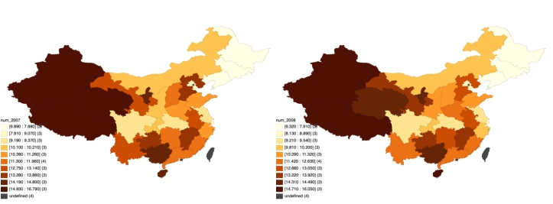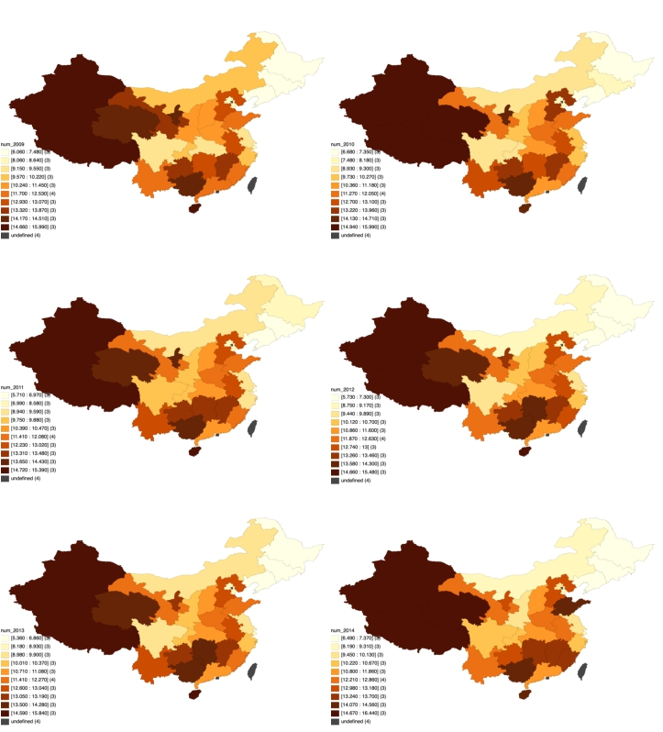

31
Figure 3: Chinese birth rate from 2007 to 2014

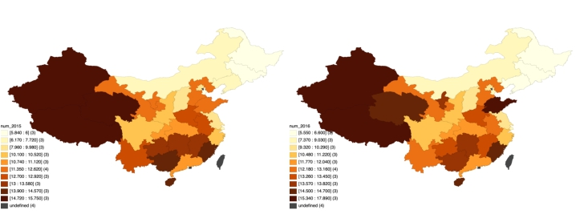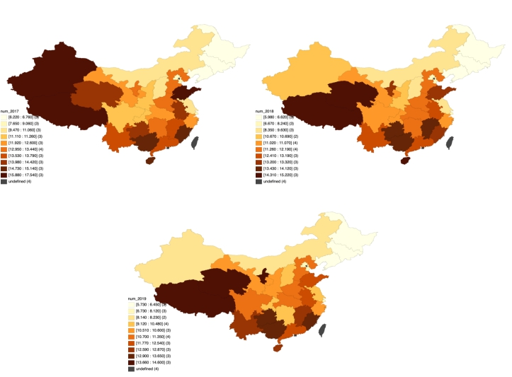

Figure 4: Chinese birth rate from 2015 to 2019

32

Acknowledgement

First and foremost, I would like to express my gratitude to my advisor, Professor Simon Bowmaker. You have offered me great help and detailed suggestion in every phase of this project. I am very proud of this work and this would not have been possible without your guidance.

I would like to also thank Professor Christina Wang, Professor Ye Jin and Profes- sor Marti Subrahmanyam for coordinating this program, and that also goes to Xinyi Yang who have contributed a lot.

Finally, I would like to thank all the speakers in this course, all the professors I have taken course from and all the fellow students. You have showed me what great research and great effort looks like, and that has definitely set a high bar for me to aim for.

33

