Impact of Covid-19 on Stock Market:

A study between US and China

by

Zhiyu Guo

An honors thesis submitted in partial fulfillment
of the requirements for the degree of
Bachelor of Science
Business and Economics Honors Program
NYU Shanghai
May 2023

Professor Marti G. Subrahmanyam Professor Xin Zhou
Professor Christina Wang
Professor Ye Jin

Faculty Advisers Thesis Adviser

Content
Abstract 3
1. Introduction 4
2. Literature Review 7
3. Data 11
3.1 Covid-19 Confirmed Cases 11
3.2 Search Index 13
3.3 Stock Return 15
3.4 Volatility Index (VIX) 16
3.5 Other Financial Data 16
4. Methodology 17
4.1 Linear Regression on Different Covid-19 Periods 17
4.2 Monthly Fixed Effects Regression 18
4.3 Regression with Interaction Terms 18
5. Results 20
5.1 OLS Regression Results 20
5.2 Monthly Fixed Effects Regression Results 22
5.3 Interaction Term Regression Results 23
6. Conclusion 25
7. Reference 28
8. Appendix 31

Abstract
The aim of this study is to investigate the distinct impact of the COVID-19 pandemic on the stock markets of the United States and China, focusing specifically on three distinct outbreaks: the initial outbreak, the Delta variant outbreak, and the Omicron variant outbreak. To accomplish this, daily data on newly confirmed COVID-19 cases, as well as Search Index related to COVID-19 keywords and topics, were utilized to represent the pandemic's development. Additionally, daily stock returns for the S&P500 and CSI300, as well as their corresponding volatility indices, were examined. The study also controlled for daily stock trading volume and interest rate data. The study utilized various statistical models, such as OLS regressions, monthly fixed effects regressions, and regressions with interaction terms, to investigate the relationship between COVID-19 and the stock market. The findings reveal that the Search Index better explains COVID-19's impact on both the U.S. and China stock markets, for that models with the Search Index as the dependent variable demonstrate higher performance than COVID-19 cases alone. Moreover, the U.S. stock market demonstrates a greater relationship with the pandemic than China's market. Regarding the outbreaks, the strongest impact is observed during the initial outbreak, followed by the Omicron variant outbreak, with the Delta variant having the least impact. This pattern is apparent in the U.S. market but not significant enough in the Chinese market.

Introduction
Started in 2020, the Coronavirus disease 2019 (COVID-19) has caused a worldwide pandemic affecting and changing people’s life in every aspect. Revealed by World Health Organization (WHO), as of the end of 2022, there have been 730,762,294 confirmed cases, including 6,697,000 deaths. Despite gradually emerging from the shadow of the pandemic nowadays, the financial market was among the first to be severely impacted by the outbreak. DIJA, S&P500 and other major index suffered record-breaking drops during the 2020 stock market crash.
Since the beginning of the pandemic, there has been a great deal of research into how the virus affects financial markets. The results have varied widely from country to country. The Chinese stock market has been severely affected, while studies have found relatively little long-term impact on the U.S. market (Gao et al., 2022). Such gap in the role of COVID-19 towards the stock market could result from the divergent health policies issued by governments (Capelle-Blancard & Desroziers, 2020).
Indeed, China and the U.S. had very distinct policies dealing with the virus, which has led to a huge difference in how the outbreak has infected and in the daily lives of citizens. While the two countries both had massive lockdown period in early 2020, the U.S. gradually lifted the stay-at-home policy later that year. While China insisted on a lockdown policy when cases of COVID-19 was confirmed and banned international travelers; such policy was not lifted until December 2022. These differences in policy development led to significant disparities in infection situations. At the end of October 2022, the U.S. had totally 96,175,252 confirmed cases, while mainland China only had 1,096,447 officially confirmed cases (including the no-symptom cases).
In spite of the distinct healthcare policies, the novel coronavirus itself is also developing a large number of variants, the most representative ones being the Delta variant and the Omicron variant. The emergence of these two variants have significantly changed the spreading pattern of the virus, the infection rate, and the death rate. Countries also needed to adapt new policies to deal with the Covid-19 variants.
The emergence of the Omicron variant at the end of 2021 proved to be a game changer in the ongoing COVID-19 pandemic. With its increased transmissibility, it rapidly spread across the globe, causing a surge in COVID-19 cases and hospitalizations. Countries around the world responded by updating their policies and guidelines to control the spread of the virus. To be specific, the US issued new recommendations of mask wearing and travel restrictions. While China published more aggressive approach including strict lockdowns, mass testing and contact tracing measures.
However, little research has been conducted on the Omicron variant's impact on the global financial market, as most studies focus on the original COVID-19 virus. Therefore, this study aims to investigate the effects of the Omicron variant on financial markets, and how it differs from the first outbreak. Specifically, this study will focus on the stock markets of China and the US, which are the two largest financial markets in the world and have distinct policies related to the COVID-19 pandemic. By comparing the effects of the Omicron variant with those of the original virus, this study aims to shed light on the unique impact of the Omicron variant on the financial markets.
The most intuitive access to Covid-19 situation would be to use the infection cases data, including infected cases, death cases, and cured cases, which are adapted by many literatures. However, with the Omicron variant, these case numbers boosted greatly, but not necessarily reflecting the true attention on the pandemic by the general public. Therefore, this paper takes the initiative to use not only Covid-19 cases but also the search index, to represent the developing trend of the pandemic. Such search index reflects how many times a certain keyword has been searched within a time range. For China and the US, Baidu Search Index and Google Search Trends are used respectively.
For the financial market, daily stock return of S&P500 and CSI300, along with the corresponding Volatility Index are exploited. These two indices are widely regarded as benchmarks for the US and China stock market.
The models used for this study are mainly regressions on the stock market and Covid-19. OLS regressions for different outbreaks are used to study the impact of Covid-19 in specific time frames. Monthly fixed effects regressions focus on the robustness of independent variables by controlling for short-time variability. Then, interaction terms for Search Index are utilized to study the different impact of Covid-19 in different virus outbreaks.
The remainder of the paper is organized as follows. Section 2 summarizes the literature. The data and methodology are discussed in Section 3 and Section 4. Section 5reports the results, and Section 6 concludes. Some of the tables and figures are relegated to the Appendix.

Literature Review
Since the outbreak of COVID-19, enormous research studies have been done on its impact to the world financial market. Given that COVID-19 is an international major event, it has greatly influenced all parts of the finance market, and studies have focused on different aspects of its significance. With detailed research on different market indicators, different pandemic indicators, different industries and countries, timeline and policies, previous studies have a general conclusion that COVID-19 does have huge impact on the financial world at the beginning of the outbreak, which became less powerful over time and varied across contexts.
The mainstream to access financial market is through stock index, as plenty of studies found the significant relationship between stock return and COVID-19 cases. Besides stock return, Zhang et al. specifically looked into stock volatility risk and found that global financial market risk increased substantially due to the outbreak and uncertainty in pandemic (2020). Ozili and Arun investigated macroeconomic variables such as global inflation rate, unemployment rate and energy commodity index, where a positive relationship with COVID-19 death cases is found (2020). Also, dividend futures showed a significant decline in expected growth rate (Gormsen & Koijen, 2020). CAPE ratio indicates the sharp fall in equity market and the various recover pace of different countries (Shiller et al., 2020).
For the measurement of COVID-19, previous literature found different level of significance for confirmed, death, and cured cases in different models. In China and some of the first countries affected by the outbreak, stock markets were more sensitive to cumulative than new indicators, confirmed than death cases (Alber, 2020). In Al-Awadhi et al.’s study of China market, daily growth in total confirmed and death cases have the significant impact (Al-Awadhi et al., 2020). While in India, market is only affected by daily growth in death cases but not confirmed ones (Jucunda, 2022), and the Pakistani market is related only to recoveries (Ahmed, 2020). Besides the COVID-19 cases, other variables like covid fear index, google search index are used to capture public’s attitude and attention towards the pandemic, and number of lockdown days is used to represent to influence of government policy (Ozili & Arun, 2020; Rubbaniy et al., 2021; Vasileiou, 2021).
Regarding the search index variable, it has been proven to be a good indicator of the pandemic process. Higgins et al. found that keywords for specific Covid-19 symptoms on Google Trends have high correlations to newly confirmed cases and death cases, such keywords could reflect clinical manifestations (2020). Google Trends are useful to generate worldwide pictures of the outbreak and predict the pandemic in real time. (Effenberger et al., 2020). Besides its direct relation to Covid-19, Google Trends are also related to financial market returns. Costola et al. found that Google Trends have a notable ability to explain stock market returns, with the Italian index standing out as a leading indicator to other countries' market returns; and such influence was most pronounced during various phases of Italy's lockdown (2021).
The degree of impact varies in different regions. While studies have found the Chinese market to be greatly impinged by COVID-19 for a long duration, some researchers have found no significant impact on the U.S. market, or only impact in the beginning stage (Alber, 2020; Gao et al., 2022; Nuhu A. Sansa, 2020; Onali, 2020). For other countries, besides India and Pakistan mentioned above, Wang and Enilov found correlations between COVID-19 and stock market in G7 countries except Japan (2020). Capelle-Blancard and Desroziers concluded such divergence between countries is mostly due to the various infect situation health policies implemented within different countries (2020).
Just as indicated above, the health policy is another significant variable affecting the financial market. The lockdown policy has affected countries to varying degrees, with liquidity in emerging markets affected by closed places, but developed markets and European stock markets do not reflect this policy (Rubbaniy et al., 2021; Zaremba et al., 2021). For other policies such as social distancing, travel restriction, significant impact on economic activities were found (Ozili & Arun, 2020).
When looking closer to the impact, there is no doubt that different industries react to the pandemic in divergence manners. In China, traditional industries suffered huge decline while high-tech industries along with education and health industries enjoyed growth, partially because the country’s policy supports (He et al., 2020). However, In U.S., education and health sectors are severely impacted just like travel and hospitality industries (Ozili & Arun, 2020). Despite the negative effects, gaming industry around the world seized the opportunity for a boost (Şener et al., 2021).
There also exists significant time-varying pattern between COVID-19 and stock market, however such topic is not targeted by much research. Gao et al. revealed that U.S. market became insensitive to the pandemic after the huge melt-down in March, while Chinese market remains sensitive to the relatively small increase in cases (Gao et al., 2022). Similar insensitivity based on the passage of time is also found all over the world as people were no longer troubled by the pandemic after the first month of outbreak (Capelle-Blancard & Desroziers, 2020).
Very limited number of studies have focused on the period beyond the first wave of Covid-19, the first half of 2020. Several studies have focused on the second wave of COVID-19 in late 2020. Rubbaniy et al. found the European market being again heavily impacted when facing the second wave of pandemic (2021). While Jucunda concluded that Indian market was not sensitive to the second wave (2022). However, there exists even fewer studies focusing on the relationship between the Omicron variant in early 2022 and stock market. Zhu and Pan found the Omicron variant to have impact on the Asian market (2022). But whether or not the third wave of pandemic have affected the global market in the same way of the first two waves remain unclear. And whether Omicron acted as a game changer to shift the financial world’s general attitude and attention towards the pandemic requires further research.

Data
Data used in this study are mainly in two categories, the Covid-19 data, and the financial data. The time frame of the data covers the period from September 1st, 2019, to October 31st, 2022, spanning one quarter before the initial outbreak of Covid-19, and the entirety of the Covid-19 pandemic. The choice of October 31st, 2022 as the end date was primarily motivated by the need for data accuracy. In the United States, mainstream sources of Covid-19 cases data, such as the World Health Organization (WHO), shifted from daily to weekly reporting starting from November 2022. Similarly, in China, accurate Covid-19 confirmed data ceased in mid-December, coinciding with the end of China's lockdown policy, as PCR testing decreased and self-test kits became more prevalent, resulting in challenges in tracking the numbers.

3.1 Covid-19 Confirmed Cases
Covid-19 cases data are classified into different categories, including new cases and cumulative cases, in which there are confirmed cases, death cases, and cured cases. Among these different categories, newly confirmed case is the most representative variable throughout the pandemic that draws public attention. This study primarily utilizes daily newly confirmed Covid-19 cases in the U.S. and China to capture the dynamic nature of the Covid-19 outbreak.
Obtained from JHU database, the U.S. daily confirmed cases exist significant gaps in weekday and weekend data. This discrepancy is attributed to lower testing rates on weekends, resulting in abnormal increases in case counts on Mondays. Such seasonality could be easily observed in Figure 1.
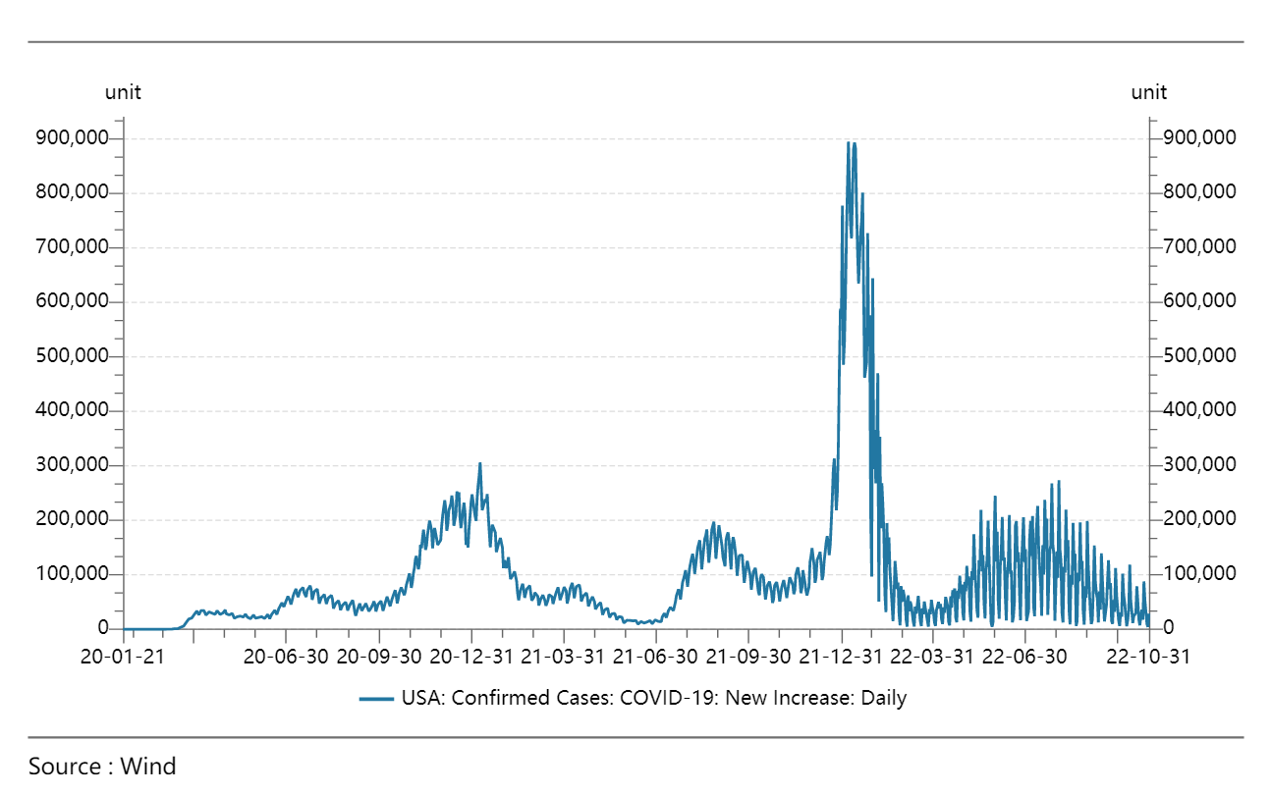
Figure 1. Daily Newly Confirmed Cases in the U.S.
Therefore, a moving average of seven days is calculated to measure the data in weekends and eliminate seasonal problems. Given that the confirmed case data for each day are released on the next day, the stock market would not have access to today’s confirmed cases data. Therefore, a moving average of the last seven days is used. The formula used is presented as follows:

$${7d_Case}_{t} = \sum_{j=i}^{7}{{Case}_{t-j}} / 7$$

Where Case_{t} denotes the newly confirmed Covid-19 cases for day t, and 7d_Case_{t} denotes the moving average of last seven day confirmed cases for day t.
For China, there exists even more categories for newly confirmed cases, including mainland, Hongkong, Macao, and foreign imported cases. Since this study focuses on the stock market of mainland China, Hongkong and Macao data are not included in Covid-19 cases. As foreign-imported cases take only a very small fraction of the total confirmed cases and remains relative constant over time, this foreign-imported cases are combined with mainland cases to represent the whole daily increase. Introduced in March 2020, the no-symptom case refers to Covid-19 cases that are tested positive but have no apparent infected symptoms. While not officially declared as confirmed cases by the Chinese government, such cases take dominant part in the total case numbers, leaving the real confirmed cases to remain abnormally low over time. Therefore, a sum of confirmed case, no-symptom case, mainland case, and foreign-imported case is used to represent the daily growth of Covid-19 cases in China.
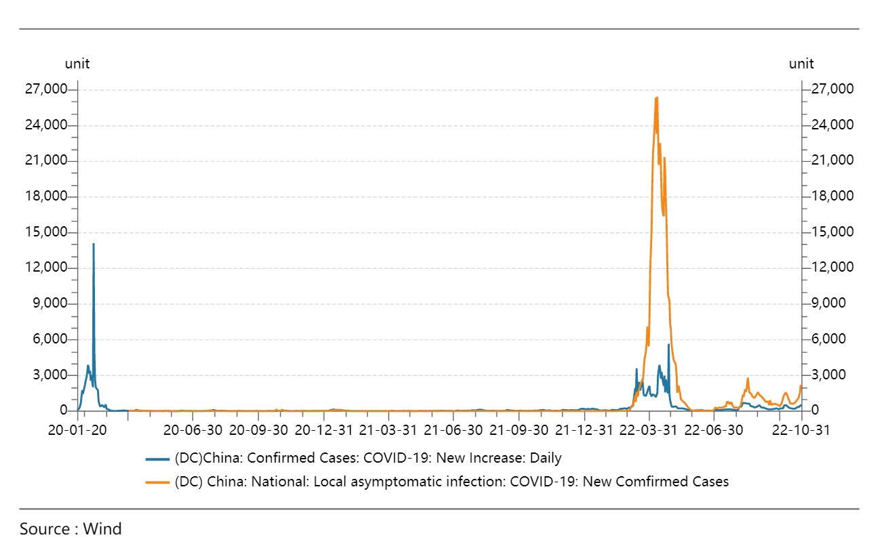
Figure 2. Daily Newly Confirmed Cases in China

3.2 Search Index
Search data from the biggest searching engines in the U.S. and China, Google, and Baidu, are used to form Covid-19 search index. Google provides a keyword searching data called Google Trend, which has one disease search term “Coronavirus disease 2019” that contains relevant search keywords towards the topic. Google trend provides an index scaling from 0 to 100, where 100 represent the peak search, within any given time periods.
However, for any time period that is longer than nine months, google trend will only return weekly data instead of daily. To obtain daily data for a time range of almost three years, a technique by Qingzong Tseng is used to combine daily data of different periods together. Such technique separates the three-year period into multiple shorter periods within nine months that has significant overlaps between each other. Then it uses the overlapping data to rescale each period and combine them together into the daily data trend for three years.
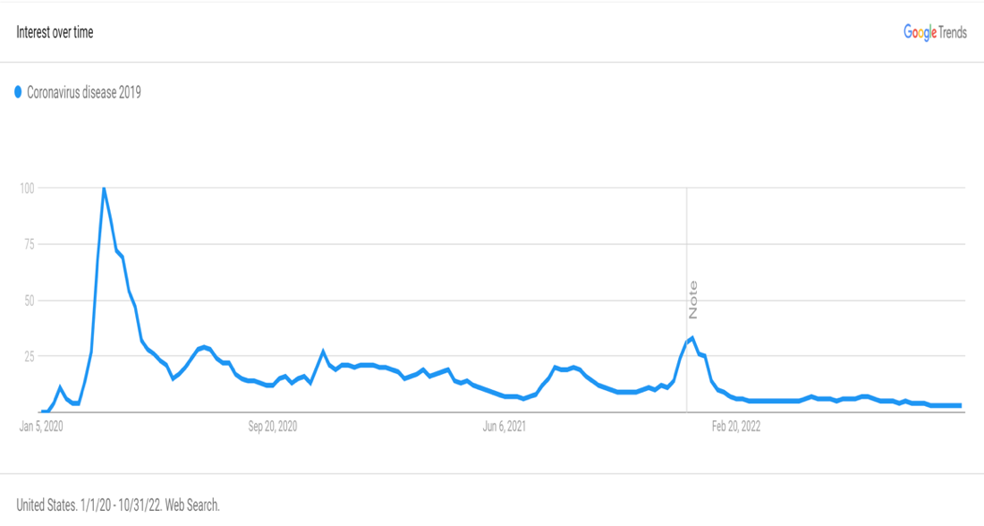
Figure 3. Covid-19 Search Index in the U.S.
For Baidu Index, although it provides daily data, there is no combined term to represent the pandemic. Therefore, a sum of several mainly used keywords, including “疫情”, “新冠”, “新型冠状病毒”, “新型冠状病毒肺炎”, is calculated to capture the search trend of Covid-19.
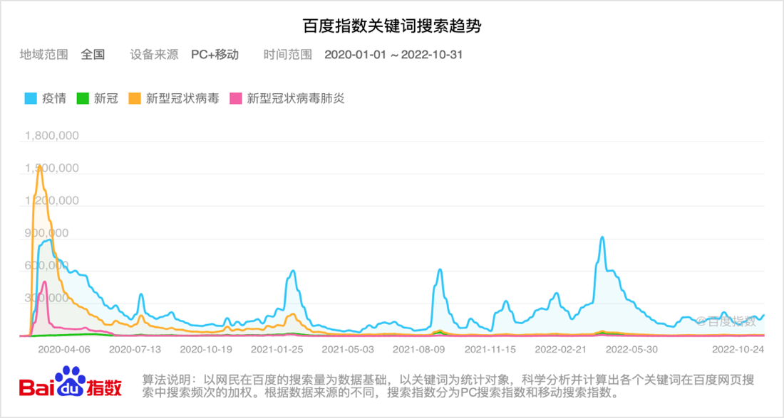
Figure 4. Covid-19 Search Index in China
Search Index also contains seasonal changes that most searches occur on weekdays, leaving the index on weekends to be much lower. Therefore, the same technique of taking a moving average of the seven days is also applied to all Search Index data.

3.3 Stock Return
S&P500 and CSI300 index are used to represent the US and China stock market, respectively. Daily stock returns are calculated based on the percentage changes between the closing prices of today and yesterday. The formula used is presented as follows:
$${Return}_{t}= {Price}_{t}/{Price}_{t-1}-1$$
Where Return_{t} is the daily stock return for day t, and Price_{t} is the stock closing price for day t.
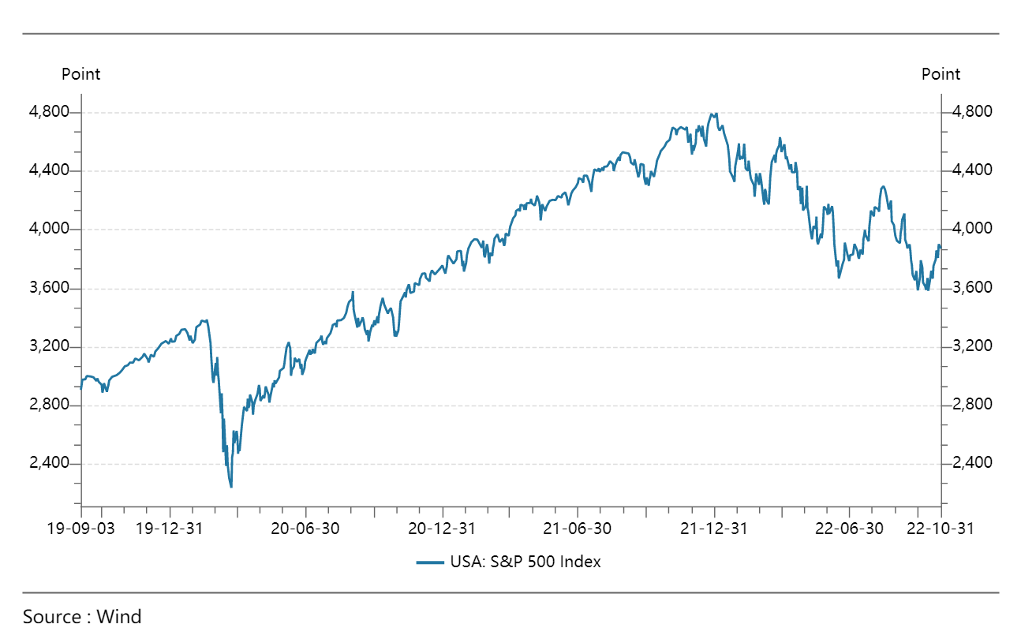
Figure 5. S&P500 Daily Stock Index
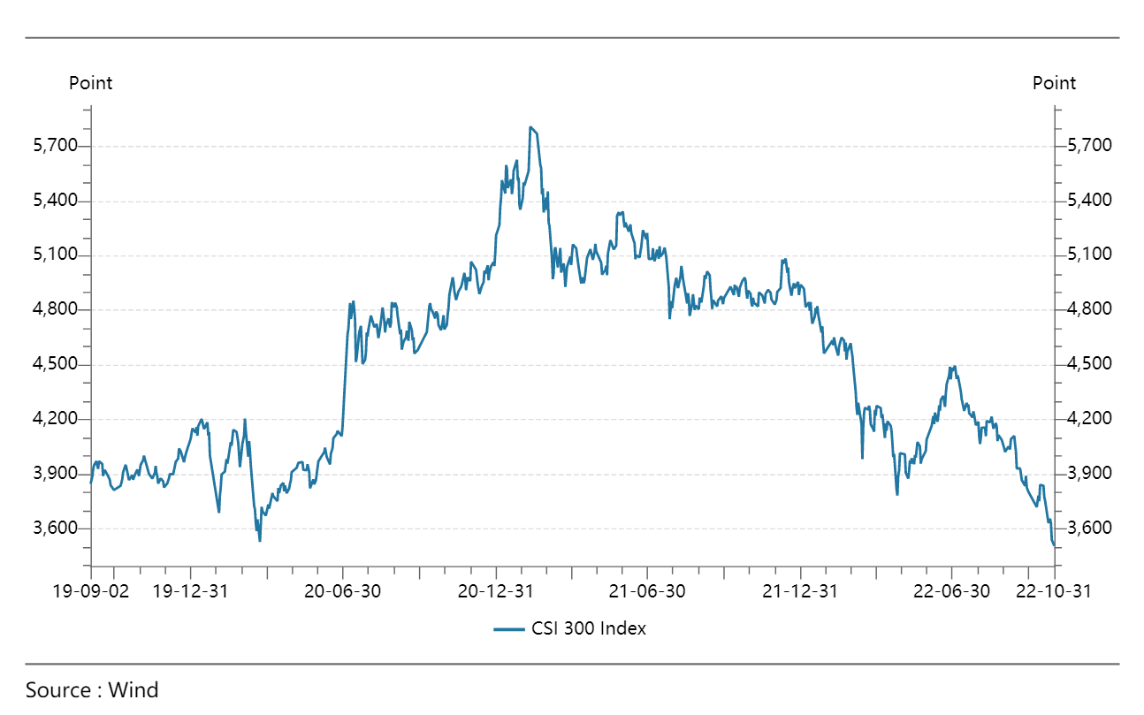
Figure 6. CSI300 Daily Stock Index

3.4 Volatility Index (VIX)
VIX is a widely used indicator that aims to predict the expected volatility of the S&P 500 stock index over the next 30 days. VIX is recognized as a popular gauge of market uncertainty and risk perception and is often referred to as the "Fear Index" due to its ability to capture public sentiment and fear towards the financial markets. VIX for S&P500 is calculated by the Chicago Board Options Exchange (CBOE), while VIX for CSI300 is provided by Volatility Institute at NYU Shanghai (VINS).

3.5 Other Financial Data
The daily trading volumes of S&P 500 and CSI 300 indices are incorporated as control variables to account for potential confounding factors in the stock market analysis. Additionally, the interest rates for the U.S. and China are captured using the one-month LIBOR (London Interbank Offered Rate) and one-month SHIBOR (Shanghai Interbank Offered Rate). These variables are included to control for potential effects of trading activity and interest rate changes on stock performance, and to enhance the robustness and validity of the findings.

Methodology
Regressions are mainly adopted to study the relationship between stock market and the pandemic. In regression models, the financial data of daily returns and VIX are used as dependent variables, while Covid-19 confirmed cases and Search Index are used as primary independent variables, along with other control variables of stock volume and interest rates.

4.1 Linear Regression on Different Covid-19 Periods
The study examines data from September 1st, 2019, to October 31st, 2022, and identifies five distinct periods based on the status of Covid-19 infections. These periods are categorized as follows: (1) the total Covid-19 spreading period, and (2) four specific time ranges of four months each, which include the periods before the pandemic, during the first outbreak, the Delta variant outbreak, and the Omicron variant outbreak, as detailed in Table 1. Ordinary Least Squares (OLS) linear regressions are performed on each of these periods, for both the U.S. and China, to study the impact of Covid-19 within different time frames. The models used are presented as follows:

$${Return}_{i,t}=α + β_{1}{7d_{S}earch}_{i,t} + β_{2}{7d_{C}ase}_{i,t} + β_{3}{VIX}_{i,t} +$$
$$ControlVariables + ε_{i,t}$$
$${VIX}_{i,t}=α + β_{1}{7d_{S}earch}_{i,t} + β_{2}{7d_{C}ase}_{i,t} + β_{3}{Return}_{i,t} +$$
$$ControlVariables + ε_{i,t}$$

Where Return_{i,t} denotes the daily stock return for country i (China and U.S.) one day t, 7d_Search_{i,t} indicates the moving average of seven days Search Index on topic Covid-19, 7d_Case_{i,t} indicates Covid-19 newly confirmed cases moving average of the last seven days, and VIX_{i,t} denotes the Volatility Index. Other control variables Volume_{i,t} and InterestRate_{i,t}, which respectively indicates the daily stock market volume and one-month LIBOR/SHIBOR, are included in the OLS regression.

4.2 Monthly Fixed Effects Regression
Besides OLS regression, monthly fixed effects regressions are used to capture short-term variability and control for time-invariant heterogeneity. Dummy variables for each month are added to the OLS regression, the models used are presented as follows:

$${Return}_{i,t}=α + β_{1}{7d_Search}_{i,t} + β_{2}{7d_Case}_{i,t} + β_{3}{VIX}_{i,t} +u_{t}+ ε_{i,t}$$
$${VIX}_{i,t}=α + β_{1}{7d_Search}_{i,t} + β_{2}{7d_Case}_{i,t} + β_{3}{Return}_{i,t} +u_{t}+ ε_{i,t}$$

Where u_{t} denotes the monthly fixed effects for each month during the pandemic periods.
The monthly fixed effects regressions aim to eliminate time-varying bias and test the robustness of each independent variable, namely the Covid-19 confirmed cases and Search Index.

4.3 Regression with Interaction Terms
To thoroughly examine the variations in the impact of Covid-19 on the stock market during different outbreaks, interaction terms are incorporated for each of the three distinct periods, namely the initial outbreak, the Delta variant outbreak, and the Omicron variant outbreak. The inclusion of these interaction terms allows for a comprehensive analysis of how the relationship between the stock market and Covid-19 may differ across these virus variants. The models used are presented as follows:

$${VIX}_{i,t}=α + β_{1}{7d_Search}_{i,t} + β_{2}{7d_Case}_{i,t} + β_{3}{Return}_{i,t} + β_{4}Dummy1+ β_{5}Dummy1×{7d_Search}_{i,t} + ε_{i,t}$$
$${VIX}_{i,t}=α + β_{1}{7d_Search}_{i,t} + β_{2}{7d_Case}_{i,t} + β_{3}{Return}_{i,t} + β_{4}Dummy2+ β_{5}Dummy2×{7d_Search}_{i,t} + ε_{i,t}$$
$${VIX}_{i,t}=α + β_{1}{7d_Search}_{i,t} + β_{2}{7d_Case}_{i,t} + β_{3}{Return}_{i,t} + β_{4}Dummy3+ β_{5}Dummy3×{7d_Search}_{i,t} + ε_{i,t}$$

Where Dummy1, Dummy2, and Dummy3 are dummy variables that takes value 1 if data being in the first four months of the first, second, and third outbreak of Covid-19, corresponding to the Period3, Period4, and Peroid5 in Table 1.
Such interaction terms could help to study whether each outbreak has long-term or short-term impacts on the stock market and could be compared to indicate the different influences each variant brought to the financial world.

Results

5.1 OLS Regression Results
OLS regression results are shown in Table 2.1 and Table 2.2, where Table 2.1 summarizes models with daily stock return as dependent variable, and Table 2.2 is for VIX as dependent variable.
When examining the first six models, which are models for Chinese stock market, using daily stock return as dependent variables. None of these models show a good fit. In model (1) and (2), which are regressions for the whole Covid-19 periods, both the Covid-19 confirmed cases variable and the Search Index variable are not statistically significant, with a low overall r-squared value, these models indicate no significant relationship between Covid-19 situations and the daily stock return. From model (3) to model (6), only the Search Index variable shows significance during the Delta and Omicron outbreak.
While for the U.S. market, it can be seen from model (8) that both Search Index and confirmed cases show significance in the regression. When breaking down the time ranges, such relationship could be seen again in the first outbreak in March 2020, but not in the later Delta and Omicron variants. By comparing the twelve models in Table 2.1, there exists distinguishable differences in the model performance of the U.S. and China markets. While none of the models show good fits, the U.S. stock returns seems to have a closer relationship with Covid-19, and especially in the first outbreak. Instead, China shows an increasing impact of Covid-19 overtime, with the biggest one on the Omicron variant.
The models presented in Table 2.2, which utilize VIX as the dependent variable, consistently exhibit higher R-squared values and more statistically significant results compared to other models. Specifically, in all twelve models, the Search Index variable shows significance in all periods except for Period4, which corresponds to the Delta variant period. This consistent pattern highlights the significance of employing the Search Index as a representation of Covid-19 in these models. Moreover, it suggests a comparatively weaker relationship between stock markets and Covid-19 during the Delta variant periods.
The confirmed cases variable shows less significance than the Search Index in almost all models. It is worth noticing that for model (22), which is for the U.S. market during the first outbreak, the r-squared is 0.911, meaning that most variants of VIX are explained by the Covid-19 variables. Such high performance shows a strong relationship between the stock volatility and Covid-19 during the first outbreak. And by comparing model (22) with model (23) and (24), the overall performance dropped a lot in later outbreaks, indicating a weaker relationship between VIX and Covid-19 over time. While such pattern could not be clearly seen in China, in model (16) to model (18).
When cross comparing China and The U.S. models in Table 2.2, it is clear that the U.S. models have overall better performances than the Chinese ones. Such difference is most clear in model (14) and model (20), which are regressions for all Covid-19 periods. Model (14) has r-squared of 0.248 and model (20) has r-squared of 0.744, with a gap of 0.5 in the r-squared. Also, from model (15) and model (21) that before Covid-19, the VIX explained by other control variables are roughly the same (0.530 and 0.491). Therefore, the 0.5 differences in r-squared further showed that the stock markets in two countries are being differently impacted by the pandemic.
Combining models in Table 2.1 and Table 2.2, a clear pattern is shown that the U.S. stock market has a stronger relationship with Covid-19 in 2020, and such relationship gets weaker overtime in later outbreaks. However, Chinese stock market does not show such pattern, with even higher significance of Covid-19 variables in Omicron variant than in the first outbreak.
Therefore, it is clear that stock volatility shows much better fits for the Covid-19 variables in both China and the U.S. models. Also, the Search Index has higher significance than the confirmed cases in almost all models. To this extent, the Search Index seems to be a better explanatory variable towards Covid-19 situations. Therefore, future models focus more on using VIX as the dependent variable and using Search Index as the primary independent variable.

5.2 Monthly Fixed Effects Regression Results
Table 3 presents a summary of the model results for monthly fixed effects regressions, where the dependent variables are daily stock returns and VIX, and the analysis is conducted for both the U.S. and China, covering the entire period of the Covid-19 pandemic. Models (1) and (2) indicate that the confirmed cases variable loses its statistical significance in the regression after adding monthly fixed effects, while the Search Index variable remains statistically significant.
In contrast, models (3) and (4) for the U.S. reveal that both the Search Index and confirmed cases variables continue to be statistically significant for both dependent variables, even after accounting for monthly fixed effects. These findings suggest that the Search Index variable outperforms the confirmed cases variable in regression analyses examining the relationship between Covid-19 and stock market dynamics, as it consistently demonstrates significance across different countries and dependent variables.
Such result is consistent with what presented in Table 2.1 and Table 2.2 that Search Index showed much more significance than confirmed cases throughout different models.

5.3 Interaction Term Regression Results
In Table 4, the regression results with interaction terms for Search Index and different outbreak periods are presented, with VIX serving as the dependent variable. Models (1) to (3) represent regressions conducted for the Chinese market, where each model includes one dummy variable and one interaction term for each outbreak period, corresponding to Period3, Period4, and Period5 as shown in Table 1. Similarly, models (4) to (6) depict the same settings for the U.S. market.
For all six models, the dummy variables are all significant, and follows the pattern of having positive coefficients in the first outbreak and the Omicron variant, while showing negative coefficients in the Delta variant periods. This indicates a relative drop of the VIX during the Delta variant, and increase in the other two outbreaks, when comparing with the whole Covid-19 periods.
For model (1) to (3) of Chinese stock market, none of the three interaction terms are significant, and even in model (1) that the Search Index variable itself shows no significance. These interaction terms indicates that there are no apparent differences in the performance of Search Index during different Covid-19 periods.
For model (4) to (6) of the U.S. stock market, all of the three interaction terms are significant. Such results mean that during the three outbreaks, the Search Index variable has different relationships towards the stock market. To be specific, the coefficients for the three interaction terms are 0.4663, -0.3783, and -0.5955. The first positive coefficient means that compared with the whole Covid-19 period, the Search Index has a higher impact on the VIX during the first outbreak. Similarly, the two negative coefficients indicate a drop in the relationship between Search Index and stock volatility during the Delta and Omicron variants.

Conclusion
As the most important and influential global events in the beginning of the 2020 decades, the Coronavirus disease has impacted every aspect of people’s life and work worldwide. Instead of hinge one the society once and then gradually fade away, the various variants of Covid-19 caused multiple waves of infection in over two years. Given the varying infection and death rates associated with each Covid-19 variant, as well as the diverse societal responses to these new variants, each outbreak has resulted in distinct outcomes and unique impacts on society. And the question raised that, how exactly does such impact different from each other? This paper intends to answer this question with a specific focus on the stock market, between the U.S. and China.
Using Covid-19 daily newly confirmed cases and Search Index towards the topic of Covid-19 to represent the Covid-19 situation and using daily stock return along with stock volatility index for the financial market, this paper take advantages of Ordinary Least Squares Regressions, monthly fixed effects regressions and interaction terms to study the impact of Covid-19 on the stock market, with a focus on the three major outbreaks, namely the initial outbreak in 2020, the Delta variant outbreak, and the Omicron variant outbreak.
Based on the regression findings, it is evident that the Search Index serves as a more effective explanatory variable in understanding the impact of the pandemic compared to confirmed cases. Additionally, the stock volatility index exhibits a stronger correlation with Covid-19, as opposed to daily stock returns.
Overall, the relationship between the U.S. stock market and Covid-19 appears to be more pronounced compared to the Chinese market during the entire period of the pandemic. Moreover, when examining each outbreak period individually, the first outbreak generally exhibits the strongest correlation between the stock market and Covid-19, while the Delta variant outbreak displays the weakest association between these two variables.
In the case of China, it appears that Covid-19 variables, particularly the confirmed cases data, are relatively less effective in explaining stock market variations. While a slight decline in the relationship between Covid-19 variables and the stock market is observed over time from the first outbreak to later variants, there is insufficient evidence to establish a significant trend in their relationship. The Search Index also does not exhibit distinct changes in its relationship with the stock market during different outbreaks.
On the other hand, in the United States, both confirmed cases and the Search Index show significance in their relationship with the stock market. Additionally, Google Search Trend demonstrates the highest correlation with stock market volatility. This relationship has been observed consistently throughout the pandemic, with a peak during the initial outbreak in March 2020. During this time, most variations in stock market volatility could be explained by Covid-19 data. However, the explanatory power of Covid-19 variables decreased significantly during the Delta and Omicron variants. Furthermore, the relationship between the Search Index and VIX also changed during different outbreaks. In the initial outbreak, the Search Index exhibited a strong relationship with volatility, while this relationship significantly declined in the later Delta and Omicron variant outbreaks.
In summary, a general trend of Covid-19 having stronger relationship to the stock market in the beginning of Covid-19 is well observed. The Search Index towards Covid-19 topics show a decreasing relation to the stock volatility in Delta and Omicron for the U.S. market. However for China, there is no enough evidence to conclude the distinct relationship between Covid-19 and stock market during different outbreaks.

Reference
Ahmed, S. (2020). Impact of COVID-19 on Performance of Pakistan Stock Exchange (SSRN Scholarly Paper No. 3643316). Social Science Research Network. https://doi.org/10.2139/ssrn.3643316
Al-Awadhi, A. M., Alsaifi, K., Al-Awadhi, A., & Alhammadi, S. (2020). Death and contagious infectious diseases: Impact of the COVID-19 virus on stock market returns. Journal of Behavioral and Experimental Finance, 27, 100326. https://doi.org/10.1016/j.jbef.2020.100326
Alber, N. (2020). The Effect of Coronavirus Spread on Stock Markets: The Case of the Worst 6 Countries (SSRN Scholarly Paper No. 3578080). Social Science Research Network. https://doi.org/10.2139/ssrn.3578080
Capelle-Blancard, G., & Desroziers, A. (2020). The Stock Market Is not the Economy? Insights from the COVID-19 Crisis (SSRN Scholarly Paper No. 3638208). Social Science Research Network. https://doi.org/10.2139/ssrn.3638208
Costola, M., Iacopini, M., & Santagiustina, C. R. M. A. (2021). Google search volumes and the financial markets during the COVID-19 outbreak. Finance Research Letters, 42, 101884. https://doi.org/10.1016/j.frl.2020.101884
Effenberger, M., Kronbichler, A., Shin, J. I., Mayer, G., Tilg, H., & Perco, P. (2020). Association of the COVID-19 pandemic with Internet Search Volumes: A Google TrendsTM Analysis. International Journal of Infectious Diseases, 95, 192–197. https://doi.org/10.1016/j.ijid.2020.04.033
Gao, X., Ren, Y., & Umar, M. (2022). To what extent does COVID-19 drive stock market volatility? A comparison between the U.S. and China. Economic Research-Ekonomska Istraživanja, 35(1), 1686–1706. https://doi.org/10.1080/1331677X.2021.1906730
Gormsen, N. J., & Koijen, R. S. J. (2020). Coronavirus: Impact on Stock Prices and Growth Expectations (SSRN Scholarly Paper No. 3555917). Social Science Research Network. https://doi.org/10.2139/ssrn.3555917
He, P., Sun, Y., Zhang, Y., & Li, T. (2020). COVID–19’s Impact on Stock Prices Across Different Sectors—An Event Study Based on the Chinese Stock Market. Emerging Markets Finance and Trade, 56(10), 2198–2212. https://doi.org/10.1080/1540496X.2020.1785865
Higgins, T. S., Wu, A. W., Sharma, D., Illing, E. A., Rubel, K., Ting, J. Y., & Alliance, S. F. (2020). Correlations of Online Search Engine Trends With Coronavirus Disease (COVID-19) Incidence: Infodemiology Study. JMIR Public Health and Surveillance, 6(2), e19702. https://doi.org/10.2196/19702
Jucunda, M. (2022). Sensitivity of the Indian Stock Market to COVID-19 (SSRN Scholarly Paper No. 4139534). Social Science Research Network. https://papers.ssrn.com/abstract=4139534
Nuhu A. Sansa. (2020). The Impact of the COVID-19 on the Financial Markets: Evidence from China and USA (SSRN Scholarly Paper No. 3567901). Social Science Research Network. https://doi.org/10.2139/ssrn.3567901
Onali, E. (2020). COVID-19 and Stock Market Volatility (SSRN Scholarly Paper No. 3571453). Social Science Research Network. https://doi.org/10.2139/ssrn.3571453
Ozili, P. K., & Arun, T. G. (2020). Spillover of COVID-19: Impact on the Global Economy. 30.
Rubbaniy, G., Khalid, A. A., Umar, M., & Mirza, N. (2021). European Stock Markets’ Response to COVID-19, Lockdowns, Government Response Stringency and Central Banks’ Interventions (SSRN Scholarly Paper No. 3785598). Social Science Research Network. https://doi.org/10.2139/ssrn.3785598
Şener, D., Yalçın, T., & Gulseven, O. (2021). The Impact of COVID-19 on the Video Game Industry (SSRN Scholarly Paper No. 3766147). Social Science Research Network. https://doi.org/10.2139/ssrn.3766147
Shiller, R. J., Black, L., & Jivraj, F. (2020). CAPE and the COVID-19 Pandemic Effect (SSRN Scholarly Paper No. 3714737). Social Science Research Network. https://doi.org/10.2139/ssrn.3714737
TSENG, Q. (2019, November 29). Reconstruct google trends daily data for extended period. Medium. Retrieved April 27, 2023, from https://towardsdatascience.com/reconstruct-google-trends-daily-data-for-extended-period-75b6ca1d3420
Vasileiou, E. (2021). Explaining stock markets’ performance during the COVID-19 crisis: Could Google searches be a significant behavioral indicator? Intelligent Systems in Accounting, Finance and Management, 28(3), 173–181. https://doi.org/10.1002/isaf.1499
Wang, W., & Enilov, M. (2020). The Global Impact of COVID-19 on Financial Markets (SSRN Scholarly Paper No. 3588021). Social Science Research Network. https://doi.org/10.2139/ssrn.3588021
Zaremba, A., Aharon, D. Y., Demir, E., Kizys, R., & Zawadka, D. (2021). COVID-19, government policy responses, and stock market liquidity around the world: A note. Research in International Business and Finance, 56, 101359. https://doi.org/10.1016/j.ribaf.2020.101359
Zhang, D., Hu, M., & Ji, Q. (2020). Financial markets under the global pandemic of COVID-19. Finance Research Letters, 36, 101528. https://doi.org/10.1016/j.frl.2020.101528
Zhu, W., & Pan, L. (2022). How the Covid-19 Affects Regional Spillover: Evidence from the Asian Stock Market (SSRN Scholarly Paper No. 4196823). Social Science Research Network. Retrieved September 8, 2022, from https://papers.ssrn.com/abstract=4196823

Appendix

Table 1 Regression Periods
Periods | Description | Time Frame for CN | Time Frame for US
Period 1 | Total Covid-19 periods | 2020.01– 2022.10 | 2020.03 – 2022.10
Period 2 | Four months before Covid-19 | 2019.09 – 2019.12 | 2019.09 – 2019.12
Period 3 | Four months since first outbreak | 2020.01 – 2020.04 | 2020.03 – 2020.06
Period 4 | Four months since Delta | 2021.07 – 2021.10 | 2021.07 – 2021.10
Period 5 | Four months since Omicron | 2022.03 – 2022.06 | 2021.12 – 2022.03

Table 2.1 OLS Regression Results (Stock Return as dependent variable)
 | (1)  Period1 | (2)  Period1 | (3)  Period2 | (4)  Period3 | (5)  Period4 | (6)  Period5 | (7)  Period1 | (8)  Period1 | (9)  Period2 | (10)  Period3 | (11)  Period4 | (12)  Period5
7d_Search | 0.0141  (0.039) | 0.0495  (0.042) |  | -0.0738  (0.286) | 0.8670**  (0.422) | 1.0854***  (0.394) | 0.0269  (0.040) | 0.4235***  (0.061) |  | 1.4179***  (0.321) | -0.2230  (0.279) | -0.2429  (0.317)
7d_Case | -0.0443  (0.038) | -0.0328  (0.038) |  | 0.7645  (0.936) | -27.4131  (22.650) | 0.0673  (0.062) | -0.0341  (0.040) | -0.1184***  (0.039) |  | -8.5096**  (3.971) | 0.0615  (0.251) | -0.0258  (0.070)
VIX |  | -0.1558***  (-0.048) | -0.4613**  (0.198) | -0.2948**  (0.138) | -1.2900**  (0.520) | -0.8550***  (0.254) |  | -0.6075***  (0.076) | -0.7563***  (0.229) | -2.1653***  (0.391) | -0.8172***  (0.214) | -0.4747**  (0.231)
Volume |  | 0.1141  (0.046) | 0.5196***  (0.136) | 0.2901  (0.226) | 0.2562*  (0.148) | 0.4509*  (0.232) |  | 0.0904*  (0.052) | -0.0378  (0.066) | 0.0847  (0.248) | -0.1678  (0.104) | 0.0243  (0.139)
InterestRate |  | -0.0382  (0.044) | -0.6734*  (0.384) | -0.3159**  (0.153) | 0.9530  (1.270) | -1.9516***  (0.610) |  | 0.1935***  (0.049) | 0.5962  (0.376) | -0.0255  (0.933) | -6.3644  (11.261) | 0.2527  (0.846)
Constant | -0.0091  (0.040) | -0.0077  (0.041) | 0.8115*  (0.419) | 0.3044  (0.350) | -7.5237  (5.433) | -0.8630**  (0.386) | 0.0047  (0.042) | 0.0887**  (0.042) | -1.4633**  (0.629) | -3.5107  (2.238) | -5.2811  (8.289) | 0.1739  (0.535)
# Obs. | 684 | 684 | 81 | 79 | 80 | 82 | 674 | 674 | 84 | 85 | 85 | 84
R² | 0.002 | 0.020 | 0.164 | 0.127 | 0.113 | 0.200 | 0.002 | 0.099 | 0.125 | 0.309 | 0.264 | 0.090
Adj. R² | -0.001 | 0.013 | 0.132 | 0.067 | 0.053 | 0.148 | -0.002 | 0.092 | 0.092 | 0.265 | 0.218 | 0.032
Country | CN | CN | CN | CN | CN | CN | US | US | US | US | US | US
Robust standard errors in parentheses. *** p<0.01, ** p<0.05, * p<0.1

Table 2.2 OLS Regression Results (VIX as dependent variable)
 | (13)  Period1 | (14)  Period1 | (15)  Period2 | (16)  Period3 | (17)  Period4 | (18)  Period5 | (19)  Period1 | (20)  Period1 | (21)  Period2 | (22)  Period3 | (23)  Period4 | (24)  Period5
7d_Search | 0.3127***  (0.033) | 0.2726***  (0.031) |  | 0.6881***  (0.130) | 0.1339  (0.092) | 0.6990***  (0.154) | 0.6533***  (0.026) | 0.5820***  (0.021) |  | 0.6742***  (0.044) | -0.1145  (0.135) | -0.4936***  (0.141)
7d_Case | 0.0106  (0.032) | 0.0371  (0.030) |  | -3.2719***  (0.671) | 4.3141  (4.887) | 0.0703***  (0.025) | -0.1897***  (0.026) | -0.1225***  (0.019) |  | -5.6278***  (0.771) | 0.0996  (0.120) | 0.0387  (0.033)
Return |  | -0.0972***  (0.030) | -0.1428**  (0.061) | -0.1987**  (0.093) | -0.0595**  (0.024) | -0.1514***  (0.045) |  | -0.1445***  (0.018) | -0.1589***  (0.048) | -0.1291***  (0.023) | -0.1903***  (0.050) | -0.1082**  (0.053)
Volume |  | 0.3569***  (0.034) | 0.4203***  (0.067) | 0.2932  (0.185) | 0.1605***  (0.027) | 0.3293***  (0.093) |  | 0.3356***  (0.022) | -0.0437  (0.030) | 0.0613  (0.060) | 0.1285**  (0.049) | 0.2992***  (0.057)
InterestRate |  | -0.1246***  (0.034) | -1.3188***  (0.158) | -0.2178*  (0.127) | 0.5676**  (0.266) | -0.9978***  (0.248) |  | 0.3295***  (0.020) | 1.0294***  (0.132) | -0.3902*  (0.224) | -12.8773**  (5.250) | -0.4996  (0.400)
Constant | 0.1241***  (0.034) | 0.0666**  (0.032) | 0.7364***  (0.223) | -0.5831**  (0.281) | 0.4110  (1.181) | -0.3098*  (0.164) | 0.1020***  (0.027) | 0.1236***  (0.020) | -2.2629***  (0.157) | -2.7493***  (0.461) | -10.0266**  (3.849) | -0.4074  (0.251)
# Obs. | 684 | 684 | 81 | 79 | 80 | 82 | 674 | 674 | 84 | 85 | 85 | 84
R² | 0.118 | 0.248 | 0.530 | 0.500 | 0.412 | 0.362 | 0.500 | 0.744 | 0.491 | 0.911 | 0.439 | 0.541
Adj. R² | 0.115 | 0.242 | 0.511 | 0.465 | 0.472 | 0.320 | 0.498 | 0.742 | 0.472 | 0.905 | 0.404 | 0.511
Country | CN | CN | CN | CN | CN | CN | US | US | US | US | US | US
Robust standard errors in parentheses. *** p<0.01, ** p<0.05, * p<0.1

Table 3 Monthly Fixed Effects Results
 | (1)  Return | (2)  VIX | (3)  Return | (4)  VIX
7d_Search | 0.3348***  (0.129) | 0.1241**  (0.053) | 0.7603***  (0.096) | 0.5225***  (0.028)
7d_Case | -0.0532  (0.129) | -0.0115  (0.053) | -0.4036***  (0.125) | -0.2317***  (0.043)
Return/VIX | -0.6155***  (0.093) | -0.1034***  (0.016) | -1.3136***  (0.102) | -0.1568***  (0.012)
Volume | 0.1263*  (0.070) | 0.2171***  (0.027) | 0.0620  (0.055) | 0.1520***  (0.028)
InterestRate | -0.3165  (0.220) | 0.1748*  (0.090) | 0.7124**  (0.361) | -0.0332  (0.125)
Return_Lag1 | -0.0842**  (0.039) | -0.0768***  (0.016) | -0.3757***  (0.036) | -0.1178***  (0.013)
Return_Lag2 | -0.0609  (0.039) | -0.0468***  (0.016) | -0.0446  (0.036) | -0.0639***  (0.012)
# Obs. | 684 | 684 | 674 | 674
R² | 0.109 | 0.816 | 0.308 | 0.901
Adj. R² | 0.054 | 0.804 | 0.267 | 0.895
Country | CN | CN | US | US
Robust standard errors in parentheses. *** p<0.01, ** p<0.05, * p<0.1

Table 4 Interaction Terms Results
 | (1)  Period3 | (2)  Period4 | (3)  Period5 | (4)  Period3 | (5)  Period4 | (6)  Period5
7d_Search | 0.0729  (0.078) | 0.2316***  (0.030) | 0.2762***  (0.032) | 0.1479**  (0.059) | 0.5885***  (0.021) | 0.6358***  (0.022)
7d_Case | 0.0743**  (0.031) | 0.0230  (0.028) | -0.0051  (0.037) | -0.0334  (0.021) | -0.1250***  (0.018) | -0.1018***  (0.028)
Return | -0.0934***  (0.029) | -0.1066***  (0.028) | -0.0988***  (0.030) | -0.1427***  (0.017) | -0.1474***  (0.028) | -0.1499***  (0.017)
Volume | 0.3756***  (0.034) | 0.4445***  (0.033) | 0.3548***  (0.034) | 0.2799***  (0.022) | 0.2986***  (0.022) | -0.2925***  (0.022)
InterestRate | -0.1105***  (0.034) | -0.1211***  (0.032) | -0.1172***  (0.035) | 0.2335***  (0.023) | 0.3057***  (0.020) | 0.3557***  (0.020)
Dummy1 | 0.6664***  (0.130) |  |  | 0.2970***  (0.082)
Interaction1 | 0.0749  (0.088) |  |  | 0.4663***  (0.068)
Dummy2 |  | -0.9572***  (0.104) |  |  | -0.3563***  (0.061)
Interaction2 |  | -0.0430  (0.180) |  |  | -0.3783**  (0.176)
Dummy3 |  |  | 0.2405**  (0.115) |  |  | 0.2667***  (0.073)
Interaction3 |  |  | 0.0210  (0.146) |  |  | -0.5955***  (0.126)
Constant | -0.0096  (0.035) | 0.1717***  (0.032) | 0.0396  (0.034) | 0.0175  (0.023) | 0.1659***  (0.021) | 0.0880***  (0.020)
# Obs. | 684 | 684 | 684 | 674 | 674 | 674
R² | 0.281 | 0.344 | 0.253 | 0.768 | 0.757 | 0.766
Adj. R² | 0.273 | 0.337 | 0.245 | 0.766 | 0.755 | 0.764
Country | CN | CN | CN | US | US | US
Robust standard errors in parentheses. *** p<0.01, ** p<0.05, * p<0.1

