Synthetic Control Methods:

Evaluating the Effect of the Pandemic on

User Engagement of DingTalk in Hubei

by

Sally Wang

An honors thesis submitted in partial fulfillment

of the requirements for the degree of

Bachelor of Science

Business and Economics Honors Program

NYU Shanghai

May 2021

Professor Marti G. Subrahmanyam Professor Renyu Zhang
Professor Christina Wang
Professor Wendy Jin

Faculty Advisers Thesis Adviser
Abstract
With the COVID-19 outbreak resulting in most universities, businesses, and other entities going remote in China, the market of remote working has been placed in the spotlight. March 2020 has witnessed the rapid growth of the number of active users of online collaboration tools like DingTalk, WeChat Work, and Lark. But since June 2020 when most people resumed their normal life, the number has declined although it is still relatively higher than what it was before the pandemic. Will the demand for remote work continue to grow or is it just an illusion caused by the pandemic? By using the weekly active user rates of DingTalk in Hubei from October 2019 to December 2020 as an input and applying the Synthetic Control Methods, this research reveals that there is no significant evidence to support that the employees have cultivated user habits to online collaboration tools during the pandemic.

Keywords: online collaboration tools, remote working, telecommuting, social software & collaboration, Hubei, China

Acknowledgment
I am extremely grateful to Professor Renyu Zhang for his invaluable guidance throughout this thesis paper, and to Boyan Xu, Professor Guodong Chen, Professor Dengfeng Yan, and Xinyi Yang for helpful discussions. I also thank all faculty advisers and seminar participants in the Business and Economics Honors Program. All errors are my own.
Table of Contents

1. Introduction 4
2. Literature review 9
3. Methods 11
4. Analysis and discussion 14
5. Conclusions and limitations 17
References 18
Appendices 20

1. Introduction
1.1 The development of remote working and market forecast
The idea of an office is usually a collection of workstations, computers, printers, meeting rooms, and so on. But nowadays, users are not required to stay at specific locations. They can use mobile phones, laptops, and other terminals to work and communicate. Figure 1 is the Google Trends of search from January to April 2020 (Savić, 2020). The lines show that both terms experienced a sharp increase in search frequency in March 2020. Compared with the blue line, which represents the frequency of searches of telecommuting, the red line representing remote work shows higher term popularity. In the middle of March, “remote work” reached the peak popularity among all search terms. The pandemic has inevitably brought remote work from a concept to reality for office workers no matter what industry they belong to.
At the beginning of this paper, it is necessary to clarify the definition of telecommuting, remote work, and online collaboration tools in this paper. Telecommuting is “a work arrangement in which the employee works outside the office” (Savić, 2020). It was first coined in 1973 by Jack Nilles who worked as a NASA communications system engineer and director of interdisciplinary research at the University of Southern California. He wanted to explore the possibility of reducing reliance on car travel to offices in the context of serious air pollution and gas shortage (Nilles, 2007). Remote work seems to be synonymous with telecommuting. But remote working implies that the employee lives far away from the organization’s main headquarters or office. Someone working at a multinational company is a good example here. In both scenarios, employees utilize IT tools to keep in touch with colleagues, such as mobile devices, telephones, online chats, video conferences, collaboration platforms, and email.
The market of online collaboration tools is one vertical segmentation of the technologies involved in the arrangement of telecommuting and remote working. One of the problems of remote mode compared to offline office stems from the asynchrony of information flow. The purpose of having online collaboration tools is to let all parties involved in work know in time what they want to do, what each other is doing, and how they are doing. Disassembled from functions, the vertical segmentation of the telecommuting industry includes instant messaging, document collaboration, conference system, task management, and other parts. Gartner defines this market that is undergoing tremendous changes as Social Software & Collaboration, including communications, meetings, file sharing, workflow management, and other subdivisions. In 2018, the global market in this field reached 2.8 billion U.S. dollars and is expected to reach 4.8 billion U.S. dollars by 2023, with a five-year compound annual growth rate of approximately 15% (Gao, 2020).

1.1.1 Global perspective
From a global perspective, the development of telecommuting is relatively mature. According to Global Workplace Analytics and Office for National Statistics of the UK, more than 3.6% of the US workforce and 15.95% of the UK workforce worked from home half-time or more in 2018. Especially in technology companies, telecommuting has become one of the regular ways of working. Data shows that 24% of companies around the world have adopted remote mode in 2017. By 2020, about half of technology companies will have about 29% of their employees to achieve remote office (Gao, 2020). In Silicon Valley, telecommuting has long become the norm for programmers. In companies such as Google, Facebook, and Oracle, employees only need to submit a simple request when they want to work from home. Microsoft is one of the earliest companies to implement remote offices. As a multinational company, its employees need to collaborate with colleagues from all over the world. Remote office greatly promotes office flexibility. In August 2019, Microsoft Japan piloted a new project called “Work-Life Choice Challenge Summer 2019” for 2,300 regular employees to take Fridays off during the summer. After the implementation of the new system, labor productivity increased by 39.9% compared with previous performance. Such improvements were partially thanks to a decrease in meeting length and an increase in remote conferences, which gives employees much more working flexibility. Data from the German enterprise application software giant SAP shows that its employees work at home for 26% of the total working time, and 79% of employees believe that remote work can improve their quality of life and work quality. The consulting industry has also specially formulated plans for remote working. The world’s top consulting company BCG has developed two plans concerning analysts’ working hours, FlexLeave and FlexTime. These plans encourage analysts to work remotely, giving them full flexibility in time, and greatly improving the retention rate of outstanding talents.

1.1.2 Map of China’s Telecommuting Industry
In China, before the pandemic, telecommuting was not an active market as it was in the United States and Europe. Data from Global Workplace Analytics shows that 1.8 million people were working remotely in China in 2005, accounting for 0.23% of the whole workforce. The number reached 3.6 million in 2014. If we assume the compounded growth rate to be constant, which is 8%, the number of people working remotely at the end of 2019 would be only about 5.3 million. However, in February, right after the state government announced the official date of resuming work, nearly 300 million employees across the country started remote mode (iimedia, 2020). The astonishing difference between 5.3 million and 300 million not only implies that the service providers were going to be surprised by the huge increase in user traffic but also implies that we, as users and researchers, have a lot to explore in this industry.
From the perspective of the Chinese market, social software and collaboration tools are mainly based on instant messaging-centric mobile office software developed by major Internet giants, such as WeChat Work by Tencent, DingTalk by Alibaba, Lark by ByteDance, and WeLink by Huawei. Such online collaboration platforms will also be the focus of this research. There are several other vertical segmentation as well. Yealink and Kedacom are solution providers whose main products are office automation systems. Tencent Documents, WPS Office, and Graphite Documents appear in the document collaboration market. In addition to the video conferencing functions embedded in DingTalk and WeChat Work, Zoom’s user recognition is relatively high in the market of instant communication. From the App Store free application list, DingTalk, WeChat Work, Kwai, and TikTok firmly occupy the top four positions on the list. Due to the increasing demand at the application level, the pressure on cloud service vendors to expand capacity has continued to increase, which further drove the increase in demand for underlying resources such as IDC and servers.

1.2 Overview on the market of online collaboration tools in China in the context of pandemic
It is not easy to satisfy the sudden demand for hundreds of millions of people to work at home. Under the influence of the strong demand, Tencent, Alibaba, Huawei, and ByteDance provided their telecommuting products for free. On one hand, it represents corporate social responsibility and establishes a good firm image. On the other hand, they have launched different collaborative working solutions for companies of different sizes, laying a solid foundation for telecommuting technology. It is an opportunity for new business development as users get familiar with the software and cultivate habits.
On January 24, 2020, the Tencent VooV Conference announced that it would allow 300 people to attend online meetings for unlimited time free of charge until the end of the epidemic. It would also provide 7*24 hours of service to facilitate corporate remote working, and provide support for government emergency, medical supply deployment, and online classrooms. On January 26, DingTalk announced that it would allow a maximum of 302 users to attend an online meeting simultaneously until March 30th. It can meet the needs of a large number of small and medium-sized enterprises. Lark adjusted the plan twice. On February 10, it announced that it would allow all small and medium-sized enterprises (less than 100 people) and anti-epidemic organizations (neighborhoods, hospitals, and non-profit organizations) to use the business version for free for three years. On February 24, Lark announced that it would be available to all enterprises and organizations across the country, regardless of scale or duration.
The weekly active users of the above three software grew according to their announcement of the free plans, demonstrated by Figure 2. Among the three software, DingTalk has the biggest user base, which was over 50 million before the pandemic. Tencent VooV, as a new product launched by Tencent after the pandemic, grew from zero to around 40 million. Lark is more like a boutique software whose user base was only 750 thousand on average. The patterns show that no matter how big or small the user base is, the announcement of a free plan immediately increases the number of subscriptions and active users who download the app within a week. There is a sharp decrease in active users after the week of March 16th. This may be because, at the beginning of March, 27 provinces had lowered their emergency response levels and a majority of schools had confirmed the time to restart. Such a decrease may indicate that although some tasks can be done remotely in a crisis, manual work and face-to-face communications are still not replaceable by online collaboration technologies.

2. Literature review
COVID-19 is not only a challenge to social governance and medical capability but also a test of whether the current enterprise operating system can respond well to emergencies. While many companies are unable to resume work normally, some of them chose to go online. As mentioned above, in February 2020, more than 18 million companies in China went online, and more than 300 million people utilized remote working technologies. With the pandemic being controlled gradually, it is worthwhile considering the following questions. Will the remote office model continue and become a long-term trend? What are the factors that could explain and predict the growth in the online collaboration market? Is the demand just an illusion of pandemic or is it real demand? In fact, different parts of the world also have experienced such global health emergencies, political or financial crises in the past decades, and such external forces just like COVID-19 seemingly had promoted the growth of telecommuting. Therefore, the first two questions have been studied by many socialists, economics, and business management teams. The literature review synthesizes the related findings in the Western context. Some characteristics are identified and tested in the linear regression model later to see what can be applied in the context of China.
One study by Charles Gascon and his colleagues in 2019 found that the growth of the telecommuting industry in the United States is not linear. According to the Census Data, 0.7% of the workforce in the US worked from home in 1980. By 2017, the number increased to 3%. What’s interesting is that the growth did not accelerate until around 2005. There is one note corresponding to the curve, which says “The sampling frequency changed from every 10 years to every single year beginning in 2005, so it is possible the growth rate began its acceleration before 2005 but after 2000” (Gascon, 2019). So what happened in around 2000 that led to the growth from the 1980s till now? Charles Gascon and his colleagues found the following factors that could explain the growth in telecommuting in the US. First, a shift in employment away from labor-intensive jobs -- manufacturing and production jobs -- to service-sector jobs contributed to about 2% of growth in telecommuting. Although it is not a key factor on the national level, the occupational shift still plays an important part in explaining the regional variations of growth. The second key is technological advancement. It was around 2005 that enterprise-level high-tech unicorns in the United States began to emerge. It was also around 2005 that venture capitals continuously nurtured important players including Dropbox, Zoom, Slack, and so on. According to TechCrunch's data, in the first 11 months of 2018, SaaS startups in the United States received a total amount of venture capital financing, accounting for 70.1% of the total financing of U.S. startups (Yang, 2020).
What kind of economy or employee is more likely to adjust to remote working mode? Demographic data from this U.S. study finds telecommuters to be primarily high-income, highly educated, male, independent professionals (Luukinen, 1996). This result concurs with a large phone survey of Finnish workers. According to Gascon’s research, the worker's age, education level, place of residence, and whether one has children are determinants of telecommuting, holding everything else constant (2019). College-educated employees who live in metro areas with children under 5 in the house are more likely to telecommute. In the paper “How Many Jobs Can Be Done at Home?”, researchers found that workers in occupations that can be performed at home typically earn more (Dingel, 2020). These are all characteristics taken into consideration later in the multiple linear regression model.

3. Methods
This research will use a multiple linear regression model and the synthetic control method to answer the research question: Have the online collaboration software providers successfully cultivated user habits during the pandemic?

3.1 Multiple Linear Regression
In order to answer this question, we need to first figure out what factors could explain the growth in the online collaboration market in China. In the multiple linear regression model, the outcome Y we would like to observe is the number of weekly active users (WAU) of DingTalk. I chose this specific online collaboration tool because it is the most mature and has the most users among all products, thus related information such as user scale can be accessed more easily from public sources. The period of observation is from October 1, 2019 to December 31, 2020, 66 weeks in total. Based on the literature review, I identified nine characteristics:
- Population: the number of inhabitants of each province at the end of 2019 in 10,000;
- User_scale: the number of business users of DingTalk in each province;
- K12: the number of students in primary schools, junior, and senior high schools in each province at the end of 2019;
- Back_to_school: the number of days between February 3rd and the date of resumption of school after the pandemic in each province;
- Disposable_income: average disposable income of people in each province at the end of 2019;
- Commute_time: the average time employees spending on commuting in each province;
- Commute_distance: the average distance of commuting for employees in each province;
- Info_rate: the number of people using computers used per 100 persons in each province / national average;
- Tertiary industry % GDP: the added value of tertiary industries in the proportion of its GDP in each province.
3.2 Synthetic Control Method
Based on the linear regression model in 3.1, independent variables with p-values lower than 0.05 will be selected as covariables in the Synthetic Control Methods. This method has been widely used to evaluate the effect of an intervention, usually policy, implemented in a specific region (Abadie et al, 2003). To answer the question of whether the online collaboration software providers successfully cultivated user habits during the pandemic, we need to know what would have happened without the social distance policy. Since it is almost impossible to find a region that has not been affected by the virus, the current data I obtained does not allow me to answer this question on a national level. What I can try to answer is whether the pandemic and delayed resumption of work policy in Hubei Province helped cultivate user habits for online collaboration tools. There may be some implications that I can generalize to the national level. I selected Hubei Province as the target region because it was most affected by the pandemic and it postponed the date of resumption of work longer than other provinces did.
While Hubei is the target province, other provinces in China are selected as potential control units because they are provinces without the intervention of delayed resumption of work. Then I choose a set of characteristics that affect the number of active users. Here I use the four statistically significant variables from the previous multi-linear regression model as the covariates for the synthetic control. Then the method uses linear programming to generate a weighted average of some of the potential control units to create a synthetic Hubei from the beginning of the pandemic to February 12th, the date right before all provinces other than Hubei resumed work. The idea is to approximate the growth of weekly active users in Hubei using the data of other provinces. If there is a trend of divergence between the synthetic curve and the real curve, it means that the intervention had a certain effect on the user retention rate of DingTalk, thus implying that the pandemic actually has influenced the development of the online collaboration market. Two inferential methods proposed in a later paper by Abadie -- in-time placebo and in-space placebo are used to test the significance of our estimates (2010).

4. Analysis and discussion
Table 1 illustrates the outcome of the multivariable linear regression model. User_Scale, K-12, Back_to_School, and Disposable_Income are four characteristics with statistical significance. The signs of all coefficients are consistent with the literature review. The more to-B users in one province, the higher the WAU in that province will be. The larger the population of K-12, the higher the WAU in that province will be. The more delayed one province resumed the school, the higher the WAU will be. The higher the average disposable income, the higher the WAU will be.
The coefficient indicates that one unit of increase in to-B users in one province is associated with an increase of .023 in WAU in that province. One unit of increase in the K-12 population is associated with an increase of .045 in WAU. One day delay in going back to school is associated with an increase of 2.12 in WAU. One unit of increase in the average disposable income is associated with an increase of .004 in WAU.

4.2 Preliminary result of the synthetic control method
The Synthetic Control Methods shows that the estimated Synthetic Hubei was 43% Shaanxi, 23% Ningxia, 21% Beijing, and 13% Shandong according to the calculation. Appendix A shows the counterfactual WAU curve of DingTalk users in Hubei (red dotted) and its difference from the actual WAU curve (blue).
The first panel in Appendix A shows the trend of both the synthetic curve and the actual curve. The treatment period is the 20th week, Feb 10th - 16th, right after the resumption of work nationally except for Hubei. The pretreatment fit is very close. After this point of time, the actual WAU underperforms the control. One possible interpretation is that at the beginning of the resumption of work, many businesses adopted online collaboration tools like DingTalk. Hubei, as the only province did not resume work, had fewer active business and had a lower WAU than other provinces. Therefore, the synthetic WAU curve, which is approximated by data from Shaanxi, Ningxia, Beijing, and Shandong, is higher than the actual curve. After Hubei resumed work on March 16th, which was around Week 25, actual WAU started to overperform the control and stayed at a high level until the end of July. One possible interpretation is that office workers and students returned to work and study later than those from other provinces. Therefore, the synthetic curve is lower than the actual curve.
The second panel shows the difference between the observed data and counterfactual predictions. During the period when all provinces resumed work except Hubei, the number of the actual WAU in Hubei was lower than the synthetic one by about 1 million. After Hubei resumed work on March 16th, the number of the actual WAU in Hubei was higher than the synthetic one. In the middle of May, the difference reached 2 million. When it approached August, the impact of the pandemic subsided and schools started summer break. The synthetic curve and the actual curve started to converge. Such convergence indicates that the longer exposure of collaboration tools had no significant impact on the WAU of DingTalk in Hubei in the post-pandemic era.
The third panel in Appendix A shows the cumulative effect of the intervention.

4.3 Validity Test
The Synthetic Control Methods do not provide a significance test on the treatment effect. We can create a significance level using a permutation test. By observing the “in-time placebo” plot in Appendix B, we see that the outcome of the synthetic Hubei and actual Hubei do not diverge until the rest of the country resumed work in Week 20. This increases our confidence in the counterfactual outcome provided by the synthetic control model.
We estimate a series of placebos, pretending that the treatment occurred in one of the control units and applying what we did for Hubei to this unit. We repeat this process for each of the control units. In such “in-space” placebo tests illustrated by the second plot in Appendix B, Hubei is recognized as a clear outlier in the Post-period / pre-period RMSPE distribution. This increases our confidence in the synthetic control estimates.

5. Conclusions and limitations
Based on the multiple linear regression model, some findings are consistent with the evidence from previous studies in the Western context while others are not. The added value of tertiary industries in the proportion of its GDP in each province is not a significant indicator of the growth of online collaboration tools. The informatization rate represented by the number of people using computers used per 100 persons in each province over the national average is not significant either. Commute time and distance, which both sound quite intuitive, also failed to prove their significance.
The Synthetic Hubei has converged to the actual Hubei since late July. Although the number of weekly active users is still higher than what it was before the pandemic, it may be a result of natural growth. Therefore, there is no significant evidence to support that the employees have cultivated user habits to online collaboration tools during the pandemic.
The main limitation of this study is the frequency of data sampling and the accuracy of data. Only the number of Weekly Active Users can be obtained. And the covariates were almost all collected from the Statistical Yearbook China, which is sampled on an annual basis. The data of user scale are vaguely compiled based on the revealed statistics on the official website of DingTalk. Although in the data cleaning process, some missing data were replaced by the mean or median of the numbers of nearby provinces, it may still be problematic.

References
Abadie, Alberto, and Javier Gardeazabal. “The Economic Costs of Conflict: A Case Study of the Basque Country.” The American Economic Review, vol. 93, no. 1, American Economic Association, 2003, pp. 113–32.
Abadie, Alberto, et al. “Synthetic Control Methods for Comparative Case Studies: Estimating the Effect of California’s Tobacco Control Program.” Journal of the American Statistical Association, vol. 105, no. 490, June 2010, pp. 493–505. DOI.org (Crossref), doi:10.1198/jasa.2009.ap08746.
Bailey, D., & Kurland, N. (2002). A Review of Telework Research: Findings, New Directions, and Lessons for the Study of Modern Work. Journal of Organizational Behavior, 23, 383–400. https://doi.org/10.1002/job.144
Dingel, Jonathan I., and Brent Neiman. “How Many Jobs Can Be Done at Home?” Journal of Public Economics, vol. 189, Sept. 2020, p. 104235. ScienceDirect, doi:10.1016/j.jpubeco.2020.104235.
Gao, Ruoxuan. “Three core changes after the paradigm shift in the remote office era.” Weixin Official Accounts Platform, http://mp.weixin.qq.com/s?__biz=MjM5OTE0ODA2MQ==&mid=2650889056&idx=1&sn=7ab5e6caa1ff29225096aec7e288d1d1&chksm=bcca14128bbd9d04cf0f8adf9a55cb80917fb87dbfb4925c8245aa83e3b8bf232be88a85655e#rd. Accessed 7 Apr. 2021.
Gascon, Charles. Working from Home: More Americans Are Telecommuting | St. Louis Fed. https://www.stlouisfed.org/publications/regional-economist/third-quarter-2019/working-home-more-americans-telecommuting. Accessed 7 Apr. 2021.
Lund, Susan, and Anu Madgavkar. The Future of Remote Work: An Analysis of 2,000 Tasks, 800 Jobs, and 9 Countries | McKinsey. McKinsey Global Institute, Nov. 2020, https://www.mckinsey.com/featured-insights/future-of-work/whats-next-for-remote-work-an-analysis-of-2000-tasks-800-jobs-and-nine-countries.
Nilles, J. “The Telecommunications-Transportation Tradeoff: Options for Tomorrow.” (2007).
Rodgers, Skye. “What’s the Difference Between Working Remotely, Telecommuting, and Working from Home?” Remote Work From Home Job Search Tips and Advice, 3 Dec. 2020, https://www.virtualvocations.com/blog/telecommuting-job-search-help/differences-working-remotely-telecommuting-working-home/.
Savić, Dobrica. COVID-19 and Work from Home: Digital Transformation of the Workforce. no. 2, 2020, p. 4.
Yang, Lynn. Why Is Remote Work so Hard in China? https://mp.weixin.qq.com/s/ao2GojHbbiFcfNoRxzLK_g. Accessed 8 Apr. 2021.

Appendices
Figure 1: Frequency of Searches for Telecommuting (blue line) and Remote Work (red line) from January 7th to April 6^{h} in 2020
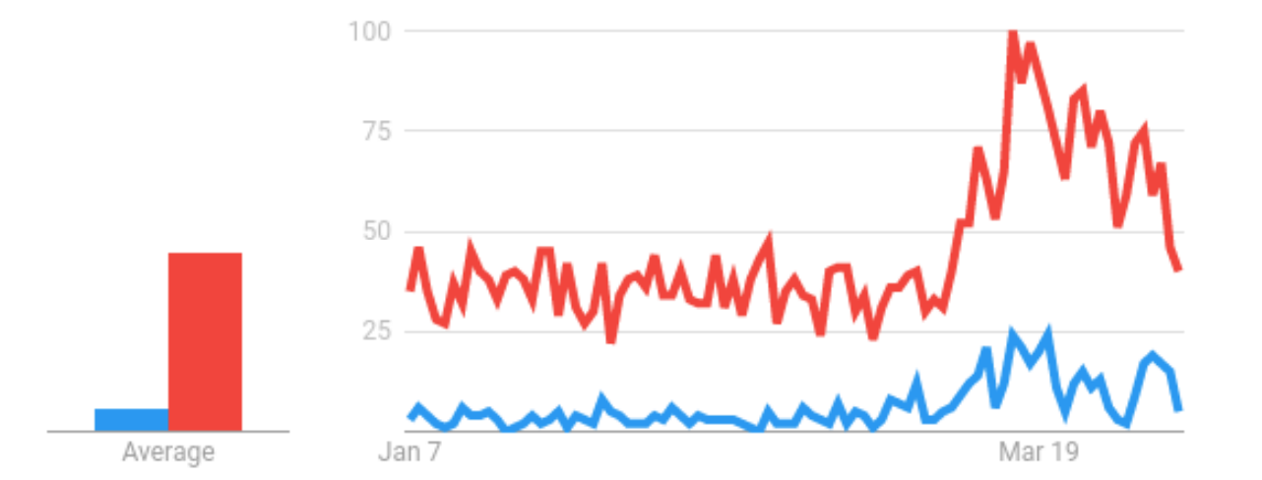

Figure 2: Weekly Active Users of DingTalk, Tencent VooV, and Lark from January 1st to October 30th, 2020
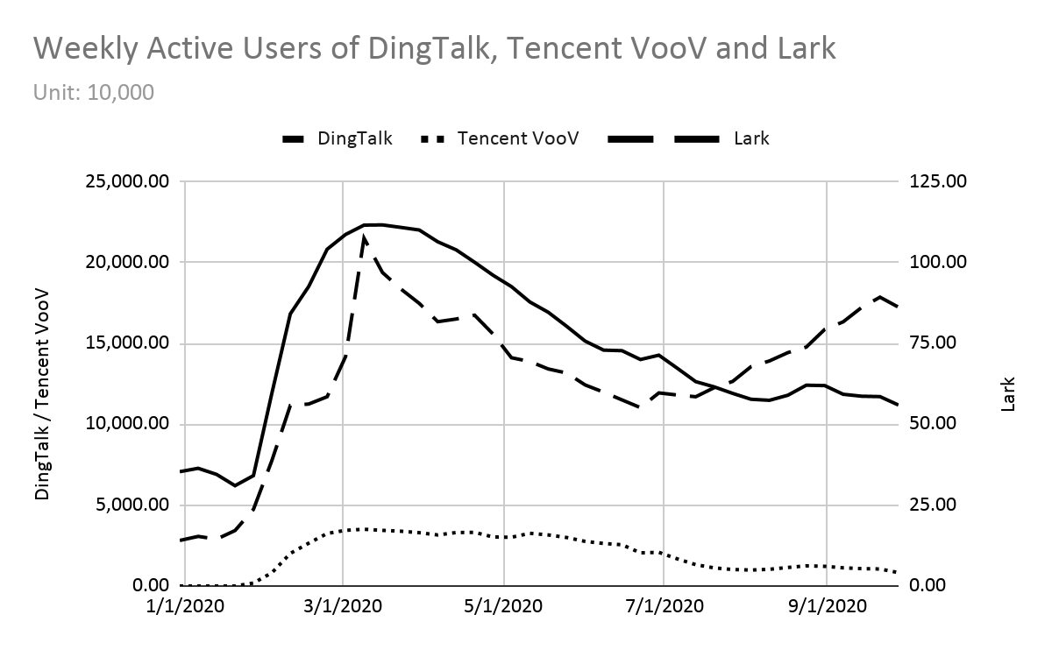
Table 1: Output of Multivariable Linear Regression Model
Linear regression
active_user | Coef. |  | St.Err. | t-value |  | p-value | [95% Conf |  | Interval] |  | Sig
population | .065 |  | .033 | -1.97 |  | .049 | 0 |  | .131 |  | **
user_scale | .023 |  | .002 | 12.69 |  | .000 | .02 |  | .027 |  | ***
k12 | .045 |  | .011 | 3.99 |  | .000 | .023 |  | .067 |  | ***
back_to_school | 2.12 |  | .402 | 5.27 |  | .000 | 1.332 |  | 2.908 |  | ***
disposable_income | .004 |  | .001 | -2.65 |  | .008 | .001 |  | .007 |  | ***
commute_time | 7.521 |  | 4.658 | 1.61 |  | .107 | -1.614 |  | 16.657
commute_distance | -21.25 |  | 12.395 | -1.71 |  | .087 | -45.558 |  | 3.058 |  | *
info_rate | -40.608 |  | 37.665 | -1.08 |  | .281 | -114.474 |  | 33.258
tertiary industry % GDP | 4.073 |  | 2.144 | 1.90 |  | .058 | -.132 |  | 8.277 |  | *
Constant | -346.66 |  | 117.507 | -2.95 |  | .003 | -577.106 |  | -116.214 |  | ***
Mean dependent var |  | 403.166 |  |  | SD dependent var |  |  | 387.094
R-squared |  | 0.536 |  |  | Number of obs |  |  | 2046.000
F-test |  | 261.082 |  |  | Prob > F |  |  | 0.000
Akaike crit. (AIC) |  | 28638.125 |  |  | Bayesian crit. (BIC) |  |  | 28694.361
*** p<.01, ** p<.05, * p<.1

Appendix A: Output of the Synthetic Control Methods
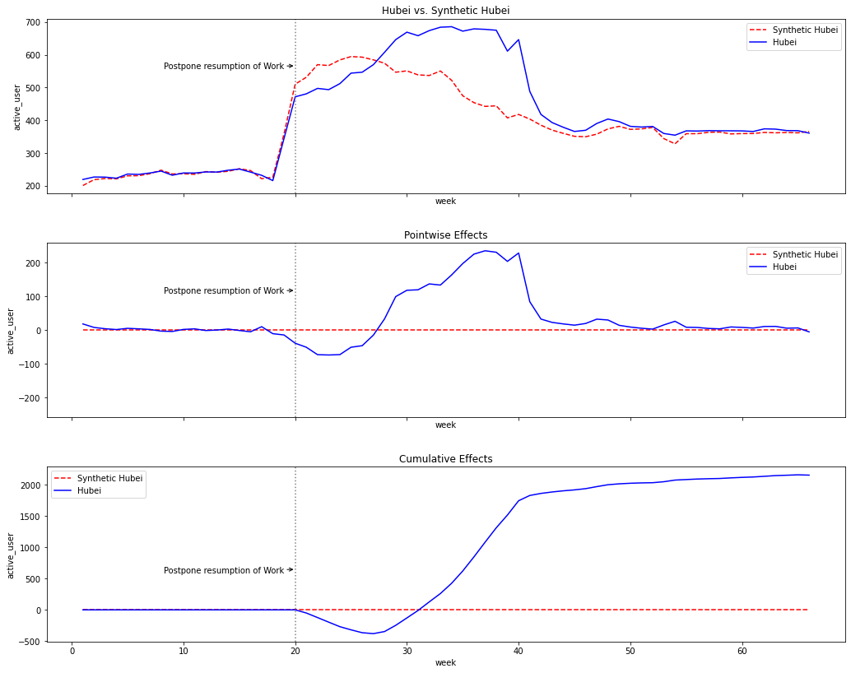
Appendix B: Validity Test
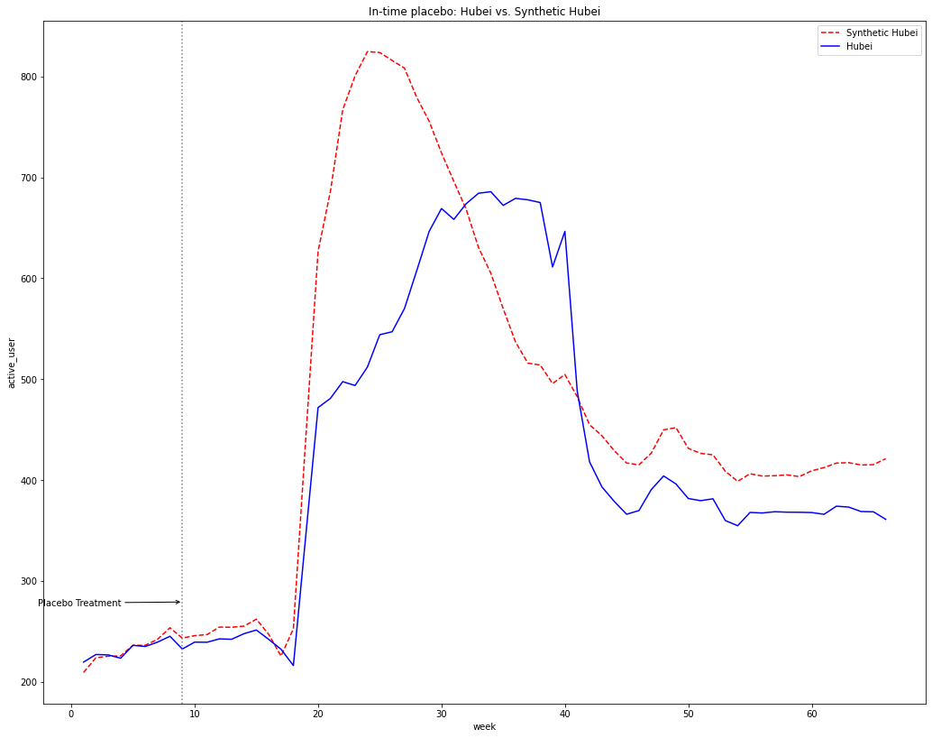

Appendix B – cont.
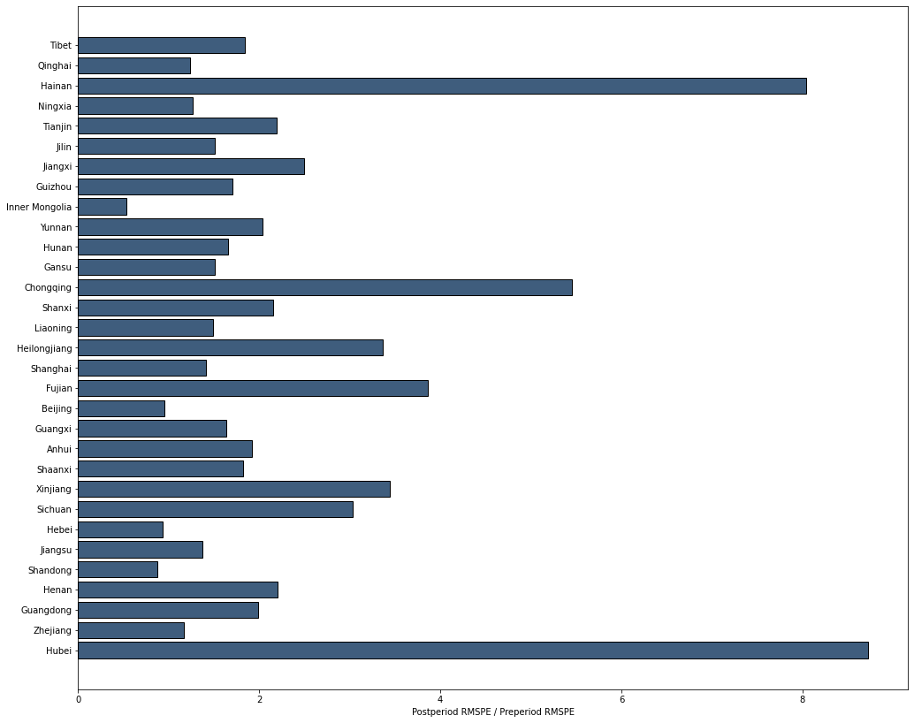

Source: https://www.smallbizgenius.net/by-the-numbers/remote-work-statistics/#gref
Source: https://www.ons.gov.uk/employmentandlabourmarket/peopleinwork/employmentandemployeetypes
Source: https://www.theguardian.com/technology/2019/nov/04/microsoft-japan-four-day-work-week-productivity
Source: https://meeting.tencent.com/buy.html
Source: https://36kr.com/p/1725145579521
Source: China Statistical Yearbook 2020 compiled by National Bureau of Statistics of China
Source: Official Website of DingTalk. Accessed on February 2nd, 2021.
Source: Public data
The package for the synthetic control methods was accessed via GitHub, contributed by Oscar Engelbrektson. https://github.com/OscarEngelbrektson/SyntheticControlMethods
Hainan and Chongqing should be discarded from the list of control units because their pre_rmspe is incredibly low. This indicates that some of the covariates of these two provinces are extremely lower or higher than the sample average.

