Factors Influencing User Usage of

Bike Sharing App in China

by

Yujia Ni

An honors thesis submitted in partial fulfillment

of the requirements for the degree of

Bachelor of Science

Business Honors Program

NYU Shanghai

May 2018

Professor Marti G. Subrahmanyam Professor Renyu Zhang
Professor Yiqing Lu

Faculty Advisers Thesis Adviser

Yujia Ni
Renyu Zhang
BUSF-SHU 3 Business Honors Program
May.10th, 2018

Factors Influencing User Usage of bike sharing App in China

Since the second half of the year 2016, bike sharing business, leading by Mobike and OFO, has been developing rapidly in China. Lots of research has been done on the business model of the bike sharing business and why such business can gain much popularity. However, little research has focused on the influence of market factors, such as promotion and financial- related news, on the user usage. This paper aims to fill the research gap. It uses estimated download numbers, user activity rate, and posts from Weibo. Following are the key findings: (1) promotion, such as free rides and red pockets, is the main driver of user usage; however, they become less effective in the long run; (2) financial-related news have a negative effect on user usage; (3) holidays and festivals have a negative effect on user usage; (4) the effect of new types of bike may depend on the usefulness of the bike or the release timing. Implications and limitations of this research will be discussed in the end.

- Introduction
Bike sharing business started in late 2014 and had been growing slowly since then. In April 2016, Mobike started its business formally in Shanghai. In the same year in October, OFO changed its business focus from university campuses to cities. Since then, the “battle between orange and yellow” started. Different kinds of marketing strategies were used to attract users, stimulate the consumption, and, the most important thing, get more market share. According to an industry report made by BigData- Research, a third-party data research institution, the total market share of Mobike and OFO is 91.3% (OFO has 51.2%, the largest market share; Mobike has 40.1%, ranking the second). (BigData, P16)
The sudden rise of bike sharing business attracts people’s attention. There are a lot of news, social media posts, and academic research online about this hot topic. Most of them focus on its development and social problems it caused, such as theft or damage of sharing bikes, or pay attention to its business model and profitability. There is also research about user satisfaction. Using a bivariate ordered probit (BOP) model, Guo and his colleagues find that users satisfaction degree is affected by user’s income and user’s perception of bike sharing. (Guo et al., P1) In another research, Ma and his colleagues identify the reasons why Chinese users recommend bike sharing apps. They find that the usefulness of the app and the trust of users are two main factors determining a user’s intention to recommend. (Ma et al., P779)
However, little research has been done focusing on the relationship between the user usage and marketing factors, such as promotion, financial-related news, and holidays or festivals. This paper aims at filling the research gap and tries to answer the following questions: whether do marketing factors have an influence on user usage? If so, how do they influence? Do they have a positive effect or a negative effect on user usage?
This research uses an aggregate approach. It compares the change of download numbers in App store and user monthly active rate with the occurrence of events. The data of download numbers and monthly active rate are from Qimai and TalkingData respectively. They are professional third-party mobile App data analysis companies in China. The occurrence of an event is recorded from news and Weibo posts posted by official Mobike and OFO accounts.
This paper is organized as follows. In Section 2, I will describe how data were collected and the methodology I used; Section 3 focuses on data analysis and key findings of the research; Implications and the limitation of this research will be discussed in Section 4 and Section 5.
- Research Methodology & Data
Data used for this research can be classified into two categories: one is the user usage data; the other is the occurrence of events. Because it is hard to convert the occurrence of an event to an actual number, this research uses crossing contrast, by observing the change of user usage data before and after the occurrence of an event, to study its effect on user usage.
For the user usage data, since Mobike and OFO haven’t released their data of users to the public, I collected data from two third-party mobile App data analysis companies, Qimai and Talking data. Qimai monitors the download ranking of Apps in both iOS and Android app stores, and, it calculates the estimated daily downloads of an App based on its ranking, related keywords, and the popularity of the keywords. TalkingData tracks the frequency of users opening an App, and converts the frequency to the monthly active rate of the App. The estimated daily download number measures how attractive the Apps is to the new user; the active rate represents the user loyalty of old users.
For the occurrence of events, this paper records event from Weibo posts posted by the official accounts of Mobike and OFO. The reason why this paper chooses Weibo as the main source data is that not only Weibo is one of the biggest social media platforms in China, but also it contains different kinds of information. Users make posts about their user experience; newspaper and mass media make comments and report news about social issue related to bike sharing business; more importantly, bike sharing companies create a new post as soon as there is an update about the company, such as promotion, investment information, and release of a new kind of bike. According to the Weibo posts, a chronology (See Table 1in the appendix) is made. Table 2 is the visualized version of it. The vertical cells are the months, and the horizontal cells are the dates. Different colors represent different kinds of events.
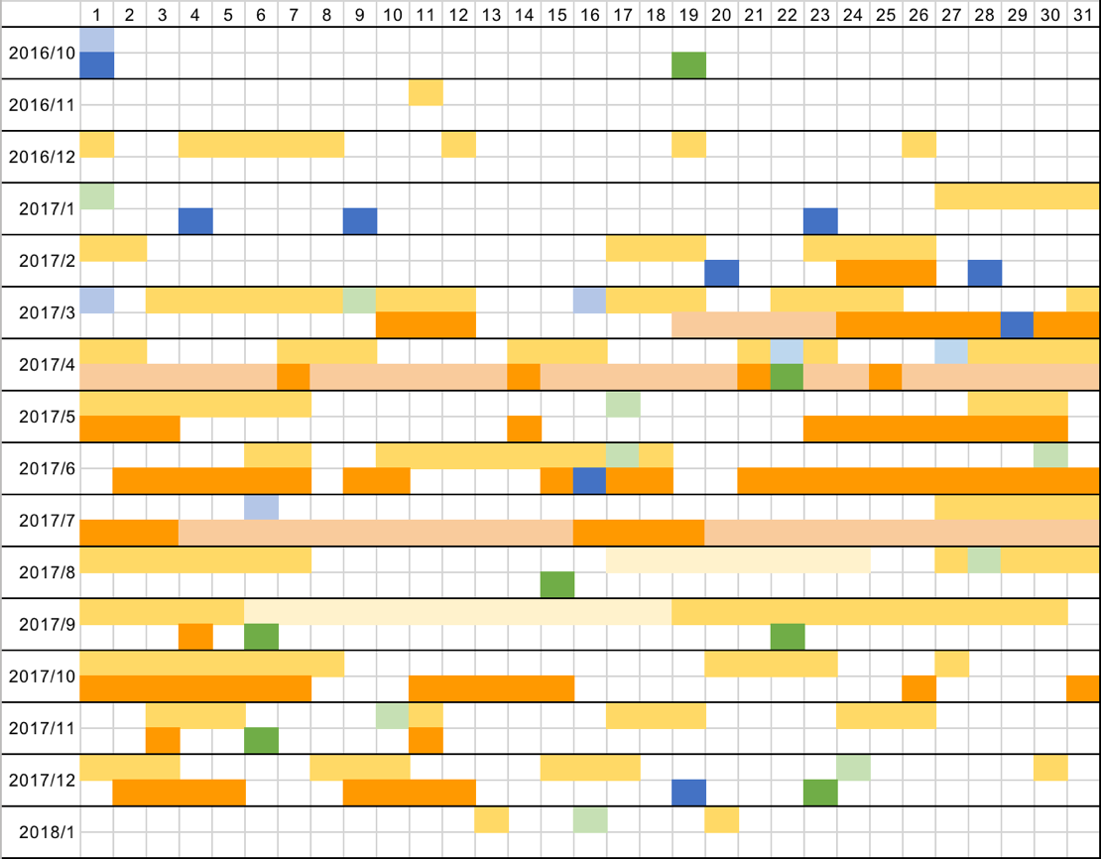
Table 2. Visualized Chronology of Mobike and OFO
Source: Weibo
- A block in yellow or orange means that there is a promotion on that day. A promotion
can be a free ride, red pocket, or free or discount monthly pass. Blocks in light yellow and orange represent the potential influence of monthly pass.
- A block in green means that there is a new type of bike released on that day. Mobike’s data is in dark green; OFO’s data is in light green.
- A block in blue means that there is a financial-related news on that day. A financial-related news is defined as a news about the funding or investment about the company or about a cooperation with other companies (e.g. DiDi) or App (e.g. Alipay, WeChat). Mobike’s data is in dark blue; OFO’s data is in light blue.

- Data Analysis
This paper tests following hypothesis: (1) Promotion, financial-related news, holidays and festivals, and the introduction of new kinds of bikes have impact on the user usage of the bike sharing Apps; (2) all of these factors should have positive influence of the user usage of the bike sharing Apps; they can increase the download number or the user active rate.
To test these hypothesizes, this paper compares the change of download number and the user active rate before and after an occurrence of an event. If the download number or the active rate increases after an event, the event has a positive impact on the user usage; if the download number or the active rate decreases after an event, the event has a negative impact on the user usage.

Promotion
Data in Table 3 shows the number of days with promotions in each month. If we compare the data in Table 3 with the changing trend of the download number and the active rate in Figure 1 and Figure 2, we can notice that the density of promotion is positively related with the user usage.
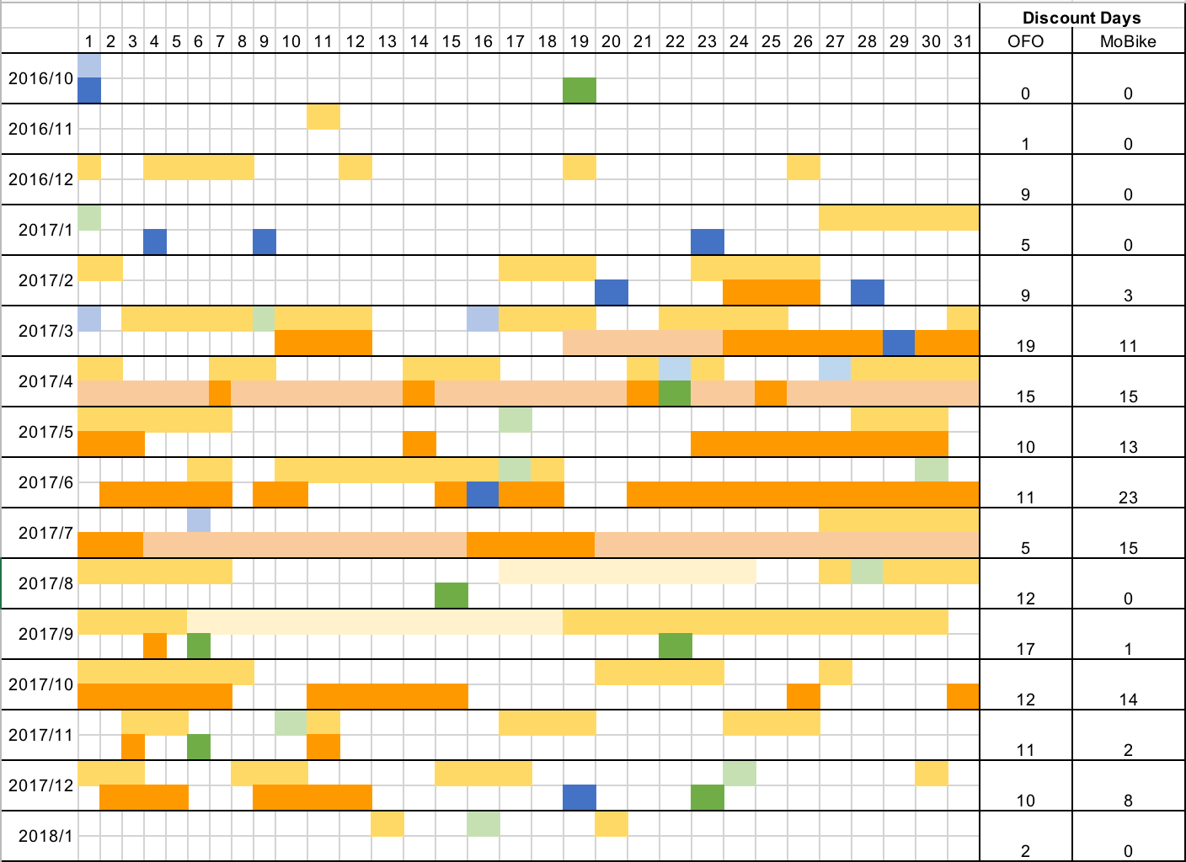
Table 3. Number of Days with Promotion Each Month
Source: Weibo
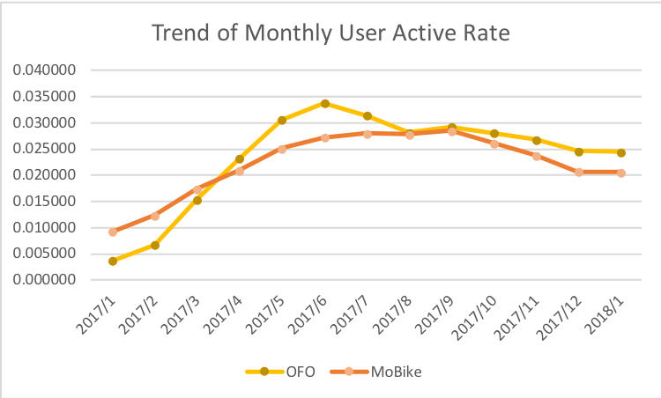
Figure 1. Trend of Monthly Active Rate

Source: Talking Data: http://mi.talkingdata.com/app/trend/115557.html

Figure 2. Trend of Estimated Monthly Download Number
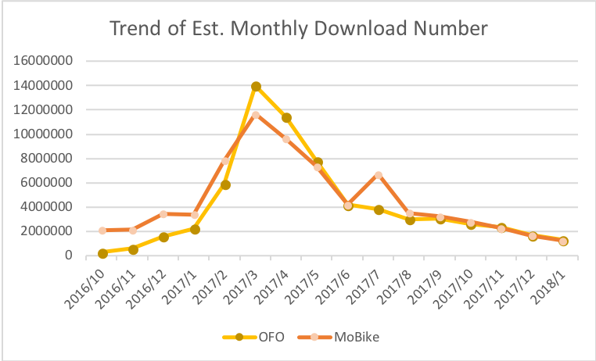
Source: Qimai: https://www.qimai.cn/app/downloadEstimate/appid/1044535426/; https://www.qimai.cn/app/rank/appid/1056015676/

We can observe from Table 3 that from February to July 2017, Mobike and OFO had a fierce promotion competition. During that period, both of them did high-density promotion including free rides and red pocket bikes; meanwhile, the download number and the active rate increased. There are 3 timing we need to pay more attention: March, April, and July 2017.
Since Mobike is the first one starting bike sharing business in cities, at the beginning its download number and active rate were higher than OFO which stepped into the market later. However, in Mid-March 2017, the estimated download number and the active rate of OFO for the first time exceeded Mobike’s. According to the record in Table 1 and Table 3, we can find that OFO offered more discounts. In March, there were 19 out of 31 days with free rides. Comparing to promotion intensity of OFO, the discount of top-up offered Mobike was not enough to attract people’s attention from free rides. The similar thing happened in July 2017 as well. At the end of June and the beginning of July 2017, Mobike, in total, released 300 million free monthly passes; meanwhile, there were no free rides offered by OFO during the same period. As a result, there was a significant increase in the estimated download number of Mobike and a decrease in the active rate of OFO in July.
The positive relation between promotion and user usage can also be proved by regression. Table 5 and Table 6 show the linear regression result, and we can see that number of days with promotion positively correlated with both download number and active rate.

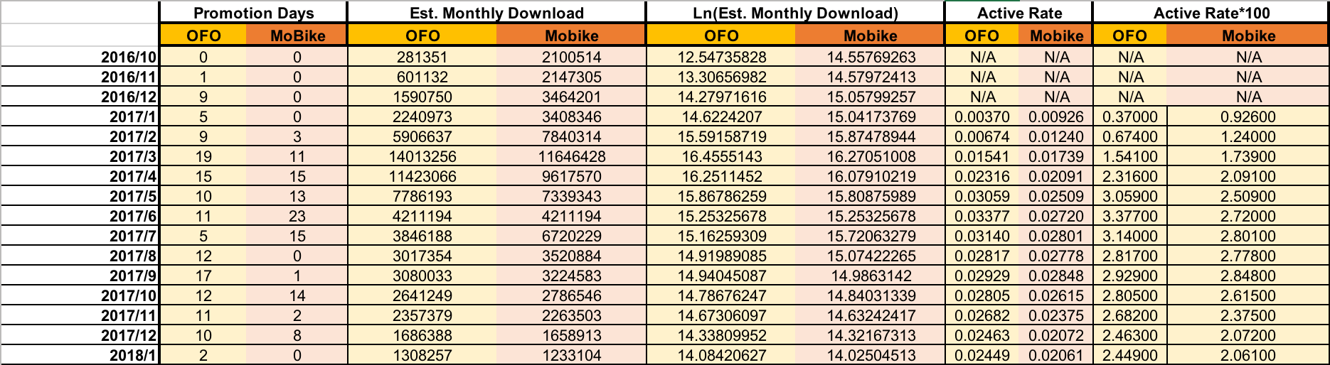
Table 4. Number of Days with Promotion, Est. Download Number & Active Rate

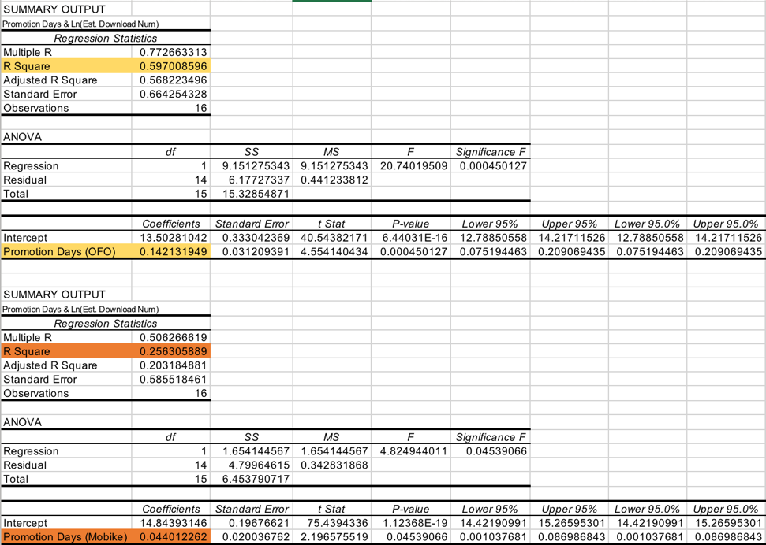
Table 5. Regression Result (Number of Days with Promotion & Ln (Est. Download Number))
Table 6. Regression Result (Number of Days with Promotion & (Active Rate * 100))
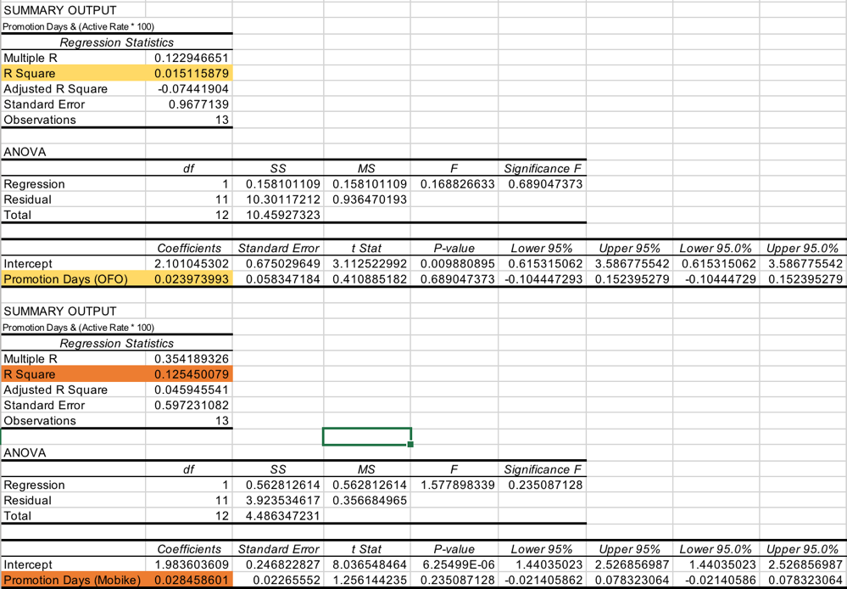
However, the promotion competition cultivated a mindset of the users: a better bike sharing app should offer more free rides. (Zou, P71) When users took free rides and discounts for granted but Mobike and OFO stopped their high-density promotions, the download number and the active rate suddenly dropped. Figure 3 shows how significant this effect was.
Figure 3. Trend of Estimated Download Number in App Store (From July 2016 to January 2018)
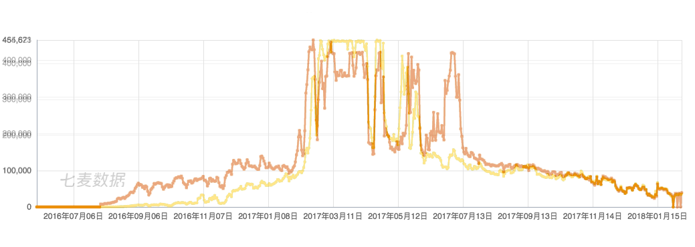
Source: Qimai
- Orange line represents Mobike; Yellow line represents Mobike
Promotions have a positive impact on user usage. If the density of promotion increase, more users will use the product or service; if the density decreases, fewer users will use the product or service. Therefore, promotion could be a good strategy to attract users or get more market share in the early stage, but it won’t be a good strategy in the long term to maintain user loyalty and profitability of the business.

Financial-Related News
The release of news is an event, and it is hard to convert an event to a number. To study the influence of financial-related news, this paper compares the user usage data before and after the occurrence of an event. If data increase after an event, it implies that this event has a positive effect on user usage; if the data decrease, it means that this event has a negative effect on user usage.
The analysis result shows that financial-related news has a negative impact on user usage, which rejects the previous hypothesis. Financial-related news refers to any news about funding, investment, and strategic cooperation with other companies or Apps. From Figure 4.1 and 4.2, we can see that for most of the time, the estimated daily download number decreased after a financial-related news was released.
On January 9th, 2017, Mobike announced that its user could unlock a Mobike using WeChat; two months later, on March 16th, OFO also made an announcement that its users could unlock an OFO bike using Alipay. Moreover, if the user has high enough credit score, he or she could use an OFO bike without paying the deposit. These two announcements brought lowered download number in the next few days, but a higher active rate of that month. Since nowadays users prefer better user experience, if there is a highly-integrated App, which has multiple functions, users will use this app instead of downloading other apps. For example, users can already use WeChat to chat, to social, and to make payments. If they can use sharing bike with WeChat, there is no need for them to download a bike sharing App. This may explain why download number decreased after Mobike and OFO connected with WeChat and Alipay respectively. However, the better user experience that users can use sharing bike without downloading any extra Apps helps bring up the monthly active rate and maintain user loyalty.
On January 4th and 23rd, Mobike got funding or investment from other companies, including Tencent and C-Trip. However, after the investment news released, the daily download number slightly decreased and there was no promotion on nearby dates. A similar situation happened after February 20th, when Mobike announced that it got its round D funding from Temasek Holdings. Even though the free ride from February 24th to 26th pushed the daily download number up, the number fell again on February 28th, when Mobike announced that it started strategic cooperation with China Merchants Bank. OFO has the same situation. In April and July, it announced that it received funding from other companies, including Didi and Alibaba, but its user usage data dropped after its announcements.
This finding rejects the previous hypothesis that investment-related news should have a positive impact on user usage. Generally speaking, got funding is a good news because it means that the company got the funding has the potential to grow or to make great profitability in the future. However, in fact, the download number dropped after an investment news was released. It may because that normal users either don’t care about financial news like investors or professional financial analysists or they see such news from a different angle. Since normal users need to pay a deposit to the bike sharing companies, they are very sensitive to how the cash of the companies flows. Whenever there is an investment news, they may be worried about how their money will be used. When users’ trust of a company decreases, it will be hard for a company to attract new users and keep old users as well.
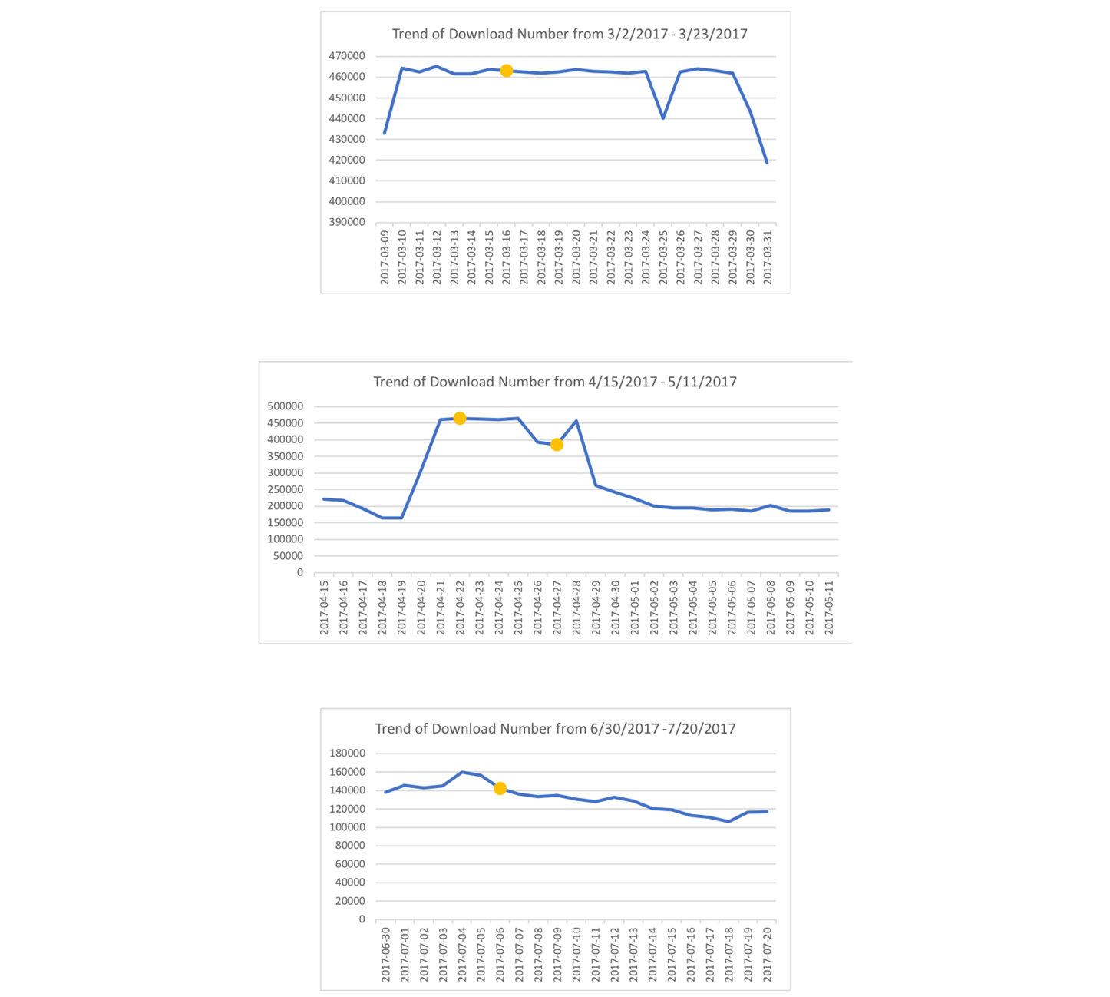
Figure 4.1 Changes of Download Number before and after the Release of Financial-Related News (OFO)

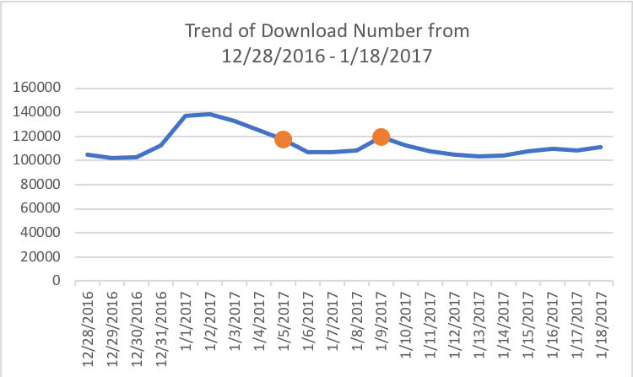
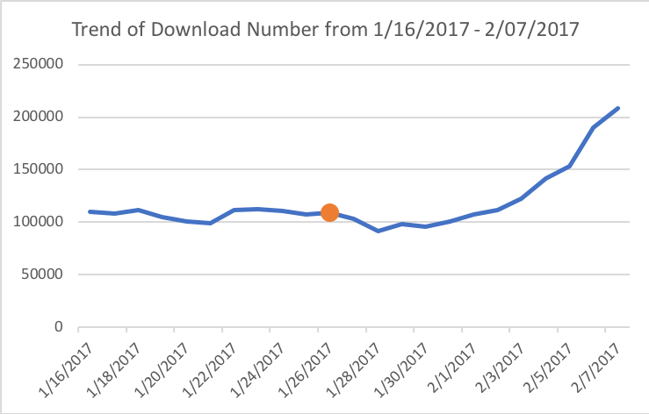
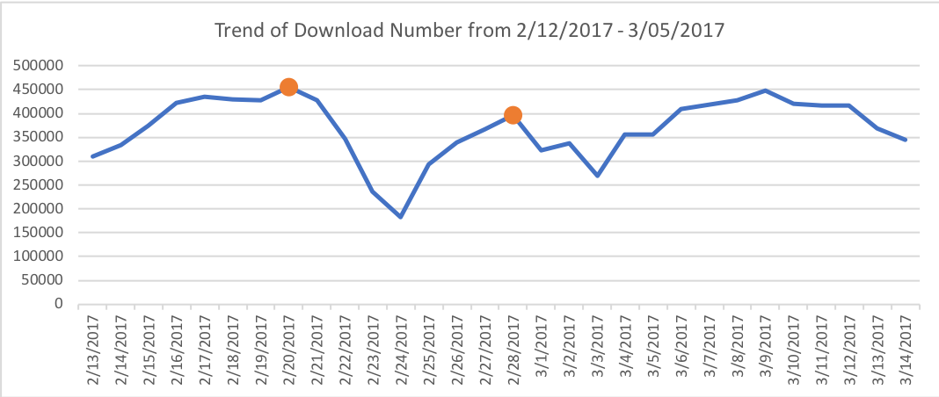
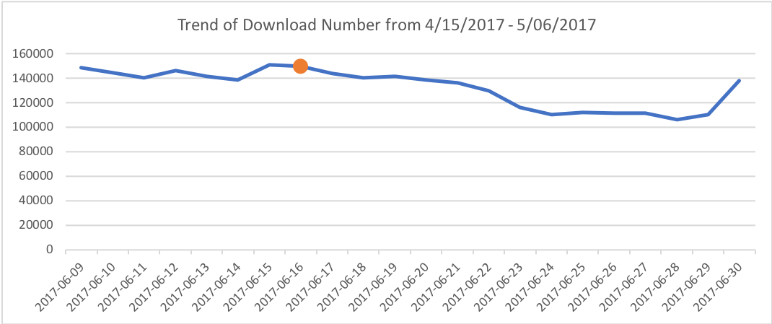
Figure 4.2 Changes of Download Number before and after the Release of Financial-Related News (Mobike)

Holidays & Festivals
The trend of decrease also happens when there is a holiday or festival. From Figure 5.1 and 5.2, after Mobike and OFO stopped their high-density promotion, we can observe that the daily download number during the holiday period was relatively lower than the download number on normal dates. Moreover, if we compared the monthly active rate, the months with a holiday usually had a lower active rate. Even though there were still promotions, such as free rides and red pockets, to stimulate user usage, in fact, such promotion could not hedge the negative effect of the holiday factors. It is probably because that during holidays or festival, people usually stay at home or travel with family members. They have less need for sharing bike as they do on weekdays when they need sharing bike to get to the metro station quicker.
Figure 5.1 Changes of Download Number Before and After Holidays and Festivals (Mobike)
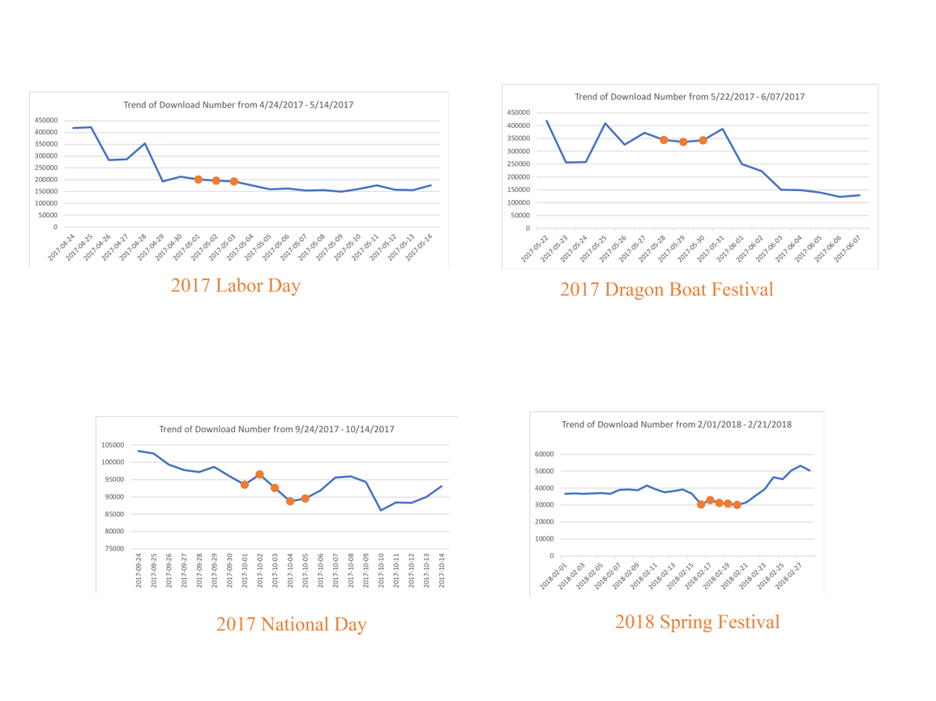

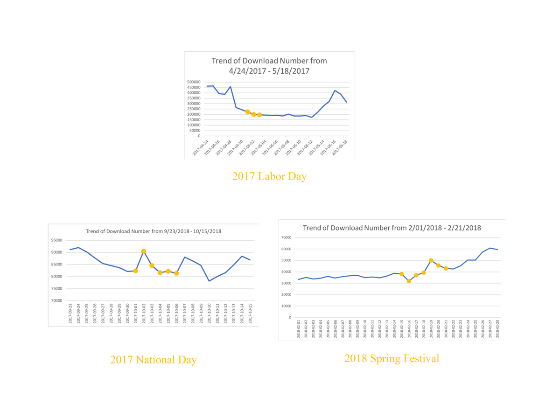
Figure 5.2 Changes of Download Number Before and Holidays and Festivals(OFO)

New Types of Bikes
This paper also researches the impact of new types of bikes on user usage. However, its impact is unclear. Sometimes the download number increased after a new type of bike was released. For example, the introduction of Feng Qing Yang from Mobike and Minions Yellow Bike from OFO elevated the daily download number. Sometimes the opposite happened. New Lite and Justice League Bike released by Mobike and the Princess Bike released by OFO all had a negative impact on the daily download number. Figure 6.1 and Figure 6.2 shows the changing trend of daily download number before and after the releases of new bikes.

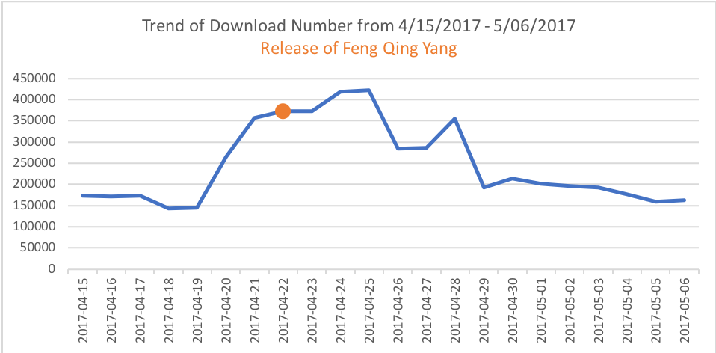
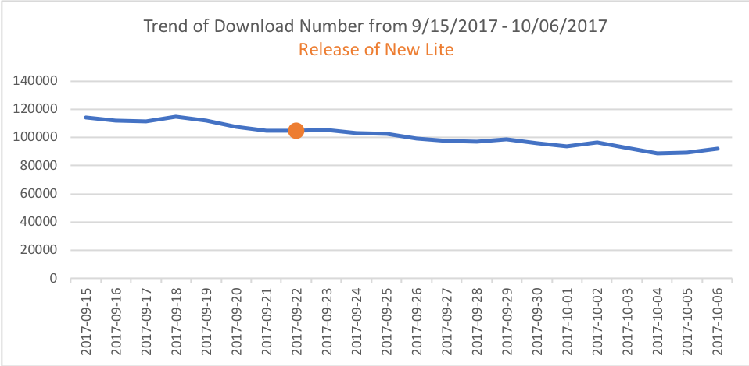
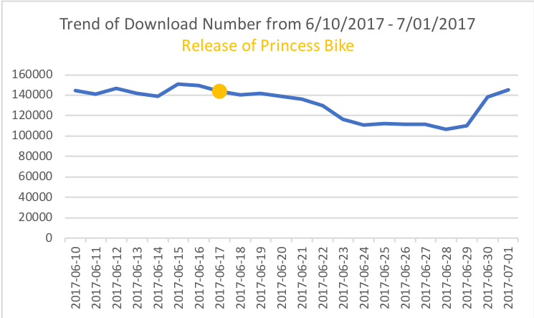
Figure 6.1 Changing Trend of Daily Download Number (Release of Functional Bike)

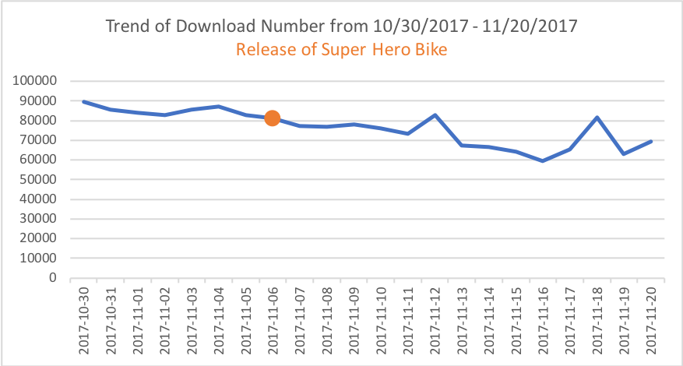
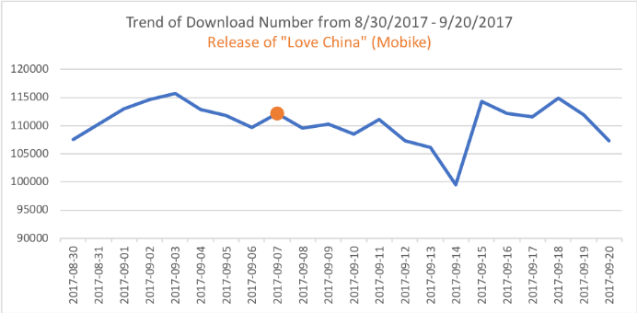
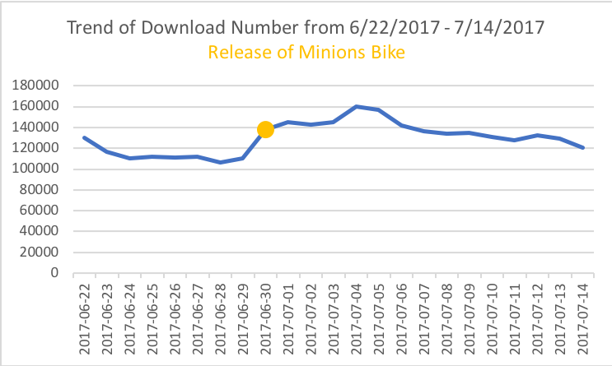
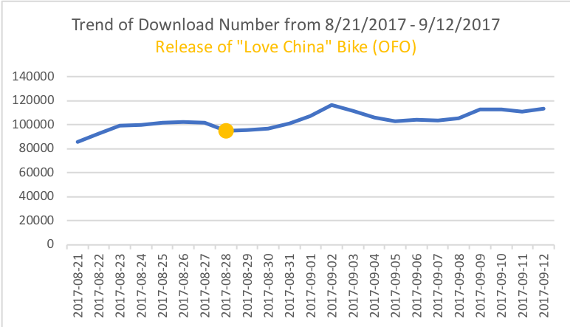
Figure 6.2 Changing Trend of Daily Download Number (Release of Bike with Special Themes)

There are two possible factors influencing user usage: one is the usefulness of the new bike; the other is the appearance of the new bike.
Feng Qing Yang and New Lite from Mobike and Princess Bike from OFO are bikes with improved functions. For this kind of bike, the one with significant improvement could attract more user. Take Feng Qing Yang as an example. On the launch event, Mobike marketed it as the fastest, lightest and most comfortable bike in the market. Mobike also invited an audience to lift its new bike high, and the young lady made it without difficulty. Since the weight of Feng Qing Yang was remarkably reduced, this new type of bike improved the biking experience and increased user satisfaction, resulting in a higher download number.
The Justice League Bike from Mobike and Minions Yellow Bike from OFO are designed with the theme of popular films and are decorated with an attractive appearance. For this type of bike, the one first released into the market could gain more user. At the end of June 2017, OFO first released bikes with a specific theme. It combined the appearance of Minions, its featured big eyes with OFO bikes. Since such combination was fresh to the market, it quickly attracted a lot of people’s curiosity and attention. There were many users showing off that they found or rode a Minions bike on social media. The same situation happened when Mobike and OFO both released their “Love China” Bike. OFO released its version in August, while Mobike released its version in late September. We can see from Figure 6.2 that OFO enjoyed an increase in download number, while Mobike experienced a decrease. However, after that, bikes with special themes, the Justice League Bike and the Pokémon Bike, didn’t receive as much attention as the Minions bike. Users gradually got familiar with such marketing strategy, therefore, the effect of it became less and less obvious.

- Conclusion & Implications
Nowadays, the scale of the sharing economy in China has been expanding. Despite OFO and Mobike, more and more companies have joined into the battlefield of sharing traveling. For example, Meituan, an App used to focus on group purchase and food delivery, started taxi business and tried to compete with DiDi, a dominant traveling App in China.
However, bike sharing business has been in the market for two years, and it already stepped into the decline stage of its product life cycle (See Figure 7.1). However, the two biggest players in the market, OFO and Mobike, are still using traditional “burn money” method, such as continuously putting bikes into the market and offering free rides or discounted monthly passes, to maintain their business. However, such way didn’t help them capture new customers. What’s worse was that both of the companies couldn’t maintain user loyalty because their product and promotion strategies are too similar to each other. Users would always choose the one offering free or cheaper service. Moreover, announcing financial related news would bring negative impact on user usage.
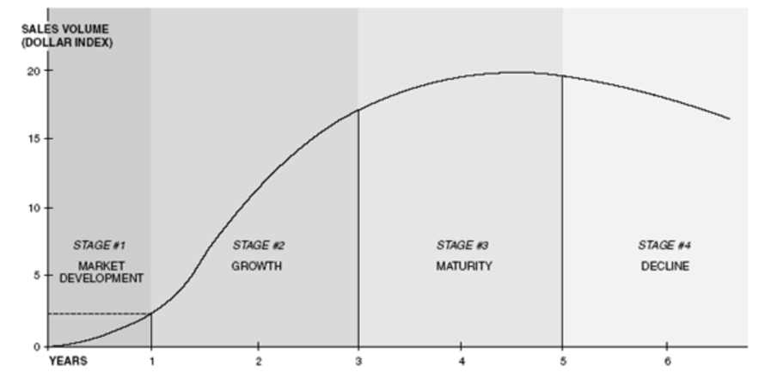
Figure 7.1 Normal Product Life Cycle
Source: HBR: Exploit the Product Life Cycle https://hbr.org/1965/11/exploit-the-product-life-cycle
Figure 7.2 Hypothetical Product Life Cycle
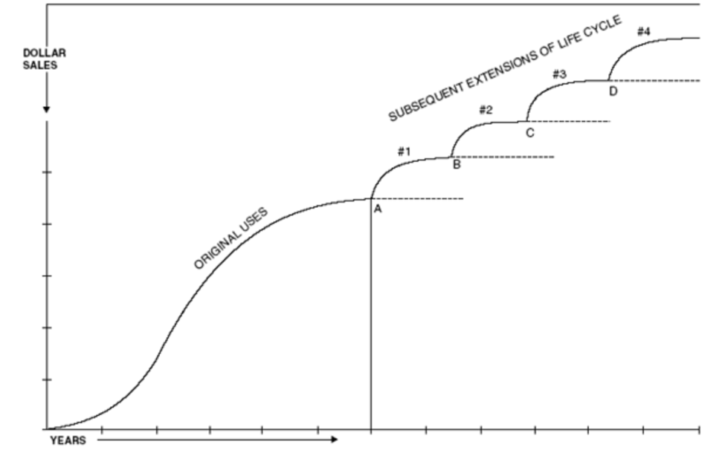
Source: HBR: Exploit the Product Life Cycle https://hbr.org/1965/11/exploit-the-product-life-cycle
To step out of the decline stage and extend the product life cycle, bike sharing companies should use money in the right place. Instead of continuing the “burn money” strategy, companies need to think of new marketing strategies to attract potential new users and maintain the user loyalty of old users. To attract new users, companies should do more market research and study user insights before they launch a new type of bike or do a market promotion. Companies can test how usefulness potential users think a new bike is and when and where they will likely accept a new promotion. To maintain high user loyalty, companies can hold different kinds of activities to create and tighten the bond between users and the brand. For example, companies can organize offline activities like one-day biking trip or create online activities to encourage users to ride more. As long as users’ trust and satisfaction of the brand increase, users would commit to use the product or even recommend to others. It is important for a company to know that committed customers stay longer. (Hill, P17)
- Limitations & Future Research
First, data used to measure user usage (download number in App store and monthly user active rate) are second-hand data from third-party data analysis companies. If the bike sharing companies opened their data to the public, future research should be based on these primary data. Secondly, since bike sharing business officially started development in 2016, this research only covers the data from October 2016 to January 2018. There are not enough data in the database. Future researchers need to collect more data to do further analysis. Third, factors studied in this research, such as promotion and investment news, are a small fraction of all the possibilities. Future research can study how other possible factors (e.g. government control, weather, temperature, workday and weekend effect, and the potential influence from the competitors etc.) influence user usage and why they have a positive or negative impact on user usage.

Appendix

Table 1. Chronology of Mobike and OFO
 | OFO | Mobike
2014 | OFO was found
2015 | June, started business in university campus  October, got pre-A funding | Mobike was found  End of October, got round A funding
2016/01 | Got round A funding
2016/02
2016/03
2016/04 |  | Launched in Shanghai
2016/05
2016/06
2016/07
2016/08 | Got round A+ funding | Got round B funding
2016/09 | Got round B funding and investment from DiDi | Got round B+ and C funding
2016/10 | Got round C funding | Got round C+ funding  10/19 released new bike: Mobike Lite
2016/11 | Expand to cities  Gifts on 11/11
2016/12 | 12/1 free ride  From 12/5 free ride every Monday  12/4 – 12/8 riding coupon for free  12/24 – 12/25 offline Christmas activity in Beijing and Shanghai  12/26 released free travel coupon with DiDi
2017/01 | Released the first generation of smart lock  1/27 – 2/2 Spring Festival free ride | 1/4 got round D funding  1/9 User can use Mobike on WeChat  1/23 Strategic investment
2017/02 | 2/17 free ride for the whole weekend  2/23 students and teachers can get free month pass for free  2/23 – 2/26 free ride | 2/20 got D+ funding  2/24 – 2/26 free ride  2/28 Strategic cooperation with China Merchants Bank
2017/03 | Got round D funding  3/3 – 3/5 free ride  3/6 – 3/9 free ride during rush hour  3/9 released new bike: OFO Curve  3/10 – 3/12 Tree Planting Day free ride  3/16 Cooperation with Zhima Credit user don’t have to pay the deposit if he or she has enough credit score  3/17 – 3/19 free ride | 3/10 – 3/12 Tree Planting Day free ride  3/19 Top up RMB100 and have extra RMB110  3/24 released “Red Pocket” bike  3/29 connected to WeChat Wallet
2017/04 | Free ride on every Friday, Saturday and Sunday  4/22 got D+ funding  4/17 connected with DiDi  4/29 – 5/1 Labor Day free ride | 4/7 Amount of red pocket doubled  4/14 Amount of red pocket doubled  4/21 Amount of red pocket doubled  4/22 Released new bike: Feng Qing Yang  4/25 Amount of red pocket doubled
2017/05 | 5/1 – 5/7 Labor Day free ride  5/7 release red pocket  5/28 – 5/30 Dragon Boat Festival free ride | 5/1 – 5/3 Amount of red pocket doubled  5/14 Mother’s Day top up RMB300 and get RMB514  5/23 – 5/30 Dragon Boat Festival collect sticker and get red pocket
2017/06 | 6/6 - 6/7 Gaokao free ride  6/11 - 6/18 free ride  6/17 released new bike: Princess bike  6/20 new user need to pay 199 RMB deposits instead of 99  6/30 released new bike: Minions | 6/2 – 6/6 gift for game King of Glory and red pocket  6/3 pay less with WeChat Pay  6/6 - 6/7 Gaokao free ride  6/9 – 6/11 collect stickers and get red pocket  6/16 got round E funding  6/15 – 6/18 free ride  6/18 send gift with Jingdong  6/21 New users can get free ride for the first 6 rides  6/26 – 6/28 free ride  6/29 10 million free monthly passes
2017/07 | 7/6 got 700 million funding  7/27 – 8/7 free monthly pass | 7/1 20 million free monthly passes  7/16 – 7/20 gifts and red pockets with VipShop  7/21 90% off monthly pass & quarterly pass for 5 RMB
2017/08 | 8/7 – 8/13 free ride  8/8 connected with Gaode Map  8/17 monthly pass for 1 RMB  From 8/17 released free monthly pass with other Apps or games  8/27 – 9/5 collect stickers and get red pocket  8/28 released new bike: Love China | 8/15 released new bike: Minnie Mouse
2017/09 | released free monthly pass with other Apps or games  9/19 – 10/1 collect stickers and get red pocket | 9/4 user get discount if user WeChat Pay  9/6 released new bike: I Love China  9/22 released new bike: New Lite
2017/10 | 10/1 – 10/8 free ride  10/20 – 10/23 red pocket  10/27 user can get red pocket if ride during specific time period | 10/1 – 10/7 Amount of red pocket doubled  10/11 – 10/15 free monthly pass  10/26 free monthly pass and extra red pockets  10/31 zombie bike with extra red pockets
2017/11 | 11/10 released new bike: Pokémon  11/11 red pocket and free monthly pass  Every Friday user can get red pocket if ride during specific time period | 11/3 connected to QQ free monthly pass  11/6 released new bike: Justice League
2017/12 | Every Friday user can get red pocket if ride during specific time period until 12/15  12/24 Père David's deer bike | 12/2 – 12/5 collect stickers and get red pocket  12/12 collect stickers and get red pocket  12/23 released new car: Christmas New Lite
2018/01 | 1/12 Tecent news released that OFO had problem with its capital chain  1/12 special offer  1/16 new bike released: Kumamon

Work Cited
Hill, Nigel, and Jim Alexander. “Chapter 3: Loyalty”, The Handbook of Customer Satisfaction and Loyalty Measurement, Taylor & Francis Group, 2006. ProQuest Ebook Central.
Ma, Liang, Xin Zhang, and Gao S. Wang. "Identifying the Reasons Why Users in China Recommend Bike Apps." International Journal of Market Research, vol. 59, no. 6, 2017.
Guo, Yanyong, et al. "Identifying the Factors Affecting Bike-Sharing Usage and Degree of Satisfaction in Ningbo, China." PLoS One, vol. 12, no. 9, 2017. ProQuest.
Levitt, Theodore. "Exploit the Product Life Cycle." Harvard Business Review., 01 Aug. 2014. Web.
2016中国共享单车市场研究报告. Rep. BigData-Research, 2017. Web.
Zou, Lingyuan. “稳住”共享单车的用户. 现代企业文化(上旬) Modern Enterprise Culture 7 (2017): 70-71. Print.

Battle between Orange and Yellow: the color of Mobike is orange, while the color of OFO is yellow.
Tencent: one of the largest Internet service providers in China
C-Trip: a popular online ticket service company in China

