The Socio-political-economic Factors

Driving Deforestation in the Brazilian Amazon

by

Qianchun Yuan

An honors thesis submitted in partial fulfillment

of the requirements for the degree of

Bachelor of Science

Business and Economics Honors Program

NYU Shanghai

May 2020

Professor Marti G. Subrahmanyam Professor Rodrigo Zeidan
Professor Christina Wang
Professor Jens Leth Hougaard

Faculty Advisers Thesis Adviser

Abstract
This project is aimed at identifying important socio-political-economic factors that drive up the deforestation rate in the Brazilian Amazon. Relying on the annual recordings on forest cover change of 498 out of 760 municipalities that form the region called Legal Amazon, from 2002 to 2017, I build a municipality-level panel data on deforestation along with potential climatic, economic and political driving factors. The econometric results indicate a statistically significant association between deforestation and precipitation, value added of agriculture, as well as the area size for soybean cultivation. However, no significant impact from a tight election or local mayor’s party relationship with the central government is revealed.

Introduction
Among the 17 Sustainable Development Goals in the 2030 Agenda for Sustainable Development, 6 are, somehow, related to forests: no poverty, zero hunger, clean water and sanitation, affordable and clean energy, climate action, and life on land (Tumusiime et al. 138). In the case of the Amazon region, the rainforest is closely associated with the water cycle and biodiversity of surrounding regions. The biomass there also “holds about 100 billion tons of carbon,” “equivalent to more than 10 years’ worth of global fossil-fuel emissions,” making it a crucial component in alleviating climate change (Davidson et al. 321). However, at the same time, the Amazon rainforest also has great potential to support economic development, and thus to improve the welfare of local people.
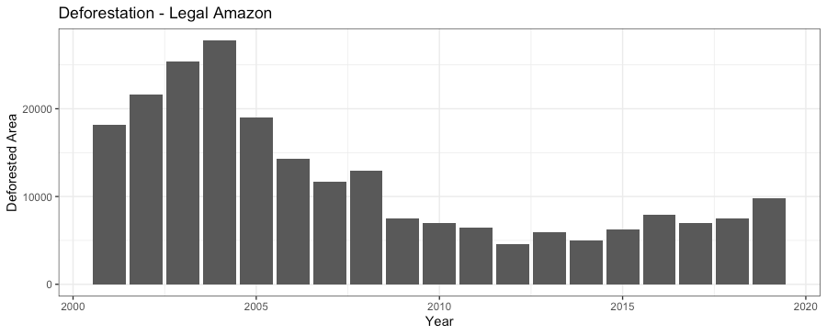
Fig1: Deforestation in Legal Amazon from 2001 to 2019. Source: TerraBrasilis.
The deforestation of Amazônia Legal, also known as Brazil's Legal Amazon, has been a major issue for decades. Even though deforestation rates have fallen in the 2010s, there is discouraging news moving ahead. In 2019, the deforestation rate has been the highest since 2008 as shown in Fig 1, and 30% higher than 2018. The conflict between conservation and development has no simple solution. But for a correct analysis of the tradeoffs between the two, we need a correct diagnosis of the main drivers of deforestation.
This research is therefore designed to disentangle part of this complex issue by identifying the key socio-political-economic factors that potentially drive the deforestation of Brazilian Amazon, and hopefully offer some insights in balancing ecological conservation and economic development. Starting from detailed data on deforestation in each of the 760 municipalities located in Amazonia Legal annually from 2000 to 2018, the research will look into the connection between deforestation and several socio-political-economic factors at municipality level, with a special focus on the impact of mayoral election conditions and the political relationship between the local and central government. This focus is justified by the rising concern about the political forces in Brazil and findings on the notable impact of elections on deforestation. The project would like to extend the research effort by exploring another two specific mechanisms in which political forces affect deforestation, namely tight election or party affiliation.
The data employed is composed of two major parts: the dependent variable, namely deforestation, and potential driving factors in three categories: climatic, economic and political. A two-way linear fixed effects regression model is utilized to do the analysis. The results suggest a significant correlation between deforestation and factors including precipitation, temperature, value added of agriculture, GDP per capita, as well as the area size for soybean cultivation. But it fails to find significant impact from a close election or party relationship with the central government.

Literature Review
Numerous researches have been done on different scales to study the factors driving deforestation. Studies at national level that involve dozens of countries attribute deforestation to urban population growth, agricultural exports (DeFries et al.), or commercial agriculture (Hosonuma et al.). In their study using global Google Earth imagery, Curtis et al. further claim that “27 ± 5% of all forest disturbance between 2001 and 2015 was associated with commodity-driven deforestation.”
In the Amazon area specifically, although there is already a shared consensus on the impact of economic development, especially agriculture, different researches focus on different aspects of agriculture. Barona et al. for example, focus on the dynamics of Brazilian soy industry expansion versus the expansion of cattle ranching. There are also findings on the impact of global market of agricultural products in particular. Laurance’s research suggests that the rising price for soy, due to the United States’ switch to corn, promotes deforestation in Amazonian forests and savanna-woodlands. On top of it, the exchange rate of dollar and Brazilian local currency is also found relevant to deforestation due to its interlinkage with commodity prices (Richards et al.). Further efforts are even devoted to take advantage of the globalization of agricultural products and find opportunities for conversation (Nepstad et al.). Therefore, I consider it necessary to include economic indicators in different aspects in my analysis.
Politically, there are studies suggesting factors like elections are also potential driving forces for deforestation, especially in Brazil. Using a panel dataset at Brazil’s municipal level from 2002 to 2012, Pailler identifies an 8-10% increase of deforestation rate “when an incumbent mayor runs for re-election”, interpreting it as linked to corruption and campaign finance. More generally speaking, Rodrigues-Filho et al. show in their study with state-level time series data from 1990 to 2011 that the highest deforestation rates in some years, which are unexplainable by conventional factors, “correlate with large administrative shifts caused by presidential elections.” They argue that “although institutional vulnerability immediately after major elections in Brazil is an acknowledged fact,” it is not considered a possible driver for deforestation and is actually worth more attention.
Therefore, I decide to focus on the economic and political factors at the same time to disentangle some of the connections. By focusing on the economic and political drivers of deforestation, I am not meant to neglect the impact of factors including transportation networks (Fearnside; Alves; Laurance et al.), property rights (Paneque-Gálvez et al.; Araujo et al.) or deforestation control policies (Angelsen; Tacconi et al.). Instead, I would like to reveal some socio-political-economic conditions favoring the constructions of roads, the insecure property rights or the loose mitigation policy and enforcement, which ultimately contribute to deforestation in the Amazon area and ecological crises in the aftermath.
Furthermore, non-human factors like climatic factors, have dynamic interaction with deforestation as well (Da Silveira et al.). Therefore, I include them in the model as control variables.

Data Collection and Process
The key dataset which I start with has the annual recordings on the size change of areas covered by forest in 760 municipalities in Amazônia Legal during the period of 2000-2018. The datasets on potential factors that might contribute to deforestation are added to this main dataset. Therefore, the original integrated form of data also has 760*19=14,440 observations, with each observation corresponding to a one-year recording of a given municipality. However, due to the unavailability of data in some municipalities, the panel data analysis only focuses on 7,968 observations covering 498 municipalities in 8 out of 9 states, excluding Rondônia, from 2002 to 2017. The detailed reasons for such choice are discussed below.
All the datasets used are derived from corresponding Brazilian statistical agencies.

3.1 The dependent variable
This deforestation recording dataset originally has variables recording areas of accumulated deforestation, annual incremental deforestation (Increment), remaining forests (Forest), water bodies etc. In the empirical analysis, the Defor_incre, namely deforestation increment rate, is treated as the key dependent variable, calculated in the following way:
Defor_incre = Increment / Forest in last year *100
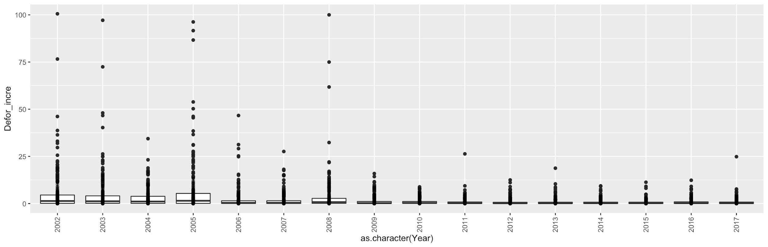
Fig 2: Distribution of Defor_incre for 7,968 observations in each year.

3.2 The potential drivers of deforestation
I divide the variables into three categories: climatic, economic and political. The analysis focuses on the impact of economic and political factors while the climatic factors are included for control purposes.

3.2.1 Climatic Factors
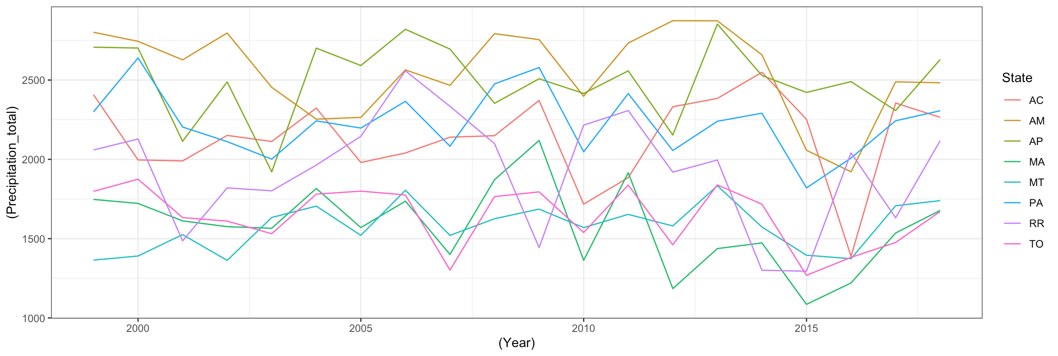
Each state in Brazil has multiple stations that monitor meteorological conditions, but the number of stations is far smaller than the number of municipalities. Therefore, I averaged the monitored data from different stations in each state and used the same averaged number for all municipalities in the same state. Among all monitored variables, I choose total precipitation in millimeter (Precipitation_total) and average compensated temperature in degrees celsius (Temp_compensated) to be the representative indicators. The distributions of both variables are shown below. However, as there are no stations in the state of Rondônia, the whole state is excluded in the regression analysis.
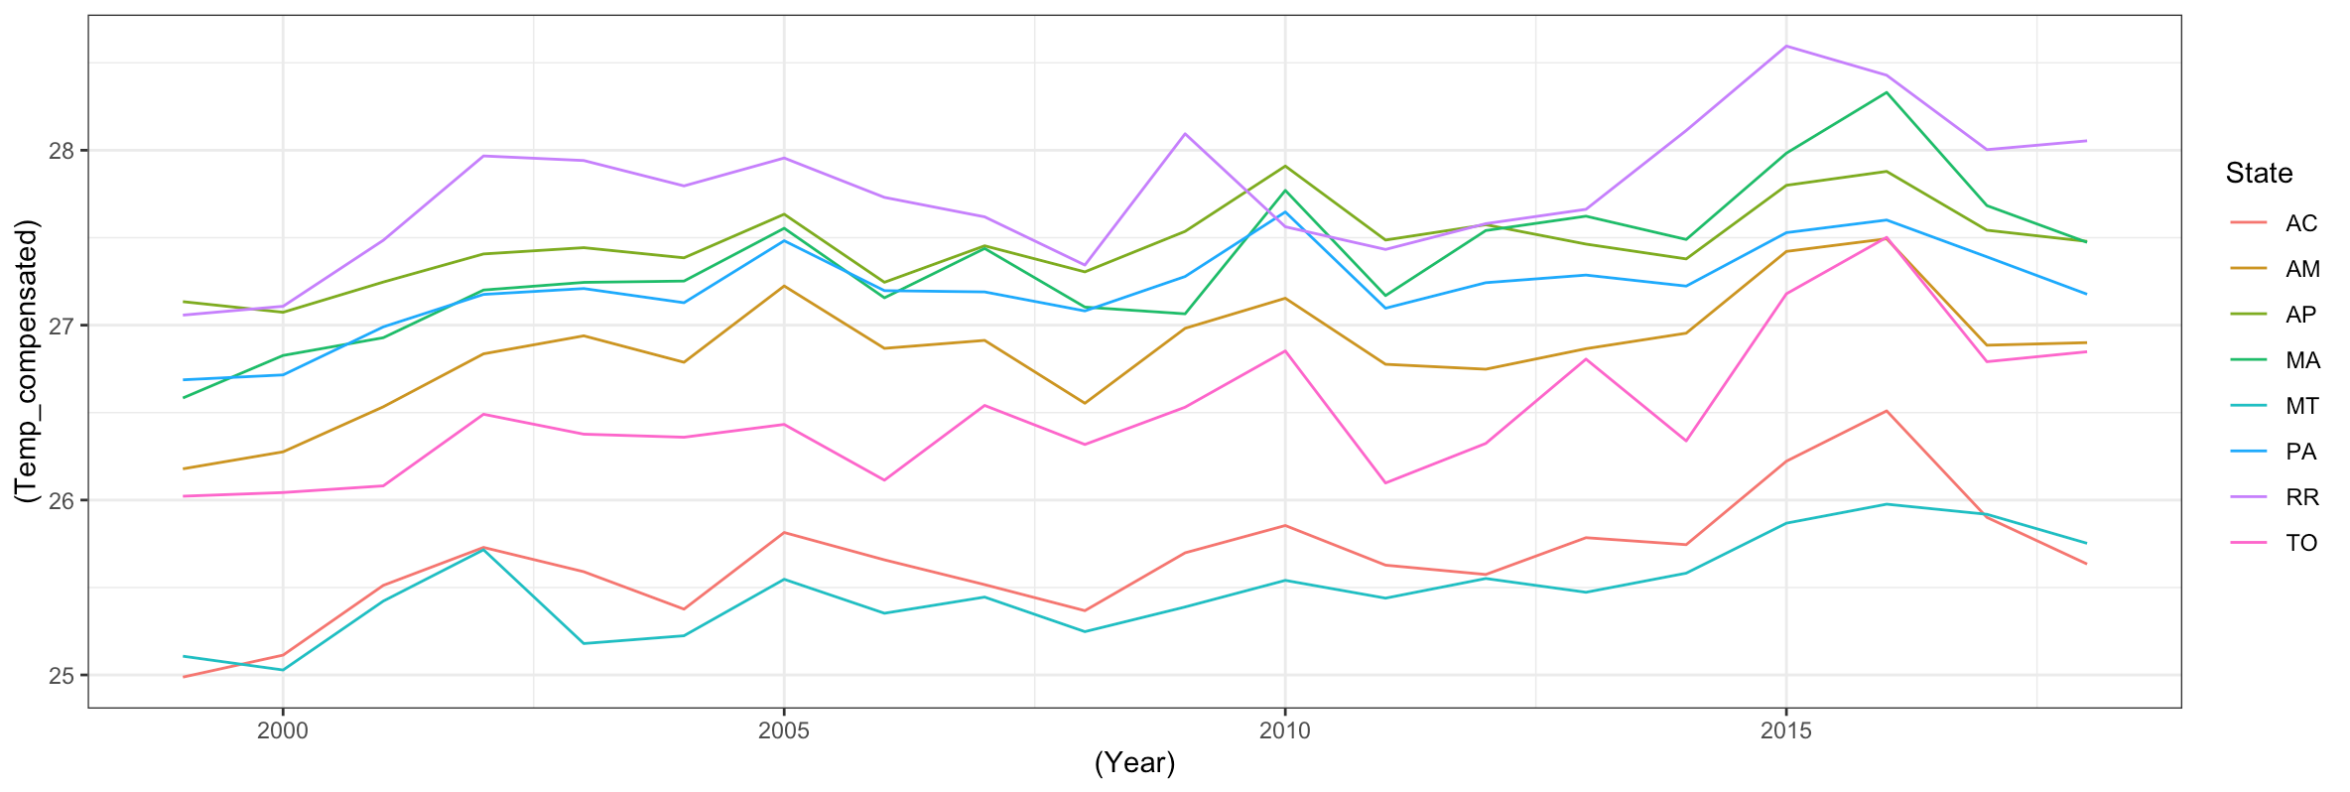
Fig 3: Distribution of total precipitation (in millimeter) and average compensated temperature (in degrees celsius) for each state in each year.

3.2.2 Economic Factors

3.2.2.a Macroeconomic indicator
The macroeconomic indicators collected include variables on the value added for each main sector, taxes, GDP as well as GDP per capita (GDP_pc). Due to the high correlation among the variables, I only include the value added of agriculture (VA_agriculture) and GDP per capita (GDP_pc) in analysis. Figure 4 shows the distribution of two variables and their logarithmic values. Due to the high skewness of the original values, logarithmic values are used in the regression model. As the data only covers 2002-2017, the final analysis is limited to this period as well.
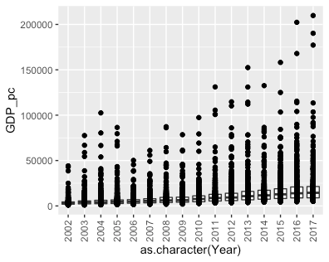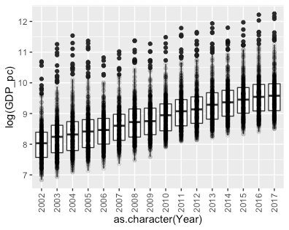
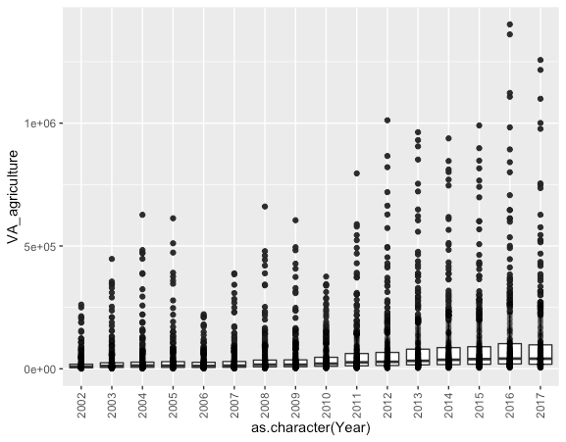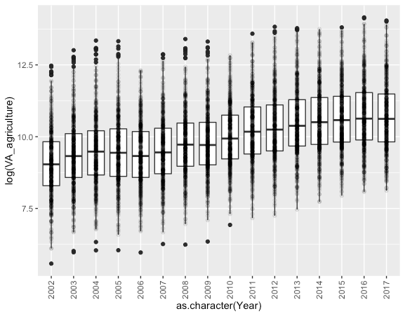
Fig 4: Distribution of GDP per capita, value added of agriculture and their logarithmic value in each year.

3.2.2.b Agricultural production
To further study the agricultural forces revealed by previous studies, I include the agricultural production data for three key crops: soybean, corn and sugarcane. The measures considered are the size of area for cultivation (area_cultivated), the size of area that is actually harvested (area_harvested), tons of harvested product (ton_harvested), average yield (avg_yield) and the reais (Brazilian currency) value of product (value_Reais). However, due to the high correlation of the variables, the final analysis model includes only the area size for cultivation of soybean and sugarcane in proportion to total municipality area (area_cultivated_soy_ratio, area_cultivated_sugarcane_ratio) and average yield of all three crops (avg_yield_soy, avg_yield_sugarcane, avg_yield_corn).

3.2.2.c Export of key commodities
I also look into data on export of key products, namely, soybean, sugarcane (including ethanol), corn, wood and meat. The dataset records the export of each commodity in every individual municipality. Both kilogram and dollar value measures for these exported products are considered.

3.2.3 Political Factors - election and party affiliation
The original dataset on election records the name, the party (party) and the number of votes (num_votes) of mayoral candidates for each 4-year-cycle election from 2000 to 2016. The research focuses on the impact of election condition as well as the party relationship of local mayors with the central government in each year. For the election condition, a dummy is created to indicate if the election is a tight contest (close_election = 1 if the percentage difference of votes between the best two candidates is less than 5%). It is plausible to argue that the elected candidates faced with a tight contest would also encounter different political and social conditions from candidates with a landslide victory. Thus, I assume that the effect should be consistently present till the next election and affecting deforestation throughout the four years.
According to the party coalition as specified in Table 1, another two dummy variables are also formed to indicate whether the incumbent mayor belongs to the support or opposition party coalition in relation to the central government (support, opposition), with the rationale that the party coalition will affect political resources available to the mayor.
Year | Support | Opposition
2000 | PSDB PFL PTB PMDB PPB | PT PDT PC do B PSB
2001 | PSDB PFL PTB PMDB PPB | PT PDT PC do B PSB
2002 | PSDB PFL PTB PMDB PPB | PT PDT PC do B PSB
2003 | PT PL PC do B PSB PTB PDT PPS PV | PSDB PFL PPS Prona
2004 | PT PL PC do B PSB PTB PPS PV PMDB | PSDB PFL PPS Prona
2005 | PT PL PC do B PDT PSB PTB PP PMDB | PSDB PFL PPS Prona
2006 | PT PL PC do B PDT PSB PTB PP PMDB | PSDB PFL PPS Prona
2007 | PT PC do B PDT PSB PTB PP PMDB PR PRB PV | PSDB PFL PPS Prona DEM
2008 | PT PC do B PDT PSB PTB PP PMDB PR PRB PV | PSDB PFL PPS Prona DEM
2009 | PT PC do B PDT PSB PTB PP PMDB PR PRB PV | PSDB PFL PPS Prona DEM
2010 | PT PC do B PDT PSB PP PMDB PR PRB | PSDB PFL PPS Prona DEM
2011 | PT PC do B PDT PSB PTB PP PMDB PR PRB PTC PSC | PSDB DEM SD PMB PPS
2012 | PT PC do B PDT PSB PTB PP PMDB PR PRB PTC PSC | PSDB DEM SD PPS PMN
2013 | PT PC do B PDT PSB PTB PP PMDB PR PRB PTC PSC | PSDB DEM SD PPS PMN
2014 | PT PC do B PDT PSB PTB PP PMDB PR PRB PTC PSC | PSDB DEM SD PPS PMN
2015 | PT PC do B PDT PSB PTB PP PMDB PR PRB PTC PSC | PSDB DEM SD PPS PMN
2016 | PT PC do B PDT PSB PTB PP PMDB PR PRB PTC PSC | PSDB DEM SD PPS PMN
2017 | PMDB PP PSDB PSD DEM PRB PPS PV PSB PTB PR | PSOL PC do B PT Rede PT do B PMB PDT
Table 1: The party coalition in each year in relation to the central government.

3.3 Data cleansing
Started with 14,400 observations covering 760 municipalities from 2000 to 2018, this research though only focuses on 498 municipalities from 2002-2017 in final regression analysis. The reasons for excluding the other observations are summarized as follows, with the whole process demonstrated in Fig 5.
- Municipalities with no forest or unreasonable value of forest size are excluded.
- Observations in 2001 and 2018 are dropped due to the unavailability of macroeconomic data.
- Municipalities in the state of Rondônia are excluded for the lack of meteorological monitoring stations in Rondônia.
- 7 municipalities with agricultural production data missing in some years are excluded as well, which can yield a balanced panel.
Fig 5: Data cleansing process.

Regression Models
Given the data process method described above, a typical panel is ready for analysis with 498 targeted municipalities and 16 observations across years of 2002-2017. All the regression analyses are carried out using the “plm” package in R. I start the analysis with a pooling model, but that is for different samples at different periods. Therefore, fixed effects or random effects are employed and compared with each other. After dropping the variables with high correlation, I run a Hausman test and the result suggests the use of fixed effects. This is in accordance with the highly possible existence of omitted factors. Thus, I decide to use the following two-way linear fixed effects regression model,
Y_{it} = 𝛽X_{it} + 𝛼_{i} + 𝜆_{t} + u_{it}
for i = 1, 2, . . . , 498 and t = 1, 2, . . . , 16 where 𝛼_{i} and 𝜆_{t} are unit and time fixed effects, respectively. It accounts for unobserved unit-specific (in this case municipality-specific, but time-invariant) and time-specific (but unit-invariant) confounders at the same time. The regression results are summarized in Table 2.

Signif. codes: 0 ‘***’ 0.001 ‘**’ 0.01 ‘*’ 0.05 ‘.’ 0.1 ‘ ’ 1
 | 1 | 2 | 3 | 4 | 5
Precipitation_total | 0.0008 * | 0.0011 *** | 0.0011 *** | 0.0011 *** | 0.0011 ***
Temp_compensated | -0.9148 * | -0.4877 | -0.4443 | -0.4577 | -0.4919
log(VA_agriculture) | 1.6534 *** | 1.4410 *** | 1.4288 *** | 1.4324 *** | 1.4360 ***
log(GDP_pc) | -0.6005 * | -0.1324 | -0.1182 | -0.1294 | -0.1191
area_cultivated_soy | -0.1113 *** | -0.0653 * | -0.0723 * | -0.0717 * | -0.0654 *
avg_yield_soy | 0.0001 | 0.0000 | 0.0000 | 0.0000 | 0.0000
area_cultivated_sugarcane | -0.0773 | -0.0707 | -0.0730 | -0.0713 | -0.0739
avg_yield_sugarcane | 0.0000 | 0.0000 | 0.0000 | 0.0000 | 0.0000
avg_yield_corn | -0.0001 | -0.0001 . | -0.0001 * | -0.0001 * | -0.0001 .
ex_vl_soy | 0.0000 | 0.0000 | 0.0000 | 0.0000 | 0.0000
ex_vl_sugar_ethanol | 0.0000 | 0.0000 * | 0.0000 * | 0.0000 * | 0.0000 *
ex_vl_corn | 0.0000 | 0.0000 | 0.0000 | 0.0000 | 0.0000
ex_vl_wood | 0.0000 | -0.0000 . | -0.0000 . | -0.0000 . | -0.0000 .
ex_vl_meat | 0.0000 | 0.0000 | 0.0000 | 0.0000 | 0.0000
close_election = 1 |  | 0.0140 |  |  | 0.0125
support = 1 |  |  | -0.1137 |  | -0.2396 .
opposition = 1 |  |  |  | -0.0182 | -0.1766
R-Squared: | 0.0194 | 0.0226 | 0.0227 | 0.0226 | 0.0231
Adj. R-Squared: | -0.0499 | -0.0566 | -0.0557 | -0.0559 | -0.0564
Table 2: Regression results of models with different variables.
As shown in Table 2, the dummies on political factors are not included in the regression model 1, but added one by one in model 2, 3 and 4, and altogether in model 5. Unfortunately, the comparison between the first and the latter models indicates insignificance of tight contest and party affiliation.
However, we do have two interesting findings. The first is about GDP per capita (GDP_pc), which is representative of a region’s economic development and standard of living. GDP per capita is only significant in model 1 and has a negative coefficient. In contrast, the log of value added in the agriculture sector is significant in all five models with a positive coefficient consistently. Therefore, it is plausible to argue that it’s not general economic development that is associated with deforestation, but agriculture. Secondly, the coefficient of area used to cultivate soy (area_cultivated_soy) has a consistently negative coefficient in the models, which suggests more soy production, less deforestation. This can be confusing at first glance, but actually supports some previous findings. In their study on the impact of pasture and soybean, Barona et al. find evidence that an increase of soy displaced pasture further, “leading to deforestation elsewhere”. Thus, it is reasonable to get the negative coefficient as data on the area used to cultivate soy and deforestation in the same year is used.

Conclusion and Discussion
In conclusion, the project finds that from 2001 to 2017 in the Brazilian Amazon area, agricultural development, not economic development in general, contributes greatly to deforestation, while there’s no significant correlation between deforestation and tight election or party affiliation. Additionally, soybean production is found to be negatively correlated with deforestation in the same region in the same year, probably due to the displacement of deforestation.
However, further researches are needed. First of all, the project only studies the impact of political forces in two aspects: tight election or party affiliation. Other political mechanisms need to be explored. Additionally, data on pasture also need to be included so as to explore dynamics between soybean production and cattle ranching along with the other socio-political-economic factors listed here. Furthermore, the project initially would like to include the commodity futures price in analysis but it is incompatible with the fixed effect model used. Other methods need to be considered to analyze the impact of commodity price and the interactive effect of price and export.

Reference
Alves, D. S. “Space-Time Dynamics of Deforestation in Brazilian Amazônia.” International Journal of Remote Sensing, vol. 23, no. 14, Taylor & Francis, Jan. 2002, pp. 2903–08. Taylor and Francis+NEJM, doi:10.1080/01431160110096791.
Angelsen, Arild. “Policies for Reduced Deforestation and Their Impact on Agricultural Production.” Proceedings of the National Academy of Sciences, vol. 107, no. 46, Nov. 2010, pp. 19639–44. www-pnas-org.proxy.library.nyu.edu, doi:10.1073/pnas.0912014107.
Araujo, Claudio, et al. “Property Rights and Deforestation in the Brazilian Amazon.” Ecological Economics, vol. 68, no. 8, June 2009, pp. 2461–68. ScienceDirect, doi:10.1016/j.ecolecon.2008.12.015.
Armenteras, Dolors, et al. “National and Regional Determinants of Tropical Deforestation in Colombia.” Regional Environmental Change, vol. 13, no. 6, Dec. 2013, pp. 1181–93. Springer Link, doi:10.1007/s10113-013-0433-7.
Assunção, Juliano, et al. “Property-Level Assessment of Change in Forest Clearing Patterns: The Need for Tailoring Policy in the Amazon.” Land Use Policy, vol. 66, July 2017, pp. 18–27.
Assunção, Juliano, and Romero Rocha. “Getting Greener by Going Black: The Priority Municipalities in Brazil.” Environment and Development Economics, vol. 24, no. 2, Apr. 2019, pp. 115–37.
Barber, Christopher P., et al. “Roads, Deforestation, and the Mitigating Effect of Protected Areas in the Amazon.” Biological Conservation, vol. 177, Sept. 2014, pp. 203–09. ScienceDirect, doi:10.1016/j.biocon.2014.07.004.
Barona, Elizabeth, et al. “The Role of Pasture and Soybean in Deforestation of the Brazilian Amazon.” Environmental Research Letters, vol. 5, no. 2, Apr. 2010, p. 024002. iopscience-iop-org.proxy.library.nyu.edu, doi:10.1088/1748-9326/5/2/024002.
Cho, Jaeil, et al. “Satellite-Based Assessment of Amazonian Surface Dryness Due to Deforestation.” Remote Sensing Letters, vol. 7, no. 1, 2016, pp. 71–80.
Curtis, Philip G., et al. “Classifying Drivers of Global Forest Loss.” Science, vol. 361, no. 6407, American Association for the Advancement of Science, Sept. 2018, pp. 1108–11. science-sciencemag-org.proxy.library.nyu.edu, doi:10.1126/science.aau3445.
Da Silveira, Luiz Gustavo Teixeira, et al. “Precipitation recycling and deforestation in the amazon: A numerical modeling study.” Revista Brasileira De Meteorologia, vol. 32, no. 3, 2017, pp. 417–32.
Davidson, Eric A., et al. “The Amazon Basin in Transition.” Nature, vol. 481, no. 7381, Jan. 2012, pp. 321–28. www.nature.com, doi:10.1038/nature10717.
DeFries, Ruth S., et al. “Deforestation Driven by Urban Population Growth and Agricultural Trade in the Twenty-First Century.” Nature Geoscience, vol. 3, no. 3, Mar. 2010, pp. 178–81. www.nature.com, doi:10.1038/ngeo756.
Fearnside, Philip M. “Brazil’s Cuiabá- Santarém (BR-163) Highway: The Environmental Cost of Paving a Soybean Corridor through the Amazon.” Environmental Management, vol. 39, no. 5, May 2007, pp. 601–14. PubMed, doi:10.1007/s00267-006-0149-2.
Gasparri, N. I., et al. “Linkages between Soybean and Neotropical Deforestation: Coupling and Transient Decoupling Dynamics in a Multi-Decadal Analysis.” Global Environmental Change, vol. 23, no. 6, Dec. 2013, pp. 1605–14. ScienceDirect, doi:10.1016/j.gloenvcha.2013.09.007.
Gollnow, Florian, and Tobia Lakes. “Policy Change, Land Use, and Agriculture: The Case of Soy Production and Cattle Ranching in Brazil, 2001–2012.” Applied Geography, vol. 55, Dec. 2014, pp. 203–11. EBSCOhost, doi:10.1016/j.apgeog.2014.09.003.
Hajjar, R., et al. “Scaling up Sustainability in Commodity Agriculture: Transferability of Governance Mechanisms across the Coffee and Cattle Sectors in Brazil.” Journal of Cleaner Production, vol. 206, Jan. 2019, pp. 124–32. EBSCOhost, doi:10.1016/j.jclepro.2018.09.102.
Hosonuma, Noriko, et al. “An Assessment of Deforestation and Forest Degradation Drivers in Developing Countries.” Environmental Research Letters, vol. 7, no. 4, IOP Publishing, Oct. 2012, p. 044009. Institute of Physics, doi:10.1088/1748-9326/7/4/044009.
Houghton, R. A. “Carbon Emissions and the Drivers of Deforestation and Forest Degradation in the Tropics.” Current Opinion in Environmental Sustainability, vol. 4, no. 6, Dec. 2012, pp. 597–603. ScienceDirect, doi:10.1016/j.cosust.2012.06.006.
Laurance, William F., Ana K. M. Albernaz, et al. “Deforestation in Amazonia.” Science, vol. 304, no. 5674, May 2004, pp. 1109–11. science-sciencemag-org.proxy.library.nyu.edu, doi:10.1126/science.304.5674.1109b.
Laurance, William F., Miriam Goosem, et al. “Impacts of Roads and Linear Clearings on Tropical Forests.” Trends in Ecology & Evolution, vol. 24, no. 12, Dec. 2009, pp. 659–69. PubMed, doi:10.1016/j.tree.2009.06.009.
Laurance, William F. “Switch to Corn Promotes Amazon Deforestation.” Science, vol. 318, no. 5857, Dec. 2007, pp. 1721–1721. science-sciencemag-org.proxy.library.nyu.edu, doi:10.1126/science.318.5857.1721b.
Lima, André, et al. “Land Use and Land Cover Changes Determine the Spatial Relationship between Fire and Deforestation in the Brazilian Amazon.” Applied Geography, vol. 34, May 2012, pp. 239–46. EBSCOhost, doi:10.1016/j.apgeog.2011.10.013.
López-Carr, David, and Jason Burgdorfer. “Deforestation Drivers: Population, Migration, and Tropical Land Use.” Environment: Science and Policy for Sustainable Development, vol. 55, no. 1, Routledge, Jan. 2013, pp. 3–11. Taylor and Francis+NEJM, doi:10.1080/00139157.2013.748385.
Macedo, Marcia N., et al. “Decoupling of Deforestation and Soy Production in the Southern Amazon during the Late 2000s.” Proceedings of the National Academy of Sciences, vol. 109, no. 4, Jan. 2012, pp. 1341–46. www-pnas-org.proxy.library.nyu.edu, doi:10.1073/pnas.1111374109.
Nepstad, Daniel C., et al. “Globalization of the Amazon Soy and Beef Industries: Opportunities for Conservation.” Conservation Biology, vol. 20, no. 6, 2006, pp. 1595–603. Wiley Online Library, doi:10.1111/j.1523-1739.2006.00510.x.
Pailler, Sharon. “Re-Election Incentives and Deforestation Cycles in the Brazilian Amazon.” Journal of Environmental Economics and Management, vol. 88, Mar. 2018, pp. 345–65. ScienceDirect, doi:10.1016/j.jeem.2018.01.008.
Paneque-Gálvez, Jaime, et al. “Land Tenure and Forest Cover Change. The Case of Southwestern Beni, Bolivian Amazon, 1986–2009.” Applied Geography, vol. 43, Sept. 2013, pp. 113–26. ScienceDirect, doi:10.1016/j.apgeog.2013.06.005.
Richards, Peter D., et al. “Exchange Rates, Soybean Supply Response, and Deforestation in South America.” Global Environmental Change, vol. 22, no. 2, May 2012, pp. 454–62. EBSCOhost, doi:10.1016/j.gloenvcha.2012.01.004.
Rodrigues-Filho, Saulo, et al. “Election-Driven Weakening of Deforestation Control in the Brazilian Amazon.” Land Use Policy, vol. 43, Feb. 2015, pp. 111–18. ScienceDirect, doi:10.1016/j.landusepol.2014.11.002.
Sauer, Sérgio. “Soy Expansion into the Agricultural Frontiers of the Brazilian Amazon: The Agribusiness Economy and Its Social and Environmental Conflicts.” Land Use Policy, vol. 79, Dec. 2018, pp. 326–38. EBSCOhost, doi:10.1016/j.landusepol.2018.08.030.
Sy, V. De, et al. “Land Use Patterns and Related Carbon Losses Following Deforestation in South America.” Environmental Research Letters, vol. 10, no. 12, IOP Publishing, Nov. 2015, p. 124004. Institute of Physics, doi:10.1088/1748-9326/10/12/124004.
Tacconi, Luca, et al. “Law Enforcement and Deforestation: Lessons for Indonesia from Brazil.” Forest Policy and Economics, vol. 108, Nov. 2019. EBSCOhost, doi:10.1016/j.forpol.2019.05.029.
Tumusiime, David Mwesigye, et al. “Policy and Institutional Drivers of Deforestation.” Environmental Policy and Law, vol. 48, no. 2, 2018, pp. 137–44.
Verburg, René, et al. “The Impact of Commodity Price and Conservation Policy Scenarios on Deforestation and Agricultural Land Use in a Frontier Area within the Amazon.” Land Use Policy, vol. 37, Mar. 2014, pp. 14–26. ScienceDirect, doi:10.1016/j.landusepol.2012.10.003.

