The Short-term Effect of Asset Restructuring
on Listed Chinese Companies

by

Yuxin Xia

An honors thesis submitted in partial fulfillment

of the requirements for the degree of

Bachelor of Science

Business Honors Program

NYU Shanghai

May 2018

Professor Marti G. Subrahmanyam Professor Jennifer Carpenter
Professor Yiqing Lu

Faculty Advisers Thesis Adviser

Abstract

This paper focuses on the expected effect of asset restructuring on listed Chinese companies through event studies and regressions over the abnormal returns. Different from most studies that focus on a small sample of asset restructuring events within a specific topic or time period, this paper analyzes more than 30,000 cases in a ten-year period of time, covering almost half of all the asset restructuring events that made by listed companies in mainland China. Thus the study provides a picture of the overall performance of asset restructuring in China, as well as comparisons among events with different characteristics. This empirical study reveals some important factors in asset restructuring that influence the abnormal return of company stocks, including a positive impact from longer days of suspension, using stocks as the payment method, having a buoyant market around the announcement date of restructuring and the restructuring type being asset exchange or tender offer.
Keywords: asset restructuring, Chinese stocks, abnormal return

Acknowledgements

I would like to express my sincere gratitude to Prof. Jennifer Carpenter, my thesis advisor, for providing me with critical feedback and constructive suggestions throughout the program both in person and through Skype meetings, and sharing related databases and articles with me. I want to thank Prof. Yiqing Lu as well for her support and encouragement in carrying out the research analysis though several one-to-one conversations. I am also thankful to Calvin Zhao, a writing fellow, for constantly checking the progress with me and offering writing guidance.
Moreover, I would like to thank Prof. Marti G. Subrahmanyam for organizing the business honors program, giving me the opportunity to conduct a research project, pairing me with a mentor and giving me feedback on every presentation.
Finally, I appreciate all the efforts made by the community in making business honors seminar a place for sharing advanced topics and ideas.

1. Introduction
Asset restructuring, for example acquiring new assets or stripping existing assets, is generally believed as an efficient way for companies to react to market opportunities and threats. For listed companies in China, the announcement of asset restructuring events have led to surprising changes in shareholders’ wealth. Taking merger and acquisition for example, during the 50 days after the restructuring, Chinese listed companies enjoy 11% cumulative abnormal return (Wong & Cheung, 2009). The high return has not only led to increasing popularity of asset restructuring but also numerous research projects studying the effect of asset restructuring on companies. Most studies focus on a narrow topic within this field, analyzing typically fewer than 1,000 cases, such as only study listed companies with M&A or only study the asset restructuring cases happened in a particular year (Li & Chen, 2002; Chen & Zhang, 1999). Although the studies have provided explanations over influencing factors such as payment method and restructuring types, the studies do not aim at showing readers a whole picture of the overall performance of the asset restructuring in China, or how one variable of asset restructuring influences the stock market performance in general. To fill in this gap, in this paper, I analyze a dataset covering more than 30,000 asset restructuring cases in China, and use both event studies and regression models to identify factors in asset restructuring events that influence most companies’ stocks performance, which is indicated by abnormal returns from stocks around the announcement dates of the restructuring events. Since the stock market reveals investors’ expectation, these influencing factors are also the factors that influence people’s expectation of how restructuring events will affect companies’ performance.
The remainder of the paper is divided into four parts: section 2 is a literature review of theories analyzing different factors in asset restructuring events and their cumulative abnormal return statistics; section 3 describes the data sources, data cleaning processes and the methodology I used for regression and event studies; section 4 shows the firm
and event specific variables with some interpretation of how each of them influences the stock market performance and people’s expectations. For example, paying by stocks, days of suspension, the restructuring being a major restructuring event are all positively correlated with the abnormal return while having a stagnant market around the announcement date is negatively correlated with the abnormal return; section 5 summarizes the paper and states limitations.

2. Literature Review
In China, asset restructuring was initially a conventional term only among investors. Although later on it starts to appear in academia, it still does not have a clear definition. Usually, it refers to every major nonoperational or abnormal changes made by a company that can even go beyond the category of assets, such as debt restructuring and equity transfer. Based on a famous database for Chinese stock market: CSMAR, asset restructuring in China is categorized into seven types: asset acquisition, asset divestiture (sometimes also called asset sales, asset stripping), asset exchange, merger, tender offer, debt restructuring and equity transfer.
Types of restructuring influence the abnormal return. Not only changes happened to asset, debt or stock lead to different abnormal return, different ways of changing assets can lead to different abnormal return as well. For selling and buying assets, existing studies show divergent opinions on their effects on stock market. When studying the announcement effects of restructuring, Mulherin and Boone (2000) use a three-day event window (-1, +1) with announcement date as day 0 and find that “both acquisitions and divestitures in the 1990s increase shareholder wealth” and “the symmetric, positive wealth effects for acquisitions and divestitures are consistent with a synergistic explanation for both forms of restructuring”. Studies on Chinese market also show significant positive abnormal return for acquiring and target firms around takeover periods (Song et al., 2017; Wong & Cheung, 2009). However, other studies have shown that while target firms’ stockholders have significant gain around the date of announcement, acquiring firm stockholders have almost no gain or even losses due to premium paid during acquiring (Asquith & Kim, 1982; Jensen & Ruback, 1983; Agrawal & Mandelker, 1992). For tender offer, studies have shown that the act of bidding will increase the valuation of the target company because “the announcement of a tender offer is presumed to alert other firms to the general intent of the bidding firm and initiate a competitive (auction type) process for the target shares” (Bradley, 1980). For asset exchange, an activity combines selling and buying assets, some studies report significant cumulative abnormal return (Chen & Zhang, 1999) while others report insignificant cumulative abnormal return (Jin et al., 2006; Lou et al., 2014), and sometimes the results change with different cumulative days. Usually the abnormal return is positive on the announcement date, but declines or become negative with a longer cumulative period such as cumulative return over event window (-20, 20).
When studying the effect of acquisition on stocks, some researchers also mention the influence of payment method. For bidding firms in asset acquisition or merging, they have on average -1.3% abnormal return if stocks are used as a payment method, but only -0.8% abnormal return for cash offers (Travlos & Papaioannou, 1991). In China, empirical studies find similar results that disfavor the cash payment: “takeovers financed through alternative modes of consideration generate significantly higher abnormal returns than takeovers financed purely through cash” because of tax benefits and information asymmetry (Song et al., 2017).
Besides restructuring types and payment method, whether it is a related party transaction also influences the abnormal return on stock market. In China, managers are able to manipulate the value of assets with professional valuers to get any valuation they want (Lou, Wang & Yuan, 2014). Such manipulation of assets’ value always happens in a transaction between two related parties. Studies have found that the abnormal return in stock market is negatively correlated with related party transactions (Gordon et al., 2004).
Some studies also mention the relative size of the transaction influencing the abnormal return. When studying asset sales and asset exchange, Huang and Chen (2012) use a regression model to show that there is “a statistically positive relationship between the wealth effect and the relative size of the divestiture”, in which the relative size is defined as “the reported asset sale/exchange price divided by the asset value of the parent at the year-end prior to the announcement of the transaction”.
The existing studies have shown the cumulative abnormal return for different types of restructuring, and have mentioned the influence of payment method, number of days cumulated for calculating abnormal return, trading position, relative size and whether it is a related party transaction. However, since those papers only study a few cases (fewer than 2000 cases), the result they provided may not be applicable to other companies. Similar to existing studies, I use cumulative abnormal return to measure the impact of events on stock market but apply event studies and regressions on a much bigger dataset to show influencing factors of abnormal return due to asset restructuring in China.

3. Data and Methodology
3.1 Datasets and Attributes
There are three main datasets used in the research.
(1) Asset Restructuring Dataset (A shares only) (from CSMAR China Asset Restructuring Research Database)
The first dataset records asset restructuring events, with relevant variables:
First Declare Date - the announcement date of the asset restructuring event
Restructuring Type - records the type of a restructuring among eight types: asset acquisition, asset divestiture, asset exchange, merger, debt restructuring, share repurchase, tender offer and equity transfer (only seven types appear in the dataset)
Expense - records the payment from the buy side
Payment Type - records the method of payment: pay by assets, stocks, cash, debt or a combination of them
Relevance Sign - records if the transaction is a related party transaction, for example a transaction between seller and buyer or between parent and subsidiary companies
Major Restructuring Sign - a flag showing whether the asset restructuring event is a major asset restructuring that is one of these three cases: 1) the total assets purchased or sold account for more than 50% of the total assets of the listed company for the most recent fiscal year 2) Operating revenue generated from the assets purchased or sold account for more than 50% of the operating revenue reported of the listed company in the same period 3) The total net book value of the assets purchased or sold accounted for more than 50% of the ending net book value of total assets of the listed company and the amount exceeds 50 million RMB (Administrative Measures for the Material Assets Reorganization of Listed Companies, 2016).

(2) Historical Stock Price Dataset (from WIND SSE & SZSE Stock Database)
The second dataset contains the historical stock prices for each listed Chinese stock in mainland China, with relevant variables:
Close Price - the close price of a stock for each trading day (share adjusted)
Trading Status - whether the stock is traded on a working day
Company Nature - state owned, collective owned or private
PE ratio - the trailing twelve months price earning ratio of the company issued the stock

(3) Industry Index Dataset (from WIND SSE & SZSE Stock Database)
The industry index dataset contains the average performance of stocks categorized by industries. There are several industry index available for Chinese stocks provided by different companies. CSI SWS Securities Index is one of them, and has been regarded as the most authentic. It is provided by Shenyin & Wanguo Securities Co.,Ltd. and is available on the WIND financial terminal, with relevant variables:
Shenwan Industry Name - each company is categorized into one of the 28 main industries
Industry Index - the weighted average of the stock prices based on free float market capitalization

3.2 Data Description
The data is collected over a ten years’ period of time from 2006/1/1 to 2015/12/31. Starting from 2006/1/1, the revisions of the Company Law and the Securities Law of the People’s Republic of China came into effect. The reform is “unusually extensive” with half of the provisions amended, deleted or added and thus has led to profound effects on the China’s economy (Wang, 2008). In order to accommodate the regulation changes, the starting time of the ten years’ period I chose is right after the implementation of the reform. Although the security regulations of China have been modified every year, the changes are minor compared with the ones happened in 2006.
There are 57261 asset restructuring cases announced during the ten years’ period (2006-2015). For a company, it is possible to announce several restructuring events on a single day, thus leads to multiple entries in the restructuring dataset. However, there is only one abnormal return for a single company per day that incorporates all the restructuring announcements. To avoid over-calculating the abnormal return for one restructuring event, only the restructuring event with the biggest expense value is not deleted from the dataset with the assumption that the abnormal return is mostly resulted from the announcement of that biggest restructuring event. This adjustment reduces the sample size to 33962 entries.
One more filter was placed on these 33962 entries to get rid of extreme values. In China, there is a limit on the stock price percentage change which is ±10% per trading day. However, there are some special cases where the daily percentage change of a stock can exceed the limit such as during initial public offering, non-tradable shares reform and stocks being moved out of Special Treatment category. In the asset restructuring cases, there are only a few such cases. During these cases, the stocks can have surprisingly large abnormal return, usually positive, that can greatly influence the sample mean. There are around 10 cases with more than 500% abnormal return, as shown in Fig 1.
To avoid the influence of extreme values and to put the focus on general cases, stocks having more than ±10% daily price movement after the announcement date are removed from the dataset. Considering the rounding errors, the limitation is relaxed to ±10.05% in filtering. The dataset without extreme abnormal returns contains 31771 data points, as shown in fig 2.

Fig 1: abnormal return on the first day after announcement with extreme values
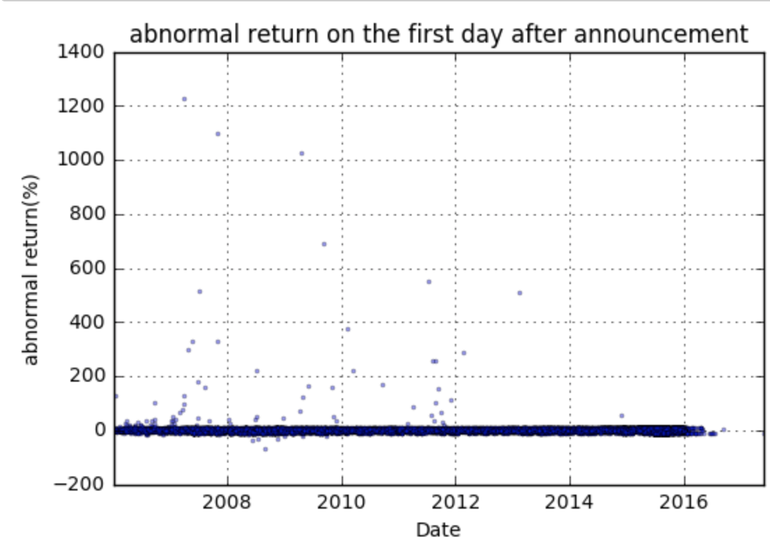
Fig 2: abnormal return on the first day after announcement without extreme values
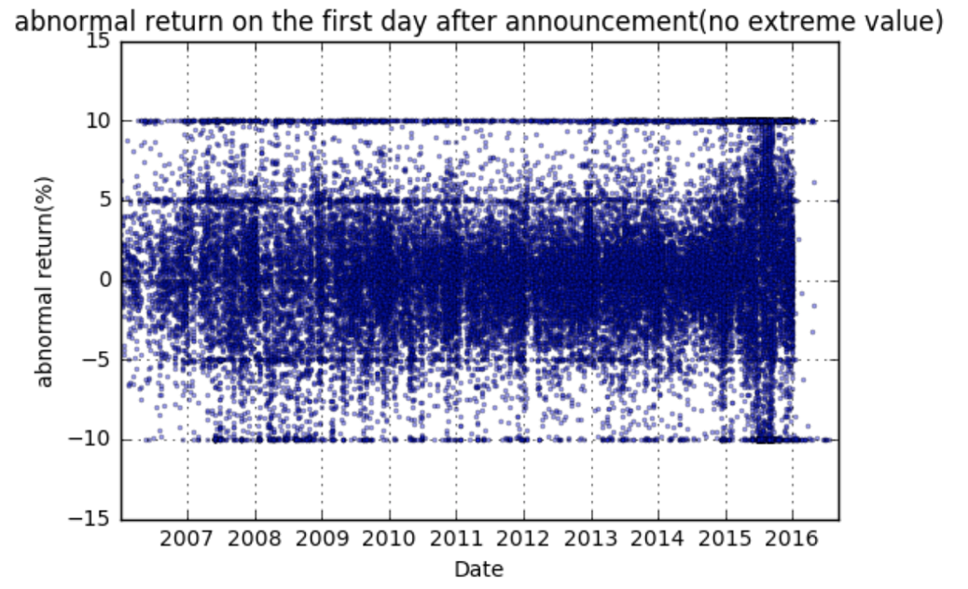
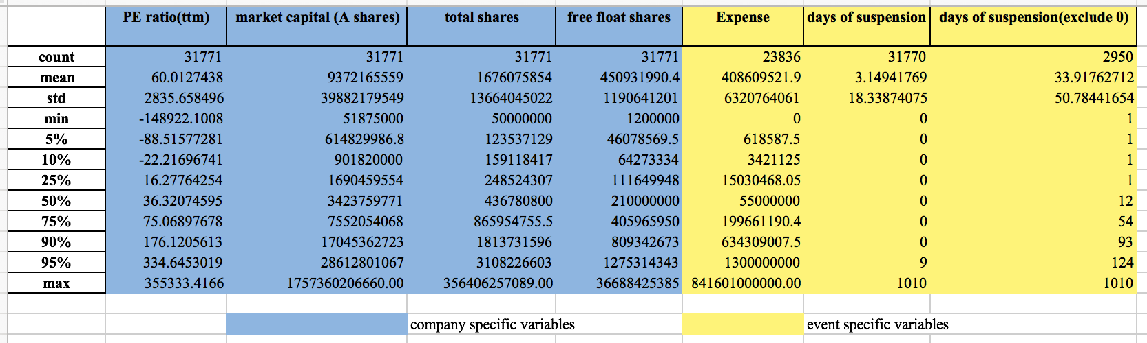
A description of the numeric data in the dataset:

3.3 Methodology
An event study is used to study the direction and magnitude of the daily abnormal return as well as cumulative abnormal return around announcement date of the restructuring event with an event window from day-10 to day15. Day 0 is the first trading day that the announcement is available to the general public. Usually day 0 is the announcement date, but in the case of having announcement during a suspension, day 0 is the date when the stock resumes from the suspension. This makes day 0 always fall on the first day that the public is able to react to the announcement.
To calculate the daily abnormal return, I use the market adjusted return model because it requires less estimation than the other two commonly used models: mean-adjusted and risk-adjusted model. The abnormal return is the difference between the actual return and expected return. I subtract the industry return, which is calculated with Shenwan Industry Index, from the return of a stock to get the market-adjusted return. Because of the variance among industries, the industry index can better represent the expected performance of a stock than a more general stock market index such as Shanghai composite index, or Shanghai and Shenzhen Stock Index.
Besides daily abnormal return, cumulative abnormal returns are also worth studying. First of all, the efficient market hypothesis may not be true in China and thus impact of one event on stock prices can linger for several days. Even with the efficient market hypothesis, the daily abnormal return on the event day may not fully show the market reaction towards the event. Because of Chinese government’s restriction on stock price volatility (±10% per trading day), the daily abnormal return fails to fully show the impact of the event. This can be solved by calculating the cumulative abnormal return with a period of time after the announcement date. Another reason for calculating abnormal return with an interval of time rather than a single day is due to the “extended length for information dissemination”, where companies may make a sequence of announcement related to the same event on different days or it may take some time for the financial press to release the news (Peterson 1989). As a result, 3-day (day0-day2) cumulative abnormal return is calculated in this project.
With 3-day cumulative abnormal return, I use a regression model to find the significant factors influencing the abnormal return. Based on these firm specific or event specific variables, I separate the data into groups and examine the distribution of abnormal returns over different categories to see how one variable influences the abnormal return.

4. Results and Discussion
4.1 Regression Over the 3-day Cumulative Abnormal Return
Dependent variable: 3-day cumulative abnormal return
Independent variables: type of restructuring (asset acquisition, asset divestiture, asset exchange, merger, debt restructuring, share repurchase, tender offer and equity transfer), payment method for the restructuring (asset, cash, stock, debt, cash and asset, cash and stock, cash and debt, other), companies’ nature (owned by central government, local government, a group, private, or foreigners), days of stock suspension due to the restructuring, market movement during the suspension, and whether the restructuring is a related party transaction (Y/N). Industry of the company and year of the restructuring (2006-2015) are used as control variables.

Result:
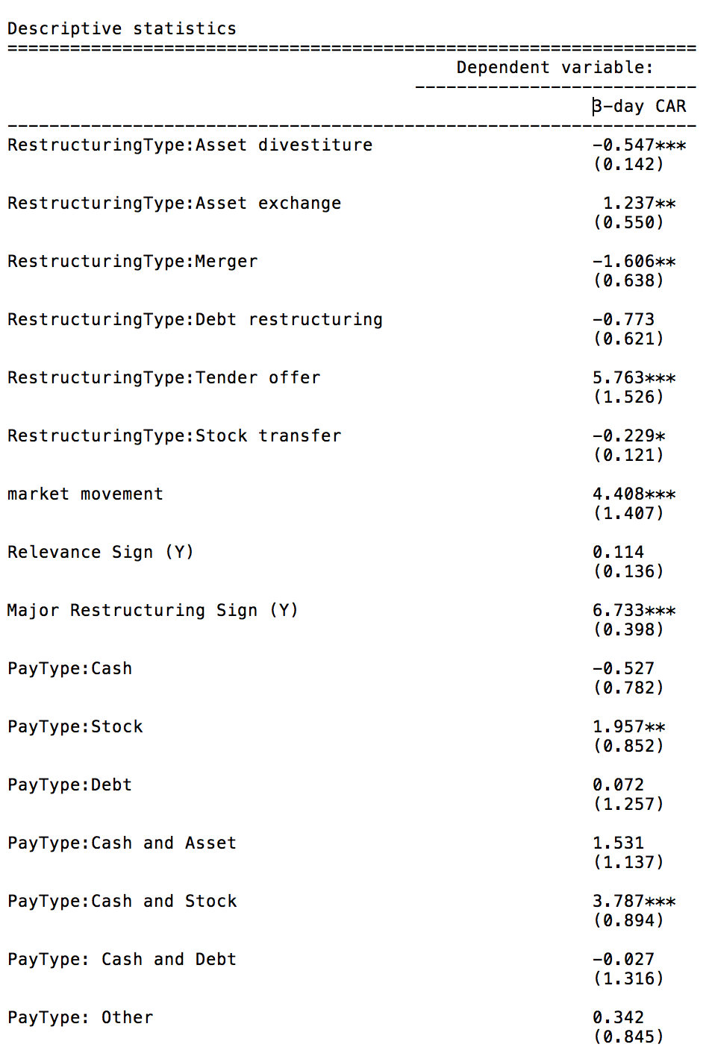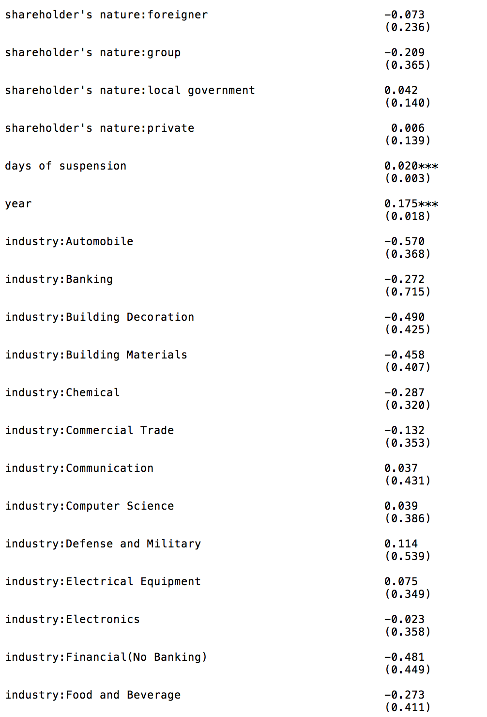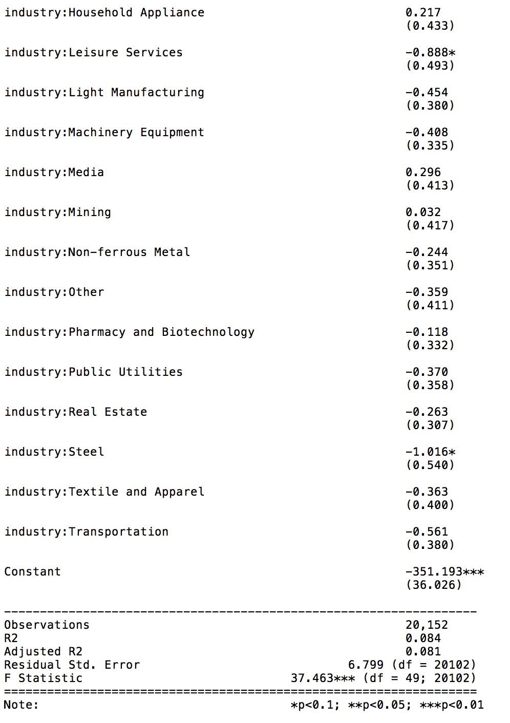

From the regression result, restructuring type with asset exchange, tender offer, payment method with stocks, days of suspension, major restructuring sign are positively correlated with the 3-day cumulative abnormal return. Because of the low R-square, the model can not be used to predict the 3-day cumulative abnormal return, and it should not be due to the unpredictability of stock prices. However, the significance levels of some independent variables show explanatory factors of the abnormal return that will be explained in the following paragraphs.

4.2 Influencing Factors of the Abnormal Return
(1) Firm specific variables
Nature of the Company
3-day cumulative abnormal return for companies with different companies’ nature:

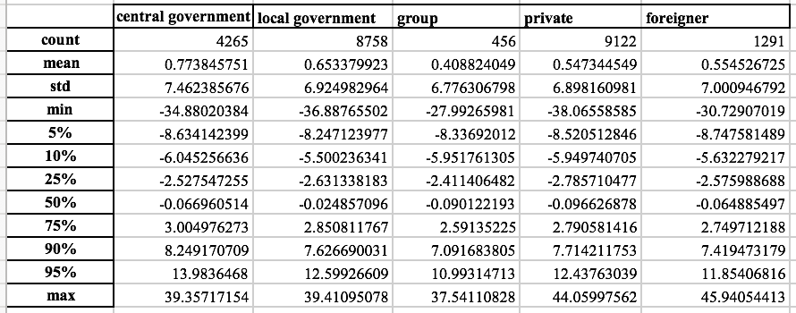
We can see some difference among groups, such as companies owned by the central government seem to have a better performance towards the high end and companies owned by a group of people do not perform well in almost all percentiles. However, there is not a clear relationship between the abnormal return and the degree of government control. The reason is likely because for different groups, they have different advantages: the companies owned by the government can gain some regulation advantages, while the companies owned by individuals are easier to be manipulated and usually towards the companies’ benefit. In asset restructuring, valuation of the asset is tricky. Because “in China, professional valuers are not properly regulated and are typically not independent”, sometimes managers “can collude with professional valuers to opportunistically manipulate the valuation” (Lou, Wang and Yuan 2014). In private companies, it is easier for managers to collude with valuers and thus make the abnormal return more extreme than government owned companies.

(2) Event Specific Variables
Days of Suspension
Companies tend to have temporal suspensions when making big announcements so as to reduce the fluctuation of stock prices. During asset restructuring, around 10% of companies in the dataset had a suspension. Suspensions usually result in lower liquidity because stocks are not tradable during that period of time. However, lower liquidity may not lead to lower abnormal return, as shown in fig 3.
Fig 3. the relationship between days of suspension and 3-day cumulative abnormal return
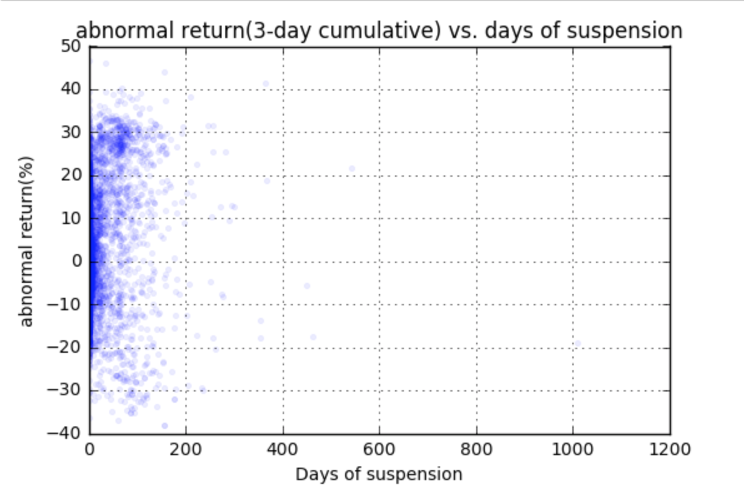
To show the influence of days of suspension on the magnitude of abnormal return, I conduct a regression on the absolute value of 3-day cumulative abnormal return with the independent variable: days of suspension:
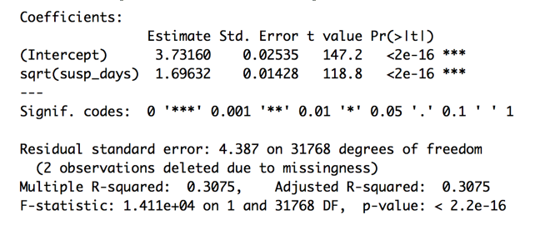
With longer suspension, stocks tend to have bigger abnormal return, both in positive and negative direction. The reason is that during the suspension, the stocks are not tradable, and thus can not follow the market movement. After resumption, the price movement partly incorporates the market movement happened during its suspension.
Moreover, the regression analysis done before shows that the relationship between days of suspension and abnormal return is positive. Based on Barber and Odean’s (2007) theory of attention for investors, a long period of suspension attracts investors’ attention when the stock resumes and thus leads to more trading activities, which is usually buying activities because it is not likely for the investors to hold the particular stock that they can sell. I divide the companies based on their industry to further verify the theory. Since the theory focuses on the investors’ attention, industries with hot topics in the news should be under the public’s attention and thus more likely to attract investors’ attention when something unusual happens, such as resuming from a long suspension.
I pick electronic industry as a representative of the hot topic because since 21st century, electronic industry has emerged as the dominant industry in China’s national economy (Pecht, 2006). The two traditional industries I picked are transportation and public utility industries. They seldom produce news that excites the public.
Here are the regression results of data from these three industries:
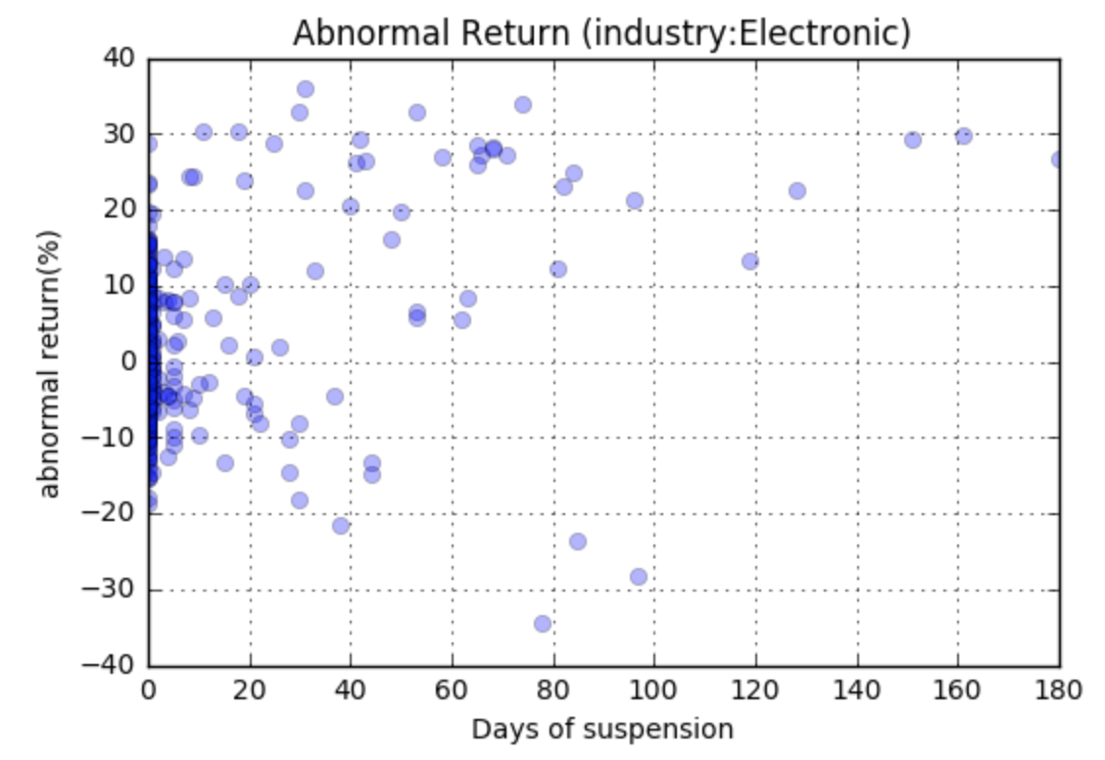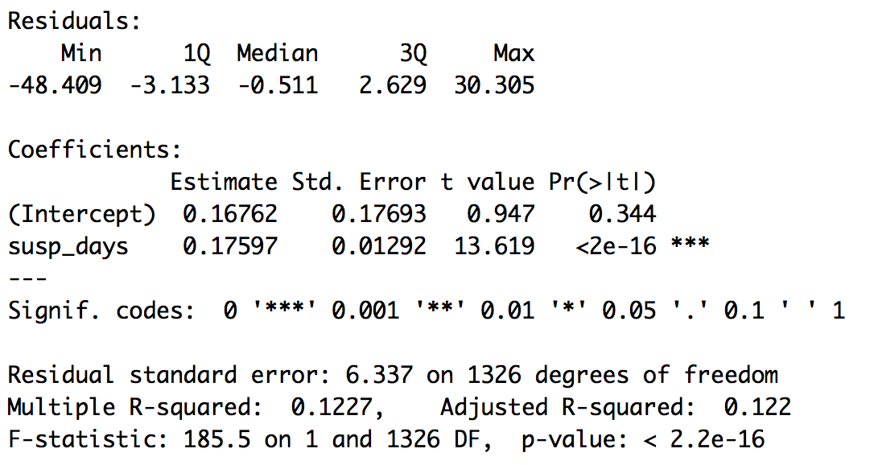
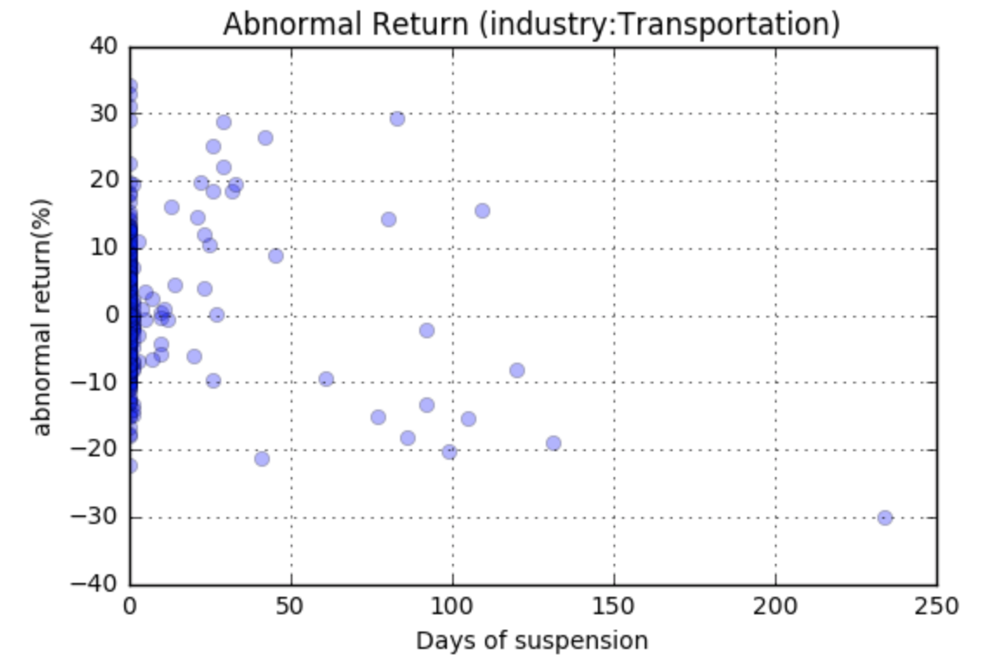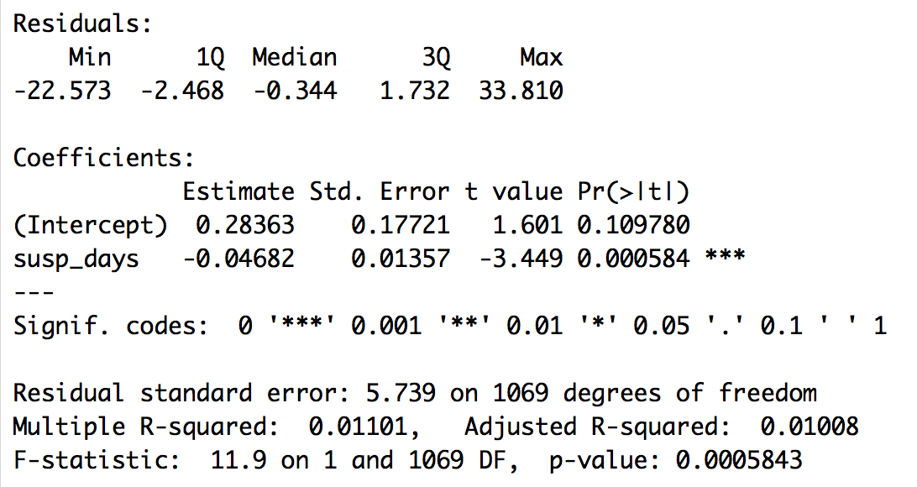
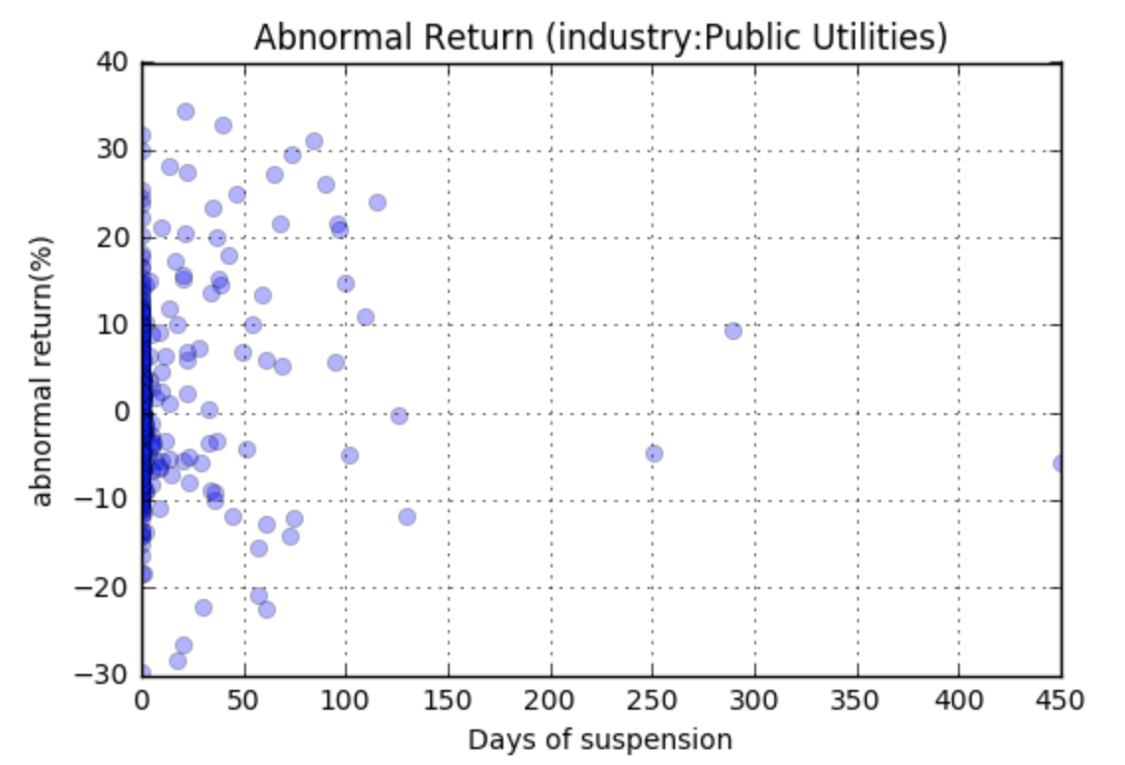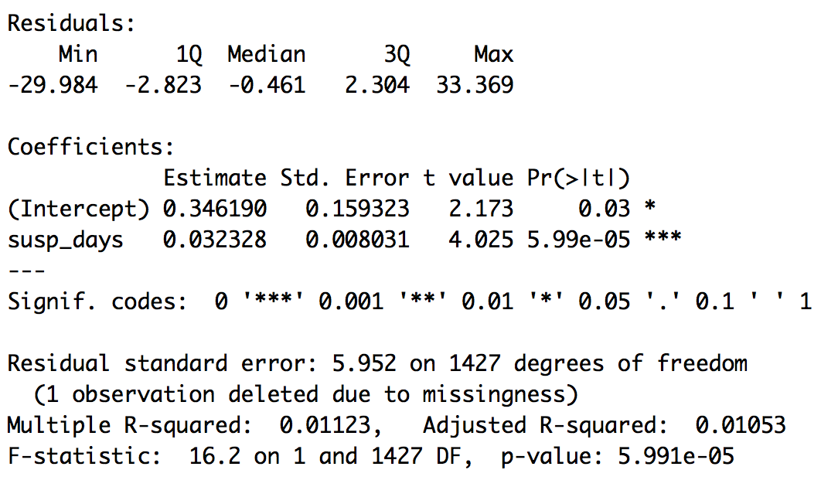
Days of suspension is positively correlated with 3-day abnormal return for companies in electronic industry, but has little relationship with companies in transportation industry or public utility industry. This is consistent with Barber and Odean’s theory of attention for investors. Popular companies within public’s daily attention are more likely to have the attention effect when they come to the asset restructuring events with suspensions.

Type of Payment
There are several methods to pay for a transaction: by asset, cash, stock, debt or a combination of them. The regression model mentioned above has shown the investors’ preference for stock payment with positive coefficient around 2 before stock payment.

The benefit from paying by stocks can be further shown from the following table:
Payment method vs. 3-day cumulative abnormal return:
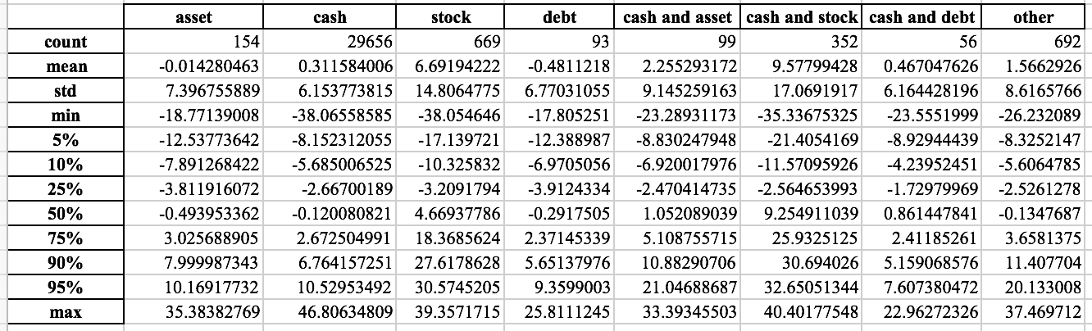
Restructuring events paid with stocks either partially or fully have not only high abnormal return on average, but also have a higher return in almost every percentile. The phenomenon shows investor’s preference for stock payment, which can be explained by “perceived cost”. In an article talking about the stock-based compensation for employers, Murphy (2003) argues that the reason a company prefers paying by stocks is not because of reducing agency problems, but rather because of its low cost, not in terms of the economics cost, but “perceived cost”. Similarly, in the stock market, when a company pays a transaction by stocks, investors notice the improvement in assets without any accounting charges. The low “perceived cost” leads to a higher valuation of the company from investors.

Type of Restructuring
There are seven types of restructuring in the dataset: asset acquisition(11493 cases), asset divesture(6440 cases), asset exchange(290 cases), merger(244 cases), debt restructuring(284 cases), tender offer(44 cases) and equity transfer (12976 cases) and their abnormal return are shown in the figure below(fig 4).

Fig 4. abnormal return and cumulative abnormal return for different asset restructuring types
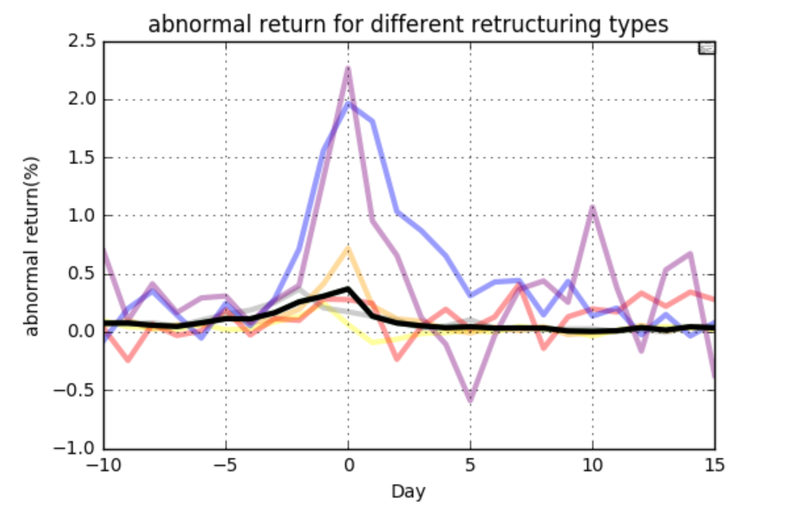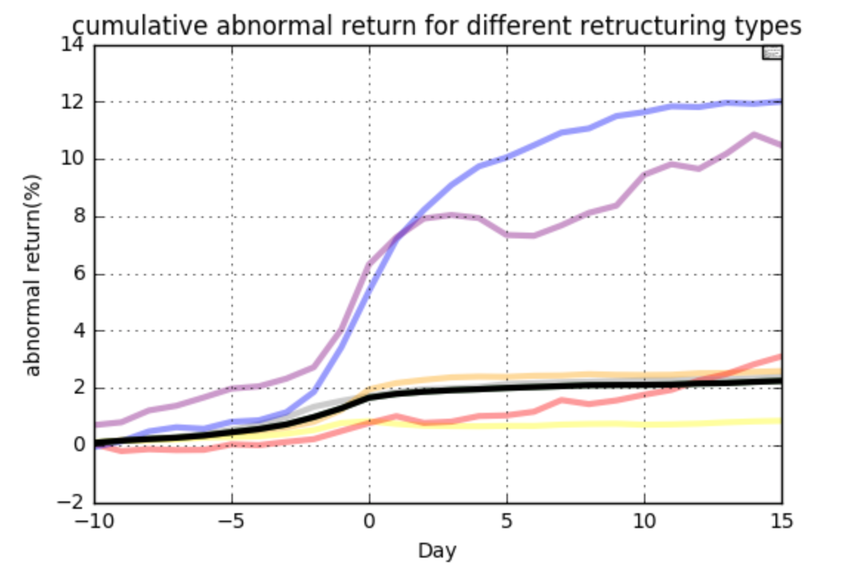
a descriptive table for 3-day cumulative abnormal return for different types of restructuring:
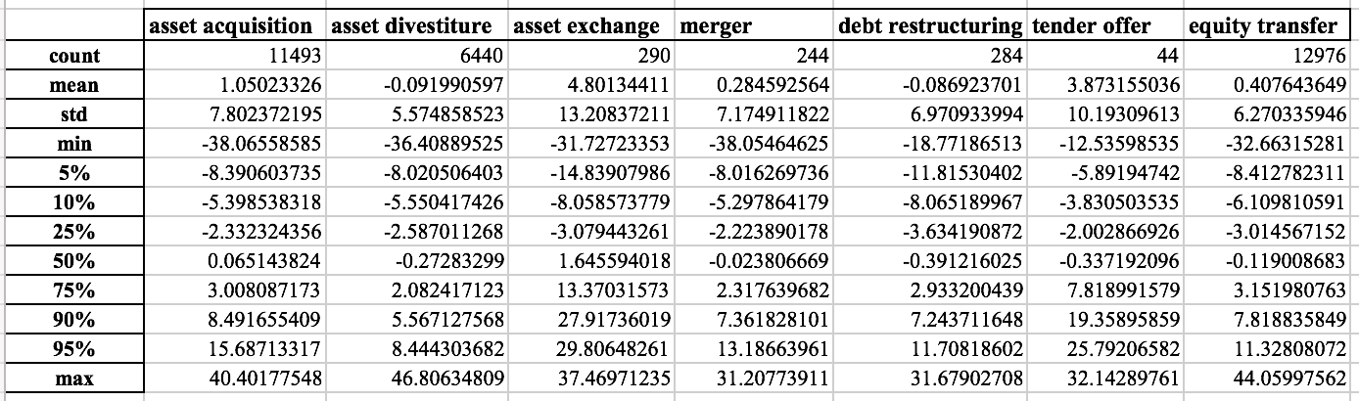
Asset exchange and tender offer have relatively high abnormal return, which is consistent with the positive coefficient of these two variables in the regression model at the beginning of this section. In terms of tender offer, it happens rarely in the Chinese stock market. During tender offer, stockholders can sell the shares to one large shareholder rather than sell them in the market. The price of the tender offer has a lower bound that links to the historical price of the stock. When the tender offer’s price is much higher than the market price, people will dump the shares to the big shareholder. This will not only cause losses to the big shareholder, but also may make the company go private if the big shareholder owns too many shares. Because of these two reasons, the big shareholder tends to keep the stock price high during the period of tender offer.

In terms of stock exchange, it is mostly a related party transaction. Whether there is a relationship between two trading parties can be shown from the dummy variable: relevance sign. Although fewer than 1/3 of the transactions in the whole dataset are related party transactions, around 80% companies in the asset exchange category are related party transactions. Because of the relationship between the companies, the trading is usually not a fair trade, in which a company is able to exchange lower quality assets with higher quality assets to improve performance, or exchange higher quality assets with lower quality assets to help the other company to develop. Although companies do not have to be listed to be able to make an asset exchange with other companies, based on the listed companies’ data in the dataset, most companies involved in asset exchange is the buyer, and there is a clear difference in the 3-day cumulative abnormal return between sellers and buyers. The obvious difference in abnormal return for sellers and buyers (fig 5) implies the unfairness in trading, and further leads to the positive abnormal return for asset exchanges because most listed companies in asset exchange are on the buyer side.
Fig 5: abnormal return for sellers and buyers in asset exchanges
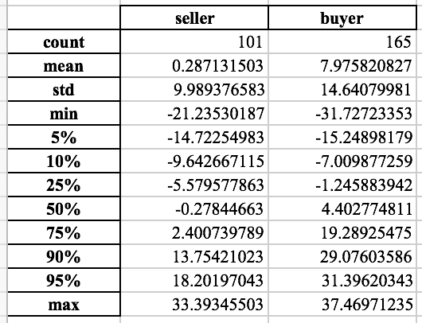
Market Movement around Day 0
Although the abnormal return is the difference between the market return and individual stocks’ return, which does not include the market performance, the abnormal return is still influenced by the market, especially when the market is volatile. The graph below(fig 6) shows the monthly correlation between 3-day cumulative abnormal return and 3-day cumulative market return starting from day0. The market return is calculated from the Shanghai (security) composite index that is a common index to represent the performance of Chinese Stocks.
Fig 6. correlation between market performance and abnormal return of individual stocks calculated monthly
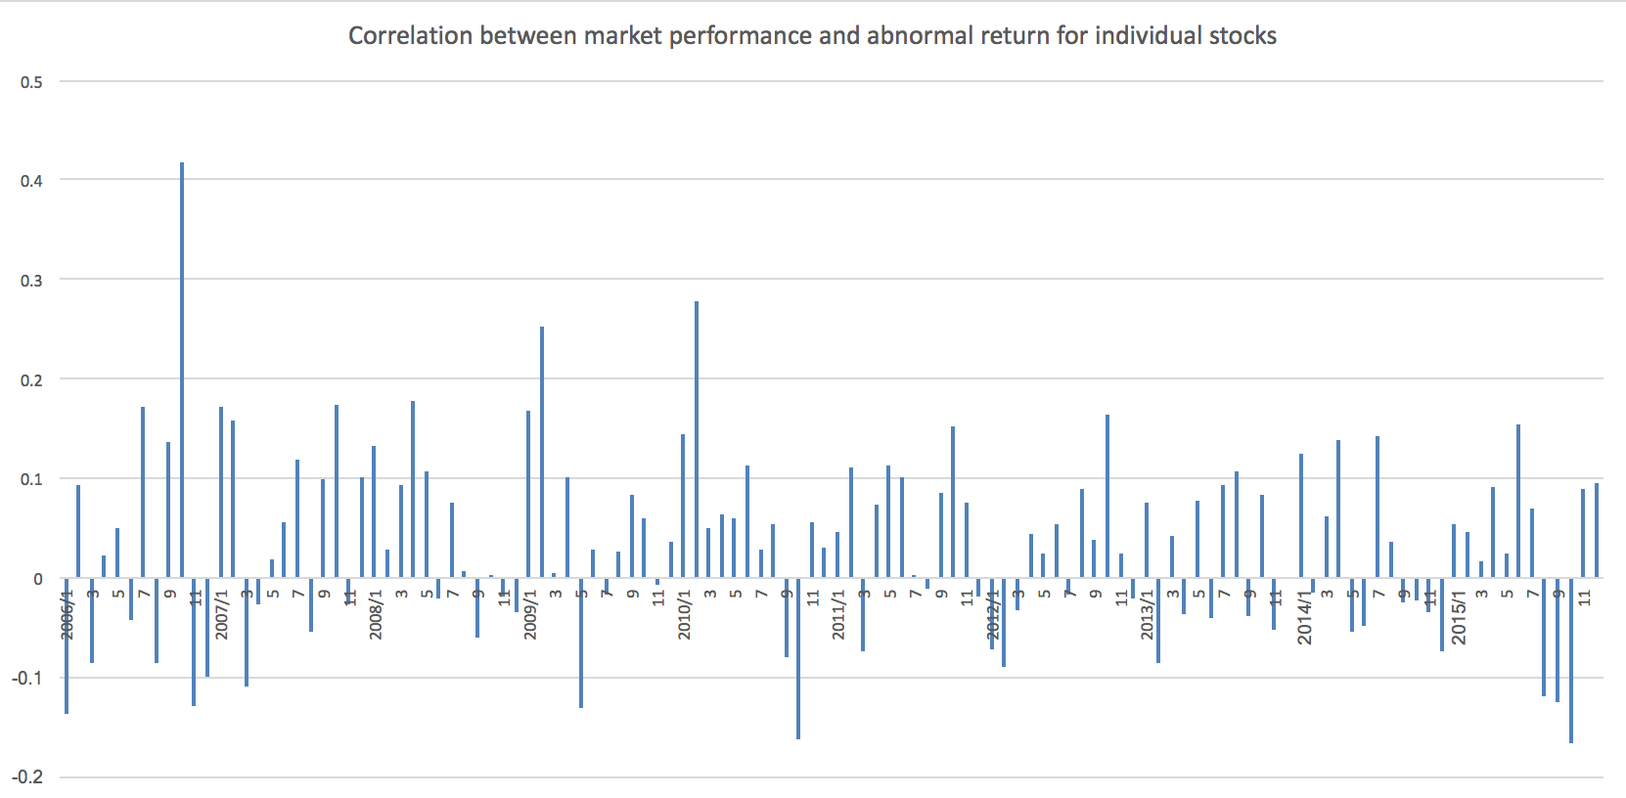
Although the correlation changes with time, the correlation is mostly positive. This shows that when the general market is doing well, the companies with asset restructuring are doing even better, but when the market is going down, the companies with asset restructuring suffers more.

Major Restructuring Sign
Fig 7. The distribution of stocks’ abnormal return (%) with/without the restructuring being a major restructuring
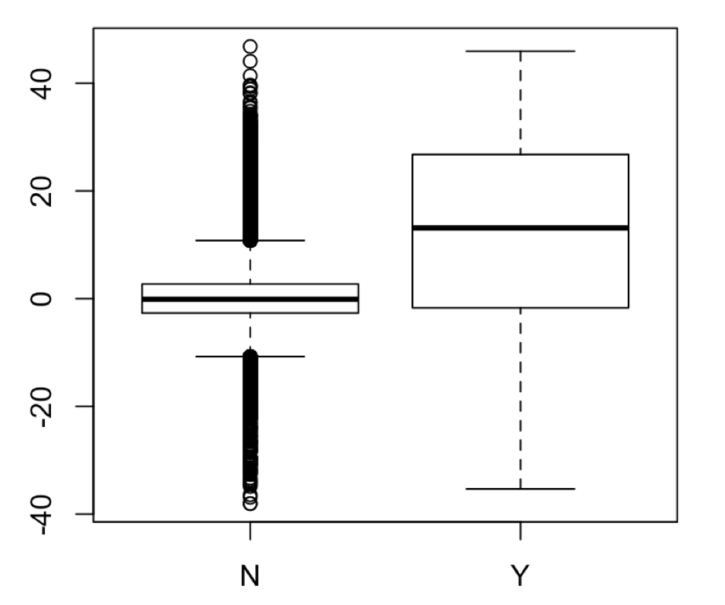
Major restructuring sign is assigned by the relative size of the restructuring compared with the size of the company. It can be used to show whether a restructuring has significant influence on the underlying companies. Although expense to the buy side also describes the size of the restructuring, around 1/3 of the companies do not have the expense data. For companies having major restructuring events, they usually gain a relatively high 3-day cumulative abnormal return, as shown in fig 7. This indicates a positive expectation to major asset restructuring events from investors.

5. Conclusion
Although there are many articles that mention the stock price movements and abnormal return of compnaies’ stocks after the announcement of asset restructuring, most of them have a quite specific topic and thus only cover limited number of restructuring cases. In this study, I collect a data sample of more than 30,000 restructuring cases happened in mainland China from 2006 to 2015 to show the general performnacc of asset resturcturing in Chinese stock market. From the regression analysis and event studies, payment method, restructuring type, days of suspension, market movement, industry of the company and whether the transaction is a related party transcation are all influening factors to the abnormal return for announcements of asset restructuring. The study can help people partly understand the abnormal return resulted from an announcement of the asset restructuring event. What’s more, companies with the knowledge of how some event specific variables will influence their stock prices after the announcement of resturcturing events can take these factors into consideration when deciding the details of restructuring, such as payment method or days of suspension.
Here are some limitaions of the research that can be further improved. In the case when there are several restructuring events for one company on the same day, I simply take the event with the biggest expense value as the representive of all the events. However, when there are a lot of events with similar sizes happened on one day, this approach does not accurately captures the characteristics of the events. A more sophisticated way can be used to aggregate the information of each event. Also, because of the limitation in variables, I only considered around ten factors, and some factors are not tested fully. With more data, the model will be able to better explain stock movements.

Reference

Administrative Measures for the Material Assets Reorganization of Listed Companies (2016). available at: http://en.pkulaw.cn/display.aspx?cgid=280104&lib=law

Agrawal, A., Jaffe, J. F., & Mandelker, G. N. (1992). The post‐merger performance of acquiring firms: a re‐examination of an anomaly. The Journal of finance, 47(4), 1605-1621.

Asquith, P., & Kim, E. H. (1982). The impact of merger bids on the participating firms' security holders. The Journal of Finance, 37(5), 1209-1228.

Barber, B. M., & Odean, T. (2007). All that glitters: The effect of attention and news on the buying behavior of individual and institutional investors. The review of financial studies, 21(2), 785-818.

Bradley, M. (1980). Interfirm tender offers and the market for corporate control. Journal of business, 345-376.

Chen X.Y., & Zhang T.Y. (1999). The market response to asset restructuring in Shanghai in 1997. Economic Research Journal (9). (in Chinese)

Gordon, E. A., Henry, E., & Palia, D. (2006). Related party transactions: associations with corporate governance and firm value. In EFA 2004 Maastricht Meeting Paper & AFA.

Huang, W., & Chen, K. C. (2012). Asset sales, asset exchanges, and shareholder wealth in China. Review of Development Finance, 2(1), 1-8.

Jensen, M. C., & Ruback, R. S. (1983). The market for corporate control: The scientific evidence. Journal of Financial economics, 11(1-4), 5-50.

Jin, Z., Jiang, X., & Guo, C. (2006). Applying the event study methodology to the asset restructuring performance of the listed companies in china. Journal of East China Normal University.

Lou, F., Wang, J., & Yuan, H. (2014). Causes and consequences of corporate asset exchanges by listed companies in China. International Review of Economics & Finance, 31, 205-217.

Mulherin, J. H., & Boone, A. L. (2000). Comparing acquisitions and divestitures. Journal of corporate finance, 6(2), 117-139.

Murphy, K. J. (2003). Stock-based pay in new economy firms. Journal of Accounting and Economics, 34(1-3), 129-147.

Pecht, M. (2006). China's Electronics Industry: The Definitive Guide for Companies and Policy Makers with Interest in China. William Andrew.

Peterson, P. P. (1989). Event studies: A review of issues and methodology. Quarterly journal of business and economics, 36-66.

Shanmin, L., & Yugang, C. (2002). Study on Wealth Effects of M&A of Listed Companies [J]. Economic Research Journal, 11, 003.

Song, X., Tippett, M., & Vivian, A. (2017). Assessing abnormal returns: the case of Chinese M&A acquiring firms. Research in International Business and Finance, 42, 191-207.

Travlos, N. G., & Papaioannou, G. J. (1991). Corporate Acquisitions: Method of Payment Effects, Capital Structure Effects, and Bidding Firms Stock Returns. Quarterly Journal of Business and economics, 3-22.

Wang, B. (2008). China's new company law and securities law: An overview and assessment.

Wong, A., & Cheung, K. Y. (2009). The effects of merger and acquisition announcements on the security prices of bidding firms and target firms in Asia. International journal of economics and finance, 1(2), 274.

