Analyzing Corporate Debt Sustainability in China’s State-Owned Enterprises

by

Yanbing Wang

An honors thesis submitted in partial fulfillment

of the requirements for the degree of

Bachelor of Science

Business Honors Program

NYU Shanghai

May 2019

Professor Marti G. Subrahmanyam Professor Pricila Maziero
Professor Yiqing Lu
Professor Shuang Zhang

Faculty Advisers Thesis Adviser

Abstract
While China’s economy has grown significantly in the past decades, the corporate sector has also largely increased its debt usage. China’s state-owned enterprises (SOEs) contributes to two-thirds of the debt pile. This paper investigates the financial sustainability of China’s SOEs with their rising indebtedness. The findings show that the leverage of China’s SOEs has greatly increased before 2005 and stayed relatively flat after 2007. The real estate industry is the main driver of the growth. However, the increasing leverage is not compensated by the similar amount of increase in profitability. Profitability and solvency ability of China’s SOEs have negative growth over time. The study further casts doubt on China’s SOEs ability to retain their current debt level.

- Introduction
Since the Reform and Opening up 40 years ago, China’s economy has grown substantially. In 1978, China was one of the poorest countries in the world. GDP per capita was only 156 USD, less than one third of the average 490 USD of other impoverished African countries. From 1978 to 2018, China’s GDP growth has averaged 9.5%, making it the greatest economic growth in human history. Now China has become the world’s second largest economy by nominal GDP and the world’s largest economy by purchasing power parity. Another evidence of a country’s economic scale is the number of firms in the Fortune Global 500 list. In the latest 2018 ranking, there were 120 Chinese companies in the list, only six places less than the top performer, the United States. China’s state-owned enterprises contributed to 80% of the list, of which three state-owned utility and energy giants State Grid, Sinopec Group and China National Petroleum are among the top five.

While state-owned enterprises have played a significant role in China’s economic growth, they also got blamed for the likely economic slowdown and looming financial crisis. In its November 2018 news report “Debt, not trade war, is China’s biggest problem”, Forbes points out that the growing debt problem in China would not only impact domestic economy but also the stability of global economy. In 2018, China’s gross debt exploded to 317 percent of GDP, according to Goldman Sachs (2018), which was significantly above the average ratio of emerging market and surpassed developed markets including the US (105%). Based on IMF statistics, corporate debt counts for 165 percent of the country’s GDP in 2017 and two-thirds of it is in state-owned enterprises. Banks in China mostly chose to extend preferential credit access to SOEs given the expectation that central government would compensate creditors in case of a default. However, a lot of SOEs are operating at the frontier of inefficiency and constitute the core of debt-laden “zombie firms”. Therefore, my research interest lies in the examination of the sustainability of high debt pile in China’s SOEs.

There are mainly three financial indicators examined in this paper: leverage, profitability and solvency ratio. Leverage measures a firm’s use of debt to finance its assets. Highly leveraged firms are more vulnerable to potential shocks, resulting in higher risk of default and bankruptcy. Profitability measures a firm’s ability to use existing capital to generate profits. More profitable firms usually have lower risk of default because they would have more earnings to cover debt payments. Solvency ratio is closely correlated with leverage and profitability. It measures a firm’s ability to meet its debt obligations. The combination of the three financial indicators is used to examine China’s SOE’s financial sustainability.

The empirical results in this paper show that China’s SOE’s overall leverage has increased significantly before the 2005 Split Share Structure Reform and largely stayed flat after the reform. The increasing leverage is mainly driven by the real estate industry, in which the leverage has climbed nearly 4 times from 2000 to 2017. The growth in leverage is not accompanied by a similar growth in profitability. Rather, the overall profitability has a negative growth rate since 2000. This strongly indicates that China’s SOEs might have difficulties retaining their current level of debt. More effective deleveraging policy or improvement in profitability is needed for China’s SOEs to be financially sustainable.

Studies have given adequate recognition of government ownership in association with higher leverage. State-owned firms may enjoy implicit or explicit loan guarantees, enabling them to borrow at favorable rates (Dewenter and Malatesta, 2001). In addition, SOEs normally cannot freely issue stock except as part of a privatization, since the stock issuance would result in the dilution of state control. Therefore, it is reasonable for SOEs to turn to debt borrowing as a prior means of financing. Empirical evidence is given from China. Chinese government’s dual ownership of SOEs and large banks, such as the Big Four banks (the Industrial and Commercial Bank of China, the Bank of China, the China Construction Bank and the Industrial and Commercial Bank of China), benefits SOEs with preferential loans, and thus “SOEs tend to have higher leverage, use more long-term debt, and hold less cash” (Shao et al., 2015). Pessarossi and Weill (2013) point out that “(in China) financial factors play a much more minor role in corporate debt choices, whereas central government ownership is a key determinant of preference for the bond market”. A handful of other studies (Sun and Tong, 2003 and Xiao, 2011) also confirms the major role of Chinese government ownership in corporate financing and the positive relationship between government intervention and leverage.

It is generally acknowledged that government firms are less efficient than private ones. One main supporting explanation is that “SOEs would forgo maximum profit in pursuit of social and political objectives, such as wealth redistribution” (Dewenter and Malatesta, 2001). This argument is particularly relevant under the institutional context of China, where SOEs were not only supposed to reach production targets but also provide substantial employment for the large population and undertake social welfare functions. Moreover, the existence of agency problem in SOEs would degrade firm performance as conflicts lie in managers’ incentives and government interests (Qian, 1996). On the one side, the claimant of managers to the residual cash flow is not easily transferable as shares in SOEs as in private firms. On the other side, government intervention constrains the discretion and accountability of top management. Evidence from China has shown that lessening of government control through flexibility in labor employment and mitigation of agency cost would positively boost firm performance (Xu et al., 2005).

The unique scope of my data and analysis contributes to the existing literature in several ways. Firstly, based on the special institutional context of China, this paper provides a comprehensive examination of leveraging China’s state-owned enterprises and particularly shed lights on their financial sustainability. Previous studies on China’s corporate sector mainly reveal the effect of government ownership on firms’ financing decisions and performance. However, less attention was given to the rationality and sustainability of SOEs higher leverage tendency. The panel data used in this research documents the overall trend of leverage, profitability and solvency ability in China’ SOEs since 2000. It highlights the unmatched growth in leverage compared to profitability and solvency. Secondly, the paper only targets China’s SOEs instead of including all public firms to give more specific and precise analyses. The IMF Working Paper (Chivacul and Lam, 2015) is one of the very few studies on the vulnerabilities of China’s leveraging corporate sector. The paper uses all listed Chinese firms (over 25,000) spanning from 2003 to 2013 to investigate indebtedness in China. The finding of the working paper shows that the rise in leverage has mainly been driven by firms in real estate and construction sector, which corresponds to my results as well. Nevertheless, adding to the working paper’s finding, “SOEs’ leverage at the tail end of the distribution has significantly increased”, my research particularly breaks down the indebtedness problem in SOEs and covers longer period of time from 2000 to 2017.

The remainder of this study proceeds as follows. Section 2 discusses sample selection and data. Section 3 examines trends of leverage, performance and solvency ability in China’s SOEs since 2000 at the aggregate and industry levels. Empirical results are presented in Section 4 and Section 5 concludes the paper.

- Sample Selection and Summary Statistics
The sample includes 812 Chinese state-owned enterprises listed on the Shanghai Stock Exchange and Shenzhen Stock Exchange between 2000 and 2017. The selection criterion is that the ultimate controlling shareholder is the State-owned Assets Supervision and Administration Commission of the State Council (SASAC). SASAC not only administers central SOEs but also has counterparts at provincial and local government to administer local SOEs. Among the 812 SOEs, 259 firms are directly controlled by State Council SASAC, known as central SOEs, and 553 firms are local SOEs. The firm-level corporate data are obtained from Wind-Financial database, where financial, industry, and ownership information is available. There is no existing dataset on Wind specializing in Chinese SOEs. The sample data used in this research are all self-collected based on the selection criterion explained before. For financial data originally in Chinese Yuan on Wind, its corresponding US dollar value is calculated using annual average closing price for dollar-yuan exchange rate provided by Macrotrends.

The firm-level variables are constructed by inspiration of the literature in the field of capital structure (Graham et al., 2014 and Shao et al., 2015) as well as Wind financial analysis dataset. Leverage is measured using debt-to-assets ratio, as total liabilities divided by total assets. Profitability of a firm is measured by earnings before interest and taxes (EBIT) divided by total operating revenue. Net profit margin as another measure of profitability is also tested in the research. However, the EBIT measurement is preferred to avoid the confounding correlation between the interest payment and leverage. Two measures, liquidity ratio and solvency ratio, are examined for a firm’s financial health. Interest coverage ratio, as operating profits divided by interest expense, is a more robust measure in the case of Chinese SOEs’ preference for long-term debt as noted in the literature before. I used the logarithm of book value of total assets to measure firm size in the regression. Capital expenditure as proxy for growth opportunity (Adam and Goyal, 2008) is scaled by total assets, and tax shield effect according to the Tradeoff Theory (Kraus and Litzenberger, 1973) is captured by firm-level corporate tax rates. More details about variable definitions can be found in Appendix A.

Table 1. Industry distribution of the sample

Industry Code | Industry Name | Count
C | Manufacturing Industry | 406
D | Utility Industry | 69
F | Wholesale and Retail Industry | 68
G | Transport, storage and postal service industry | 56
K | Real Estate Industry | 47
B | Mining Industry | 43
E | Construction Industry | 33
I | Information Transmission, Software and IT Services | 18
J | Financial Industry | 17
A | Agriculture, forestry, animal husbandry and fishery | 12
N | Environment and public facility management industry | 10
L | Leasing and Commercial Service Industry | 9
H | Accommodation and Catering Industry | 7
M | Scientific research and technical service industry | 7
R | Cultural, sports and entertainment industry | 5
S | Diversified industry | 5

Table 1 summarizes the industry distribution of the 812 SOEs. The firms are classified into 16 industry categories using China Securities Regulatory Commission (CSRC) codes. Note that manufacturing is a broad classification that includes metals, automotive, beverages, home appliances, and more. Manufacturing industry has achieved large economies of scale in China due to the low labor cost, increasing use of technology and good infrastructure. Not surprisingly, half of the Chinese SOEs are distributed in manufacturing industry. Public utility and transportation sectors are normally taken over by big SOEs, so as mining and construction operations on the top of the list. In early 20th century, China’s retail industry was dominated by state-owned retailers. In past decades, state-owned retailers are relatively shrinking with the expansion of private enterprises (Zhuang, 2013). However, retail is still one important industry that Chinese SOEs operate in.

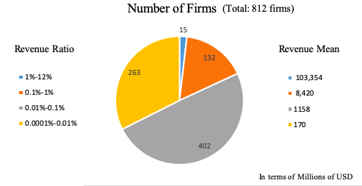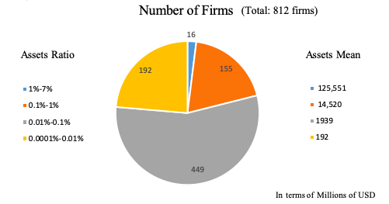

Fig. 1. Firm size composition by revenue Fig. 2. Firm size composition by assets

Fig. 1 and fig. 2 present the firm size composition in terms of total revenue and total assets. Graph 1 shows that only 15 of the 812 firms are relatively large firms with average revenue 103,354 million USD, contributing to 1% - 12% of all the sample firms’ total revenue; 132 of them are medium large firms with average annual revenue 8,420 million USD and 263 of them are very small firms taking up less than 0.01% of total revenue. Around half of the firms are medium small firms with average revenue 1,158 million USD, contributing to 0.01% to 0.1% of total revenue. Fig. 2 illustrates similar results with respect to total assets: only 2% of the 812 firms are large firms; around 20% are medium large firms and another 23% are very small firms; 55% of
the firms are medium small firms that individually contributes to 0.01% to 0.1% of total assets of all sample firms. The description of firm size here only loosely refers to the relative size of the firm compared to the peer SOEs in the same sample. The relatively “very small” firm here corresponds to a firm with average annual revenue 170 million USD that actually applies to the general definition of a medium-sized business.

Table 2 presents summary statistics for the 812 state-owned enterprises during the period 2000-2017. Panel A contains aggregate firm characteristics. All variables excluding the profitability have positive skewness with absolute value far greater than 1, indicating that the distributions of firm characteristics are highly skewed to the right.

Table 2. Summary Statistics
Panel A. Firm characteristics
 | Mean | Median | St. dev | 10th percentile | 90th percentile |  | Skewness
Leverage (ratio) | 55.97 | 53.89 | 133.25 | 24.74 | 78.99 |  | 56.95
Net Profit | 107.60 | 12.95 | 729.49 | 0.07 | 167.63 |  | 19.20
Profitability (ratio) | 8.75 | 8.62 | 272.69 | 1.08 | 30.09 |  | -109.20
Nb. Of employees (persons) | 11039 | 3702 | 33255 | 686 | 20872 |  | 9.18
Long-term Debt | 911.44 | 101.37 | 3123.89 | 3.11 | 1678.24 |  | 8.70
Short-term Debt | 551.04 | 100.98 | 1670.49 | 7.24 | 1219.25 |  | 7.94
Book value of assets | 3990.85 | 779.53 | 16122.77 | 152.50 | 13928.77 |  | 13.33
Book value of equity | 1537.46 | 349.09 | 7792.18 | 73.13 | 2571.56 |  | 18.09
Capital Expenditure | 261.33 | 26.1 | 1718.56 | 1.82 | 351.95 |  | 19.3
Enterprise Value | 2636.60 | 699.00 | 13196.79 | 189.00 | 4560.00 |  | 25.47
Increased investment | 186.42 | 15.00 | 991.35 | 0 | 344.00 |  | 24.22
Market capitalization | 2158.98 | 634.84 | 11767.26 | 164.83 | 3704.70 |  | 31.36
Notes: In millions of US dollar, otherwise indicated above. The firm characteristics are presented in dollar value in summary statistics here. However, the corresponding variable in regression might be adjusted for firm size. See Appendix A for details.

Panel B. Correlation Matrix
 | (1) |  | (2) | (3) | (4) | (5) | (6) | (7) | (8)
Leverage (1) | 1
Book value of assets (2) | 0.0102 |  | 1
Book value of equity (3) | -0.0043 |  | 0.9402* | 1
Capital Expenditure (4) | -0.0248* |  | 0.0528* | 0.0728* | 1
Enterprise Value (5) | -0.0021 |  | 0.8114* | 0.8697* | 0.8654* | 1
Increased investment (6) | 0.0113 |  | 0.3361* | 0.2982* | 0.1782* | 0.2252* | 1
Market capitalization (7) | -0.0071 |  | 0.7260* | 0.8105* | 0.7997* | 0.9813* | 0.2199* | 1
Profitability (8) | -0.1508* |  | 0.0013 | 0.0114 | 0.0349* | 0.0056 | 0.0126 | 0.0056 | 1
* denotes significance level at 10%
Panel C. Leverage by Industry
Industry | Obs | Mean |  | Median |  | Std. Dev | 10th percentile | 90th percentile | Skewness
Construction | 368 | 74.45 |  | 76.65 |  | 15.44 | 55.23 | 88.19 | 1.24
Real Estate | 519 | 65.71 |  | 67.78 |  | 16.76 | 42.97 | 84.5 | 0.01
Financial | 181 | 62.21 |  | 66.61 |  | 18.81 | 37.97 | 82.24 | -8
Utility | 766 | 61.36 |  | 60.47 |  | 29.08 | 35.56 | 81.79 | 6.48
Retail | 747 | 57.19 |  | 59.5 |  | 18.97 | 30.56 | 82.82 | -0.57
Manufacturing | 4,502 | 56.6 |  | 51.67 |  | 187.25 | 23.34 | 75.83 | 41.12
Scientific research | 57 | 52.55 |  | 50.65 |  | 16.35 | 32.42 | 75.34 | 0.06
Leasing & commercial | 94 | 51.51 |  | 50.97 |  | 24.83 | 22.71 | 75.72 | 1.6
Diversified | 55 | 49.52 |  | 55.52 |  | 19.92 | 20.83 | 73.82 | -0.23
Mining | 519 | 46.79 |  | 49.33 |  | 17.82 | 20.48 | 67.91 | -0.11
Agriculture | 132 | 45.48 |  | 41 |  | 18.68 | 23.85 | 69.39 | 0.2
Transport | 664 | 45.27 |  | 43.77 |  | 19.94 | 18.83 | 72.57 | 0.2
Environment | 105 | 42.96 |  | 40.57 |  | 21.78 | 15.49 | 70.19 | 0.99
Information Technology | 182 | 40.96 |  | 44.38 |  | 17.88 | 16.62 | 61.96 | -0.11
Accommodation | 77 | 37.76 |  | 33.58 |  | 18.15 | 17.78 | 66.66 | 0.7
Entertainment | 54 | 35.78 |  | 34.17 |  | 12.13 | 18.74 | 53.3 | 0.06

On average, sample SOEs have around 55% debt-to-assets ratio, which is slightly higher than the benchmark 50%. However, there is a fat tail of firms with very high leverage with 90th percentile at 78.99 debt-to-assets ratio. In general, Chinese SOEs have considerable number of employees. Even 10th percentile of the sample has 686 employees, which could be considered as medium-sized business. The gap between median and mean number of employees come from the fact that a few large SOEs provide more than 10 thousand job opportunities while most SOEs have 1000 to 10,000 employees. This statistic provides evidence of a main social responsibility of Chinese SOEs which is job creation. For other measures of the firm size, such as book value of assets, market capitalization and enterprise value, the distributions are all highly right-skewed, which implies that most firms are relatively medium small firms while a small number of firms have very large size.

Panel B provides the correlation matrix of key variables. It shows that leverage has negative relationship with capital expenditure and profitability at a 0.1 significance level. The correlation between leverage and other financial variables are not all significant in the matrix. Nevertheless, given the highly skewed distribution of the variables as well as complex factors relating to industries and regulations, more rigorous investigation will be shown in the regression section.

Panel C ranks the leverage of the 812 firms between 2000-2017 by industry. The five industries that have highest debt-to-assets ratio are construction, real estate, financial, utilities and retail industries. Real estate and utility industries require significant investment in buying properties and infrastructure, making it reasonable for carrying more debt. For financial industry, it is common to have a high leverage ratio given the fact that banks make profits from borrowing at a lower rate and lending at a higher rate. Construction sector overall has the highest leverage ratio. It could be explained by the fact that Chinese construction firms usually have smaller turnover ratio, meaning that they have longer period before collecting cash from accounts receivable. However, firms in construction sector usually have high prepaid expenses that needs large capital, resulting in more borrowing.

- Leverage and Performance Trends

Aggregate Trends

Before the Split Share Structure Reform of 2005, the states owned shares were not tradable at market price but priced at the book value of assets (He et al, 2017 and Huang et al, 2018). As the result, executives compensated based on book value have no incentives to improve firm market performance. The 2005 reform has made state non-tradable shares publicly tradable, which mitigates the agency conflicts between management and government. Majority of the firms have completed the reform by the end of 2007 (Li, 2011). The effect of the reform has been shown in the sample.

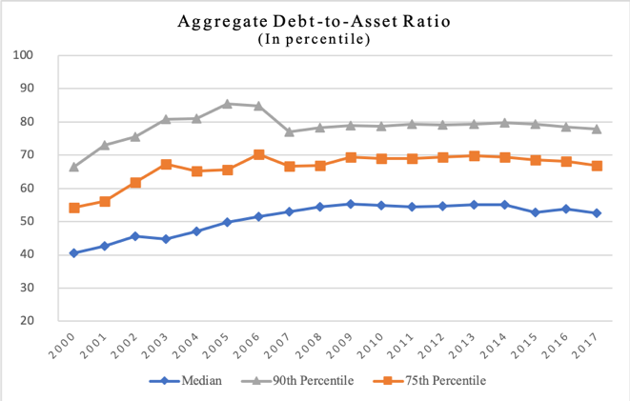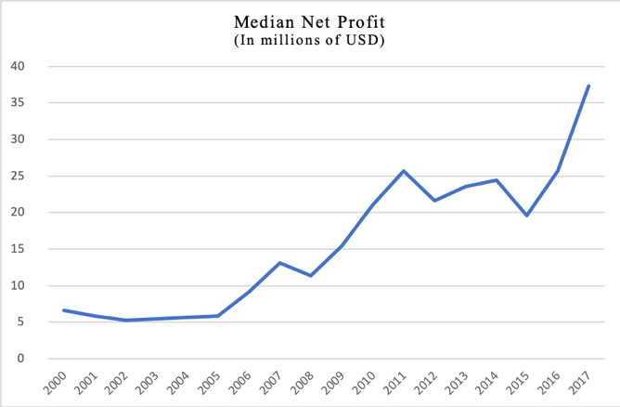
Fig. 3. SOEs leverage ratios Fig. 4. SOEs median net profit

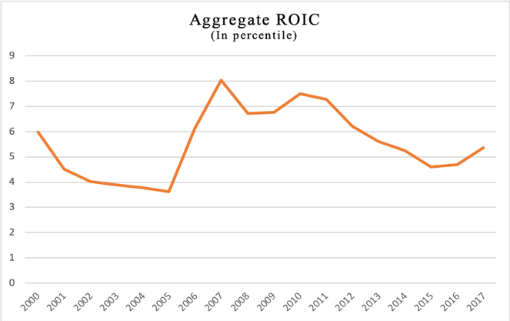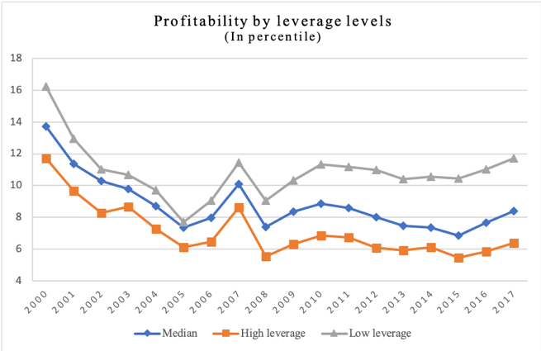
Fig. 5. SOEs median return on invested capital ratios Fig. 6. Operating margin of SOEs by leverage levels

Fig. 3-6 illustrates the aggregate leverage and profitability of the sample from 2000 to 2017. Fig. 3 shows that on average SOEs have increased their leverage by 30 percent from 2000 to 2007. Since 2007, the leverage ratios of SOEs have stayed relatively flat without deleveraging. The debt-to-assets ratios at 75th and 90th percentile are considerably high. As the baseline, the debt-to-assets ratio greater than 0.6 suggests high risk of default. The leverage at 90th percentile mounted at 85 percent before the reform, meaning debt borrowing is more than five times of equity issuance, indicates serious problem. The 90th percentile graph also demonstrates the effect of SOEs’ privatization on deleveraging from 2005 to 2007.

Fig. 4 shows that the median net profit has an overall increasing trend with fluctuation in some years. Nevertheless, given the fact that the sample data is highly right-skewed, using net profit alone to measure firms’ profitability is not persuasive. Instead, return on invested capital and operating profit margin
as indicators of the firm profitability have better explanatory power because these two ratios have been adjusted for firm size. As is shown in Fig. 5 and Fig. 6, these two indicators don’t have an increasing trend as presents in the net profit graph. On the contrary, aggregate operating margin has significantly decreased by 50 percent before the 2005 reform corresponding to the 30 percent increase in leverage. Both measures of profitability show evidence for an improving firm performance during the reform. In addition, Fig. 6 presents the firm profitability with respect to different leverage levels. Firms with debt-to-assets ratio greater than 0.6 are considered high leverage (risky) firms and with ratio less than 0.4 are considered low leverage (healthy) firms. In the post-Reform period, the operating performance of low leverage firms is 1.8 to 2 times better than firms with high leverage. Since the profitability is counted using EBIT, the profits of highly leveraged firms after interest payment would be worse. Generally, the graphs above suggest a negative relationship between firm leverage and operational performance.

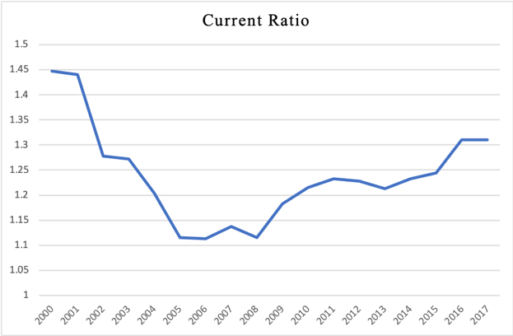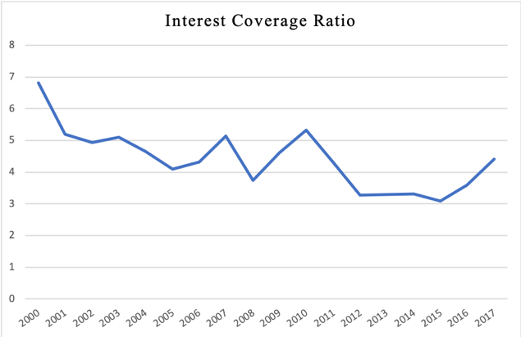
Fig. 7. SOEs liquidity ratio Fig. 8. SOEs solvency ratio

Fig. 7 and Fig. 8 presents liquidity and solvency ratios of SOEs spanning the 17 years. Liquidity ratio (current ratio) examines a firm’s ability to pay off its current liabilities with current assets and solvency ratio (interest coverage ratio) examines its ability to pay off the debt obligations in the long term. In parallel with the trend of profitability, both liquidity and solvency ratios drop 20 to 40 percent in the pre-Reform period, indicating an increasing financial risk in SOEs. Since 2008, the liquidity of SOEs has steadily improved over time. However, the solvency ratio of SOEs has an overall decreasing trend with fluctuations at a lower rate in the post-Reform period.

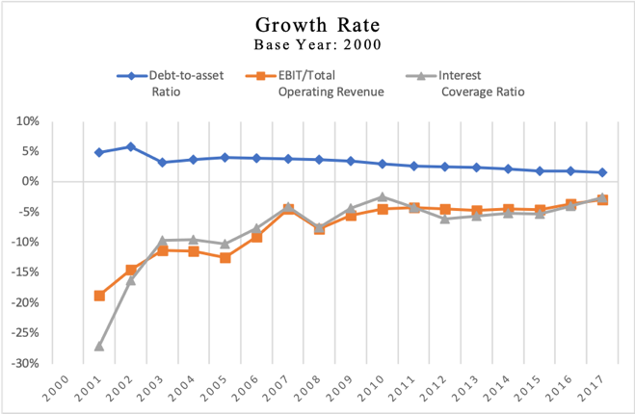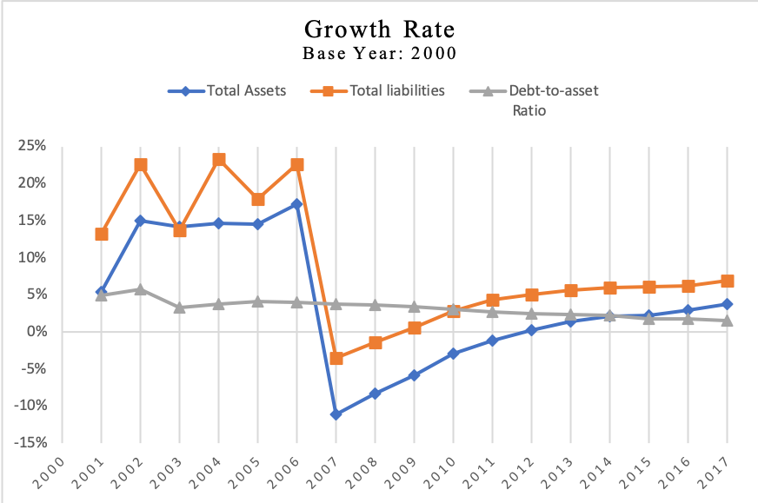

Fig. 9. Growth rate of leverage, profitability and solvency ratio Fig. 10. Growth rate of total assets, liabilities and leverage

Fig. 9 and Fig. 10 illustrate the logarithm growth rate of important financial indicators of SOEs using the base year 2000. Fig. 9 shows that the leverage ratio continues to have positive growth rate with decreasing margin over the 17 years while profitability and solvency ratio all have negative growth rate. The increase of debt in SOEs has not been compensated by the similar amount of growth in profitability and solvency ability but rather accompanying a general decline in profitability and solvency. This indicates an increasing risk of SOEs’ not meeting their financial obligations. To further investigate the two determinants of the leverage ratio, Fig. 10 presents the growth rate of total assets (denominator) and total liabilities (numerator). The overall growth rate of total liabilities is 5 to 10 percent higher than the growth rate of total assets resulting the increase of leverage over time. The notable drop of the growth rate in 2007 is due to the non-tradable share reform explained before that a large number of SOEs go public in 2007. It causes a sudden increase of sample size in 2007 that the data of firms with relatively smaller size and liabilities becomes available.

Industry Trends

As is widely known, the leverage ratio varies a lot across different industries. Firms usually decide their capital structure according to the median leverage ratio in the industry (Hull, 1999). Although the aggregate median leverage of SOEs grows steadily before the reform and stays relatively flat after the reform, the variation across industry is significant. Some industries, especially real estate, experienced substantial growth for more than 10 years.

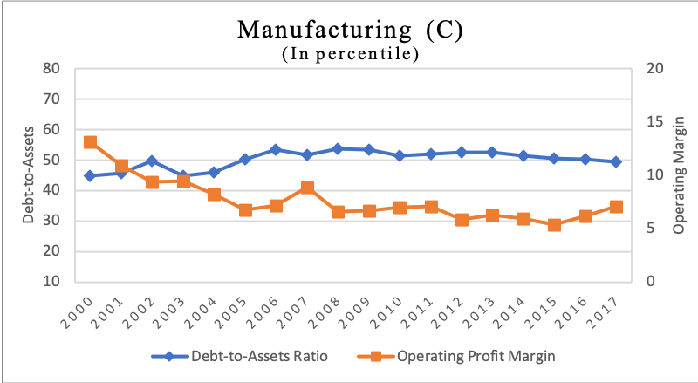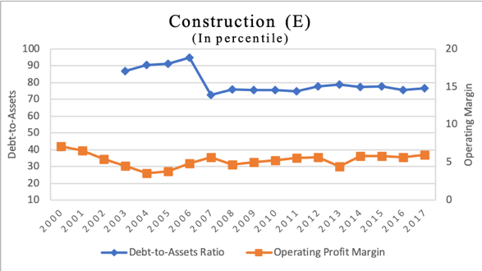

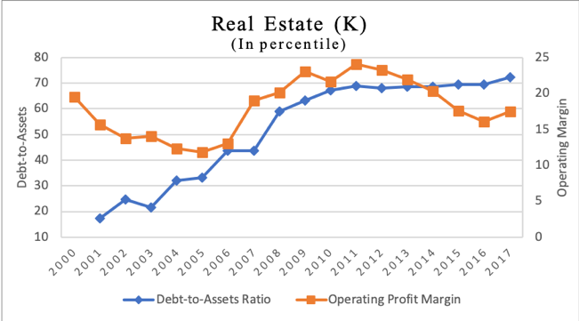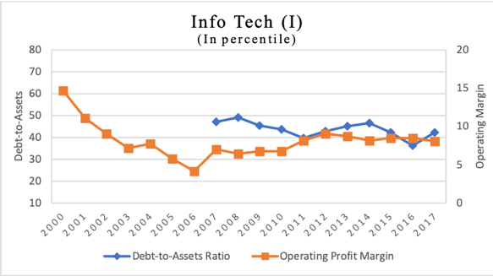

Fig. 11. SOEs median leverage and profitability in manufacturing, construction, information technology and real estate industries.

The leverage and profitability of firms in manufacturing industry have similar trends as the aggregate median ratio given the fact that manufacturing firms take up half of the sample. The leverage of manufacturing sector largely stays flat and fluctuates around 50 percent. The profitability shrinks 50 percent in the pre-Reform period and stays flat afterwards. Construction and real estate are two most highly leveraged industries. Before the 2005 reform, median leverage in construction industry peaks at 95 percent, which implies that almost all assets in the industry are in the form of liabilities. The industry deleverages to around 75 percent after the reform. Profitability of the industry follows a similar path as that of the manufacturing industry. Real estate industry is the main driver behind the increasing debt pile in SOEs. As is shown in the third graph of Fig. 11, the leverage ratio in real estate industry remarkably increases from 20 percent to over 70 percent. The significant growth marks the real estate from a health, lightly leveraged industry to a risky, highly leveraged industry. Even though the median profitability of the industry experiences a similar growth between 2007 and 2011, the overall operating margin stays around 17 percent. With the same level of operating performance but 4-times of the leverage than 2000, the real estate sector faces a dramatic increase of financial vulnerabilities. Contrarily, information technology sector has the leverage ratio below average and also slightly deleverages over time. The almost symmetric fluctuation of debt-to-assets ratio and operating margin indicates a negative relationship between leverage and profitability. The trends of SOEs in other industries are demonstrated in Appendix B.

- Empirical Results

To check the robustness of the trends denoted in the previous section, I undertook fixed effect and random effect regressions on the panel data. There is a potential endogeneity problem within the leverage regression model because leverage and profitability simultaneously affect one another. Therefore, the later discussion mainly talks about the correlations between the variables rather than causal relationships. The regression model is specified as follows:

Leverage_{i,t} = β₀ + 𝜶₁Profitability_{i,t} + β₁X_{i,t} + γ₂Sector₂ + … + γ₁₆Sector₁₆ + δ₀T₂₀₀₀ +… + δ₁₆T₂₀₁₆ + μ_{i,t}

The model examines the effects of firm characteristics, sector and time on SOE’s leverage. X_{i,t} controls all firm-level characteristics. The differences across industries are captured by the dummy variables Sector_{n}. T_{n} are the dummy variables that captures time trend effect. The partial results are presented in Table 3 and Table 4.
Table 3 presents the aggregate leverage ratio with respect to different industries. The result shows, controlling for firm characteristics, SOEs in construction, real estate and retail industries have significantly higher leverage while SOEs in information technology industry have lower leverage.

Table 3. Aggregate leverage and industry

Debt/Assets
 | Aggregate (RE)
Agriculture | -.6009  (6.099)
Mining | -8.5219  (5.3304)
Manufacturing | .8027  (5.0616)
Utility | 3.3817  (5.2111)
Construction | 11.5747**  (5.4263)
Retail | 9.2734*  (5.2522)
Transportation | -6.9474  (5.2569)
Accommodation | -6.9207  (6.6398)
Info Tech | -11.0313*  (6.2358)
Financial | 4.1101  (7.0858)
Real Estate | 10.9134**  (5.2765)
Leasing | 2.5838  (6.4390)
Scientific research | 9.6277  (7.8596)
Environment | 1.1511  (6.8070)
Entertainment | -4.7171  (10.1050)
Observations | 4,105
R-squared | 0.388

Notes: RE refers to random effects model. Fixed effects model is not relevant when examining industry effect because the industry dummy variables would be dropped due to collinearity. Fixed effects model has already adjusted for firm-level differences.

Table 4. Aggregate and industry leverage on profitability and time

Debt/Assets
 | Aggregate  (RE) | Aggregate (FE) | Real Estate (FE) | Construction  (RE) | Info Tech  (RE) | Manufacturing (RE)
Profitability | -.0819***  (.0069) | -.0761***  (.0071) | -.0946***  (.0300) | -.1260  (.0895) | .1989  (.3213) | -.0369***  (.0095)
t1 | -4.1896  (3.3612) | -2.6617  (3.4374) |  |  |  | -2.5479  (4.0655)
t2 | 1.1950  (2.4143) | 3.4004  (2.5424) |  |  |  | 5.5143***  (3.0693)
t3 | 1.3707  (2.4295) | 3.6365  (2.5230) |  |  |  | 8.7896***  (3.2205)
t4 | .41271  (2.2731) | 2.7785  (2.3763) |  |  |  | 7.7372***  (3.2544)
t5 | 4.5965**  (2.1088) | 7.2766***  (2.2153) |  | 18.2871***  (4.8328) |  | 6.7935***  (3.1683)
t6 | 5.5836**  (2.1893) | 8.2846***  (2.2697) |  | 14.9640***  (4.8573) |  | 3.3505  (3.6645)
t7 | 6.0579***  (1.7689) | 8.190***  (1.8496) |  | 14.5252***  (4.7324) |  | 9.6982***  (2.8843)
t8 | 5.0102***  (.82488) | 5.800***  (.9682) | 3.8042  (3.1882) | 8.5683***  (2.5742) | 3.9322  (8.3522) | 6.8773***  (1.264)
t9 | 4.8649***  (.78612) | 5.9120***  (.9004) | 4.2628  (2.9974) | 10.4100***  (2.2821) | -3.9714  (7.6235) | 7.2023***  (1.2230)
t10 | 4.6818***  (.7475) | 5.4958***  (.8347) | 2.0256  (2.6082) | 6.6167***  (1.9653) | -12.2510**  ( 6.1740) | 6.8349***  (1.1546)
t11 | 4.8029***  (.7199) | 5.4786***  (.7773) | 5.2739**  (2.4353) | 5.1286***  (1.9218) | 3.8925  (6.7244) | 6.0268***  (1.1070)
t12 | 4.3747***  (.6908) | 4.8339***  (.7258) | 4.2896*  (2.3142) | 4.3317**  (1.7472) | -3.0321  (6.2971) | 5.7978***  (1.0646)
t13 | 3.3811***  (.6636) | 3.9402***  (.6868) | 4.0425*  (2.1651) | 4.7887***  (1.6106) | -6.3919  (6.4673) | 4.3631***  (1.030)
t14 | 2.9843***  (.6559) | 3.2688***  (.6665) | 3.5466*  (2.0996) | 4.3166***  (1.5457) | -7.7196  (8.2505) | 4.2217***  (1.01032)
t15 | 1.8228***  (.6487) | 2.0211***  (.6506) | 2.4911  (2.0004) | 3.6758**  (1.5472) | -5.6689  (5.7036) | 2.1940***  (1.0279)
t16 | 1.5886**  (.6266) | 1.6866***  (.6242) | 2.0689  (1.8658) | 1.1847  (1.4446) | -4.9629  (5.1642) | 1.9814***  (.9813)
t17 | 1.4332**  (.6187) | 1.5405**  (.6139) | .6597  (1.8306) | 1.5176  (1.3662) | -.7082  (5.1778) | 2.4122***  (.9790)
Constant | 21.7281***  (5.4961) | 17.0791***  (3.6336) | 15.5038  (11.2434) | 32.9124***  (6.5136) | 62.5417***  (15.5585) | 31.1268***  (3.7683)
Observations | 4,105 | 4,105 | 335 | 225 | 47 | 1,781
R-squared | 0.388 | 0.239 | 0.272 | 0.509 | 0.888 | 0.264
Notes: RE refers to random effects model. FE refers to fixed effects model. Some variables are dropped in industry regressions due to collinearity problem.
*** denotes significance level at 1%
** denotes significance level at 5%
* denotes significance level at 10%

Table 4 presents the relationship between leverage, profitability and time. The first row of coefficients demonstrates a significant negative relationship between leverage and profitability in Chinese SOEs at the aggregate level and by industries (except IT industry). It is consistent with the analysis in the last section: an increase in leverage is associated with a decline in profitability. This is a strong indication that Chinese SOEs, particularly in the highly leveraged industries such as real estate and construction, may have difficulty retaining their current level of debt. The positive relationship between leverage and time is consistent at the aggregate level and by industries (except IT industry). The leverage in Chinese SOEs has increased over time with the highest growth around the reform (2005 - 2007). After the reform, the growth rate of leverage has a decreasing trend but is still positive. However, IT industry with comparatively lower leverage has actually deleveraged over time. There is also no significant indication of declining profitability in IT industry. The result suggests that IT industry is the least vulnerable industry that would be more likely to sustain its financial stability.
- Conclusion

As the development of China’s economy, the debt ratio of the country has also grown significantly. Corporate debt has increased to 165 percent of the country’s GDP and two thirds of the debt are in China’s state-owned enterprises. Since the stability of China’s economy is closely related to the health of global economy, it is necessary to investigate the rising indebtedness in China’s state-owned enterprises. This paper provides a comprehensive study on the financial sustainability of China’s SOEs. The key findings are as follows:
- On average, SOEs have increased their leverage by 30 percent between 2000 and 2005. After the 2005 reform, the leverage of SOEs have largely stayed flat. At the same time, profitability has significantly decreased by 50 percent and solvency ratio has dropped by 20 to 40 percent before the reform.
- The increase in leverage is not compensated by a similar increase in profitability. On the contrary, profitability and solvency ability has an overall negative growth rate. This is a strong indication that SOEs may have difficulty retaining their current level of debt.
- Construction and real estate are two highly leveraged industries. The real estate sector has increased the leverage to 4-times from 2000 to 2017, but its profitability ratio has stayed at the same level. This indicates increasing financial vulnerabilities in real estate industry. The information technology sector has relatively less debt and does not increase the leverage over time. The IT sector has the lowest default risk compared to other sectors.
- The negative relationship between leverage and profitability is significant in China’s SOEs. More efficient deleveraging policy or profitability improvement is needed to sustain the debt condition in China’s SOEs.

Appendix A. Variable definitions

Variables | Definitions
Leverage ratio | Debt-to-assets ratio; total liabilities divided by total assets
Profitability | Operating profit margin; operating Profits (EBIT) divided by total operating revenue
Liquidity ratio | Current ratio; current assets divided by current liabilities
Solvency ratio | Interest coverage ratio; operating profits (EBIT) divided by interest expense
Net profit | Net income after tax and interest payment
Return on invested capital | Net operating profit after tax divided by total invested capital
Net profit margin | Net profit divided by total operating revenue
Central | A dummy variable taking the value of 1 if the firm is a central SOEs, and 0 otherwise
Size | Natural logarithm of book value of total assets
Capital expenditure | Capital expenditure divided by total assets
Increased investment | Increased investment divided by total assets
Market-to-book ratio | Market capitalization divided by book value of equity

Appendix B. Leverage and profitability of SOEs in other industries

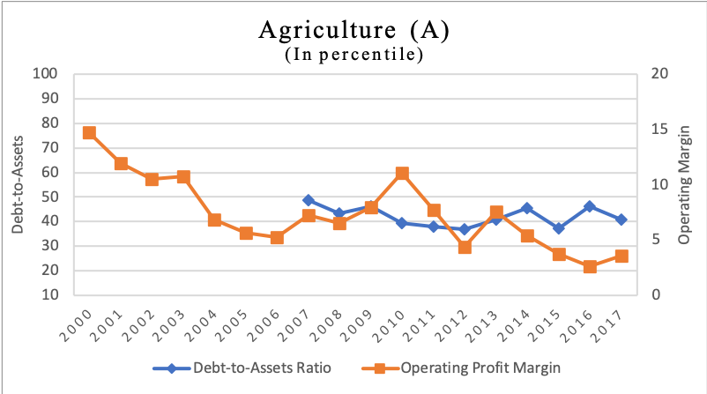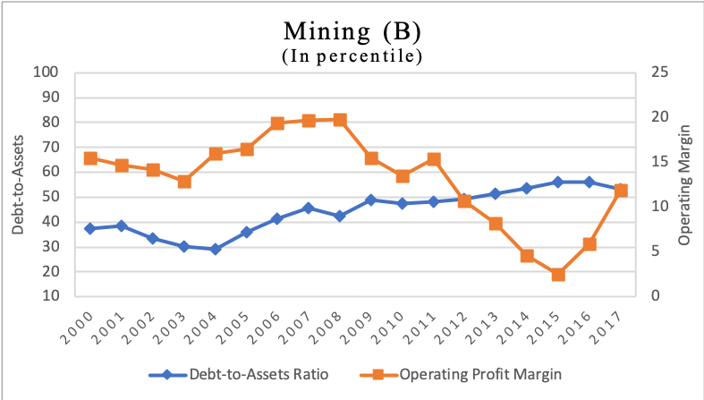
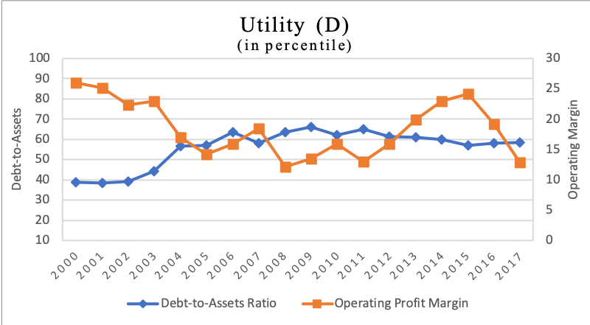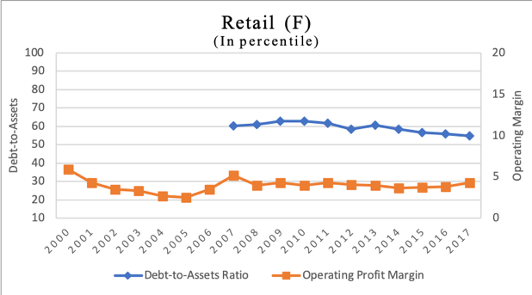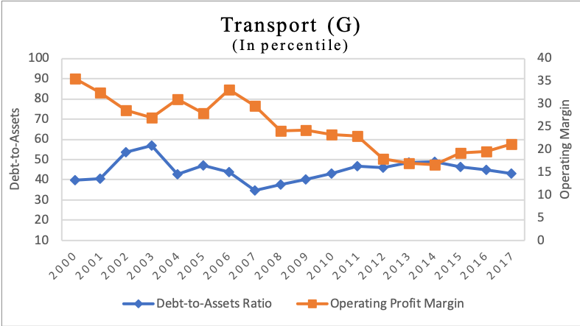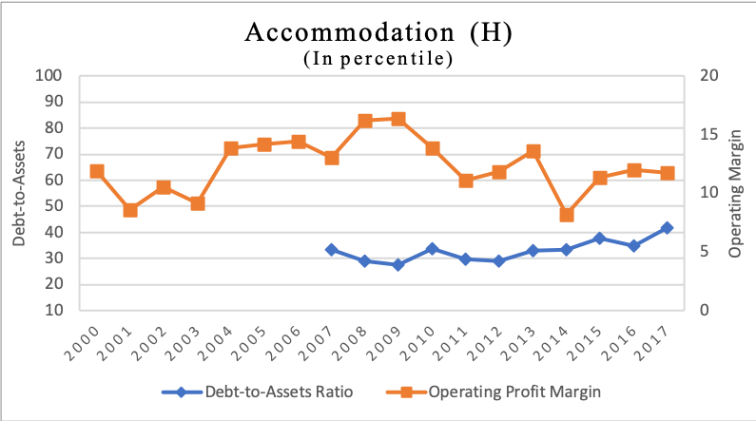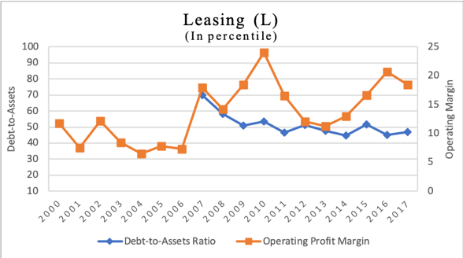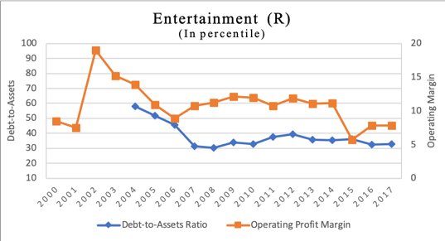

Appendix C. Additional regression results on firm characteristics

Debt/Assets
 | Aggregate  (RE) | Aggregate (FE) | Real Estate (FE) | Construction  (RE) | Info Tech  (RE) | Manufacturing  (RE)
Profitability | -.0819***  (.0069) | -.0761***  (.0071) | -.0946***  (.0300) | -.1260  (.0895) | .1989  (.3213) | -.0369***  (.0095)
Central | -1.356  ( 1.0008) |  |  |  | 1.3003  (3.2010) | -3.6864***  (1.4264)
Size | 3.90***  (.292) | 4.5868***  (.4306) | 7.7652***  (1.3132) | 5.4898***  (.7811) | 1.5835  (2.0861) | 2.2216***  (.4816)
Capital expenditure | -78.745***  (4.796) | -70.8447***  (4.9151) | -196.5542***  (36.2053) | -108.8058***  (15.6333) | -542.2165***  (89.2918) | -69.4608***  (6.7607)
Increased investment | -3.45 (.727)*** | -2.2101***  (.7629) | -7.6738  (6.9065) | -3.0935  (4.1227) | -24.9440**  (9.9727) | -2.0988***  (.7991)
Market-to-book ratio | 27.84***  (1.23) | 24.4443***  (1.2358) | 61.4702***  (8.6008) | 13.6734***  (2.030) | 257.3136***  (51.1543) | 23.1458***  (1.6538)
Long-term debt | .00006  (.00008) | .000125  (.00009) | -.00026  (.00032) | -.00016  (.00015) | .001245  (.0029) | .00098***  (.0004)
Short-term debt | .0007***  (.00016) | .000795***  (.00016) | -.00058  (.0011) | .00012  (.0003) | .00008  (.00075) | .0032***  (.0004)
Tax rate | .1489***  (.0394) | .14389***  (.0416) | -.3112**  (.1567) | -.0621  (.1220) | -1.6609***  ( .4641) | .2027***  (.0587)
Constant | 21.7281***  (5.4961) | 17.0791***  (3.6336) | 15.5038  (11.2434) | 32.9124***  (6.5136) | 62.5417***  (15.5585) | 31.1268***  (3.7683)
Observations | 4,105 | 4,105 | 335 | 225 | 47 | 1,781
R-squared | 0.388 | 0.239 | 0.272 | 0.509 | 0.888 | 0.264
Notes: The dummy variable for central government ownership is dropped in some regressions due to collinearity problem.
*** denotes significance level at 1%
** denotes significance level at 5%
* denotes significance level at 10%

Reference
Adam, T.R. and Goyal, V.K. (2008). The investment opportunity set and its proxy variables. Journal of Financial Research, 31, 41-63.
Chivakul, Mali and Lam, W.R. (2005). Assessing China’s corporate sector vulnerabilities. IMF Working Paper, 15/72.
Dewenter, K., Malatesta, P. (2001). State-owned and privately owned firms: an empirical analysis of profitability, leverage, and labor intensity. American Economic Review. 91, 320–334.
Goldman Sachs. (2018). China Credit Conundrum: Mapping China’s Credit, 2. New York.
Graham, J., Leary, M., & Roberts, M. (2014). A Century of capital structure: The leveraging of corporate America. Journal of Financial Economics,118, 658-683.
He, W., Mukherjee, T.K. and Baker, H.K. (2017). The effect of the split share structure reform on working capital management of Chinese companies. Global Financial Journal, 33, 27-37.
Huang, X., Kabir, R. and Zhang, L. (2018). Government ownership and the capital structure of firms: Analysis of an institutional context from China. China Journal of Accounting Research, 11, 171-185.
Hull, Robert. (1999). Leverage ratios, industry norms, and stock price reaction: An empirical investigation of stock-for-debt transactions. Financial Management, 28(2), 32-45.
Kraus, A.; Litzenberger, R.H. (1973). A State-Preference Model of Optimal Financial Leverage. Journal of Finance, 28, 911–922.

Li, K., Wang, T., Cheung, Y.-L., and Jiang, P. (2011). Privatization and Risk Sharing: Evidence from the Split Share Structure Reform in China. The Review of Financial Studies, 24(7), 2499–2525.
Mourdoukoutas, Panos. (2018). Debt, not trade war, is China’s biggest problem. Forbes. Retrieved from https://www.forbes.com/sites/panosmourdoukoutas/2018/11/24/debt-not-trade-war-is-chinas-biggest-problem/#5c51432e4c4d.
Pessarossi, P., Weill, L. (2013). Choice of corporate debt in China: the role of state ownership. China Economic Review. 26, 1–16.
Qian, Yingqian. (1996). Enterprise reform in China: agency problems and political control. Economics of Transition, 4 (2), 427-447.
Shao, Y., Hernández, R. and Liu, P. (2015). Government intervention and corporate policies: evidence from China. Journal of Business Research, 68(6), 1205-1215.
Sun, Q., Tong, W. (2003). China share issue privatization: the extent of its success. Journal of Financial Economics. 70, 183–222.
Xiao, Zuoping. (2011). Ownership control right divergence, Government intervention and choice of capital structure: Empirical evidence from listed companies in China. Nankai Business Review, 2(3), 303-324.
Xu, L.C., Zhu, T. and Lin, Y.-M. (2005). Politician control, agency problems, and firm performance: evidence from a national survey of ownership restructuring in China. Economics of Transition, 13(1), 1-24.
Zhuang, Guijun. (2013). Structural change in China's retail industry in the first decade of the new century. Journal of Marketing Channels, 20, 288-324.

Source: https://www.macrotrends.net/2575/us-dollar-yuan-exchange-rate-historical-chart
Return on invested capital ratio is calculated as net operating profit after tax divided by total invested capital.
Operating profit margin is calculated as earnings before interest and taxes (EBIT) divided by total operating revenue.
For more details about firm-level control variables, please refer to Appendix A and Appendix C.
Additional regression results with firm-level control variables can be found in Appendix C.
This refers to the variable in the regression. The capital expenditure in the summary statistics is its absolute value without adjustment for total assets.

