Analysis of High Frequency VIX and its Predictive Power in the Chinese Market

by

Yue Yu

An honors thesis submitted in partial fulfillment

of the requirements for the degree of

Bachelor of Science

Business and Economics Honors Program

NYU Shanghai

May 2020

Professor Marti G. Subrahmanyam Professor Menachem Brenner
Professor Christina Wang
Professor Jens Leth Hougaard

Faculty Advisers Thesis Adviser

Abstract
This paper studies the performance of high frequency IVIX in the Chinese market. By analyzing the relationship with its underlying SSE 50 ETF return, this paper seeks to test whether we could observe the strong negative asymmetric relation and lagged effect at intraday level in the Chinese market. Regarding the result, we discover the weak negative correlation and no lagged effect comparing to the US market. Possible explanations for the above unique phenomena would also be provided.
This paper further explores the forecasting ability of daily IVIX on future daily realized volatility. By comparing with GARCH(1,1) estimate, which is often considered as a good estimate for forecasting realized volatility, this paper concludes that IVIX has better predictive performance than GARCH(1,1) and the combined model of these two estimates outperforms their separate univariate model.
This paper also looks into predicting future implied volatility at intraday level. Both traditional time series forecasting model and Deep Learning Algorithm are applied to the data, namely ARIMA model and Long Short Term Memory (LSTM) model. By comparing the result using MAPE, RMSE and MSE, this paper draws conclusion that LSTM model has higher prediction accuracy than ARIMA model.

- Introduction
VIX, originally proposed by Prof. Menachem Brenner and Dan Galai in 1989 (Brenner & Galai, 1989), is a volatility index for the S&P 500 index return produced by the Chicago Board Options Exchange (CBOE) in a model-free way. It typically increases sharply when the market goes down, so it is also known as “fear index”. As a forward-looking index, it is implied by the current prices of the options on S&P 500 (European type) and contains information about the expected future stock market volatility over the next 30 days. Due to its wide application in volatility forecasting and relationship with market returns, it is often used in risk management and hedging in the industry. In this paper, I would specifically focus on VIX in the Chinese stock market. China has started option trading in 2015, with Shanghai Stock Exchange(SSE) published 50 ETF as the first option. SSE uses similar method as CBOE to construct a volatility index for SSE 50 ETF called IVIX, which is a Chinese-versioned VIX. It started to publish it in 2015 and stopped publishing it in 2018 February due to the panic it caused in the market.
While considerable research has examined the VIX index including its dynamics, term structure, jump analysis and forecasting power in the US market, there is very limited research done on the Chinese market. The lack of official reporting of IVIX since February 2018 is one of the reasons of the absence of IVIX research. Another reason is possibly due to the limited liquidity (volume of trading) in the Chinese option market, which just started in 2015. This paper seeks to complement literature by providing empirical performance analysis on IVIX using high frequency data in the emergent Chinese market.
This paper is divided into three sections. For the first section, this paper focuses on analyzing relationship of IVIX and its underlying stock return. Relationship between stock return and VIX is a broadly studied and well documented topic in the US market. This paper refers to models used in the literature and compares the different results in the US and Chinese markets. Similar regression models used in Giot (2005) are adopted in this paper to analyze the negative correlation, asymmetric effect, lagged effect and size effect. Contrary to the empirical evidence in US market, this paper finds weak negative correlation and no lagged effect between return and implied volatilities. Combining with results and reasonings from Li, Yu and Luo(2019) and Zheng et al.(2017), this paper also seeks to provide explanations on this unique phenomenon with reference to investor structure and behavioral theories.
The second section studies the predictive performance of IVIX on future realized volatility of the underlying asset. This paper uses three regression models with daily data and compares IVIX with GARCH(1,1) estimate, which is often considered as a good estimate for forecasting realized volatility. From the regression result, together with several error estimates of the forecasting series, this paper concludes that daily IVIX has better performance than GARCH(1,1) estimate in forecasting daily realized volatility in the Chinese market.
The third section looks into forecasting future implied volatility in the Chinese market. This paper introduces both parametric and nonparametric model, namely ARIMA (time series model) and Long Short Term Memory (LSTM, a deep learning algorithm). Upon applying the two models on empirical data, several error estimates are used to compare the prediction accuracy of future intraday IVIX.
The rest of the paper is structured as follows: Section 2 introduces the broad literature of VIX analysis on both US and Chinese market and proposes research question of this paper. Section 3 focuses on the calculation method of high frequency IVIX and measurements of other variables used in this paper. Section 4 provides an overview of methodology used in this paper. Section 5 reports the regression result and analyzes relationship of return and IVIX. Section 6 compares IVIX and GARCH(1,1) estimate in forecasting future realized volatility. Section 7 discusses the predictive performance of IVIX on future implied volatility. Section 8 concludes the paper.
- Literature Review
There are a wide range of previous studies on the relationship of implied volatility and the underlying stock return. The significant negative and asymmetric correlation is first pointed out by Black (1976). He proposes leverage hypothesis to account for the asymmetry that negative shocks in return will increase the leverage, thus driving up volatility. Another traditional hypothesis to explain the asymmetric effect is the volatility feedback hypothesis presented by Poterba and Summers (1986), focusing on the long term economic process. Leverage hypothesis and volatility feedback hypothesis are mostly suitable for low frequency data (weekly and monthly), but couldn’t provide good interpretation for intraday data. Low(2004) suggests that behavioral theory could be used for intraday evidence, fitting the gap. Hibbert (2008) and Talukdar, Daigler, and Parhizgari (2017) take a step further and verify that negative and asymmetric relation in high frequency data is consistent with behavioral theories rather than the two traditional hypothesis. However, the negative and asymmetric correlation is not always consistent with the Chinese market. Zheng, Jiang and Chen(2017) find that daily VIX is positive related to SSE 50 ETF price during the whole sample period. Li, Yu and Luo(2019) add to the argument that intraday IVIX is also positively related to the underlying stock price.
Using implied volatility to forecast future realized volatility is another heated topic in the volatility studies. Various researchers have explored the relationship and arrived at different conclusions at different frequencies. Prevailing studies such as Christensen and Prabhala (1998) show that the implied volatility of S&P 100 can predict the actual realized volatility in the underlying index using daily returns. However, it is discovered by Andersen and Bollerslev(1998) that due to the noise in daily squared returns, models which intend to forecast realized volatility measured by daily returns usually have low R-square values. Therefore, Blair et al. (2001) follow their direction and use high frequency returns to measure realized volatility. They arrive at the conclusion that high frequency observations provide more accurate estimation of future realized volatility. They also conclude that VIX outperforms other estimates in forecasting realized volatility measured by high frequency returns. Day and Lewis(1992) further combine VIX and GARCH(1,1) estimate using multivariate regression. The result shows that its prediction accuracy is higher than any of the two separate univariate models.
Since implied volatility is itself an important tool for option pricing, risk management and trading strategies, having an accurate prediction of future implied volatility is essential and profitable. There exist various types of models for volatility prediction. Simple time series regression models such as ARIMA, which combines past volatility terms and noise process, are often considered as benchmark models. ARCH class model is another popular volatility forecasting model proposed and studied by many scholars (e.g. Bollerslev, Cho and Kroner(1992) and Bollerslev, Engle and Nelson(1994)). Instead of sample standard deviation, it constructs conditional variance of return. Among all ARCH class model, GARCH(1,1) is the most widely used in financial time series modelling. In addition, along with the rapid growth of Machine Learning and Deep Learning, non-parametric models have attracting more attention. Park, Kim and Lee(2014) compare the result of parametric and nonparametric models in predicting option price. It turns out that non-parametric models have better accuracy on both in-sample and out-of-sample prediction. Therefore, this paper proposes to use Long Short Term Memory (LSTM) Model as well.
In this paper, we add to the literature by solving the below research questions using high frequency data:
- Do high frequency IVIX and SSE 50 ETF have the similar relationship comparing to the US market with regard to negative, asymmetric, size and lagged effect? How can we interpret the relation?
- Does daily IVIX provides more accurate forecast of future daily realized volatility than GARCH(1,1) estimate?
- Does high frequency IVIX has predictive power for future implied volatility? Which model between ARIMA and LSTM performs better?
- Data and Measurement of Variables
3.1 Calculation of High Frequency VIX
Shanghai Stock Exchange(SSE) published daily IVIX index from February 2015 and stopped publishing in February 2018 due to market panic. So the IVIX available doesn't include more recent data from 2018~2019. Also, daily data could not provide enough evidence for this paper’s hypothesis. Due to the two above reasons, this paper first computes the high frequency IVIX in the Chinese market using transaction data of SSE 50 ETF from February 9th 2015 to October 22nd 2019 at 1-minute frequency. The raw data is provided by Volatility Institute in NYU Shanghai. For each minute and each option, the raw data includes information about the open and close price, trading volume and total turnover. Since the raw data uses option id to denote different options, the option code table is also needed in this paper, which contains option id and its option type, maturity date and strike price. Combining the two dataset above, we can merge them to get the full information of every minute’s transaction. The following graph is a snapshot of the merged data for every minute.
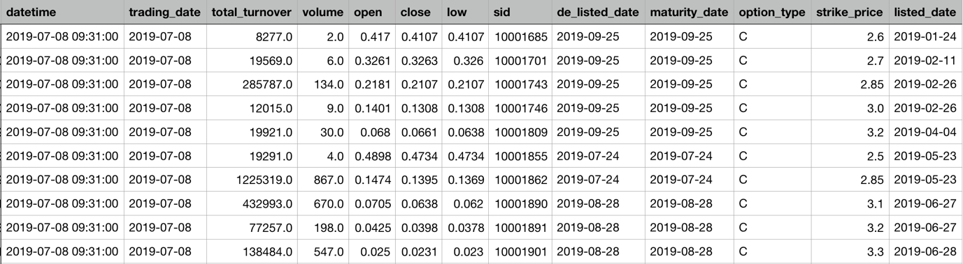
Figure 1 Snapshot of Merged Raw Data
Shanghai Stock Exchange changed the calculation method of IVIX in 2016, one year after they started publishing IVIX index. The second method is similar to the calculation method of VIX by CBOE, only that they are using different underlying options. To be consistent with the more recent data after 2018 and VIX in other markets, this paper uses the calculation method published in CBOE Whitebook of VIX index. According to the Whitebook, IVIX is designed to measure the market expected implied volatility of the target of 30 trading days derived from put and call options of SSE 50 ETF. To avoid the high volatility when maturity date is approaching, this paper rolls over to the set of options in next period if the near term options has maturity date less than seven trading days.
The formula for calculating implied volatility of near term option and next term option are listed below:
$$σ_{1}^{2}= \frac{2}{T_{1}}\sum_{i}{\frac{∆K_{i}}{K_{i}^{2}}e^{R_{1}T_{1}}Q\left(K_{i}\right)-\frac{1}{T_{1}}{\left[\frac{F_{1}}{K_{0}}-1\right]}^{2}}$$
$$σ_{2}^{2}= \frac{2}{T_{2}}\sum_{i}{\frac{∆K_{i}}{K_{i}^{2}}e^{R_{2}T_{2}}Q\left(K_{i}\right)-\frac{1}{T_{2}}{\left[\frac{F_{2}}{K_{0}}-1\right]}^{2}}$$

$T —$ Time to expiration, computed by the total minutes from the transaction to the expiration day divided by the total minutes in a year
$R —$Risk-free interest rate to expiration. This paper uses SHIBOR for risk-free interest rate in the Chinese market(Shanghai Interbank Offered Rate)
$F —$Forward index level derived from index option prices. To compute it, this paper first identifies the strike price with smallest difference between call price and ask price, then applies the formula $F=Strike Price+e^{RT}*(Call Price-Put Price)$.
$K_{0} —$First strike below the forward index level F
$K_{i} —$Strike price of i^{th} out-of-the-money option
$K_{i} —$Interval between strike, defined by $∆K_{i}=\frac{K_{i+1}-K_{i-1}}{2}$
${Q(K}_{i}) —$The midpoint of the bid-ask spread for each option with strike Ki

Since $σ_{1}$ and $σ_{2}$ denote the implied volatility of near term option and next term option respectively, the expected volatility targeted at 30 trading days should be the weighted sum of these two implied volatilities. Therefore, IVIX index could be calculated by the following equation:
$$VIX=100*\sqrt{\left\{T_{1}σ_{1}^{2}\left[\frac{N_{T_{2}}-N_{30}}{{N_{T_{2}}-N}_{T_{1}}}\right]+T_{2}σ_{2}^{2}\left[\frac{N_{30}-N_{T_{1}}}{{N_{T_{2}}-N}_{T_{1}}}\right]\right\}*\frac{N_{365}}{N_{30}}}$$

$N_{T_{1}}$ — total number of minutes to the settlements of the near-term option
$N_{T_{2}}$ — total number of minutes to the settlements of the next-term option
$N_{30}$ — total number of minutes in 30 days
$N_{365}$ — total number of minutes in 365 days

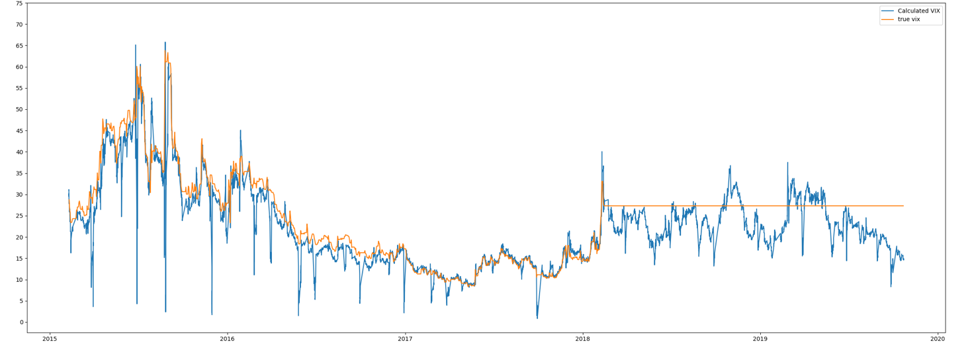
The graph of the computed high frequency IVIX and SSE published IVIX is reported below. We could see that before 2016 when SSE changed the calculation method of IVIX, the posted IVIX is slightly larger than the calculated IVIX using CBOE method. After SSE changed the calculation method, the posted IVIX and high frequency IVIX correspond to each other. Although the general trend is very promising, there are significant spikes in the calculated high frequency IVIX which cannot be ignored. It may due to the fact that SSE 50 ETF, similar to other options in the Chinese market, is not heavily traded. The data points are sparse and a large proportion of trading minutes do not update new closing prices. To remove the negative effect, this paper applies smoothing functions in the data preprocessing process. The major code is attached in Appendix.
Figure 2 High frequency IVIX and SSE published IVIX
3.2 Measurements of other variables
- SSE 50 ETF returns:
We apply log difference on the high frequency SSE 50 ETF close price as the underlying stock return, which is common practice when analyzing stock price.
- Annualized realized volatility:
We first use the sum of squared returns in intraday level to acquire the daily realized volatility. We then annualize the variable by multiplying square root of 252 (there are approximately 252 trading days in a year) in order to make it the same scale with IVIX and GARCH(1,1) estimate.
- GARCH(1,1) estimate
GARCH is intensively used to estimate implied volatility, especially GARCH(1,1) model (e.g. Heynen & Kat 1994). We could obtain the GARCH estimate by performing GARCH(1,1) model on high frequency returns. In this paper, we get the daily GARCH(1,1) estimate from Volatility Institute in NYU Shanghai.
- Daily IVIX
Daily IVIX is measured as the average of high frequency IVIX during that day.

- Methodology
This paper is divided into three sections to answer the corresponding research question.
The first section focuses on the overall performance of high frequency IVIX and its relationship with SSE 50 ETF. This section mainly uses statistics and regression models for analysis. Descriptive statistics is used to summarize overall volatility level and its underlying assets. We use regression models in Giot (2005) to analyze the four effects. In each model, dummy variables are included to separate the impact of positive return and negative return.
The second section analyzes the forecasting ability of daily IVIX and GARCH(1,1) estimate on future daily realized volatility. We use both univariate regression and multiple regression which are also used in Blaire et al.(2001) to compare the predictive performance of the two estimators.
The third section compares the prediction performance of high frequency IVIX on future implied volatility between traditional time series model ARIMA and Deep Learning algorithm LSTM.
- The first method is ARIMA(Autoregressive Integrated Moving Average). This paper applies differencing method and then conducts Augmented Dickey-Fuller test to ensure that the high frequency IVIX is stationary. Then this paper selects model using Box-Jenkins method. Plots of autocorrelation and partial autocorrelation are shown to decide which component to use. After selecting model, the paper uses Bayesian Information Criterion(BIC) to determine the order of ARIMA model. The model is given by :
$$V_{t}=α_{0}+α_{1}V_{t-1}+α_{2}V_{t-2}+…+{ α}_{p}V_{t-p}+ϵ_{t}+β_{1}ϵ_{t-1}+…+β_{q}ϵ_{t-q}$$
Where $V_{t}$ denotes the high frequency IVIX at time t
$ϵ_{t}$ denotes the white noise series at time t
- The second method is called Long-Short Term Memory Model (LSTM). LSTM is a recurrent neural network in Deep Learning field. For all recurrent neural networks (RNN), they have the similar pattern below:
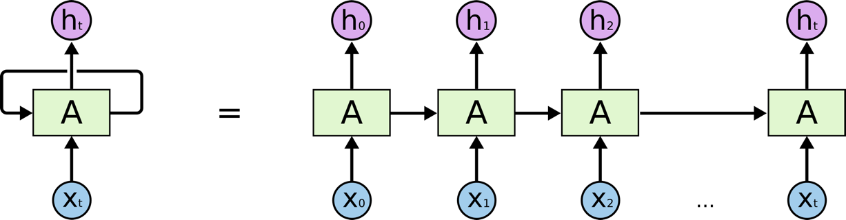
Figure 3 Structure of Recurrent Neural Network (RNN)
The green cell “A” on the graph denotes a chunk of neural network, containing neural structure to learn the pattern. The $x_{t}$ below denotes the input at different time and $h_{t}$ denotes the output. As the graph implies, recurrent neural network takes the output of last period and passes it together with the new input into the next period. This feature allows the neural network to have a “memory” of past information and therefore has broad application in the field of speech recognition and machine translation. LSTM, as a typical example of RNN network, has the following specific structure in the cell “A”:
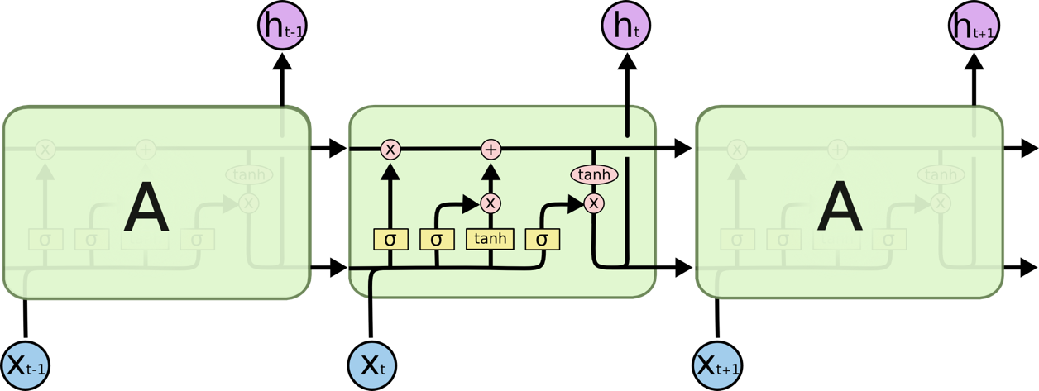
Figure 4 Structure of LSTM

The upper line denotes the cell state, which can be understood as the long term memory of the model. It is carried through the model in different state and contains information about all the previous period. The yellow box denotes the sigmoid function transformation with an output of $[0,1]$. This ensures that the output is squeezed to the range $[0,1]$. In each cell A, there are three gates controlling the output and cell state at each period, corresponding to the short term and long term memory.
- Forget gate: It applies a sigmoid function to the cell state from last period, in order to control how much of the “long term memory” should be thrown away. In this paper’s case, the long term memory is the long term volatility pattern.
- Input gate: It first applies a sigmoid function to the combination of output of last period and new input of this layer to obtain the “short term memory”. Then it applies an activation function with output range $[0,1]$ to determine how much “short term memory” should be merged in the cell state, which is the “long term memory”. Intuitively, the IVIX level of last minute affects the IVIX level of next minute. Combined with IVIX pattern in the past, they are carried on to later predictions.
- Output gate: It applies a sigmoid function to the cell state to determine what’s the output of this period due to the current cell state.
This paper compares the result of the above two methods using Mean Absolute Error(MAE), Root Mean Square Error(RMSE) and also the imbedded loss function in Deep Learning package.

- Relationship of IVIX and SSE 50 Return

This paper focuses on more recent timeframe from July 1st 2018 to September 22nd 2019. The above graph provides an overview about the relationship of IVIX and the underlying SSE 50 Index in the sample period. The sample period can be divided as three parts. It first goes through a period of low-level SSE 50 Index. During the first half year of 2019 from January to April, it experiences a relatively large market growth and then stays around that level for the rest of the sample period. Descriptive Statistics of IVIX, SSE 50 and its returns are provided below. IVIX has an average level of 23.5, higher than CBOE VIX throughout the same period which has the average level of 16. The underlying SSE 50 ETF return has approximately zero mean. This may due to the fact that we are working with data at 1 minute frequency and the absolute change between minutes are small. Similar to most of the literature, log difference is applied to stabilize the time series and eliminate the right-skewness of both IVIX and SSE 50 at the same time.

 | IVIX | SSE 50 | 50ETF Return | log 50ETF return
Mean | 23.51214908 | 2656.931013 | 0.00646365 | 0.000001032
Standard Error | 0.017370125 | 0.814253584 | 0.00723612 | 0.000001187
Median | 23.03011877 | 2693.9596 | -0.03 | -0.000004923
Mode | 25.77494623 | 2443.7585 | 0 | 0.000000000
Standard Deviation | 4.798683569 | 224.9654603 | 1.999055968 | 0.000328044
Sample Variance | 23.02736399 | 50609.45835 | 3.996224764 | 0.000000108
Kurtosis | -0.396273316 | -1.519884451 | 260.7241706 | 253.124718682
Skewness | 0.135766526 | 0.071731333 | -1.812533856 | -1.797701101
Range | 29.05126978 | 797.0427 | 162.4588 | 0.025606928
Minimum | 8.447256905 | 2250.3639 | -90.9759 | -0.014098364
Maximum | 37.49852668 | 3047.4066 | 71.4829 | 0.011508564
Count | 76320 | 76320 | 76320 | 76320

  - Negative Effect:
The negative relation between contemporaneous underlying return VIX is broadly studied by many scholars at both low and high frequency (e.g. Whaley (2000), Bollerslev et al.(2007), Hibbert (2008)). Due to this feature, VIX is therefore considered as “fear index”. To test the existence of negative effects in the Chinese market, this paper conducts similar tests as Hibbert (2008) by regressing contemporaneous IVIX and its underlying asset return on the intraday data as below.
$$r_{IVIX,t}=α_{0}+α_{1}r_{ETF,t}+ϵ_{t}$$
 | Coefficients | Standard Error | t Stat | P-value
Intercept $α_{0}$ | -1.829E-06 | 9.0326E-06 | -0.2024673 | 0.83955193
$$α_{1}$$ | -0.67267 | 0.02753935 | -24.425776 | 2.916E-131
Table 1 Regression Result of contemporaneous return & IVIX
From the regression result, the coefficient of contemporaneous return is -0.67267 with small p-value. We can therefore conclude that the contemporaneous return and IVIX is negatively correlated. However, the coefficient is much smaller than the strong negative observations in the US market, which is -3.6 in Hibbert(2008). Comparing to the US market, the negative relation of IVIX and stock return is weak in Chinese market. We take a step further and separate positive return and negative return to investigate the reason of weak correlation. We then introduce two dummy variables to the model to study their coefficients respectively.
$$r_{IVIX,t}=β_{0}^{-}D_{t}^{-}{+β}_{0}^{+}D_{t}^{+}+β_{1}^{-}r_{ETF,t}D_{t}^{-}+β_{1}^{+}r_{ETF,t}D_{t}^{+}+ϵ_{t}$$

$r_{IVIX,t}$ - ${ ln⁡V}_{IVIX,t}-{ \ln{V}}_{IVIX,t-1}$
$r_{ETF,t}$ - ${ ln⁡P}_{ETF,t}-{ ln⁡P}_{ETF,t-1}$
$D_{t}^{-}$ - dummy variable for negative return, $D_{t}^{-}=1$ when $r_{ETF,t}$ is negative
$D_{t}^{+}$ - dummy variable for positive return, $D_{t}^{+}=1$ when $r_{ETF,t}$ is positive

 | Coefficients | Standard Error | t Stat | P-value
Intercept | 2.17488E-05 | 0.00014538 | 0.14959737 | 0.88108268
Positive Return $β_{1}^{+}$ | 0.172507094 | 0.04613112 | 3.73949541 | 0.00018452
Negative Return $β_{1}^{-}$ | -1.977959687 | 0.04673976 | -42.318567 | 0
Positive Dummy$β_{0}^{+}$ | -9.18224E-05 | 0.00014621 | -0.6280154 | 0.52999575
Negative Dummy $β_{0}^{-}$ | -0.000339909 | 0.00014615 | -2.3257137 | 0.02003644
Table 2 Regression Result of positive return & negative return
From the regression result, $β_{1}^{+}$ has a significant positive value and $β_{1}^{-}$ has a significant negative value. It means that for positive and negative return, IVIX would increase in both cases. This contradicts the literature and empirical results in the US market where strong negative correlation is observed. Our result shows that the negative effect only appears on negative returns, while positive return is positively related to VIX. Although the conclusion is surprising, this paper is not the first to document this phenomenon in the Chinese market. The result corresponds to Li, Yu and Luo’s paper (2019). Li et al. (2019) provide high frequency empirical evidence that over a long sample period, IVIX and its underlying return are overall positive correlated. They extract sub-period of market decline, and therefore conclude that although the overall correlation is positive, there still exist strong negative relation between SSE 50 ETF return and IVIX during large market fluctuations and especially in negative return. Although Li et al. use different sample period, their result corresponds to this paper’s conclusion. Zheng, Jiang and Chen (2016) ascribe the positive correlation to the unique investor structure in Chinese market. Since SSE 50 ETF is the first traded option in Chinese market, the lack of experience of investors may lead to different trading patterns. Comparing to the large proportion of institutional investors in US market, retail investors are dominating in Chinese market. Different from institutional investors, Retail investors usually don’t obey investment principles strictly or use risk management tools. When market goes down, they will hold on to their stock due to loss aversion, leading to the decrease of volatility. When market goes up, some investors will sell their stock with an intention to realize the profit, bringing the volatility up. Zheng et al. (2016) therefore argue that IVIX should be considered as “greed index” rather than “fear index” in Chinese market. Li et al. corroborate this argument by taking a step further by examining the negative correlation between VXFXI (CBOE China ETF Volatility Index) and the underlying FXI. FXI has similar underlying stock components as SSE 50 Index, while the only difference is that they are traded by different markets and investors, which supports Zheng’s argument about investor structure.
  - Asymmetric Effect:
We directly interpret the regression result of second model in Table 2, $β_{1}^{-}$ is significantly larger in absolute value than $β_{1}^{+}$, which indicates that negative returns yield much larger relative changes in the IVIX than positive return. This is expected and documented in the literature on both US and Chinese market. As for the explanation of this asymmetric effect, leverage hypothesis proposed by Black(1976) is supported by many other scholars. However, more recent studies provide strong empirical evidence showing that behavioral theories provide more explanation in intraday data than classic theories such as leverage hypothesis and volatility feedback hypothesis. Comparing to the traditional theories which focuses on long term effect, behavioral theories such as representativeness and extrapolation bias have shorter response time, meaning that we can observe the expected relationships in a smaller time frame. It could therefore justify the strong intraday evidence.
  - Size Effect:
$$r_{VIX,t}=β_{0}^{-}D_{t}^{-}{+β}_{0}^{+}D_{t}^{+}+β_{1}^{-}r_{ETF,t}D_{t}^{-}+β_{1}^{+}r_{ETF,t}D_{t}^{+}+β_{2}^{-}r_{ETF,t}^{2}D_{t}^{-}+β_{2}^{+}r_{ETF,t}^{2}D_{t}^{+}+ϵ_{t}$$
 | Coefficients | Standard Error | t Stat | P-value
Intercept | 2.17488E-05 | 0.00014472 | 0.15028128 | 0.8805431
Positive Return$β_{1}^{+}$ | -0.343892155 | 0.062632333 | -5.490649 | 4.0173E-08
Negative Return $β_{1}^{-}$ | -0.802602129 | 0.068240127 | -11.761439 | 6.5718E-32
Positive Dummy $β_{0}^{+}$ | -1.12241E-05 | 0.000145697 | -0.0770373 | 0.9385941
Negative Dummy $β_{0}^{-}$ | -0.000155443 | 0.000145698 | -1.0668837 | 0.28602773
Positive Squared Return $β_{2}^{+}$ | 147.683863 | 12.18071027 | 12.1244049 | 8.4254E-34
Negative Squared Return $β_{2}^{-}$ | 220.2692248 | 9.355205654 | 23.545097 | 3.852E-122

Comparing to the first model, squared term of returns are added to this regression model so that it enlarges the impact of extreme return on IVIX. We use this model to test whether the size of the SSE 50 ETF returns can have a strong influence on the change of IVIX. From the regression Result, both $β_{2}^{+}$ and $β_{2}^{-}$ are significantly different from zero. We can conclude that the size of return indeed has an impact on the change in IVIX. The sign and absolute value difference of $β_{2}^{+}$ and $β_{2}^{-}$ again justify our previous conclusion of partial negative effect and asymmetric relation.
  - Lagged Effect
$$r_{ETF,t}=β_{0}r_{VIX,t}+β_{1}r_{VIX,t-1}+β_{2}r_{VIX,t-2}……+β_{15}r_{VIX,t-15}+ϵ_{t}$$

 | Coefficients | Standard Error | t Stat | P-value
Intercept | 1.0325E-06 | 1.1826E-06 | 0.87308238 | 0.38262093
VIX at t | -0.0115755 | 0.00047346 | -24.448565 | 1.677E-131
VIX at t - 1 | 0.00020892 | 0.00047418 | 0.4405878 | 0.65951269
VIX at t - 2 | 0.00019944 | 0.00047433 | 0.42047896 | 0.67413678
VIX at t - 3 | -0.0004534 | 0.00047446 | -0.9556874 | 0.33923322
VIX at t - 4 | 0.0004176 | 0.00047456 | 0.87996995 | 0.37887836
VIX at t - 5 | 0.0005915 | 0.00047461 | 1.24628541 | 0.21266346
… | … | … | …. | ….
VIX at t - 12 | 0.00046125 | 0.00047465 | 0.97176457 | 0.33117077
VIX at t - 13 | 3.0143E-05 | 0.00047465 | 0.06350583 | 0.94936389
VIX at t - 14 | 0.00047033 | 0.00047417 | 0.9919129 | 0.32124316
VIX at t - 15 | -8.982E-05 | 0.00047346 | -0.1897088 | 0.8495378

The third model adds the lagged term of IVIX to test the influence of past IVIX on current stock returns. By the regression result, every lagged term has a large p-value indicating that they are not significantly different from zero. This conclusion is in contrast with literature in US market using daily data. However, it is in accordance with the behavioral theories which provides more reasonable explanation on high frequency data, as shown in (1). Comparing to classic theories which emphasize lagged term, behavioral theories focus more on the contemporaneous relation due to its shorter response time. It also explains the insignificance of lagged term in the third model.
As a conclusion, we use several regression models on intraday data in the Chinese market to analyze the relationship between IVIX and its underlying stock return. Our results show that IVIX is weakly negative correlated with underlying returns, contrary to the US market. More specifically, IVIX is positively correlated with positive return and negative correlated with negative return. There exists asymmetric relation and size effect, but no lagged effect on the data. Behavioral theories could provide more suitable explanation than traditional theories such as leverage hypothesis and volatility feedback theories for above phenomena using high frequency data in the Chinese market.
- Forecasting future realized volatilities
Realized volatility is computed using the sum of squared returns over the past period, therefore is often considered as an estimator for the actual movement in the market. Implied volatility, on the other hand, reflects market’s expectation of volatility for future fluctuations. The topic of using implied volatility to forecast future realized volatility for underlying asset is investigated thoroughly on various markets and at different frequencies. Instead of using implied volatility, another common way to forecast future realized volatility is using GARCH model, specifically, GARCH(1,1) model below, which is a linear function of its own delay:
$$h_{t}=b_{0}+b_{1}ϵ_{t-1}^{2}+b_{2}h_{t-1}$$
In this section, we examine whether the high frequency IVIX we computed has predictive power on future realized volatility and how is the predictive performance comparing to GARCH(1,1) estimate. Regarding to the data, the daily GARCH(1,1) estimate is obtained from Volatility Institute in NYUSH. The daily realized volatility is measured using sum of squared returns in intraday level. The daily IVIX is computed as the average of intraday IVIX.
We first regress realized volatility with lagged IVIX and lagged GARCH(1,1) estimate respectively and get the regression result below.
Model 1:
$${RV}_{t}=α_{0}+α_{1}IVIX_{t-1}+ϵ_{t}$$
Model 2:
$${RV}_{t}=β_{0}+β_{1}GARCH_{t-1}+ϵ_{t}$$

Dependent Variable | Constant | Coefficient | P-value | Adj. R square
Model1: $IVIX_{t-1}$ | 0.01161 | 1.40113978 | 3.2593E-15 | 0.206971067497624
Model2: $GARCH_{t-1}$ | -0.007556 | 1.75997785 | 2.3896E-09 | 0.12315302934213

From the regression result, coefficients for the lagged dependent variable in both models are significant with small p-value. It indicates that IVIX and GARCH(1,1) estimate both have predictive power, corresponding to other literature. Regarding the adjusted R square, lagged IVIX model has higher adjusted R-square comparing to lagged GARCH model, suggesting that the first model captures more information about future realized volatility than the second model. We further use them in the same regression model and compare their contributions to future realized volatility. The regression model and result are presented below.
Model 3:
$${RV}_{t}=γ_{0}+γ_{1}IVIX_{t-1}+γ_{2}GARCH_{t-1}+ϵ_{t}$$
 | Coefficients | Standard Error | t Stat | P-value
Intercept | -0.0511654 | 0.03175707 | -1.6111483 | 0.10834685
$$IVIX_{t-1}$$ | 1.14300904 | 0.19038354 | 6.00371764 | 6.3776E-09
$$GARCH_{t-1}$$ | 0.8415576 | 0.30813948 | 2.73109304 | 0.00673948

Since the three volatility measures are all annualized standard deviation of underlying asset, we could directly compare their coefficients and p-values. From the result, both coefficients are significantly different from zero. The lagged IVIX term has larger coefficient and smaller standard error than the lagged GARCH term. Therefore, we could conclude that IVIX has better predictive performance than GARCH(1,1) estimate on future realized volatilities. We then use the above three models to predict future realized volatilities and compare the MAPE, RMSE and MSE of the prediction results.

 | Model1:  IVIX | Model2:  GARCH(1,1) | Model3:  IVIX & GARCH(1,1)
MAPE | 25.80720 | 25.88163 | 25.06478
RMSE | 0.07140 | 0.07200 | 0.06989
MSE | 0.00508735 | 0.00518463 | 0.00488494

From both the three estimates, IVIX alone has better performance than GARCH(1,1) estimate in forecasting future realized volatility. Combining IVIX and GARCH(1,1) estimates using model 3, these two variables could together provide more accurate prediction than any of the two univariate model, same as the result by Day and Lewis(1992). The third model also has higher adjusted R-square than the previous two models. From the regression result of the three models above as well as the forecasting errors, we could conclude that both IVIX and GARCH(1,1) estimate could be used to forecast future realized volatility. Between the two models, IVIX has more accurate predictions.
- Forecasting future implied volatilities
For the implied volatility, this paper applies both simple time series forecasting model and deep learning algorithm, namely ARIMA and Long Short Term Memory(LSTM). We use ARIMA as benchmark and compare the predictive performance of the two models.
  - ARIMA Model
ARIMA model combines the Autoregressive Model(AR) and Moving Average Model(MA). It uses past volatilities and noise processes to predict volatility in the current state. The general formula with parameter p and q is listed below.
$$r_{t}=θ_{1}r_{t-1}+θ_{2}r_{t-2}+…+θ_{p}r_{t-p}+ϕ_{1}ϵ_{t-1}+…+ϕ_{q}ϵ_{t-q}+δ$$
    - Stationary Test
We first apply differencing method on the original data with term 1, 2 and 3, then use Augmented Dickey Fuller (ADF) test to find the least differencing term that transforms the original time series to a stationary one. In this case, we use first order differencing.
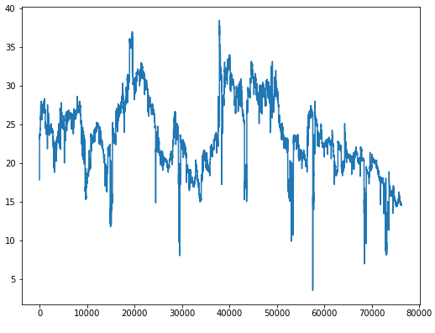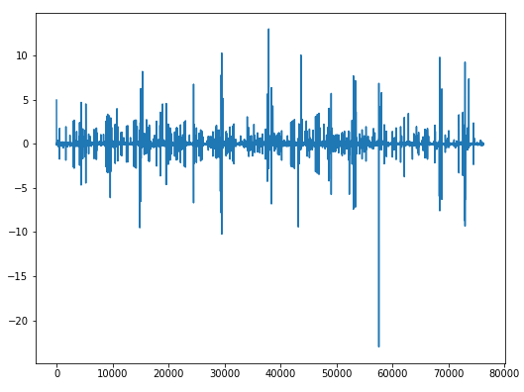
Figure 5 Before Differencing Figure 6 After Differencing
    - Select Parameters p, q
We use Akaike Information Criterion(AIC) and Bayesian Information Criterion (BIC) to select the parameters of ARIMA. AIC and BIC are two methods of scoring a model based on its log-likelihood and complexity. We build an AIC and BIC matrix for all possible p and q values, then choose the one with lowest AIC value. From the matrix, the p and q value for this model are 7 and 0 respectively.
    - Gaussian white noise test
Since ARIMA model assumes residual to be Gaussian white noise when the model is a good fit of the data, we then perform Ljung-Box test to test that whether residual is white noise. According to the result, the Ljung-Box statistics is 3786.93 with p-value almost zero. It indicates that there exists auto-correlation in the model residual. Therefore, we can conclude that there is nonlinear pattern that couldn’t be captured by the ARIMA model.
    - Prediction Result
Due to the above point, the prediction result is not satisfying. Prediction graph is provided below. We train the model on the past 76300 minutes to estimate the coefficients, then predict 20 minutes into the future.
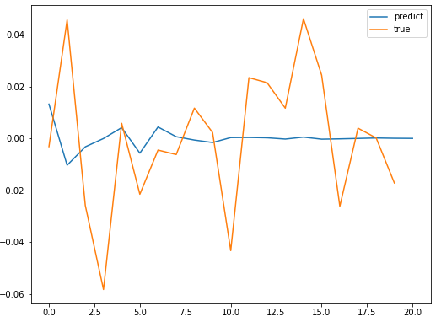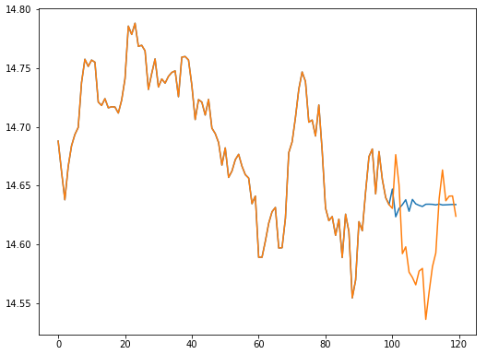
Figure 7 Predict result & true value for next 20 minutes Figure 8 Larger time frame
Due to the above point, we introduce a non-parametric algorithm in Deep Learning called Long Short Term Memory (LSTM) model. Usually, implied volatility is predicted using time series model in short intervals. Some patterns and term structures may not be well captured, especially using high frequency data. Park, Kim and Lee(2014) explores a variety of both parametric and non-parametric models in predicting option price and non-parametric models outperform traditional parametric models on both in-sample and out-of-sample predictions. Following Park et al, this paper chooses from Neural Network algorithm and compares the prediction result with ARIMA model. As Chou(1988) points out, volatility has the property of long term persistence. Therefore, we chooses LSTM which could combine the long term properties and short term patterns.
  - LSTM Model
We use a stack of LSTM layers to construct our neural network model, with individual LSTM layer having structure in Figure 4. The multiple layers model instead of single layer is conducive to improve the predictive performance.
Figure 9 Structure of multiple stacked LSTM layers
For the input into the LSTM, we apply the “moving window” method. We construct a list of IVIX data with window size 100 minutes and use it as input. Each corresponding output is the next minute right after the 100 minutes input. Intuitively, it means that the most recent 100 minutes are taken as “short term memory”. Combining with the “long term memory” which is stored in the LSTM model, we can predict value of IVIX for the next minute.
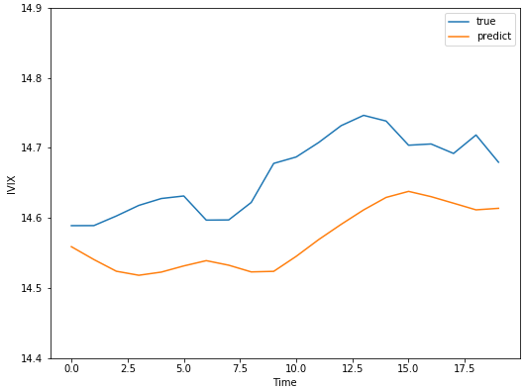
Figure 10 LSTM prediction result of next 20 minutes
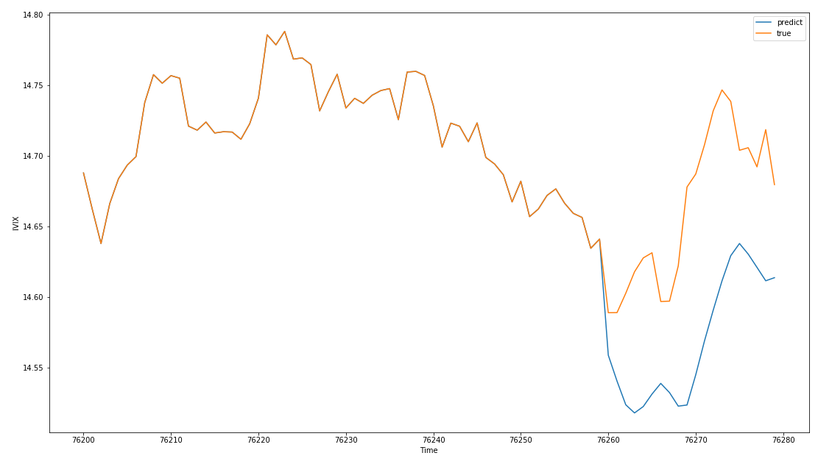
Figure 11 LSTM prediction result in a longer timeframe
 | ARIMA | LSTM
MAPE | 121.06719354688633 | 0.6228053212579682
RMSE | 0.27013212030762398 | 0.10707219599370389
MASE | 0.6972520013247729 | 4.314042275680275

Prediction result is shown as above. From the graph, LSTM outperforms traditional ARIMA model in predicting the next 20 minutes. It is also verified by the smaller Mean Absolute Percentage Error(MAPE), Root Mean Square Error(RMSE) of LSTM than ARIMA model. We notice that the Mean Absolute Scaled Error (MASE) of LSTM is larger than 1 while MASE of ARIMA is smaller than 1. MASE estimate examines the model and test whether it is better than the prediction using average value. From the result, ARIMA is better than the average value and LSTM is worse than the average value. It is because we use high frequency data and the change between minutes is very small, thus having average value of 0. When predicting over short term(next several minutes), it is possible that average value can have a better performance than other models. However, average value is not able to capture any term structure or fluctuations of IVIX, leading to a bad performance in the long term. Judging from MAPE, RMSE and the prediction graph, LSTM can capture the trend of implied volatility than ARIMA model. We could therefore conclude that implied volatility has predictive power of future implied volatility and LSTM could provide more accurate prediction than ARIMA.
- Conclusion
As a conclusion, we use high frequency data on IVIX in the Chinese market and provide empirical evidence on various analysis. Regarding the relationship between IVIX and underlying return, we find that although IVIX and underlying return is overall negative correlated, negative return is negatively correlated with IVIX, while positive return is positively correlated with IVIX, which is different from the significant negative relation observed in the US market. Asymmetric effect and size effect are significant. Lagged terms has little impact on IVIX comparing to contemporaneous term. This unique phenomenon may due to the investor structure in Chinese market, which are dominated by retail investors instead of institutional investors. The insignificance of lagged term could be explained using behavioral theories. Both daily IVIX and daily GARCH(1,1) estimate have predictive power on future daily realized volatility. IVIX contributes more than GARCH(1,1). The mixture of the two estimates could provide more accurate predictions than any of the two univariate models. As for the predictive power of IVIX on future implied volatilities, we compare ARIMA and LSTM model performance using MAPE, RMSE and MASE. Combining the results, LSTM has better performance than ARIMA model.
Acknowledgments
I would like to express my deep gratitude to my thesis advisor, Professor Menachem Brenner, for his patient guidance and constructive advice throughout the study. Professor Brenner provides me with valuable insights into this topic, as well as statistical models I could explore.
I would like to thank Professor Marti Subrahmanyam and Professor Christina Wang and Professor Jens Leth Hougaard for coordinating this Business Honors Program and arranging fantastic speaker series.
My grateful thanks also extends to Professor Xin Zhou and Research fellow Zhengyun Jiang and Ruitao Wang from Volatility Institute in NYUSH. They kindly provide me with empirical data in my study and constant inspirations and support along the way.

Appendix

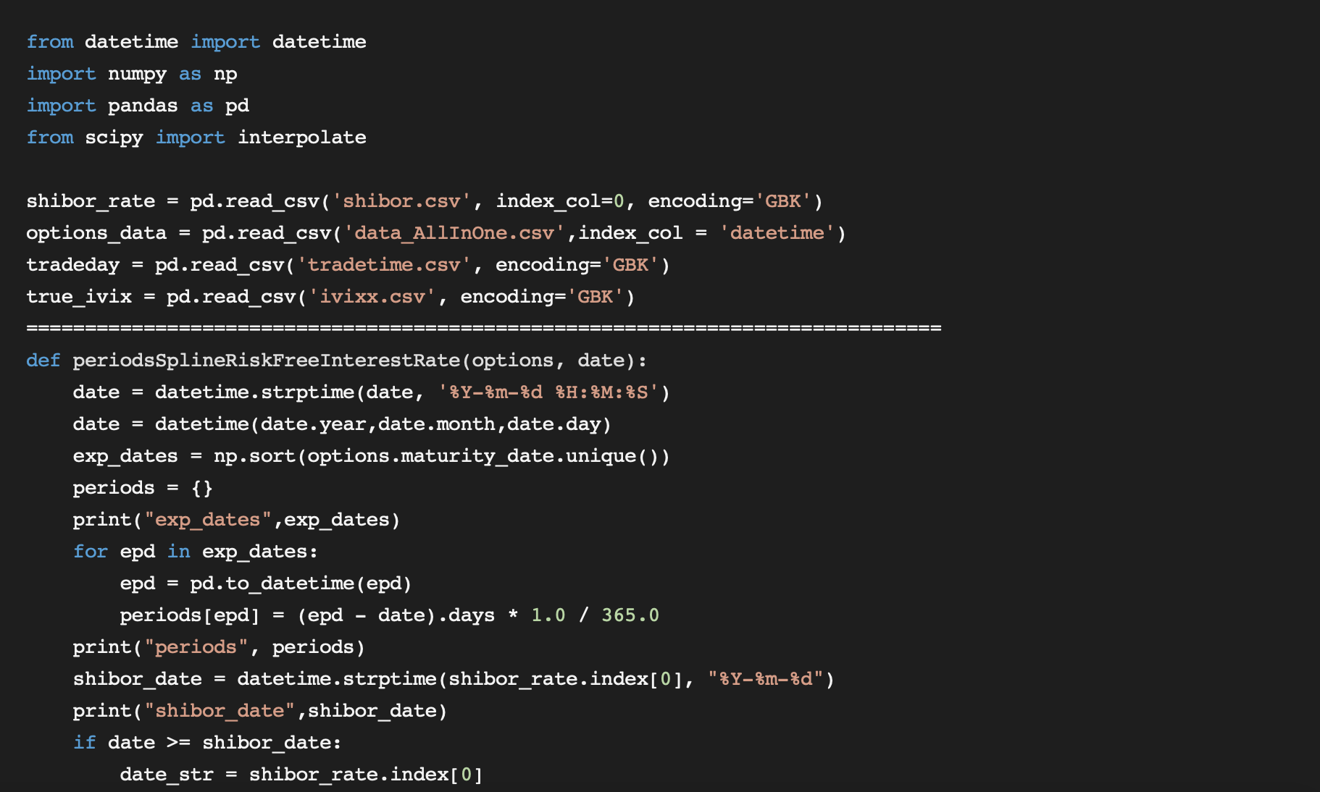
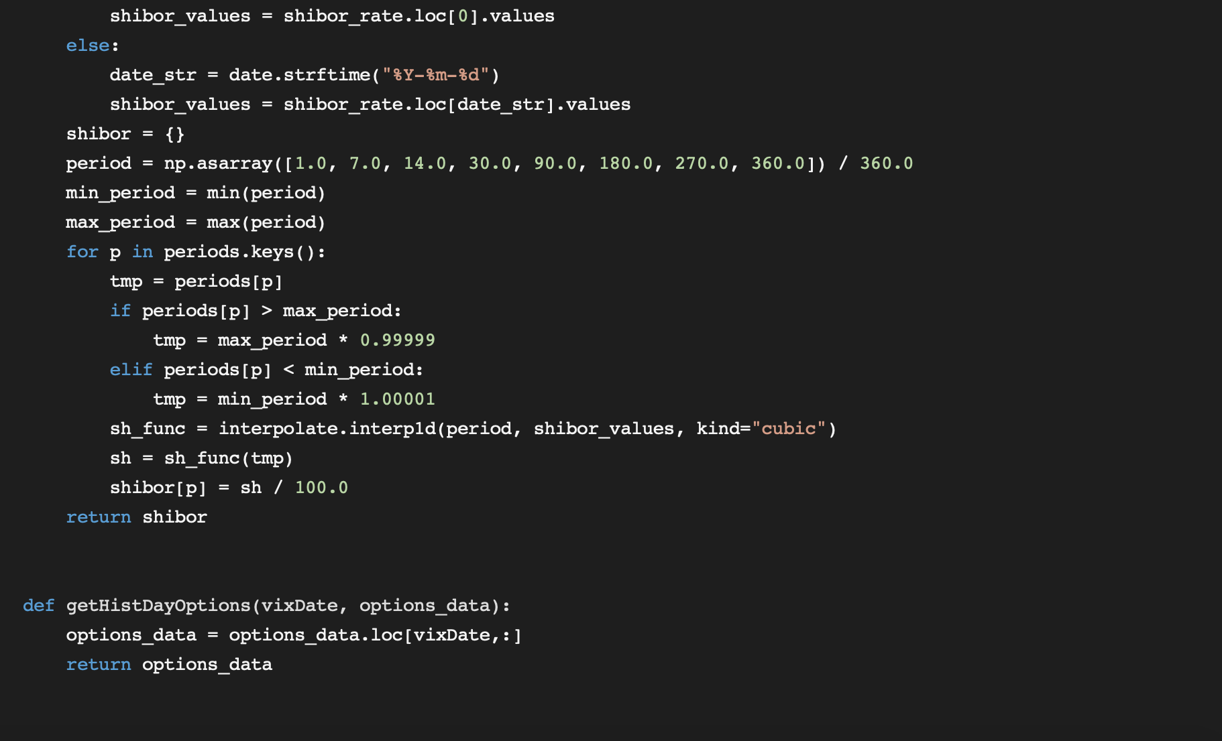
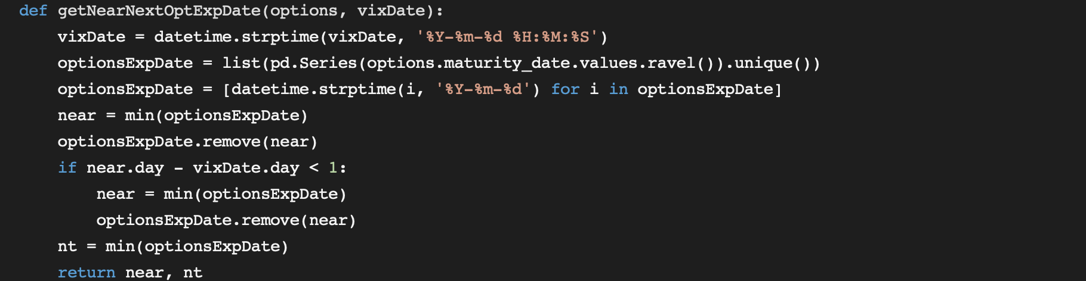

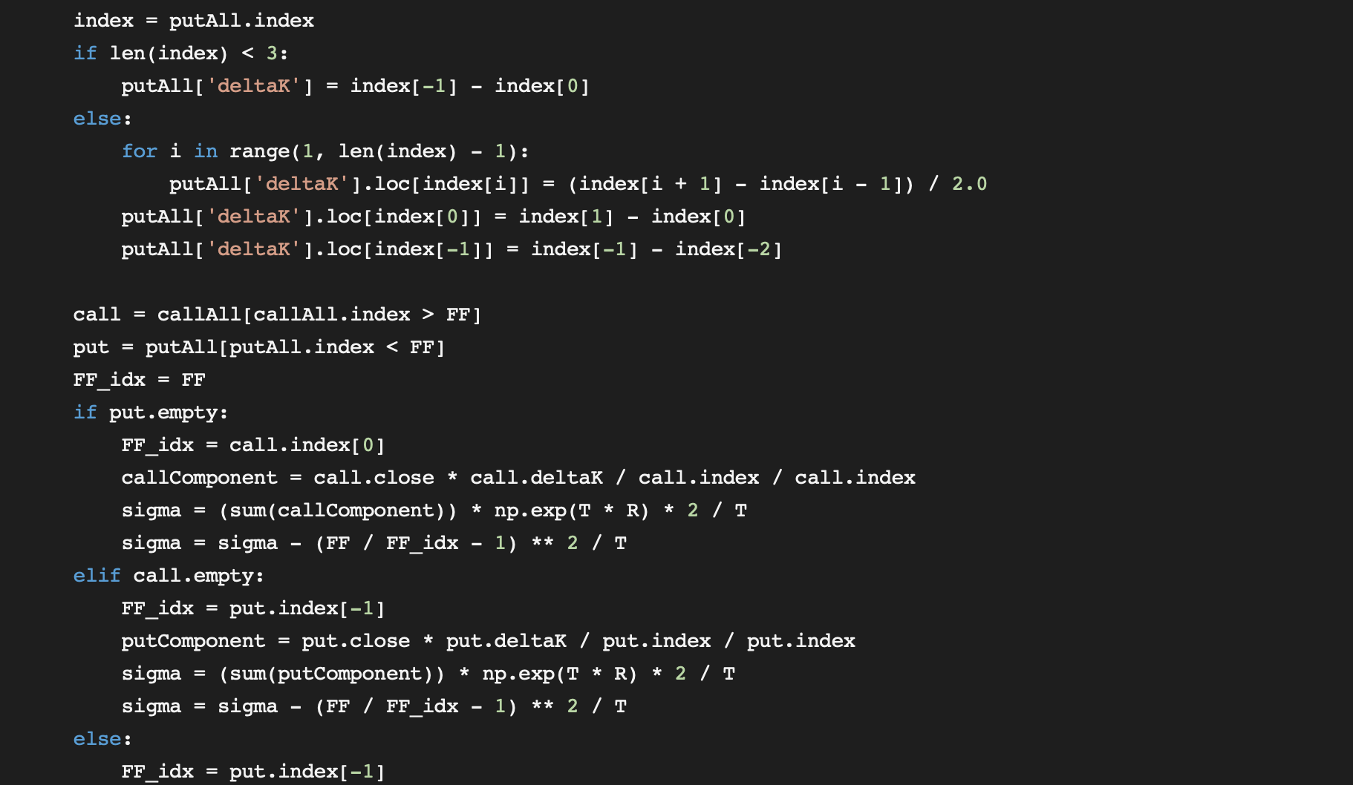
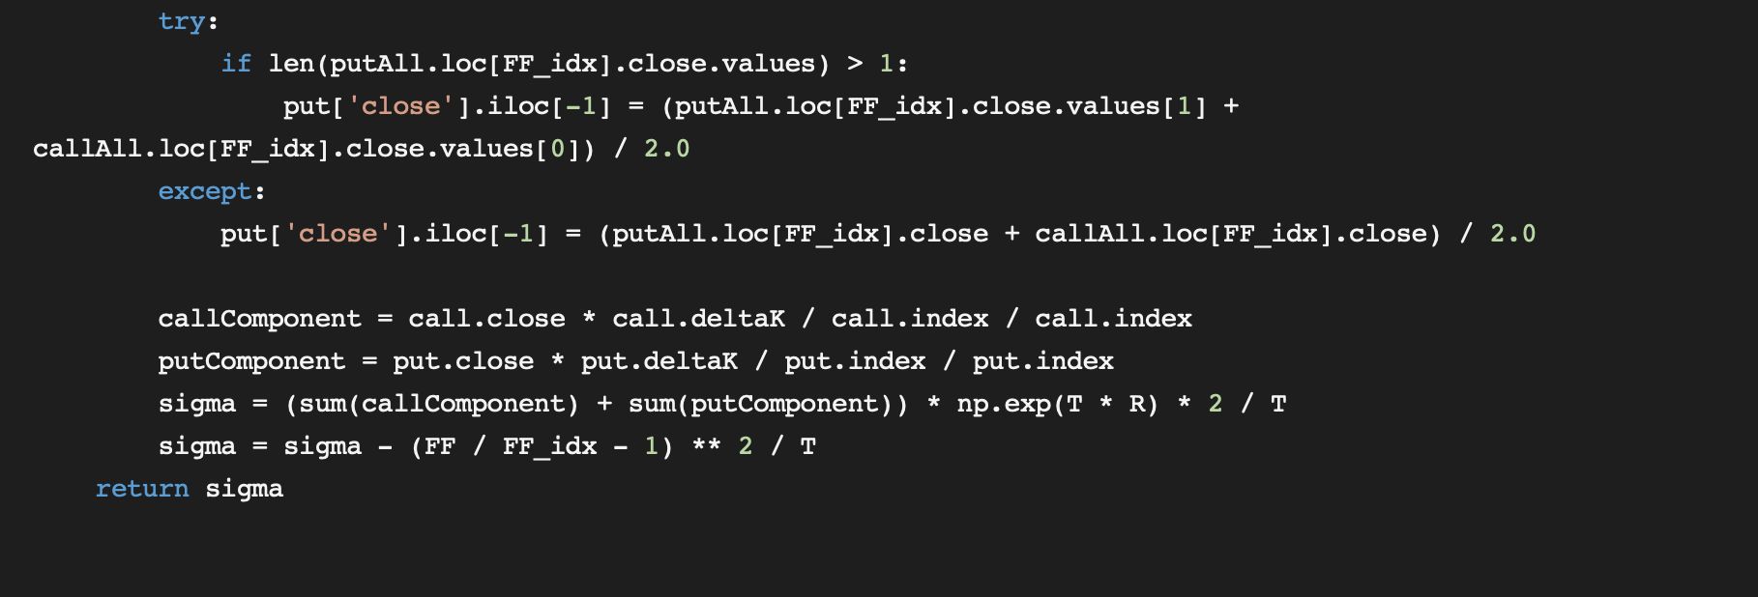

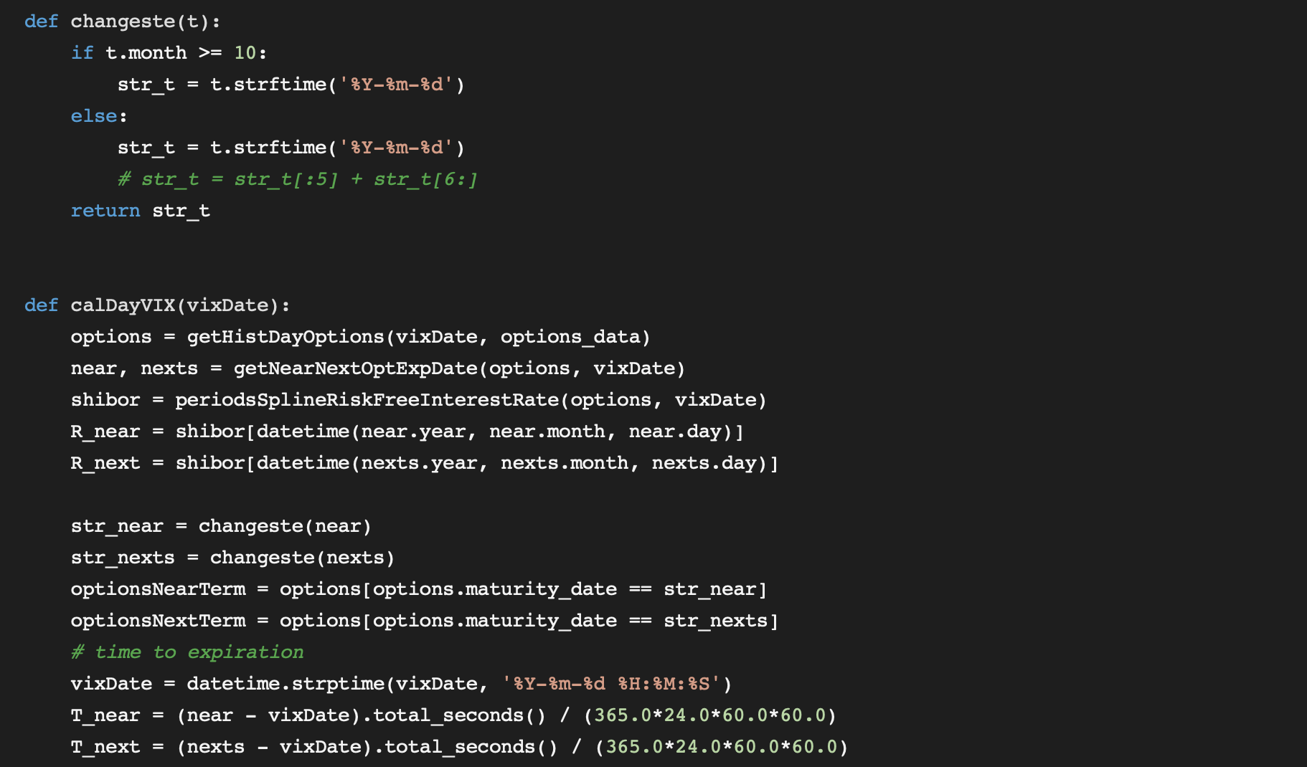
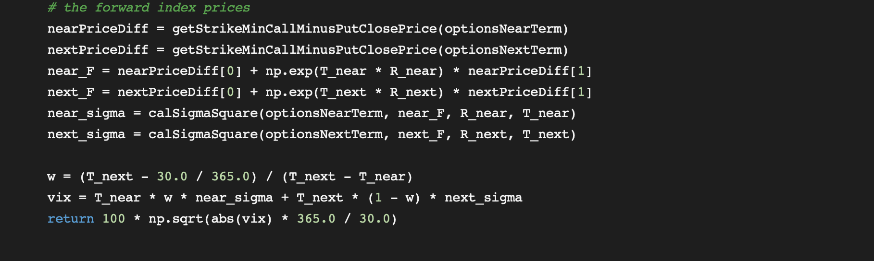

Reference
Andersen, T., & Bollerslev, T. (1998). Answering the Skeptics: Yes, Standard Volatility Models do Provide Accurate Forecasts. International Economic Review, 39(4), 885-905. doi:10.2307/2527343
Black, F. (1976) Studies of Stock Price Volatility Changes. In: Proceedings of the 1976 Meeting of the Business and Economic Statistics Section, American Statistical Association, Washington DC, 177-181.
Blair, Bevan & Poon, Ser-Huang & Taylor, Stephen. (2001). Forecasting S&P 100 Volatility: The Incremental Information Content of Implied Volatilities and High-Frequency Index Returns. Journal of Econometrics. 105. 5-26. 10.1016/S0304-4076(01)00068-9.
Bollerslev, Tim & Kretschmer, Uta & Pigorsch, Christian & Tauchen, George. (2007). A Discrete-Time Model for Daily S&P500 Returns and Realized Variations: Jumps and Leverage Effects. Journal of Econometrics. 150. 151-166. 10.1016/j.jeconom.2008.12.001.
Bollerslev, Tim, Chou, Ray and Kroner, Kenneth F., (1992), ARCH modeling in finance: A review of the theory and empirical evidence, Journal of Econometrics, 52, issue 1-2, p. 5-59, https://EconPapers.repec.org/RePEc:eee:econom:v:52:y:1992:i:1-2:p:5-59.
Bollerslev, Tim, Engle, Robert and Nelson, Daniel B., (1986), Arch models, ch. 49, p. 2959-3038 in Engle, R. F. and McFadden, D. eds., Handbook of Econometrics, vol. 4, Elsevier,https://EconPapers.repec.org/RePEc:eee:ecochp:4-49.
Brenner, Menachem, and Dan Galai. “New Financial Instruments for Hedge Changes in Volatility.” Financial Analysts Journal, vol. 45, no. 4, 1989, pp. 61–65., doi:10.2469/faj.v45.n4.61.
Chou, R. (1988). Volatility Persistence and Stock Valuations: Some Empirical Evidence Using Garch. Journal of Applied Econometrics, 3(4), 279-294. Retrieved May 1, 2020, from www.jstor.org/stable/2096644.
Christensen, Bent Jesper and Prabhala, N. R., (1998), The relation between implied and realized volatility, Journal of Financial Economics, 50, issue 2, p. 125-150, https://EconPapers.repec.org/RePEc:eee:jfinec:v:50:y:1998:i:2:p:125-150.
Day, Theodore & Lewis, Craig. (1992). Stock Market Volatility and the Information Content of Stock Index Options. Journal of Econometrics - J ECONOMETRICS. 52. 267-287. 10.1016/0304-4076(92)90073-Z.
Giot, Pierre. (2005). Relationships Between Implied Volatility Indexes and Stock Index Returns. Journal of Portfolio Management - J PORTFOLIO MANAGE. 31. 92-100. 10.3905/jpm.2005.500363.
Granger, Clive & Poon, Ser-Huang. (2003). Forecasting Volatility in Financial Markets: A Review. Journal of Economic Literature. 41. 478-539. 10.1257/002205103765762743.
Heynen, R.C., & Kat, H.M. (1994). Volatility Prediction: A Comparison of the Stochastic Volatility, GARCH (1,1) and EGARCH (1,1) Models.
Hibbert, Ann Marie & Daigler, Robert & Dupoyet, Brice. (2008). A Behavioral Explanation for the Negative Asymmetric Return-Volatility Relation. SSRN Electronic Journal. 10.2139/ssrn.3362617.
Li, Jupeng & Yu, Xiaoli & Luo, Xingguo. (2019). Volatility index and the return–volatility relation: Intraday evidence from Chinese options market. Journal of Futures Markets. 39. 10.1002/fut.22012.
Majmudar, Utkarsh & Banerjee, Arnab. (2004). VIX Forecasting. SSRN Electronic Journal. 10.2139/ssrn.533583.
Medvedev, N. (2019). Multi-Step Forecast of the Implied Volatility Surface Using Deep Learning.
Park, Hyejin, Namhyoung Kim, and Jaewook Lee (2014). “Parametric models and non-parametric machine learning models for predicting option prices: Empirical comparison study over KOSPI 200 Index options”. In: Expert Systems with Applications 41(11), 5227ˆa5237. issn: 09574174. doi: 10.1016/j.eswa.2014.01.032.
Poterba, J., & Summers, L. (1986). The Persistence of Volatility and Stock Market Fluctuations. The American Economic Review,76(5), 1142-1151. Retrieved May 2, 2020, from www.jstor.org/stable/1816476
Whaley, Robert. (2000). The Investor Fear Gauge. Journal of Portfolio Management. 26. 12-17. 10.3905/jpm.2000.319728.
Wu, Yaofei. (2017). Performance Analysis of Shanghai Stock Exchange iVX Index and Its Potential for Risk Management. NYUSH Business Honors Program Final Thesis.
Zheng, Chengli & Yao, Yinhong. Relationship between Implied Volatility Index and its Underlying Market Index.
Zheng, Zhenlong & Jiang, Zhengyun & Chen, Rong. (2016). AVIX: An Improved VIX Based on Stochastic Interest Rates and an Adaptive Screening Mechanism. Journal of Futures Markets. 37. 10.1002/fut.21824.

