Intergenerational Wealth Mobility in South Korea:

Evidence from the Korean Labor & Income Panel Study (KLIPS)

by

Yunjie(Chloe) Song

An honors thesis submitted in partial fulfillment

of the requirements for the degree of

Bachelor of Arts

Business and Economics Honors Program

NYU Shanghai

May 2020

Professor Marti G. Subrahmanyam Professor Jess Benhabib
Professor Christina Wang
Professor Jens Leth Hougaard

Faculty Advisers Thesis Adviser
- Introduction
There has been a revived research interest on wealth inequality in recent years. As more microdata became available, many researchers have spent efforts estimating the wealth distribution using administrative data and survey data. Researchers found that wealth distribution has become increasingly skewed to the privileged few, marking increased inequality in many countries, such as the US and France. Besides changes in the wealth distributions across time, another issue closely related to inequality is social mobility. As the gap between the rich and the poor increases, children from a lower socioeconomic background may find it harder to climb up the social ladder. It is natural to ask: how the wealth of the child and that of the parent are correlated? This paper will focus on characterizing the intergenerational correlation of wealth in South Korea.
The intergenerational mobility of earnings and that of wealth have received extensive research attention. Charles and Hurst used data from the Panel Study of Income Dynamics (PSID) to analyze the intergenerational wealth mobility in the US. They found that the age-adjusted elasticity of child wealth with respect to parental wealth is 0.37 and that lifetime income and asset ownership explain most of the correlation (2003). Chetty et al. used data from the population tax records and Statistics of Income (SOI) to characterize the intergenerational mobility of earnings. They found that rank-based mobility has remained stable. However, inequality has increased, meaning that “the rungs of the ladder have grown further apart, but children’s chances of climbing from lower to higher rungs have not changed” (2014a). Although their topic of interest is income rather than wealth, the empirical methods are similar. Ueda focused on South Korea and estimated the intergenerational mobility of income. He found the elasticity to be 0.25 for sons in their 30s (2013). A detailed literature review on intergenerational mobility can also be found in Solon (1999) and Black and Devereux (2010).
South Korea became the country of interest because of its dual character. On the one hand, it is known that chaebols in South Korea control a substantial amount of national wealth and have dominating power in the economy. As chaebols are essentially family-run business conglomerates, they can accumulate their corporate bonds with allies and transfer the executive roles to the next generation of the family, thus, keeping the wealth within the family. On the other hand, the proportion of wealth owned by the wealthiest is relatively small compared to the US or China. In 2010, the top 1% and top 10% owned around 25% and 62%-65% of national wealth, a slightly smaller number when compared to China and a significantly smaller number when compared to the U.S (World Inequality Database n.d.).
This paper will use data from the Korean Labor and Income Panel Study (KLIPS), the same data that Ueda used, to measure the intergenerational mobility of wealth with three different statistics. The paper is organized as follows. Section II discusses the methodology used. Section III introduces the data used. The estimation results are presented in Section IV, followed by a brief discussion of the results. Section V concludes.

- Methodology
1. Definition of Wealth
In this paper, wealth is defined as the sum of assets less the sum of liabilities. Specifically, it is measured as the sum of real estate properties, financial assets, main household assets such as cars, other assets reported, less the sum of debts.

2. Characterization of Wealth Mobility
Analyzing wealth mobility amounts to characterizing the joint distribution of parent and child wealth. The joint distribution can be decomposed into two components: the marginal distributions of parent/child wealth and the copula of the distribution (Chetty et al. 2014b). Three statistics will be used to characterize the wealth mobility: log-log estimate, quintile transition matrix, and rank-rank estimate. The latter two estimates measure the copula of the distribution, and log-log estimate captures information in both the marginal distributions and the copula. We denote the natural log of parent wealth as $W_{p}$; the natural log of child wealth as $W_{c}$; the age of parent as $age_{p}$; the age of child as $age_{c}$.

2.1 Log-log intergenerational elasticity
The first statistic is the log-log intergenerational elasticity of child wealth with respect to parent wealth. Log-log elasticity has been a commonly used measure for estimating intergenerational income correlations (Chetty et al. 2014a). This method can also be applied to estimate intergenerational wealth correlations using the following construction (Charles and Hurst 2003).
Regress $W_{c}$ on $W_{p}$, $age_{p}$, $age_{p}^{2}$, $age_{c}$, $age_{c}^{2}$. After controlling for the age of child and the age of parent, we can then analyze the correlation between parent and child wealth. The coefficient $α_{1}$ before $W_{p}$ is the age-adjusted elasticity of child wealth with respect to parent wealth.
$$Wc=β+α_{1}Wp+α_{2}age_{p}+α_{3}age_{p}^{2}+α_{4}age_{c}+α_{5}age_{c}^{2}+Residual$$
As pointed out in previous literature, an ordinary least squares (OLS) estimate of $α_{1}$ may be downward biased because of the measurement error caused by the correlation between parent wealth and residual (Charles and Hurst 2003). In later analysis, we will apply a several-period average of parent wealth to reduce such bias.

2.2 Quintile transition matrix
The second statistic is the quintile transition matrix, which records the child’s position in the child wealth distribution given the parent’s relative wealth position. Construction is as follows. Regress $W_{p}$ on agep and agep squared. Record the residuals $R_{p}$. Do the same for the children and record the residuals $R_{c}$. Divide $R_{p}$ and $R_{c}$ into five equal parts using the quintiles. Then it is possible to construct the quintile transition matrix M, where $M_{ij}$ denotes the percentage of children entering quintile i given their parent being in quintile j. For example, $M_{51}$ denotes the percentage of children rising to the upper quintile given their parents are from the lower quintile.
$$W_{c}=β+α_{1}age_{c}+α_{2}age_{c}^{2}+Residual_{c}$$
$$W_{p}=β+α_{1}age_{p}+α_{2}age_{p}^{2}+Residual_{p}$$
The idea is that the residuals capture the wealth difference not explained by age. After controlling for age, we can rank the child and the parent in their respective distributions, and detect the correlation between their ranks.

2.3 Rank-rank estimation
The third statistic is the rank-rank estimation. The idea is very similar to the previous statistics. In the previous method, we use regressions to control for child and parent ages. Here, we directly control the child to be of similar ages by focusing on specific birth cohorts.
$$rank_{child}=β+αrank_{parent}+residual$$
We rank children based on their incomes relative to other children in the same birth cohort; rank parents of these children based on their incomes relative to other parents with children in these birth cohorts. Then, we bin parent rank into two-percentile point bins (so we have 50 equal-width bins) and regress the mean child wealth rank in each bin on the mean parent wealth rank in each bin. $α$ can be interpreted as the difference in the mean percentile rank of children from the richest families versus children from the poorest families.
When studying income mobility, Chetty et al. (2014a) find that the rank-rank relationship is almost perfectly linear and highly robust to alternative specifications. Therefore, we would like to try this method in our wealth mobility estimation.

- Data and Procedure
The data is obtained from the Korean Labor and Income Panel Study (KLIPS, henceforth) conducted by the Korea Labor Institute. KLIPS is a labor-related panel survey started in 1998 (Wave 1) with a sample of 5000 urban households and is conducted annually. Until 2017 (Wave 20), there have been 20 waves of data available. The survey is mainly composed of two components: the household survey and individual survey. Since wealth-related variables, such as assets and debts, are recorded only in the household survey, we focus only on the household data. The members who branched out from the original households and formed a new family of their own will be registered as a new household. Every year, the same set of questions are asked to the existing household members and the new households. The survey design makes it possible to track the branched-out children to their parent families and carry out intergenerational mobility analysis. The wealth correlation estimated in this paper is the one before any transfer of bequests. Given the span of the KLIPS data, most of the parents are alive when the child wealth measure is taken. Therefore, it makes sense to consider the wealth correlation before any transfer of bequests.

1. Wealth Calculation
In the KLIPS household dataset, wealth-related variables include the following: a) current market value of the owned home that the household is living; b) market value of owned home/land other than the current home; c) financial assets, including savings in banks; stocks, bonds, trusts; savings-type insurance; “Gye” (private mutual saving club); personally made loans; other; d) market value of the car(s) the household own; e) debts, including debts from banks; debts from non-financial institutions; personally obtained loans; rent (deposit money) to pay back; “Gye”; other; e) other assets. We calculated the net wealth by subtracting the total debts from total assets.

2. Procedure
2.1 Procedure for the log-log estimate and transition matrix
Child family wealth data and their demographics information are taken from the 2017 (Wave 20) survey, and parent family wealth data is the average wealth of three years between 2000 (Wave 3) and 2002(Wave 5). Since the wealth correlation estimated here is the one before the transfer of bequests, the demographics information of the parents in 2017 (Wave 20) is also selected so that we can later check that at least one parent was alive in 2017. After merging the three datasets, we obtained 2046 samples of parent-child matches.
Before any analysis, several filtering conditions need to be applied to the parent-child pairs. First, we check the relationship between the branched-out family member in Wave 20 and the head of the household in the original family in Wave 3. Only the samples for which the branched-out member is indeed a child in the original household are kept. Second, we keep the parent-child pair for which the head of households in Wave 3 and Wave 20 are at working age (between 25 and 65). Third, we keep only the pairs with both the parent and child family having positive wealth. We also make sure that at least one parent was alive in Wave 20. This leaves us with 1248 parent-child pairs after all filtering conditions are applied. Since the size of each family varies, and the wealth represents that of the whole family, we counted the working households in each family and calculated wealth per capita, which is total family wealth divided by working households, for each family. Both parent wealth and child wealth are converted to the value in 2015, adjusting for inflation and economic growth.

2.2 Procedure for rank-rank estimation
We focus on birth cohorts 1976-1979. Child family wealth is measured as the mean wealth over 2015-2017 (when the children are 38-41 years old). Parent family wealth is measured as the mean wealth over 2000-2002 (considering only parents who have strictly positive wealth). The mean age of the parents in 2000 is about 53 years old. In the perfect situation, we would like to control all children and all parents to be of similar ages. However, since the KLIPS household survey only spans 20 years (while the average age of giving birth is around 30s), it is not possible to obtain a large sample of parent-child pairs where the parent and the child are of the same age. Therefore, the goal is to minimize the age gap between the child and the parent when their respective wealth measure is taken. Such approach is different from the income elasticity estimation method in Chetty et al. because income tends to stabilize after a certain age while wealth is always accumulative (2014a). For the first sample of rank-rank estimation, we select the parents who are older than 38 years old in 2000. We have 489 parent-child pairs under this filtering. For the second sample of rank-rank estimation, we select the parents whose age is between 38 and 50 years old in 2000. We have 150 parent-child pairs under this filtering.

- Results
1. Log-log Regression
We perform the log-log regression on both unweighted data and weighted data to estimate the intergenerational wealth elasticity.
In the unweighted data, we have 1248 parent-child pairs. The estimated elasticity coefficient is about 0.185, meaning that a parent whose wealth is 50% above average will have wealth 9.25% above average in the child generation (See Table 1). All coefficients are statistically significant, with p-values smaller than 0.05. The wealth elasticity of the US (1984-1999) is 0.37 (Charles and Hurst 2003, 1162). By simple comparison, the elasticity in South Korea (2000-2017) is much lower than that of the US (1984-1999).
Weighted data have also been analyzed. In the original survey, each household participated in the survey is assigned a household weight each year. Here, we used the parent household weights in 2000 (Wave 3). In the weighted data, the elasticity estimate is 0.18, similar to that of the unweighted data (See Table 2). All coefficients are statistically significant at 5%.
Besides, we also replaced child household wealth and parent household wealth by the respective wealth per capita. The resulting elasticity estimate on the unweighted data is about 0.16, with coefficients statistically significant at 10% (See Table 3).

Table 1. log-log regression results on unweighted data
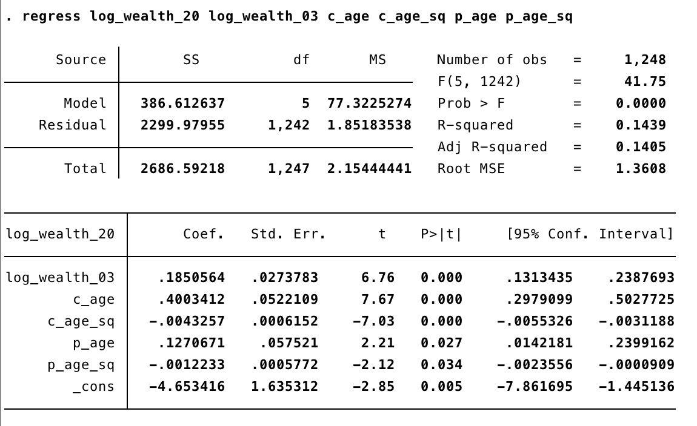

Table 2. log-log regression results on weighted data
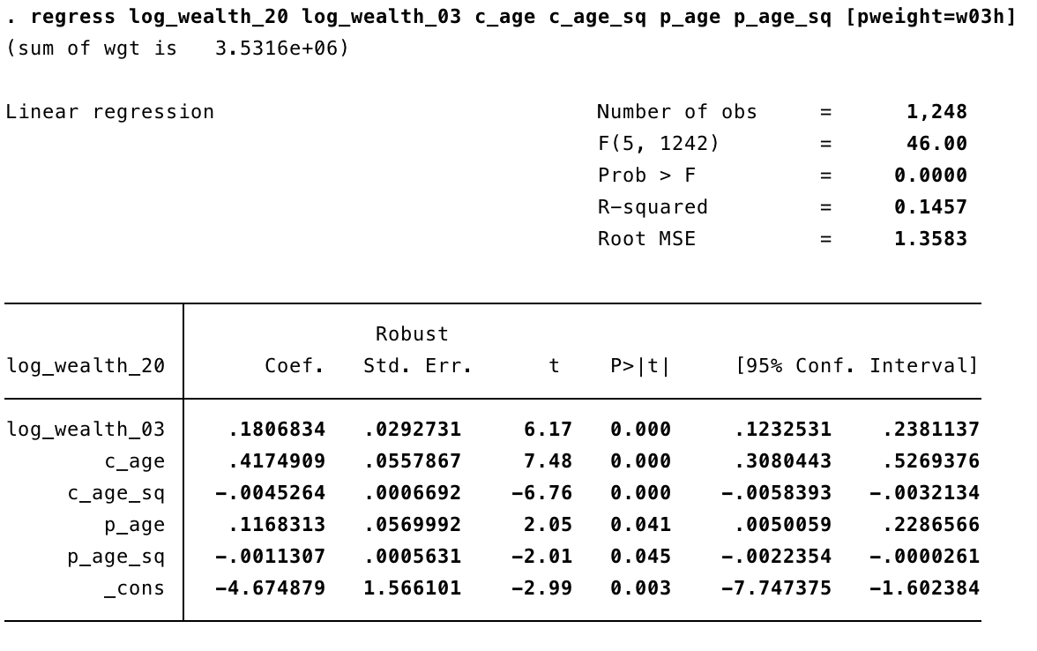
Note: Weights refer to 2000(Wave 3) parent household weights.

Table 3. log-log regression results on unweighted data
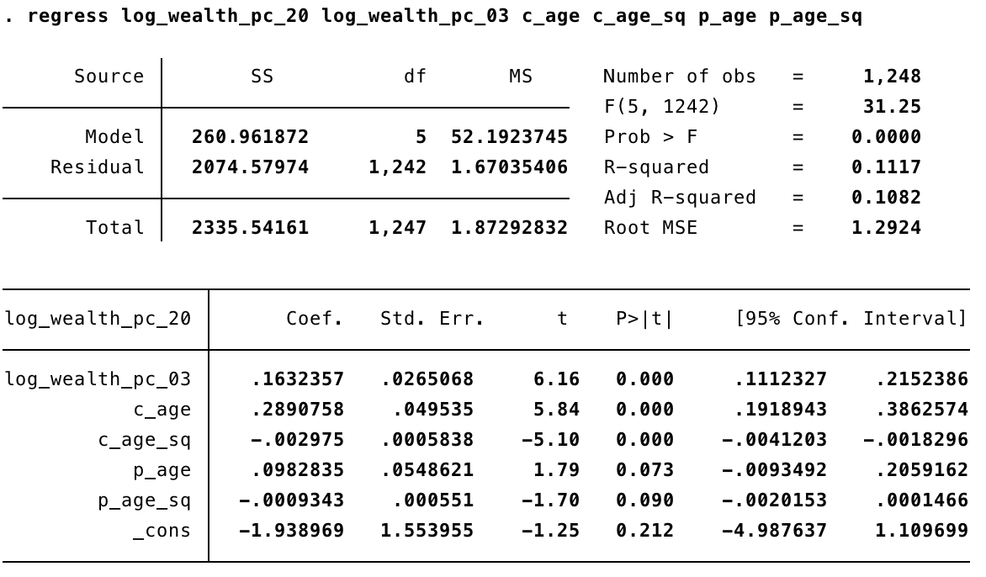
Note: we use wealth per capita instead of family wealth for both parent and child households.

2. Quintile Transition Matrix
We have 1248 parent-child pairs in total. We divide the 1248 residuals into groups of 249, 249, 250,250,250, and construct the transition matrix for unweighted data (See Table 4). The likelihood ratio chi-square statistics of the table is around 62, with a p-value < 0.001. We reject the hypothesis that each cell is equal to the other.
We compare the quintile transition matrix in South Korea (2000-2017) to that in the US (1984-1999) (See Table 5). It seems that South Korea is a relatively more mobile society than the US. For example, the percentage of children reaching the upper quintile from the bottom quintile is 11.24%, compared to 7% in the US. We observe that the chance of reaching the upper quintile increases if children come from a better-off parent family. However, we notice that wealth transition is less mobile and very sticky for the wealthiest and poorest populations in both countries. We look at the two highest percentages in the matrix: 29.32% of children from the bottom quintile were still stuck in the bottom, and 28% of children from the top quintile could remain in the top quintile. The situation is the same in the US, where 36% of the children from the bottom/top quintile remained in the same quintile.
We also consider using a mobility measure to capture the quintile transition matrix. Here, we consider the index proposed by Shorrocks (1978) and Geweke et al. (1986). The index $μ$ can be calculated according to the following equation summarized by Quah (1996).
$$μ\left(P\right)= \frac{K-tr\left(P\right)}{K-1}$$

$$where P denotes the transition matrix, K is the number of states, tr\left(P\right) denotes the trace of P$$

$μ$ takes values between 0 and 1. If there are no transitions, meaning all households remain in their respective quintile, then $μ$ equals zero. If the society is entirely mobile, meaning 20 percent of households remain in their respective quintiles, then $μ$ equals one. A higher $μ$ would indicate higher mobility. The $μ$ of South Korea (between 2000 and 2017) is 0.9485.

Table 4. Quintile transition matrix in South Korea (2000-2017)
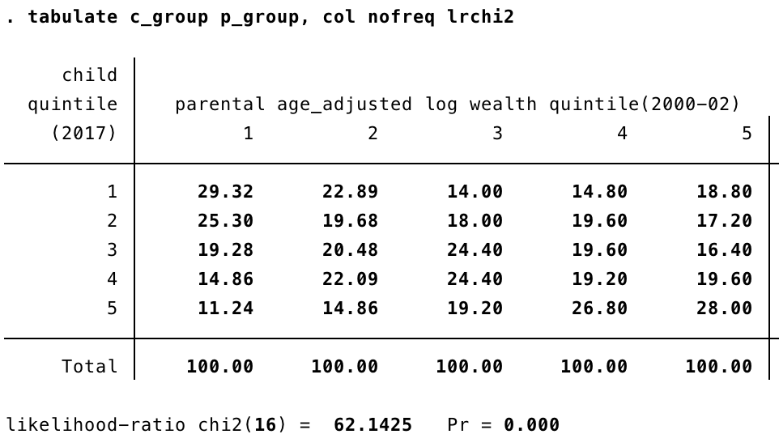
Note: Columns represent parent quintiles, and rows represent child quintiles.

Table 5. Quintile transition matrix in the US (1984-1999)
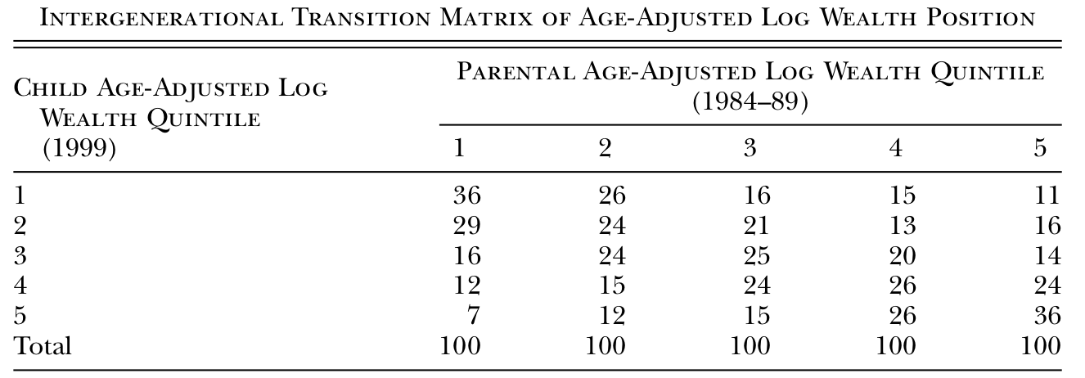
Note: The table is taken from Charles and Hurst (2003).

3. Rank-rank Correlation of Wealth
We first look at the sample where parent age is controlled to be over 38 years old. The figure is constructed by binning parent rank into two-percentile point bins (so we have 50 dots in the figure), and we plot the mean child wealth rank in each bin vs. the mean parent rank in each bin. The slope of the fitted line is 0.22, meaning that a one percentage point increase in parent mean rank is associated with a 0.22 pp increase in the child’s mean rank (See Figure 1). We then look at the sample where parent age is controlled to be between 38 and 50 years old. The slope of the fitted line is 0.32 (See Figure 2). The rank-rank plots below are not perfectly linear, compared to the income rank-rank plots in Chetty et al. (2014a). It would be ideal if we can control the parent to be of similar ages as the child in the sample.
Figure 1. Mean child wealth rank vs. parent wealth rank in South Korea (sample 1)
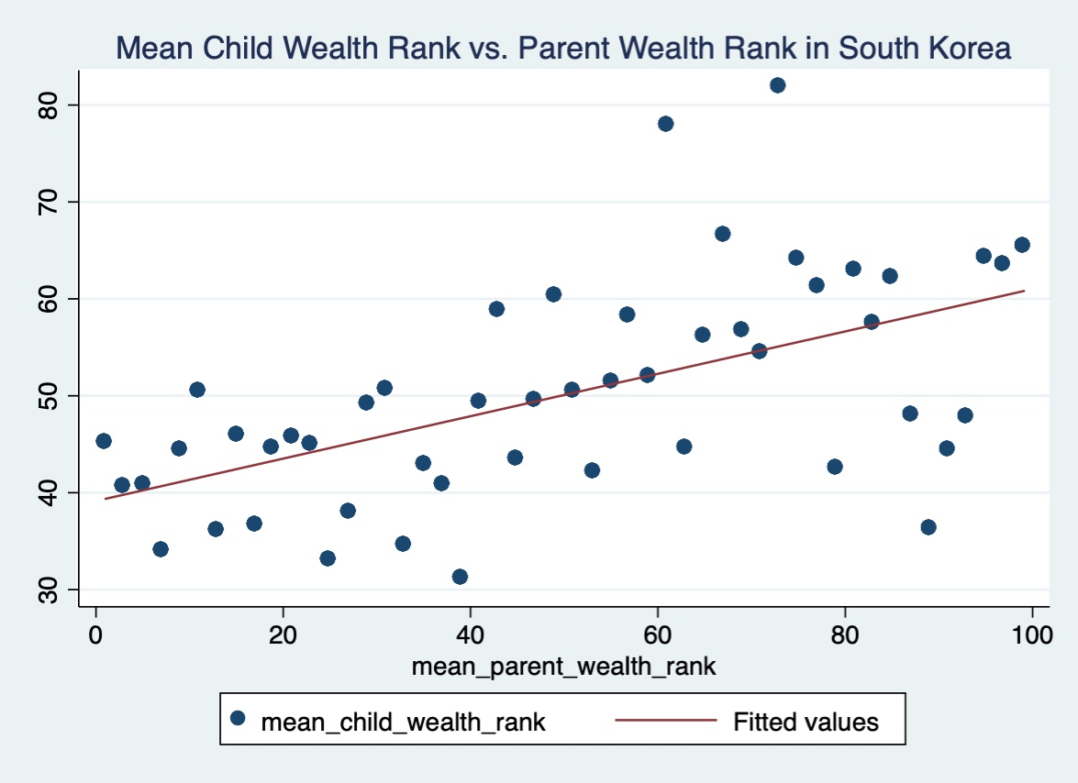
Note: The age of all parents is controlled to be over 38 years old (489 parent-child pairs). The figure is constructed by binning parent rank into two-percentile point bins and plotting the mean child wealth rank in each bin vs. the mean parent rank in each bin.

Figure 2. Mean child wealth rank vs. parent wealth rank in South Korea (sample 2)
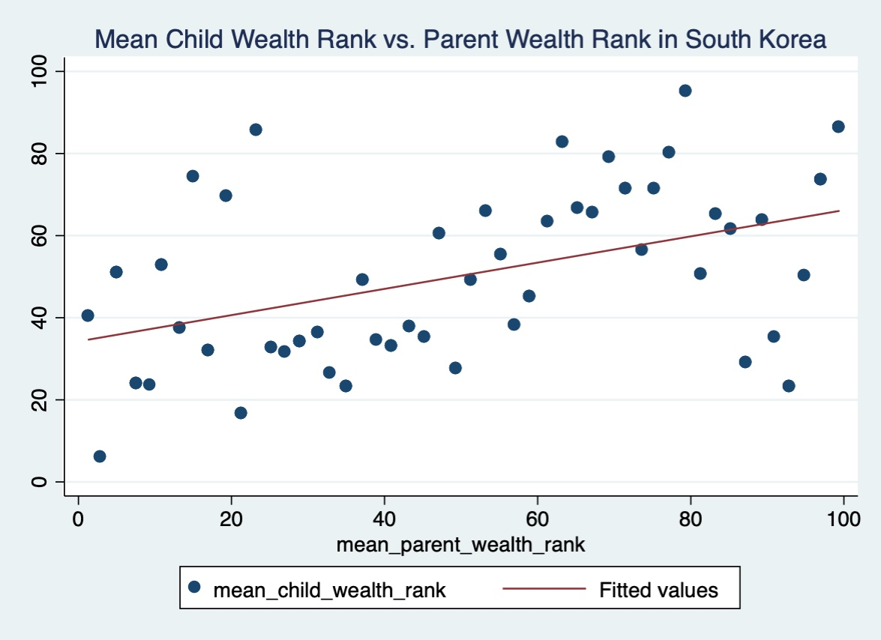
Note: The age of all parents is controlled to be between 38-50 years old (150 parent-child pairs). The figure is constructed by binning parent rank into two-percentile point bins and plotting the mean child wealth rank in each bin vs. the mean parent rank in each bin.
In general, we find that intergenerational wealth mobility is higher in South Korea (2000-2017) than that in the US (1984-1999). Note that this paper analyzes the wealth correlation before any transfer of bequests, which neglects the role of inheritance. The inheritance in South Korea itself is a complicated issue. On the one hand, most chaebols do pass a large chunk of wealth to the next generation after their death. On the other hand, South Korea has an inheritance tax rate of 50%, and this can go up to 65% if inheritance benefits a company's largest shareholder. Given that a successor will still receive at least 35% of the wealth, bequests could potentially be a crucial channel for wealth transfer in South Korea. Incorporating the inheritance information may lead to a higher intergenerational wealth correlation.

- Conclusion
In the paper, we discussed three statistics measuring wealth correlation. Using KLIPS data, we found that intergenerational wealth elasticity is about 0.18; the mobility index is 0.9485; the rank correlation between the child and parent is 0.32 (or 0.22, based on the sample chosen). The estimates produced in this paper may be used to calibrate theoretical models in the future. The wealth correlation estimated in this paper is the one before any transfer of bequests. If the bequest information is incorporated, we may find a higher wealth correlation.
Much future work can be further carried out. For example, we can investigate different channels through which parents transfer their wealth to the children (such as lifetime income, asset ownership, education) as Charles and Hurst did (2003). We can also try estimating the wealth correlation after the transfer of bequests if we can obtain such data.

References

Black, Sandra E, and Paul J Devereux. 2010. “Recent Developments in Intergenerational Mobility.” IZA Discussion Paper 4866, The Institute for the Study of Labor (IZA), Bonn, Germany.

Charles, Kerwin Koﬁ, and Erik Hurst. 2003. “The Correlation of Wealth across Generations.” Journal of Political Economy 11 (6): 1155–82.

Chetty, Raj, Nathaniel Hendren, Patrick Kline, and Emmanuel Saez. 2014. “Where Is the Land of Opportunity? The Geography of Intergenerational Mobility in the United States*.” The Quarterly Journal of Economics 129 (4): 1553–1623. https://doi.org/10.1093/qje/qju022.

Chetty, Raj, Nathaniel Hendren, Patrick Kline, Emmanuel Saez, and Nicholas Turner. 2014. “Is the United States Still a Land of Opportunity? Recent Trends in Intergenerational Mobility.” American Economic Review 104 (5): 141–47. https://doi.org/10.1257/aer.104.5.141.

Dardanoni, Valentino. 1993. “Measuring Social Mobility.” Journal of Economic Theory 61 (2): 372–94. https://doi.org/10.1006/jeth.1993.1073.

Geweke, John, Robert C. Marshall, and Gary A. Zarkin. 1986. “Mobility Indices in Continuous Time Markov Chains.” Econometrica 54 (6): 1407–23. https://doi.org/10.2307/1914306.

Quah, Danny T. 1996. “Convergence Empirics across Economies with (Some) Capital Mobility.” Journal of Economic Growth 1 (1): 95–124. https://doi.org/10.1007/BF00163344.

Shorrocks, A. F. 1978. “The Measurement of Mobility.” Econometrica 46 (5): 1013–24. https://doi.org/10.2307/1911433.

Solon, Gary. 1999. “Intergenerational Mobility in the Labor Market.” In Handbook of Labor Economics, 3:1761–1800. Elsevier. https://doi.org/10.1016/S1573-4463(99)03010-2.

Ueda, Atsuko. 2013. “Intergenerational Mobility of Earnings in South Korea.” Journal of Asian Economics 27 (August): 33–41. https://doi.org/10.1016/j.asieco.2013.05.002.

World Inequality Database. n.d. “Wealth inequality, Korea, 2000-2013.” Accessed May 1, 2020.
https://wid.world/country/korea/

See Zucman (2019) for a detailed literature review.
1 The quintile transition matrix is irreducible, finite, and aperiodic. Thus, it has a unique stationary distribution. Since the matrix is doubly stochastic, its stationary distribution is the uniform distribution, where all entries take value 20%. Assuming the transition matrix is time-invariant, we can calculate the time (i.e., number of generations) it takes to reach the stationary state. For South Korea, it takes ten generations to reach the stationary distribution (i.e., an entirely mobile society). As the interval between generations is 17 years, it will take approximately 170 years to reach the mobile society. We do the same calculation for the US and find that it takes 17 generations to reach the entirely mobile society, which is about 255 years (with a 15-year-interval between generations). Note that before calculation, we slightly adjust the matrix to ensure the rows and the columns both add up to 1. Besides the mobility index proposed by Shorrocks (1978) and Geweke et al. (1986), other accepted mobility indices include the second largest eigenvalue modulus of the transition matrix (See Dardanoni (1993) for a detailed summary).

