The effects of soccer betting odds and soccer game results on public listed soccer club share returns
By
Yuxin Wu

An honors thesis submitted in partial fulfillment
of the requirements for the degree of

Bachelor of Science

Business Honors Program
NYU Shanghai
May 2019

Professor Marti G. Subrahmanyam Professor Anthony Saunders
Professor Yiqing Lü
Professor Shuang Zhang

Faculty Advisers Thesis Adviser

Abstract
This article tests whether match results and betting odds will impact share returns of public listed soccer clubs. Market data of the two largest public listed soccer clubs, Manchester United Football Club from Britain and Juventus Football Club from Italy are fed into the models. In addition, by comparing the results with the previous study on Borussia Dortmund from Germany, we find supports that the game results will, when the clubs are relatively independent, have an impact on the share returns. Meanwhile, the betting odds along with the surprise effect derived from it will not have a significant influence on the share returns.

Keywords: stock, return, soccer, game results, betting odds.

Acknowledgments
I would like to thank my thesis advisor Professor Anthony Saunders, who guides me through this process and provide me with a lot of valuable suggestions.
I would like to express my appreciations to faculty advisors of the program Professor Marti G. Subrahmanyam, Professor Yiqing Lü, and Professor Shuang Zhang. Also, I would like to thank the coordinator of this program Ms. Xinyi Yang. All of them put great efforts in this program.
Special thanks to my family and Ms. Yao You for all the supports. Thanks for always being on my side and encouraging me to move forward.

I Introduction
Soccer is now the world’s most popular sport. In season 2017/2018, the top 20 most profitable soccer clubs generated 8.3 Billion Euros in total. Compared with the revenues of those clubs in season 2016/2017, there was a 0.4 Billion Euro or approximately 5% increase. The recent World Cup 2018 in Russia was another peak of this sport. The global audience was set to hit 3.4 billion, which was the historical high, and the revenue was set to research 6 Billion Dollars. The huge amount of revenue generated, and the increasing number of audiences shows a strong growing power in this already successful sport. Also, increasing revenues and profits highlight the economic significance of soccer. In the last few decades, soccer has attracted a huge amount of capital. A lot of once public listed soccer club has become privately owned clubs. These changes require a new investigation into the remaining public listed soccer clubs. At the same time, as soccer is becoming more and more popular, the betting market also thrives accordingly. Thus, research on how the betting odds market is related to the stock market is also necessary.
Public listed soccer clubs provide people with a great opportunity to study how information and expectation can impact the share prices. The game results serve as a good source of information. Firstly, almost all games are held either during the nights of weekdays or at weekends when the stock market is closed. That is, the game itself does not affect the stock market. Thus, gives us a chance to see how one pure signal can impact the stock market. Secondly, because the results only come out after the matches and when the stock market is closed. There will not be anyone who can get inside information beforehand (assuming the games are fair). By applying the soccer game results, one may be able to test the market efficiency. It is always hard to clearly quantify the expectation of people, but soccer betting odds which are derived from the probability whether a team will win, draw, or lose and of course the margin (mark) of the betting odds firm, can serve as a relatively good and solid source of the quantitative expectation. And these may help us to test whether expectation can have an impact on the stock and how quantitative expectation can have an impact on the stock market.

II Literature Review
As game results or betting odds can serve as a good model for scholars to exam variable effects, several papers have covered this topic. For example, in 1993, Scherr et.al tested the results on the share price for Boston Celtics, the paper pointed out that the share went up for a win and went down for losing, especially when the game was near the end of the season, the effect became more obvious. In year the 2006, Stadtmann tested the stock return of Broussia Dortmund, and he found that the game results would affect the share price and the unexpected part of new information would influence the stock prices. In 2014, Croxson and Reade used the high-frequency data and found that major news like a goal during the game would update the stock prices. In 2009, Palomio et.al found out that investors would ignore non-salient information such as betting odds but would overact to the game results which would influence investors’ mood (especially when the team was strongly expected to win). And in 2001, Forrest, et.al suggested that a soccer team would gain strength from attendances and home advantage. And in the year 2012, Bell et.al found that the share price would be affected by the game result and game points.
Most of the articles were published at least seven to eight years ago. And most of the articles tested only the clubs within a single country. This paper is trying to test whether the results and betting odds still impact the stock price now bases on the fact that the number of clubs still being publicly listed, the general environment, the operating styles of clubs nowadays, etc. have changed greatly. Also, this paper does not limit to a single country but tend to exam the model in a broader soccer market. This paper tends to not only test but also revise the past researches in similar fields. With the data and information about the new environment, it is necessary for me to carry out research like this to retest the effects.

III Data and Methodology
This paper tests whether the game results and the betting odds will impact the stock price. We will basically use factors include Surprise effect, Modified Game Result, Goal Difference, and
Home or Away Game as the factors. After more and more once public listed clubs have been purchased by the private group or individuals, there are not many remaining public listed clubs left
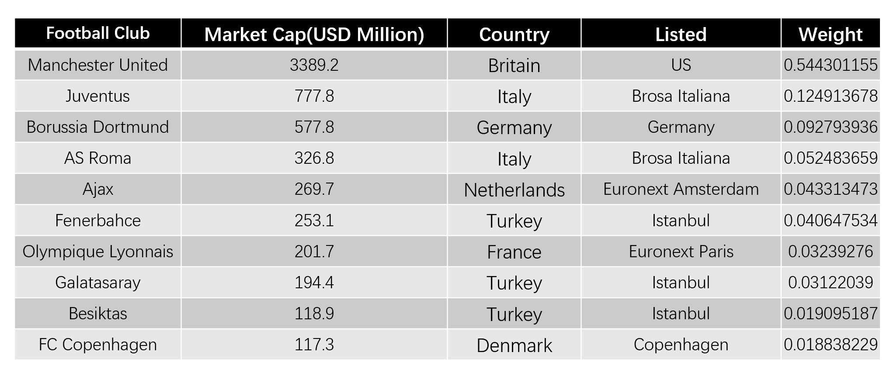
(Table 1)
If I use the ten most valued public listed soccer clubs in the current stock markets to form an index, I will get an index include one club from Britain (Manchester United), two from Italy (Juventus, AS Roma), one from Germany (Borussia Dortmund), one from Netherlands (Ajax), three from turkey (Galatasaray, Besiktas), one from France (Olympique Lyonnais), and one from Denmark (FC Copenhagen) (Table 1). If I calculate their weight using the market cap (data from Bloomberg), I will get that the three biggest clubs, Manchester United, Juventus, and Borussia Dortmund together weigh more than 75% of the index. Based on this information, I will mainly test Manchester United and Juventus in this research while also using the Borussia Dortmund data from the previous researches.

Data
The data I use for the research including the daily stock price of Manchester United and Juventus from 2012-2017; the daily market index of S&P 500 and Italy stock market (FTSE MIB) from 2012-2017 (Bloomberg); and also many soccer data of both team from season 2012-2017, including the game results, goal differences (Football-Data), the betting odds (Bet365), then revenues (Manchester United Annual Report & Juventus Annual Report).
Of course, there are many other soccer related factors or features that may affect game results or potentially affect share prices, for example, team status, the position of the team on the table, etc. The reason why these kinds of data are not included in this project is firstly, these data or information are hard to extract; while secondly, the betting odds is an efficient model that include all these kinds of information into consideration. According to Spann and Skiera, betting odds are one of the best-performed models in terms of predicting accuracy among all the forecasting models tested. Thus, if some features are really that critical to impact the game results, and to reflect the stock returns, betting odds must have somehow included those features into consideration.

Methodology
- Dependent Variable
The dependent variable is modified share return (hereinafter called share return) set to be the return on stock minus the return on the market (Formula 1)
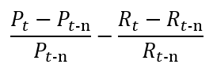
(Formula 1 P-stock price, R-market index)

- Game Result
One of the main purposes of this research is to test whether the game results have an effect on the stock returns. So, I set winning the game as 1, draw as 0, and losing the game as -1, indicates that I assume winning a game will positively contribute to the stock returns and losing a game will negatively contribute to the stock. If it is a draw, there will be no effect on the stock returns. The assumption is mainly based on the previous conclusion that game results will affect the stock returns. More specifically, the share price will go up for a win while going down for losing (Scherr et.al). But I also include the key competitor factor into the game result base on my assumption that winning a game against the key competitor will provoke a higher return on a stock and losing a game against the key competitor will cause a larger decrease on the stock return. Because my tested team, both Manchester United and Juventus are top teams in their leagues, I define only the top six teams in that league one season before will be considered as their key competitors. What I am doing here is to time 2 to each result. As to say, winning a game against a key competitor = 1 * 2 = 2; losing a game against a key competitor = -1 * 2 = -2; if the game result is draw = 0 * 2 = 0. This double assumption is mainly based on the traditional English term “six-pointer”, which indicates that if two key competitors have the close position on a table, a game between them is like the winner takes 3 points and the loser loses 3 points. Based on people’s common understanding towards a key game, I set the key competitor factor as this way.

- Visibility
I defined the number of how many people watched a certain game (either in the stadium or before the television) is the visibility of a certain game. But the past data of the visibility of a certain game is hard to extract. So, instead, I used the average broadcasting revenue (Manchester United Annual Report & Juventus Annual Report) as the number to reflects the people who are exposed to the game through TV and matchday revenue (Manchester United Annual Report & Juventus Annual Report) as the number of to reflect the attendance.

- Expectation & Surprise effect
The betting odds are given by the betting company (Bet365). Betting odds is consisted of a home win betting odd, a draw odd, and an away win odd. Using these odds, following Stadtmann’s formula, we are able to calculate a mark for the betting company (Formula 2). Then using the mark, we are able to calculate the probability of a win (Formula 3), losing (Formula 4), and a draw (Formula 5). Win probability, losing probability, and draw probability are used to reflect the betting odds and expectation.
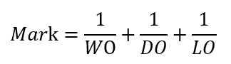
(Formula 2 WO-Winning Odds, DO-Drawing Odds, LO-Losing Odds)
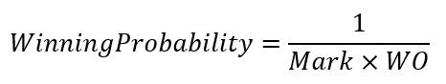
(Formula 3)
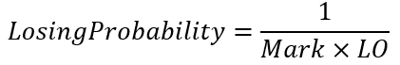
(Formula 4)
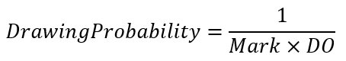
(Formula 5)
For the unexpected effect in my model, sometimes the betting odds are really close, so it is hard for us to determine whether this team for this game should win or lose or draw. Thus, it becomes rather inaccurate if I just set surprise effect as a team loses a game that it is highly expected to win, or a team wins a game that it is highly expected to lose. Instead, following Bell et. al.’s method, I use surprise points as the unexpected factor. I applied the probability of a win, probability of losing, and the probability of a draw to calculate the expected points gained (Formula 6). Then, I use the actual points to minus the expected points and gain the unexpected effect.
(Formula 6, WP-Probability of Win, DP-Probability of Draw, LP-Probability of Losing)

- Goal Difference
The methodology for goal difference is quite simple. I use the goal gained by the team minus the goal gained by the competitor to measure the goal difference. For example, if Manchester United scores 2 goals in the game while Aston Villa, its competitor scores one goal, then the goal difference will be 1. But here, I also include the key competitor effects. That is to say, if facing a key competitor, the goal difference will also be double, which is aligned with the game result. For example, if Manchester United scores 2 goals and Manchester City (which is a key competitor by definition) scores 3 goals, then the goal difference will be (2 - 3) * 2 = -2.

- Other factors
Other factors including whether the game is a European game or not and whether this game is a home game for the team or not will be recorded using the dummy variable, for example, if Manchester United is playing a European Champions Leagues game in Madrid against Real Madrid, then the home dummy will be zero and European dummy will be one.

IV Models
Manchester United
For the first five models, I use the closing stock price and closing market index one trading day before the match (if the match is on weekends) or the match day (if the match is on weekdays) and the closing price of the next trading day after the match to calculate the return.
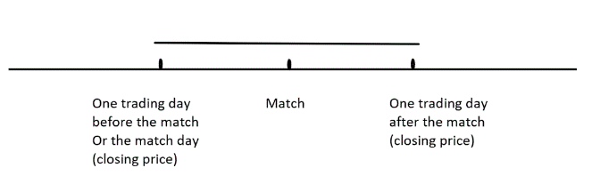
Model 1
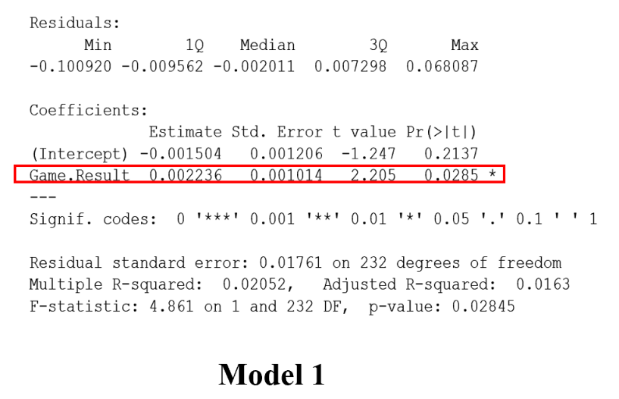
This model is simply to test whether the game results will affect the return. As we can see from the results, the p-value for the game result is 0.0285, which indicates that the game result is statistically significant and will impact the return of stock price.

Model 2
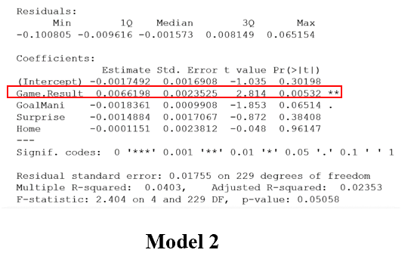
This model is applied to test whether a game is held at home or away, game for MANU is a win, lose, or draw game, goal difference, and surprise effect will affect the returns of the stock. As we can see from the results, game result, with a p-value equals 0.00532 is the only factor that is statistically significant and will affect the return of the stock. While other independent variables like goal difference, surprise effect, and whether it is a home game will not impact the return of the stock.

Model 3
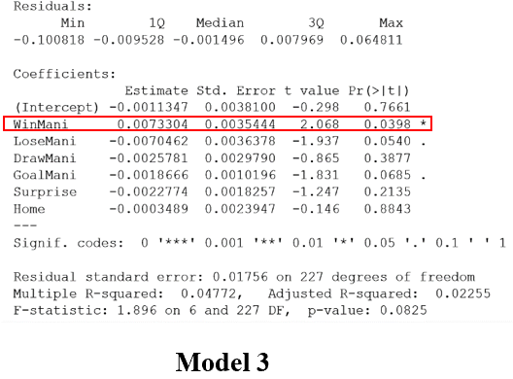
In this model, in order to see how exactly the game result will affect the returns, the game result is split into win or lose or draw. The results show that win result with a p-value equals to 0.0398 is statistically significant with a beta value of 0.0073304 while losing result with a p-value equals to 0.054, is almost statistically significant, and its beta value is -0.0070462. As is shown in this model, the game result is still the only factor that will impact the return. Whether winning a game or losing a game has a symmetric effect on the stock returns.

Model4
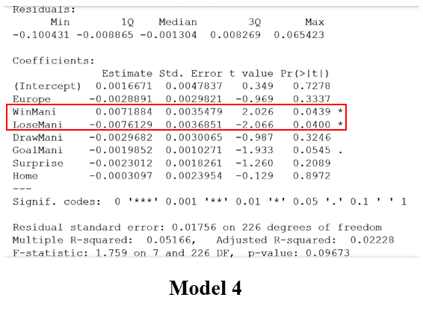
In this model, whether the game is a European game (UEFA Champion League game or UEFA Europe Cup game) is considered using a dummy variable. Normally speaking, a European game is more significant than a Premier League game. But the result indicates that whether a game is a European game or nor is not statistically significant. Still, only game results matter. More specifically, only win result with a p-value equals to 0.0439 and a losing result equals to 0.04 are statistically significant, while draw result with a p-value equals 0.3246 is not statistically significant. And like the previous model 3, the result of this model shows that a winning result and a losing result have the symmetric effect on the game result.

Model 5
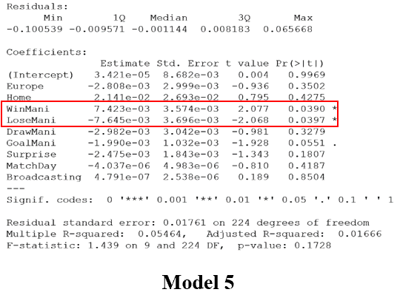
Other than all the factors mentioned above, two more factors are considered in this model, which are matchday revenue for each game and broadcasting revenue for each game. These two factors, on one hand, will directly affect MANU’s revenue, while on the hand serve as a relatively accurate number to estimate the visibility and exposure of one certain game. But still even taken these factors into consideration. Only the actual game result will impact the returns.

Juventus
Now testing another club, Juventus using the same model that used to test Manchester United. Similarly, I used the closing stock price and closing market index one trading day before the match (if the match is on weekends) or the match day (if the match is on weekdays) and the closing price of the next trading day after the match to calculate the return.

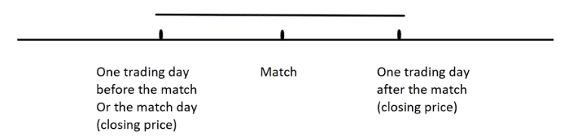

Model 2 & Model 3

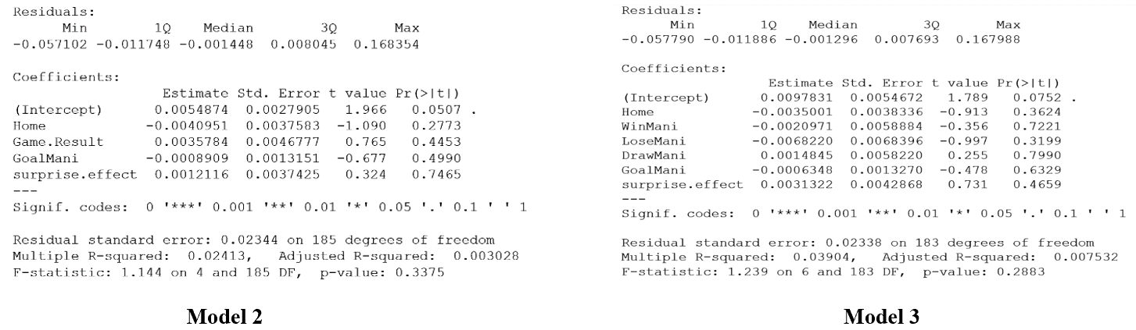
The results indicate that none of the “soccer factor” is statistical significance. Which means that unlike Manchester United tested before, Juventus’s stock return cannot be explained by the game results, Goal ahead, or surprise effect. So, the mystery here is what actually affects Juventus’s stock price. One thing that Juventus is quite different from Manchester United is that Juventus has a mother company EXOR group, which is also a public listed firm. Thus, a new model is applied to see whether the stock return of EXOR group can explain the return of Juventus.

Model 7

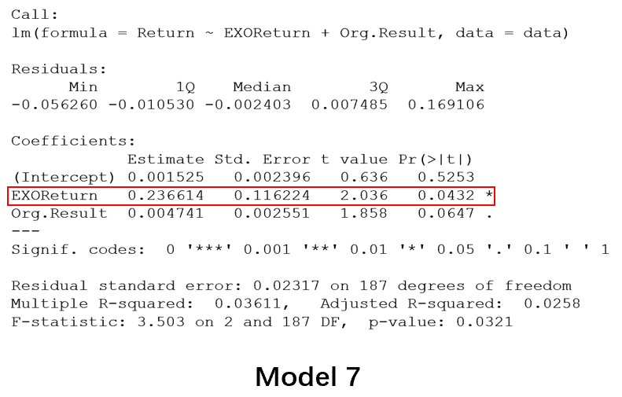
In this model, we only include two independent variables, one is EXOR group’s stock return and the other is the game result (using Formula 1 to calculate). And the results indicate that the EXOR return is statistical significance, with a p-value equals to 0.0432. The Game result may also have an impact on the return, but with a p-value equals 0.0647, greater than 0.05, it is not significant enough for us to take that into consideration. This model can only indicate that the return of Juventus is related to the return of EXOR group, but how these two are related may still be not clear. But due to the fact that EXOR group has many other child companies which are much larger than Juventus, for example, FIAT, etc. it is very unlikely that the return of Juventus affects the return of EXOR group but the other way around.

Manchester United
Also, I use the closing price or index two trading days after the match, three trading days after the match, four trading days after the match, and five trading days after the match to test when will the information be fully digested by the stock return applying model 2.

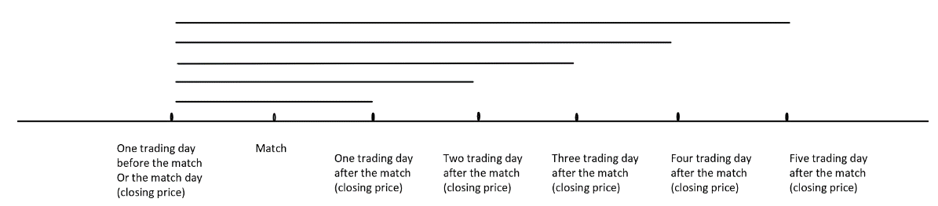

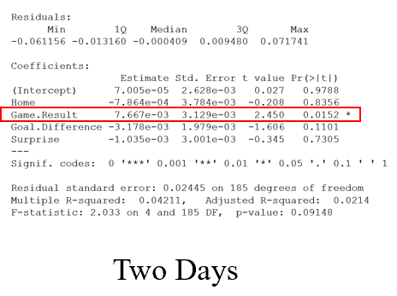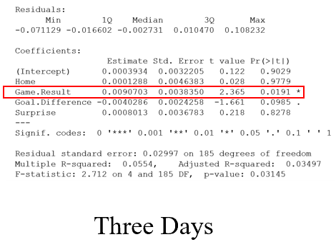
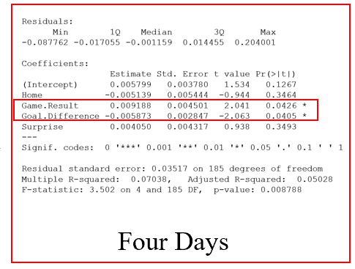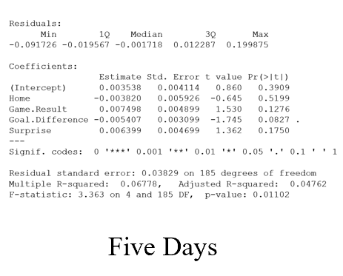

As we can see from the results, the effect of the information on the games will be fully digested four days after the match.
So, based on this result. We can assume that after the fourth day, the return of the stock will not be affected by the previous game results. The only major event after the game result has been digested and in the middle of a season will be the expectation of the next game.
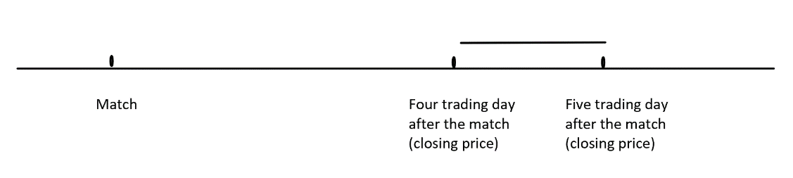
Thus, we test that information. The model we apply model 6.
Model 6

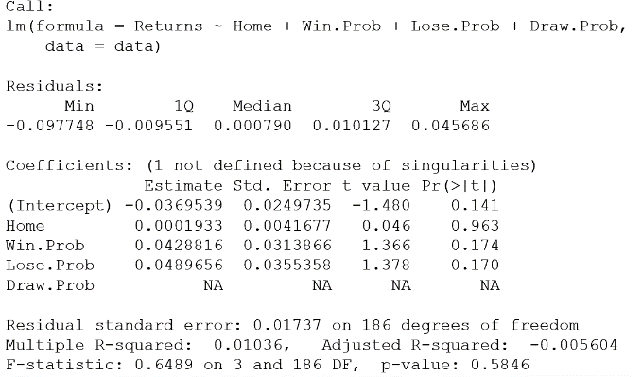

But this test itself does not carry much meaning, because often times, after the fourth day of the previous game, the next game has already started. Thus, in this way, the major information will again be the game result. So, to test whether the next game betting odds have an impact on the stock return, I need to test a few days before the next game.
I use the closing price or index two trading days before the match, three trading days before the match if the match is held on the weekend to test will the stock return be affected by the expectations right before the game starts applying the same model.

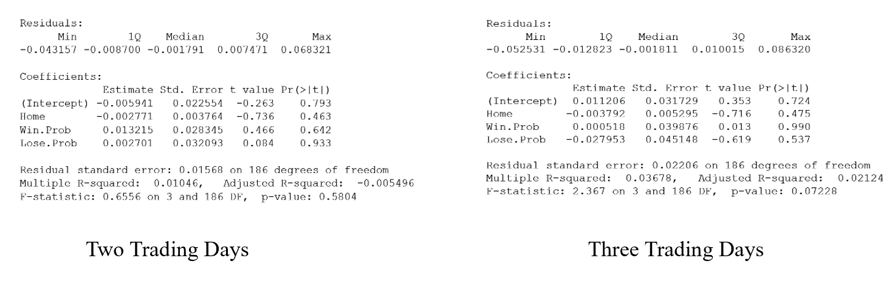
Still, we can see that the results indicate that expectation does not impact the return for MANU right before the game starts.

Juventus
The same model is applied to the data of Juventus.
Since none of the soccer factors affect Juventus’s return. I apply the closing price and index one trading day after the match and two trading days after the match to see whether the expectation for the result of the next game right after the match will impact Juventus’s return. Similarly, model 6 is used for testing.
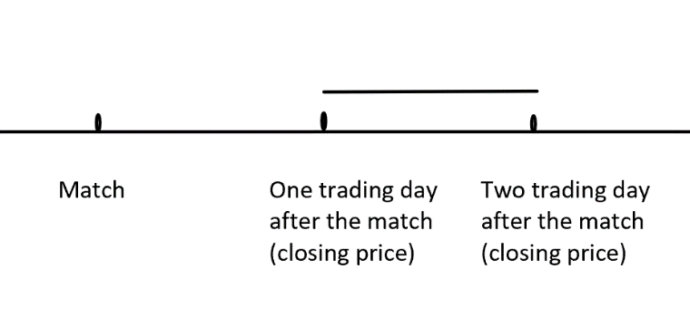
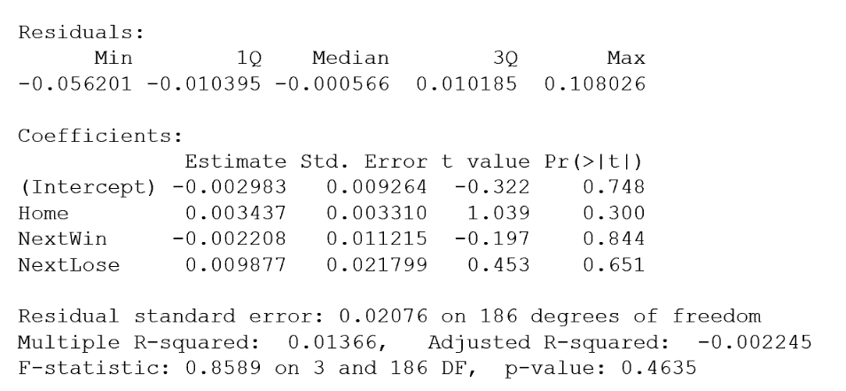
The result indicates that right after the match, the expectation will not impact the return of Juventus.
Also, I test whether the expectation right before the game starts will impact the return is tested using model 6. I feed the closing price and index one trading day before the match, two trading days before the match, and three trading days before the match into this model.

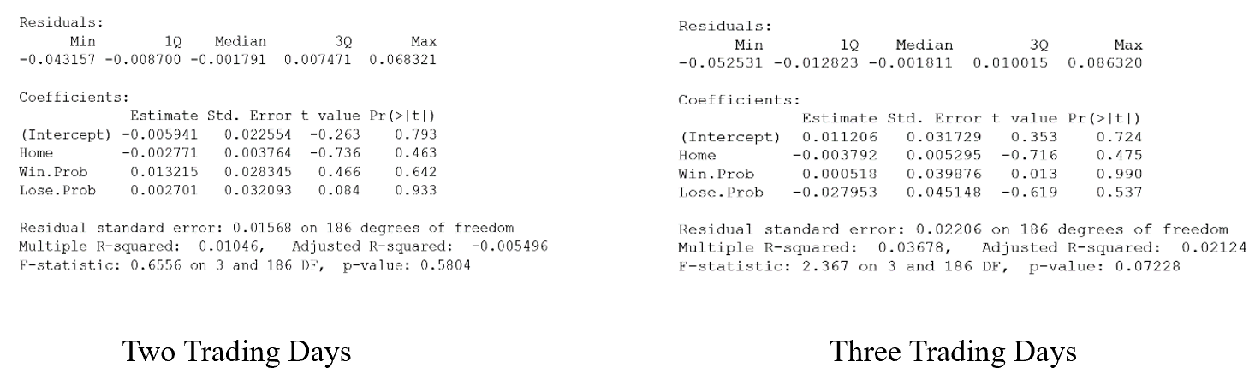
Still the results show that the expectations right before the game will not have a significant impact on the returns.

Borussia Dortmund
But according to the research conducted by Stadtmann, a different result was shown by using a similar idea when testing the game data and stock data of Borussia Dortmund from the year 2000 to the year 2006. Compared the model applied in this paper, Stadtmann’s model shows that Dortmund’s stock return is impacted by many more factors including game results, unexpected factor, different kinds of game, and even the winning or losing of its rivalry Bayern Munich (Table 2). More soccer related factors will impact the returns of Dortmund’s stock return. The similar kind of phenomena also exists in some other clubs like Birmingham, Sheffield United, Preston, etc. Based on the model used by Bell, et. al., game results, the goal ahead, and surprise effects will also impact the returns of the club.
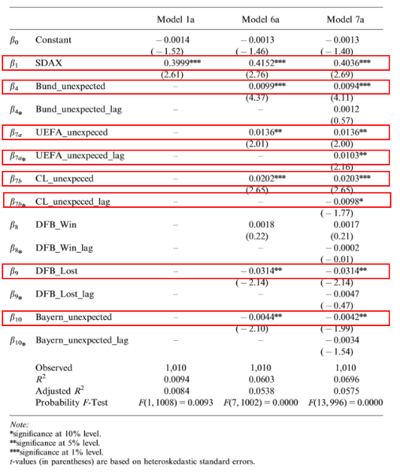
(Table 2)

V Conclusions & Future Works
As we can see from all the results listed above, from Manchester United, only the game results (more specifically, the win and losing) will affect the share returns. None of the other factors like Europe game or not, home game or not, goal difference, surprise effect, match day revenue, and broadcasting revenue has a statistically significant impact on the returns. And neither before nor after the games, the probability of winning, losing, or drawing a game, derived from the betting odds will impact the returns. But as for another team, Juventus, none of the factors can influence the returns, including the game results, Europe game or not, home game or not, goal difference, surprise effect, match day revenue, and broadcasting revenue. We found that the only factor that reflects the return of Juventus is the return of EXOR Group, which is the mother company of Juventus. While based on the previous research conducted by Stadmann, the share price of Dortmund is impacted by many different factors including the game results, the goal difference, and even the performance of its key competitor Bayern Munich will influence its share price.
These three clubs, though all soccer teams, are very different in their natures. Manchester United is the club that generates most revenues among all three, Juventus is the second, while Dortmund is the third. Dortmund is acting relatively more freely because there are no huge shareholders and it is also considered to be more “pure football” than the rest of two clubs. Juventus and Manchester United both have huge family controlling it. It is the Glazer family for Manchester United and Agnelli family for Juventus. But for Manchester United, it is more independent than Juventus, because the operation of the club is to a large extent on its own. While the operating of Juventus is still closely related to the operation of the EXOR group. Based on the results testing whether the game result and betting odds can reflect the returns of Manchester United, Juventus, and Dortmund, we can see a pattern that if a club is more “independent” and less “commercial”, then its return is more likely to be affected by the “soccer factors” like game results, goal difference, unexpected performance during the games, and the performance of key opponents.
Additionally, this research shows that although soccer betting odds can be a relatively strong and accurate model predicting the result, it is still quite unlikely for people to accept it and use it to make their investment decisions. In many cases, only the actual results may influence people’s decisions.
In the past few decades, scholars have tended to bond all the soccer clubs together and tested them as a whole. But this research shows that the differences among soccer clubs and differences among what factors impact the return are very obvious and big. Though it is reasonable and necessary for us to test them together, this bundling together does not bring us a very accurate result. Thus, in the future researches, it may be less appropriate for scholars to use the category “soccer” to bundle these stocks together.
After all, the soccer results and soccer betting odds are different kinds of information. Therefore, for the next step, I may not need to be limited in the soccer field. Instead, I will try to apply what has been found to a broader view, to see how exactly different information and under what kind of situation some specific information may affect different kinds of stocks in the market.

Bibliography
Annual Financial Report. Report. Manchester United. 2018.
Annual Financial Report 2018. Report. Juventus. 2018.
Bell, Adrian R., Chris Brooks, David Matthews, and Charles M. Sutcliffe. "Over the Moon or Sick
as a Parrot: The Effects of Football Results on a Clubs Share Price." Applied Economics, 2009, 3435-452. doi:10.2139/ssrn.1428452.
Bet365. Scooer Betting Odds. Raw data.
Bloomberg. Market Capitalization. Raw data.
Boudway, Ira. "Soccer Is the World’s Most Popular Sport and Still Growing." Bloomberg. June 12,
2018. www.bloomberg.com/news/articles/2018-06-12/soccer-is-the-world-s-most-popular-sport-and-still-growing.
Croxson, Karen, and J. James Reade. "Information and Efficiency: Goal Arrival in Soccer Betting."
The Economic Journal 124, no. 575 (2013): 62-91. doi:10.1111/ecoj.12033.
Deloitte Football Money League 2019. Report. Deloitte. 2019.
Football-Data. Football Data. Raw data.
Forrest, David, and Robert Simmons. "Outcome Uncertainty and Attendance Demand in Sport: The
Case of English Soccer." Journal of the Royal Statistical Society: Series D (The Statistician) 51, no. 2 (2002): 229-41. doi:10.1111/1467-9884.00314.
Hytner, David. "“Jürgen Klopp: Borussia Dortmund Are 'Worth Falling in Love With'." The
Guardian. November 3, 2013. www.theguardian.com/football/2013/nov/03/borussia-dortmund-jurgen-klopp-arsenal.
New York Times. "FIFA Set to Make $6.1 Billion From World Cup." June 12, 2018.
www.nytimes.com/2018/06/12/sports/fifa-revenue.html.
Palomino, Frederic, Luc Renneboog, and Chendi Zhang. "Information Salience, Investor Sentiment,
and Stock Returns: The Case of British Soccer Betting." Journal of Corporate Finance, December 24, 2008, 368-87. doi:10.2139/ssrn.1313084.
Scherr, Abbott F., and Thompson M. "Returns When Signals of Value Are Frequent: The Boston
Celtics." Journal of Business and Economic Studies, 1993, 69-83.
Spann, Martin, and Bernd Skiera. "Sports Forecasting: A Comparison of the Forecast Accuracy of
Prediction Markets, Betting Odds and Tipsters." Journal of Forecasting 28, no. 1 (2009): 55-72. doi:10.1002/for.1091.
Stadtmann, Georg. "FREQUENT NEWS AND PURE SIGNALS: THE CASE OF A PUBLICLY
TRADED FOOTBALL CLUB." Scottish Journal of Political Economy. August 08, 2006. Accessed May 05, 2019. https://onlinelibrary.wiley.com/doi/abs/10.1111/j.1467-9485.2006.00391.x.

Ira Boudway, “Soccer Is the World’s Most Popular Sport and Still Growing”. (Bloomberg 2018)
Deloitte, “Deloitte Football Money League 2019” (Deloitte 2019)
Tariq Panja, “FIFA Set to Make $6.1 Billion From World Cup” (New York Times 2018)
Frederic Palomino, et. al. “Information Salience, Investor Sentiment, and Stock Returns: The Case of British Soccer Betting”, (Journal of Corporate Finance, 2008), 368
Adrian Bell, et. al. “Over the Moon or Sick as a Parrot: The Effects of Football Results on a Clubs Share Price” (Applied Economics 2012), 3436
Frederic Palomino, et. al. “Information Salience”
Frederick Scherr, et. al. “Returns When Signals of Value Are Frequent: The Boston Celtics” (Journal of Business and Economic Studies 1993)
Georg Stadtmann, “Frequent News and Pure Signals - The Case of a Publicly Traded Football Club.” (Scottish Journal of Political Economy 2006)
Karen Croxson, et.al. “Information and Efficiency: Goal Arrival in Soccer Betting.” (The Economic Journal, 2013)
Frederic Palomino, et. al. “Information Salience”
David Forrest, and Robert Simmons. “Outcome Uncertainty and Attendance Demand in Sport: the Case of English Soccer.” (Journal of the Royal Statistical Society 2002)
Adrian Bell, et. al. “Over the Moon”
Martin Spann, et. al. “Sports Forecasting: A Comparison for the Forecast Accuracy of Prediction Markets, Betting Odds and Tipsters” (Journal of Forecasting 2008)
Georg Stadtmann, “Frequent News and Pure Signals”, 492
Adrian Bell, et. al. “Over the Moon”, 3439
Georg Stadtmann, “Frequent News and Pure Signals”, 499
Adrian Bell, et. al. “Over the Moon”, 3446
Georg Stadtmann, “Frequent News and Pure Signals”, 499
Georg Stadtmann, “Frequent News and Pure Signals”, 499
David Hytner, “Jürgen Klopp: Borussia Dortmund Are 'Worth Falling in Love with' .” (The guardian 2013)

