Implied Volatility of SSE 50 ETF Option:

Price-Volatility Relationship and Predictive Power

by

Ziyun Lu

An honors thesis submitted in partial fulfillment

of the requirements for the degree of

Bachelor of Science

Business and Economics Honors Program

NYU Shanghai

May 2020

Professor Marti G. Subrahmanyam Professor Christina Wang
Professor Christina Wang
Professor Jens Leth Hougaard

Faculty Advisers Thesis Adviser
Table of Contents
Acknowledgments 3
Abstract 4
Introduction 5
Data 10
Methodology 14
Hypotheses 15
Empirical Results 16
Conclusions 22
References 24
Appendix 26

Acknowledgments
First and foremost, I would like to thank my thesis advisor, Professor Christina Wang, for her support and guidance throughout the entire year of my research process. Her insights in Quantitative Finance and advice for research direction has been invaluable to my thesis. I would also like to thank our TA, Ms. Xinyi Yang for her organization and commitment to NYU Shanghai Business and Economics Honors program. Finally, I would like to thank my friends and family for their supports and encouragements.

Abstract
This thesis constructs and studies the VIX-type implied volatility of the Shanghai Stock Exchange (SSE) 50 ETF Option (IV). I examine the correlation between IV and the underlying price of SSE 50 ETF with intraday data from February 2018 to April 2020. I further investigate whether IV can be used to predict future realized volatility of its underlying – SSE 50 ETF. The correlation between IV and price is observed to be significantly positive in a subsample parallel to the period when US-China trade friction persists. In contrast, this correlation becomes negative during large shocks, such as the outbreak of COVID-19. This thesis also constructs a GARCH (1,1) forecasted volatility index with daily returns of SSE 50 ETF and compares the predictive power of GARCH (1,1) forecasted volatility with that of IV. Regression results show that both IV and GARCH (1,1) forecasted volatility contain predictive power for future realized volatility of SSE 50 ETF while IV is a superior predictor.
Keywords: Implied volatility, SSE 50 ETF, Volatility prediction

Introduction
Option implied volatility is widely believed to be the market’s estimate for the future volatility of the underlying asset over the remaining period of the option. A considerable amount of research has been made to investigate the true predictive power of implied volatility (IV). In general, early papers document that implied volatility is an inefficient predictor for future volatility, while more recent studies suggest that IV is a strong predictor. Day and Lewis (1992) finds that historical volatility contains greater predictive power about future volatility than implied volatility. Similar results are found in a different sample period that implied volatility almost does not correlate with future volatility; neither reflects recent observed realized volatility (Canina and Figlewski, 1993). However, more recent studies show that implied volatility contains strong predictive power. Szakmary et al. (2003) uses data from 35 future option markets and suggests that implied volatility outperforms historical volatility as a predictor for a vast majority of the commodities in their study. Becker, Clements, and White (2009) finds that implied volatility of S&P 500 index options can anticipate the impact of non-continuous price changes in the S&P 500 index.
One thing notable here is that early research commonly uses the “old VIX” – VXO index or some similar calculations based on the Black-Scholes formula, as the measure of implied volatility. Specifically, the VXO index is based on 8 at-the-money calls and puts on the OEX index (S&P 100) and uses the Black-Scholes model to extract the implied volatilities. However, more recent studies use the revised model-free VIX as the implied volatility that researchers work with. Revised to incorporate more traded options, the current VIX index takes as inputs all the put and call options written on S&P 500 index (SPX) for near and next term with more than 23 days and less than 37 days to expiration and then weights the options to yield a constant maturity 30-day indicator of the expected volatility of the S&P 500 Index.
A similar implied volatility measure was once introduced to the Chinese financial market, but it is no longer available to the public. In June 2015, the Shanghai Stock Exchange published the Chinese implied volatility index (iVIX). Later in November 2016, SSE published a revised Chinese implied volatility index (iVX), which is real-time updating VIX-type volatility implied by SSE 50 ETF options. The release of iVX was suspended in February 2018 without further notification on the time when it will resume. Other volatility measures for the Chinese market include the CBOE’s China ETF Volatility Index (VXFXI) implied by US-traded iShares China Large-Cap ETF (FXI), which also follows the calculation methodology of VIX. ARCH/GARCH-type volatility computed from historical returns and volatility, is also found useful to provide estimates on asset’s volatility in the near future. A few attempts have been made to examine whether implied volatility or volatility estimates from a time series model, e.g., GARCH, can make a better prediction. Szakmary et al. (2003) finds that, from 34 out of 35 future options, implied volatility exceeded GARCH models in predicting the future realized volatility. On the contrary, Bentes (2015) shows that GARCH forecasted volatility is superior to implied volatility in terms of producing forecasts on future realized volatility with data from four stock markets analyzed in his work.
Motivated by a plethora of research, this thesis examines the predictive power of the forward-looking VIX-type implied volatility of the Shanghai Stock Exchange (SSE) 50 ETF options (IV) for future realized volatility. It further intends to compare the ability of predicting future realized volatility between the IV and GARCH forecasted volatility. In the meanwhile, it also investigates the correlation between IV and the underlying price of SSE 50 ETF under different market conditions.
Previous research often finds a stable negative correlation between VIX and the price of its underlying S&P 500 index (Badshah 2013). There have been a few attempts to examine whether this negative correlation also pertains in the Chinese market. The results are mixed, and opposite conclusions exist when examining data from different sample periods and at different frequencies. Li et al. (2019) finds the correlation between iVX and the price of SSE 50 ETF being positive over their sample period from February 2015 to February 2018 in high-frequency intraday data. A possible explanation for counterintuitive price-volatility relationship attributes the cause to the inexperience of Chinese investors (Ahn et al. 2019). Further analysis can be done on the profile of option investors, composition of trading volume breaking down by transaction size, and whether this inexperience of investor is also observed in other markets with a new introduction of option products.
In this paper, I address the following questions. How is implied volatility correlated with the underlying price during the sample period this thesis studies? Can we observe different patterns of this correlation in different subsamples? Can these patterns also be observed in high-frequency data? Does implied volatility offer good prediction for future realized volatility? Compared to other volatility estimates, such as GARCH volatility, is implied volatility superior or inferior? The analysis I conduct in this paper intends to address the above questions using data from the Chinese market.
The methodology I use in this paper begins with a simple correlation analysis that computes the correlation between IV and the price of SSE 50 ETF and tests its significance level. I investigate this price-volatility relationship for two selected subsamples1 at higher frequencies. I find that both positive and negative correlations can be observed in high-frequency data for different periods. I use predictive regressions to examine the predictive power of IV for future realized volatility of SSE 50 ETF. Results show that IV has strong predictive power and is superior to GARCH (1,1) forecasted volatility.
This thesis reconstructs the Chinese implied volatility index with SSE 50 ETF option quotes, after its official release was suspended in February 2018. It contributes to the literature by examining the two well-explored research topics with evidence from the Chinese market and analysis using intraday data. I find a subsample where implied volatility exhibits a counterintuitively positive correlation with the underlying price. This thesis tries to offer explanation for this positive price-IV correlation from analyzing social economic factors and with behavioral finance theories. Further, the sample period of this research contains February to April in 2020, when the outbreak of COVID-19 turns into a global pandemic. Empirical results in this thesis complement our understanding of the price-IV correlation and affirm the predictive power of implied volatility.
This thesis can also have implications on whether IV-related financial products can be useful risk management tools. Often, we read news about some institutional investors shorting VIX either through its futures or options as a strategy of betting against market volatility or hedging against other positions in their portfolio. The analysis finds good predictive power of implied volatility; it confirms the possibility and the potential effectiveness of introducing financial products that are related to the implied volatility index for risk management purposes. On top of these, profitable trading strategies can also be derived under the guidance of a powerful predictive tool and with a good understanding of the correlation between implied volatility and underlying price in different market conditions.

Data
In this paper, I use 1-min and daily data on SSE 50 ETF option and the price of its underlying, SSE 50 ETF from March 2015 to April 2020. The sample period of my statistical analysis ranges from January 2, 2018, to April 3, 2020, which uses non-overlapping observations on the following variables:

Realized volatility
Daily realized volatility of SSE 50 ETF is calculated with 1-minute logarithmic returns, which is also the difference of the natural logarithm of the closing prices. For a specific time period, day t, the RV for this period is defined as:
$${RV}_{t}=\sqrt{252\left(\sum_{i=1}^{n}{r_{i,t}^{2}}\right)}$$
$$r_{i,t}=100(lnP_{i,t}-lnP_{i-1,t})$$
where $r_{i,t}$ is the i^{th} minute return on day t, n is the number of trading minutes for each day, and$P_{i,t}$ is the closing price for the i^{th} minute for day t.

Implied volatility
I use SSE 50 ETF option quotes from March 2, 2015 to April 3, 2020. The options written on the SSE 50 ETF are the first and the most actively traded European-style option contracts in the Chinese market. I construct the implied volatility of SSE 50 ETF option (IV) based on the VIX Whitepaper (Chicago Board Options Exchange, 2003). Small adjustments are made in the calculation to accommodate the specificities of this option contract, which corresponds to the calculation methods of iVX. As I have introduced in the previous section, SSE published iVIX on June 2, 2015, revised it to be real-time updating on November 28, 2016, and changed the name of this implied volatility index to iVX. Therefore, I collect historical data of iVIX and iVX published by SSE. I then use it to test the validity of the implied volatility (IV) that I construct with SSE 50 ETF option transaction data. Fig. 1 plots the initial iVIX and the revised iVX on one series, and IV this paper constructs on the other, from June 2, 2015 to February 14, 2018, when SSE first launched and later suspended the release of this index. As shown in Fig. 1, IV has a strong comovement and close numerical values with SSE published volatility index, especially with iVX after November 2016. Therefore, it is valid for this paper to use the above methods to construct the VIX-type implied volatility of SSE 50 ETF option (IV) and perform further analysis.
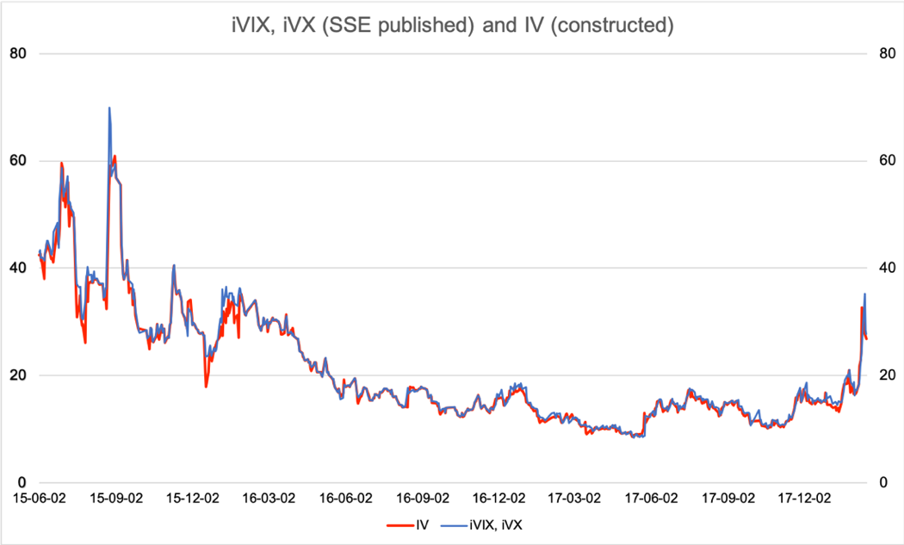
Fig. 1. Time-series plot of SSE-published implied volatility index (iVIX, iVX) and the implied volatility levels this paper constructs (IV). The plotted period is from June 2, 2015 to February 14, 2018.

GARCH (1,1) forecasted volatility
Among the various time series models, autoregressive conditional heteroscedasticity models (ARCH) and its class are considered as the most popular and commonly used models in finance to estimate volatility. Introduced first by Engle (1982), the ARCH model expanded into the generalized autoregressive conditional heteroscedasticity (GARCH) model by Bollerslev (1986). Empirical evidence supports that GARCH (1,1) is sufficient for a good modeling in many financial time series (Engle and Patton, 2001). This paper further uses GARCH (1,1) forecasted volatility and compares it with IV in terms of their predictive power for future realized volatility. Daily returns of SSE 50 ETF from March 2015 to April 2020 is used and the GARCH (1,1) forecasted volatility is obtained by:
$$σ_{t+1}^{2}= ω+ αε_{t}^{2}+βσ_{t}^{2}$$
In this research, I set the forecasting length to 1, which means these estimates are on a daily basis. Then, I construct these sigma estimates be on an equivalent annualized scale as realized volatility in the previous subsection:
$$σ_{GARCH,t}=\sqrt{252}(100{\hat{σ}}_{t})$$
I construct the GARCH (1,1) model with the first 696 return observations and use it to forecast the latter 548 volatilities. The step of refit is set to be 1, which means after estimating the sigma for period $t+1$, it takes the actual series for period $t+1$ as input and refits the parameters of the GARCH model. Then the model estimates the sigma for period $t+2$. Sigma estimates vs. actual is plotted in Appendix, with a plot of Value at Risk (VaR) at 1% level to prove the validity of the GARCH (1,1) model that this research constructs. The time period of these 548 forecasted volatility estimates are parallel to the sample period from January 2, 2018 to April 3, 2020 for the following statistical analysis.
Table 1 reports the summary statistics of the 1-min and daily close price of SSE 50 ETF, implied volatility of SSE 50 ETF option (IV), realized volatility of SSE 50 ETF (RV), and the GARCH (1,1) volatility estimates.
Table 1 Summary statistics
Variable | Mean | SD | Skewness | Kurtosis | Minimum | Maximum
price_1min | 2.757 | 0.222 | -0.242 | -1.082 | 2.246 | 3.195
price_daily | 2.757 | 0.222 | -0.246 | -1.085 | 2.255 | 3.18
IV_daily | 21.826 | 5.210 | 0.167 | -0.387 | 11.913 | 37.635
RV_daily | 16.350 | 5.540 | 1.216 | 2.459 | 7.160 | 44.435
σ_{GARCH}_daily | 21.256 | 6.689 | 0.813 | 0.177 | 11.394 | 45.801
Note: price_1min and price_daily refer to the price of SSE 50 ETF. Table 1 reports the annualized realized volatility (RV_daily) and GARCH forecasted volatility (σ_{GARCH}_daily). The sample period is from January 2, 2018 to April 3, 2020, which provides 548 daily observations and 131520 1-minite price observations.

Methodology
I study the Pearson correlation coefficient between IV and the price of SSE 50 ETF and test the significance level of the correlation throughout the whole sample and with selected subsamples. I conduct this correlation analysis with both daily data and intraday data of 5-min and 30-min intervals.
The forecasting power of IV for future realized volatility of SSE 50 ETF is examined with the following ordinary least squares (OLS) regression models:
$RV_{t}=α+β_{1}IV_{t-1}+ε_{t}$ (1)
$RV_{t}=α+β_{1}IV_{t-1}+β_{2}RV_{t-1}+ε_{t}$ (2)
where $IV_{t-1}$takes all SSE 50 ETF option transaction data by the end of period t-1 into calculation, which is almost equivalent to the implied volatility level at the beginning of period t. On top of these, lagged return $r_{t-1}$and synchronous return $r_{t}$are added as a variable to the regression model to study the leverage effect.
$RV_{t}=α+β_{1}IV_{t-1}+β_{2}RV_{t-1}{ + β}_{3}r_{t-1}+ε_{t}$ (3)
$RV_{t}=α+β_{1}IV_{t-1}+β_{2}RV_{t-1}{ + β}_{3}r_{t}+ε_{t}$ (4)
I compare the predictive power of IV and GARCH (1,1) forecasted volatility in the following OLS regression model:
$RV_{t}=α+β_{1}IV_{t-1}+β_{2}σ_{GARCH,t}+ε_{t}$ (5)

Hypotheses
- Negative and positive correlations between Implied Volatility of SSE 50 ETF Option (IV) and the price of SSE 50 ETF can be observed in different subsamples.
If the statistical analysis finds positive correlation between implied volatility and price in high frequency data, which leads to the counterintuitive interpretation that investors expect high volatility for the near future when the price of SSE 50 ETF is rising.

- IV contains predictive power for future realized volatility of SSE 50 ETF.
If this hypothesis tests true, a significant non-zero coefficient for IV should be observed in the predictive regression.

- IV has more predictive power for future realized volatility than GARCH (1,1) forecasted volatility.
If this hypothesis tests true, the adjusted R-squared of a bivariate predictive regression using IV as the regressor variable should be larger than the one using GARCH (1,1) forecasted volatility. With GARCH (1,1) forecasted volatility adding to the previous bivariate predictive regression, the adjusted R-squared should only exhibit small changes.

Empirical Results
- Testing the correlation between implied volatility and the underlying price
In this section, I first examine the correlation between the implied volatility and the price of SSE 50 ETF. In Fig. 2, the time series of daily level of implied volatility (IV) and the price of SSE 50 ETF are plotted in two panels. Panel A shows the period since the introduction of SSE 50 ETF Option. Panel B shows the sample period this thesis studies, which ranges from January 2, 2018 to April 3, 2020.
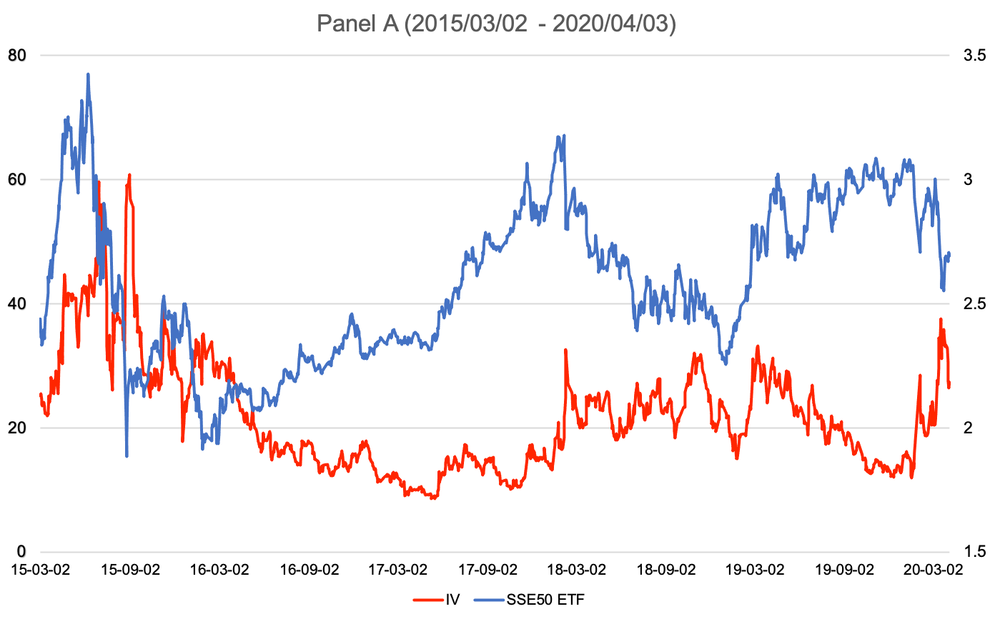
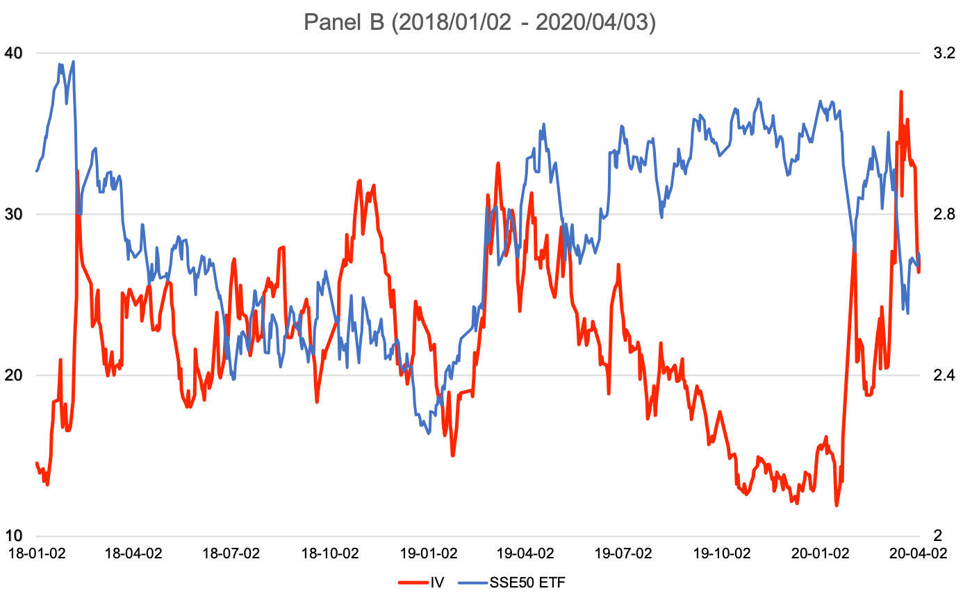
Fig. 2. Time series of IV and the price of SSE 50 ETF, (a) from Mar 2, 2015 to Apr 3, 2020, (b) from Jan 2, 2018 to Apr 3, 2020.
In Panel B, we can identify two subsamples that seem to have different patterns in the price-IV relationship. Subsample 1, denoted as C on Fig.2., ranges from February 11, 2019 to May 31, 2019, where positive co-movement between price and IV can be observed. Subsample 2, denoted as D on Fig.2., ranges from February 3, 2020 to April 3, 2020, which is the period when the outbreak of Covid-19 turns into a global pandemic.
Table 2 presents the correlations between IV and price, and IV changes and returns for the periods shown and defined in Fig.2. Throughout the sample period of this research, IV and price are negatively correlated, with a coefficient of -0.454 at the significance level of 1%. A negative correlation also exists in the changes of IV and the returns of SSE 50 ETF. Taking the daily results as an example, the coefficients are -0.403 in the full sample, and -0.038 and -0.687 for the two subsamples.
Table 2 Correlation between IV (IV changes) and price of SSE 50 ETF (returns)
Daily | A | B (Full sample) | C (Subsample 1) | D (Subsample 2)
IV and price | 0.027 | -0.454*** | 0.502*** | -0.850***
IV changes and returns | -0.183*** | -0.403*** | -0.038 | -0.687***
30-min | C | D
IV and price | 0.594*** | -0.854***
IV changes and returns | -0.069* | -0.513***
5-min | C | D
IV and price | 0.596*** | -0.857***
IV changes and returns | -0.071*** | -0.572***
Notes: Table 2 presents the Pearson correlation coefficients with significance level between IV (IV changes) and the price of SSE 50 ETF (returns) at daily, 30-min and 5-min frequencies. Period A is from March 2, 2015 to April 3, 2020. Period B is the sample period of this research, which ranges from January 2, 2018 to April 3, 2020. Period C is defined from February 11, 2019 to May 31, 2019 and period D is defined from February 3, 2020 to April 3, 2020.
Return is calculated as logarithmic difference of prices of SSE 50 ETF; ***, ** and * denote the statistical significance at 1%, 5% and 10% levels respectively.

With numerical analysis, I confirm that positive correlation between IV and price exists in period C (Subsample 1). As shown in Table 2, in period C, IV and price are positively correlation with a coefficient greater than 0.5 at the significance level of 1%, which can be observed in both daily and intraday data. This correlation coefficient is even larger when analyzing at higher frequencies. When market experiences great declines caused by the outbreak of COVID-19, as shown in period D, the correlation between IV and the underlying price appears significantly negative. The correlation coefficient of IV and price becomes -0.850, and that of IV changes and returns becomes -0.687. This is in line with previous research that finds the price-IV correlation becoming negative during large price fluctuations and negative shocks (Li et al., 2019).

- Predicting realized volatility of SSE 50 ETF using implied volatility
As IV is widely considered as market’s estimates of future volatility, I investigate the role of IV in predicting the future realized volatility of its underlying – SSE 50 ETF.
Table 3 reports the estimated results of the predictive regressions. Implied volatility ${IV}_{t-1}$ proves to be a significant independent variable for RV_{t} throughout the whole sample period, and during selected subsamples. When adding $RV_{t-1}$and lagged return or synchronous return as variables in the regression model, the adjusted R-squared is improved. Taking the full sample results as an example, in the regression using ${IV}_{t-1}$as a single variable, the adjusted R-squared is 0.5262 and its coefficient is 0.773. When $RV_{t-1}$is added to this benchmark predictive regression, the coefficient of $RV_{t-1}$ is 0.404 and that of ${IV}_{t-1}$ declines to 0.460. The value of adjusted R-squared of this multivariate regression increases to 0.6025. After adding lagged return $r_{t-1}$ to the regression model, the adjusted R-squared is improved to 0.6225. Similar evidence can also be found in the regression for selected subsamples. This indicates that these three variables, implied volatility, historical volatility, lagged return, which stands for the leverage effect, all contain certain information for the realized volatility in next period. Moreover, the coefficients of returns in the predive regressions for period C and D, one being positive and one being negative, also corresponds to our previous correlation analysis.
Table 3 Predictive regressions for the future realized volatility
 | RV_{t} | IV_{t-1} | RV_{t-1} | r_{t-1} | r_{t} | Adj. R²
Full Sample |  | 0.773*** |  |  |  | 0.5262
 |  | (24.647)
 |  | 0.460*** | 0.404*** |  |  | 0.6025
 |  | (10.996) | (10.277)
 |  | 0.445*** | 0.407*** | -0.582*** |  | 0.6225
 |  | (10.841) | (10.631) | (-5.471)
19/02/-19/05 |  | 0.919*** |  |  |  | 0.3774
 |  | (6.772)
 |  | 0.801*** | 0.126 |  |  | 0.3792
 |  | (4.652) | (1.097)
 |  | 0.850*** | 0.104 |  | 0.567* | 0.4040
 |  | (4.987) | (0.920) |  | (2.000)
20/02/-20/04 |  | 0.855*** |  |  |  | 0.5674
 |  | (7.662)
 |  | 0.778*** | 0.089 |  |  | 0.5649
 |  | (5.189) | (0.668)
 |  | 0.739*** | 0.060 | -0.770* |  | 0.6102
 |  | (5.179) | (0.473) | (-2.402)
Notes: Table 3 presents the results of the prediction regressions. The full sample is from January 2, 2018 to April 3, 2020, and two subsamples are selected. Period C (Subsample 1) is from February 11, 2019 to May 31, 2019; and Period D (Subsample 2) is from February 3, 2020 to April 3, 2020. The t values (in parentheses are based on the Newey and West (1987) standard errors. ***, ** and * denote the statistical significance at 1%, 5% and 10% levels respectively.

In the predictive regressions using ${IV}_{t-1}$ as a single regressor, ${IV}_{t-1}$ has a coefficient of 0.773 in the full sample, 0.919 in period C, and 0.855 in period D, all at the significance level of 1%. During market declines, implied volatility performs even better in predicting future realized volatility. In period C, where implied volatility and price are positively correlated, ${IV}_{t-1}$ appears to have weaker predictive power in this subsample, where the adjusted R-squared is 0.3774 compared to 0.5262 in the full sample and 0.5674 in period D. Moreover, $RV_{t-1}$ turns out to be an insignificant variable in the regressions for two subsamples. This may imply that when the market experiences large uncertainties or huge declines, implied volatility takes over historical volatility in terms of the information it contains for future volatility.

- Predicting RV using IV vs. GARCH (1,1) forecasted volatility estimates
Table 4 Predictive regressions of IV and GARCH(1,1) forecasted volatility estimates
 | $$RV_{t}$$ | $$σ_{GARCH,t}$$ | $${IV}_{t-1}$$ | Adj. R²
Full Sample |  | 0.498*** |  | 0.3606
 |  | (17.591)
 |  |  | 0.773*** | 0.5262
 |  |  | (24.647)
 |  | 0.074 | 0.697*** | 0.5286
 |  | (1.911) | (13.985)
19/02/-19/05 |  | 0.383*** |  | 0.1398
 |  | (3.609)
 |  |  | 0.919*** | 0.3774
 |  |  | (6.772)
 |  | -0.007 | 0.924*** | 0.3688
 |  | (-0.059) | (5.243)
20/02/-20/04 |  | -0.117 |  | -0.0133
 |  | (-0.650)
 |  |  | 0.855*** | 0.5674
 |  |  | (7.662)
 |  | -0.061 | 0.851*** | 0.5598
 |  | (-0.512) | (7.549)
Notes: Table 4 presents the results of the prediction regressions using IV vs. GARCH (1,1) forecasted volatility estimates. The full sample is from January 2, 2018 to April 3, 2020, and two subsamples are selected. Subsample 1 is from February 11, 2019 to May 31, 2019; and subsample 2 is from February 3, 2020 to April 3, 2020. The t values (in parentheses are based on the Newey and West (1987) standard errors.
***, ** and * denote the statistical significance at 1%, 5% and 10% levels respectively.

This subsection discusses the results obtained from regressing $RV_{t}$ on GARCH (1,1) forecasted volatility $σ_{GARCH,t}$ and compares with the previous predictive regressions using implied volatility. As shown in Table 4, $σ_{GARCH,t}$ contains predictive power for future realized volatility. In the full sample, $σ_{GARCH,t}$ has a coefficient of 0.498 at the significance of 1%, and the value of adjusted R-squared is 0.3606; and in subsample 1, $σ_{GARCH,t}$ has a coefficient of 0.383 also at the significance of 1%. Compared to the predictive regression using ${IV}_{t-1}$ as a single regressor, where the value of adjusted R-squared is 0.5262 for the full sample regression, $σ_{GARCH,t}$ may have weaker predictive power than ${IV}_{t-1}$. Similar evidence can be found in the results of regression model: ${RV}_{t}=α+β_{1}IV_{t-1}+β_{2}σ_{GARCH,t}+ε_{t}.$In this multivariate regression, $σ_{GARCH,t}$ becomes insignificant and the adjusted R-squared of this multivariate regression only from 0.5262 to 0.5286. This also indicates that ${IV}_{t-1}$ is a superior predictor for $RV_{t}$ than $σ_{GARCH,t}$.

Conclusions
The thesis constructs and studies the VIX-type implied volatility of SSE 50 ETF Option (IV) by examining its correlation with the underlying price of SSE 50 ETF and its predictive power for future realized volatility. A negative correlation between IV and price is found in the full sample from January 2, 2018, to April 3, 2020. Among the full sample, different price-IV relationships exist. IV and price are positively correlated from February 2019 to May 2019, while this correlation becomes significantly negative in the period after the outbreak of COVID-19. To explain this counterintuitive positive correlation, I refer to the socioeconomic context during the first half of 2019, where a persistent theme – US-China frictions, creates great uncertainty to the economy and sends mixed signals. Looking back at the specific time nodes, we see the trade negotiation resumes, breaks up and resumes again, and tariff is imposed, delayed, and raised by both sides. Everything goes back and forth, and this may explain the positive correlation between IV and price. From the perspective of an investor, we know this trade conflict cannot be settled in a short time, and we face mixed signals that change rapidly. Based on loss aversion from behavioral finance, when the market senses a positive sign, and the price rises, given the knowledge of this particular context, investors may be more uncertain about future price movements, and fear more for adverse changes. This corresponds to the forward-looking implied volatility increases as well when the underlying price increases.
Further, this paper analyzes the ability of IV and GARCH (1,1) forecasted volatility to predict future realized volatility of SSE 50 ETF. Results show that both IV and GARCH (1,1) forecasted volatility contain certain predictive power, where these two variables have significant non-zero coefficients in the predictive regression. Moreover, comparing the values of adjusted R-squared and analyzing with multivariate regression, I find IV is a superior predictor to GARCH (1,1) forecasted volatility. This result provides us guidance on forecasting volatility in the near future. It confirms the possibility and the potential effectiveness of introducing financial products that are related to implied volatility for risk management purposes.

References
Ahn, K., Bi, Y., & Sohn, S. (2019). Price discovery among SSE 50 Index-based spot, futures, and options markets. Journal of Futures Markets, 39(2), 238–259. doi: 10.1002/fut.21970
Badshah, I. U. (2013). Quantile Regression Analysis of the Asymmetric Return-Volatility Relation. Journal of Futures Markets, 33(3), 235–265. doi: 10.1002/fut.21551
Becker, R., Clements, A. E., & McClelland, A. (2009). The jump component of S&P 500 volatility and the VIX index. Journal of Banking & Finance, 33(6), 1033–1038. doi: 10.1016/j.jbankfin.2008.10.015
Bentes, S. R. (2015). A comparative analysis of the predictive power of implied volatility indices and GARCH forecasted volatility. Physica A: Statistical Mechanics and Its Applications, 424, 105–112. doi: 10.1016/j.physa.2015.01.020
Bollerslev, T. (1986). Generalized autoregressive conditional heteroskedasticity. Journal of Econometrics, 31(3), 307–327. doi: 10.1016/0304-4076(86)90063-1
Canina, L., & Figlewski, S. (1993). The Informational Content of Implied Volatility. The Review of Financial Studies, 6(3), 659–681. doi: 10.1093/rfs/5.3.659
Chicago Board Options Exchange (2003) “The CBOE Volatility Index – VIX.” White Paper.
Day, T. E., & Lewis, C. M. (1992). Stock market volatility and the information content of stock index options. Journal of Econometrics, 52(1–2), 267–287. doi: 10.1016/0304-4076(92)90073-Z
Engle, R. F. (1982). Autoregressive Conditional Heteroscedasticity with Estimates of the Variance of United Kingdom Inflation. Econometrica, 50(4), 987–1007. doi: 10.2307/1912773
Engle, R. F., & Patton, A. J. (2001). What good is a volatility model? Quantitative Finance, 1(2), 237–245. doi: 10.1088/1469-7688/1/2/305
Li, J., Yu, X., & Luo, X. (2019). Volatility index and the return–volatility relation: Intraday evidence from Chinese options market. Journal of Futures Markets, 39(11), 1348–1359. doi: 10.1002/fut.22012
Szakmary, A., Ors, E., Kyoung Kim, J., & Davidson, W. N. (2003). The predictive power of implied volatility: Evidence from 35 futures markets. Journal of Banking & Finance, 27(11), 2151–2175. doi: 10.1016/S0378-4266(02)00323-0

Appendix
Fig. A1. GARCH (1,1) sigma forecast vs actual
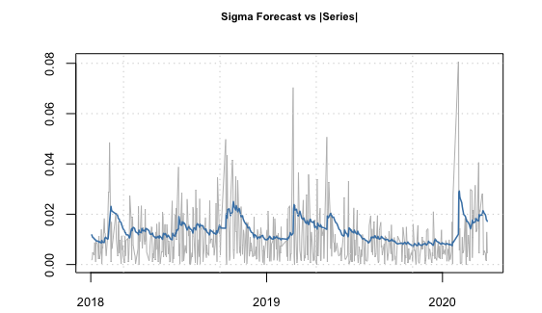

Fig. A2. Results of VaR test at level of 1%
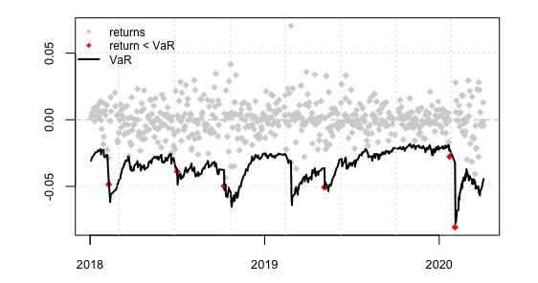

CBOE VIX Whitepaper
Shanghai Stock Exchange (SSE) launched SSE 50 ETF on February 23, 2005, which is the first ETF in mainland China. This ETF selects the 50 largest and most liquid stocks listed on SSE. On February 9, 2015, SSE introduced SSE 50 ETF Option, which is the first exchange-traded option in the mainland China.
February 3, 2020 is the first trading day in China after the Spring Festival holiday extended to February 2 due to the outbreak of COVID-19. According to statistics from Johns Hopkins University, by April 3, 2020, the number of confirmed cases of COVID-19 in the world has exceeded 1 million, the number of deaths HAS exceeded 51,000.
First 696 observations used for the starting estimation, followed by the 547 rolling forecasts.

